This job aid provides EPM query users with information on reporting table indexes and join criteria which can be used to improve performance and retrieve accurate results.

Reporting Table Indexes

A reporting table index describes a field (Single Index) or set of fields (Compound Index) that commonly are used for searching. By using indexed fields for selection and criteria, performance can be improved on an EPM query. The more indexed fields used, the better the performance. If selection criteria is used on a field in a Compound Index, preceding fields in that group must also used in criteria to maximize query performance.

The embedded Microsoft Excel spreadsheet provides a listing of major EPM reporting tables and the indexed fields which should be used for selection and criteria when creating queries.

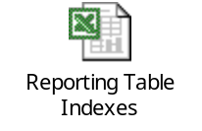

*** Check for updates to this job aid as table indexes may be added/removed over time while Core-CT EPM and Technical Teams are monitoring the EPM environment.

Reporting Table Join Criteria

When creating queries in EPM using multiple reporting tables, getting accurate data in their results can be difficult if the tables are not joined correctly. If the tables are not joined correctly, not only will the results not be accurate, but system performance can be severely degraded.

Within the EPM Query Tool, when you select multiple tables for a query, the application “auto-joins” the tables based on key fields of the same name. In many cases, this information is correct. However, in some cases, the auto-join criteria are incorrect. Also, there may be additional fields (other than key fields) that may be used to join tables.

This job aid provides the EPM end users with a cross-reference spreadsheet showing the correct fields that can be used as join criteria between all major EPM reporting tables. Please read the How to Use the Table Join Spreadsheet and the Important NOTES sections below.

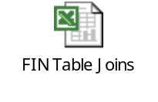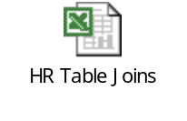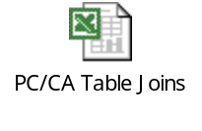

How to Use the Table Join Spreadsheet

1. Open the embedded Microsoft Excel document titled EPM Reporting Table Join Criteria.
2. The EPM Reporting Tables are listed alphabetically by application (Financials, HRMS) across the columns and down the rows by application and module.
3. Scan the columns and find the first table you want to use.
4. (Optional) Click on the filter arrow in the column header and select (NonBlanks). Only those tables that can be joined to the first table are displayed.

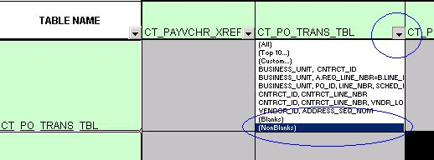

5. Scan the rows to find the second table you want to use.
6. Find the cell which intersects the column and row. This cell shows you the join criteria between the two tables.
a. If the field name in the join criteria is the same for both tables, then the field name is listed once.
b. If the field name in the join criteria is different for each table, then the relationship is denoted as A.[field name] = B.[field name] where “A” represents the table name in the column and “B” represents the table name in the row.

Important NOTES regarding Table Join Spreadsheet:

1. This spreadsheet is designed to be used online/electronically. If you choose to print the document, it will print over multiple pages. You may need to insert page breaks, change page layout, etc. for it to look correct.
2. This spreadsheet does not include configuration or translate tables.
3. The 13 different views of the CTW_LEDG_KK_BAL table have the same criteria as the CTW_LEDG_KK_BAL table, so use this table as the reference point when determining join criteria;
4. This cross-reference spreadsheet only includes tables that can be joined directly. Therefore, if you can join Table A to C by also joining table B, it will not be described in this job aid;
5. You do not always have to use all of the join criteria between tables. Depending on the results expected, you may use fields independently. Examples are BUSINESS_UNIT, VENDOR_ID, or EMPLOYEE_ID.
6. Do NOT join a table to itself unless absolutely necessary. Doing so can impact performance greatly;
7. If you are joining more than two tables, use the table join spreadsheet for each combination of tables. For example, if you are joining tables A, B, and C, you may need to join A to B, B to C, and/or A to C;
8. Join Criteria denoted by ** are joins that are not recommended by the EPM Team because these tables normally would not be joined to retrieve data and/or the tables are extremely large and performance may be impacted.
9. Use this spreadsheet to verify Auto-Join Criteria when creating a query in the Core-CT EPM application. See Invalid Auto-Joins section below.

Invalid Auto-Join Criteria

The following fields are “auto joined” in the application, but are not valid (improper joins) and can cause incorrect data to be returned: To remove these “auto joins”, just uncheck the box next to the join you wish to eliminate.

Field Name | Table 1 | Table 2
DISTRIB_LINE_NUM | CTW_PO_TRANS | CTW_REQ_TRN_TBL
DISTRIB_LINE_NUM | CTW_PO_TRANS | CTW_VCHR_TRANS
LINE_NBR | CTW_PO_TRANS | CTW_REQ_TRN_TBL
SCHED_NBR | CTW_PO_TRANS | CTW_REQ_TRN_TBL
BUSINESS_UNIT | CTW_JRNL_TRN | CTW_HR_ACCTG_LN
BUSINESS_UNIT | CTW_JRNL_TRN | CTW_POSTED_ITM
BUSINESS_UNIT | CTW_JRNL_TRN | CTW_VC_ACCTG_LN
MILESTONE_NBR | CTW_PO_TRANS | CTW_VCNT_MIL
MILESTONE_NBR | CTW_VC_ACCTG_LN | CTW_VCHR_TRANS
DEPTID | CTW_DET_PAYROLL | CTW_JRNL_TRN
DEPTID | CTW_DET_PAYROLL | CTW_HR_ACCTG_LN
DEPTID | CTW_PAYCHECK | CTW_HR_ACCTG_LN
DEPTID | CTW_PAYCHECK | CTW_POSITION
DEPTID | CTW_PAY_EARNS | CTW_POSITION
DEPTID | CTW_EMPLOYEE | CTW_POSITION
DEPTID | CTW_AUDIT_POSTN | CTW_POSITION
DEPTID | CTW_TLEMPDATA | CTW_POSITION



