
DOT Job Aid

Enter a Rate Based Contract

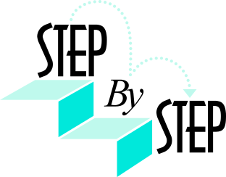1. Navigate to Customer Contracts > Create and Amend > General Information.

- Click the Add a New Value tab.

- Verify that DOTM1 defaults as your Business Unit.

- Type the contract name in the Contract field. The naming convention for DOT is the Federal Agreement Number.

Type or select the Sold To Customer. Example: [To be entered by Agency SME]

- Select the Contract Classification of Standard or Government. The Contract Classification of Internal is not used.

NOTE: The State will be using either Standard or Government type classifications. Once you specify a classification and save the contract, it cannot be changed. The classification that you select determines the functionality that is available for that particular contract type. The main difference between the Standard and Government classification is there are additional informational pages for Government contracts. Example: [To be entered by Agency SME]regarding when to use which Contract Classification
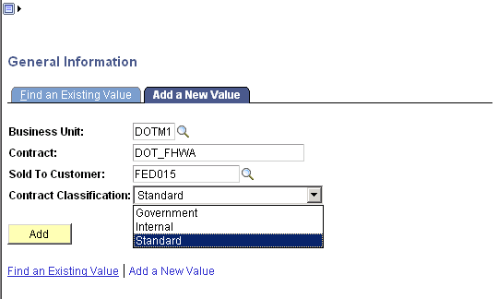
Figure 1 - This is the Add a New Value tab.

- Click . The General page displays.
- Type a description of the contract in the Description field. Example: [To be entered by Agency SME]

- Ensure the Contract Admin field defaults correctly. This field defaults based on the Sold To Customer selected on the Add a New Value tab.

- Type or select the Contract Type. The Contract Type is configured differently for each agency. It is used for reporting purposes. Example: [To be entered by Agency SME]

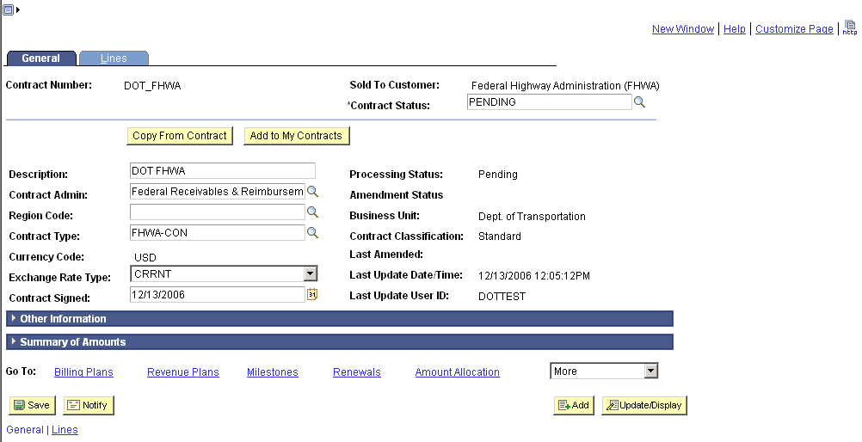
Figure 2 - This is the completed Contract General page.

- Click .

- Click the Lines tab. The Lines page displays.

- Click . The General Information – Add Contract Lines page displays.

- Type a Product name in the Product field. All products start with your agency’s three letter acronym, DOT. Example: [To be entered by Agency SME]

- Click the Price Type dropdown box. Select Rate.

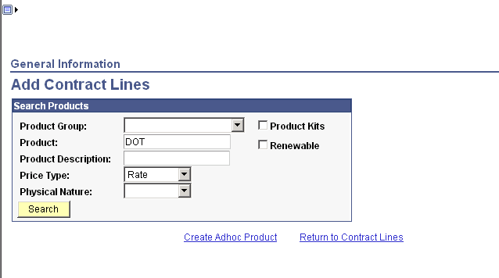
Figure 3 - This is the completed General Information - Add Contract Lines completed search page.
- Click . The search results display.

- Select the checkbox of the contract line(s) you want to add to the contract.

Note: Do not deselect any boxes in the Create Plans from Template or Combine Like Template boxes.

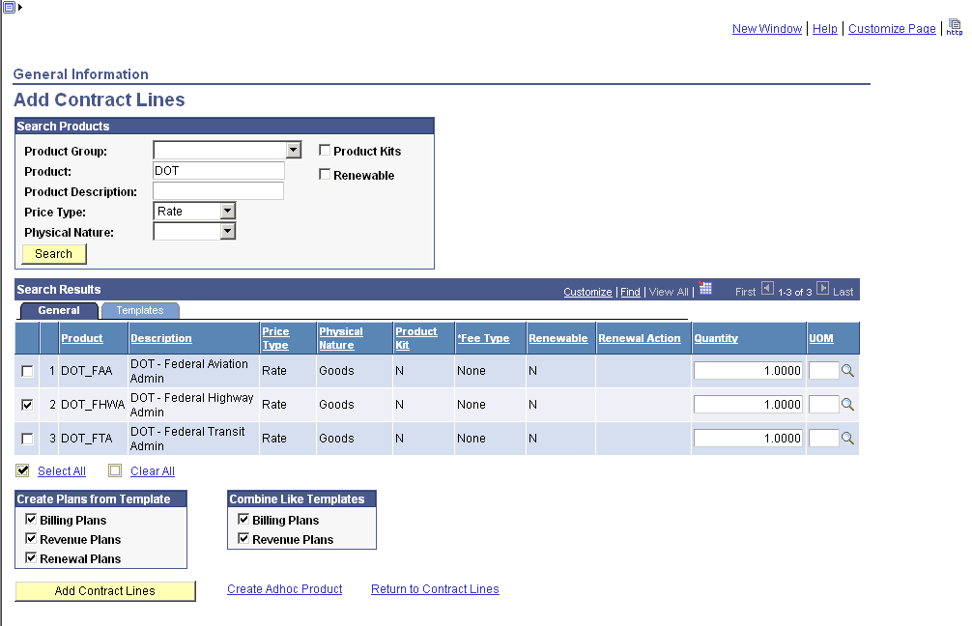
Figure 4 - This displays the Search Results on the General Information - Add Contract Lines page.

- Click . The General Information – Add Contract Lines page re-displays confirming “1 line(s) have been attached to the contract.”

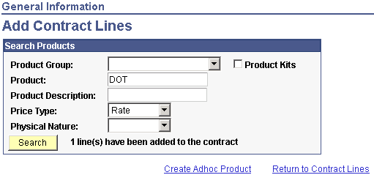
Figure 5 - This displays the Search Results on the General Information - Add Contract Lines page.

- Click Return to Contract Lines. The Lines page displays with the selected contract line.

- Click .

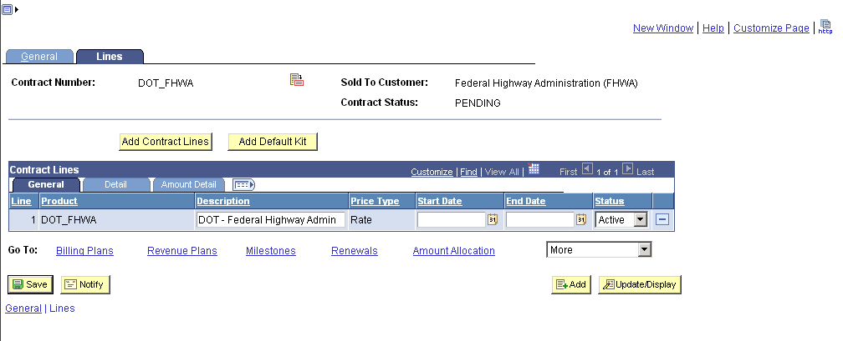
Figure 6 - This is the Lines page with a Contract Line.

- Click the Detail tab.

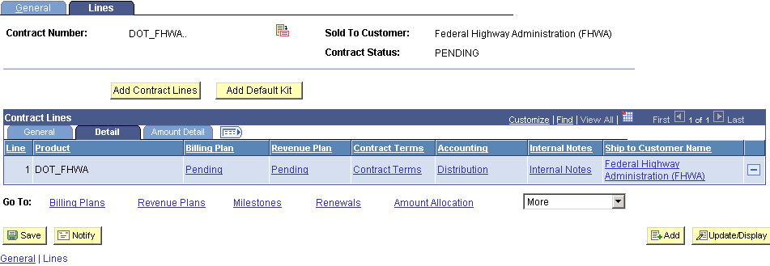
Figure 7 - This is the Lines page with the Detail tab selected.

If this is a Standard Contract, follow Steps 22 through 35. If this is a Government Contract, go to Step 36.

- Click Contract Terms to associate Projects and Activities to the Contract. The Related Projects page displays.

- Type or select the PC Business Unit. Example: [To be entered by Agency SME]

- Type the Billing Limit. The Billing Limit is the maximum dollar amount that can be billed.

- Type or select the Project. If you select a Project, you must select an Activity.

- Type or select the Activity. Example: [To be entered by Agency SME]

- Click .

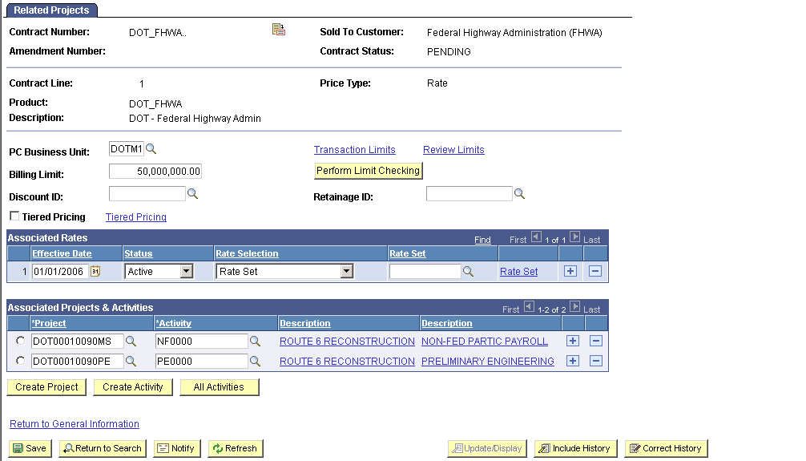
Figure 8 - This is the Related Projects page with Projects and Activities associated with the Standard Contract.

- Click Transaction Limits The Transaction Limits page displays.

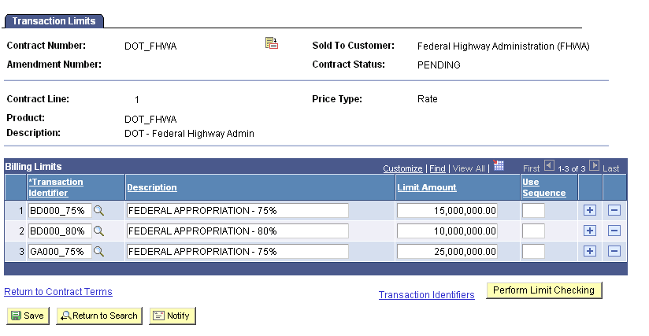
Figure 9 – This is the Transaction Limits page with multiple Transactions Identifiers associated to the Billing Limit.
- Type or select a Transaction Identifier. Once the Transaction Identifier is selected, its Description displays.

- Type the Limit Amount. The Transaction Limit Amount must equal the Billing Limit entered on the Related Projects page.

- Click .

- Click Return to Contract Lines. This returns you to the Related Projects page.

- Type or select the Rate Set. It is extremely important that you select the correct rate set as it represents the standard pricing of the transactions associated with the contract line. The Rate Sets you see in the lookup are specific to your agency. Example: [To be entered by Agency SME]

- Click .

- Click to return to the General Information page to process this contract. Go to Step 56.

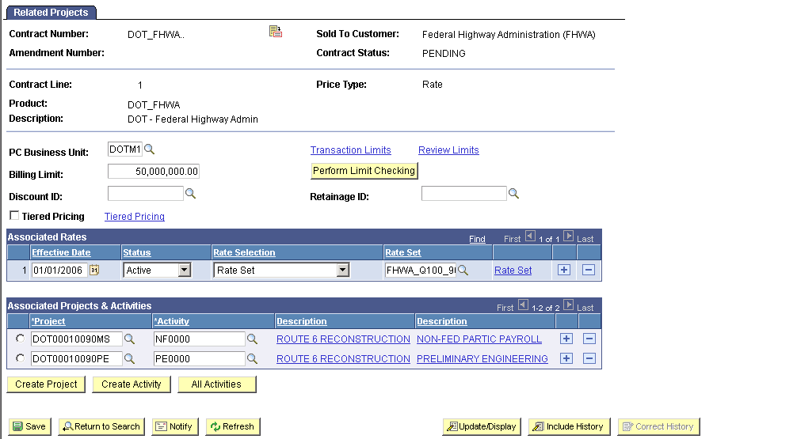
Figure 10 – This is the Related Projects page with the appropriate Rate Set selected.

If this is a Government Contract, follow the steps below after completing Steps 1 - 21.
- Click Contract Terms. The Contracts Amounts page displays.

- Type the Awarded Amount of the Contract in the Awarded field. This is the full amount of the contract award. This field can be adjusted by amendment processing.

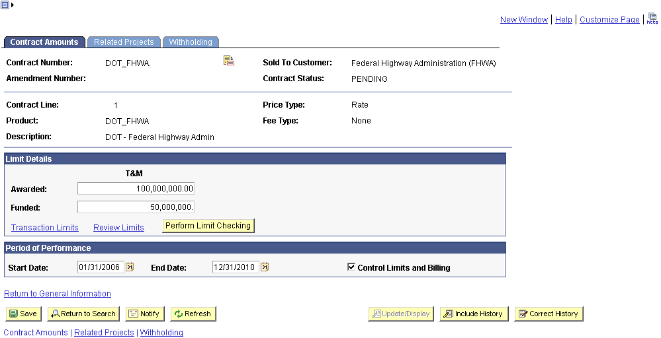
Figure 10 - This is the Contract Amounts page that displays when you create a Government Contract.

- Type the Funded Amount of the Contract in the Funded field. This is the limit amount for billable costs for this contract line. You can edit this amount over the life of the contract using amendment processing. You cannot enter a funded amount that exceeds the awarded amount or an amount less than the amount already billed.

- Type the Start Date of the Contract in the Start Date field. This is the date that invoices can begin to be created. After the contract is active, the date is no longer editable if the Control Limits and Billing option is selected.

- Type the End Date of the Contract in the End Date field. This is the date that invoices can no longer be created. Once the contract is active, you can edit this date throughout the life of the contract using amendment processing. You cannot enter an end date earlier than the current system date.

- Select the Control Limits and Billing checkbox. By selecting this check box, the Limits process and the Contracts/Billing Interface process will only select billable transactions from the Project Transaction table that have a transaction date that falls within the contract start and end dates.

- Click the Related Projects tab. The Related Projects page displays.

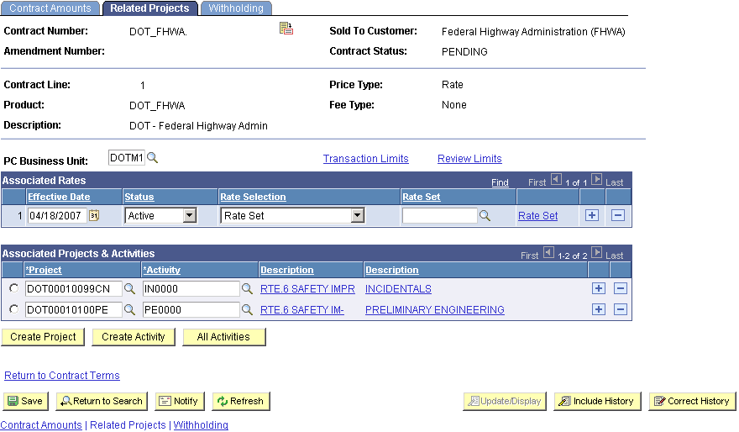
Figure 11 - This is the Related Projects page that displays when you create a Government Contract.

- Type or select the PC Business Unit. Example: [To be entered by Agency SME]

- Type or select the Project. If you select a Project, you must select an Activity. Example: [To be entered by Agency SME]

- Type or select the Activity. Example: [To be entered by Agency SME]

- Click .

- Click Transaction Limits. The Transaction Limits page displays.
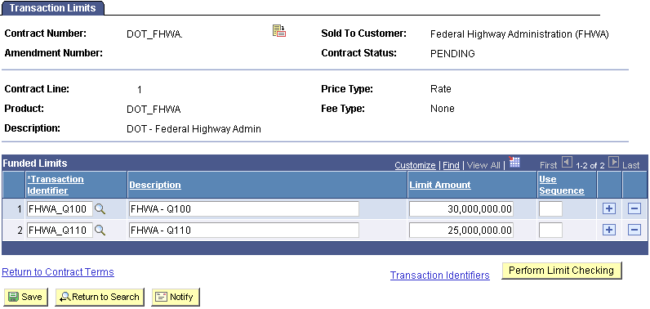
Figure 12 - This is the Transaction Limits page that displays when you create a Government Contract.

- Type or select a Transaction Identifier. Once the Transaction Identifier is selected its Description displays.

- Type the Limit Amount. The Transaction Limit Amount should not exceed the funded amount you entered on the Contract Amounts page.

- Click .

- Click Return to Contract Terms.

- Click the Related Projects tab. Type or enter a rate set in the Associated Rates group box..

- Click .
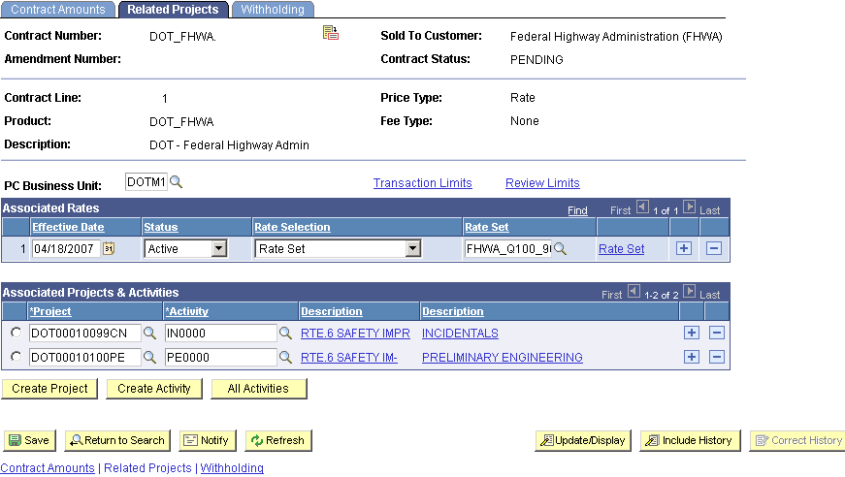
Figure 13 - This is the completed Related Projects page pertaining to a Government Contract.
- On the left hand navigation menu select General Information. This brings you to the General tab.

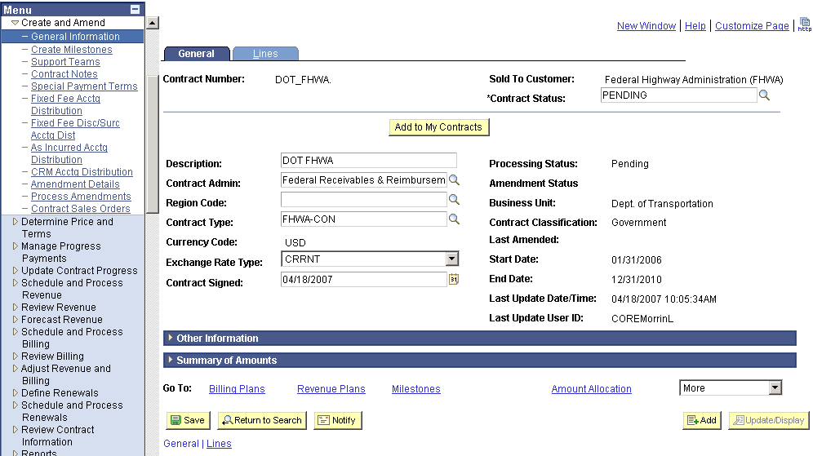
Figure 14 - This is the General tab page displaying the Contract Status and Processing Status as pending.
- Change the Contract Status from Pending to Active or another applicable status, as necessary. The Contract Status fields are directly related to the processing status of the contract.

See list below for the statuses used by your agency and the associated processing status:

Contract Status Processing Status
Pending | P – Pending
Open | A – Active
Final Voucher Submitted | A - Active
Cancelled | C – Close
Suspended | A – Active
Final Bill Pending | A – Active
Final Bill Submitted | A – Active
Closed | C – Closed

- Click .

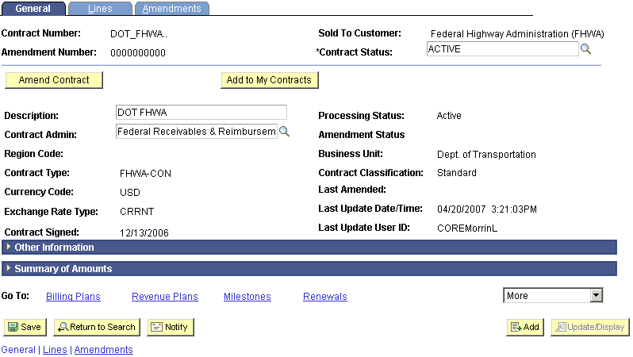
Figure 15 - This is the General page displaying the Contract Status and Processing Status as Active.

- If you would like to add the contract to the My Contracts page, click . The My Contracts page allows you to easily view and navigate to contracts that you use on a frequent basis. If you do not want to add the contract to the My Contracts page, this procedure is complete.

- If you click , the following message displays:

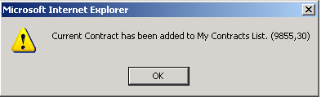

- Click OK.

- To view the contract on the My Contracts page, navigate to Customer Contracts > My Contracts.

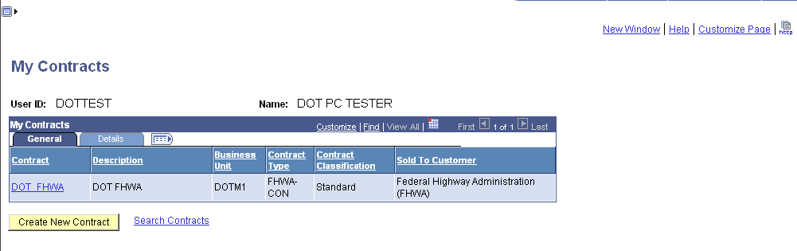
Figure 16 - This is the My Contracts page with all Contracts associated to this User ID displayed.

This procedure is complete. Please call the Help Desk if you have problems.

