Supply Chain

Overview

Supply Chain is the name given to those activities used to purchase goods and services for state agencies. Supply Chain covers all of the activities used to support the purchasing function: eProcurement, Purchasing, Receiving, Catalog Management, Inventory, and Vendor Contracts. Eprocurement forms a strong bond with catalog management and integrates with purchasing to send purchase orders to vendors of the State, and then integrates with Accounts Payable and Inventory and Asset Management if applicable.

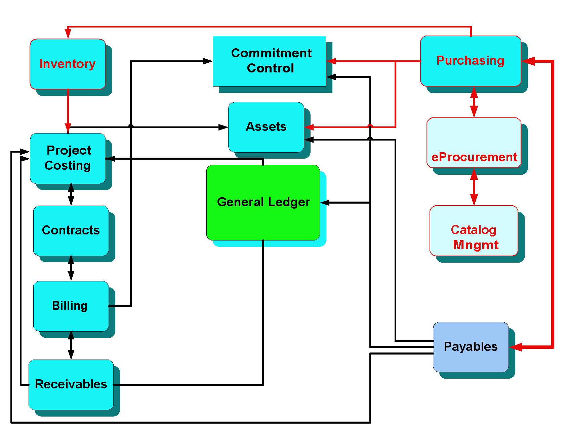
Figure 1 - High level view of Purchasing

eProcurement

(Navigation: Main Menu > Core-CT Financials > eProcurement > Create Requisition)

Overview

eProcurement is intended to be the primary type of procurement request, allowing users easy access to the Vendor Item Catalog. The Requester is responsible for creating the requisition header, adding items, may add distribution information, saving and submitting the requisition. Once saved and submitted, the requisition is given a status of “Pending Approval,” which starts the workflow approval process. Managers may be given approver roles for Amount Approver or Chartfield Approver. Fully approved requisitions are budgeted checked, sourced, and dispatched to the vendor as purchase orders.

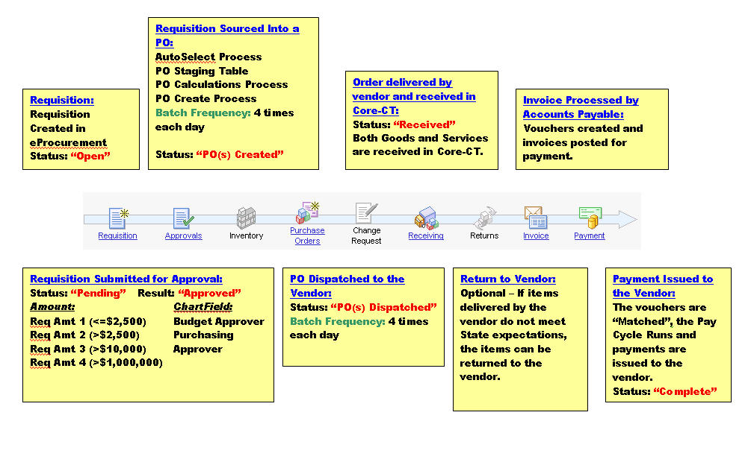
Figure 2 - Requisition Life Span

Manager / Supervisor Information

- Using eProcurement allows users to pull items from the catalog with the current contract pricing.
- eProcurement is an easy 3 Step Process:
  - Define Requisition
  - Add Items and Services
  - Review and Submit
- The Requester who initiates a requisition cannot be the Approver. (Segregation of duties)
- Requesters are responsible for entering the chartfield information on requisitions. The agency business office is responsible for providing the requester with valid chartfields to use on requisitions. If a catalog item is used, the account code will be defaulted in the requisition line.

Role | Function | May edit without reinitiating Workflow
Requester | Create requisition, add items, distributions, Save and Submit | May not edit without reinitiating workflow
Requisition Amount Approver (1,2,3,4) | Review all requisition content | May edit any dollar amount within their authority
Chartfield Approver | Approves budget and Chartfield | Chartfields only
Requisition PO Approver | Approves lines and contracts | Lines and contracts but not increase quantity or price
Ad hoc Approver | May approve or comment | May edit only with appropriate role

- Worklist Approval Navigation: Main Menu > Core-CT Financials > Worklist > Worklist
- Requisition Approvers are set up with dollar Thresholds:
  - Requisition Amount Approver 1 <= $2,500
  - Requisition Amount Approver 2 $2,501 – $10,000
  - Requisition Amount Approver 3 $10,001 - $1,000,000
  - Requisition Amount Approver 4 > $1,000,000
- The approvals are “real time” and do not require any batch processes to initiate workflow.
  - E-mail messages are automatically sent when a Requisition is denied or pushed back
- When created properly an eProcurement Requisition can be created, approved, sourced to a purchase order and dispatched to a vendor all within a few hours.
- Requisition Budget Check Exceptions
- To check for requisition budget errors: Main Menu > Core-CT Financials > Commitment Control > Review Budget Check Exceptions > Purchasing and Cost Management > Requisition

Once a requisition is properly approved and has passed budget check, it will be sourced into a purchase order and will be available for dispatch to the vendor. The batch processing times for these processes are approximately 10:00 am, 12:00 noon, 2:00 pm, and once overnight.

Purchasing

Purchase Order Navigation: Main Menu > Core-CT Financials > Purchasing > Purchase Orders > Add-Update PO’s

Overview

A purchase order is a document that authorizes a vendor to ship specific goods or provide specific services. Purchase orders can be created from requisitions, contracts, other purchase orders (active or closed), or from manual entry. A purchase order can be created by description, which implies that the item is not maintained in the State's Core-CT item catalog. Purchases that are amount based must be created as an online purchase order. Agencies purchasing goods for their Inventory module must start the purchasing process through eProcurement.

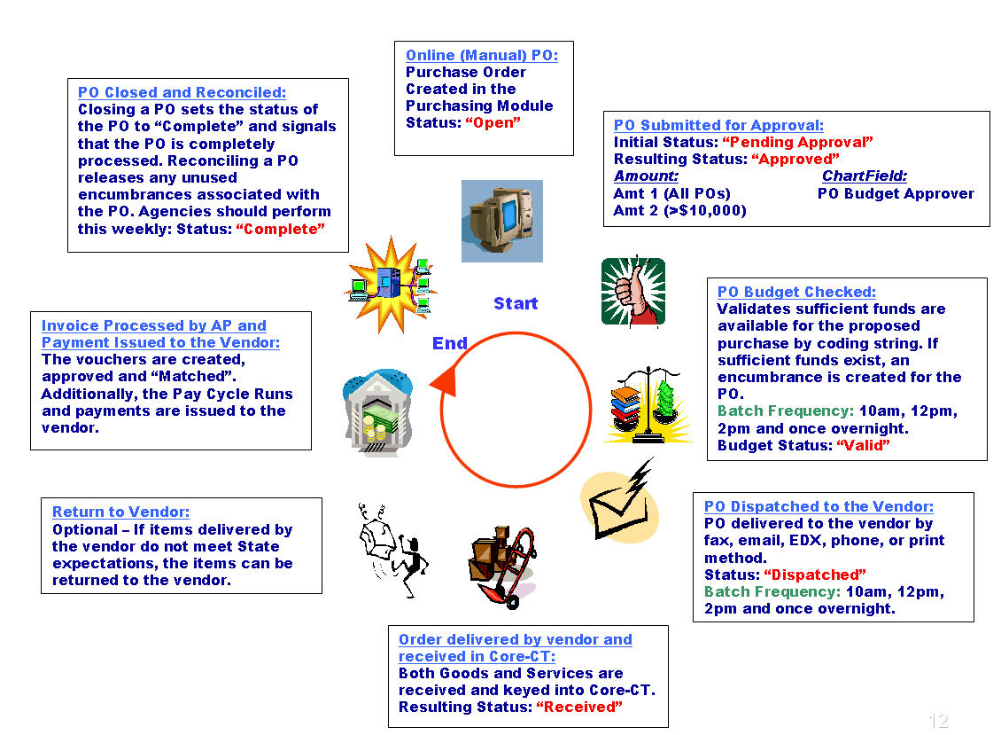
Figure 3 - Online purchase order life cycle

Manager / Supervisor Information

- Entering a purchase order is a simple 4 Step Process:
  - Enter Header Information, including Buyer and Vendor IDs
  - Enter Line Information, including Description, Qty, UOM and Price
  - Enter Schedule Information, including Due Date
  - Enter Distribution (Chartfield) Information, such as Fund, SID, Account and Program

PO Submitted for Approval:

- The Approval Process is initiated by the Buyer from the main page of the PO and consists of two types of approvals – Amount and Chartfield
  - Amount 1 (All POs)
  - Amount 2 (>$10,000)
  - PO Budget Approver

- An approved PO moves on to the automated Budget Check process, which validates that sufficient funds are available for the proposed purchase by coding string. If sufficient funds exist, an encumbrance is created for the PO.
- POs that are not approved or do not pass budget check are available to the buyer for modification or cancellation.
  - Budget check errors must be corrected.
  - Communicate with your budget unit to understand budgets.
  - Do not cancel lines that are in budget error: these lines need to be corrected.
  - To check for PO Budget Check Errors: Commitment Control > Review Budget Check Exceptions > Purchasing and Cost Management > Purchase Order
- The purchase order is dispatched to the Vendor after Budget Check. The Core-CT system will automatically dispatch PO with the dispatch method of Fax, E-mail, or EDX, agencies should not attempt to re-dispatch these POs. POs with the dispatch method of Print must be dispatched by the agency and mailed to the vendor.

Purchasing Batch Process Schedule:
10am, 12pm, 2pm and once overnight.

Purchase Order Maintenance

- Verify your Contract Type, PO Type, PO Authority match. (http://www.core-ct.state.ct.us/financials/po/ppt/cntrct_typ_po_typ_prchsng_athrty.pps)
- Receiving is required for Goods and is optional for Services.
- Line Details and Distribution lines have to match. They should both be Amount only or By quantity.
- Never delete a distribution line if the PO is budget checked or vouchered. Add a new distribution line and cancel the incorrect line.
- Verify the appropriate Profile ID when purchasing assets.
- PO Obligation is not automatically updated. Add or update when adding new quarterly funds.
- Add funds quarterly to multi-year purchase orders
- Close purchase orders before the related requisition

All purchase orders that aren’t multi year POs must be closed through the Reconciliation Workbench after the PO is fully matched.

Receiving

Receiving Navigation: Main Menu > Core-CT Financials > Purchasing > Receipts > Add/Update Receipts
Receiving Navigation – eProcurement module: Main Menu > Core-CT Financials > eProcurement > Receive Items

Overview

Receiving is the last step in the purchasing process. Receiving is performed online and a receiver is created, which is then used in the voucher creation process to pay for those goods or services.

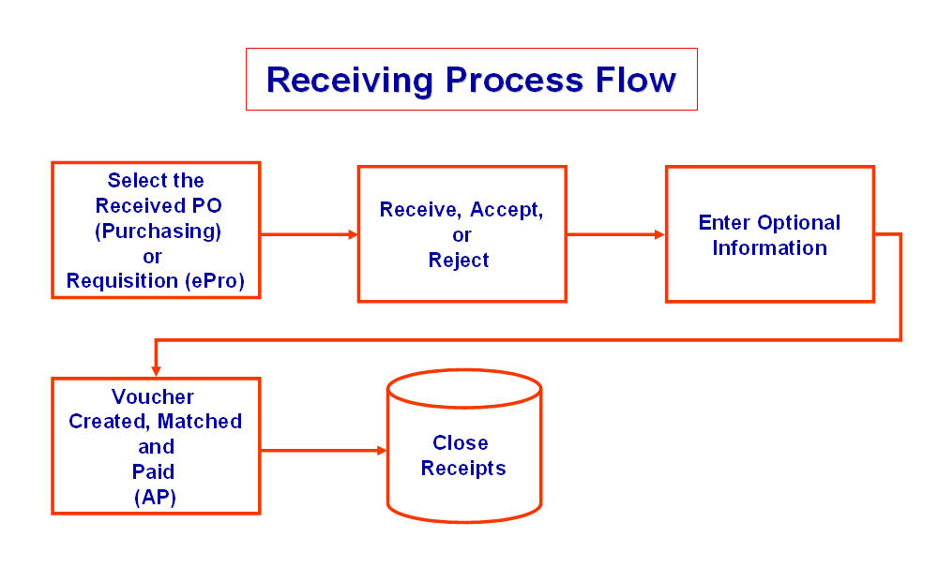

Manager / Supervisor Information

- The receiving function in CORE is a subset of the Purchasing Module
  - Casual Receiver: Can receive goods only on requisitions they created.
  - General Receiver: Can receive on all PO transactions in their business unit and includes creation of the penalty assessment.
  - Should inspection be required in the receiving process user must have the role of Receiving Inspector, which is a separate role.
- Goods or services ordered via Online purchase order can be designated in three ways: Receiving is Required; Receiving is Optional; or Do Not Receive. Individual agency business processes dictate whether purchases are to be received or not, but in general commodities require receiving and services may or may not. Inventory items (items beginning with a “CM” (catalog) number) must be received.
- Partial quantities can be received.
- Assessed penalty amounts and information can be entered directly in to the receipt page.

Matching occurs as part of the Accounts Payable process and is included here for reference.

- 2 way Match = PO to Voucher “PO receiving NOT required”
- 3 way Match = PO to Receipt to Voucher “PO receiving IS required”
- 4 way Match = PO to Receipt to Inspection to Voucher “PO receiving and inspection ARE required”

Vendor Contracts

Contracts Navigation

Main Menu > Core-CT Financials > Purchasing > Procurement Contracts > Add/Update Contracts

Overview

Vendor contracts come in two general types: DAS or ITD awarded contracts that are used by all State agencies or agency awarded contracts which are used by one or a limited number of agencies. Vendor contracts are used to manage items and services purchased by the State.

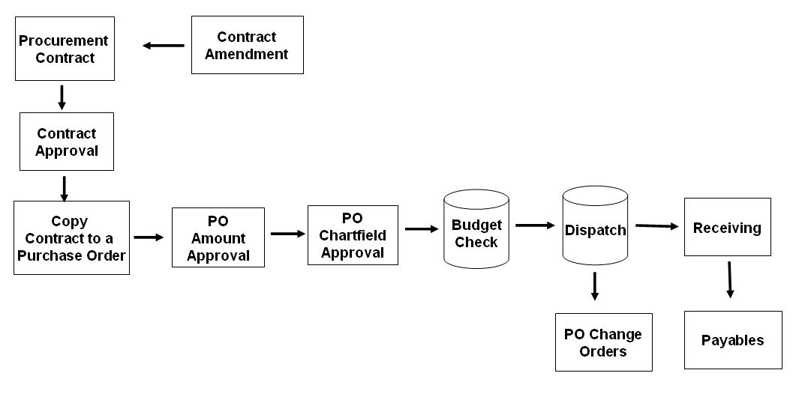
Figure 4 - Vendor Contract Process Flow

- All contracts must be entered in Core.
- Contract Process Option: Core-CT only uses two contract types, Purchase Order or General.
  - Select Purchase Order for purchase order contracts, where no retention is held back on the voucher.
  - Select General Contract when you need to retain monies on the vouchers. Selecting General will open the voucher retention links on the bottom of the Contract Header Page.
- Manually enter the contract number in the Contract ID field using the Core-CT numbering schema: two numbers to represent the calendar year, three characters to represent the Agency, four sequential numbers to represent the contract number, and two alphas to represent the vendor (For example, 07DPW9999AA). If there were an additional vendor awarded on this contract the next contract number to be used would be: 07DPW9999AB.
- For agency contracts there should be one purchase order for the life of the contract. This is required by OPM.
- If the PO does not roll to the next year due to a problem, you will have to create a new PO for that year. Core-CT notifies agencies through a daily mail on the year end process

After all transactions are complete (POs fully vouchered) and/or the Contract has expired the contract should be closed.

Frequently Used Job Aids

eProcurement Job Aids
See the UPK
Purchasing Job Aids
http://www.core-ct.state.ct.us/financials/po/Default.htm
Creating Contracts, Purchase Orders, and ePro Requisitions
http://www.core-ct.state.ct.us/financials/po/doc/cntrcts_pos_reqs.doc
Contract Type, PO Type, PO Authority match.
http://www.core-ct.state.ct.us/financials/po/ppt/cntrct_typ_po_typ_prchsng_athrty.pps
Fields that trigger a Change Order
http://www.core-ct.state.ct.us/financials/po/xls/flds_trggr_chg_ordr.xls
Will My Purchase Order Qualify for Closing
http://www.core-ct.state.ct.us/financials/po/doc/will_my_po_qualify_for_closing.doc

Useful Links

DAS contracting
http://das.ct.gov/cr1.aspx?page=161 (This takes you to the Bidder page, but see the Quick Links to the right.)

OPM PSA Policy
http://www.ct.gov/opm/cwp/view.asp?a=2982&q=383012&opmNav_GID=1806
OPM POS Policy
http://www.ct.gov/opm/cwp/view.asp?a=2981&q=382994&opmNav_GID=1806

Catalog of Online Financial Reports

Purchasing Reports
Report Number | Report Name
ctpor313 | PO Balance  http://www.core-ct.state.ct.us/reports/docs/ctpor313.doc  The report displays a detail listing of all purchase orders (PO) by PO date in chronological order. The report allows the user to specify agency PO business unit, date range, vendor ID, PO remaining balance, obligation remaining balance and chartfield combination. Report output includes encumbered, expended and unliquidated balances for each purchase order (encumbered - expended = unliquidated).  Reminder: The Future Obligation Total must be manually adjusted for each individual PO. If a change order has been done on the PO, then the Obligation Page should be updated to reflect the change order amount as well.  This report is used to monitor and review PO balance data.
popo009 | PO Activity Summary  http://www.core-ct.state.ct.us/reports/docs/popo009.doc  The report lists purchase order activity for the PO business unit, GL business unit, department, and dates selected. The report provides totals by department, PO business unit and GL business unit. The report helps to ensure that orders are delivered on time and on budget.  Reviewing this report enables you to perform comparisons and resolve discrepancies proactively. This report is used to monitor and review PO activity data.
poy1100 | Requisition to PO XREF  http://www.core-ct.state.ct.us/reports/docs/poy1100.doc  The report provides a cross-reference between requisitions and the POs created from those requisitions. The report lists requisition activity for the PO business unit and dates selected. Data elements on the report include requisition ID, date, item ID, description, quantity, PO ID, contract ID, order quantity, and price. The report is sorted in ascending order by requisition ID.  This report is used to monitor and review requisition and PO data.
poy4006 | Expediting Report by Buyer  http://www.core-ct.state.ct.us/reports/docs/poy4006.doc  The report displays a detail listing of outstanding purchase orders (PO) sorted by buyer. PO details include due date, late days, vendor ID/name and ship to ID. The run control page allows the user to specify a date range, vendor Set ID, vendor ID, buyer and agency PO business unit.  Three reports can be produced from the same run control page: Expediting Report by Buyer (POY4006), Expediting Report by Vendor (POY4007), and Expediting Report by Due Date (POY4008).  This report is used to determine which POs may require expediting.
poy4007 | Expediting Report by Vendor  http://www.core-ct.state.ct.us/reports/docs/poy4007.doc  The report displays a detail listing of outstanding purchase orders (PO) sorted by vendor. PO details include due date, late days, vendor ID/name and ship to ID. The run control page allows the user to specify a date range, vendor Set ID, vendor ID, buyer and agency PO business unit.  Three reports can be produced from the same run control page: Expediting Report by Buyer (POY4006), Expediting Report by Vendor (POY4007), and Expediting Report by Due Date (POY4008).  This report is used to determine which POs may require expediting.
poy4008 | Expediting Report by Due Date  http://www.core-ct.state.ct.us/reports/docs/poy4008.doc  The report displays a detail listing of outstanding purchase orders (PO) sorted by due date. PO details include due date, late days, vendor ID/name and ship to ID. The run control page allows the user to specify a date range, vendor Set ID, vendor ID, buyer and agency PO business unit.  Three reports can be produced from the same run control page: Expediting Report by Buyer (POY4006), Expediting Report by Vendor (POY4007), and Expediting Report by Due Date (POY4008).  This report is used to determine which POs may require expediting.
poy4010 | PO Listing by PO Date  http://www.core-ct.state.ct.us/reports/docs/poy4010.doc  The report displays a listing of purchase orders (PO) sorted by PO date in chronological order. PO data displayed on the report includes PO ID, contract ID, buyer ID, vendor ID/name and PO status. The run control page allows the user to specify agency PO business unit, date range, vendor Set ID, vendor ID, buyer and PO status.  Four Reports can be produced from the same run control page: PO Listing by PO Date (POY4010), PO Listing by Vendor ID (POY4011), PO Listing by Buyer (POY4012), PO Listing by PO Status (POY4013).  This report is used to monitor and review PO data by PO date.
poy4011 | PO Listing by Vendor  http://www.core-ct.state.ct.us/reports/docs/poy4011.doc  The report displays a listing of purchase orders (PO) sorted by vendor ID in ascending order. PO data displayed on the report includes PO ID, contract ID, buyer ID, vendor ID/name and PO status. The run control page allows the user to specify agency PO business unit, date range, vendor Set ID, vendor ID, buyer and PO status.  Four Reports can be produced from the same run control page: PO Listing by PO Date (POY4010), PO Listing by Vendor ID (POY4011), PO Listing by Buyer (POY4012), PO Listing by PO Status (POY4013).  This report is used to monitor and review PO data by vendor ID.
poy4012 | PO Listing by Buyer  http://www.core-ct.state.ct.us/reports/docs/poy4012.doc  The report displays a listing of purchase orders (PO) sorted by buyer in alphabetical order. PO data displayed on the report includes PO ID, contract ID, buyer ID, vendor ID/name and PO status. The run control page allows the user to specify agency PO business unit, date range, vendor Set ID, vendor ID, buyer and PO status.  Four Reports can be produced from the same run control page: PO Listing by PO Date (POY4010), PO Listing by Vendor ID (POY4011), PO Listing by Buyer (POY4012), PO Listing by PO Status (POY4013).  This report is used to monitor and review PO data by buyer.
poy4013 | PO Listing by PO Status  http://www.core-ct.state.ct.us/reports/docs/poy4013.doc  The report displays a listing of purchase orders (PO) sorted by PO status. PO data displayed on the report includes PO ID, contract ID, buyer ID, vendor ID/name and PO status. The run control page allows the user to specify agency PO business unit, date range, vendor Set ID, vendor ID, buyer and PO status.  Four Reports can be produced from the same run control page: PO Listing by PO Date (POY4010), PO Listing by Vendor ID (POY4011), PO Listing by Buyer (POY4012), PO Listing by PO Status (POY4013).  This report is used to monitor and review PO data by PO status.
poy4030 | PO Detail Listing by PO Date  http://www.core-ct.state.ct.us/reports/docs/poy4030.doc  The report displays a detail listing of all purchase orders (PO) sorted by PO date in chronological order. PO details include vendor ID, item description, category, price and contract ID. The run control page allows the user to specify agency business unit, date range, vendor ID and buyer.  Three reports can be produced from the same run control page: PO Detail Listing by PO Date (POY4030), PO Detail Listing by Vendor ID (POY4031), PO Detail Listing by Buyer (POY4032).  This report is used to monitor and review PO detail data by PO date.
poy4031 | PO Detail Listing by Vendor ID  http://www.core-ct.state.ct.us/reports/docs/poy4031.doc  The report displays a detail listing of all purchase orders (PO) sorted by vendor ID in ascending order. PO details include vendor ID, item description, category, price and contract ID. The run control page allows the user to specify agency business unit, date range, vendor ID and buyer.  Three reports can be produced from the same run control page: PO Detail Listing by PO Date (POY4030), PO Detail Listing by Vendor ID (POY4031), PO Detail Listing by Buyer (POY4032).  This report is used to monitor and review PO detail data by vendor.
poy4032 | PO Detail Listing by Buyer  http://www.core-ct.state.ct.us/reports/docs/poy4032.doc  The report displays a detail listing of all purchase orders (PO) sorted by buyer alphabetically. PO details include vendor ID, item description, category, price and contract ID. The run control page allows the user to specify agency business unit, date range, vendor ID and buyer.  Three reports can be produced from the same run control page: PO Detail Listing by PO Date (POY4030), PO Detail Listing by Vendor ID (POY4031), PO Detail Listing by Buyer (POY4032).  This report is used to monitor and review PO detail data by buyer.
poy4100 | PO to Requisition XREF  http://www.core-ct.state.ct.us/reports/docs/poy4100.doc  The report provides a cross-reference between requisitions and the POs created from those requisitions. The report lists purchase order activity for the PO business unit and dates selected. Data elements on the report include PO ID, contract ID, vendor ID, item description, order quantity, price, requisition ID and quantity. The report is sorted in ascending order by PO ID.  This report is used to monitor and review PO and requisition data.
pvy4000 | PO Item Category Usage by Category  http://www.core-ct.state.ct.us/reports/docs/pvy4000.doc  The report provides information about the items ordered for the purchase orders within one business unit and one item catalog. This report lists the total quantity ordered of each item and other information, including item ID, item description, item category description, category code, vendor ID, vendor name, contract ID (if any), average price, total amount, currency, and percentage of total. This report is sorted by catalog ID and category code.  Two reports can be produced from the same run control page: PO Item Category Usage by Category (PVY4000) and PO Item Category Usage by Vendor (PVY4001). This report is used to monitor and review PO item data.
pvy4001 | PO Item Category Usage by Vendor  http://www.core-ct.state.ct.us/reports/docs/pvy4001.doc  The report provides information about the items ordered for the purchase orders within one business unit and one item catalog. This report lists the total quantity ordered of each item and other information, including item ID, item description, item category description, category code, vendor ID, vendor name, contract ID (if any), average price, total amount, currency, and percentage of total. This report is sorted first by vendor and then catalog ID and category code within each vendor.  Two reports can be produced from the same run control page: PO Item Category Usage by Category (PVY4000) and PO Item Category Usage by Vendor (PVY4001). This report is used to monitor and review PO item data.

