
Job Aid

Using the Project Transaction Upload Tool and Reviewing Transactions Loaded

If this is the first time you are using the Project Transaction Upload Tool, create a folder on your local drive called Projects Upload Tool. Then download the XLS (spreadsheet) and XLA (macro) files to your local drive from the Core-CT website, www.core-ct.state.ct.us. Please note the path that you download these files to. You must keep the XLS and XLA files in the same folder. Users who upgraded to Excel 2007 or to Excel 2010 must download a new template and macro.

- Open the Project Upload Tool spreadsheet, the XLS file you copied to your local drive.

- Click . The Projects Transaction Upload page displays.

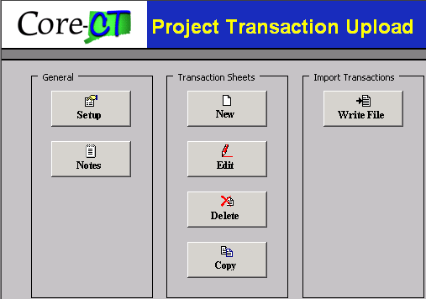
Figure 1 - This is the Project Transaction Upload Menu.
(Note for Excel 2007 users: When you open a file associated with macro workbook you are prompted: Security Warning – Some Active content has been disabled.” There is an Option button to the right of the message. You have two choices at this point: work in protected mode or enable the content. Enable the content and click OK.

Notice when you open a workbook associated with a macro workbook.

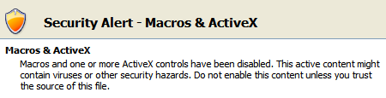
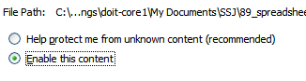

(Note to Excel 2010 users: Some changes were made in the Excel 2010 version. By default, the active content has been disabled. Click the Enable Editing button.
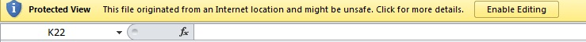

The Security warning will appear. Click the Enable Content button.

You may receive a further message. Click Yes. You can now continue as normal.
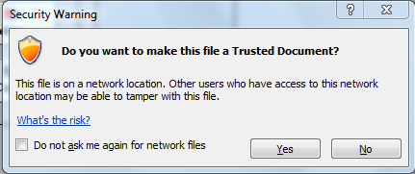

- Click 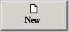 to create a new Transaction Sheet.


If you need to edit an existing Transaction Sheet, click . You will then select the Transaction Sheet you want to edit, and click .

- Enter a Transaction Sheet Name. Agencies can come up with their own naming convention. Your agency may want to keep a log, as you will not be able to use the same name more than once.

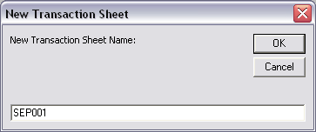
Figure 2 - This is the New Transaction Sheet box.

- Click .

- Click the Plus (+) sign located in cell E5 (just under the “Header” cell to add a header row). A New Transaction Header window opens.

If you need to edit the Header, click . Then in the Transaction Header box, highlight the transaction header you want to change and click . Once the Edit Transaction Header box displays, change the applicable Header information. Then click .

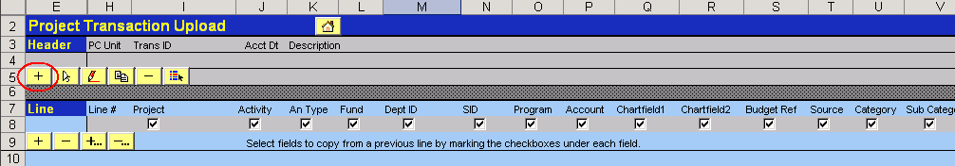
Figure 3 - This is the Project Transaction Upload spreadsheet.

- Enter the PC Unit, a unique Transaction ID, and Description.

The Trans ID is to help identify transactions using the Resource ID of the Projects Resource table. The Resource ID naming convention that will be used on the Projects Resource table is (UP + first three characters of your Business Unit + # + 10 character Transaction ID + Input File Line Number). Please see the end of this job aid to view the Project Resource table.
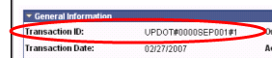

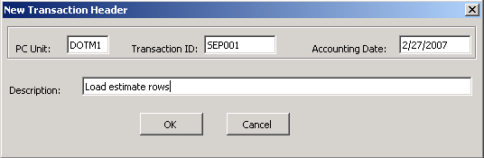
Figure 4 - This is the New Transaction Header box.

- Click .

- Click the plus (+) sign located in cell E9, under the “Line” cell.

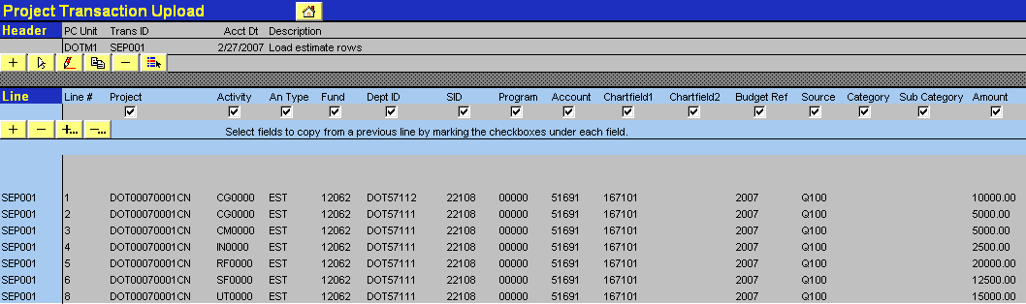
Figure 5 - This is the Project Transaction Upload spreadsheet.

- Enter the Project, Activity, Analysis Type, Fund, Dept ID, SID, Program, Account, Budget Ref, and Amount. These are all required fields. The remainder of the chartfields are optional or required depending on your agency rules. The coding will have to be accurate for the file to load successfully. If the coding is incorrect, the file will create errors and will not load.

Click the plus (+) sign located in cell E9 for each additional transaction line you would like to add.

- Click . The Project Transaction Upload page displays.

- Click in the toolbar.

(Note for Excel 2007 and Excel 2010 users: When you click the Save button, you may receive the message below.
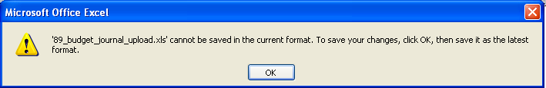
Click OK. The Save As dialog box will open.
From the Save as Type drop down menu, select Excel 97-2003 workbook (*.xls)
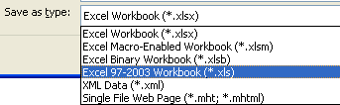
Change the File Name to 89_budget_journal_upload.xls (or other selected file name. The important point is to remember to ensure that the extension is .xls.
Excel will ask you if you want to overwrite the existing file. Click Yes.

- Click 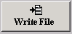. The Write Transaction to File box displays.

- Select the name of the Transaction that you just created. This is the same transaction name you entered in step 4.

- Enter the path to save the flat file. The file name should be the same as the Transaction ID that was used in step 7. The XML file should be saved in the same folder as the XLS and XLA files.

- Click .

- Close the Project Transaction Upload tool.

Once you have closed the Project Transaction Upload tool, you must now load the file into Core-CT.

- Navigate to Project Costing>Transaction Definitions>Project Transaction Upload. The Proj Trans Upload page displays.

- Click .

- Click . The Browse/Upload page displays.

- Click to select the location of the file to upload. Find the file to upload. Click once on the file to select it.

- Click to select file.

- Click . The Proj Trans Upload page displays.
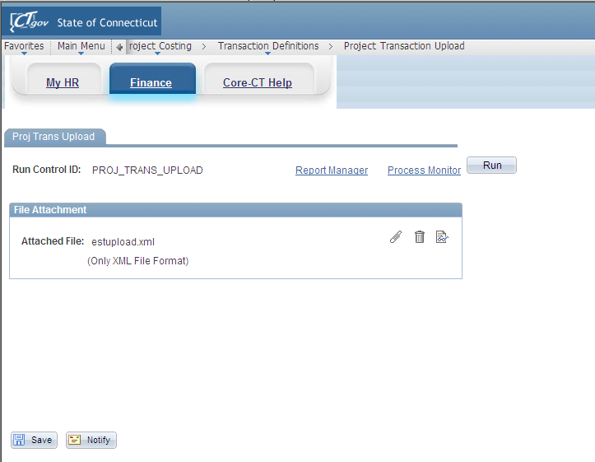
Figure 6 - This is the Proj Tran Upload page with an attached file.

- Click . The Process Scheduler Request page displays.

- Ensure the Select checkbox for Process Name: CTPCI055 is selected.

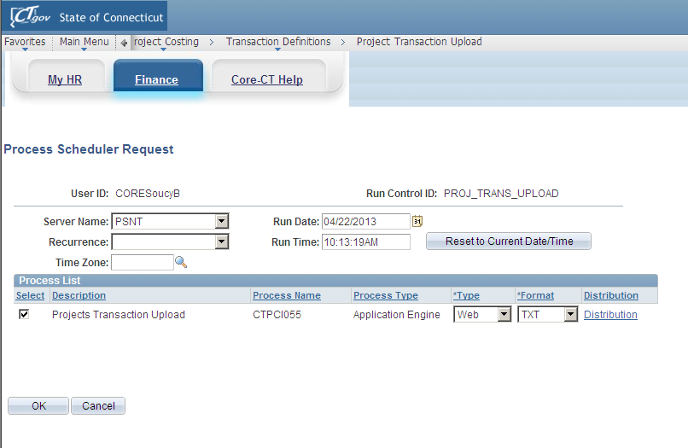
Figure 7 - This is the Process Scheduler Request page with the CTPCI055 process selected.
- Click .

- Click Process Monitor. The Process List page displays.

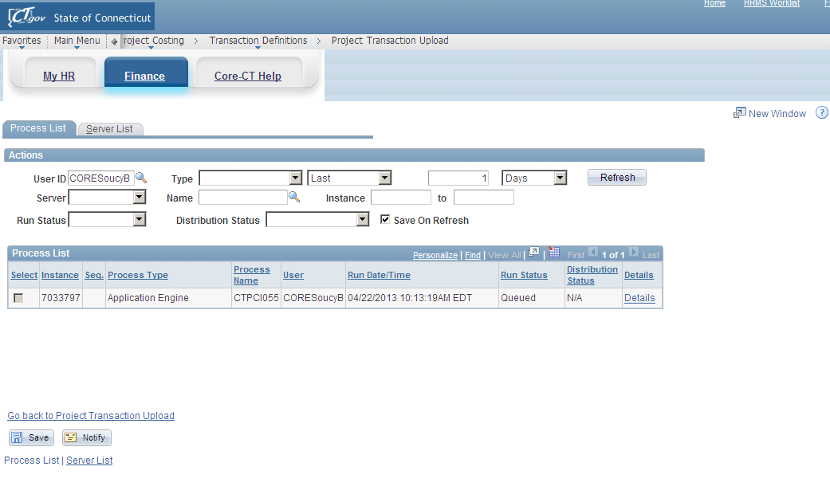
Figure 8 - This is the Process List page with the Run Status of Success and the Distribution Status of Posted for the CTPCI055 process.

- Once the Run Status is Success and the Distribution Status is Posted, click Details. The Process Detail page displays.
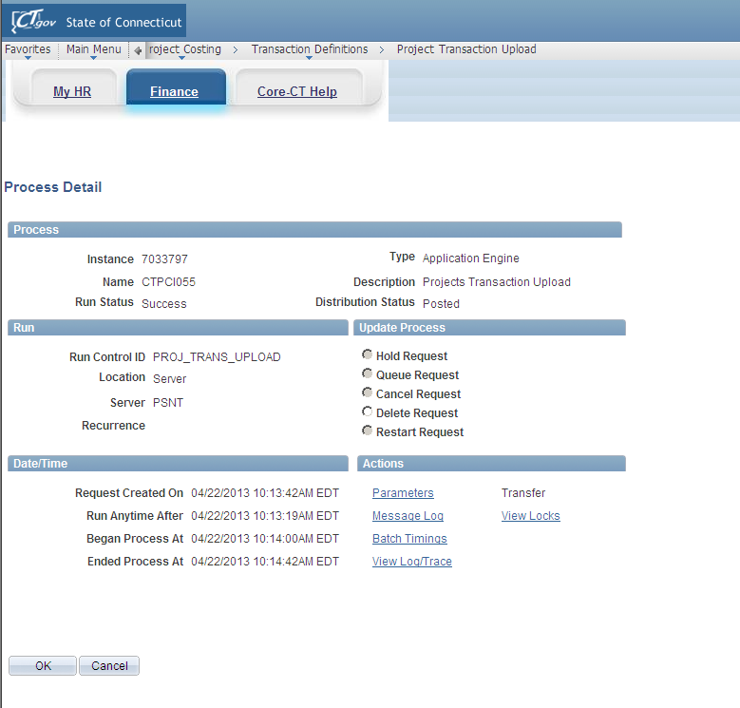
Figure 9 - This is the Process Detail page.
- Click Message Log. The Message Log page displays.

On the Message Log page, if the file has loaded successfully, you will see an Interface ID. This is a unique ID for each transaction upload. Please make note of your Interface ID because you will need it on the Review Transaction Details page to see if you received errors from the PC_Edit process.

If you do not see an Interface ID, the upload did not run successfully.

- Click . The Process Detail page displays. Your transactions have loaded successfully. Now move onto to step 34.

If you did not receive an Interface ID number, use the procedure below:

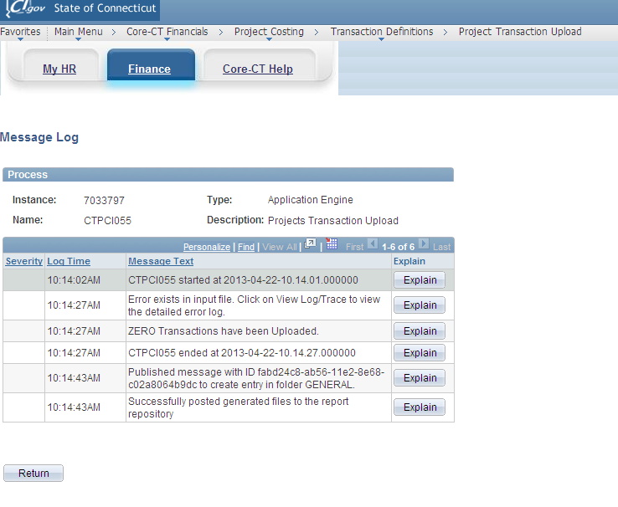
Figure 10 - This is the Message Log page with errors.

- If you have an error, view the error log.
- Click . To view the error log, click View Log/Trace. The View Log/Trace page displays.

Figure 11 - This is the View/Log Trace page.
- Click XXXXX.Error.LOG. The Error Log file opens. Read the error and then go back to the Transaction Upload Tool to fix the error. Once you have fixed the error, you will have to follow steps 18-28 again.

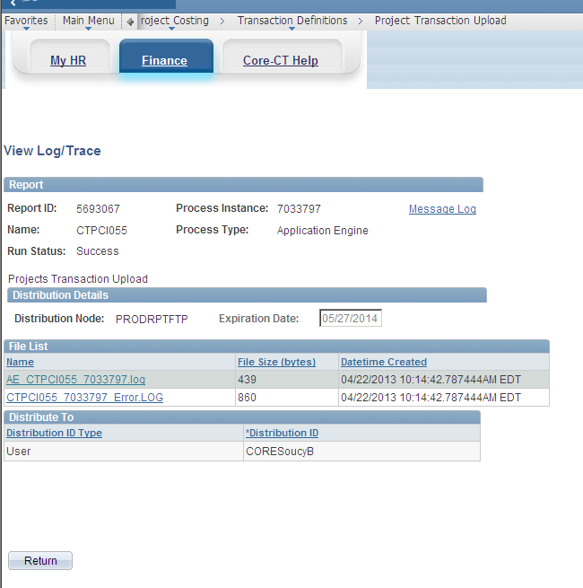

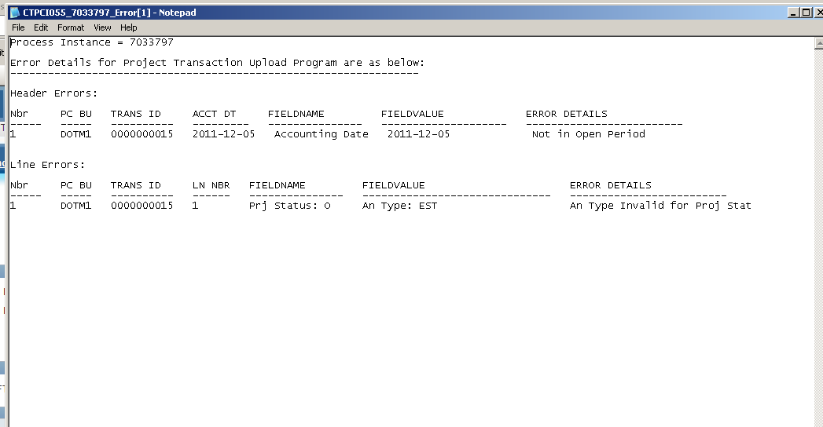
Figure 12 - This is an example of an error log.
Here is the complete list of error messages and the resolution to these errors that you may see on the Error Log:
Error Message | Resolution
Header Errors
Validate If Line exists for Header  -- FieldName =  -- FieldValue =  -- Description = Line Data Does Not Exist | If you receive the “Line Data Does Not Exist” error detail, you will have to go back to the transaction within the tool and enter line details. You can reference step 6 and Figure 3 in this job aid for more information.
Validate PC Business Unit  -- FieldName = PC Bus Unit  -- FieldValue = Prints “Blank” if blank or prints the wrong value if not blank  -- Description = Prints “Field Required” if blank or prints “Invalid PC BU” if not blank | If you receive the “Field Required” error detail, you will have to go back to the Transaction Header page and enter a valid PC Bus Unit. You can reference the Help section in step 6 for more information.  If you receive the “Invalid PC BU” error detail, ensure the PC Business Unit you entered is correct. If it is incorrect, enter another PC Business Unit. If you believe the PC Business Unit is correct, call the Core-CT Help Desk.
Validate Transaction ID  -- FieldName = Trans ID  -- FieldValue = Prints “Blank” if blank or prints the wrong value if not blank  -- Description = Prints “Field Required” if blank or prints “Greater than 10 char” if not blank | If you receive the “Field Required” error detail, you will have to go back to the Transaction Header page and enter a Transaction ID. You can reference the Help section in step 6 for more information.  If you receive the “Greater than 10 char” error detail, you will have to go back to the New Transaction Header and enter a Transaction ID that is less than 10 characters.
Validate Accounting Date  -- FieldName = Accounting Date  -- FieldValue = Prints “Blank” if blank or prints the wrong value if not blank  -- Description = Prints “Field Required” if blank or prints “Not in Open Period” if not blank | If you receive the “Field Required” error detail, you will have to go back to the Transaction Header page and enter an accounting date. You can reference the Help section in step 6 for more information.  If you receive the “Not in Open Period” error detail, ensure the date you entered is correct. In most cases, you will have to change the date to a period that is open. If you think the period should be open, call the Core-CT Help Desk.
Line Errors
Validate Project ID  -- FieldName = Project ID  -- FieldValue = Prints “Blank” if blank or prints the wrong value if not blank  -- Description = Prints “Field Required” if blank or prints “Invalid Project” if not blank | If you receive the “Field Required” error detail, you will have to go back to the Line section of the transaction, find the line number and enter a Project ID. You can reference step 10 and Figure 5 in this job aid for more information.  If you receive the “Invalid Project” error detail, you will have to go back to the Line section of the transaction, find the line number and ensure that the Project ID you entered is correct. If you believe the Project ID you entered is correct, verify with a Project Manager at your agency that the Project ID is correct and the Project has been entered into Core-CT.
Validate Activity ID  -- FieldName = Activity ID  -- FieldValue = Prints “Blank” if blank or prints the wrong value if not blank  -- Description = Prints “Field Required” if blank or prints “Invalid Activity” if not blank | If you receive the “Field Required” error detail, you will have to go back to the Line section of the transaction, find the line number and enter an Activity. You can reference step 10 and Figure 5 in this job aid for more information.  If you receive the “Invalid Activity” error detail, you will have to go back to the Line section of the transaction, find the line number and ensure that the Activity you entered is correct. If it is incorrect, enter another Activity. If you believe the Activity is correct, call the Core-CT Help Desk.
Validate PROJ_ACTIVITY  -- FieldName = Print “Act: (Activity Value)”  -- FieldValue = Prints “Prj: (Project Value)”  -- Description = Prints “Activity Not Valid for Proj ID” | If you receive the “Activity Not Valid for Proj ID,” you will have to go back to the Line section of the transaction, find the line number and ensure the Activity and Project you entered is correct. If it is incorrect, change the values. If you believe the Activity and Project ID values are correct, call the Core-CT Help Desk.
Validate Analysis Type  -- FieldName = Analysis Type  -- FieldValue = Prints “Blank” if blank or prints the wrong value if not blank  -- Description = Prints “Field Required” if blank or prints “Invalid An Type” if not blank. | If you receive the “Field Required” error detail, you will have to go back to the Line section of the transaction, find the line number and enter an Analysis Type. You can reference step 10 and Figure 5 in this job aid for more information.  If you receive the “Invalid An Type” error detail, you will have to go back to the Line section of the transaction, find the line number and ensure that the Analysis Type you entered is correct. If it is incorrect, enter another Analysis Type. If you believe the An Type is correct, call the Core-CT Help Desk.
Validate Analysis Type v/s Analysis Group  -- FieldName = An Type/An Group  -- FieldValue = Prints Analysis Type Value  -- Description = Prints “An Type Not Valid for Upload” | If you receive the “An Type Not Valid for Upload” error detail, it means that the Analysis Type does not exist in the UPALL Analysis Group for that agency. In this case, you can go into the Analysis Group lookup and view what Analysis Types are included under the Analysis Group of UPALL. If the Analysis Type should be included under the Analysis Group of UPALL and it is not currently listed, call the Core-CT Help Desk.
Validate Analysis Type v/s Project Status  -- FieldName = Prints “Prj Status: (Project Status)”  -- FieldValue = Prints “An Type: (Analysis Type)”  -- Description = Prints “An Type Invalid for Proj Stat” | If you receive this error detail, it is because the Project is not in a status which allows you upload any transactions or the Project Status is not set up to accept transactions that are loaded with that Analysis Type. The status of the Project must be changed to a status that will allow a successful upload. Until the Project Status is changed, the upload is not valid.
Validate Fund Code  -- FieldName = Fund  -- FieldValue = Prints “Blank” if blank or prints the wrong value if not blank  -- Description = Prints “Field Required” if blank or prints “Invalid Fund” if not blank | If you receive the “Field Required” error detail, you will have to go back to the Line section of the transaction, find the line number and enter a Fund. You can reference step 10 and Figure 5 in this job aid for more information.  If you receive the “Invalid Fund” error detail, you will have to go back to the Line section of the transaction, find the line number and ensure that the Fund you entered is correct. If it is incorrect, enter another Fund. If you believe the Fund is correct and you still received an error, call the Core-CT Help Desk.
Validate Deptid  -- FieldName = DeptId  -- FieldValue = Prints “Blank” if blank or prints the wrong value if not blank  -- Description = Prints “Field Required” if blank or prints “Invalid DeptId” if not blank | If you receive the “Field Required” error detail, you will have to go back to the Line section of the transaction, find the line number and enter a Department ID. You can reference step 10 and Figure 5 in this job aid for more information.  If you receive the “Invalid DeptId” error detail, you will have to go back to the Line section of the transaction, find the line number and ensure that the Department ID you entered is correct. If it is incorrect, enter another Department ID. If you believe the Department ID is correct and you still received an error, call the Core-CT Help Desk.
Validate SID  -- FieldName = SID  -- FieldValue = Prints “Blank” if blank or prints the wrong value if not blank  -- Description = Prints “Field Required” if blank or prints “Invalid SID” if not blank | If you receive the “Field Required” error detail, you will have to go back to the Line section of the transaction, find the line number and enter a SID. You can reference step 10 and Figure 5 in this job aid for more information.  If you receive the “Invalid SID” error detail, you will have to go back to the Line section of the transaction, find the line number and ensure that the SID you entered is correct. If it is incorrect, enter another SID. If you believe the SID is correct and you still received an error, call the Core-CT Help Desk.
Validate Program Code  -- FieldName = Program  -- FieldValue = Prints “Blank” if blank or prints the wrong value if not blank  -- Description = Prints “Field Required” if blank or prints “Invalid Program Cd” if not blank | If you receive the “Field Required” error detail, you will have to go back to the Line section of the transaction, find the line number and enter a Program Code. You can reference step 10 and Figure 5 in this job aid for more information.  If you receive the “Invalid Program Cd” error detail, you will have to go back to the Line section of the transaction, find the line number and ensure that the Program Code you entered is correct. If it is incorrect, enter another Program Code. If you believe the SID is correct and you still received an error, call the Core-CT Help Desk.
Validate Account  -- FieldName = Account  -- FieldValue = Prints “Blank” if blank or prints the wrong value if not blank  -- Description = Prints “Field Required” if blank or prints “Invalid Account” if not blank | If you receive the “Field Required” error detail, you will have to go back to the Line section of the transaction, find the line number and enter an Account. You can reference step 10 and Figure 5 in this job aid for more information.  If you receive the “Invalid Account” error detail, ensure that the Account you entered is correct. If it is incorrect, enter another Account. If you believe the Account is correct and you still received an error, call the Core-CT Help Desk.
Validate Chartfield1  -- FieldName = Chartfield1  -- FieldValue = Prints “Blank” if blank or prints the wrong value if not blank  -- Description = Prints “Invalid Chartfield1” | If you receive the “Invalid Chartfield 1” error detail, ensure that the Chartfield you entered is correct. If it is incorrect, enter another Chartfield 1 value. If you believe the Chartfield 1 value you entered is correct and you still received an error, call the Core-CT Help Desk.
Validate Chartfield2  -- FieldName = Chartfield2  -- FieldValue = Prints the wrong value if not blank  -- Description = Prints “Invalid Chartfield2” if not blank | If you receive the “Invalid Chartfield 2” error detail, ensure that the Chartfield you entered is correct. If it is incorrect, enter another Chartfield 2 value. If you believe the Chartfield 2 value you entered is correct and you still received an error, call the Core-CT Help Desk.
Validate Budget Reference  -- FieldName = Budget Reference  -- FieldValue = Prints “Blank” if blank or prints the wrong value if not blank  -- Description = Prints “Field Required” if blank or prints “Invalid Bud Ref” if not blank | If you receive the “Field Required” error detail, you will have to go back to the Line section of the transaction, find the line number and enter a Budget Reference. You can reference step 10 and Figure 5 in this job aid for more information.  If you receive the “Invalid Bud Ref” error detail, you will have to go back to the Line section of the transaction, find the line number and ensure that the Budget Reference you entered is correct. If it is incorrect, enter another Budget Reference. If you believe the Budget Reference is correct and you still received an error, call the Core-CT Help Desk.
Validate Source Type  -- FieldName = Resource Type  -- FieldValue = Prints “Blank” if blank or prints the wrong value if not blank  -- Description = Prints “Field Required” if blank or prints “Invalid Source” if not blank | If you receive the “Field Required” error detail, you will have to go back to the Line section of the transaction, find the line number enter a Source. The Source field is only required for DOT.  If you receive the “Invalid Source” error detail, you will have to go back to the Line section of the transaction, find the line number and ensure that the Source you entered is correct. If it is incorrect, enter another Source. If you believe the Source is correct and you still received an error, call the Core-CT Help Desk.
Validate Category  -- FieldName = Category  -- FieldValue = Prints “Blank” if blank or prints the wrong value if not blank  -- Description = Prints “Field Required” if blank or prints “Invalid Category” if not blank | If you receive the “Field Required” error detail, you will have to go back to the Line section of the transaction, find the line number and enter a Category.  If you receive the “Invalid Category” error detail, you will have to go back to the Line section of the transaction, find the line number and ensure that the Category you entered is correct. If it is incorrect, enter another Category. If you believe the Category is correct and you still received an error, call the Core-CT Help Desk.
Validate Sub-Category  -- FieldName = Resource Sub-Category  -- FieldValue = Prints “Blank” if blank or prints the wrong value if not blank  -- Description = Prints “Field Required” if blank or prints “Invalid Res Sub-Category” if not blank | If you receive the “Field Required” error detail, you will have to go back to the Line section of the transaction, find the line number and enter a Res Sub-Cat.  If you receive the “Invalid Res Sub-Cat” error detail, you will have to go back to the Line section of the transaction, find the line number and ensure that the Sub Category you entered is correct. If it is incorrect, enter another Sub Category. If you believe the Sub Category is correct and you still received an error, call the Core-CT Help Desk.
Validate Monetary Amount  -- FieldName = Amount  -- FieldValue = Prints “0”  -- Description = Prints “Cannot be Zero” | If you receive the “Cannot be Zero” error detail, you will have to go back to the Line section of the transaction, find the line number and enter an amount.
Validate UOM  -- FieldName = UOM  -- FieldValue = Prints “UOM Value”  -- Description = Prints “Invalid UOM” | If you receive the “Invalid UOM” error detail, you will have to go back to the Line section of the transaction, find the line number and enter a valid unit of measure.

Once you have received a Transaction ID number, you will have to wait until the Load Transaction batch process runs nightly. Once this process runs, you can use the procedure below to ensure you did not receive any additional errors. You should navigate to this location on a daily basis and fix any errors you find.

- Navigate to Project Costing>Third Party Integration>Review Transaction Details.

- On the Find an Existing Value tab, ensure your Business Unit defaults correctly.

- If you know your Interface ID, enter it in the Interface ID field.

- Select Errors for the Projects Interface Status field.
- Click . The Search Results display on the bottom of the screen.

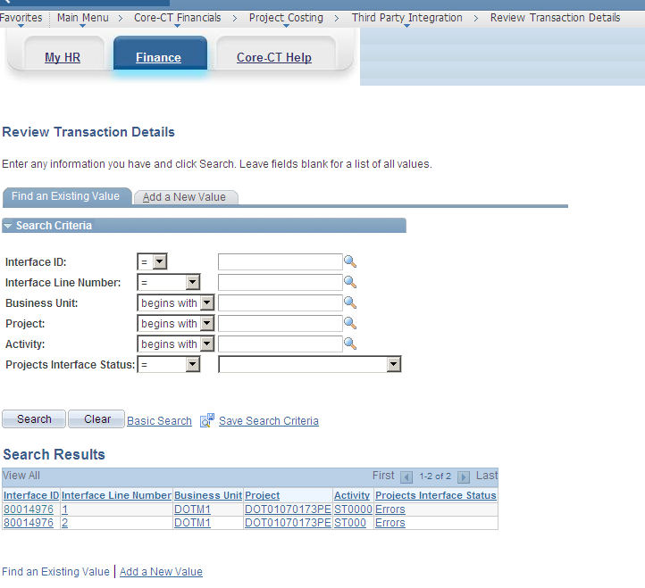

- Click the line in the Search Results that you would like to review. The Review Transaction Details page displays. If there is only one line within the Interface ID, then the Review Transaction Details page immediately displays once is clicked.

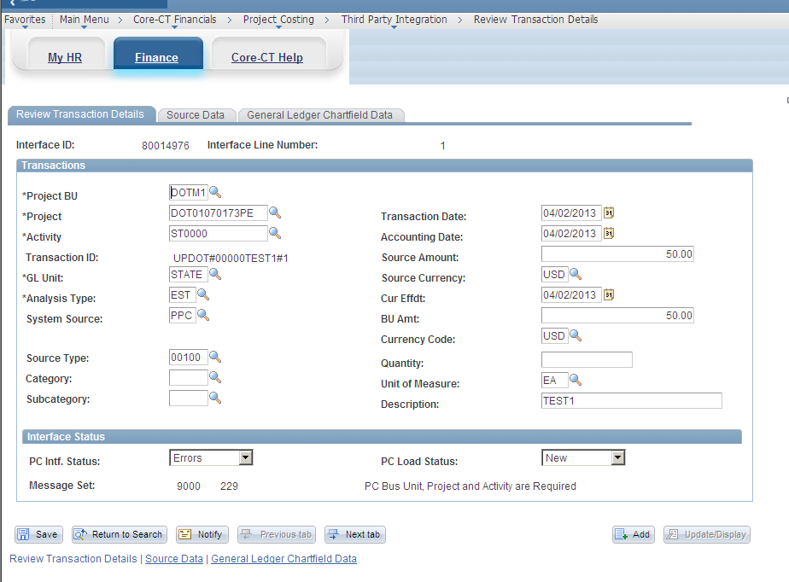
Figure 13 - This is the Review Transaction Details page with an error.

- Read the error message on the Review Transaction Details page. This error message displays under the Status field at the bottom of the page.

If you receive the Chartfield Combination is not Valid error message, check your coding to ensure it is correct. If you are still having trouble, work with your budget/financial coding staff to fix the issue.

- Based on the error message, you will have to correct the information on the Review Transaction Details, Source Data, or General Ledger Chartfield Data pages.

Once you fix the error, save your work. After the Load Transaction process runs again, you will have to ensure that you do not receive another error. You will only see one error at a time on the Review Transaction Details page. This means that your row may have multiple errors, but you will not see the next error message until you fix the first error.

To correct errors for additional lines, click . Then select another line to correct.

Additional Information:

To view the Project Resource table, follow the directions below:

- Navigate to Project Costing>Transaction Definitions>Transaction List. The Find an Existing Value page displays.
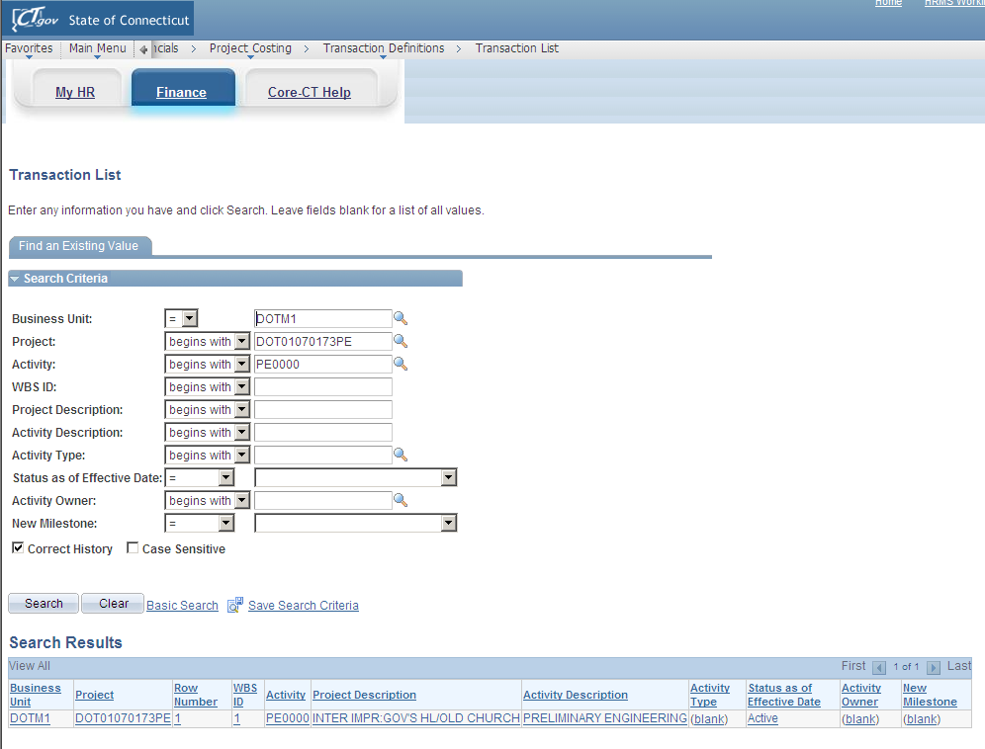
Figure 14 - This is an example of the Find an Existing Value tab with Search values.

- Ensure your Business Unit defaults correctly.

- Type the Project ID number in the Project field.

- Type the Activity.

- Click . The Transaction List page displays.
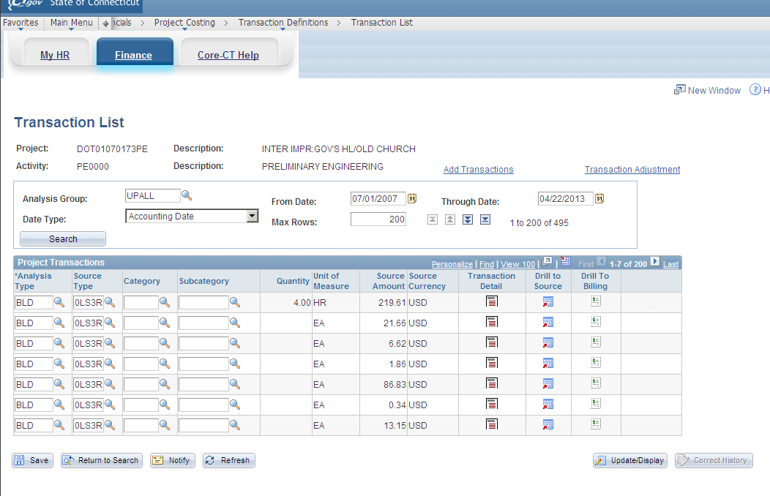
Figure 15 - This is the Transaction List page.

- Type in the Analysis Group of UPALL.

- Type the From Date and the Through Date remembering that shorter date ranges return faster search results.

- Click . The Projects Transactions rows display at the bottom of the screen.

- Find the transaction row that you are looking for and click to view more detail. The Transaction Detail page displays.

- Click Show All Transaction Details. The Show All Transaction Details page displays.

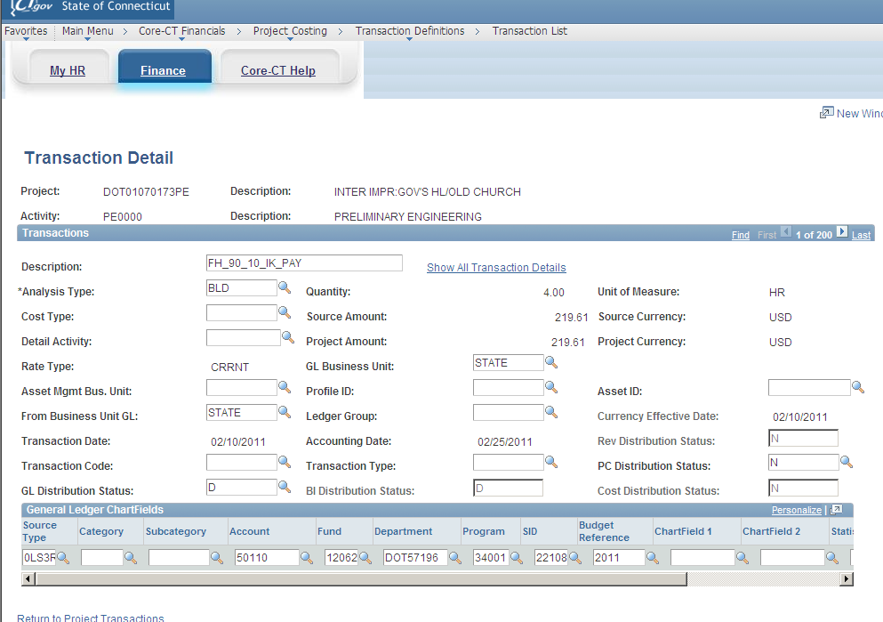
Figure 16 - This is the Transaction Detail page where you click the Show All Transaction Details link to get to the Transaction ID.
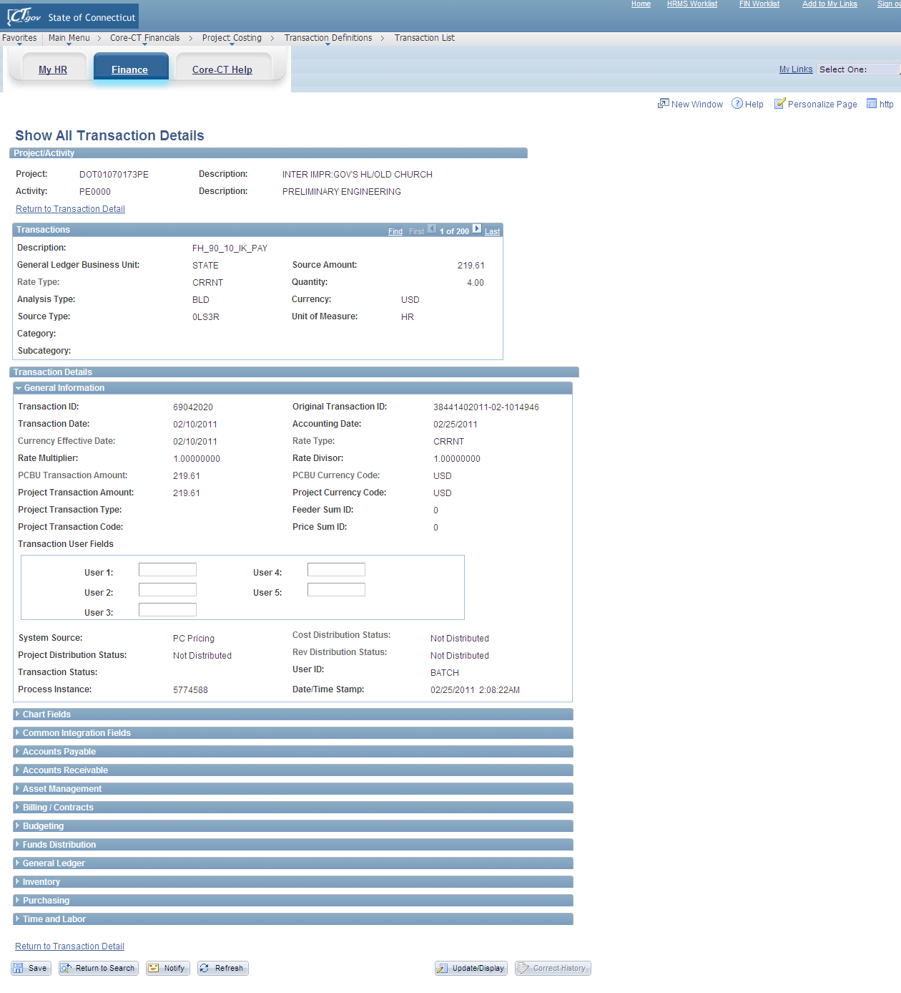
769
Figure 17 - This is the Show All Transaction Details page that displays the Transaction ID.

Notice the Transaction ID. This Transaction ID ties back to step 7 on page 2 of this job aid.

This procedure is complete. Call the Help Desk if you have problems with the Project Transaction Upload Tool.

