Objective

Use this Core-CT Workflow Routings Template for Security Liaisons to address and resolve questions of which personnel should be approving which transactions for whom.

Action Suggested

As needed, for each Core-CT user in your agency, complete this Template with names, origins and business unit information for each individual in the approval process.
Notes
- User origins will vary for the same user from Requisitions to Purchase Orders to Vouchers
- Agency Security Liaisons have access to Origin information
Support Materials

- Core-CT Web-based Learning Assistant (WLA) - Accessed from within Core-CT via the “Help” hyperlink in the top right corner of each page
- Core-CT Website - http://www.core-ct.state.ct.us/
- Agency Core-CT Super Users - http://www.core-ct.state.ct.us/fin-golive/xls/fin_super_users.xls

Note

- In several instances on this template, more than one name might need to be entered in the “Name” column. For example, there may be two or three people who can approve requisitions in the “Amt. Approver 3” role, etc. If/when this is the case, simply enlarge the relevant row of the table by clicking on the row’s bottom line and dragging it down until there is enough space for all the names you need to enter.

Core-CT User: ___________________________________________________________________________

1. eProcurement: Requisition WorkFlow
Note: Requisition WorkFlow is automatic and runs each time an approval is made.

Approval Type | Dollar Value | Role | Name | Origin | Business Unit
 |  | Requester | This User’s Name
Amount Approval | < or = $2,500 | Amt. Approver 1
Amount Approval | $2,500.01 - $10,000 | Amt. Approver 2
Amount Approval | $10,000.01 - $1,000,000.00 | Amt. Approver 3
Amount Approval | > $1,000,000.01 | Amt. Approver 4
ChartField Approval | All dollar amounts | Requisition Budget Approver
ChartField Approval | All dollar amounts | Requisition Purchasing Approver
Sourcing Process | All dollar amounts | Purchasing Error Processor

2. Purchasing: Purchase Order WorkFlow
Note: PO WorkFlow is NOT automatic. It is controlled by a batch process that runs every 15 minutes.

Approval Type | Dollar Value | Role | Name | Origin | Business Unit
 |  | Program Buyer and/or General Buyer | This User’s Name
Amount Approval | < or = $10,000 | Amt. Approver 1
Amount Approval | > $10,000 | Amt. Approver 2
ChartField Approval | All dollar amounts | PO Budget Approver

3. Accounts Payable: Voucher WorkFlow
Note: Voucher WorkFlow is NOT automatic. It is controlled by a batch process that runs every 15 minutes.

Approval Type | Name | Origin | Business Unit
Voucher Processor, etc. | This User’s Name
Match Processor (if Match fails)
Voucher Approver*
Budget Check Processor (if Budget Check fails)
* Voucher WorkFlow is determined by the Origin Code associated with the Voucher Processor and includes a single approval step (Voucher Approver).

4. Accounts Receivable: Business Process Roles
Note: Within AR, there is no WorkFlow processing. Instead, transactions progress through the business process. The roles in AR determine your security access and control the types of actions you can take when processing Receivables.
Role | Name | Origin | Business Unit
Receivable Processor
Receivable Maintenance Processor
Accounting Processor
Receivable Approver

Requisitions

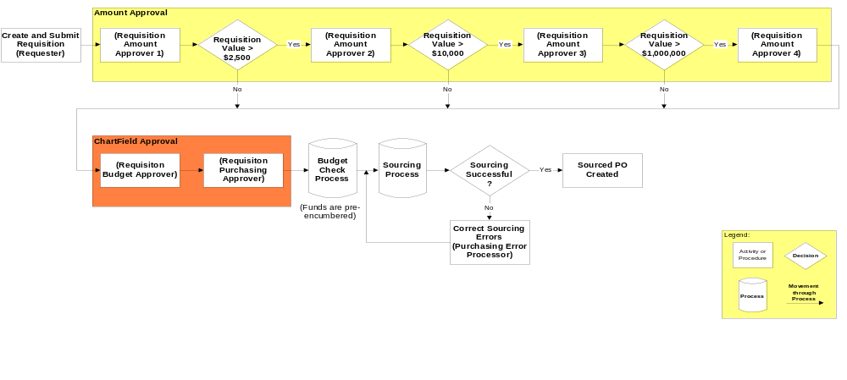

Purchase Orders

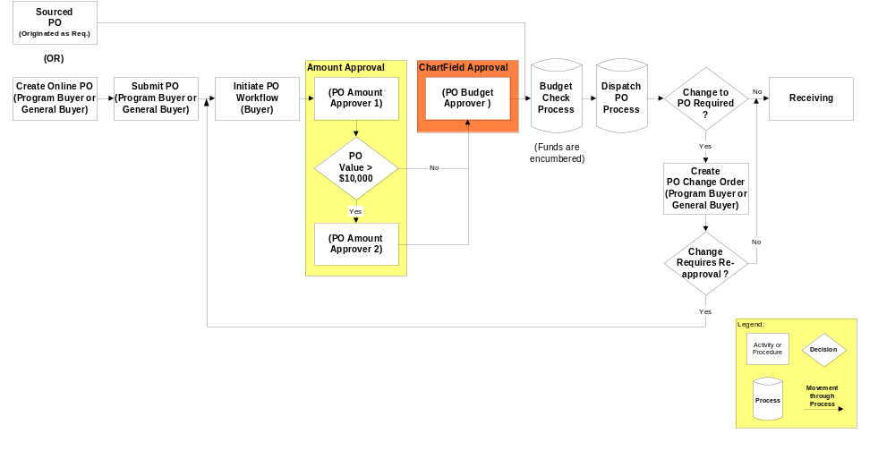

Accounts Payable

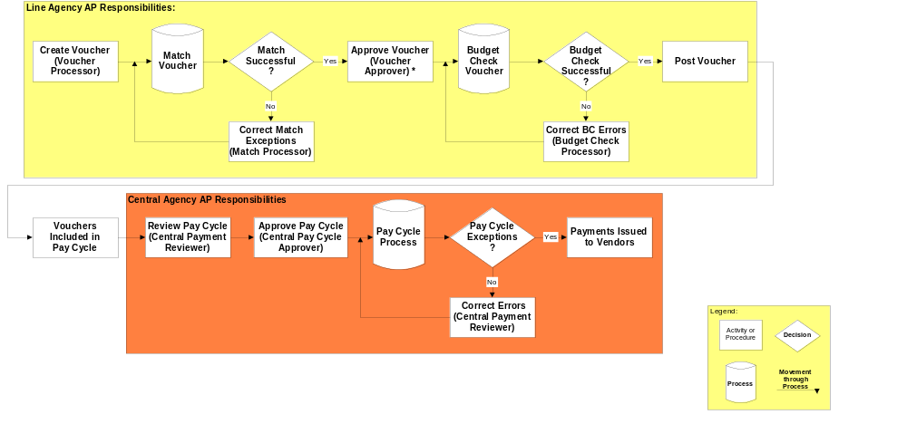

Accounts Receivable

Note: Within AR, there is no WorkFlow processing. Instead, transactions progress through the business process. The roles in AR determine your security access and control the types of actions you can take when processing Receivables.
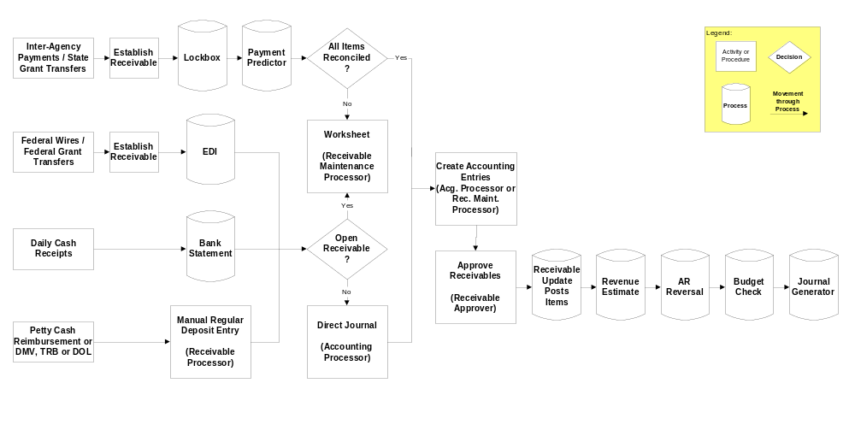

General Ledger


