HRMS Hire/Rehire Job Aid

Example One:
If an employee previously worked for the state but was not converted into Core-CT, you would navigate to Main Menu> Core-CT HRMS> Workforce Administration> Personal Information> Add a Person. After you add a new person, the system will direct you to the Modify a Person page. When you enter in the social security number on the Biographical Details page and tab out; you will receive a message stating the number matches a value currently on file in the SERS database.

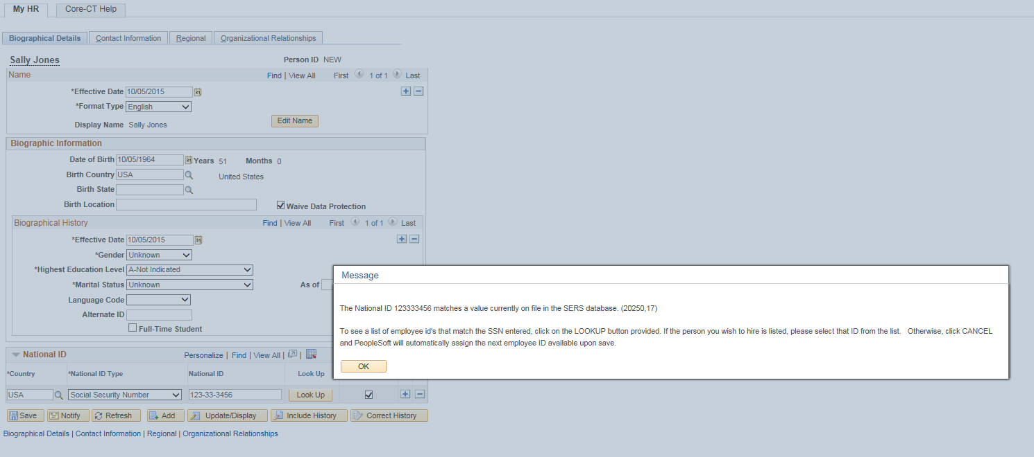

Once you click on the OK button, you will then see a “Lookup” pushbutton, click on the pushbutton.

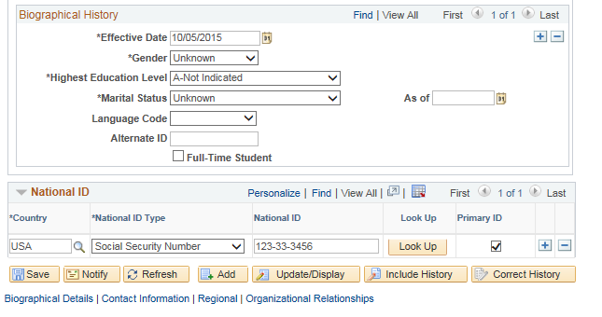

This brings you to the SERS Emplid List page. If this is the correct employee you will click on the employee number, if not please call the help desk. This means another employee has this employee’s social security number and will need to be researched. If two employee numbers appear, please click on the lowest number.
Warning: If you do not follow this process correctly a new employee ID number will be issued.

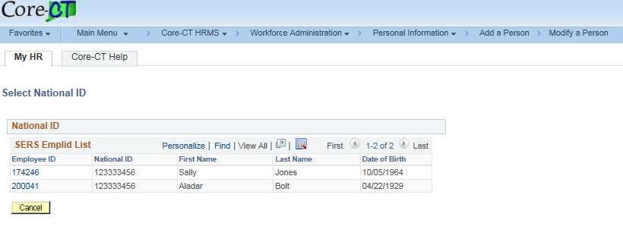

Example Two:
If you are attempting to hire an employee and are unaware they currently work for the state at another state agency. You have navigated to: Main Menu> Core-CT HRMS> Workforce Administration> Personal Information> Add a Person> Modify a Person. When you enter in the social security number on the Biographical Details page and tab out; you will receive a message stating the number is already in use by another employee. There will not be a pushbutton that says “Lookup” so at this point you need to contact DAS Central Auditing to have them review the employee. (This may be a transfer, rehire or a concurrent hire situation.) Warning: If you continue on with this process a new employee ID number will be issued.



