The Monthly Position Status Report is a report that should be run by the Agency Position Specialists to verify position counts within pertinent funding and organizational categories within their agency. This report may be run by any current or historical “as of date” from October 17, 2003 to present. Keep in mind that the Monthly Position Status Report may change if you have entered data with a retroactive effective date and rerun a report for the same “as of date”. This report may also be run either in “Summary Mode” to give a total of the positions by Fund, Class(SID) and Position Type (e.g. Permanent Full time) or in “Detail Mode” to list each position within those categories. Agency HR Specialists may access the report by navigating to:

Main Menu> Core-CT HRMS> Organizational Development> Position Management> Position Reports> Monthly Position Status Report

Although an Agency may run the report at any time, the Office of Policy and Management (OPM) is instructing that Agencies MUST run the Monthly Position Status Report on the 10th of the month and include the “as of date” as the first of that month. This will ensure that both OPM and agencies are reviewing the same data for any given reporting period. Agencies do not need to send a copy of this report to OPM; OPM will produce a copy for their records and will review the fields with the agency on an as needed basis.

Running the Report

The Agency Position Specialist navigates to:

Main Menu> Core-CT HRMS> Organization Development> Position Management> Position Reports> Monthly Position Status Report

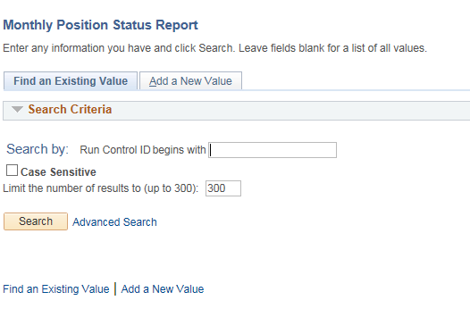

At the Run Control Page for the report enter the same run control you usually enter for reports or click on Add a New Value if you need to create a new run control for this report. After you click Add or , the parameter page will appear so you can set the proper criteria for the report you wish to run. In the below screen print the report will be run as of 04/01/2012 in Detail Mode for AES48000.

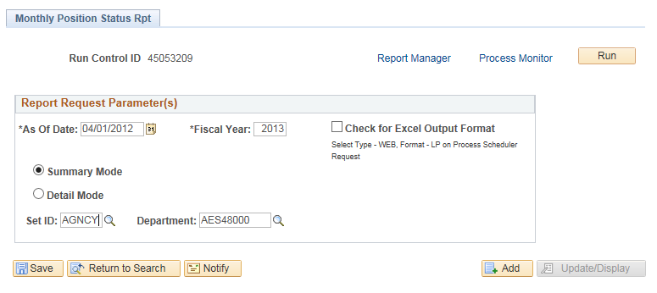

After the report criteria are selected the user clicks the button and the process scheduler request page appears. This report runs from server PSUNX. As specified in the previous screen the report has been selected to run in PDF rather than EXCEL format. Therefore, the Type should be set to Web and the Format should be set to PDF. If this report is for a large agency and you wish to run this at night when fewer users are in the system, reset the Run Time on this page for the time that would be more suitable. Click to initiate processing. 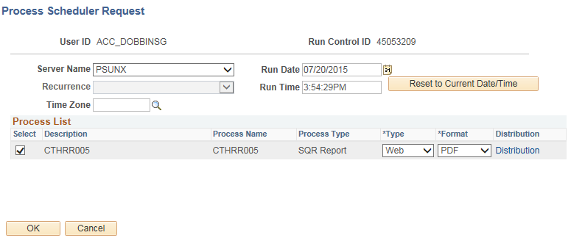

The process returns to the parameter page and shows the process instance that has been created. To view the report and/or check on the progress or processing status click on the Report Manager or Process Monitor links provided. If you have ‘scheduled’ a different time to run the report, the process will indicate that it is in Queued status.
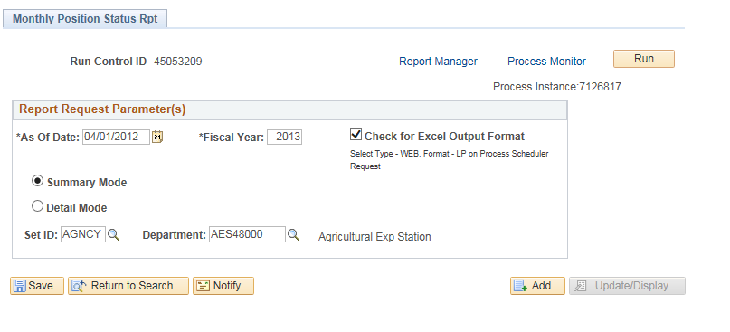

In Report Manager the reports run will be listed in order of most recent run and when completely processed will include a blue link with the process name CTHRR005

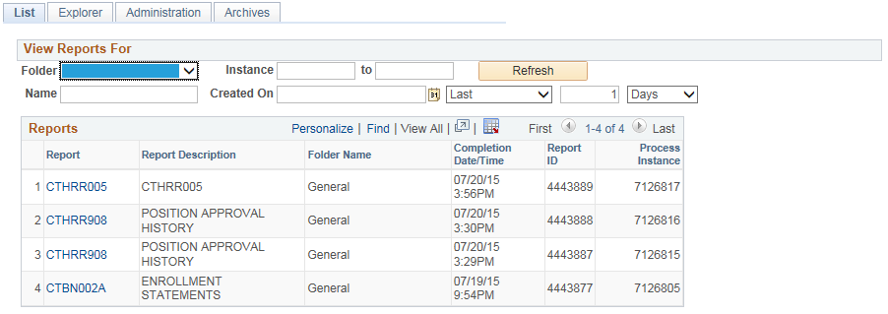

In Process Monitor the view is slightly different: the process should display “Success” in the Run Status dropdown and the Distribution Status should display a dropdown of “Posted” to allow you to view the report. In either mode, you can click every 30 seconds or so to update the page.

- The Instance number shown below is unique to each report run.
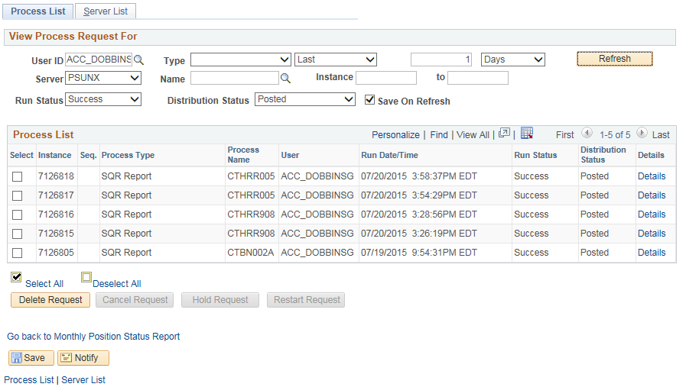

In Report Manager, after clicking on the blue report name link, the report distribution page displays with the results. The middle link which reads CTHRR005_7126817_1.PDF is the actual report result and has the PDF notation at the end to indicate the type of report which has been produced.

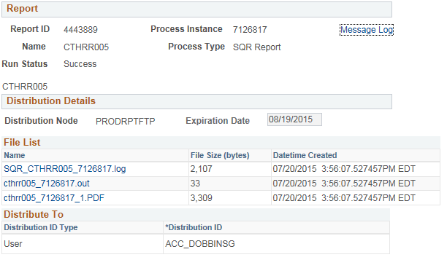

The report is now run. In order to reach the report distribution page to print, you now have to navigate to:
Main Menu> Core-CT HRMS> Reporting Tools> Report Manager

This page below will appear.
- Click the CTHRR005 report that corresponds to the correct Process Instance.
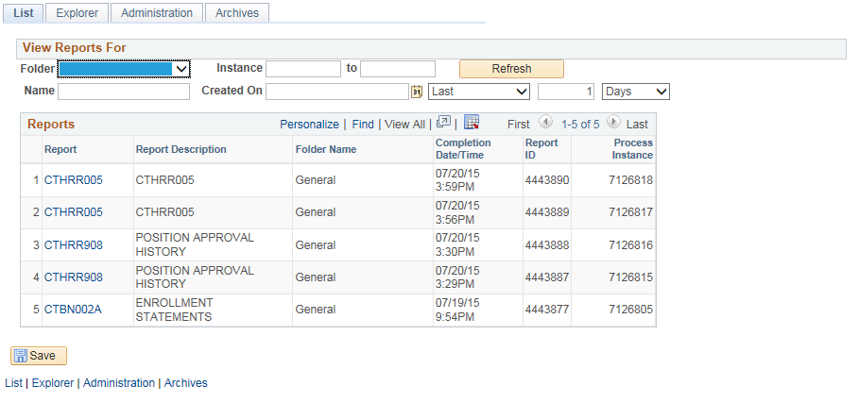

The page below will then appear.
- Click on the .PDF file to display the status report
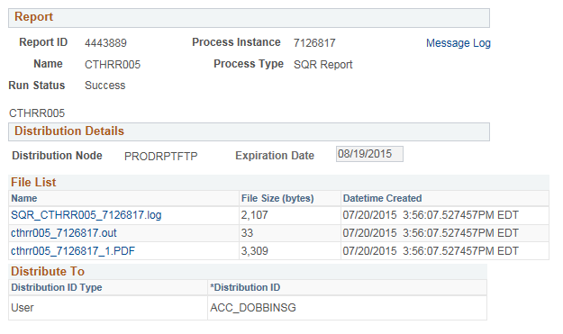

OUTDATED – need to validate that this is no longer the correct method

This is the Process Detail page where you click on the View Log/Trace link.

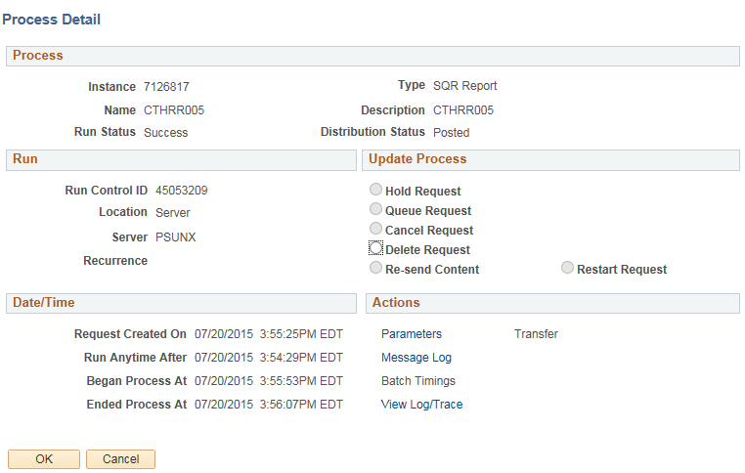

Click on the link CTHRR005_7126817_1. The PDF report displays:
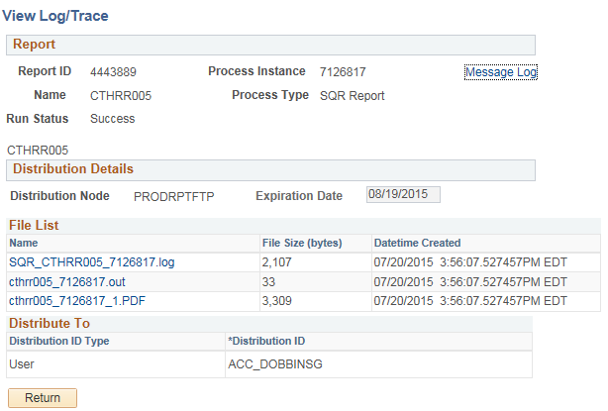

The PDF report displays as shown below. All but three columns, employee id, name and position numbers have been displayed above. The sections below will explain how the report is structured, how data is captured and displayed and how errors in position and job data will affect the report data. 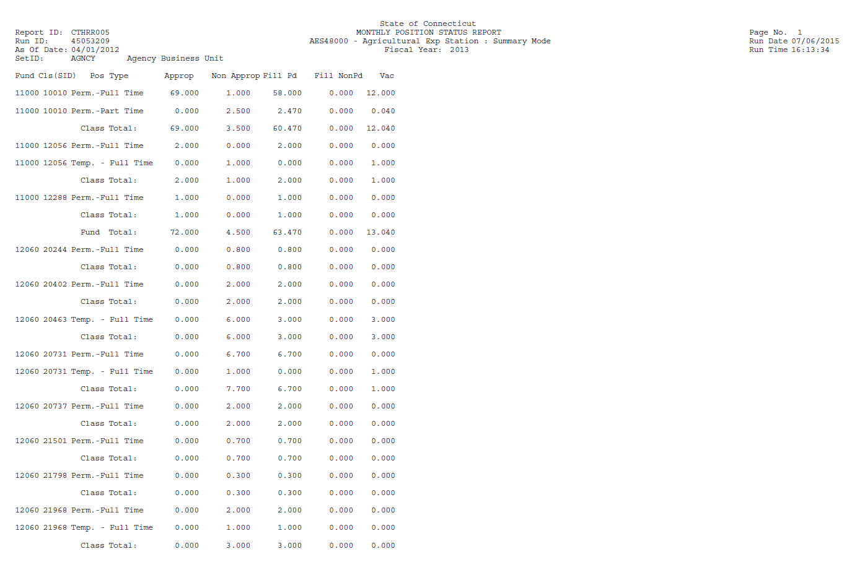

Report Format:

The report is now available as a downloadable file to Excel to allow additional analysis on active positions. (See job aid titled Monthly Position Status Report (Excel Format) at http://www.core-ct.state.ct.us/hr/human_resources/hr_jobaids.htm). When selecting this format the file will revert to all column headings with no subtotals within the report. This will allow agencies to use the results much like a query file from EPM, but the data will be exactly the same as the official report.

Sort order of report:

The Detail report will be arranged first by Department Code, Location Code, then by Fund, Class (SID), and Position Type. Within those sort categories, the Detailed Report will list the Position Number, Job Title, Job Code, Program Chartfield, and the proportional FTE (Full Time Equivalent) value of the position in relation to the funding source or sources. This report will Sub Total the sort categories in the order of Position Type, Class (SID), Fund and Location.

The Summary report will summarize by Fund, Class (SID), and Position Type and will provide subtotals of those groupings in reverse order.

The following is a listing of interpretations of the data fields in the “Detailed Mode” report:

- The Monthly Position Status Report should reflect all positions which have an Effective Status of “Active” where the position has ever had a Position Status of “Approved”, including both appropriated and non-appropriated positions.
- New positions still in workflow (not yet with a Position Status of “Approved”) will not appear on the report.
- Positions will continue to appear on the report until they have an Effective Status of “Inactive”.
- Positions undergoing some sort of change will appear as they did prior to the proposed action in process. This includes recycled and rejected positions which have not yet been returned to approved position status.
- If the position is part of your agency’s authorized count (Appropriated by General Assembly), the FTE (Full Time Equivalent) value – which must always be populated in Position Data – will appear in the Approp position column. (i.e. this occurs for Permanent (Regular) Full time positions when the position is attached to one of the following appropriated funds: 11000, 12001,12003, 12004, 12006, 12007, 12010, 12013). Also, the “Adds to FTE Actual Count” flag needs to be checked in Position Data, located in the Specific Information tab, under the Education and Government section. All positions in your authorized count should be permanent full time positions. This will be the case even if you are partially funding the position with non-appropriated funds, however only the appropriated portion will appear under the Approp column.
- If the position is NOT part of your agency’s authorized count (i.e. not appropriated by General Assembly), the FTE value from Position Data will appear in the Non-Approp position column. This occurs when the position is attached to ANY funding source other than those listed above. The “Adds to FTE Actual Value” flag should be left blank for these positions. This also can occur when one of the other criteria is not met (i.e. Not Regular, not Full Time, not checked as Adds to FTE Actual Value)
- When funding is split between appropriated and non-appropriated funding sources for a permanent full time position, the report will separates the portions of the FTE attached to each funding source to the correct column. Any positions funded even partially through appropriations should have the “Adds to FTE Actual Value” flag checked if it meets the other criteria of being full time and permanent. Any positions in the three other Position Types (Permanent Part time, Temporary Full time and Temporary Part Time) as well as some Permanent full time positions, depending on the funding source, may not be part of your authorized count.
- The FillPd (Filled Paid) and FillNonPd (Filled Non Paid) columns provide a detailed summary of the Job (Job data) FTE values. Therefore, depending on discrepancies between the Position FTE and the actual Job FTE for filled positions, agencies may find that the report does not produce expected totals. By ensuring that all incumbent (Job data) FTE values are exactly the same as the positions the incumbents are filling, agencies will be able to reconcile the totals correctly. If Position and Job data FTE values are the same, you may add the Approp and Non-Approp column values and deduct the Vac (Vacant) column value to compare to the sum of the FillPd and FillNonPd values. Discrepancies between the position FTE and the actual incumbent (Job data) FTEs will affect this analysis. If an agency has appointed more than 1 incumbent to a particular position, the FillPaid (Job FTE) will equal 2.00 but the position FTE may equal 1.00 under the Approp or Non-Approp column. This is a source of possible error which should be reviewed and/or corrected.
- If the position has multiple funding sources, the FTE of the position will be divided into the percentages specified for each Fund and Cls (SID) field combination used by the position. (See bullet above regarding split funding for appropriated positions)
- The Dis % (Funding Percentage) column is the Percent of Distribution listed on the Position Data, Combination Code Information tab, for each specified combination code. The Dis % is multiplied by the Position FTE value (located in Position Data) to determine the Approp, Non-Approp or Vac FTE from each funding source. (Normally the position FTE is the same as the JbFTE but if this has been overridden on job data you will need to check the position itself or EPM reports to verify this value.) The same procedure can be used with the JbFTE and the Dis % to determine the FillPd and FillNonPd FTE values. For example:
  - An appropriated position which is filled half time and has one (1) funding source will show .50 FTE in the Approp, FillPd and JbFTE columns and 100.00 in the Dis % column.
  - A position which is filled full time and has funding split between two (2) sources will show .50 in the Approp or Non-Approp column, .50 in the FillPd column, 50.00 in the Dis % column, and 1.00 under JbFTE column for each fund.
Reviewing the funding percentage will allow you to identify positions with multiple funding sources. For filled positions, the Name and the Emplid of the incumbent will also be printed next to each line to make these easier to identify.
- The JbFTE column will contain the total Job Data FTE value for each employee. This column is meant to show the actual total FTE value in Job data with all funding sources combined. Therefore, if an employee is listed multiple times due to many funding sources but they are a full time employee, the JbFTE value will be listed as 1.00 on each line.
- The report is position driven, not employee driven. This means that if an employee is a permanent half time employee, but is filling a permanent full time position, for the purposes of the report, the employee will be listed within the Perm. - Full Time position type but the JbFTE will indicate 50%. This report may help you to identify areas where position and Job FTE values are inconsistent and need to be adjusted.
- It is important to review particular fields to determine whether data errors are causing problems with your totals. On Position Data, check Regular/Temporary indicator against the positions with Position End Date values; check the Full Time/Part Time indicator against the position FTE value. If the position indicates “Regular” but has an end date it will appear in the section for regular positions rather than temporary. If the position is coded as part time but with a FTE value of 1.00 the report will place it with the part time positions but the full time FTE value will be reported.

All agency reports should identify special conversion positions with a Jobcode title of ConvNoAPS. These positions were included to allow for special payments such as contract settlements and arbitration awards to employees who no longer work for the agency but are entitled to payment. Unlike the legacy system, these payments must be made against an active position number. These positions provide this flexibility but in no way add to an agency’s position count.

Appropriated Positions

Agency Position Specialists must work closely with their Agency Budget Specialists and OPM Budget Analyst in order to correctly maintain their agency’s “Appropriated” count. Appropriated positions are those that are authorized by the General Assembly. As a general rule, appropriated positions are Permanent, Full Time, General and Special Appropriated Funded positions within the fund codes listed above. However, exceptions are made and should be reviewed with your OPM Budget Analyst. In addition, if agencies are splitting appropriated positions by partially funding these from other non-appropriated sources, it is crucial that these appropriated positions remain correctly identified as indicated above.

If a position is part of the appropriated count, the “Adds to FTE Actual Count” flag is checked in Position Data, in the Specific Information tab, under the Education and Government section.

The Monthly Position Status Report is used by OPM Budget Analyst to review if an agency is under or over their appropriated count. When an agency is requesting an establishment or a refill of a position, OPM reviews the data provided in this report to help determine whether funding levels will be exceeded. The Monthly Position count totals for all agencies and funds is also reported to the Office of Fiscal Analysis on a regular basis to demonstrate whether appropriated funds are being maintained within Statutory levels. A summary version of the report provides some of this information directly from Core-CT. For your convenience, your agency’s appropriated position FTE cap is printed on the report at the bottom of the appropriated column so you can compare this to the number of appropriated position FTEs and filled appropriated position FTEs.

Note: Durational positions with an ending date should NOT be coded as regular, especially when they are also appropriated funds and full time. These positions will be identified as appropriated even if not checked in the OPM extract. If positions which are durational are being coded regular due to benefits issues, agencies are advised to make the designation of regular on job data instead where the rest of the benefits setup is done. Otherwise, one of the other key criteria must be different for these not to be counted (i.e. not appropriated funds or not full time).

In addition, OPM is preparing more detailed analyses of agency trends using information from the report and from EPM. This analysis is using the Fill Paid column to compile the FTE’s for filled appropriated positions. However, the report also calculates this value (from the position FTE perspective) and the total can be found below the Grand total for the agency in the Approp column. It is marked Filled/Approp to distinguish it from all appropriated positions whether filled or vacant. Differences may occur if a filled, permanent, full-time, appropriated funds position is unchecked in the “Adds to FTE actual Value” box in position data and OPM considers that position to be appropriated, or that FTE counts for incumbents are different than the value the position is coded for. Therefore, it is imperative that agencies take great care to ensure that their data is accurate within Core-CT and that updates to align position data with budgeted levels are done.

Updating the “FTE and/or Adds to FTE Actual Count” field in Position Data.

The Agency Position Specialist navigates to:

Main Menu> Core-CT HRMS> Organizational Development> Position Management > Maintain Positions/Budgets> Add/Update Position Info

Search for the Position Number in the Position Number field
- At the Description tab, click on the button to add a new effective dated row.
- Change the Effective Date to the appropriate date.
- Update the Effective Sequence if needed.
- Change the Reason code to ‘PGC – Position General Change’.
- Click on the Detailed Position Description hyperlink and enter the justification for the change. Justification should only be entered in this section, not the Long Description or Position Approval Comment sections. (If data currently exists on this page, please delete and start with a fresh text page.)
- Under Job Information subtitle, see if the position is set up as full or part time in the *Full/Part Time dropdown. If part time, note the amount of standard hours that is indicated below in Salary Plan Information.
- In Specific Information tab under the ‘Education and Government’ section, review the setup for the ‘FTE’ field. If position is indicated as full time on the Description tab, Job Information section, then the FTE should be 1.00. If position is indicated as part time, you will need to calculate what the FTE (full time equivalent) will be. (Example: position is a part time Clerk (2007CL) and standard hours are set up as 25. Divide 25 (standard hours) by 40 (full time hours of salary plan) which would equal .625 FTE. You would enter .63 into the FTE field.)
- Checkmark the ‘Adds to FTE Actual Count’ field if the position is part of your established/appropriated count. If the position is not part of your established/appropriated count, then this box must be unchecked.
- Click on the button

Note: Positions will not go through workflow if only the following fields are changed: Effective Date, Effective Sequence, Reason, Detailed Position Description (Justification), FTE and Adds to FTE Actual Count.

Fiscal Year End Changes

During the fiscal year end transition to the new budget year, agencies will provide budget information and a roster of positions connected to their various funding sources. This process will provide agencies another opportunity to correctly identify positions which should be part of their authorized position count. The spreadsheet provided to OPM through the financial staff will update the FTE and adds to FTE actual value fields as well as many of the financial chart field values including budget reference, without the need for individual position actions. This process is an opportunity to “synch up” the existing positions with their respective funding sources. The Monthly Position Status Report can help to identify where discrepancies currently exist which need to be corrected.

