The Employee Payroll Comments page is for agency Payroll users to add notes related to Payroll issues. The page has a Subject Area, Notes field, and an Attached file feature which allows documentation to be included to the page.

Step 1: Adding a Value

Navigation: Payroll for North America > Employee Pay Data USA > Employee Payroll Comments

To add a comment for an employee that has no Existing Value, Click on the Add a New Value tab. Otherwise, if an entry was previously made for employee, click on the Find an Existing Value tab and enter employee search criteria.

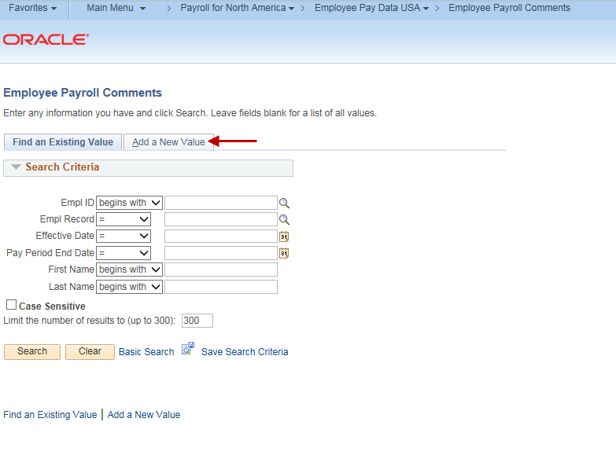

Once in the Add a New Value screen, fill in the Empl ID, Empl Record, Effective date and Pay Period End Date.

Note: The Effective Date field automatically populates with the current date, this date can be changed to reflect another date. The Pay Period End Date does not automatically populate and will need to be entered. The Effective Date and Pay Period End Date reflects Notes to a time period, not necessarily the current date or pay period.

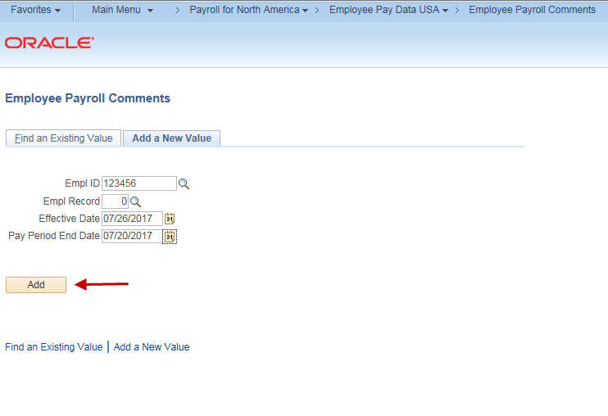

Once values are populated, click the add button.

Step 2: Adding an Employee Payroll Comment

Fill in the Subject Area and Notes. The page also has a spell check feature that can be used to correct spelling. Click on the book with the check mark.

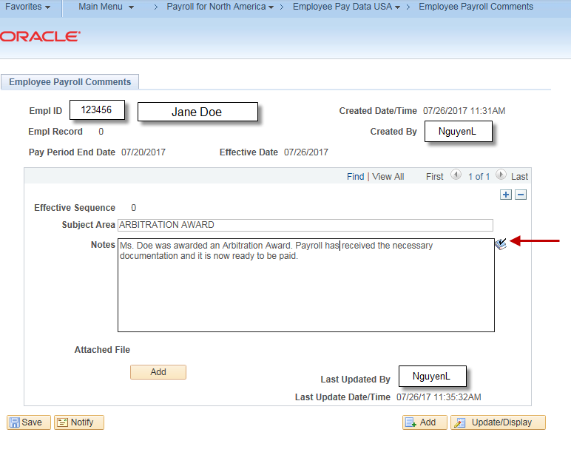

The following box is displayed if a correction is needed.
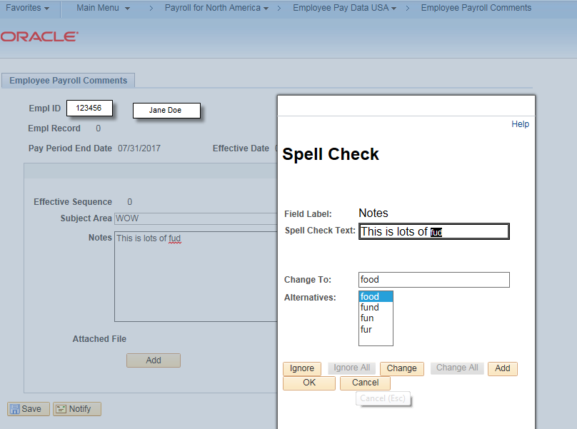

The following message is displayed if no misspellings are found.
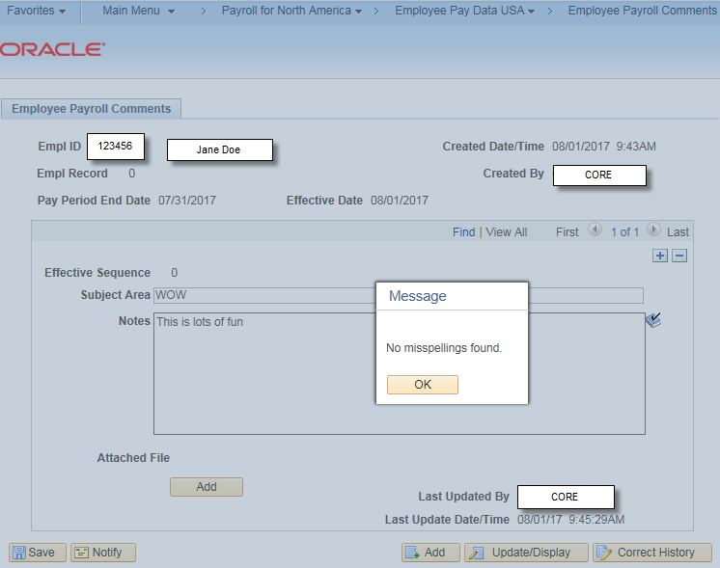

Step 3: Attaching a File

To attach documentation, click on the Attached File Add button.

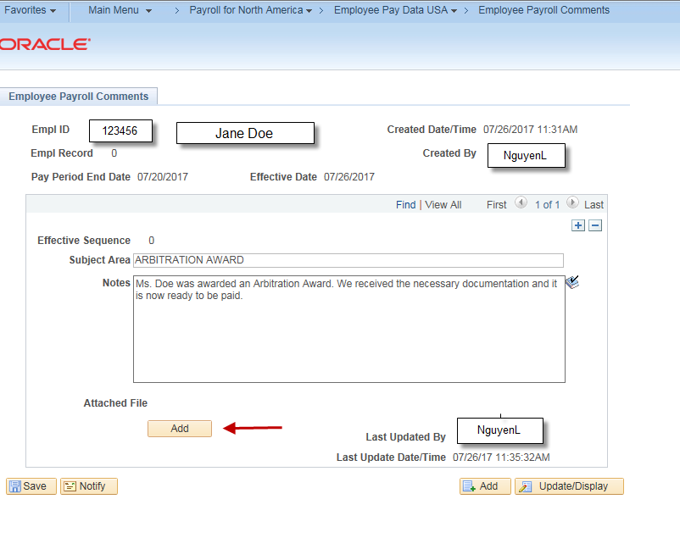

Click on the Browse tab to search for the attachment you wish to add.

Then upload button to attach the document.
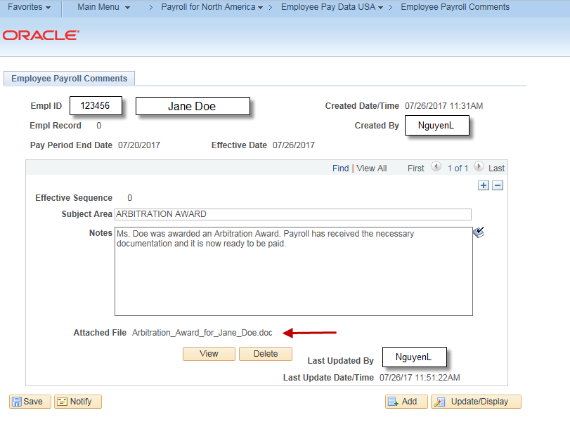

When finished with Employee Payroll Comments, save the page. If additional pages are needed, pages can be added following the same instructions, then save once complete.
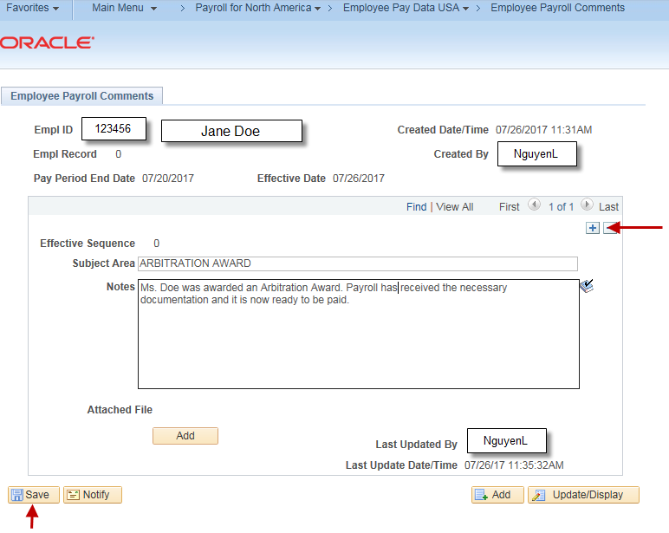

Misc.

If an error is discovered or a correction is needed on an already saved page and you try to correct it, the following message will be displayed. Correction mode is not an option on this page.

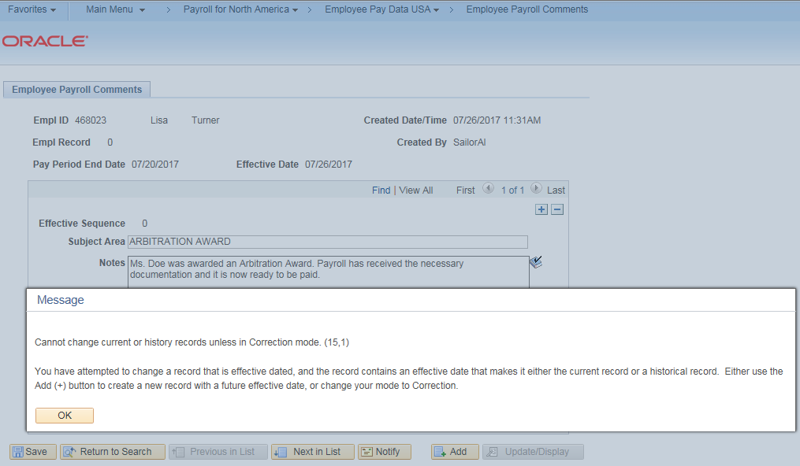

Instead a new effective dated Employee Payroll Comment page will need to be created. There it can be stated what the error or correction is, as well as what prior Employee Comment is being referred to.

The Employee Payroll Comment page also displays all prior entries that have been entered for an employee. Enter the employee ID on the Find Existing Value Tab and click Search. For a specific comment, refine your search by entering other search criteria.

