This job aid illustrates how an employee’s Time and Labor records are impacted when an employee is placed on a Leave of Absence and when the employee returns from leave.

Note: These instructions assume that the Job Data transactions have already been completed. For information on how to process the Job Data transaction, please refer to the Placing an Employee on a Leave of Absence job aid. The Leave of Absence in the following example is from 9/20/17 to 9/25/17 and the pay period dates are 9/15/17 to 9/28/17.

Part I – Turning off Rotating Averaging during the Leave of Absence (LOA)

Access Time Reporter Data:

Main Menu > Core-CT HRMS > Time and Labor > Enroll Time Reporters > Maintain Time Reporter Data

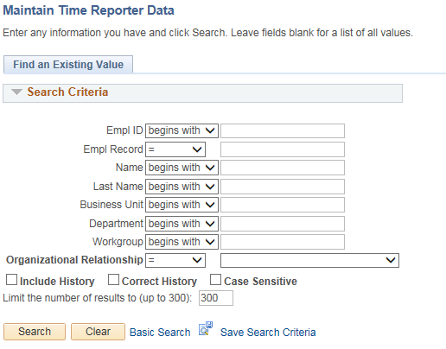

Special Note:
  - For this job aid it is assumed that the employee was already placed on a Leave of Absence in Job Data today with an effective date of September 20, 2017. The employee will return to work on September 25, 2017.
  - The leave of absence is considered to be in the current pay period.

- Enter the Employee ID in the Empl ID field

- Click

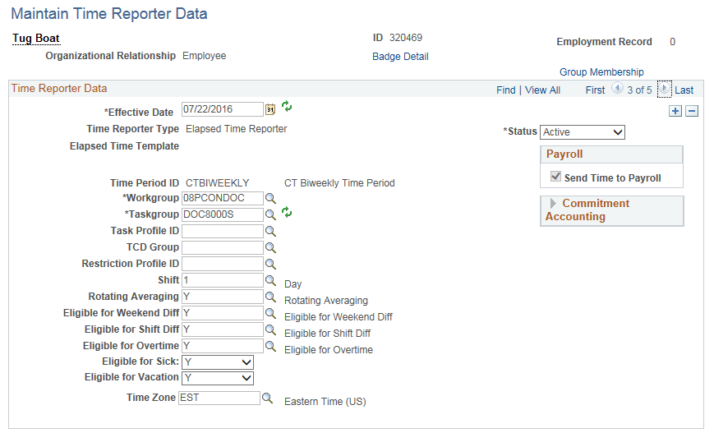

- Click to add a new row

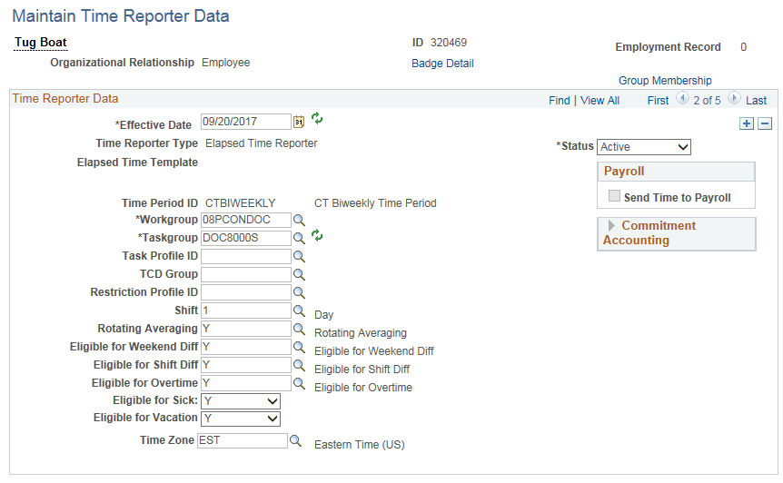

- Effective Date: Type the date or use the to select the first Friday prior to the Leave of Absence effective date (e.g., 9/15/17).

- Rotating Averaging: Enter “N”

- Click

Special Notes:
- The Rotating Averaging Schedule MUST either be active or inactive for a complete week (Friday to Thursday). Changing the status mid-week will cause inconsistencies in payroll processing. In addition, changing the status only for the period of the leave (e.g., 9/20/17 to 9/25/17) will not alter the Rotating Averaging calculation and is therefore, not appropriate.
- An overnight process will automatically insert a row with an effective date of 9/20/17 (the LOA effective date on Job Data) to Inactivate Time Reporter during the Leave of Absence. If any information is not correct on this row, log a Help Desk ticket for assistance.
- The employee will not have a rotating averaging adjustment processed by the system for this week. It must be calculated and entered manually on the Timesheet. See the section on Timesheet entry for more information.

Part II – Changing the Employee’s Schedule

Access Assign Work Schedule:

Main Menu > Core-CT HRMS > Time and Labor > Enroll Time Reporters > Assign Work Schedule

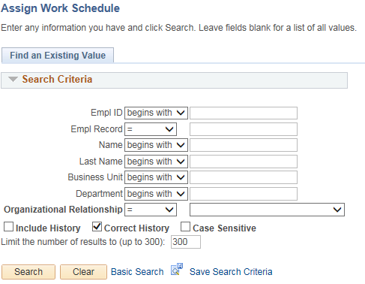

- Enter the Employee ID in the Empl ID field

- Click

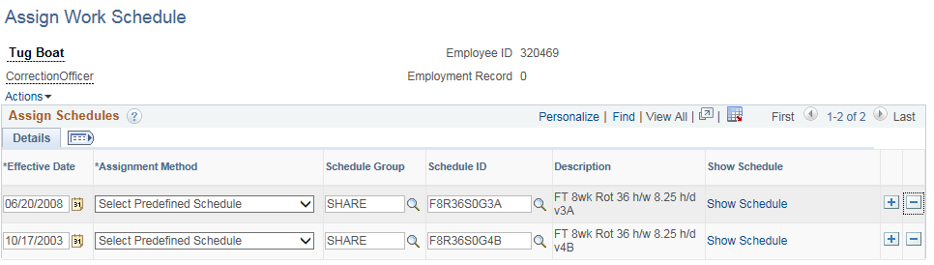

- Click the button to add a new row

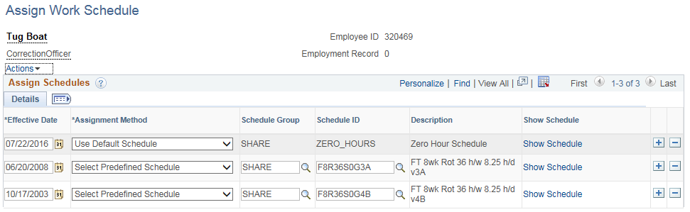

- Update the *Effective Date (e.g., 9/15/17)

- In the *Assignment Method dropdown, select “Select Predefine Schedule” (Positive Time Reporters will already be in a zero hour schedule with an Assignment Method of “Use Default Schedule”

- Schedule ID: Type or lookup “ZERO_HOURS” and add to the field

- If the reinstatement date is known, the employee can be returned at this point to the regular schedule effective with the first Friday after reinstatement from LOA (e.g., 9/29/17). Follow the steps in Part II to insert this schedule row.

- Click

Special Note:
- The employee should be placed in a zero hour schedule during the week of the LOA to ensure that payment is not inadvertently made for scheduled time.
- The Effective Date of a schedule must be a Friday. Select the Friday prior to the LOA effective date.

Part III – Posting Attendance on Timesheet

Access Timesheet:
Main Menu > Core-CT HRMS > Manager Self Service > Time Management > Report Time > Timesheet

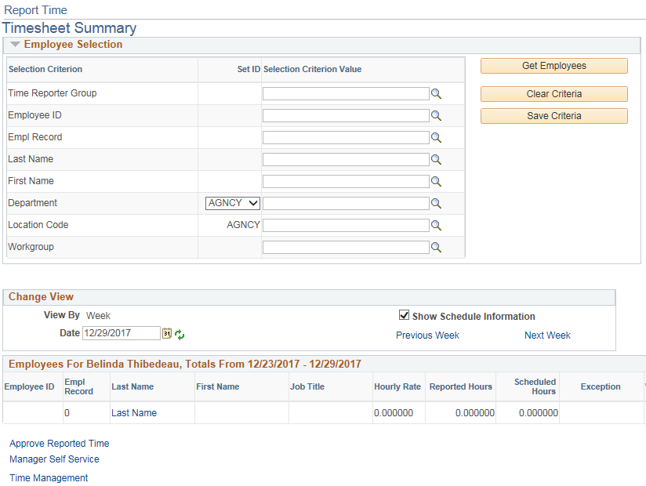

- Enter the Employee ID in the Empl ID field

- Update the Date, if necessary (e.g., 9/15/17)

- Click

Special Note:
- If the default date is within the pay period to be processed, it is not necessary to update it. Otherwise, select any date within the desired pay period.

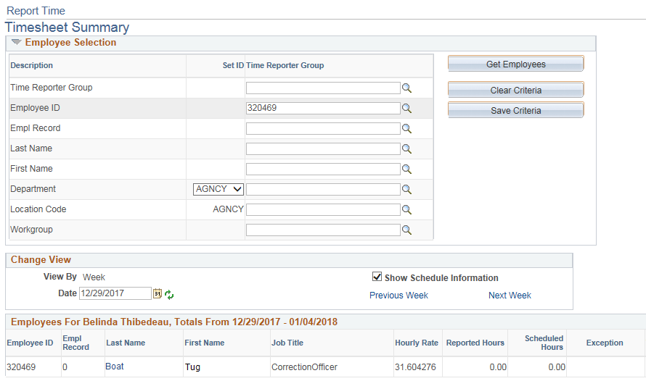

- Click the link under the Last Name Column (e.g., Boat, Tug)

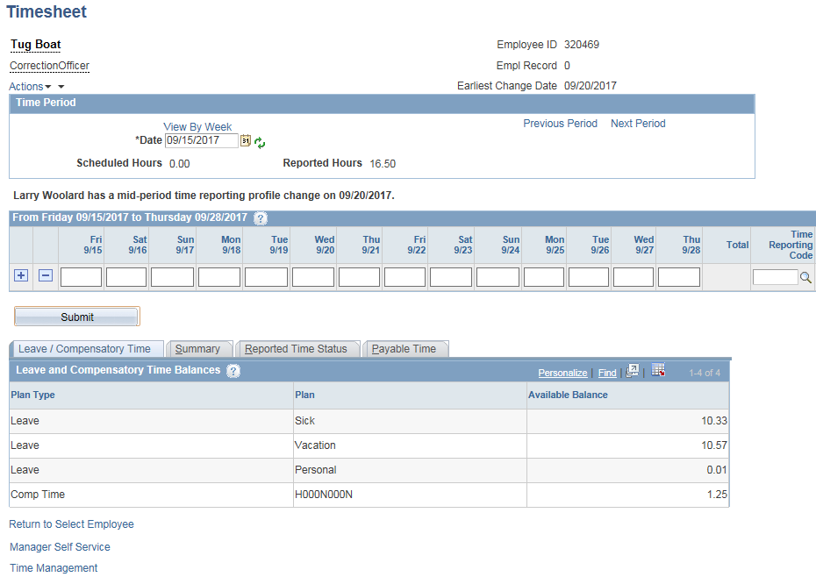

- Enter the employee’s time for the pay period

Special Notes:
- Attendance cannot be posted for the days the employee is on a Leave of Absence. Depending on when the attendance is entered the dates of the LOA may not be editable; however, these dates may be open for entry when you are performing this step in production if this step is performed on the same day the employee has been inactivated in Job Data.
- Agency HR and Payroll units MUST communicate with other regarding employee status to ensure that processing steps are performed in the correct order. Failure to do so could result in incorrect pay, inaccurate attendance, and/or inaccurate leave accrual information or may cause exceptions.
- If the employee has not been returned to his regular schedule, the entire Timesheet may be blank and all attendance would need to be entered. In this example, the employee was placed in a zero hour schedule for the entire pay period.

- Click

- The timesheet is saved

- Calculate the rotating averaging for the pay period, if necessary (e.g., $156.48)

Special Notes:
- In this example, the rotating averaging was shut off for the entire pay period and the amount needs to be manually calculated for both weeks. This needs to be entered in Additional Pay.
- It may not be necessary to manually calculate the rotating averaging for both weeks if the LOA period falls in only one of the weeks. In this case, the rotating averaging would only need to be shut off on Maintain Time Reporter for the week containing the LOA. The rotating averaging amount would be calculated by the system for the other week.
- Continue to Part IV for instructions on how to enter the rotating averaging amount.

Completing the transactions:
Special Notes:
- Remaining Tasks: Return employee from LOA on Job Data and place employee in his regular schedule (using a Friday date). Turn on Rotating Averaging Schedule on Maintain Time Reporter (using a Friday Date) if this has not already been done.
- If the steps in Parts I to III are not completed prior to Time Admin processing the employee, the system may have already calculated a Rotating Averaging adjustment. To check if the calculation has already been made navigate to the Payable Time Summary page and view the employee’s Payable Time (Main Menu > Core-CT HRMS > Manager Self Service > View Time > Payable Time Summary – if a calculation was created you will see one of these TRCs: ROTAJ, REGPN or REGNF). An offset will be created by the system for this adjustment once all of the steps in this job aid have been completed. The offset should be verified for accuracy.
- If the employee you are processing needs to have a Rotating Averaging adjustment continue to the next section.

Part IV – Entering Rotating Averaging adjustment in Additional Pay

Access Additional Pay:

Main Menu > Core-CT HRMS > Payroll for North America > Employee Data USA > Create Additional Pay

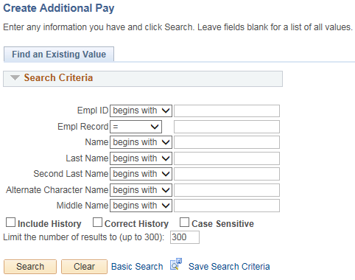

- Enter the Employee ID in the Empl ID field

- Click

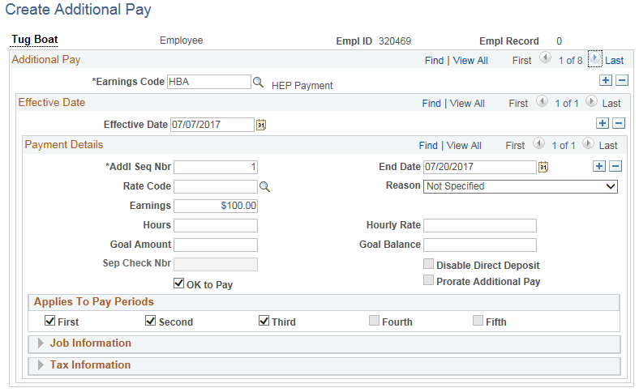

- Click to verify whether another Additional Pay record exists for the earnings code DOC

- If a DOC row is found, click next to the Effective Date to add a new row

- If a DOC row is not found, click next to the Earnings Code to add a new row

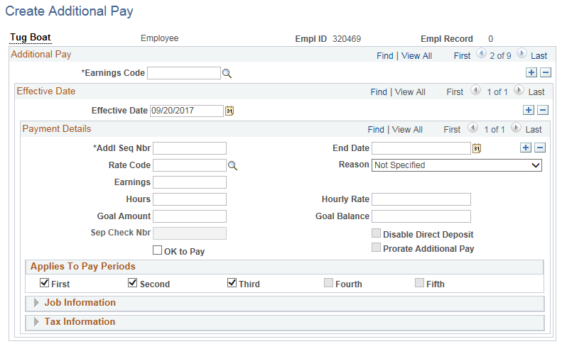

- Type in the Earnings Code ‘DOC’

- Verify the Effective Date and update, if necessary

Special Notes:
- The Effective Date should be the beginning of the pay period in which they are on a LOA.

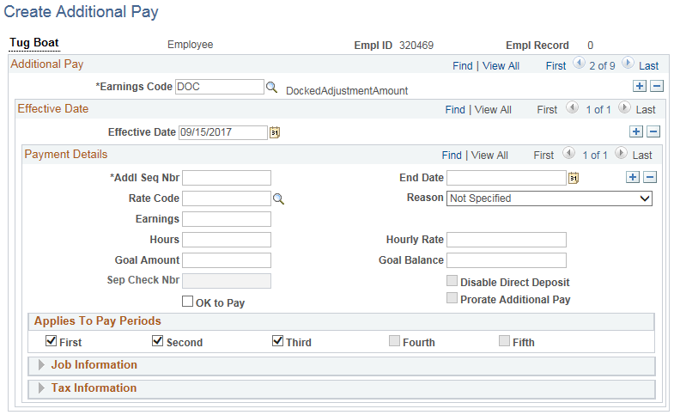

- Enter “1” in the *Addl Seq Nbr field

- Type in End Date (e.g., 09/28/17)

Special Notes:
- The End Date should be the last day of the pay period being processed.

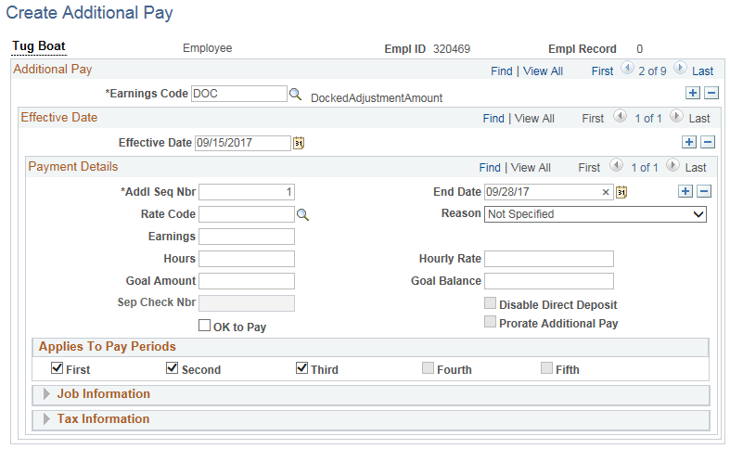

- In the Earnings field, type in the Rotating Averaging adjustment amount (e.g., -$156.48)

Special Notes:
- The Earnings amount MUST be entered as a negative number

- Click the “OK to Pay” checkbox

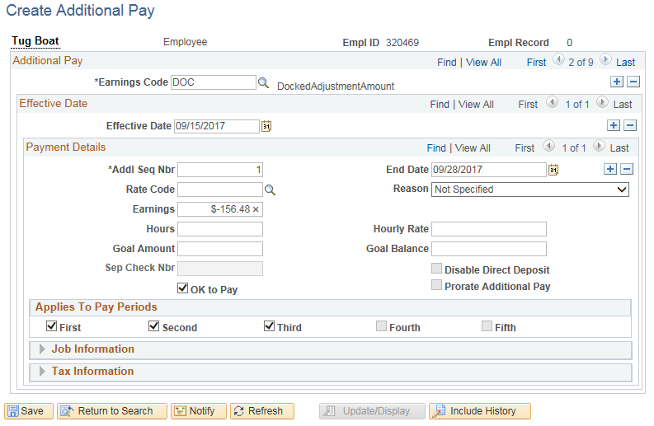

- Click

- Additional Pay entry is saved

Special Notes:
- Remaining Tasks: Return employee from LOA on Job Data, turn on Rotating Averaging Schedule on Maintain Time Reporter (using a Friday date), and place employee on regular schedule (using a Friday date), if these steps have not already been completed.

