If you are unable to access Core-CT on your mobile device, Desktop View allows you to see options and menus as seen on computers and laptops.
Selecting desktop site on portable iPhone and android devices
The purpose of this document is to assist users in selecting a desktop view on iPhone and android devices before signing into Core-CT.
Desktop View for Mobile Devices

iPhone Users: Safari Browser
Locate the web address bar (could be bottom or top) and select the AA.

Select ‘Request Desktop Site’ BEFORE you log into Core-CT
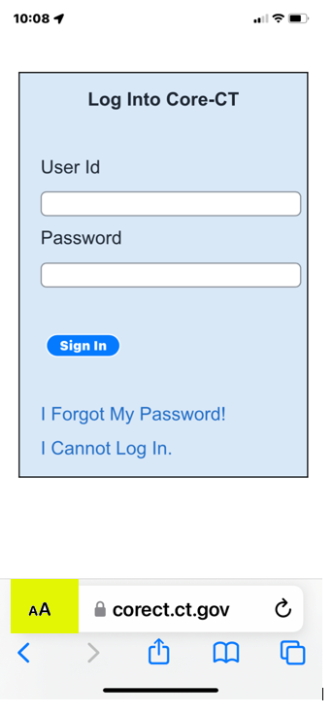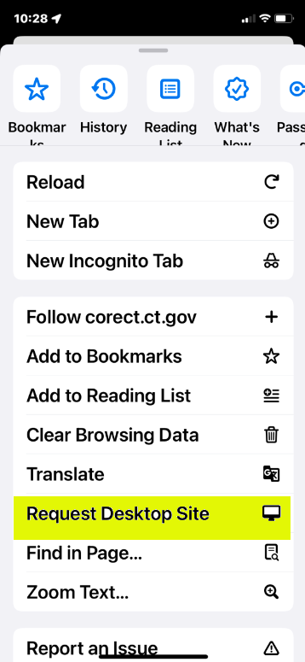

iPhone Users: Google Chrome
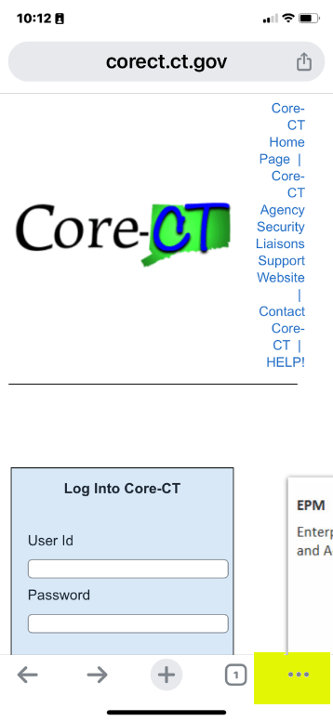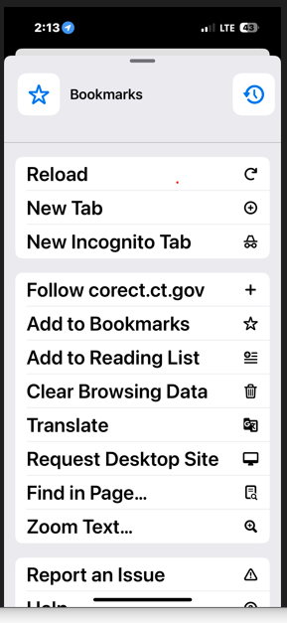
Locate the (…).

Select ‘Request Desktop Site’ BEFORE you log into Core-CT

Droid Users: Google Chrome

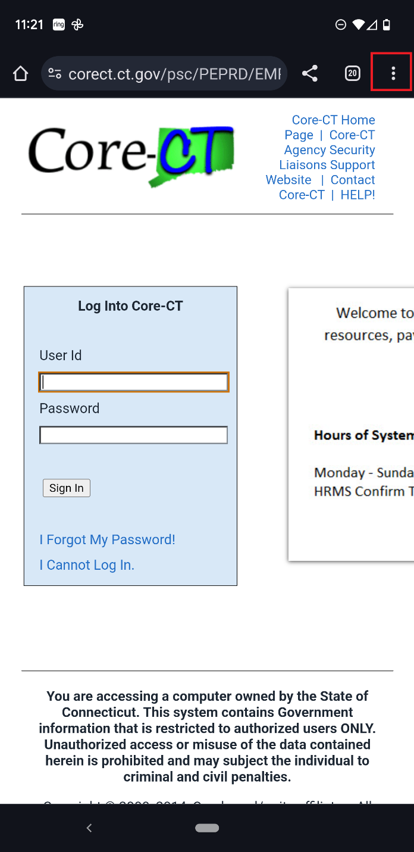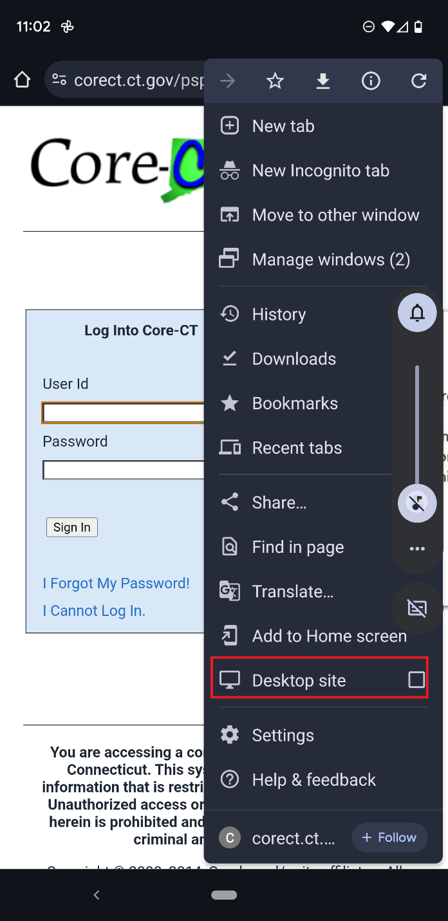
Locate the (…)

Check box for ‘Desktop Site’ BEFORE you log into Core-CT

