CT_CORE_FIN_REQUISITION_STATUS

Purpose of Query

Requisitions by Entered Date - This query shows the status of all requisitions based on the user input of business unit and date range. This query was built using the CT_REQ_TRNS_TBL table.

Folder

PO

Tables

CTW_REQ_TRN_TBL - Requisition Trans. Rpt Tbl

Prompts

BUSINESS_UNIT - Business Unit (%) – (Wildcard enabled)
ENTERED_DT - From Entered Date / ENTERED_DT - To Entered Date – (Between condition)

Sample Results:

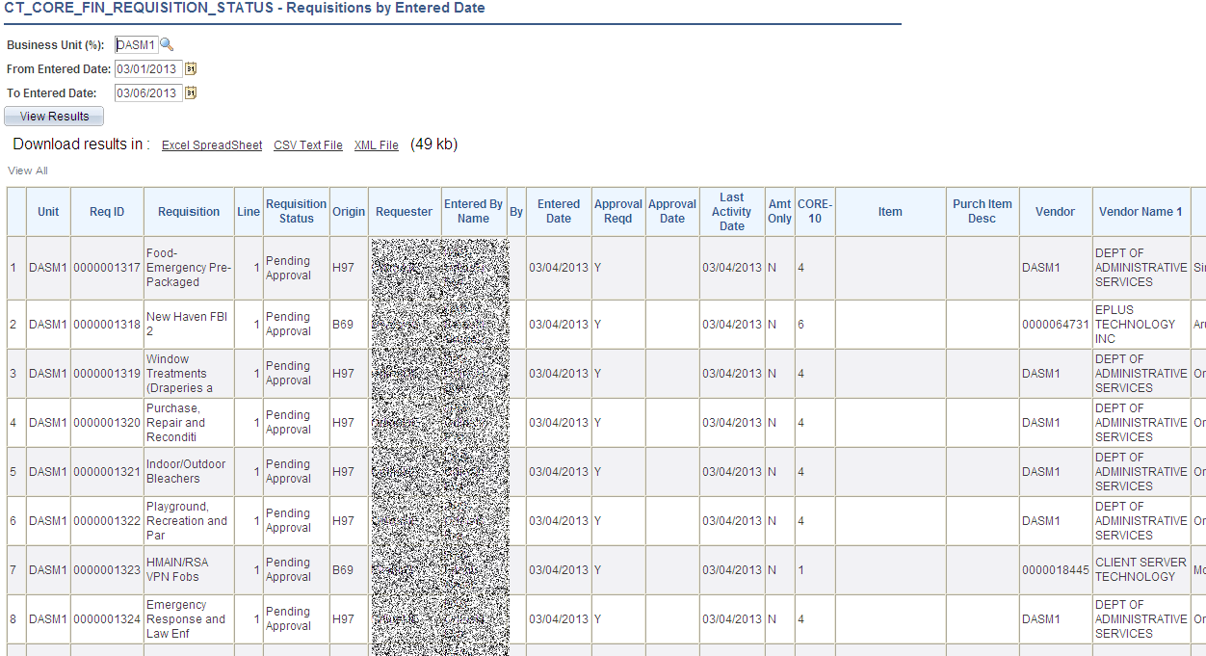

Criteria

Runtime prompts are the only criteria.

Note: Runtime prompts are included as criteria.

Fields

Col | Record.Fieldname | Format | Ord | XLAT | Agg | Heading Text
1 | A.BUSINESS_UNIT - Business Unit | Char5 |  |  |  | Unit
2 | A.REQ_ID - Requisition ID | Char10 |  |  |  | Req ID
3 | A.REQ_NAME - Requisition Name | Char30 |  |  |  | Requisition
4 | A.LINE_NBR - Line Number | Num5.0 |  |  |  | Line
5 | A.REQ_STATUS - Requisition Status | Char4 |  | L |  | Requisition Status
6 | A.ORIGIN - Origin | Char3 |  |  |  | Origin
7 | A.REQUESTOR_ID - Requester Name | Char30 |  |  |  | Requester
8 | A.CT_ENTER_BY_NAME - Entered By Name | Char30 |  |  |  | Entered By Name
9 | A.OPRID_APPROVED_BY - Approved By | Char30 |  |  |  | By
10 | A.ENTERED_DT - Entered on | Date |  |  |  | Entered Date
11 | A.APPR_REQD - Approval Required | Char1 |  |  |  | Approval Reqd
12 | A.APPROVAL_DT - Date of Approval | Date |  |  |  | Approval Date
13 | A.ACTIVITY_DATE - Last Activity | Date |  |  |  | Last Activity Date
14 | A.AMT_ONLY_FLG - Amount Only | Char1 |  |  |  | Amt Only
15 | A.CT_DOIT_FLG - CORE-10 | Char2 |  | N |  | CORE-10
16 | A.INV_ITEM_ID - Item ID | Char18 |  |  |  | Item
17 | A.CT_PURITM_DESCR - Purchase Item Description | Char30 |  |  |  | Purch Item Desc
18 | A.VENDOR_ID - Vendor ID | Char10 |  |  |  | Vendor
19 | A.CT_VNDR_NAME1 - Vendor Name 1 | Char40 |  |  |  | Vendor Name 1
20 | A.BUYER_ID - Buyer Name | Char30 |  |  |  | Buyer
21 | A.CT_ITMCAT_DESCR - Item Catalog Description | Char30 |  |  |  | Itm Catalg Desc
22 | A.UNIT_OF_MEASURE - Unit of Measure | Char3 |  | N |  | UOM
23 | A.PRICE_REQ - Requisition Price | Num11.5 |  |  |  | Price
24 | A.INSPECT_CD - Inspection Required | Char1 |  |  |  | Inspect
25 | A.MONETARY_AMOUNT - Monetary Amount | SNm25.3 |  |  |  | Amount

