TRC’s (Time Reporting Codes) are entered into the Time and Labor module, primarily through the use of the time sheet to record an employee’s time.

TRC’s(Time & Labor) map to Earnings Codes (Payroll) which in turn map to accounts and corresponding amounts recorded in the General Ledger.

The mapping of TRC to earnings code is relatively straight forward. The only TRC’s that do not map to an earnings code are the ones listed below.

TRC | Description
IFILR | Filler - No Effect
IFOTC | Unpd Invol OT Fed FMLA Caregvr
IFOTE | Unpd Invol OT Fed FMLA Emp
ILPD | WC Last State Payroll Date
IREO | WC Mult. Reocc Single PPd
IWED | WC Disability End Date
IWSD | WC Disability Start Date Info
NWS | Not Working Scheduled Hours
SBACA | Accum Sick Birth, Adopt, Cust
SFAMA | Accumulator Sick Family
SFIFA | Accum Sick Fnrl Immediate Fam
SFNIA | Accum Sick Fnrl Non-Immed Fam
UDOMA | Accumulator ULDOM
XNMEA | No Meal
XNMHC | No Meal HC
XNMPP | No Meal OPA

Earnings to Account Mapping Precedence

- 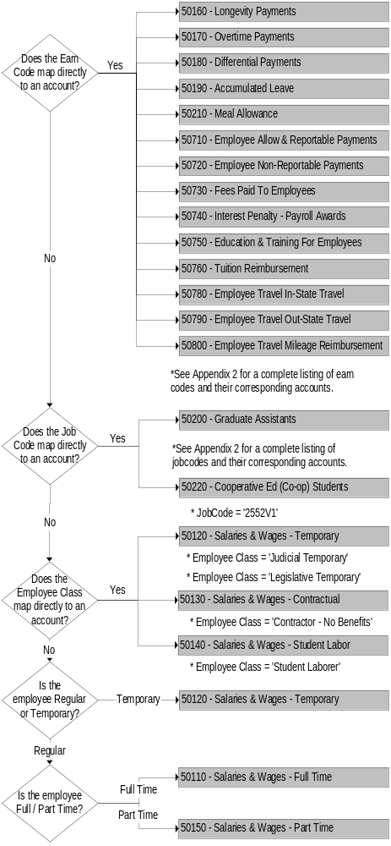In the first step, the mapping process will evaluate whether the earn code that was reported has been configured to map directly to an account. If it has been configured, then the account it is mapped to will be used in overwrite the default account in the employee’s account code combination when payroll expenditures are distributed for those earnings. If it has not been configured, then the process will proceed to step 2.

- If theJobCode has been configured, the appropriate account is selected, which will apply to all earnings for the employee. If it has not been configured, then the process will proceed to step 3.

- If an employee is classified with an Employee Class that has been configured, then the corresponding account will be mapped to all earnings. Else, the mapping process will proceed to Step 4

- If an employee is classified as Temporary, then all earnings will be mapped to the corresponding account. Else, the mapping process will proceed to Step 5.

5. Finally, if the earnings paid to an employee have not been mapped to an account, this final step will map the earnings based on whether the employee is full or part time.

- If the Earn code is configured to map to a specific account.

Time Reporting Codes mapped to Earnings Codes, mapped to Account

- Certain Jobcodes are configured.

SETID | Jobcode | Description | Account
UNIVS | 4185V1 | Graduate Assistant | 50200
UNIVS | 4185VR | Graduate Assistant | 50200
UNIVS | 045C1 | CCEducAsst | 50200
UNIVS | 2178C1 | CCEducAsst | 50200
UNIVS | 2178C2 | CCEducAsst | 50200
UNIVS | 2178C3 | CCEducAsst | 50200
UNIVS | 2178C4 | CCEducAsst | 50200
UNIVS | 2178C5 | CCEducAsst | 50200
UNIVS | 2178V1 | CCEducAsst | 50200
UNIVS | 2178M1 | CCEducAsst | 50200

- Certain employee classes are configured.

Employee Class | Description | Account
CC | Contractual-No Benefits | 50130
CO | Contractual-No Benefits | 50130
CU | Contractual-No Benefits | 50130
JT | Judicial Temporary | 50120
OT | OLM Temp and Legislator | 50120
LS | Student Laborer | 50140

- If Employee is Temporary, earnings are configured to account 50120.

- If an employee still has unmapped earnings:

Full Time earnings map to 50110
Part Time earnings map to 50150

