Common Problems and Resolutions for AR

Resources-

Everything you need to learn the process and procedures for AR can be found on the Core website.

Job Aids- CORE Website:

http://www.core-ct.state.ct.us/financials/ar/default.htm
http://www.core-ct.state.ct.us/financials/bi/default.htm

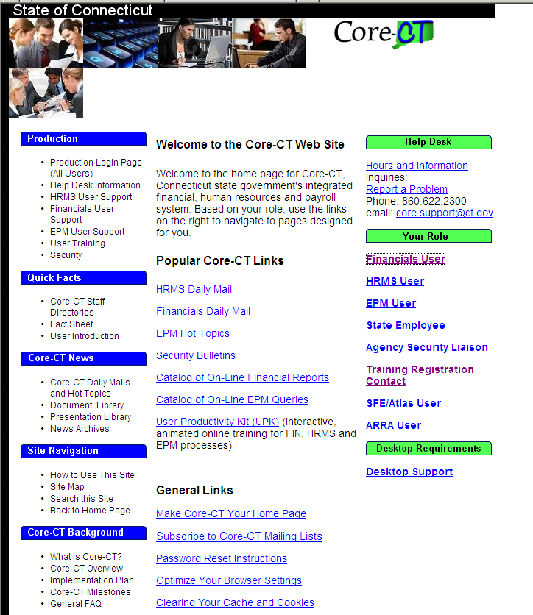
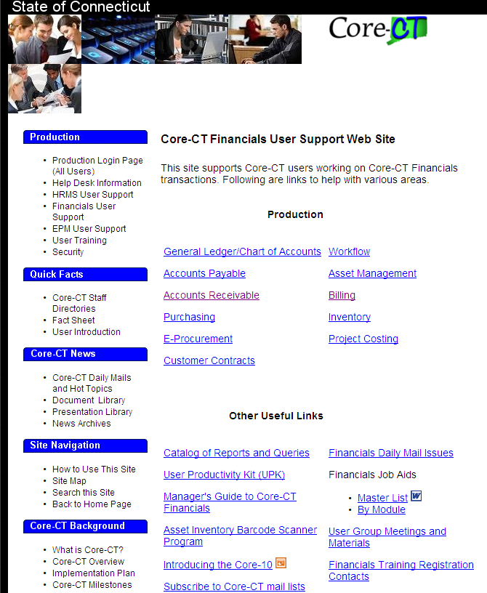

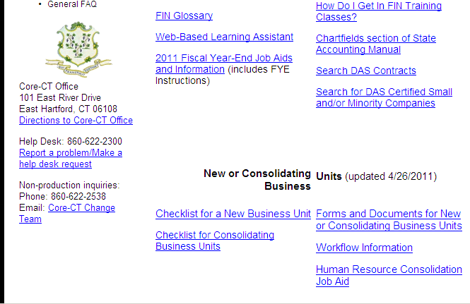

UPK Training Exercises:

Can be accessed through the Core-CT Webpage or through the individual Core-CT home page. Just click on the link for Financial UPK Exercises.

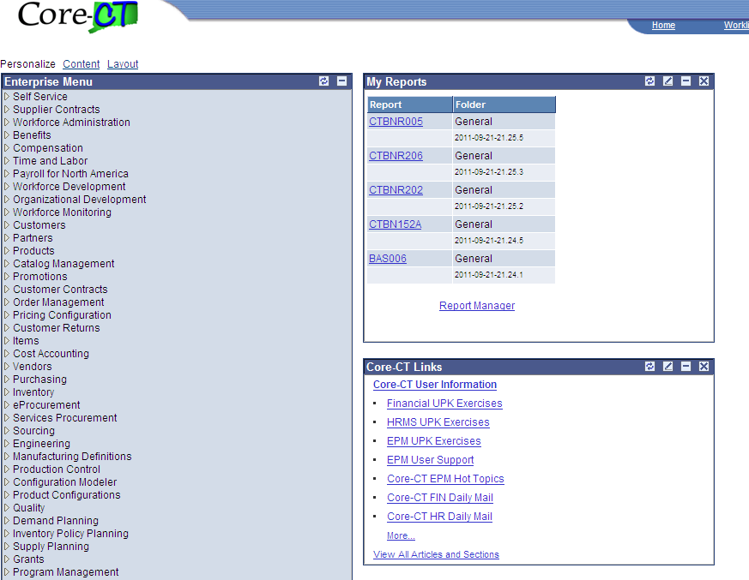

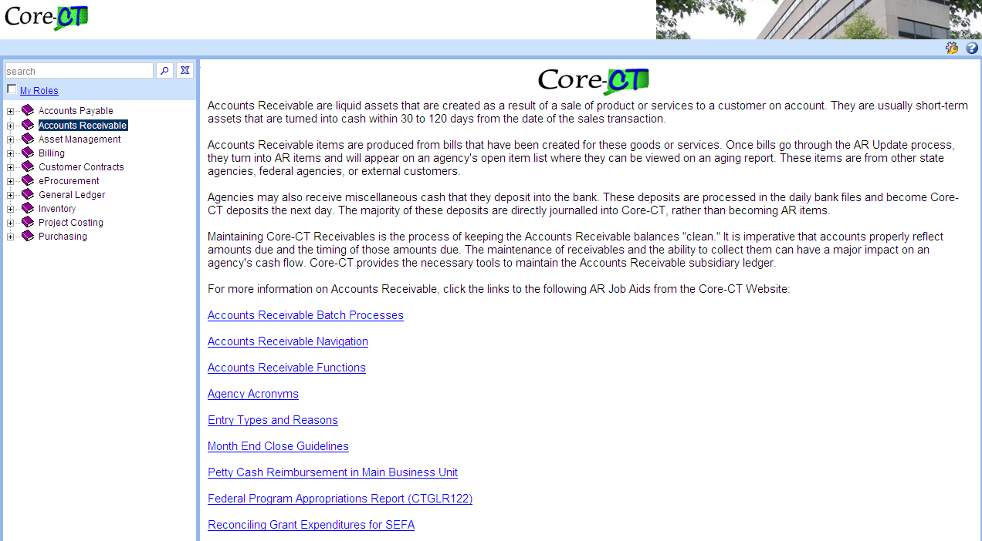

Click into the Module to open the UPK topics. Click into the topic to get to the sub-topic.

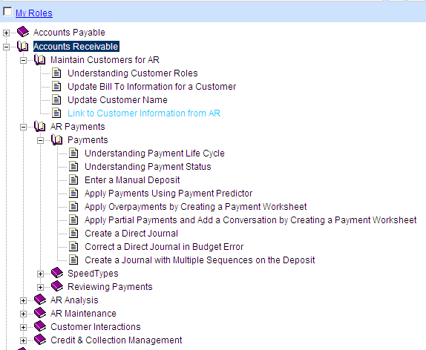

Clicking into topics will give a description with links to applicable job aids.

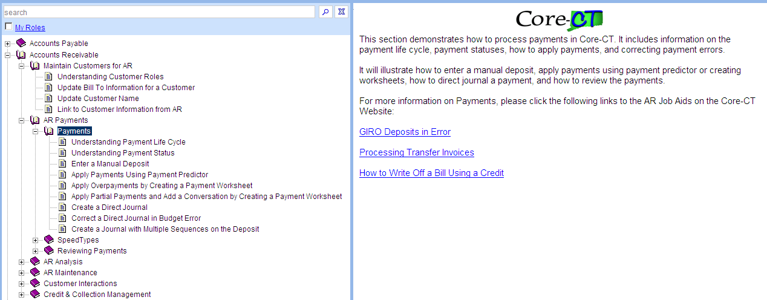

Click into the sub-topic to start an exercise. You can set the exercise to See It, Try It, Know It, Do it, or Print It modes.

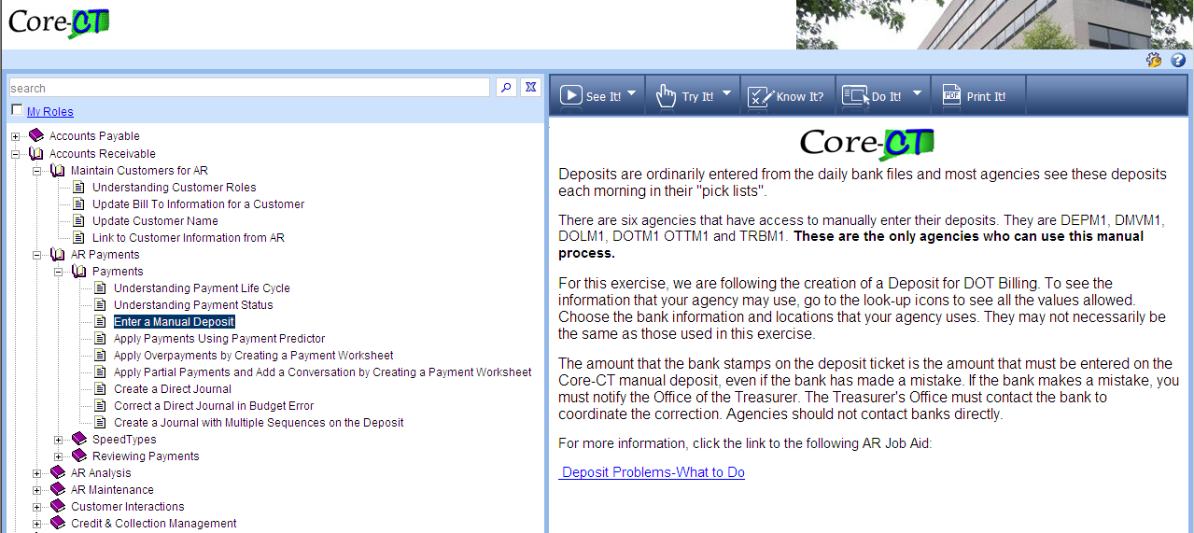

EXAMPLE: SEE IT MODE

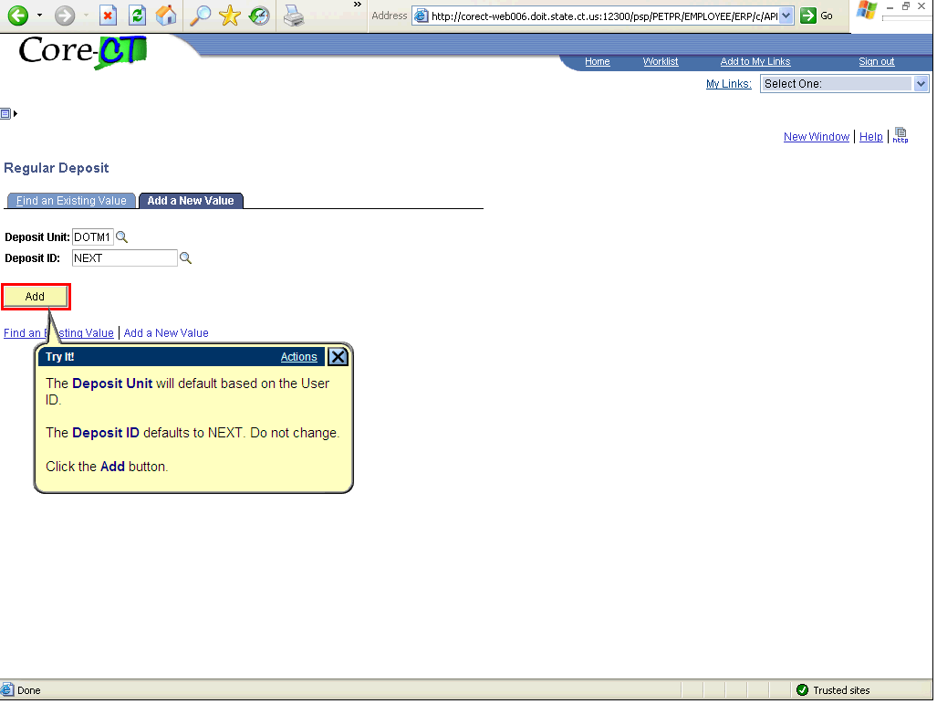

JOB AIDS:

Write-Off Policies:
Look at Job Aid- All the information is here from where to find the policies, to creating conversations, to matching on a maintenance worksheet.
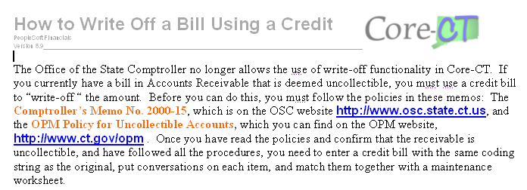

Direct Journals in Budget Error:
Look at this Job Aid- It gives all the information on how to find out if you have an error and how to correct it.

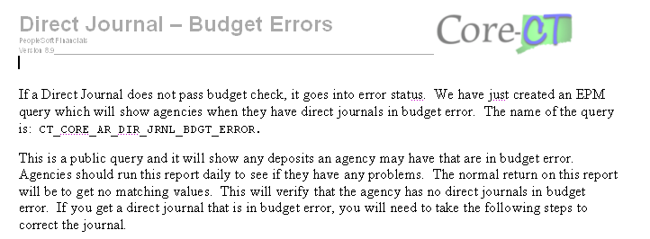

When you find a journal is in error, go to the Navigation:
Accounts Receivable>Payments>Direct Journal Payments>Modify Accounting Entries.

The Complete box is checked and the Budget Status is “Error”.
To Find out where the error is, click on the looking glass with the red x.

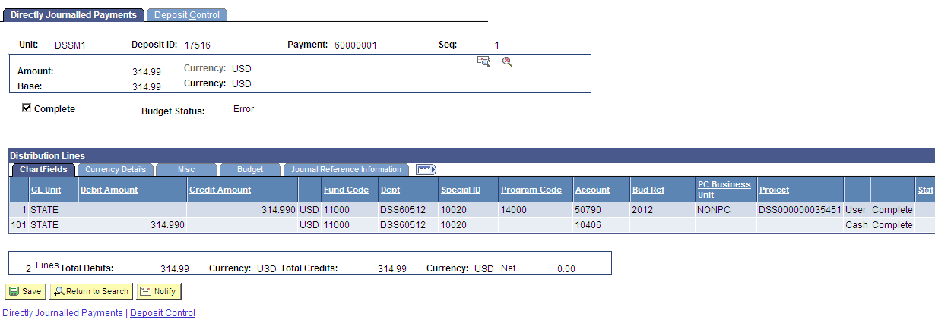
Click on the link for “Go to Transaction Exceptions”.
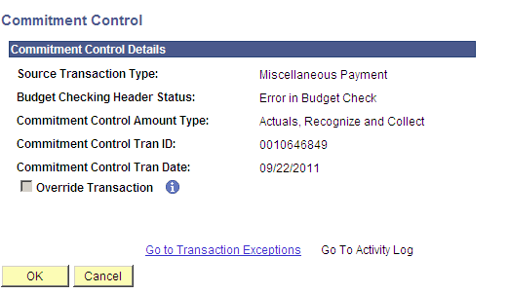

This will show you what the exception is for each line. Here, no budget exists for KK_PRJ1. Click on the Line Exceptions tab.

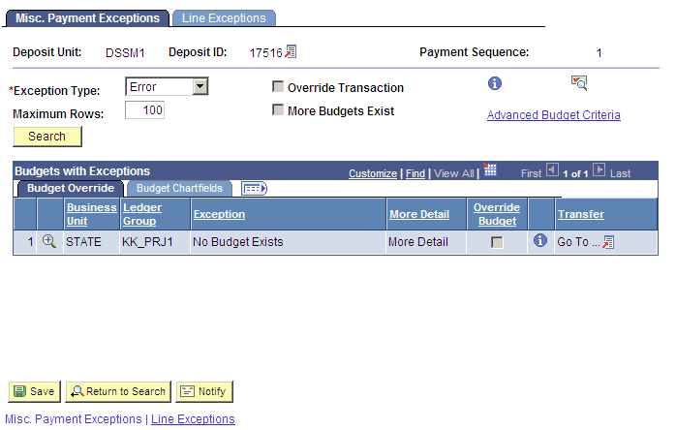
Click on the looking glass icon.
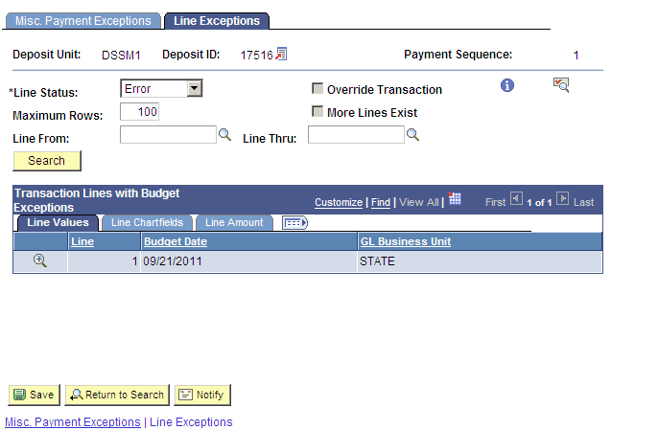

This will show you the specific line error and you know from the transaction exception that no budget exists for KK_PROJ1.

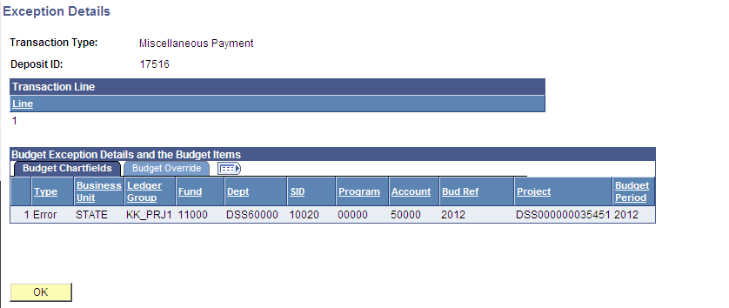

Go to your budget division to see if you are using the proper coding. In the beginning of the new fiscal year there are a lot of errors using the incorrect budget reference.

If No Budget Exists on the KK_APPROP or KK_ALLOT ledgers, you must check with Julie Wilson at OSC – 860-702-3377 to see if a budget must be entered. If any other budget, like the AGY1, AGY2 or PRJ budgets are the problem, this can be corrected at the agency level by your budget division.

Payment Predictor:

Bills must be AR Items. The date of the Customer must be less than the date of the Invoice and Deposit. There must be an exact match of the Invoice number and the Reference ID on the deposit. If the Invoice number is upper case, the Reference ID needs to be. If it is not, change it. The amounts must also be exactly the same. If the Deposit is more than the Invoice, the system will create another item called an “OA”, which will have the pending receipt accounting coding. This is a credit item and must be dealt with according the job aid, “Apply Payment to an OA Item” if it gets posted. OA’s should not be posted, they should be corrected before they get that far. Normally overpayments are directly journalled to the pending receipt coding with a second sequence to the deposit.

If the deposit is not the full amount of the invoice, the system will create a payment worksheet and leave it for the user to complete. The Payment Predictor box on the deposit will be grayed out and you cannot change the deposit. This is how you know a worksheet is pending. In this case, a payment of $2000.00 was made for a $2973.91 bill.

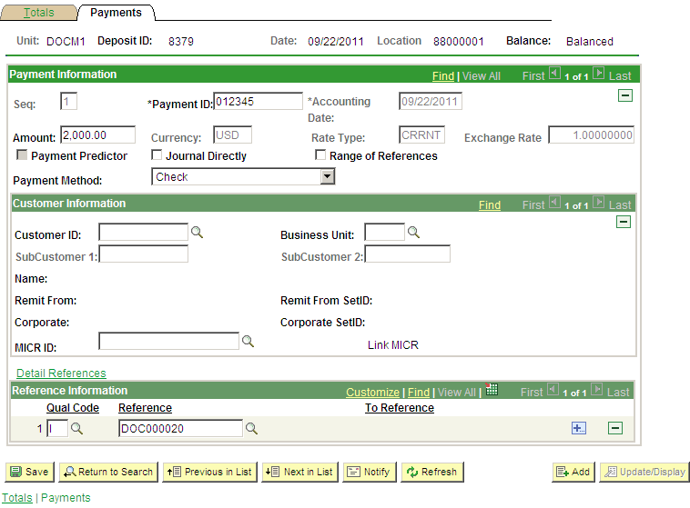

Go to the Navigation: Accounts Receivable>Payments>Apply Payments>Update Worksheet.
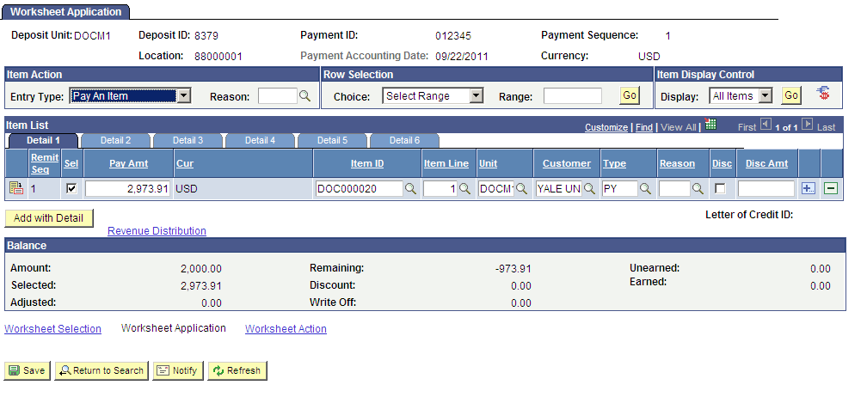

All you have to do is change the Pay Amt and click on Save. The system creates another line for the same Item ID and it stays on the Aging Report as a receivable.

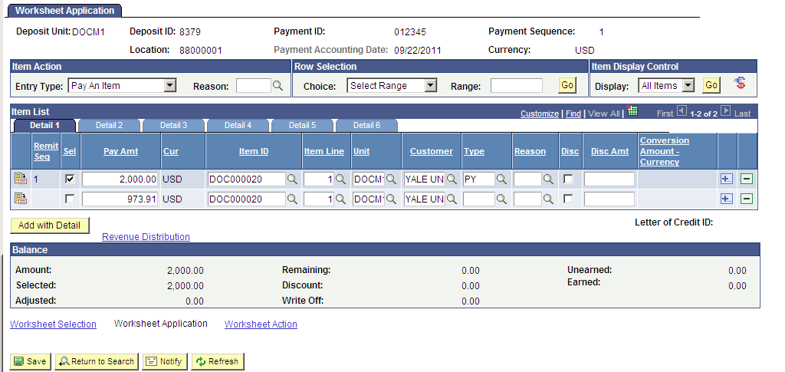

Once this is saved, click on Worksheet Action link and complete the worksheet.

This is a Payment Worksheet. It is similar to a Maintenance Worksheet, but it only involves deposits. The Pay Amt and Deposit amount must balance. You cannot apply more money than the invoice is for. If there is an overpayment there must be a sequence added to direct journal it, or create another bill to apply if there was an error on the original bill.

Creating a Direct Journal for an Overpayment:

Take the example above with a new deposit of $1000.00. The balance is $973.91. There is an overpayment of $26.09. The easiest way to handle this amount is to direct journal it to pending receipt coding and voucher it back through Accounts Payable. On the payment page, change the amount from $1000.00 to $973.91 and add the Reference Information and check off Payment Predictor. Click on the plus button under the Payment Information bar.
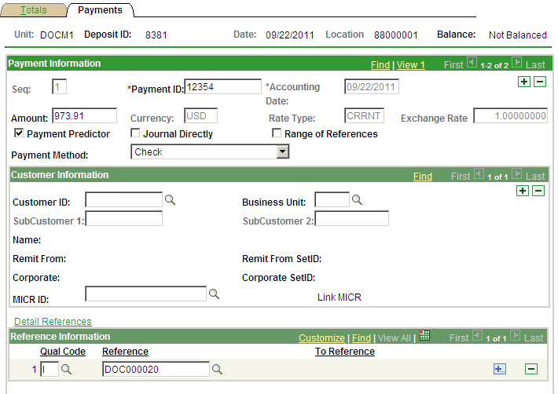

This will add a second sequence in which you will enter the remaining amount of $26.09 and check off the Journal Directly box. Change the count on the totals page then SAVE. Create your Direct Journal as you would normally, but use the pending receipt coding. Give the coding to AP so they can return the funds to the customer and code the voucher the same way the deposit was coded, to the Pending Receipt account.

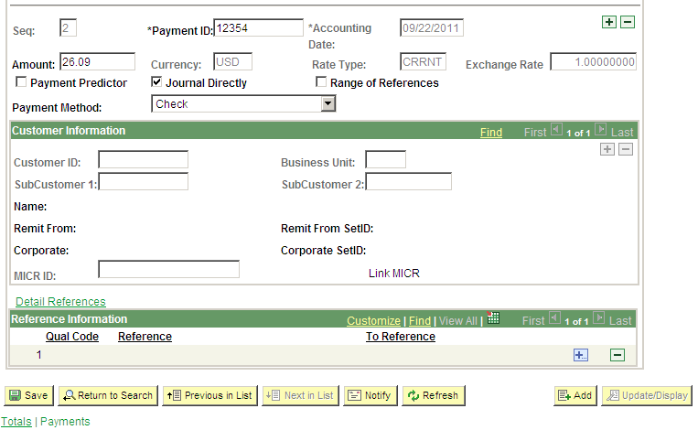

The count needs to be changed on the Totals page of the deposit also. The count needs to be the total number of sequences. This count should be 2. There should be no negatives.

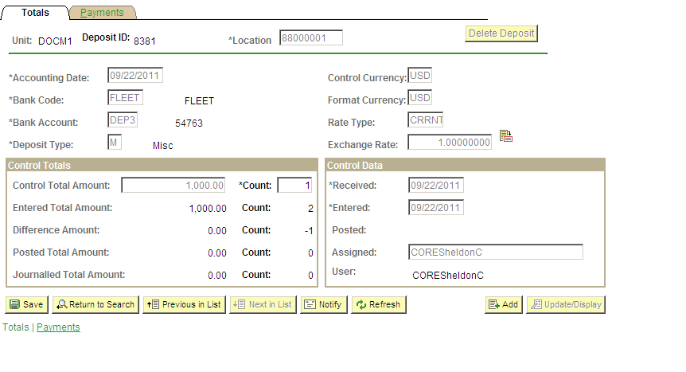

OSC does not want OA’s posted. The proper method of receiving an overpayment is to direct journal it. It is also much easier for the agency. If the deposit is an overpayment and payment predictor automatically generates a payment worksheet with an OA, you should delete the worksheet, go back to the deposit, then add a sequence for a direct journal. Do not post an OA.

If the deposit is correct, and you billed incorrectly, create a new bill for the difference with the date of the bill before the date of the deposit. Once the bill appears as an AR item, match the two bills to the deposit and you will have no remaining amount.

OSCIP DEPOSITS:
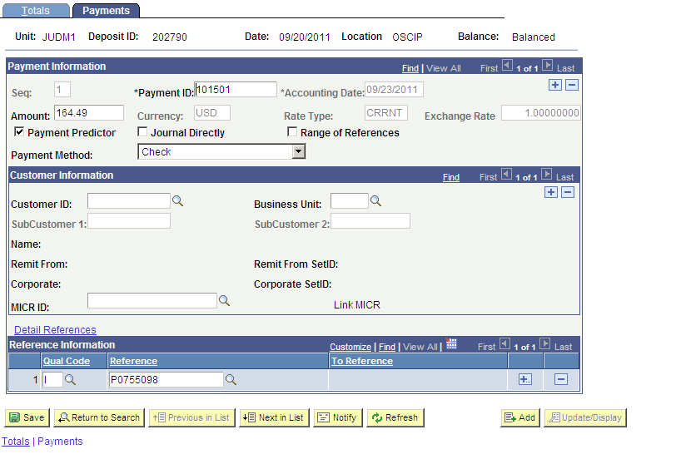

Any deposit with a location code of OSCIP comes from OSC Central Payroll. It is a reimbursement to the agency which was taken out of an employee’s paycheck. The agency should get a spreadsheet from Central Payroll identifying the employee and the coding. These deposits should ALWAYS be direct journalled. To accomplish this, the Payment Predictor box needs to be unchecked and the Reference Information line deleted. Once this is done, click SAVE, then check the Journal Directly box and SAVE again. Now a direct journal can be created.

Follow the instructions on the Comptroller’s Memorandum 2010-13 for the account coding when processing any deposits from OSCIP. This can be found on the Comptroller’s website. Call Tony Torcia, 860-702-3354, for any questions on coding issues with OSCIP.

MAINTENANCE WORKSHEETS:

Maintenance Worksheets are very similar to Payment Worksheets, but they are only used to match debit and credit bills, with no deposit money involved. If a bill has been created in error or a credit bill needs to be created to offset a bill that is deemed uncollectible, usually the billing function of “Adjust an Entire Bill” is used to create the offset. Once the bill goes through AR Update and an AR Item is created, Auto Maintenance will create a Maintenance Worksheet to be completed. The User only needs to select the items on the worksheet and add the reason codes, then save the worksheet, go to Worksheet Action, create accounting entries and set it to Batch Standard. The only time manual Maintenance Worksheets are created would be if a manual credit bill is created. The system wouldn’t know the two bills match up. You would see debit and credit bills on your aging report that need to be matched up.

Use the Aging Report as a tool to monitor your receivables. If you see debits and credits that should be matched, go to the Navigation: Accounts Receivable>Receivables Maintenance>Update Worksheet.

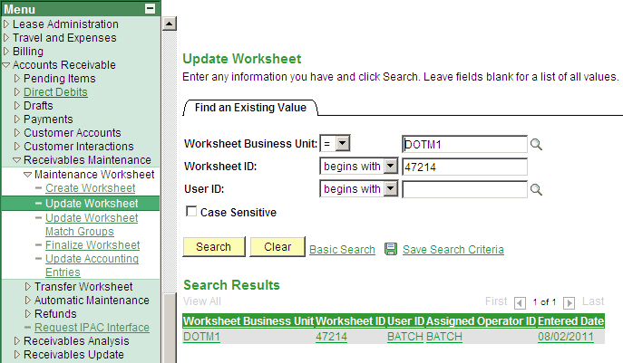

Always search here before creating a worksheet. If there is a worksheet here, it must be completed. Do not create duplicate worksheets.

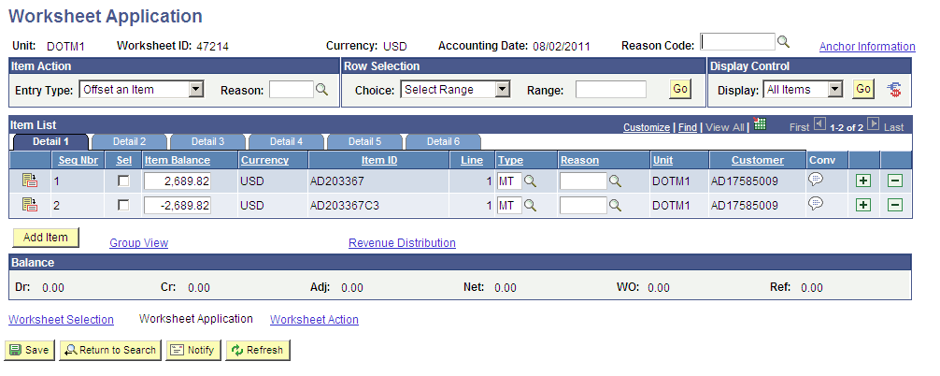

As stated before, check the select boxes, add reason codes, Save. Then go to Worksheet Action, create the accounting entries and set to Batch Standard.

