
Job Aid

Running the Active Contracts Limit Management Report

Purpose: This report is used to review the status of a customer contract in regards to what has been billed and how much is remaining on the funding limit amount. It can be used as a tool to monitor how close the contract is to the billing limit to determine appropriate action, if necessary. It will also show any contract/contract lines that are exceeding billing limits (OLTs).The steps to run this report are as follows:

- Navigate to Customer Contracts > Reports > Limit Amount.

- Click on the Add a New Value tab on the Limit Amount page and enter a Run Control ID. Example: CA_LIMIT

- Click .

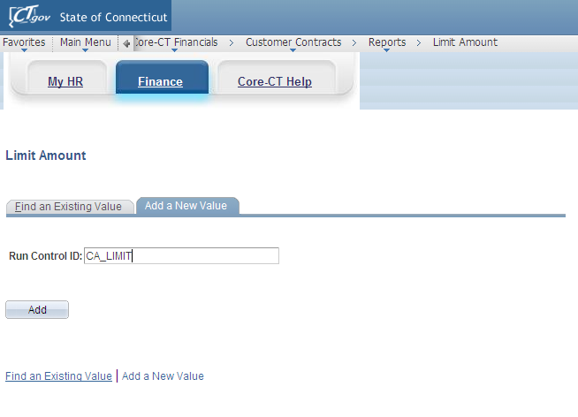
Figure 1 - This is the Add a New Value tab.
- On the Limit Report page, select or type your Business Unit. Example: DOTM1

- Leave % for any fields in the Contract Options group box that have defaulted in as % unless you want to specify the Contract Type, Sold To Customer and Contract. Example: Contract Type: FHWA-CON

- Select the Contract Classification. If you do not select a Contract Classification, the report will not display any results. Example: Contract Classification: Government

- Change the Report By field and the Max Remaining %, if necessary to narrow down the results of your inquiry. Example: *Report by: All, Max Remaining %: 100.00000000

- Click .

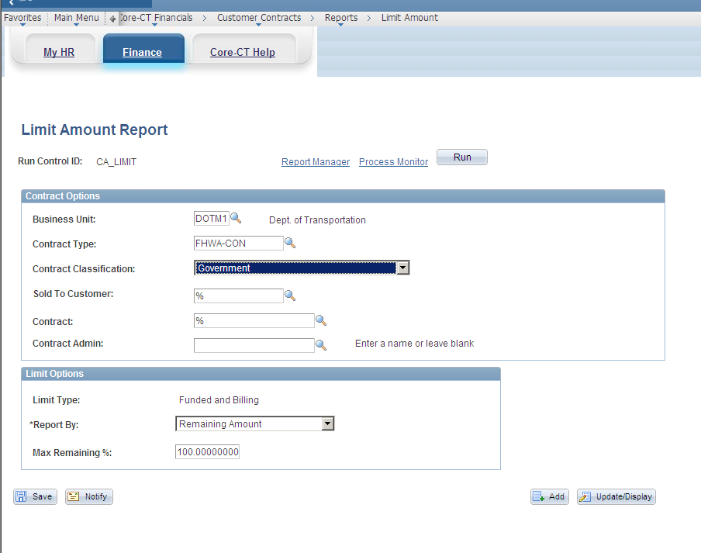
Figure 2 - This is the completed Limit Amount Report page.

- Select the CA_LMT- process to run in the Process List group box.

- Click .
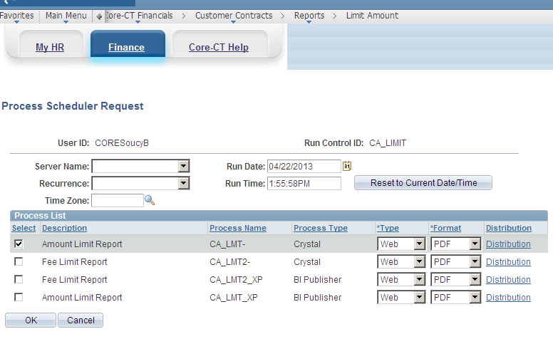
Figure 3 - This is the completed Process Scheduler Request page.

- Returning to the Limit Amount Report page, write down the Process Instance number. Example: 4623

- Click the Processor Monitor link.

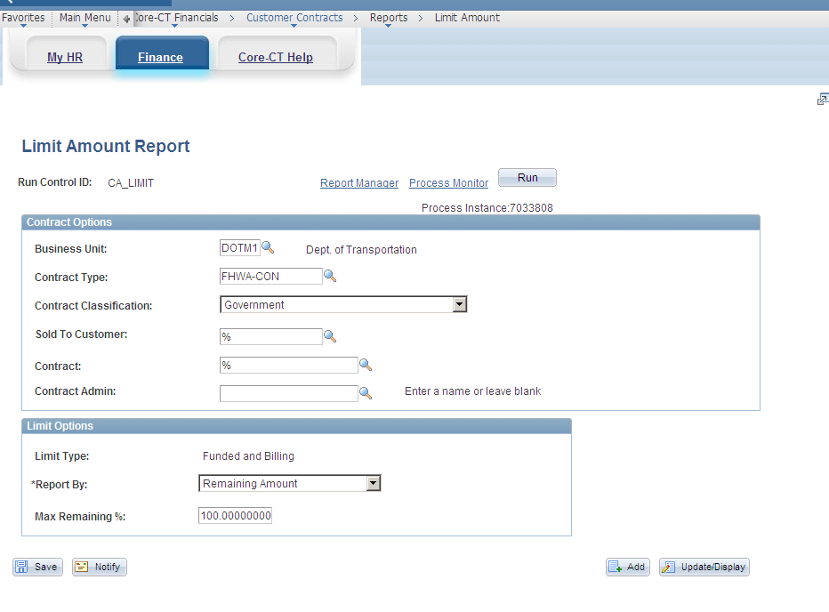
Figure 4 - This is the Limit Amount Report page with the Process Instance number displayed.

- Ensure the Run Status is “Success” and the Distribution is “Posted” for your process number. (If this does not occur, please call the Core-CT Help Desk).

- Click the Details link.

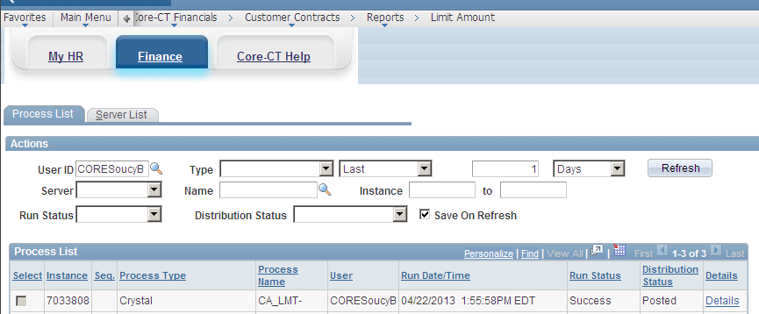
Figure 5 - This shows the Process List with the Run Status of Success with the Distribution Status Posted before clicking the Details link.

- On the Process Detail page, click the View Log/Trace link.

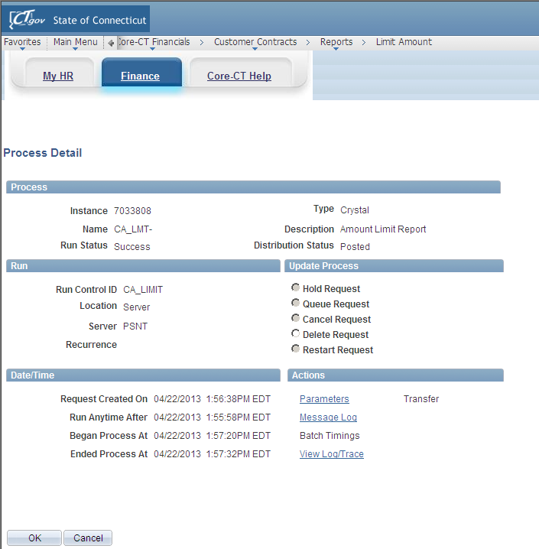
Figure 6 – This is the Process Detail page before selecting the View Log/Trace.

- Click the .PDF link on the View Log/Trace page to open the report.
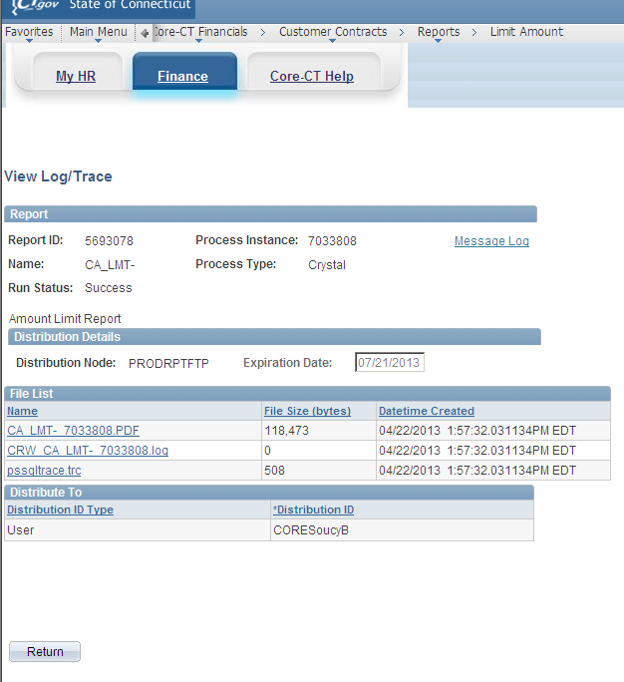
Figure 7 – This is the View Log/Trace page.
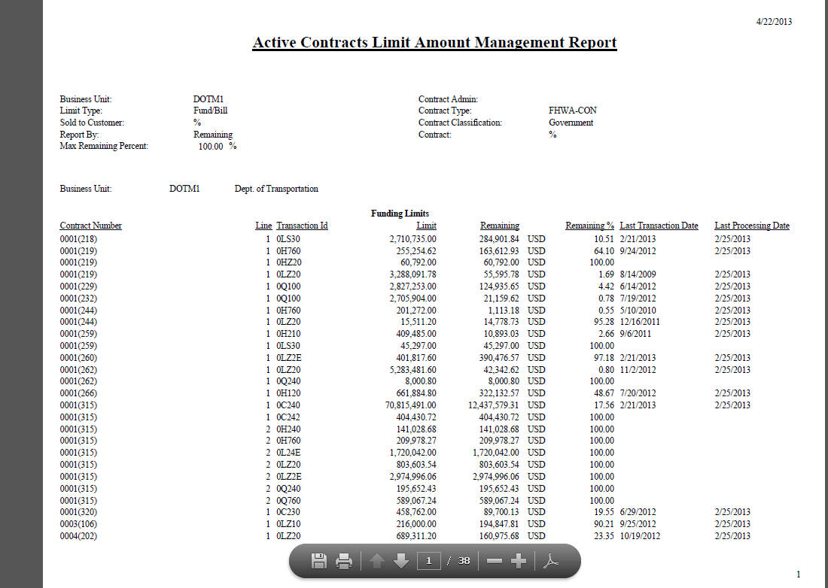
Figure 8 - This is the Active Contracts Limit Amount Management page displaying all contracts are within funding limits.

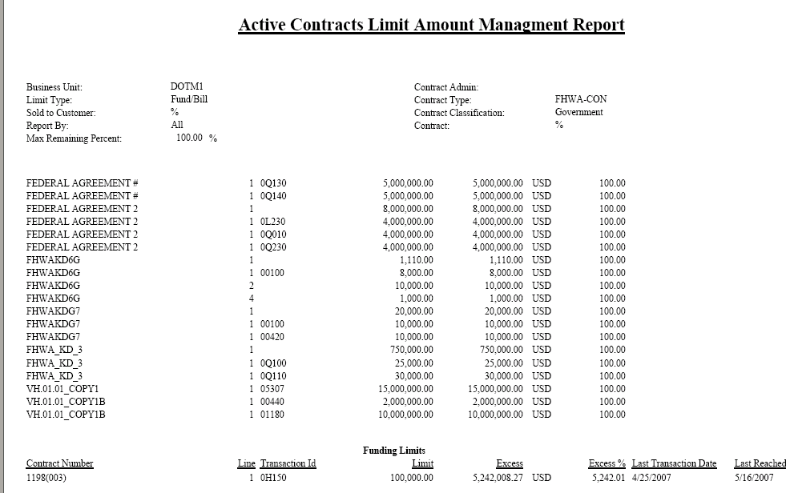
Figure 9 - This is the Active Contracts Limit Amount Management page displaying one contract in excess of funding limits.

- Above is an example of Active Contracts Limit Amount Management Report. You are looking for the status of % remaining and any excess funding limits amounts on this report. Notice that one of the contracts has an excess amount, “over the limit” (OLT). This is the sum of the excess amount.

- Queries can be used to find out the detail of the amounts that make up the sum. You can also use these queries to see which Limits are about to start producing OLTs if the Remaining amount is low or the Remaining percentage is low.

- The queries that will be available through EPM include:
- CT_CA_OLT_DETAIL_ALL_BU – Shows detail OLT information in PROJ_RESOURCE for all Business Units.

- CT_CA_OLT_DETAIL_BY_BU – Shows detail OLT information in PROJ_RESOURCE for a specific Business Unit.

- CT_CA_OLT_DETAIL_BY_CONT – Shows detail OLT information in PROJ_RESOURCE for a specific Business Unit and Contract Number.

- CT_CA_OLT_DETAIL_BY_CUST – Shows detail OLT information in PROJ_RESOURCE for a specific Business Unit and Customer ID.

- CT_CA_OLT_DETAIL_BY_TYPE – Shows detail OLT information in PROJ_RESOURCE for a specific Business Unit and Contract Type.

- Options to correct an excess amount found on the Active Contracts Limit Amount Management Report are:

- Increase the monetary limit on the contract
- Changing Participating to Nonparticipating (DOT only)
- Entering journal vouchers
- Making billing adjustments
- Changing the coding
- GL adjustments

- Once you correct the excess, you will have to wait until the Pricing process and the Limit Checking processes run again to run the Active Contracts Limit Amount Management Report again to verify that the excess is gone.

