Creating a Requisition with Multiple Distributions for all Requisition Types
*It is very important to follow these steps exactly as shown*

Navigation:
eProcurement > Requisition

Procedure:
- Enter Business Unit (if not defaulted).
- Enter Requisition Name.
- Select Requisition Type (PSA – Personal Service).
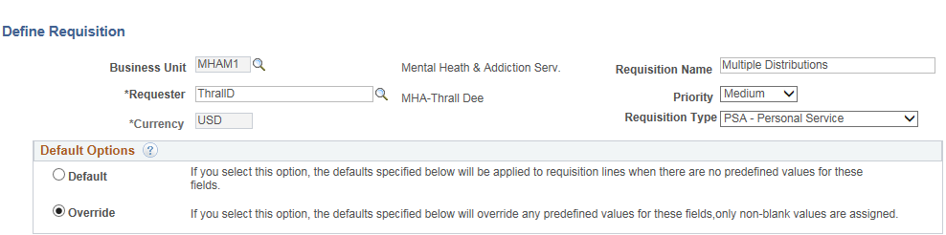
- Enter Supplier ID.
- Enter Buyer ID.
- Enter Category.
- Enter Unit of Measure.
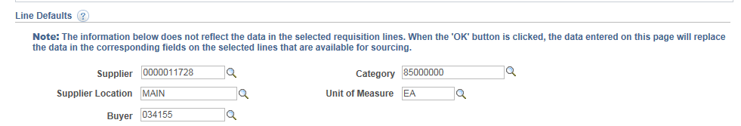
- Expand the Accounting Defaults by clicking the “Show all columns Icon” 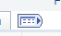
- Click on the plus sign at the end of the chartfield string to add an additional distribution line.
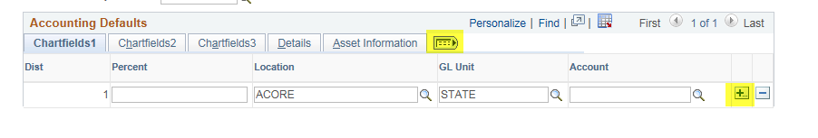
- Click OK

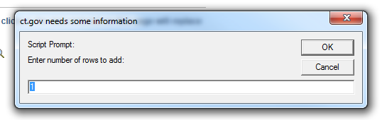
- Enter Percentages that add up to 100% and enter Chartfields (These Percentages will be re-calculated by the system later).
- Enter Chartfields Click OK.
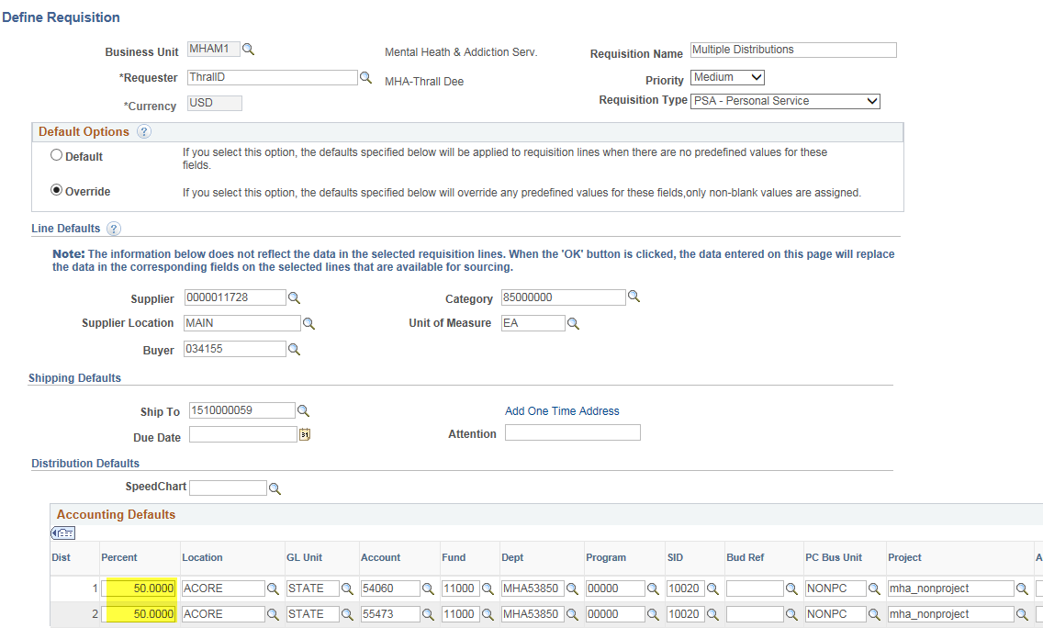

- Click on Fixed Cost Service
Note: The Category, Supplier ID, Supplier Name, and Unit of Measure fields are populated with values entered on the Define Requisition page.
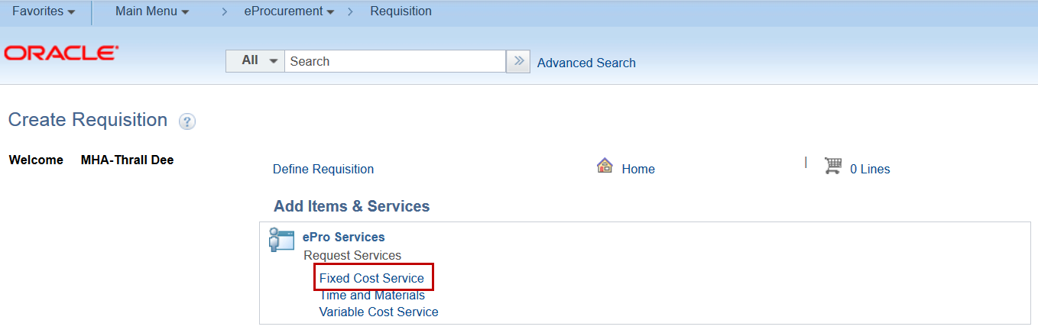
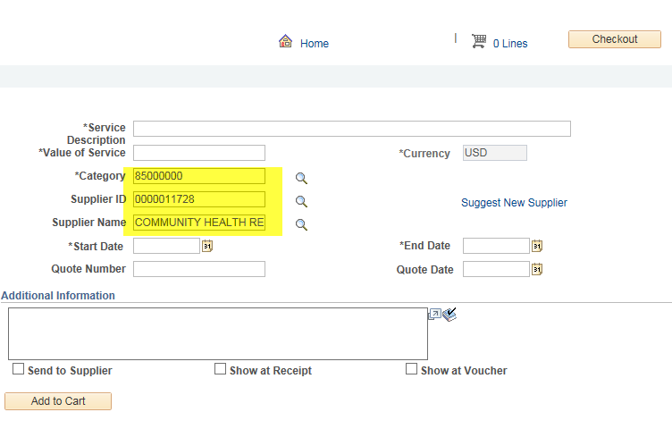
- Enter Item Description.
- Enter Value of Service.
- Enter Start Date.
- Enter End Date.
- Click Add to Cart.
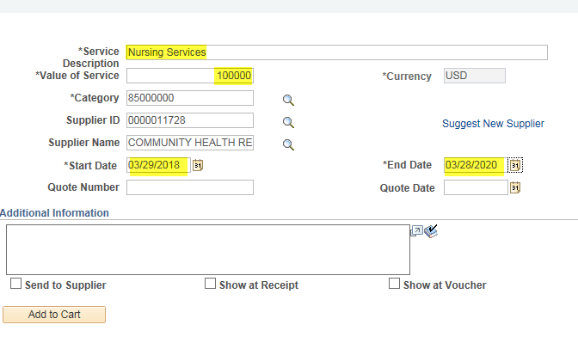
- A Message will display asking to Allocate the changed quantity base on the split distribution. Click on YES
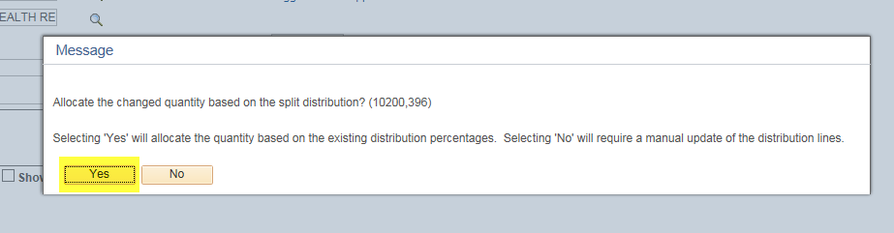
- Shopping Cart displays.
- Click Checkout.

- Note: Repeat this process to add additional services to the requisition.

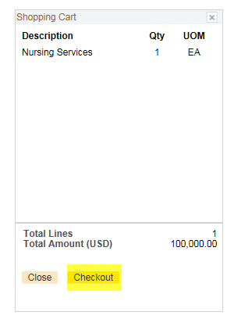
- Expand the Requisition lines by clicking on the arrow at the beginning of the line.
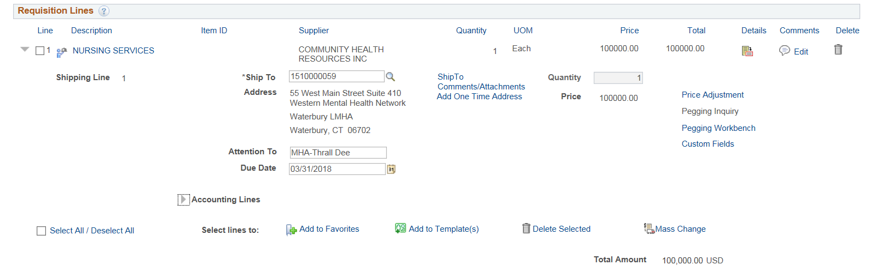
- Click on the arrow and expand the Accounting Lines
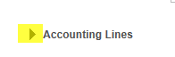

The Distribute By will default to Quantity. Change it to Amt. 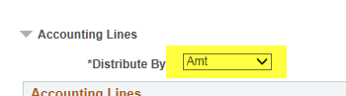

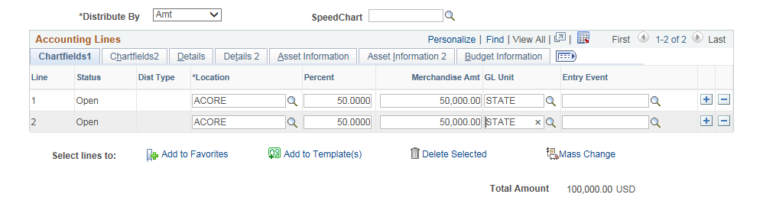
The Merchandise Amt fields will become editable. Update the Merchandise Amt on the first line to the correct amount and then use the TAB key to move out of the field. Do the same for each distribution line. (Very important to use the TAB key) The system will recalculate the Percentages when clicking the tab.
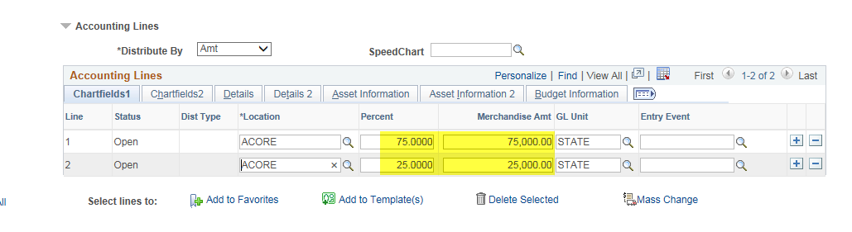

- Click on the PSA/POS Details link.
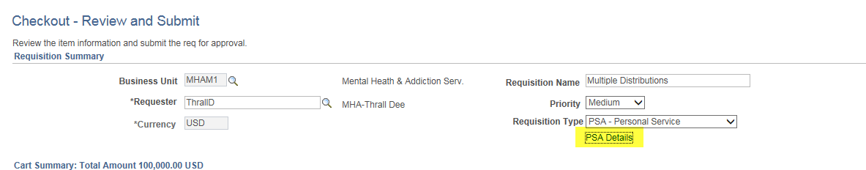

- Click on the appropriate link

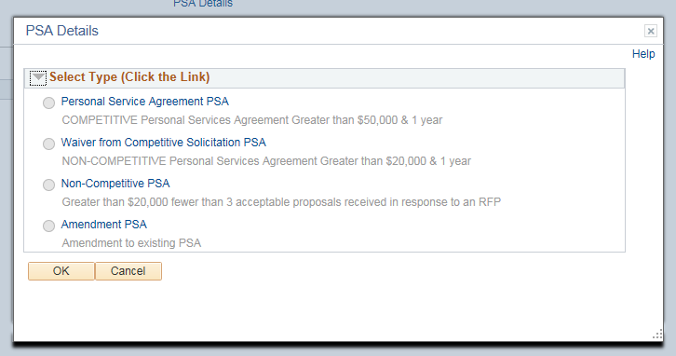

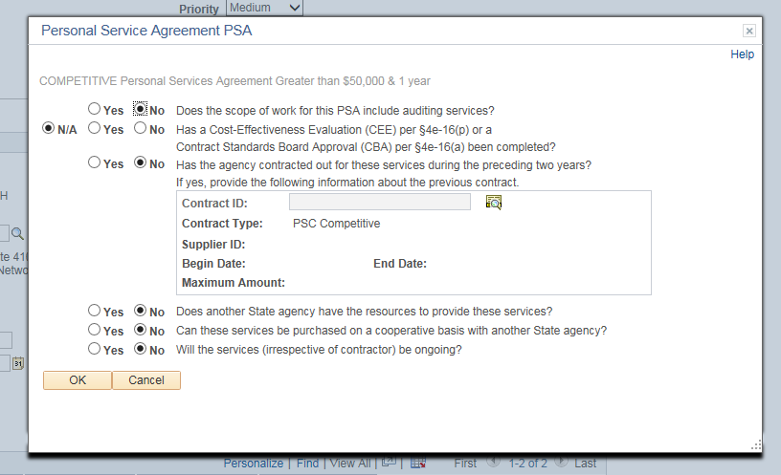
- Answer the questions. Click OK and OK
- Click on the Line Details Icon
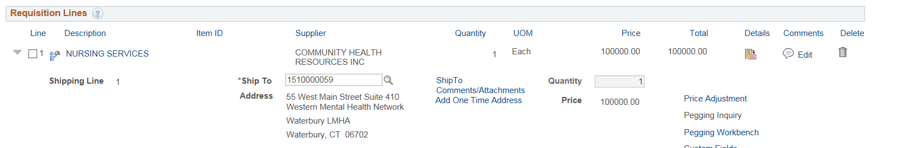

- Check the Amount Only Check Box if your Contract/PO will be an Amount Only PO
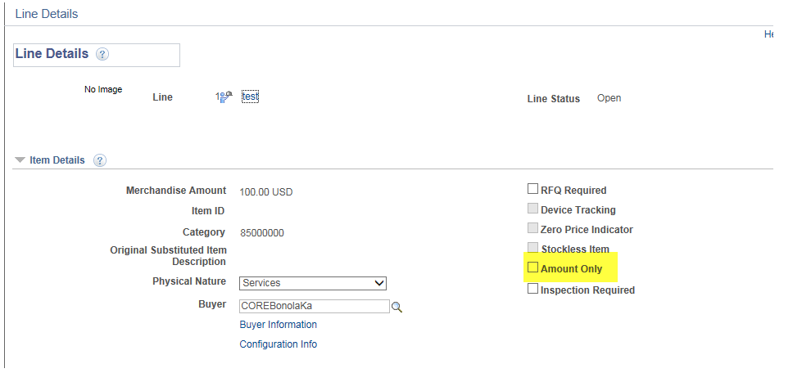

- Click OK
- Answer Yes to this message if you check the Amount Only check box.
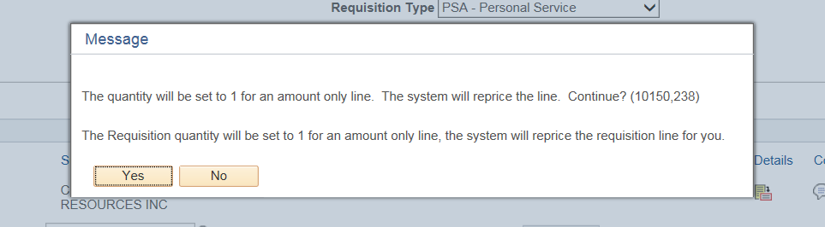

- You will then get the Allocate Message. This time answer No
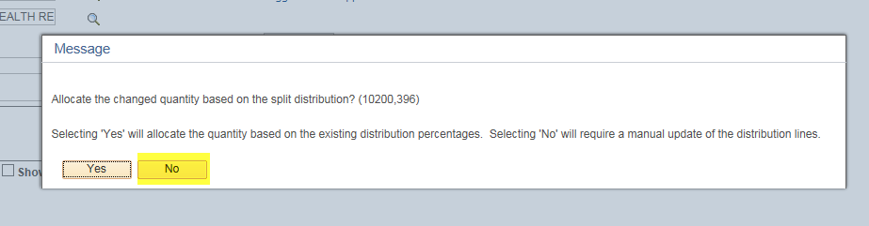
- Click on Save and Submit
- Message will be displayed. Click OK

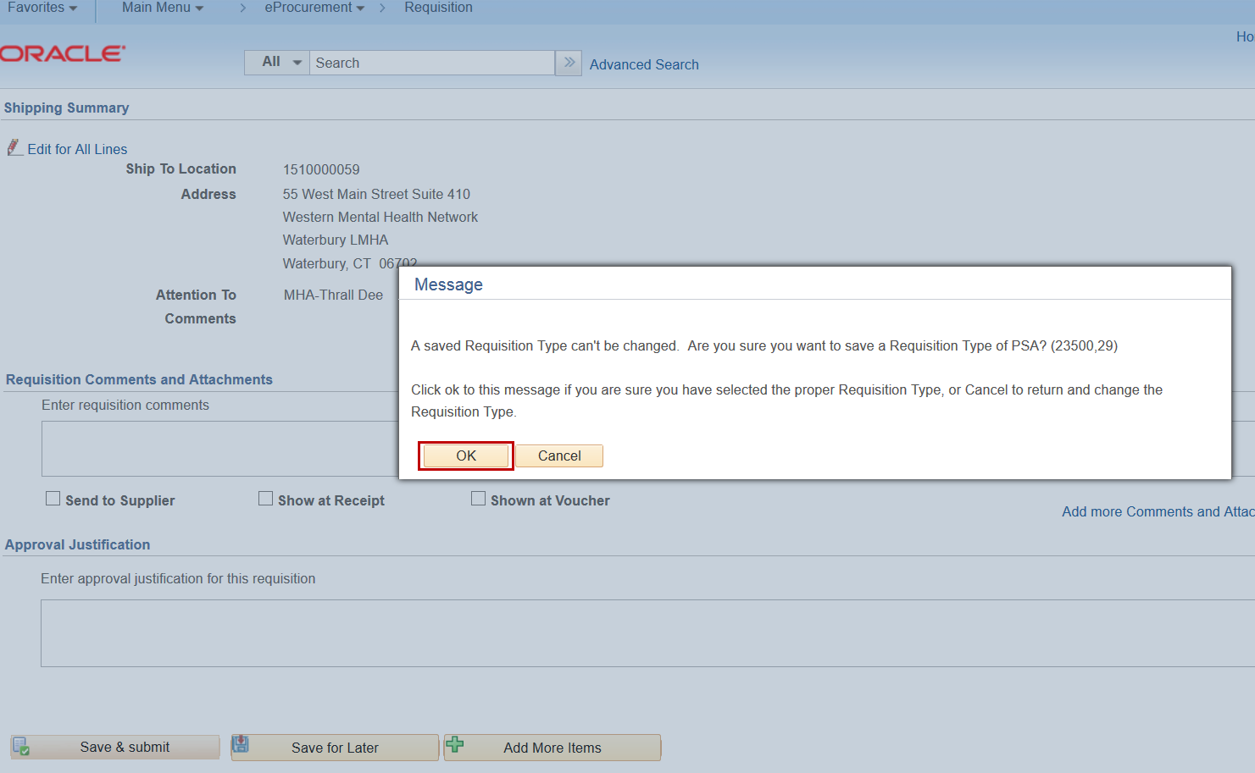

The Requisition Status will update to Pending and has been routed for Approvals.
