Scheduling Reports: PSA_POS

Navigation:
eProcurement > Reports

Procedure:
- Click on POS/PSA Approval Report link
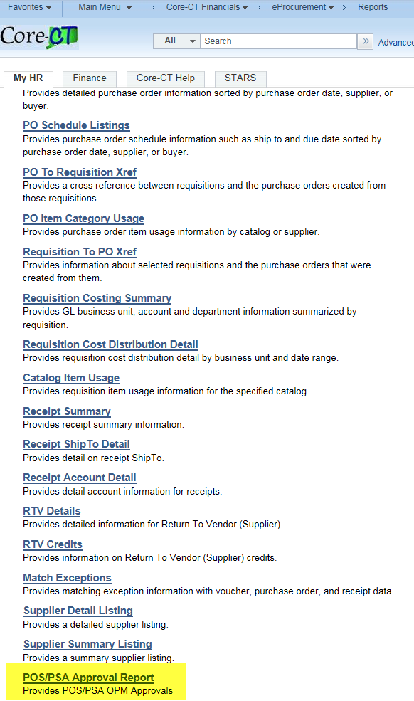

- Click on Add a New Value
- Enter a Run Control ID
- Click Add
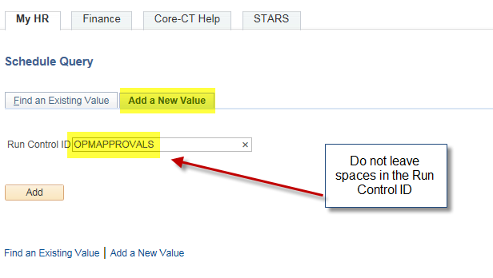

- Enter Query Name (or part of it)
- Click on Search
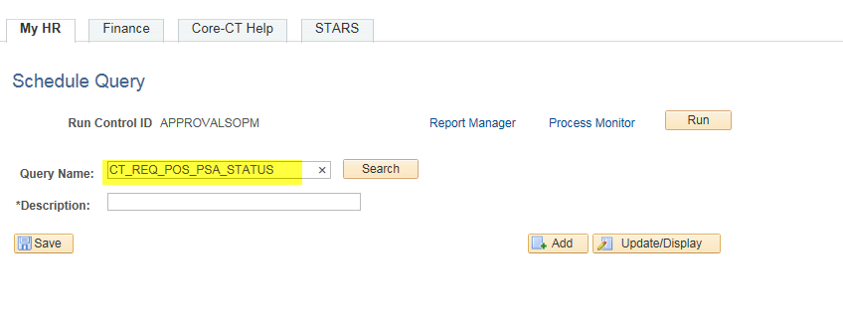

- Click on the Query Link
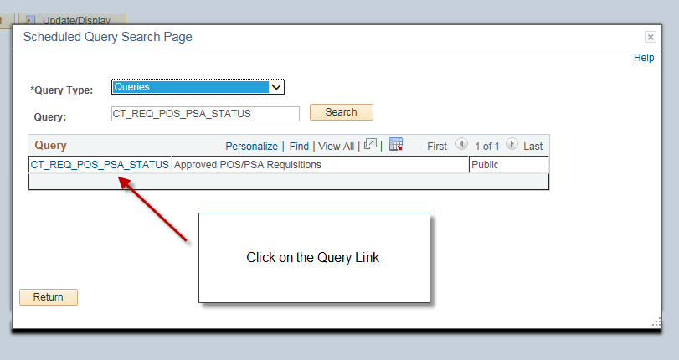

- Enter the Business Unit
- Click OK
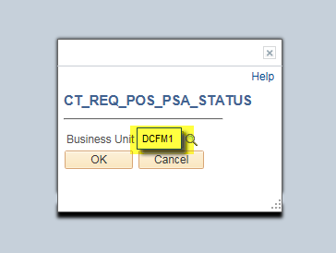

- Click RUN
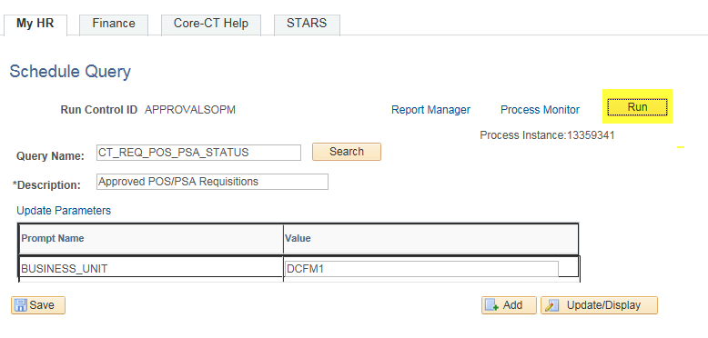
- Click the Recurrence dropdown box & choose a value.
- Then Click on the Distribution link.
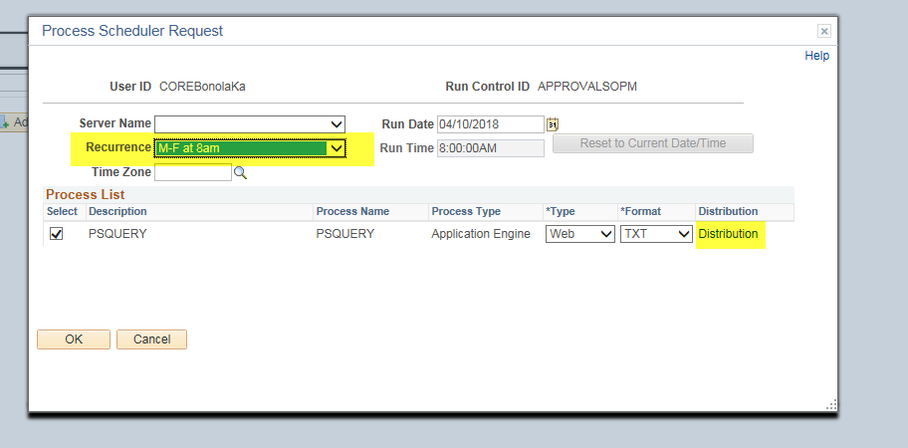

- The Distribution Detail page displays
- Check on the Email Web Report checkbox
- Add an Email Subject
- Add Message Text
- Enter Email Addresses (for multiple addresses use a semi colon ; between them)
- Enter the User and the User ID. (DO NOT DISTRIBUTE BY ROLE)
- Click OK
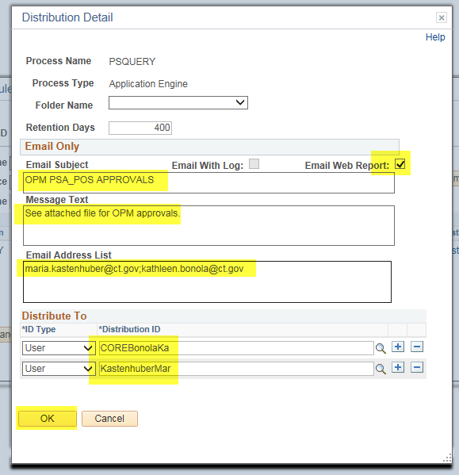

Users will receive an email with a link in it.

- Click on the link

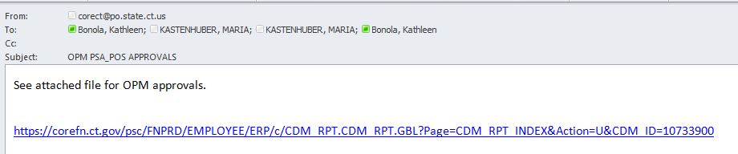

The link will have you log into Core-CT or bring you directly to the report.

- Click on the Report Name that ends in .csv

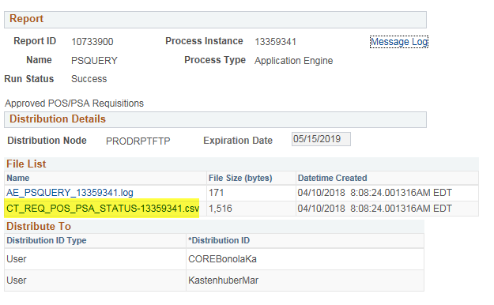

- The Report will display
