Project Costing and Customer Contracts

Overview

In Project Costing, a project is an identifier for cost collection and for monitoring progress and status for a product or service. The life span of a project can range from several months to several years. Activities are the specific tasks associated to a Project and where transactional data gets recorded and monitored.

Summary Projects () may be created to provide project grouping capabilities to present an efficient means to identify project relationships and reporting of detail projects used for tracking costs and billing purposes. The roll up and hierarchy of projects can be managed using PeopleSoft Tree functionality.

Project Costing allows the agency to analyze budget, commitments, and expenditures against a project on the PROJ_RESOURCE table. Financial staff may not have access to the EPM Payroll tables, but the related project information would be available on the PROJ_RESOURCE table. It reduces the need to review the Payroll, Purchasing, or Accounts Payable modules to look up data and includes details such as accounting dates, employee ID’s, voucher ID’s, purchase order numbers. It also:
- Establishes a link to the Customer Contracts module for automating billing transactions
- Establishes a framework for designing, planning, and building assets
- Provides high level project management reporting capability
- Phases
- Statuses
- Team Members

The State uses Customer Contracts to represent an agreement between a state agency and the customer that they are billing, which could be another State agency, a Federal agency, or a third party. This module is an integration point between Project Costing and Billing, which allows costs or labor incurred on a project to be billed through an automated process. It may also be used to claim Grant expenditure reimbursements from the Federal government. It provides a means to capture grant information and cap charges to the federal agreement budget. Configuration in the Customer Contracts module allows the agency to control what can be billed to a customer.
Manager / Supervisor Checklist

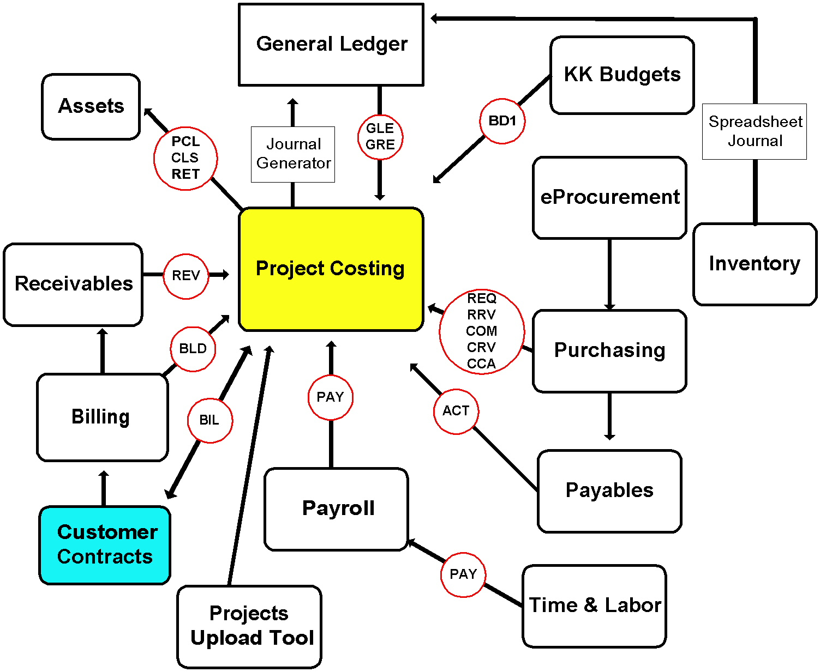
Figure 1 - This diagram demonstrates the integration between the Project Costing / Customer Contracts modules and other modules in Core-CT along with the analysis types generated by the transactions between the modules. Transactions in Core-CT, such as creating purchase orders, entering timesheets, and paying bills, are represented by Analysis Types. For example, projects accumulate expenses generated through Payables and Time and Labor, and then initiate Billing through Customer Contracts for designated expenses.

PROJECT COSTING
- New project values are created by agencies that use Project Costing
  - Projects must be associated with budgets
  - Projects must have the correct status to accumulate costs
  - Statuses are configured for and are unique to each agency
  - When agencies create a new project, they need to submit a request for HR account codes with the new project ID for use in payroll and Time and Labor. For payroll purposes, an associated Chartfield1 is required for the Activity Chartfield.
- New Project values should be created from templates which have been pre-configured for each agency.
- The project accumulates costs from the other modules. The key to integration is the coding of these transactions. They need to include Project Costing Business Unit, Project ID, and Activity ID. Depending on the configuration some agencies may also require Source Type, Category and Subcategory.
- Project Costing has three budget structures:
  - PC1 – project level budget
  - PC2 – additionally capture budget and transactions at the Fund and SID level
  - PC3 – additionally captures budget at the Activity level
- Budget journals for Project Costing are posted using the KK_PC3 ledger group. Commitment Control creates entries for the Parent budgets PC1 and PC2 from the PC3 entry. Each level can have its own Control Option. For example; Track, Track w/Budget, or Control. Please see the General Ledger / Commitment Control Manager Guide for more information.
- A project tree may be required to help with reporting of project data. The tree allows agencies to group projects that cannot be easily classified.
- A Project Upload tool is available to add data that does not get posted to the general ledger but is available in PROJ_RESOURCE for reporting (i.e. estimated budgets).
- The unique needs of each agency’s business process will determine the configuration that is used to fulfill reporting and billing requirements. Configuration includes:

 | Without Customer Contracts |  | With Customer Contracts
Activity | Required |  | Required
Analysis Groups | Required |  | Required
Analysis Types | Required |  | Required
Project Roles | Required |  | Required
Project Templates (New Projects) | Required |  | Required
Project Types | Required |  | Required
Status Type | Required |  | Required
Accounting Rules | Optional |  | Required
Rate Sets | Optional |  | Required
Activity Types | Optional |  | Optional
Categories | Optional |  | Optional
Location | Optional |  | Optional
Phase Types | Optional |  | Optional
Project Approval | Optional |  | Optional
Project Costing Trees | Optional |  | Optional
Project Events | Optional |  | Optional
Quality Types | Optional |  | Optional
Rate Plans | Optional |  | Optional
Source Types | Optional |  | Optional
Transaction Identifiers | Optional |  | Optional

CUSTOMER CONTRACTS
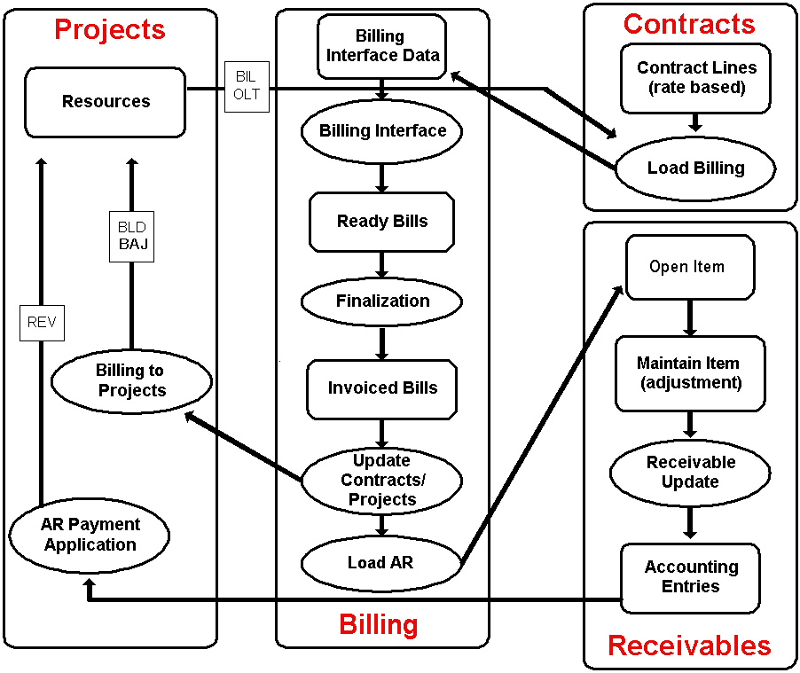
Transactions
Figure 2 - Project Costing / Billing / Customer Contract Flow - The Project Costing module works with the Customer Contracts module to generate project related customer billing. In Customer Contracts, the customer information, the rate template for marking up project costs, and the billing plan, are defined. For rate-based billing, Customer Contracts retrieves information from the Project Resource table, prices the transaction and populates the Billing interface tables with the billing information.

- Customer Contracts automate project-related billing through comprehensive configuration.
- Customer Contracts come in two classifications, Standard and Government. The classification type determines the degree of functionality available. Government classification allows for entry of awarded and funded amounts and contract start and end dates
- The agency can only attach one Project/Activity combination to one Contract at any given time.
- Rate Sets are configured and attached to Customer Contracts. Rate Sets determine how transactions will be priced before being interfaced to Billing.
- “Not to Exceed Limits” are established on each contract so an agency cannot over bill a customer. A limit amount should always be established on a Customer Contract (it should never be zero). Rows that exceed the limit are tagged as OLT (Over Limit) rows. Queries exist to help agencies manage these rows.
- Some options to correct OLT (excess amounts) are found in the EPM queries or the Active Contracts Limit Amount Management Report (Contract Limit Report – see below) are:
  - Increase the monetary limit on the contract
  - Create a journal voucher
  - Create a billing adjustment
  - Change the coding of the source transaction (via Spreadsheet or Online Journal)
  - GL adjustments

Catalog of Online Financial Reports
Click on the links (report titles, underlined and in blue) in the table below to learn, step by step, how to run the reports described. Note that two of these reports are under construction.

Report Number | Report Name
ctpcr103 | Project Data by Analysis Group(s) Report  http://www.core-ct.state.ct.us/reports/docs/ctpcr103.doc  Project Data by Analysis Group(s) Report is a flexible report which will allow the user to run and report on project financial data in several different ways such as life to date, year to date, range of period, or by a selected period.  Shows project costing data for specified periods, Analysis Groups, Chartfields, Project IDs and Project Trees for a specific Business Unit.
ctpcr106 | Project Payroll Costs Report  http://www.core-ct.state.ct.us/reports/docs/ctpcr106.doc  This report is used to list payroll cost details for a project.  This report will allow the user to enter criteria such as Project Business Unit, Project ID’s, and date range.  The report will be subtotaled and sorted either by activity or department, dependent upon the user’s selection on the run control.
ctpcr12861 | PC and GL Reconciliation Report  http://www.core-ct.state.ct.us/reports/docs/ctpcr12861.doc  This report will show any discrepancies between Project Costing and General Ledger expenses. This report will summarize the Project Data by Fiscal Year, Accounting Period, PC Business Unit and Project ID with a balance not equal to zero. If there are no differences then Projects Costing and GL are reconciled on a year to date basis through the last closed accounting period. If there is a Project ID with a balance the agency user must investigate, reconcile and fix the discrepancy if necessary.  To facilitate the reconciliation, two new queries were written to provide detail transaction information for a Project ID.  - CT_PC_TO_GL_PROJ_RES – Provides user with transaction detail from the PROJ_RESOURCE table. This query should be used in conjunction with the CT_PC_TO_GL_LEDGER query to compare results and to isolate differences in the PC to GL Reconciliation Report.  - CT_PC_TO_GL_LEDGER - Provides user with transaction detail from the JRNL_LN table. This query should be used in conjunction with the CT_PC_TO_GL_PROJ_RES query to compare results and to isolate differences in the PC to GL Reconciliation Report.  It may be necessary to run this report at the end of July using the period of '999' since the OSC frequently makes year end adjustments even after GL has been closed.
ctpcr12862 | PC and KK Reconciliation Report  http://www.core-ct.state.ct.us/reports/docs/ctpcr12862.doc  This report will show any discrepancies between the Project Costing and the Commitment Control budget ledgers. If there is a project ID with balance the agency user must investigate, reconcile, and fix the discrepancy if necessary.
ctpcr5884 | Project Status Report  http://www.core-ct.state.ct.us/reports/docs/ctpcr5884.doc  This report provides high level project status information. The report provides Project attributes, including project status, project manager, project location, project start and end dates, percent complete, project notes, and financial data based on parameter selections made by the user.
ca_lmt | Contract Limit Report  http://www.core-ct.state.ct.us/reports/docs/ca_lmt.doc  This report is used to review the remaining balances on customer contracts. The report example (last page) is sorted by Contract Number, Line, and Transaction ID, and shows the contract limit, remaining balance, remaining percentage, last transaction date, and last processing date.  Please Note: This report is for use with the Customer Contracts Module and is not related to vendor contracts.
cte14880 | Project Financial Management Report  http://www.core-ct.state.ct.us/reports/docs/cte14880.doc  This report is used by Project Costing agencies to provide a summary of historical & current expenditures together with cumulative budget and available balance. This report provides results for one or multiple specified projects.
cte 14890 | Project Billable Summary  http://www.core-ct.state.ct.us/reports/docs/cte14890.doc  This report is used by Project Costing Agencies to provide a snapshot of Project(s) amount(s) that are billable through the Customer Contracts and Billing modules, typically to the federal government.
cte14935 | Project Approval Statistics (DOT USE ONLY)  http://www.core-ct.state.ct.us/reports/docs/ctf14935.doc  This report is for DOT use only. The report displays project approval summary data including number of projects approved in selected date range, minimum days for approval, maximum days for approval and average days for approval. This report also provides detail data by project including project ID, project description, date event created, date event approved and number of days between creation and approval.
cte15473 | Project Forecast Report  http://www.core-ct.state.ct.us/reports/docs/cte15473.doc  The Project Forecast report is intended to serve as a high level estimate and analytical report providing the user an opportunity to see the current funding levels based on the previous 12 month spending pattern. The report provides an average of payroll and/or non payroll related expenses that were incurred during a rolling 12 month period, retroactive 365 days from the date the report is run. This information is meant to function as an “early warning” for funding requests between the agency and the funding source for the project, usually the federal government.
ctpcrest | Project Estimate Mod Approval (DOT USE ONLY)  http://www.core-ct.state.ct.us/reports/docs/ctpcrest.doc  This report is for DOT use only. This report is used by the Department of Transportation to review and to obtain required signed approval(s) of project estimate revisions. This report provides project attributes, including project manager, project location, estimates by activity, fund and SID for the current estimates, regardless of the pending event and for the most recent prior approval of specific events, based on parameter selections made by the user.
cte14886 | Project Incremental Cost (DOT USE ONLY)  http://www.core-ct.state.ct.us/reports/docs/cte14886.doc  This report is for DOT use only. The report is used by DOT to meet its legislative mandate to report Special Tax Obligation Bonds set forth in P.A. 05-4, Section 18. This report is an annual requirement, due on or before February 1, in which DOT is expected to provide information on any Project Incremental Cost (cost overrun) in all transportation projects financed with Special Tax Obligation Bonds in the five years preceding the date of the report. The user has unique flexibility to select chartfield combinations and to further specify whether they would like the report based on tree nodes or detail values for selected chartfield(s). Report can be run at a summary or detail level. The report is sorted and subtotaled by project ID. The report is a management tool to monitor projects for all projects funding, regardless of the source.
cte14887 | Project and Contract (PCCA) Summary  http://www.core-ct.state.ct.us/reports/docs/cte14887.doc  The report provides high level project and contract information. This Report will compare Projects between two selected dates. The Project will be categorized as Federal Funded Projects, State Funded Projects and Other Funded Projects. This report will also give Contract summary as of the day this report is run. Contracts will be categorized as Federal Participation and State/Other Participation.
CTE17668 | Contract Reconciliation Report  http://www.core-ct.state.ct.us/reports/docs/CTE17668  This report has been designed for agencies using Projects and Contracts module. This report will integrate with either the Federal Fiscal Management Information System (FMIS) or an external worksheet provided the external source is configured to be uploaded into the CORE specific input template. This report will be used to reconcile differences proactively between CORE data and the FMIS system and/or external source.
CTE18472 | Final Voucher Report (DOT USE ONLY)  http://www.core-ct.state.ct.us/reports/docs/CTE18742  This Report has been designed for Department of Transportation (DOT) to assist in Final Voucher processing and provide all necessary details about the project transactions for audit purpose. At the end of the Project Life Cycle, DOT has to submit a Final Voucher to the FHWA in order to close the Project and the related Contract. This report will produce the PA worksheet and Final Voucher report along with details of each expenditure transactions. This is not the final report to be submitted to FHWA. This report will form the basis of information needed to prepare the final voucher which will be submitted to FHWA.
CR17296 | Project Transactional Report  http://www.core-ct.state.ct.us/reports/docs/CR17296  This report is used by Project Costing agencies to review Budget, Expense, Payroll, Purchase Orders, and Pre-Encumbrance information pertaining to a single project. The User has the option of selecting all, or some, of these sections to report on. Each section offers a number of configured options that the information can be totaled by. The User must specify Project Id (required), Fund (optional), SID (optional), and a date range (required).  Note: The Budget section ignores the date range and always returns life-to-date information

Frequently Used Links
Adding and Maintaining Projects to Trees
See the UPK
Create a Project Template
See the UPK
List of Projects Reports and Queries
http://www.core-ct.state.ct.us/financials/projects/doc/prj_cstng_rprts.doc
Project Transaction Upload Instructions
http://www.core-ct.state.ct.us/financials/pc/prj_trnsctn_upld/Default.htm
List of Customer Contracts Queries
http://www.core-ct.state.ct.us/financials/cc/doc/lst_cst_cntrcts_qrs.doc

See the UPK for other procedures.

The Complete List of Manager Guides
http://www.core-ct.state.ct.us/financials/mgr/Default.htm

Accounts Payable
Accounts Receivable
Asset Management
Billing
Enterprise Performance Management (EPM)
General Ledger / Commitment Control
Help Desk
Inventory
Project Costing / Customer Contracts
Supply Chain

