# Budget Workbook for Suppliers Job Aid

The process flow below outlines the steps which need to be completed in order for Budget Definition to become a Contract Budget. *Provider Entity is not specifically tied to the Budget Workbook, the Supplier completes this when they have access to the Suuplier Portal. Once the Budget Definition has been completed by the Agency, the Supplier will complete the following:

# Provider Entity Information Entry

Supplier

Agency

The following shows how to enter Provider Entity Information.

**Navigation:** Supplier Contracts > Budgeting > Provider Entity Information

The Entity Provider Information page will display. On the Add a New Value page enter the **Supplier ID**, and click **Add.**

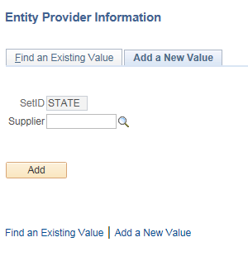

Enter **DUNS#, Provider Fiscal Year End, SAM (CAGE) No., SAM (CAGE) No. Expiration**

Answer Yes or No for the **80 percent** field

Answer Yes or No for the **$25,000,000** field

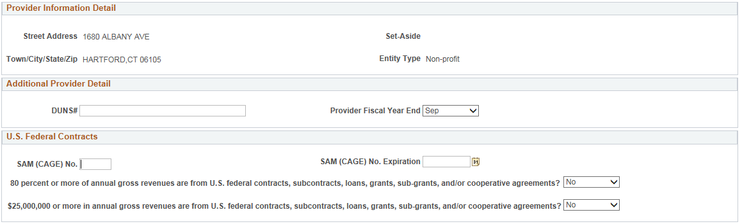

Answer Yes or No for the **Litigation Pending** field and fill in the comment field

Enter **Accreditation List**

Click **Save**

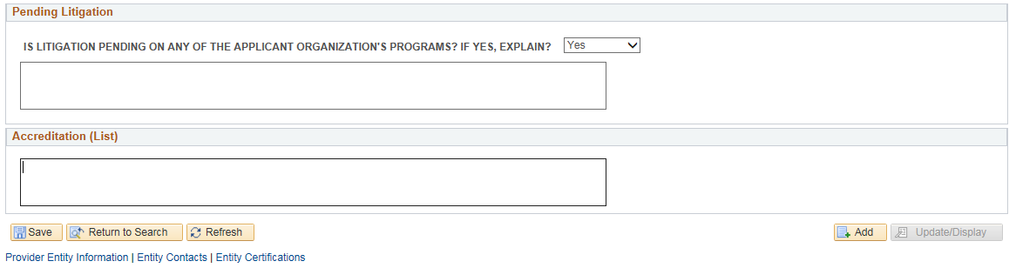

Click on the **Entity Contacts** tab

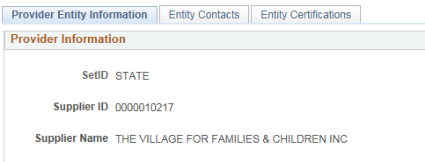

Click **Supplier Change Request** link

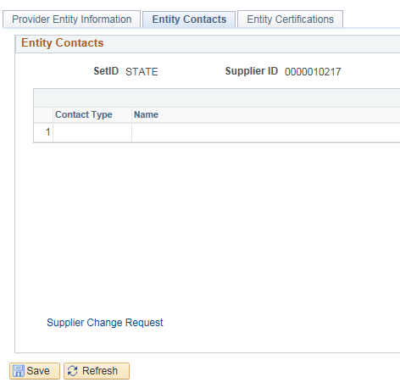

Click **Next** until the Orange Box is on the **Contacts** page

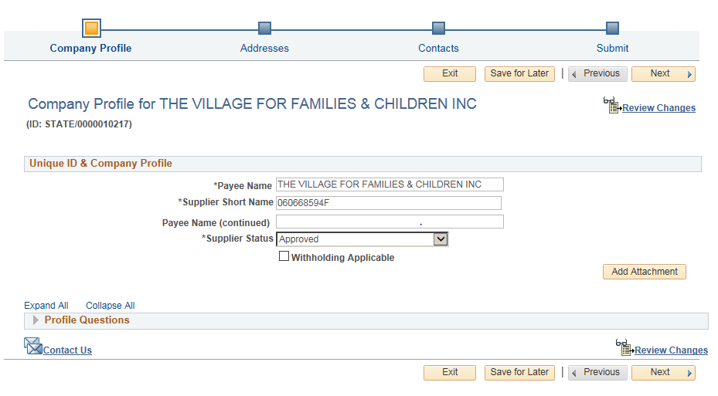

Click **Add New Contact**

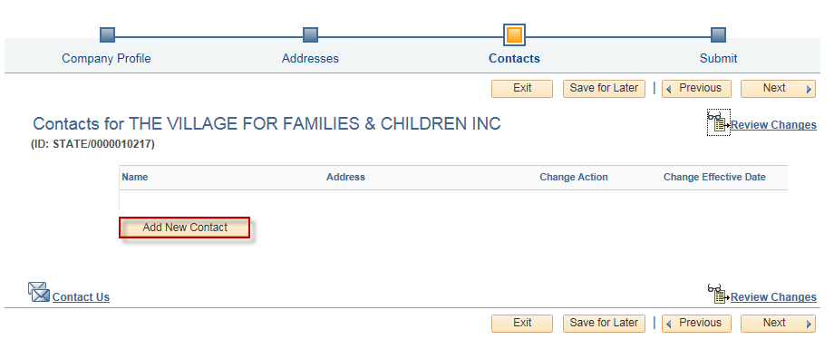

Enter **First Name, Last Name, Email Address, Contact Type,** and **Phone Type**

Click **OK**

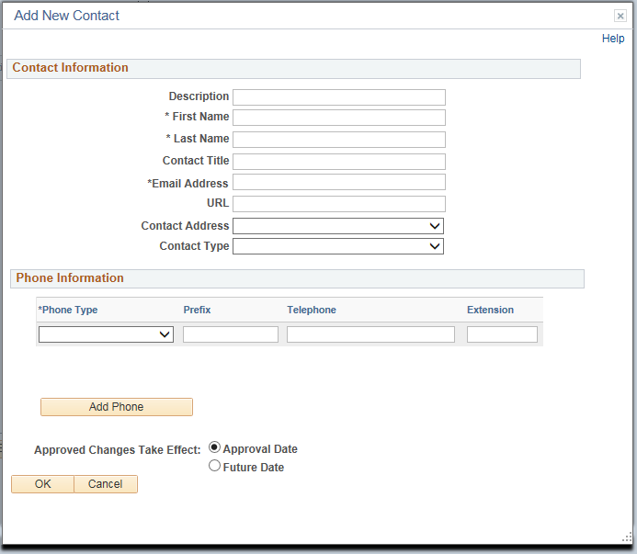

Click **Save for Later**

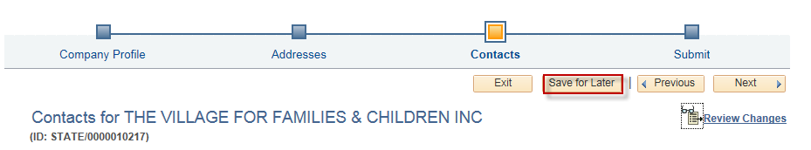

Enter your email address

Click **OK**

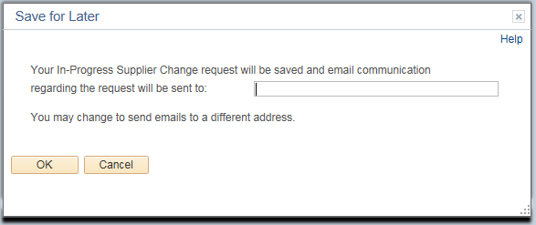

The following page should display saying the change request has been saved. Return to the **Provider Entity Information** tab in the internet browser.

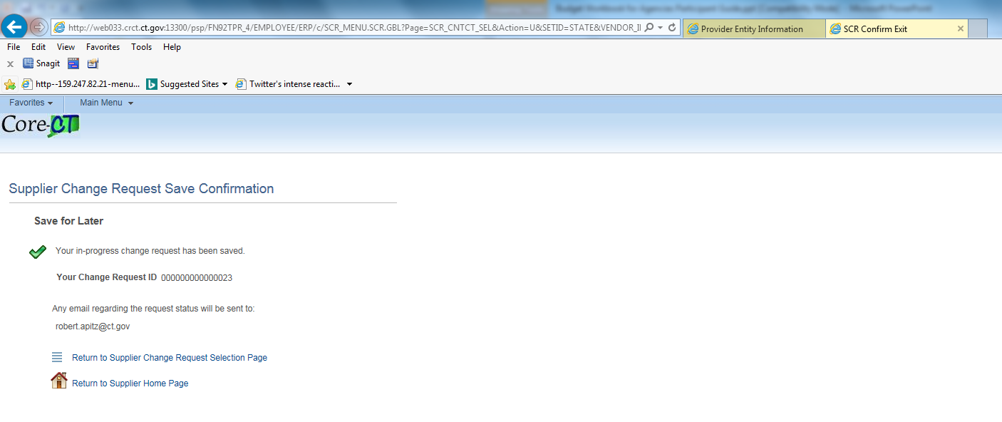

Click on the **Entity Certifications** tab

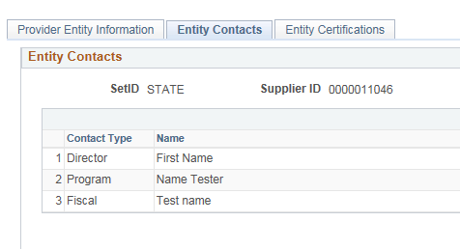

Select **Certification Type, ID Number, Expiration Date**

Click **Add Attachment**

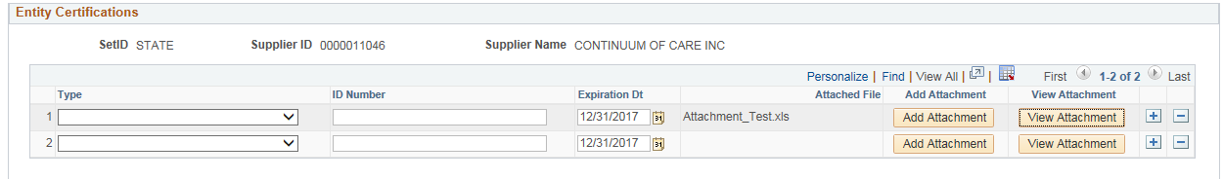

Click **Browse** and select the file that is to be uploaded

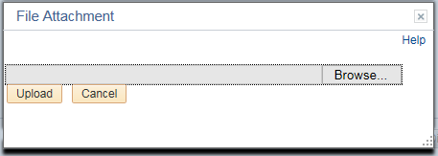

Click **Upload**

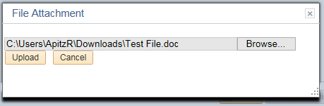

Click **View Attachment**

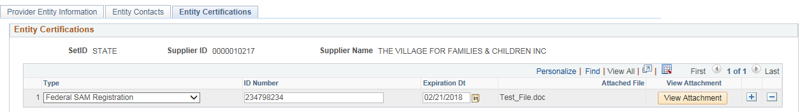

At the bottom of the screen, click **Open** and confirm the attachment has been uploaded correctly



Click **Save**

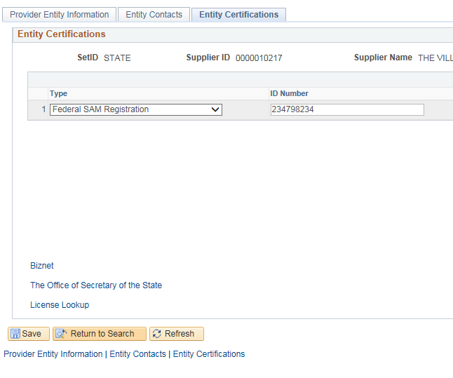

Supplier

Agency

# Provider Program Information Entry

The following shows how to enter Provider Program Information.

**Navigation:** Supplier Contracts > Budgeting > Provider Program Information

The Provider Program Information page will display. On the Add a New Value page enter the **Contract ID** and **Funding Period**, and click **Add.**

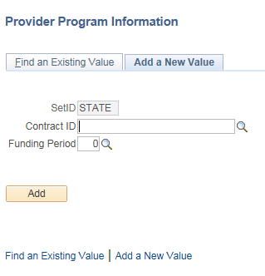

Select the **Contract ID** from the search results

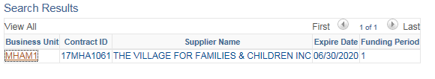

Select Yes or No for the **Statewide** field

If No was selected, enter one of the **Catchment Areas,** **City/Town,** or **Region** fields

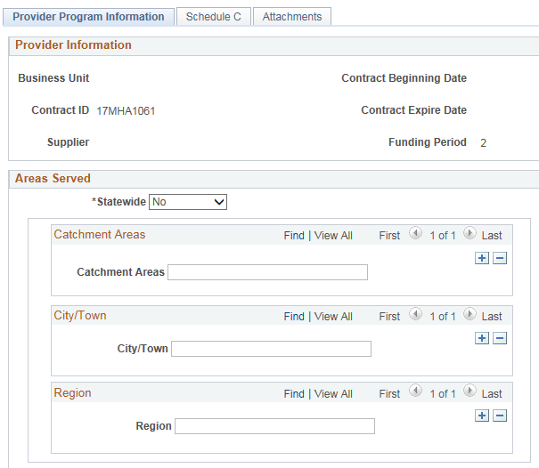

Look up **Program Code**

Enter **Service Address**

Select **Contact Type**

Enter **Name, Telephone, Email ID,** and **Days & Hrs of Operation**

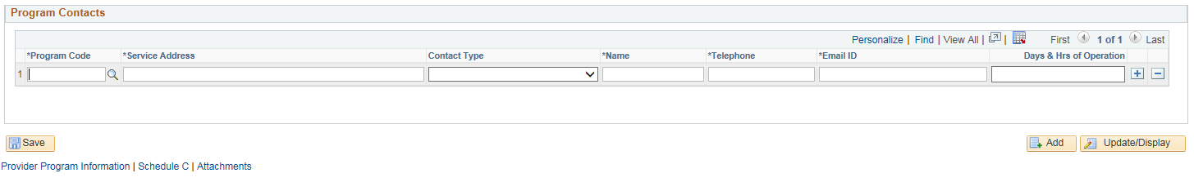

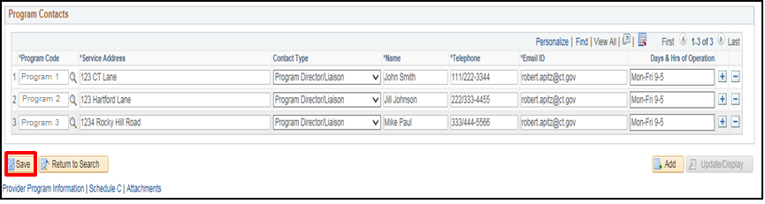

Click **Save**

Click on the **Schedule C** tab

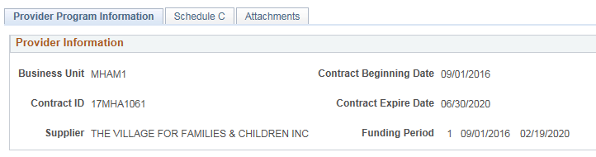

Select Yes or No to the question the Schedule C Related Parties section

Enter **Name of Related Party, Address, Description of Goods/Services Provided, Identify Costs Claimed in Report, Costs Included in this Report,** and **Actual Cost Related to Party**

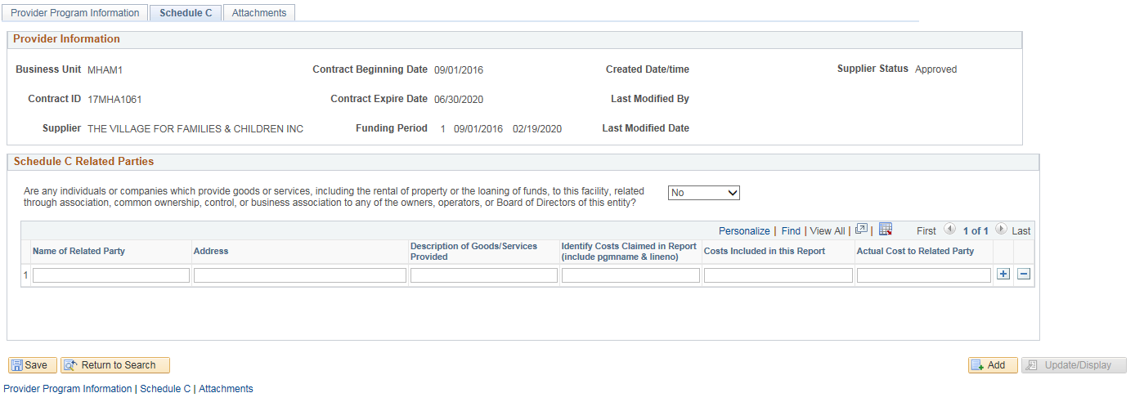

Click **Save**

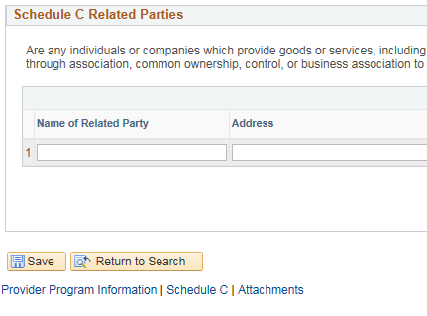

Click on the **Attachments** tab

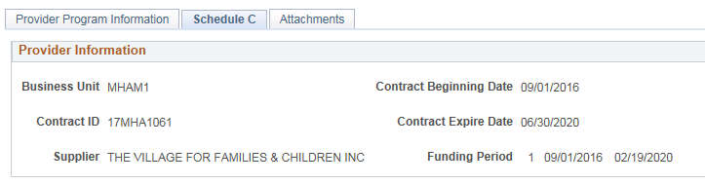

Enter **Attachment Description**

Click **Add Attachment**

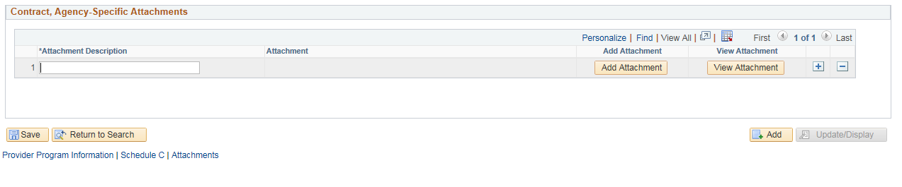

Click **Browse**

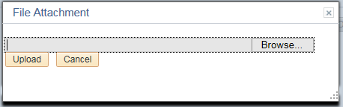

Select the attachement that is to be upload and click **Upload**

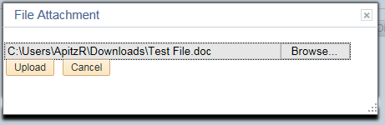

Click **Save**

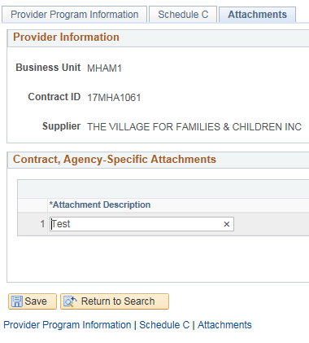

# Schedule A Salaries Entry /Budget Summary Entry & Submission

The following shows how to enter Schedule A Salaries and submit the budget.

**Navigation:** Supplier Contracts > Budgeting > Schedule A Salaries

The Schedule A Salaries page will display. Enter the **Contract ID, Funding Period**, or **Supplier Name,** and click **Search**

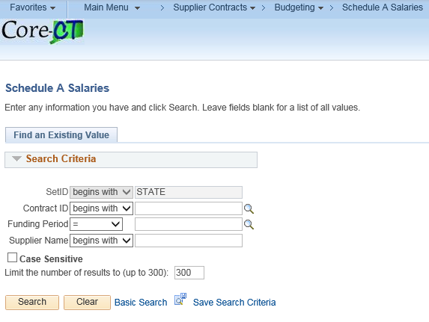

Select the **Administrative** checkbox

Enter **Number of Resources, Position Title, Name, Degree / License,** and **Total Hours Per Week**

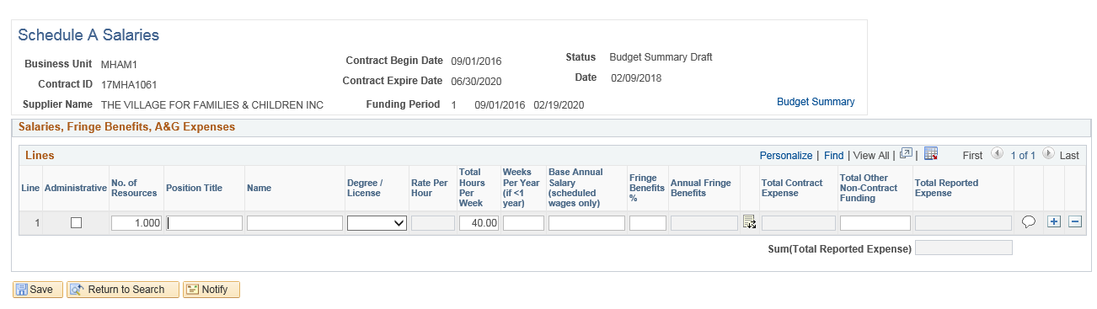

Enter **Weeks Per Year** (only if working for less than a year)**, Base Annual Salary (scheduled wages only), Fringe Benefits %**

Click on the **Program/Serivce/AG Detail** icon



Enter A & G **Program % of Time** (if applicable)

Click **‘+’ plus button** to add additional Program Code rows if necessary

Click **OK**

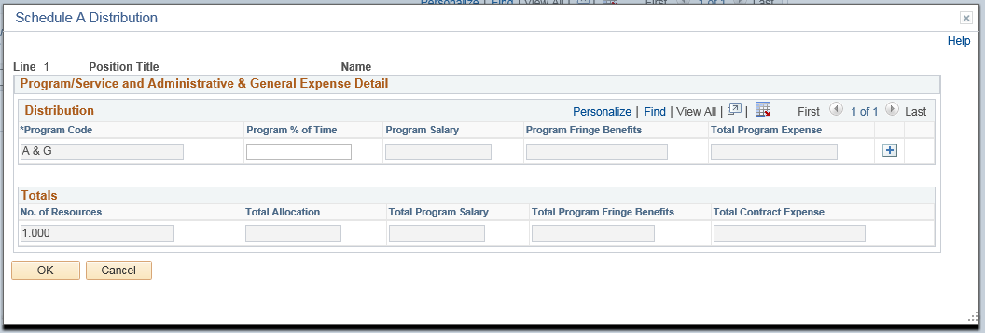

Confirm the **Total Contract Expense** field and the **Total Reported Expense** field auto-calculated properly

Click the **Justification** icon

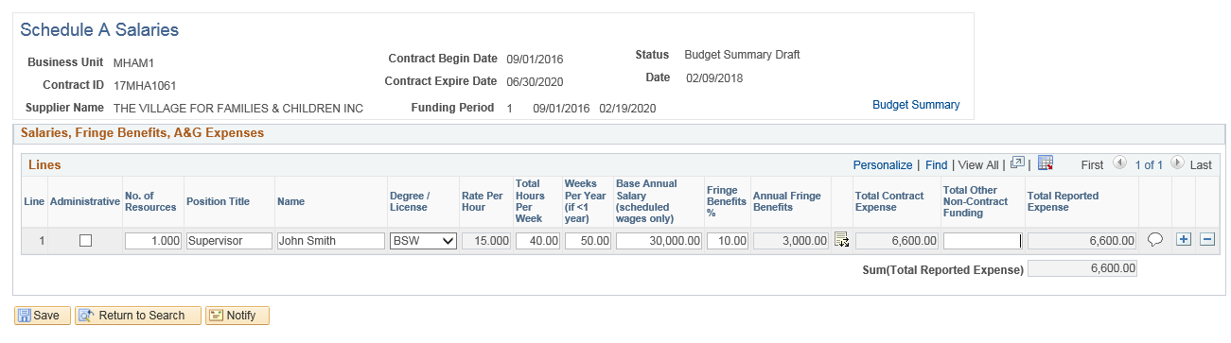

Provide justification, then click **OK**

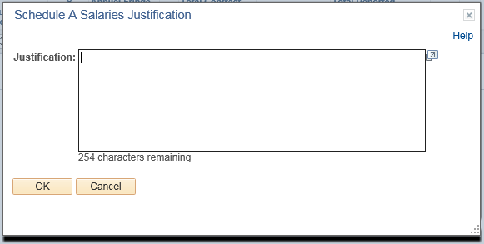

Click **Save**

The Schedule A Salaries page is now complete. Click on the **Budget Summary** link



Confirm all salary data is displayed/auto-calculated in Budget Summary Correctly

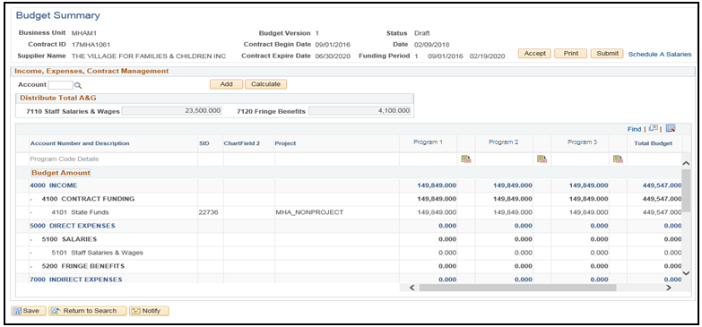Review all Salaries and Fringe Benefits fields to confirm the correct values populated from reciprocal Schedule A Salaries

Enter Funding and Expense values, including distribution of total A&G to correct Expense Account fields.

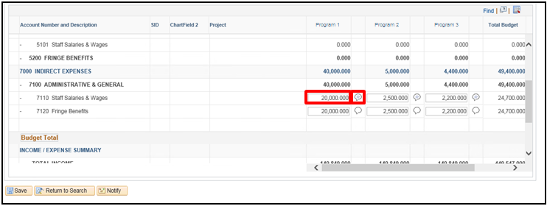Click the **Justification** icon to provide justification for fields with entered values

Click **Calculate** to update totals and confirm totals are auto-calculated correctly

Click **Save**



Click **OK**

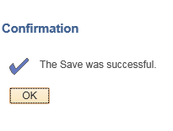

Click **Submit**

Enter **State User ID** and make sure the following fields populate

Enter message to be included in the email if needed

Click **OK**

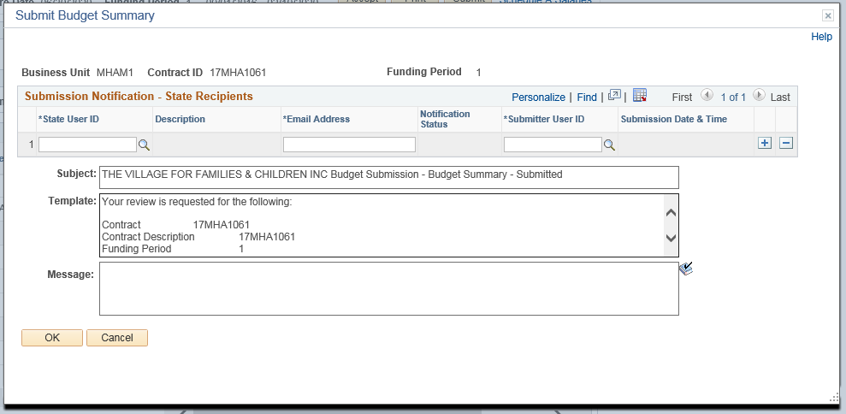

Click **OK.** At this time, the email will be sent to the Agency.The Agency will be able to follow the hyperlink to approve the Budget Summary.

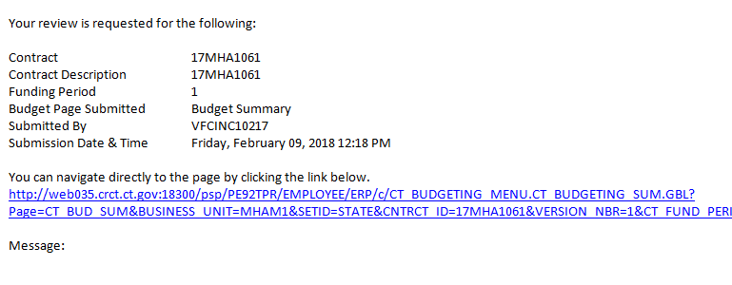

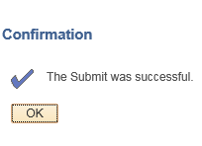

From here, the Agency will review and approve the Budget Summary.

# Run the Contract Budget Report

The following shows how to run the Contract Budget Report.

**Navigation:** Supplier Contracts > Budgeting > Budget Summary

The Budget Summary page will display. Enter **Contract ID** and click **Search**

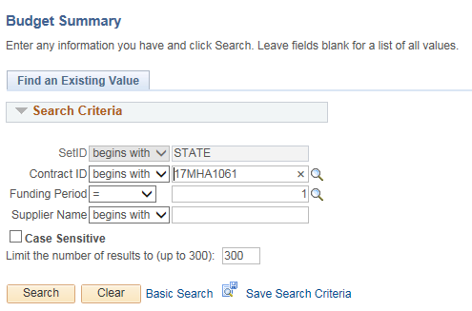

Click **Print**

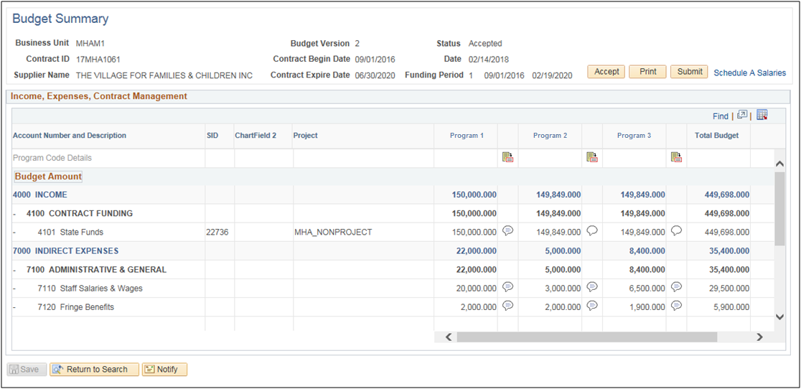

Select **PDF** or **XLS** depending on preference, and click **Print**

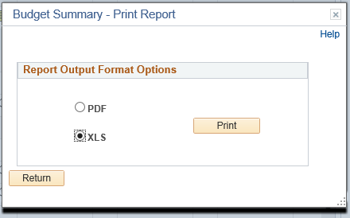

A new window will open up, showing the Contract Budget Report

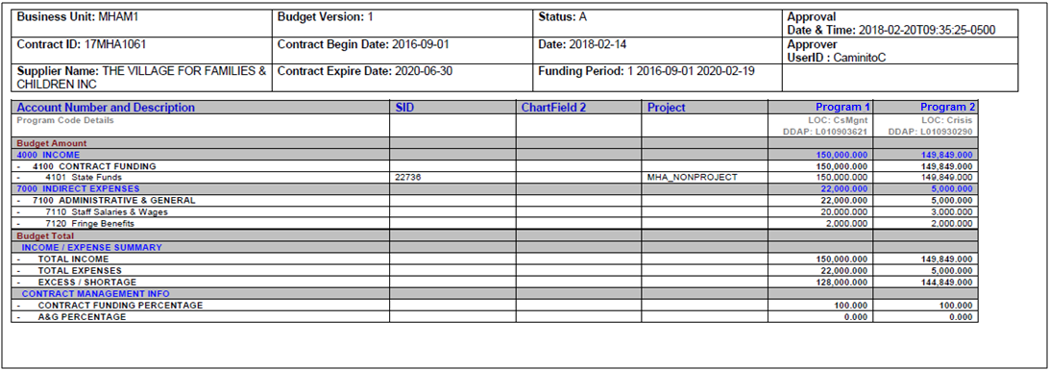

# Budget Workbook Financial Reporting

This chart shows the different reports and the Supplier/Agency roles with each.

|  |  |  |
| --- | --- | --- |
| Report Type | Supplier Role | Agency Role |
| **Multi-Year Contract Budget Report** | Run the Report | Run the Report |
| **Budget vs. Actual Reporting** | Entry and Submission | Approval |
| **Consolidated Financial Report** | Run the Report | Run the Report |
| **Salary Detail Actuals** | Entry and Submission | Approval |

# Multi-Year Contract Budget Report

The following shows how to run a Multi-Year Contract Budget Report

**Navigation:** Supplier Contracts > Budgeting > Multi-Year Contract Bud Report

The Multi-Year Contract Bud Report page will display. On the Add a New Value page enter the **Run Control ID** click **Add.**

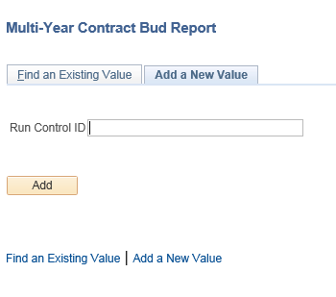

Enter **Contract ID, Funding Period Begin,** and **Funding Period End**

Click **Save**

Click **Run**

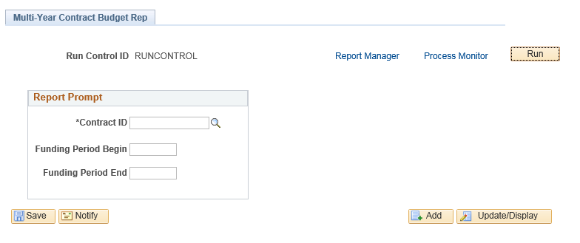

Select **PDF** under Format

Click **OK**

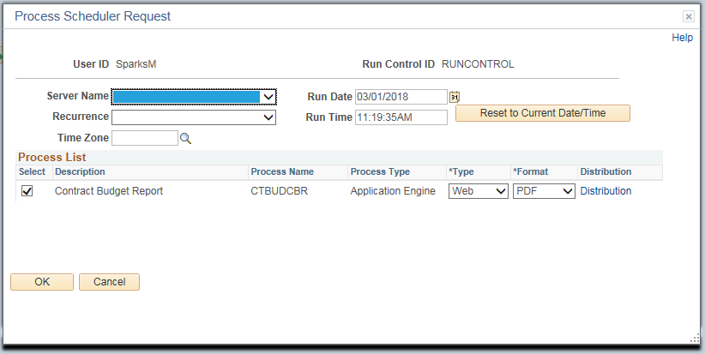

Click the **Process Monitor** link

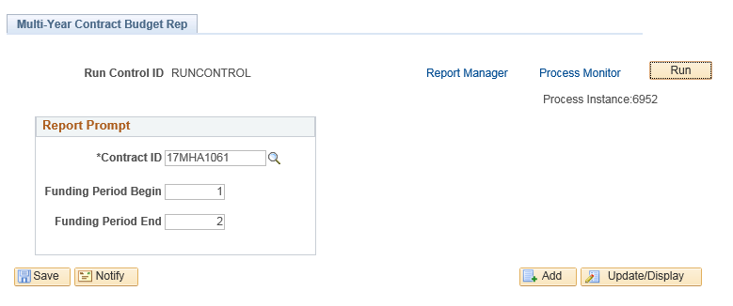

Click **Refresh** until **Run Status** and **Distribution Status** contain values

The process usually completes in less than 60 seconds

Click the **Details** link

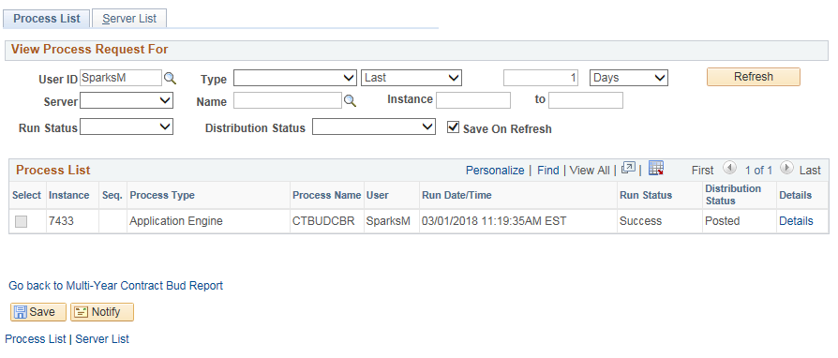

Click **View Log/Trace**

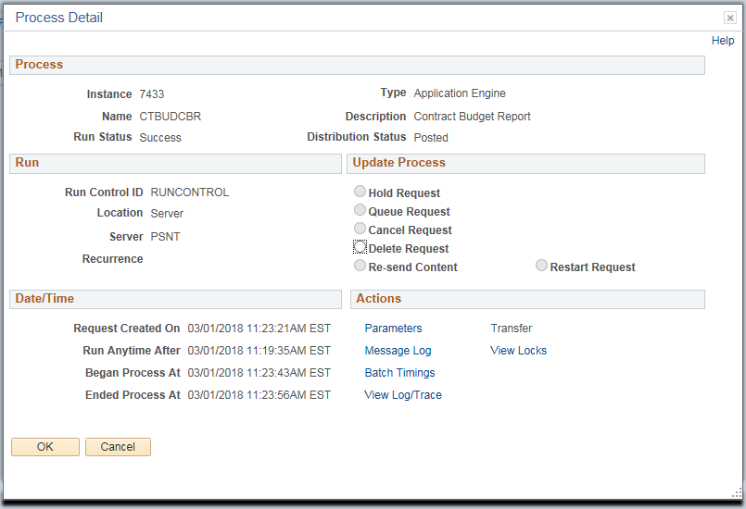

Select the file ending in “.pdf”

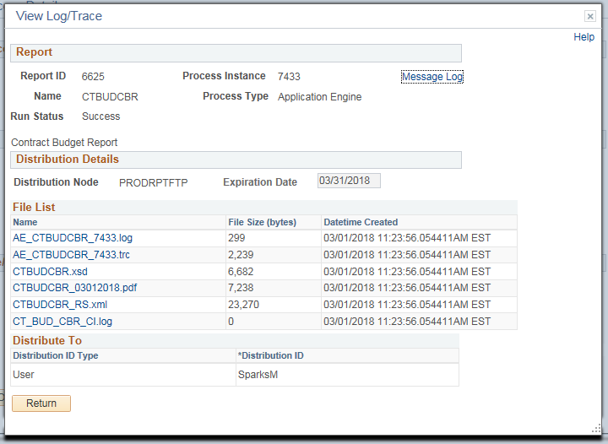

The Multi-Year Contract Budget Report is shown below

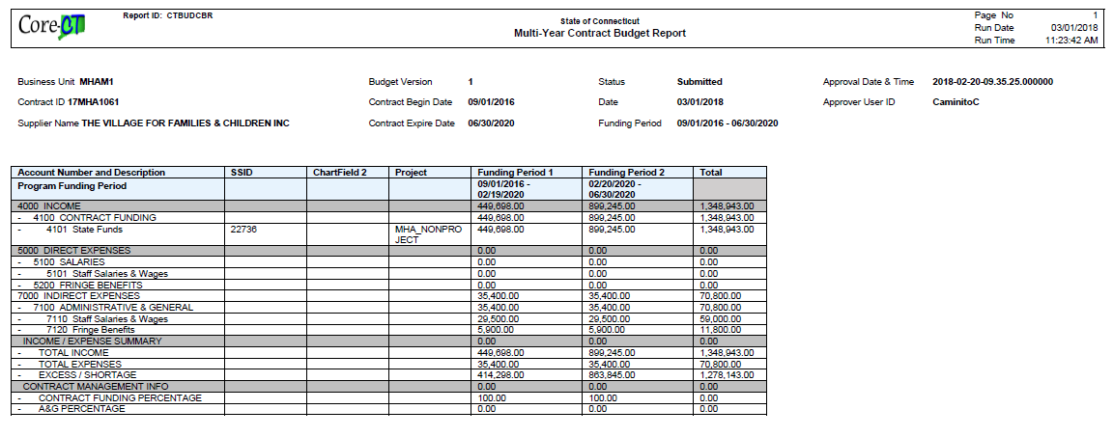

# Budget vs Actual Reporting

The process flow below outlines the steps which need to be completed in order for the Budget vs Actual Report to become approved. The Supplier will enter and submit the information, and the Agency will then approve.

Agency

Supplier

**Navigation:** Supplier Contracts > Budgeting > Budget vs Actual Reporting

The Budget vs Actual Reporting page will display. Enter **Contract ID** and click **Search**

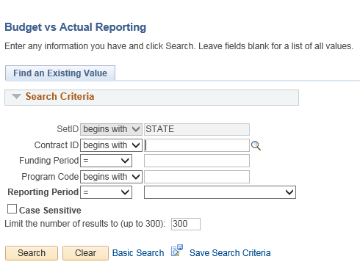

Select the Contract ID to run the report on

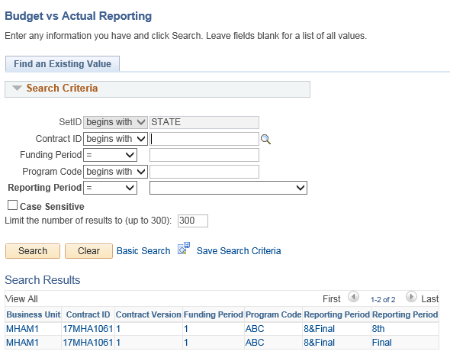

Enter **Current Actual Amount** fields

Enter **YE Expense Forecase** fields

Click the **Justification** icon for all fields with entered values

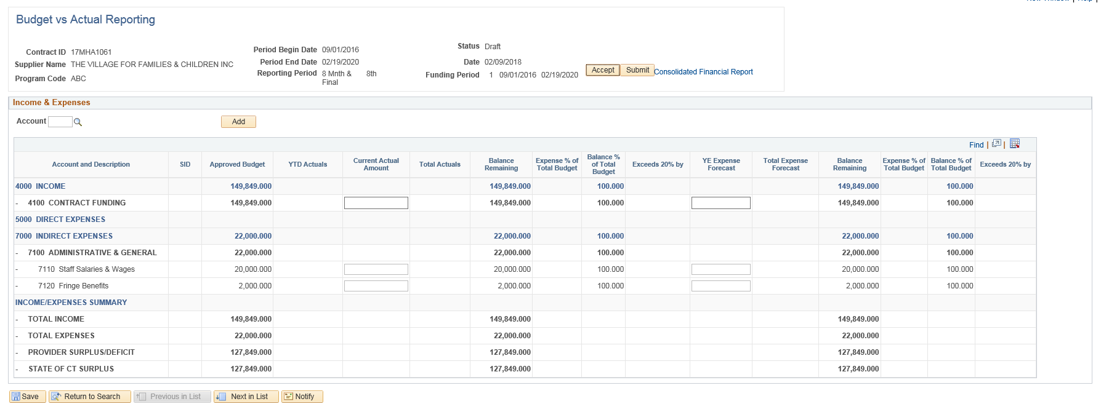

Provide Justification in all fields

Click **OK**

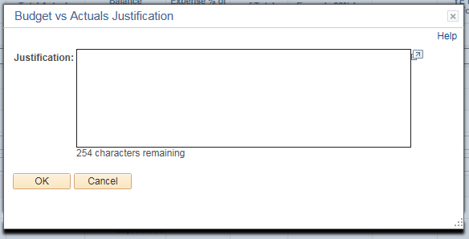

Click **Save**

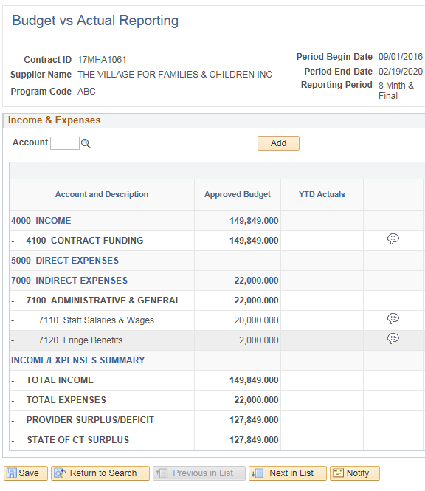

Click **Submit** to submit the Budget vs Actual Report

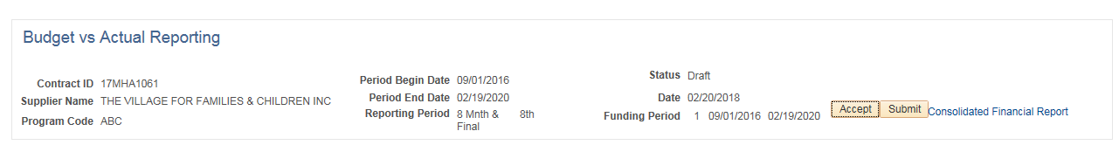

Enter **State User ID** and make sure the rest of the fields populate

Enter message to be included in the email if needed

Click **OK**

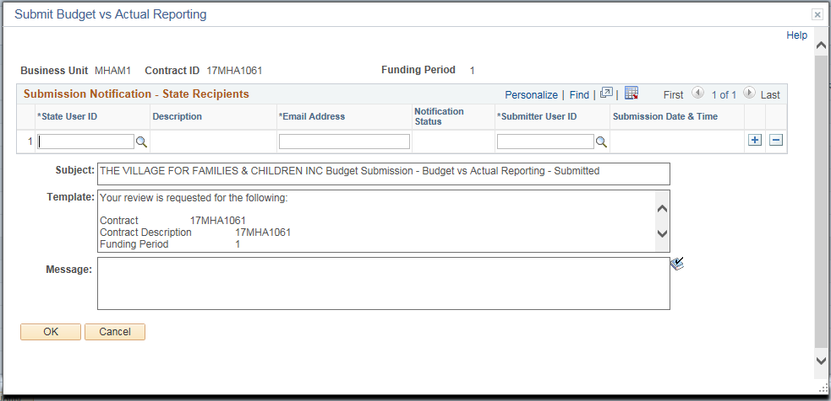

Click **OK.** At this time, the email will be sent to the Agency.The Agency will be able to follow the hyperlink to approve the Budget vs Actual Report.

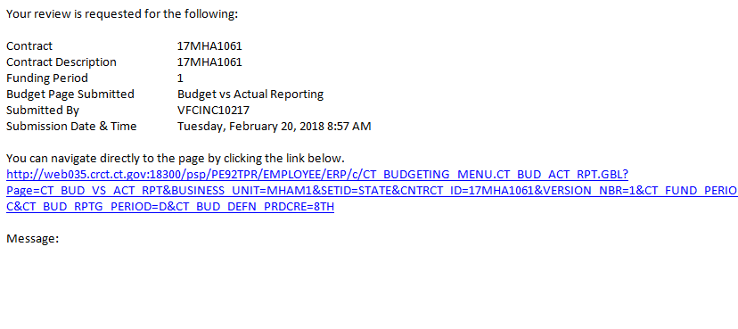



# Consolidated Financial Report

The following shows how to run a Consolidated Financial Report

**Navigation:** Supplier Contracts > Budgeting > Consolidated Financial Report

The Consolidated Financial Report page will display. On the Add a New Value page enter the **Run Control ID** click **Add.**

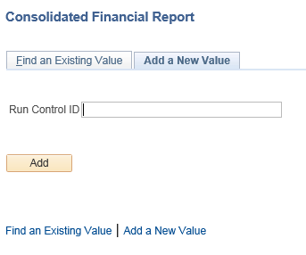

Enter **Contract ID** and **Funding Period**

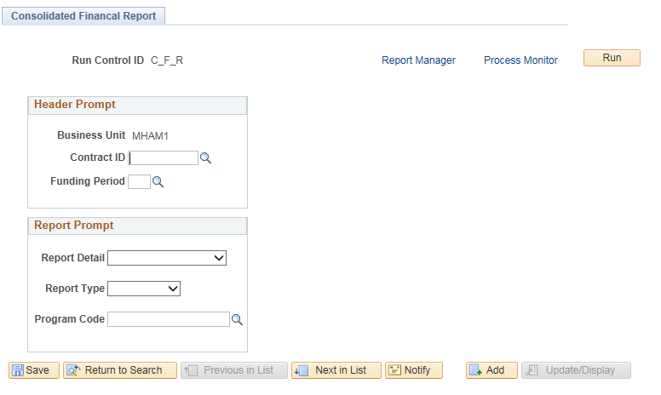

Select **Report Detail** and **Report Type**

Enter **Program Code**

Click **Save**

Click **Run**

Click **OK**

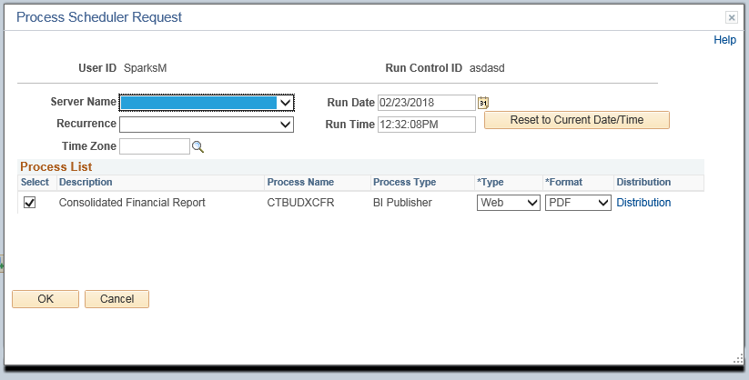

Click the **Process Monitor** link

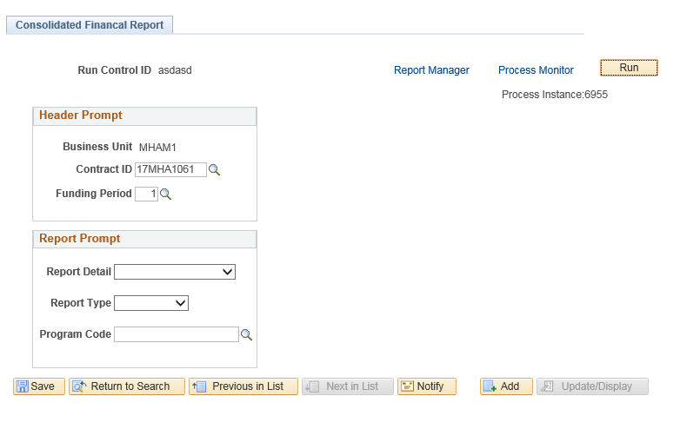

Click **Refresh** until **Run Status** and **Distribution Status** contain values

The process usually completes in less than 60 seconds

Click the **Details** link

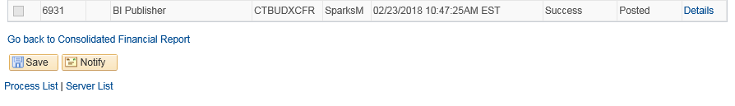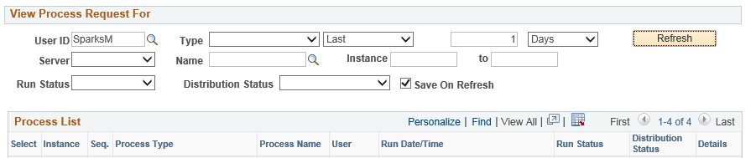

Click the **View Log/Trace** link

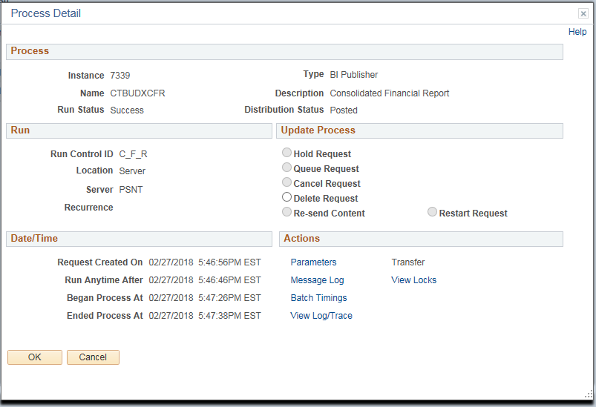

Click the “.pdf” file to view the report

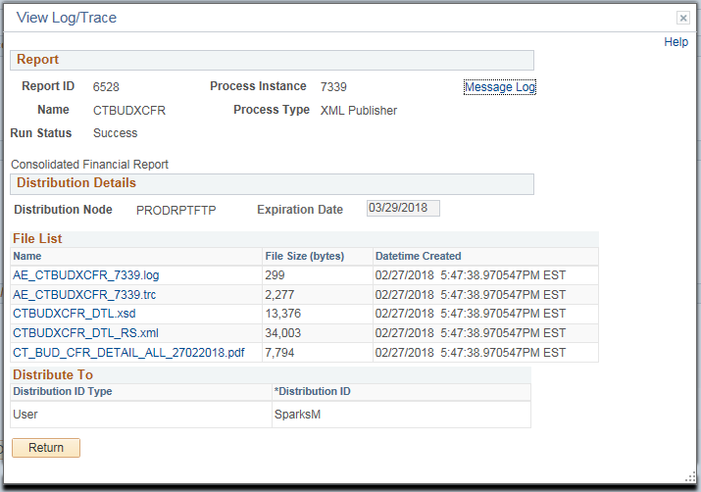

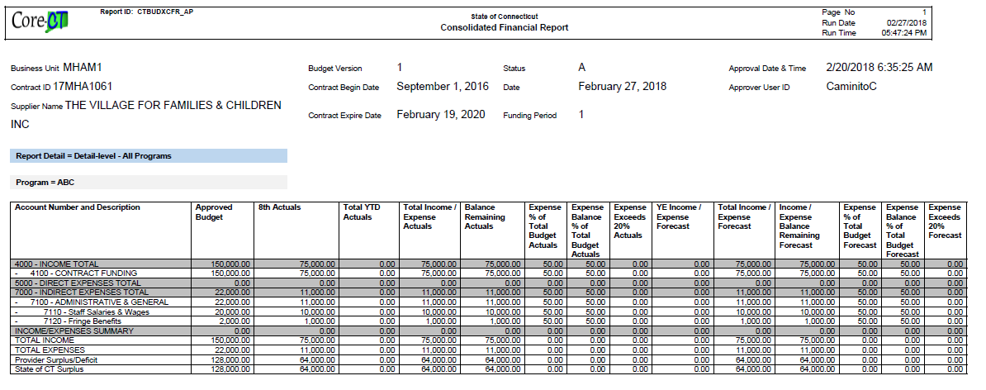The Consolidated Financial Report is shown below

# Salary Detail Actuals

The process flow below outlines the steps which need to be completed in order for the Salary Detail Actuals to become approved. The Supplier will enter and submit the information, and the Agency will then approve.

Agency

Supplier

**Navigation:** Supplier Contracts > Budgeting > Salary Detail Actuals

The Salary Detail Actuals page will display. Enter the **Contract ID** and click **Search**.

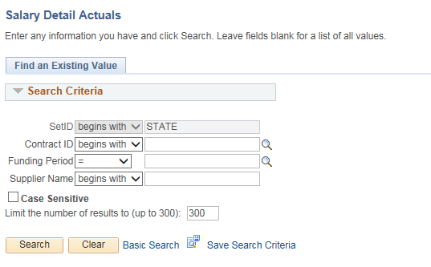

Update any of the editable fields that need to be changed.

Click on the **Funding Distribution** icon

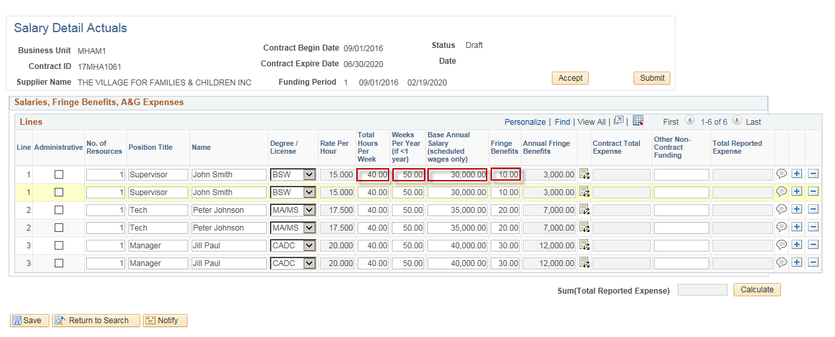

Update any of the **Program Code**(s) that need to be changed

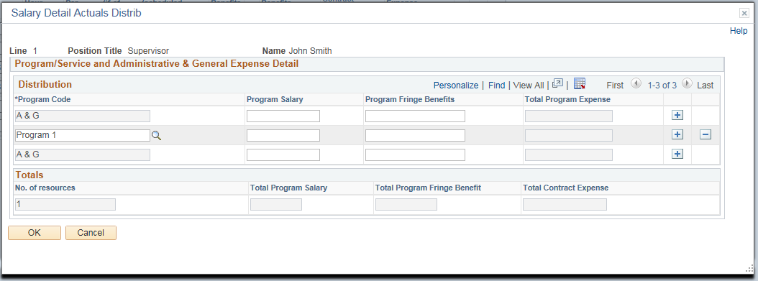

Repeat this process for all lines that need to be updated

Click **Submit**

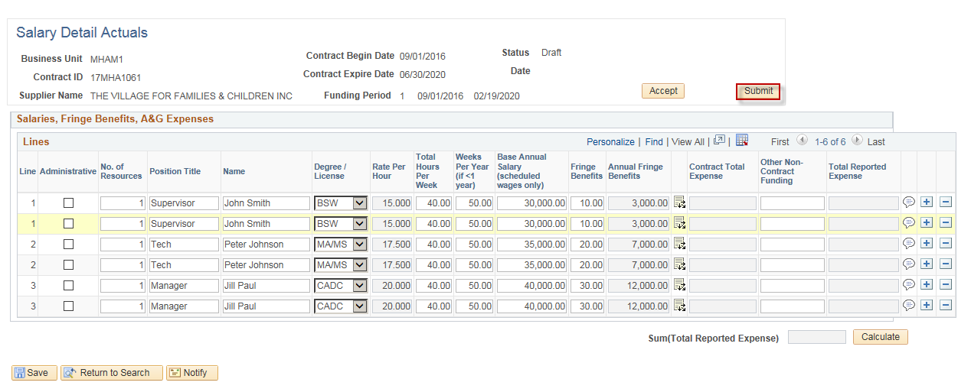

Enter **State User ID** and make sure the rest of the fields populate

Enter message to be included in the email if needed

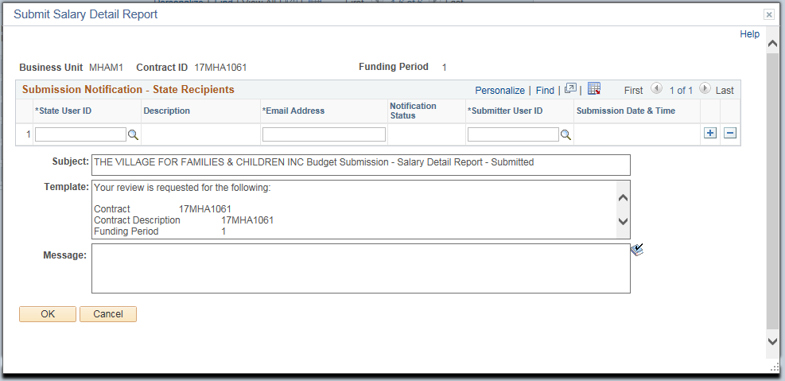Click **OK**

Click **OK.** At this time, the email will be sent to the Agency.The Agency will be able to follow the hyperlink to approve the Salary Detail Actuals.

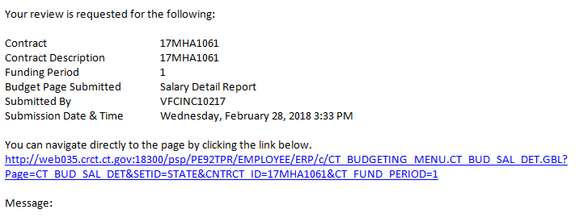



# Complete a Revision Approval

The process flow below outlines the steps which need to be completed in order for a Budget Revision to be approved. The Supplier will enter and submit the information, and the Agency will then approve.

Agency

Supplier

**Navigation:** Supplier Contracts > Budgeting > Budget Revision

The Budget Revision page will display. Enter **Contract ID**.

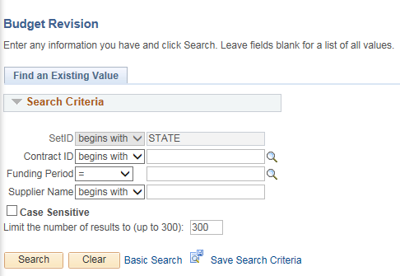

Fill in the **New Request** fields

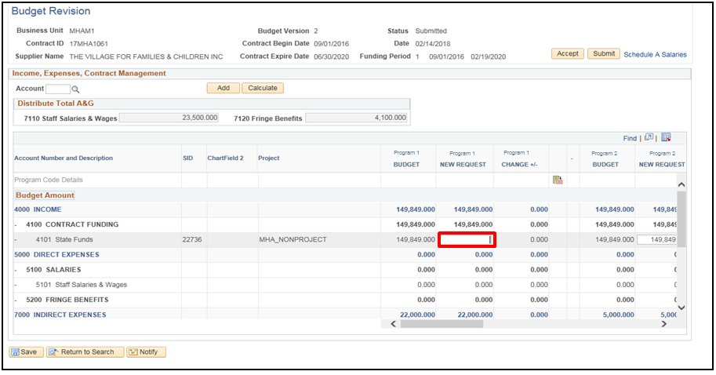

Scroll down to fill in the rest of the **New Request** fields

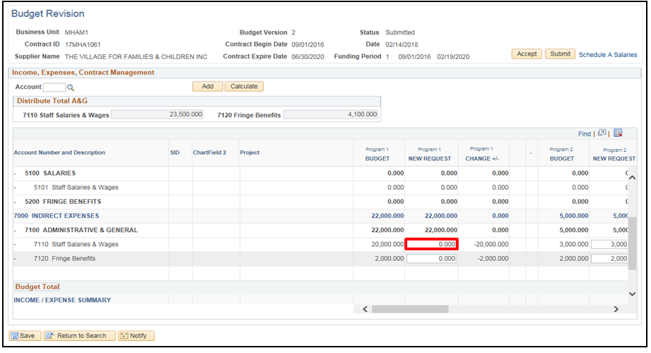

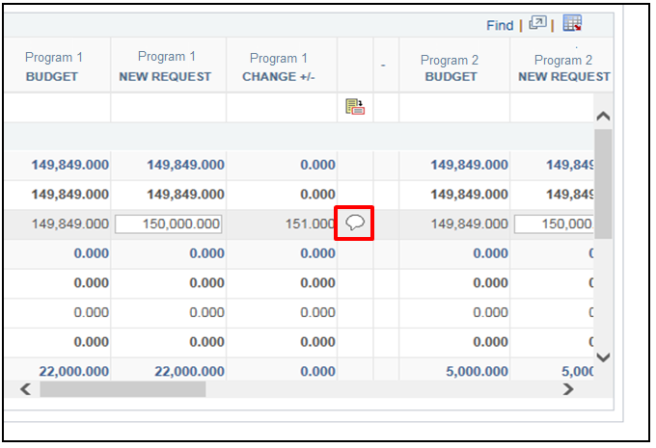Click on the **Justification** button

Provide Justification for each revision

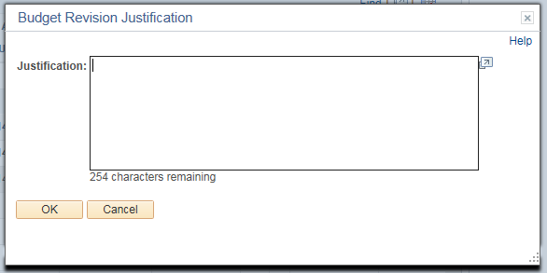

Confirm that the revised A&G for each account equals the Total A&G allocated from the “Schedule A Salaries” page

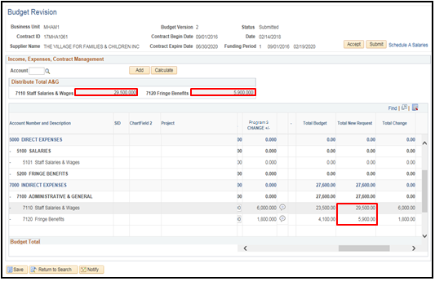Click **Save**

Click **OK**



Click **Submit.** This will open up the Submission Notification screen where the Supplier will notify the user that the Budget has been Submitted for revision.

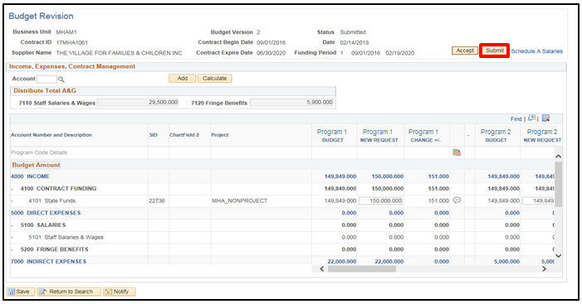

Enter message in the email if necessary.

Click **OK**

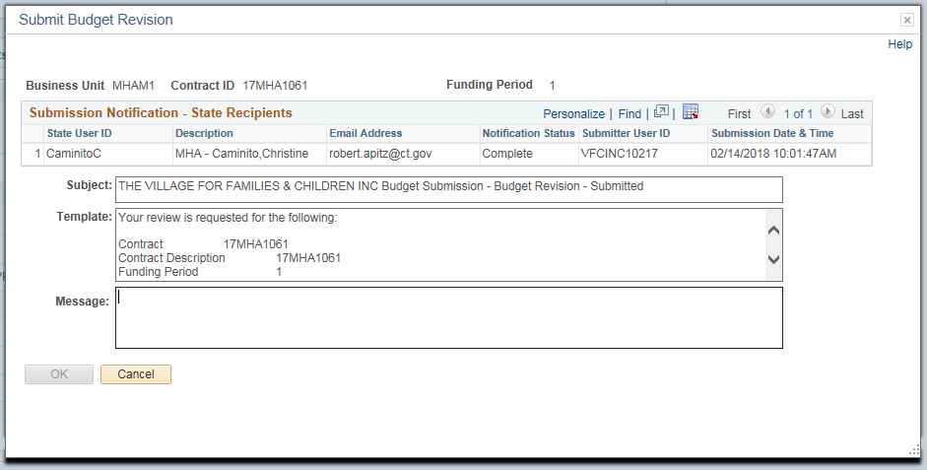

Click **OK.** At this time, the email will be sent to the Agency. They will be able to follow the hyperlink in the email shown below to begin the approval process for the Budget Revision.

