Supplier Contract Management end to end

Create a Requisition for POS/PSA Authorization
User must have the CT PSA_POS_REQUESTOR and CT_F_A_PSA_POS_SUBMITTER role
Navigation:

eProcurement > Requisition

- Enter Business Unit

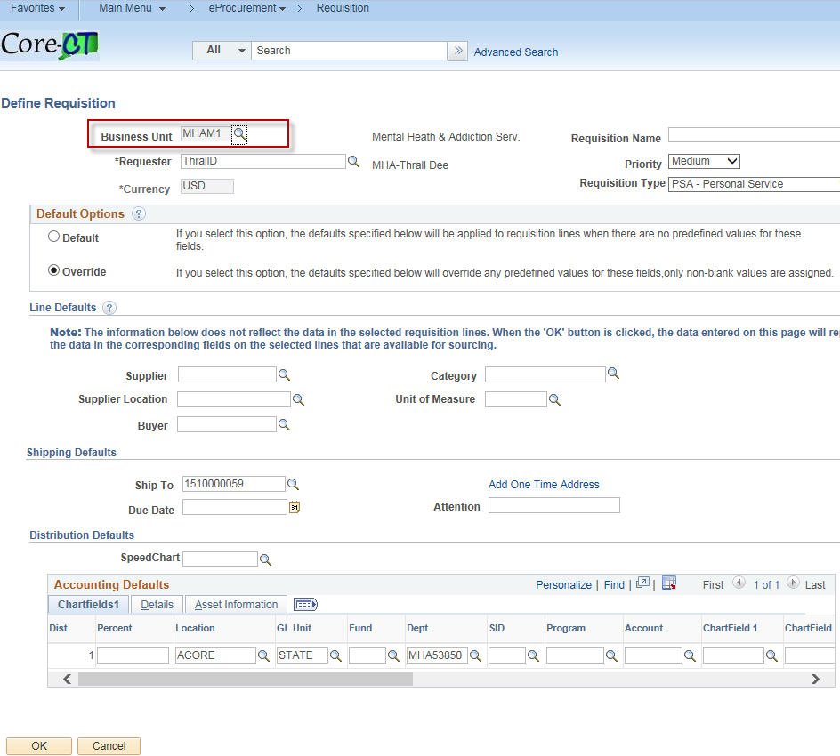

- Enter Requisition Name

- Enter Requisition Type - PSA – Personal Service

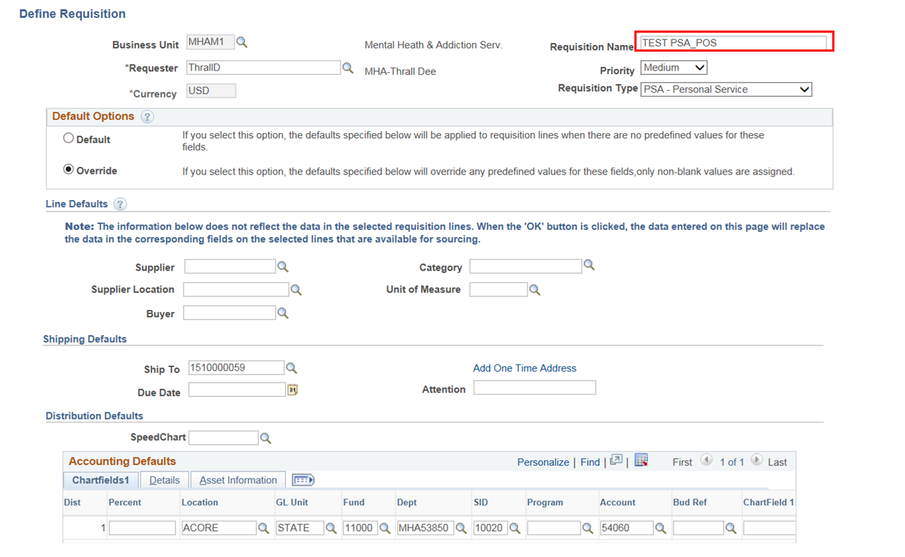

- Enter the Supplier ID

- Enter the Buyer ID

- Enter the Category

- Enter the Unit of Measure

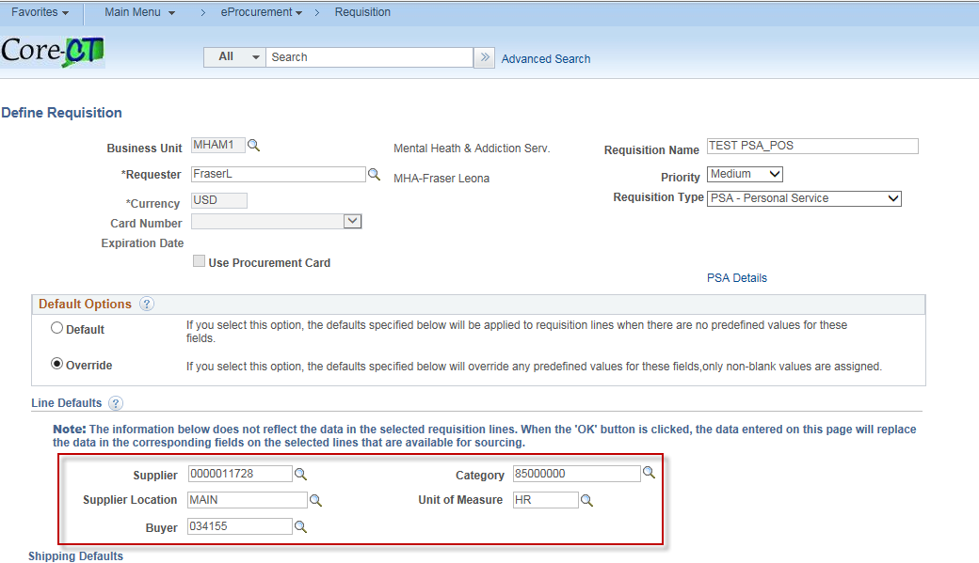

- Enter Chartfields – If the chartfields are defaulted skip this step.

- Click OK

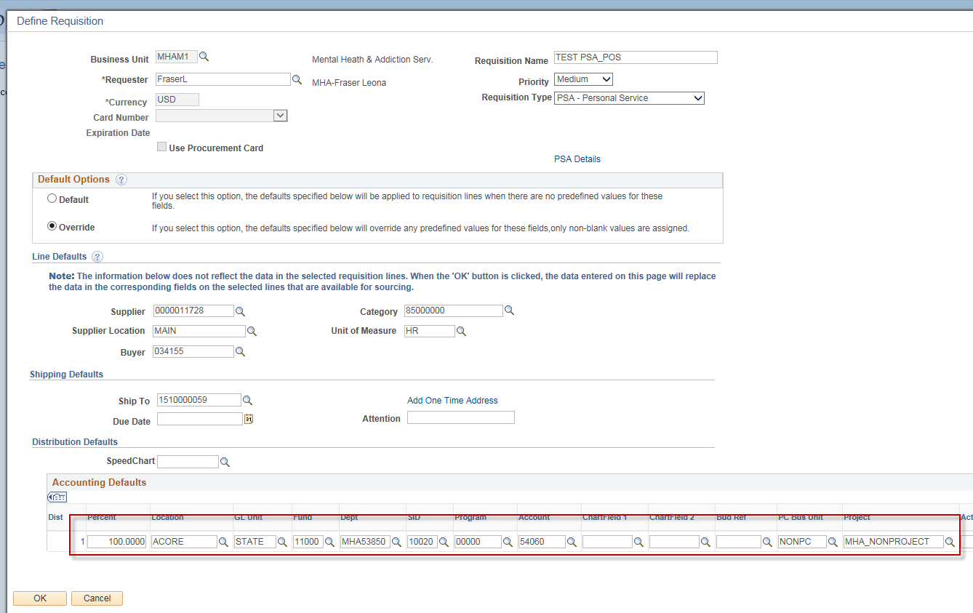

- Click Fixed Cost Service link

Note: The Category, Supplier ID, Supplier Name & Unit of Measure fields populated with values entered on the Define Requisitions page.

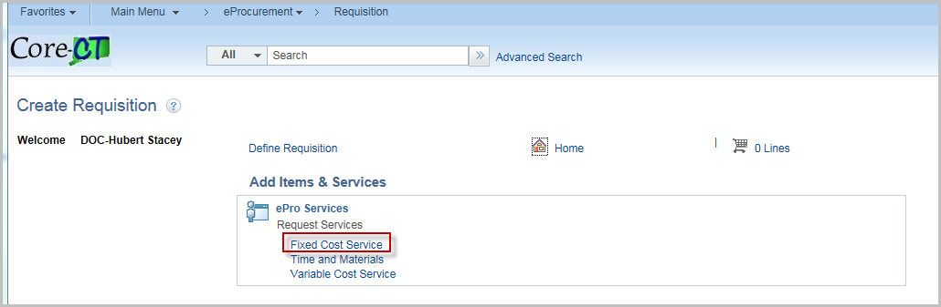

- Enter Item Description
- Enter Value of Service
- Enter Start Date
- Enter End Date

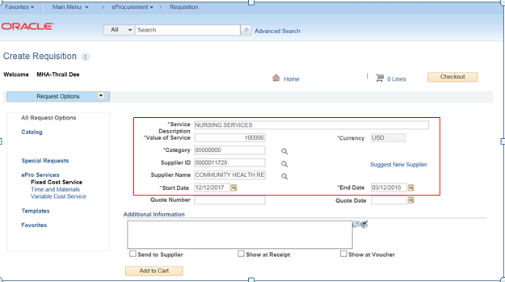

- Click Add to Cart

Note: Repeat the process for additional services you wish to place on your requisition.

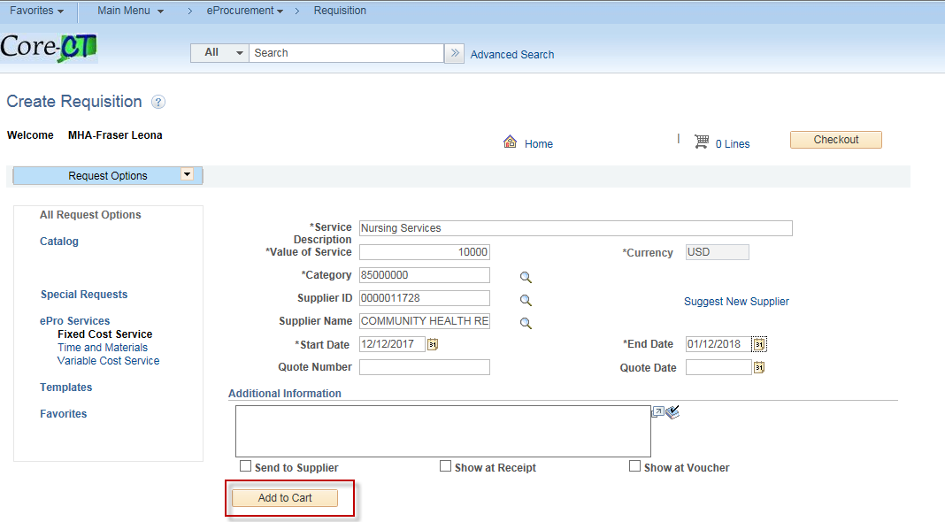

- The Shopping Cart displays on the right hand side of your screen.

- Click Checkout

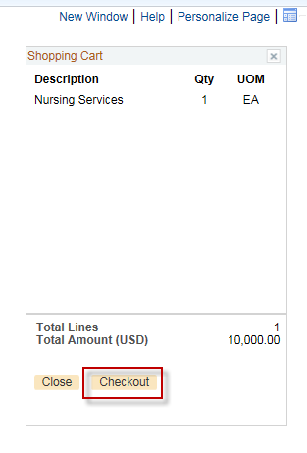

- Click on the PSA Details Link

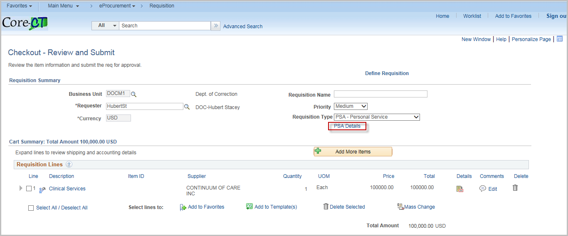

- Click the Hyperlink that pertains to your Personal Service Agreement

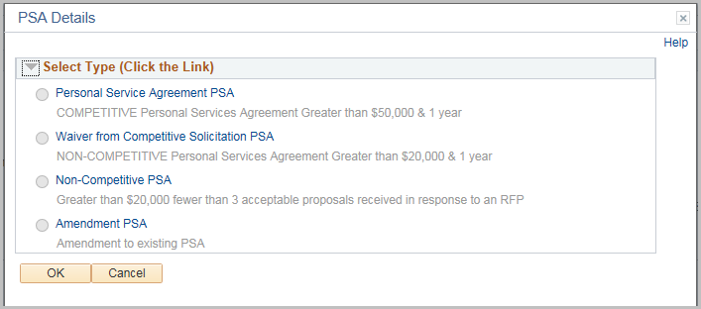

- Change default values as required

- Click OK
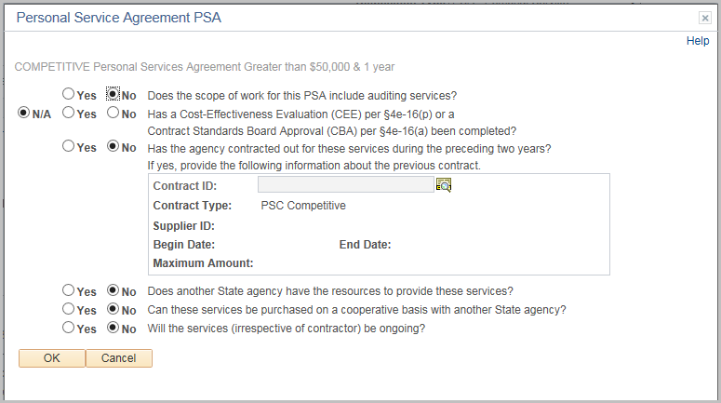

- Click OK

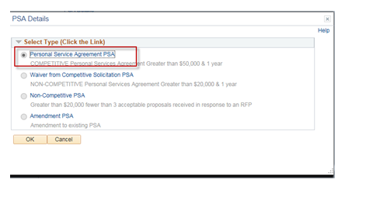
- Click on the Comments bubble

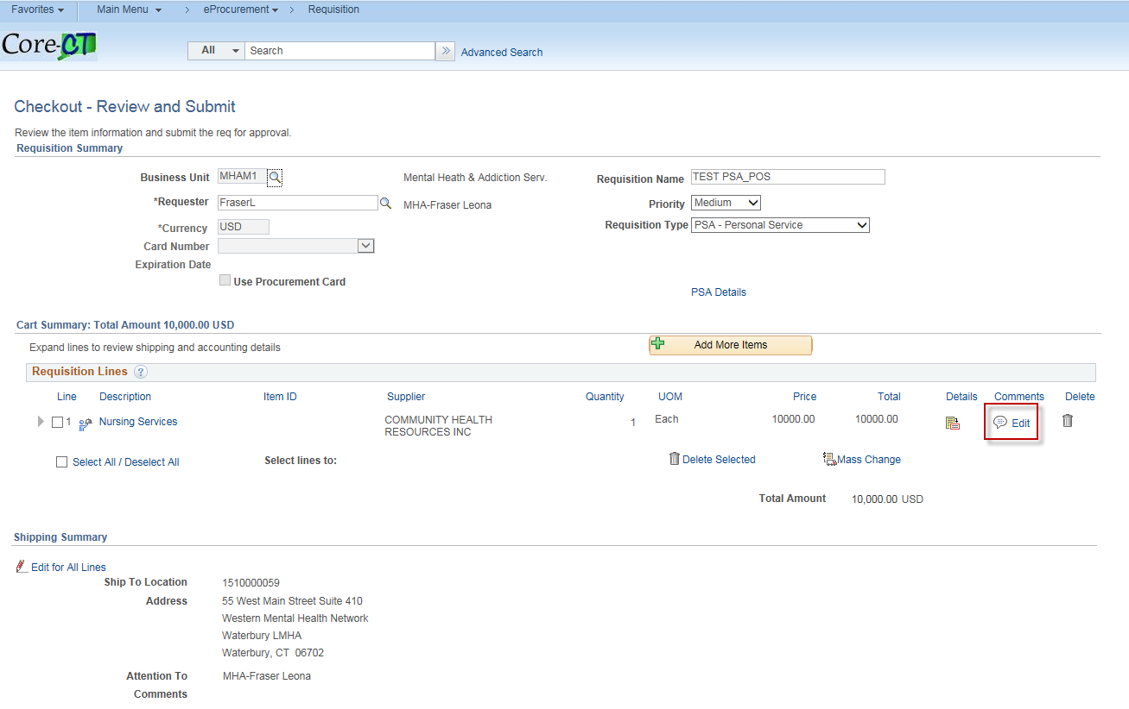

- Add Comments

- Add attachments as needed
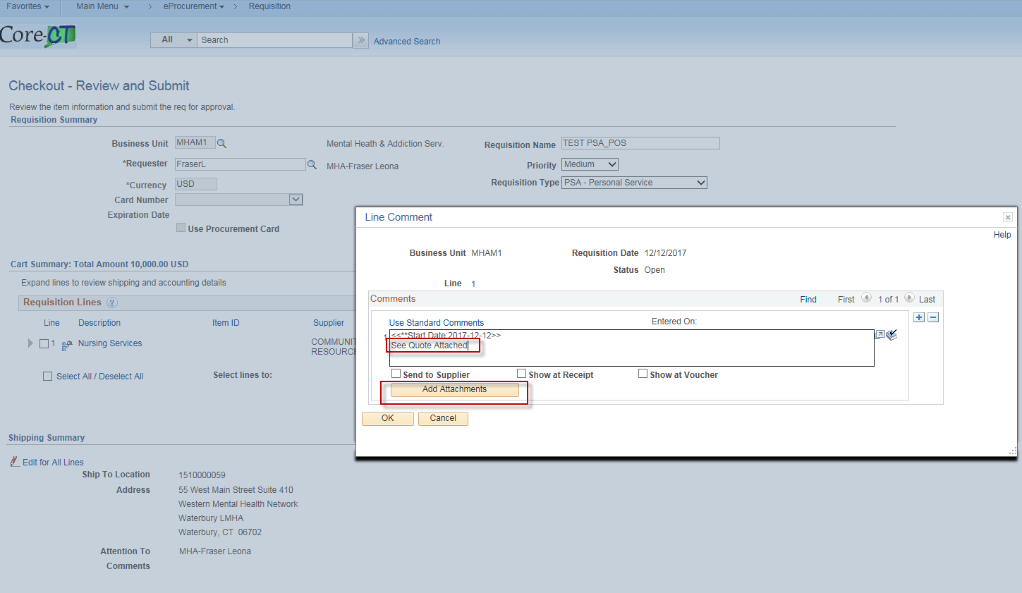

- Click Save and Submit

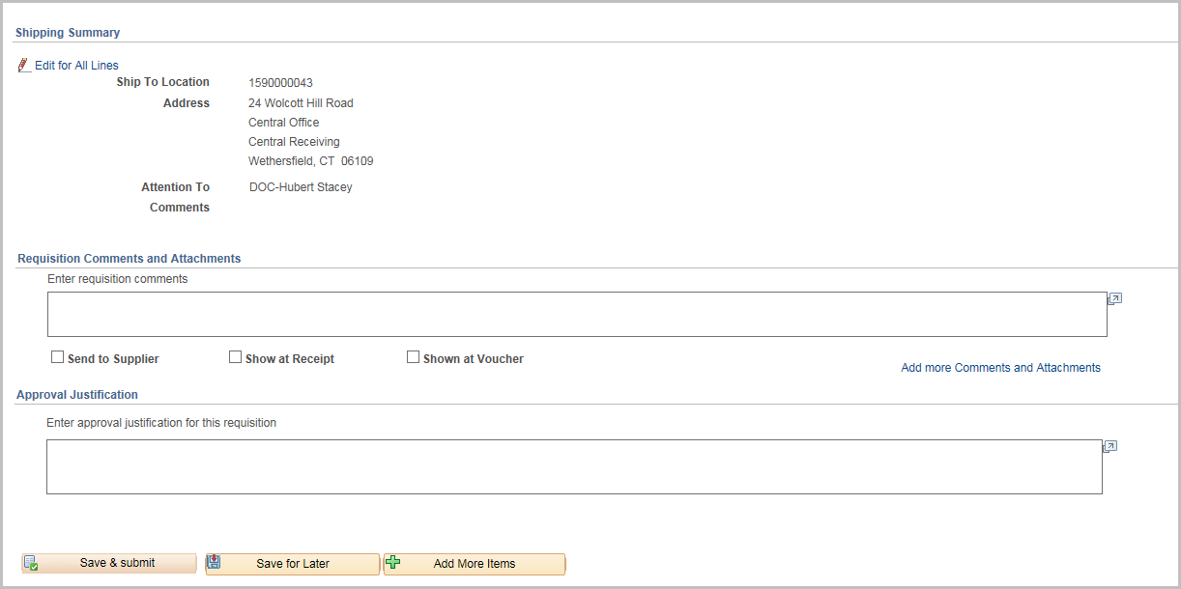

- Click OK
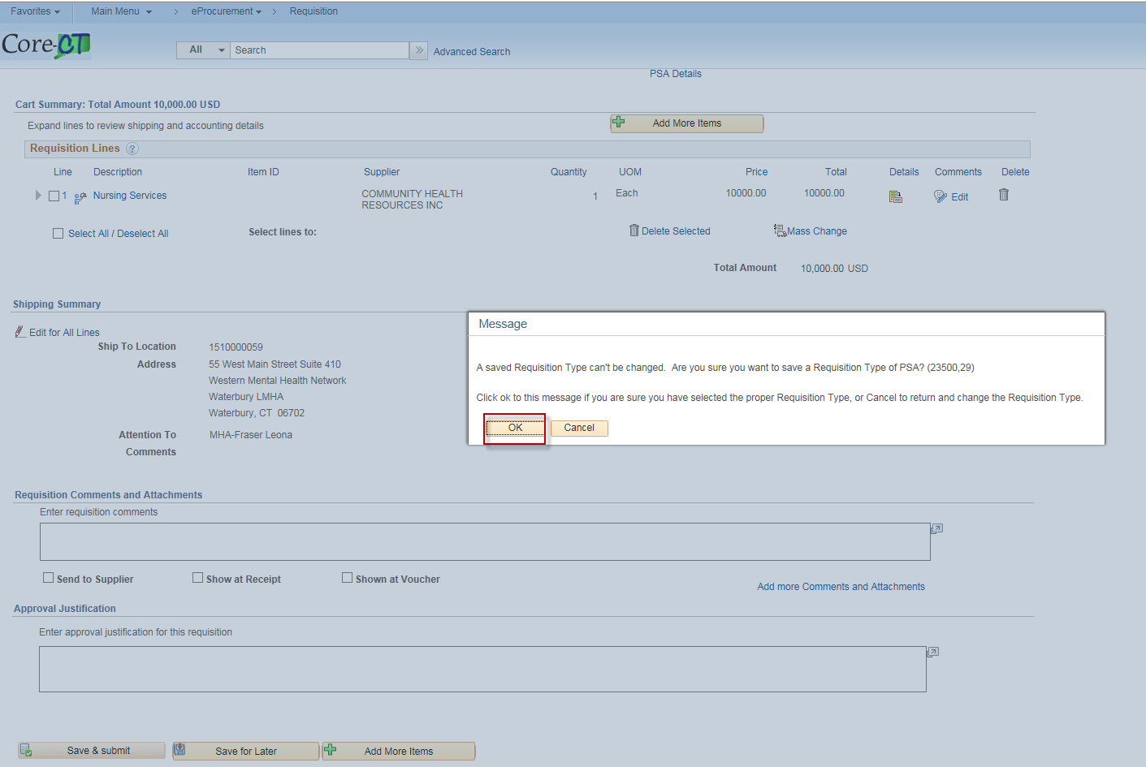

- The requisition has been submitted to PSA_POS workflow and is in pending status.
- The requisition number displays on the header.
- The Bid/Contract ID starts with the year, agency acronym & requisition number. This field is editable when converting the req to a contract.
- Default for this requisition is Amount Only. If you need to change to QTY un-check the Amount Only Box in the line details.

(Once the requisition is converted into a contract, the Contract ID will have a suffix added to it of either PSA-01 or POS-01 depending upon which requisition type was chosen).
To approve PSA/POS requisitions the users must have one of the following roles:

CT AGY SERVICE APPROVER
CT OPM BUDGET APPROVER 1
CT OPM BUDGET APPROVER 2
CT OPM FINAL APPROVER
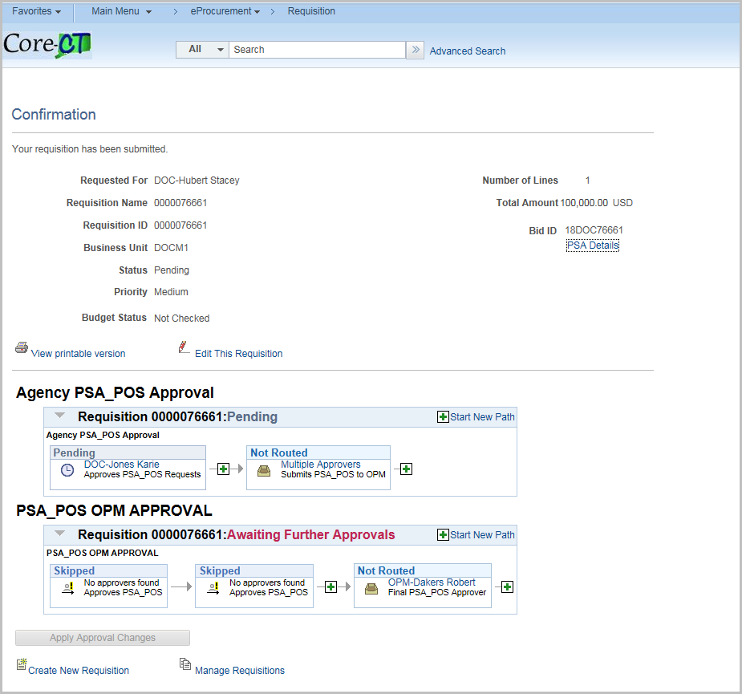

Convert Requisition to Procurement Contract

User must have the CT REQ BID CONTRACT CREATOR role

Navigation:
eProcurement > Convert REQ to Contract

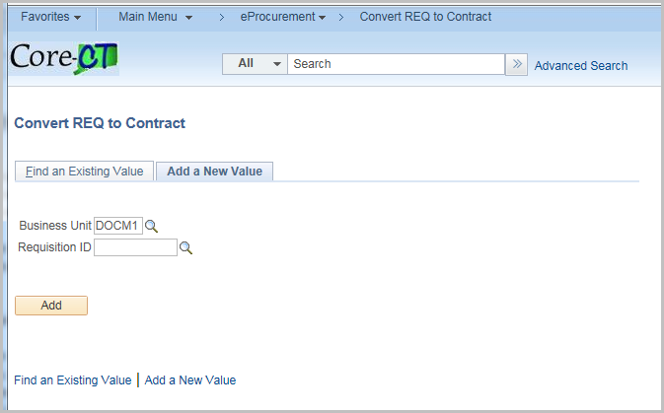

Enter the Requisition number or click on magnifying glass to locate requisition

Click Add

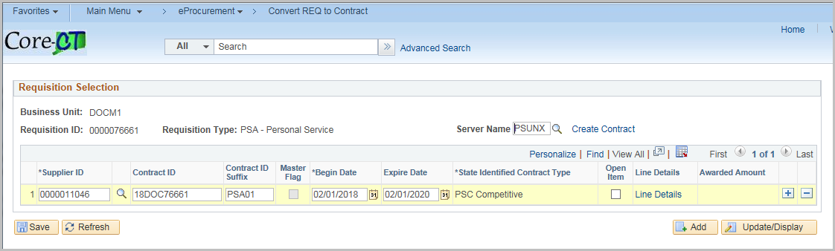

The System will default the Contract ID suffix and the Contract ID/Bid ID, Begin Date, Expire Date and State Identified Contract Type from the Requisition.

Note: You may change the Contract ID at this point in the process.

Click Line Details link
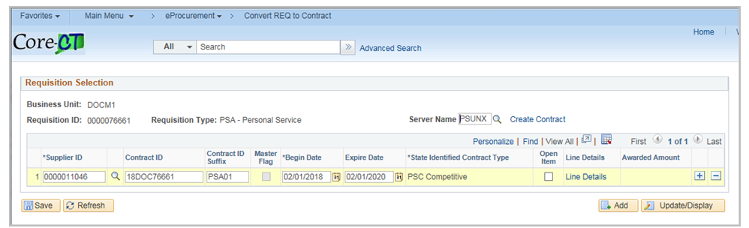

Line Details will default from the Requisition

Click OK

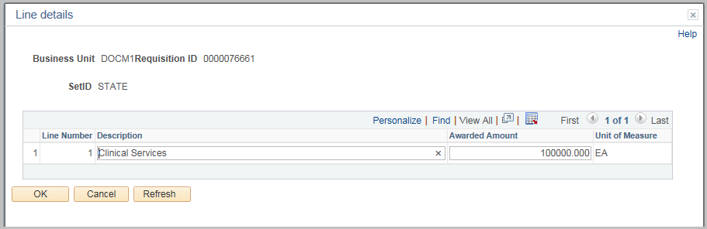

Click Create Contract

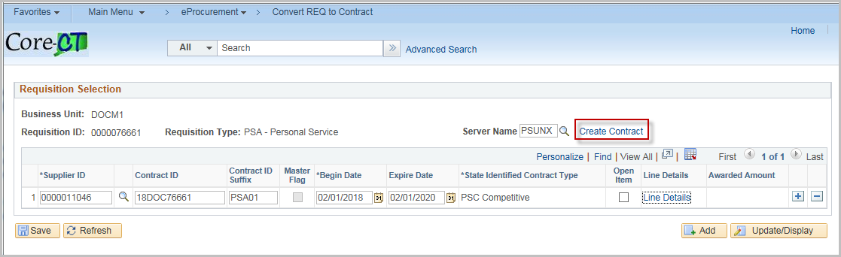
Click Yes to Continue

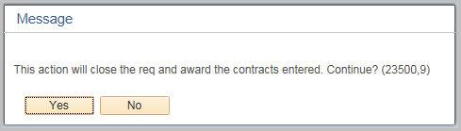

Click Yes

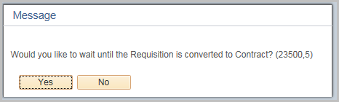

Click OK

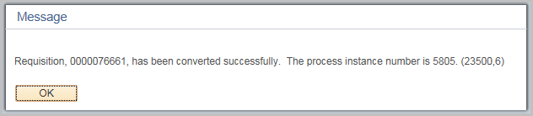

Review and Complete Procurement Contract

Navigation: Supplier Contracts > Create Contracts and Documents > Contract Entry
or Procurement Contracts > Add/Update Contracts
(either Navigation will work)

Must have a Contract Creator role to access the Procurement Contract

(Navigation from the Go To Contract link when converting requisition to contract will also work)

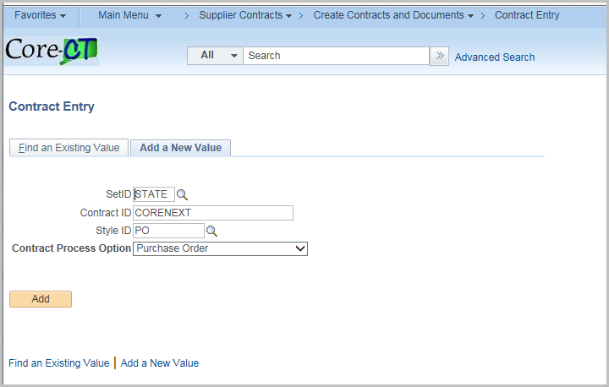

Click Find an Existing Value

Enter the Contract ID

Click Search

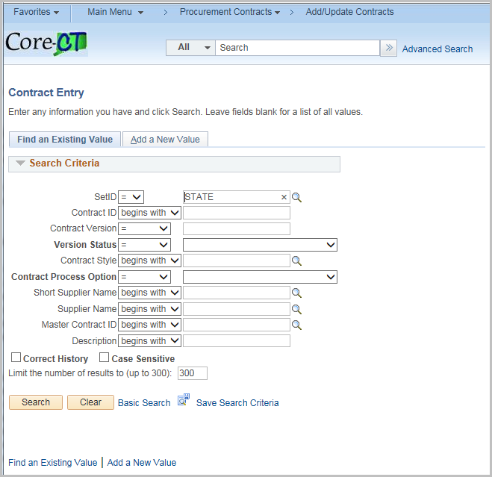

Review and update any values as necessary for the particular contract

Below is a brief explanation of the fields created on the Contract
Field | Value
Status | Defaults to Open
Administrator/Buyer | Enter the Contract Administrator - Optional
State Identified Contract Type | Defaults from the Requisition
Contract Style | Select PO
Supplier | Defaults from the Requistion
Begin Date | Defaults from the Requistion
Expire Date | Defaults from the Requistion
Supplier Contract Ref | Defaults from the Requistion
Description | Defaults from the Requistion
Maximum Amount | Defaults from the Requistion
Corporate Contract | If checked, the contract can be used Statewide  Default is checked
Price Can be Changed on Order | If checked, the line amount may be modified on the purchase order  Default is checked
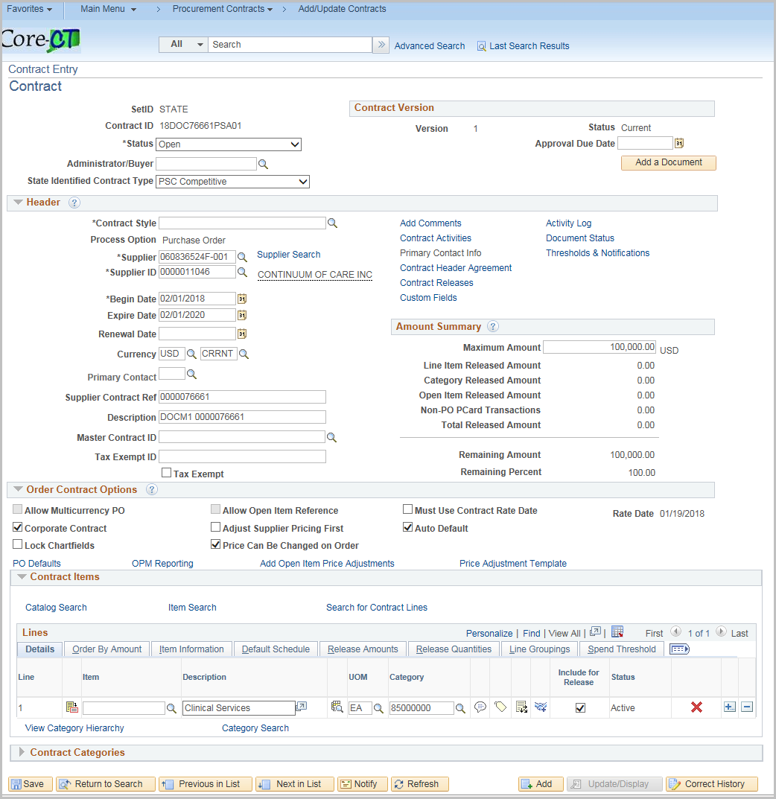

Click the PO Defaults hyperlink

Review and update any values as necessary for the particular contract

Field | Value
Business Unit | Defaults from the Requistion  When the Corporate Contract checkbox is unchecked, this is the only Business Unit that can use this Contract. If more than one business unit is needed, click the + to add more.
Buyer | Defaults from the Requisition
Origin | Defaults from the Requisition

Click OK

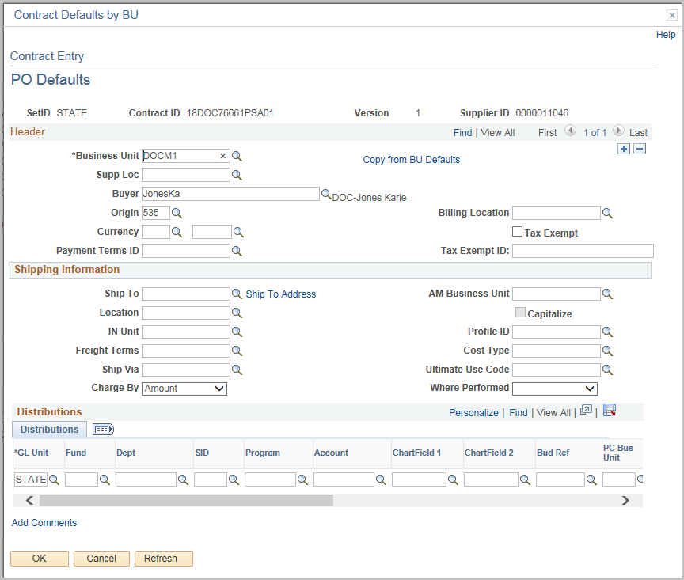

Click the OPM Reporting Link 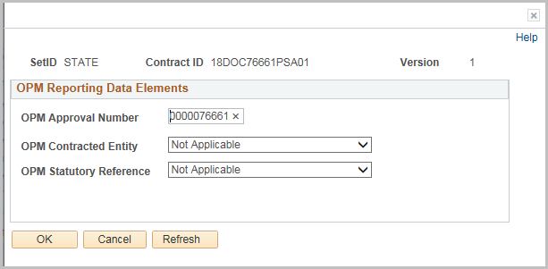
The OPM Approval Number is the Requisition number

Update the OPM Contracted Entity and OPM Statutory Reference as needed.

Click OK (you will be returned to the Main Page of the Contract.)

Contract Lines are defaulted from the Requistion
Click the Line Details Icon to view Details for each line
Alternately you can Click the Tab(s) across the Top to view specific fields displaying all lines

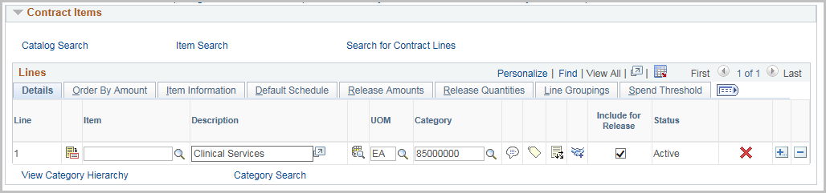

Field | Value
Physical Nature | This value is defaulted from the requisition
Maximum Line Amount | Enter the Maximum amount for the Line  This is used to calculate the remaining balance
Price Can Be Changed on Order | Default is Checked
Amount Only | This defaults from the requisition

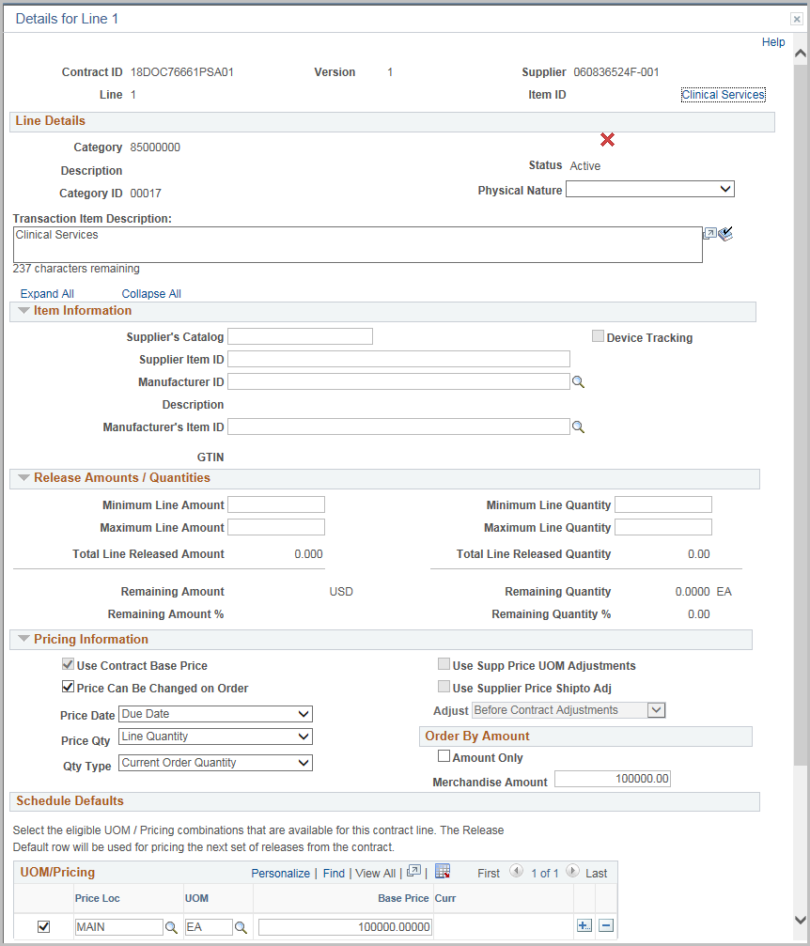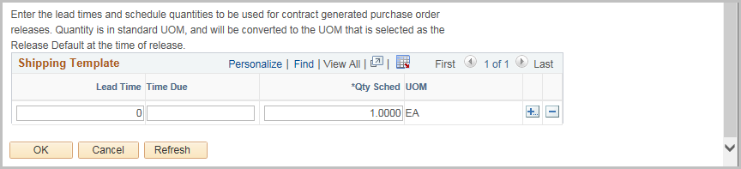

Click OK

Click the PO Distibution Details icon 

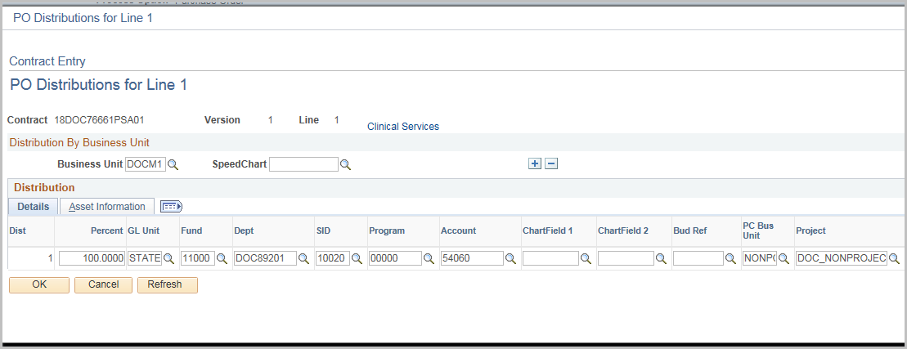

The PO Distributions are copied over from the Requistion

Click OK

Comments and Attachments will copy over from the Requisition

You can see what requisition was used to create the contract in the comments for the line and can view the requistion Schedule and Distribution line summary page by clicking on the link.
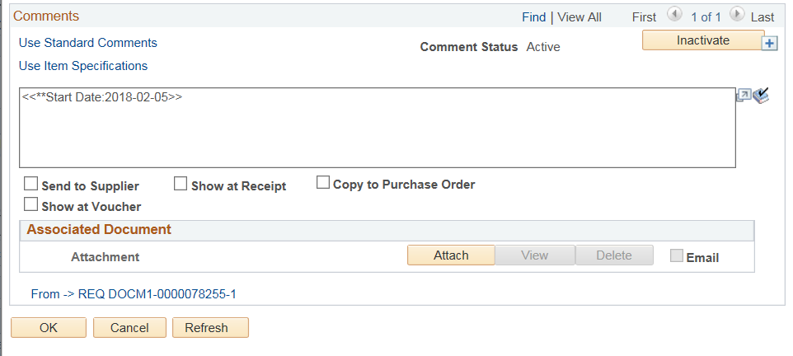

Once the Supplier Contract process has begun the Procurement Contract will update the corresponding Supplier Contract Status/Version/Amendment.

Until the Contract authored status is executed (i.e. the legal document is complete and signed off) the contract should remain in Open Status.

This will prevent creating purchase orders against the Contract.

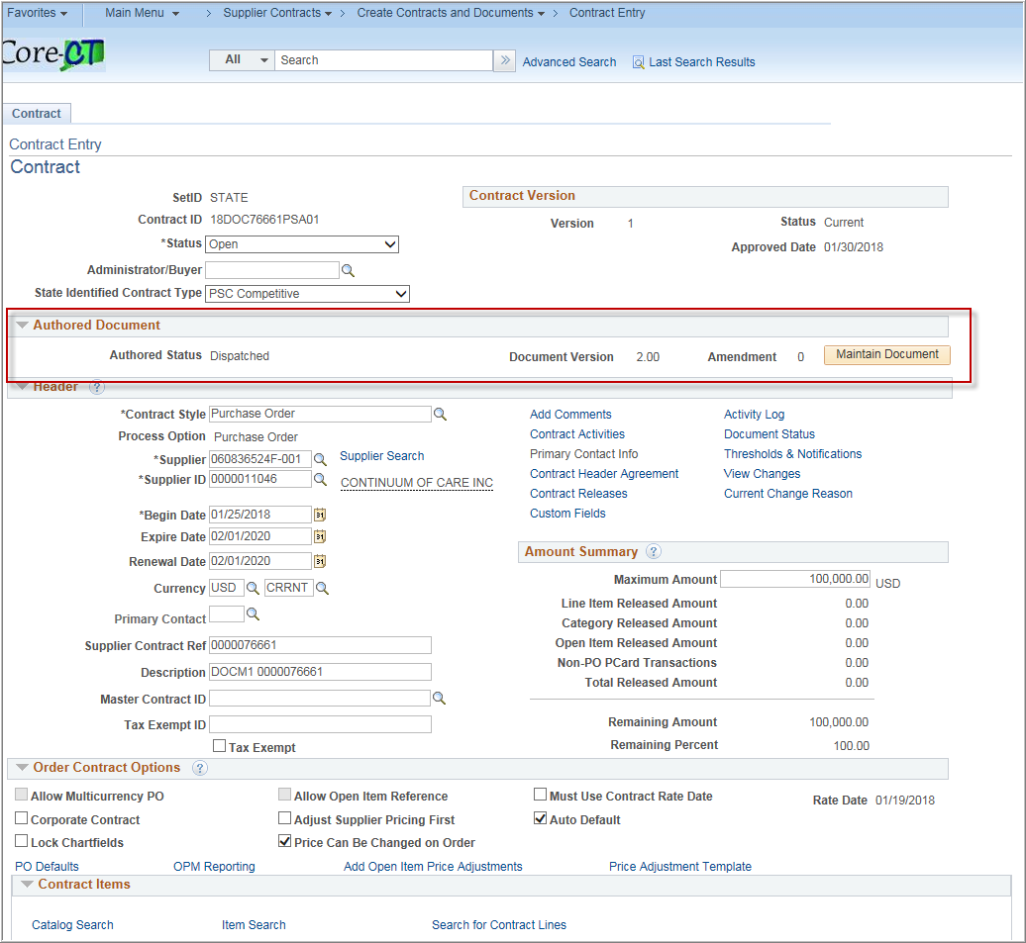

Update the Contract Status to Approved once the Supplier contract portion is completed
Security Note: User must have the Approve Contracts check box checked in their User Preferences to Approve contracts
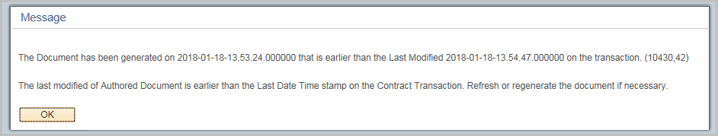
Click OK and Save the Contract
Purchase Orders may now be created using this contract.
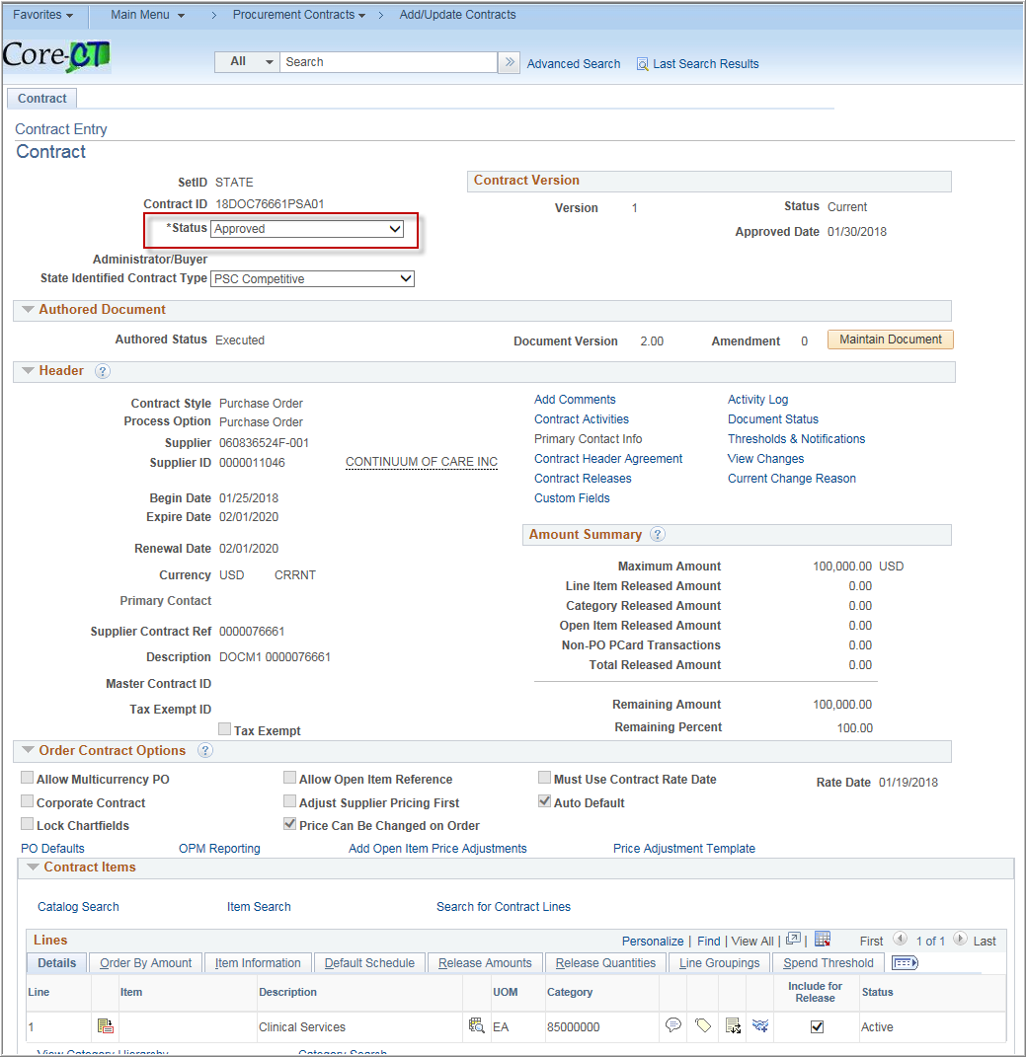

Thresholds & Notifications

Navigation: 1. Supplier Contracts > Create Contracts and Documents > Contract Entry
2. Procurement Contracts > Add/Update Contracts

(either Navigation will work)

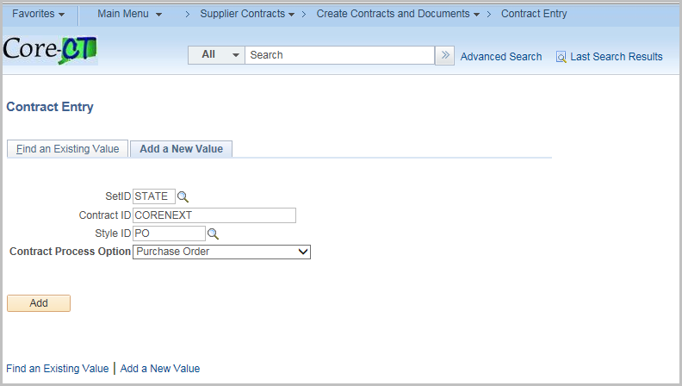
Click the Find an Existing Value Tab
Enter or Search for the Contract Id
Click Search
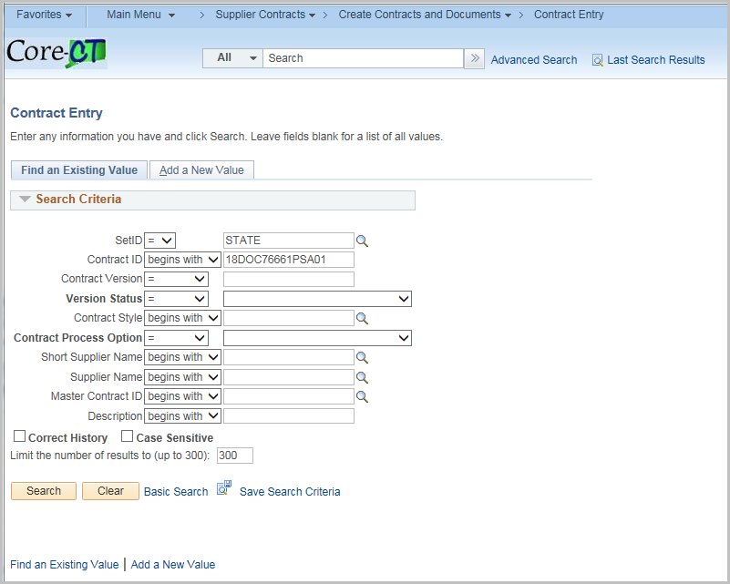
Notifications can be tied to the Approval Due Date.
To use this, enter the Approval Due Date on the Contract.
Click the Thresholds & Notifications hyperlink
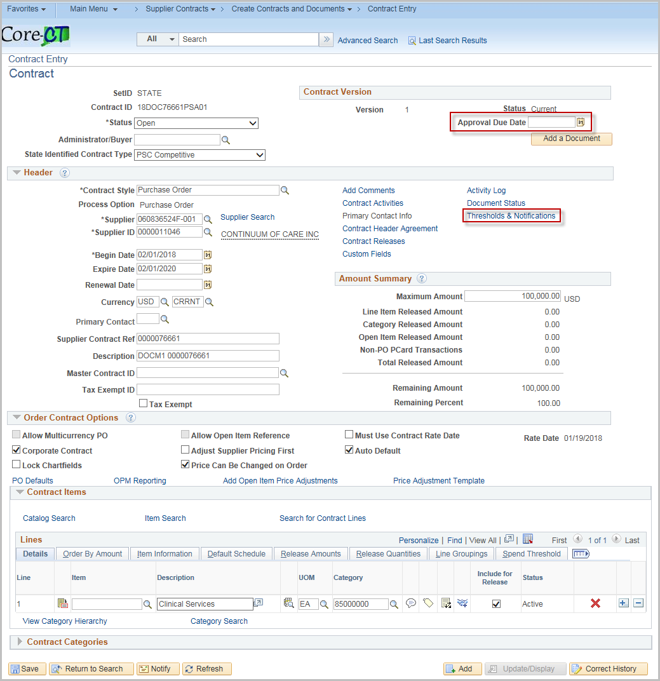

Click Expand All

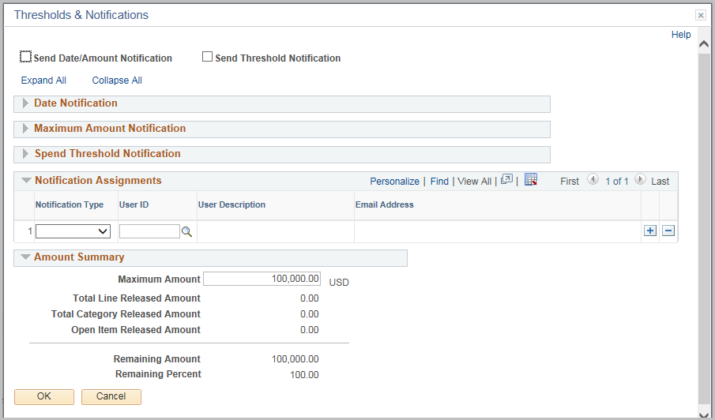
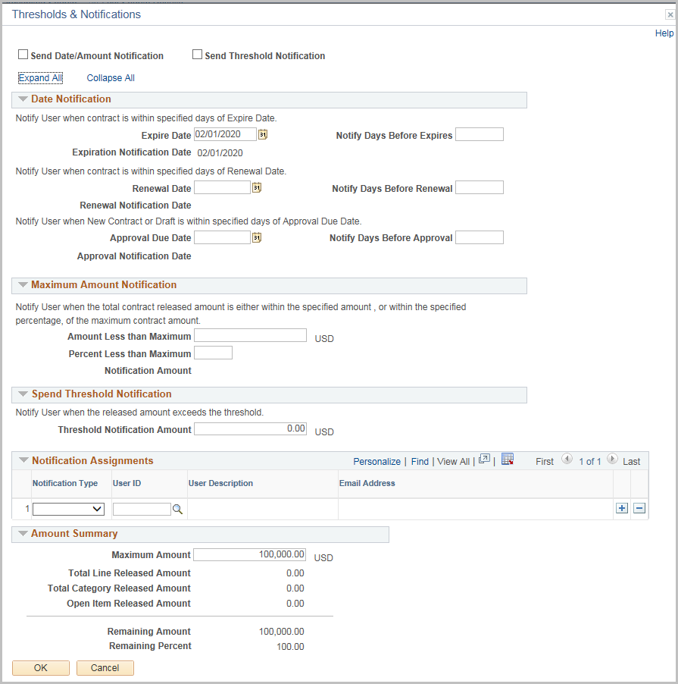

Complete the page based upon the types of threshold and notifications needed
Field | Value
Send Date/Amount Notification | Select to notify when a Contract will expire or reaches the maximum amount
Send Threshold Notification | Select to notify when a contract reaches or exceeds a spend threshold

Date Notification
Field | Value
Expire Date | Defaults from the Contract Page
Notify Days Before Expires | Enter the number of days before to send notification
Renewal Date | Defaults from the Contract Page
Notify Days Before Renewal | Enter the number of days before to send notification

*In each case the system will calculate and display the notification date
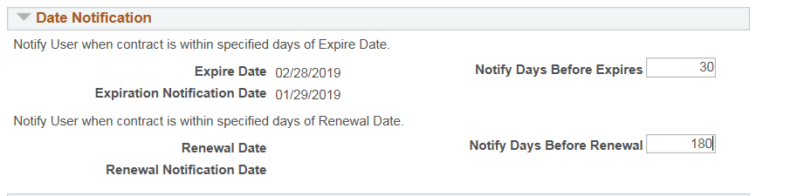
Note: Updating any of these days on the notification page will update the values on the Contract
Maximum Amount Notification
Field | Value
Amount Less than Maximum | Enter a value below the maximum to send a notification  Entering an amount will automatically calculate the percentage
Percent Less than Maximum | Enter a percentage below the maximum to send a notification  Entering a percentage will automatically calculate the amount
*Once entered, the system will calculate and display the notification amount
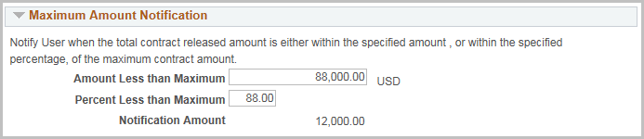
Spend Threshold Notification
Field | Value
Threshold Notification Amount | Enter a value to send a notification

*This will apply to each line on the contract
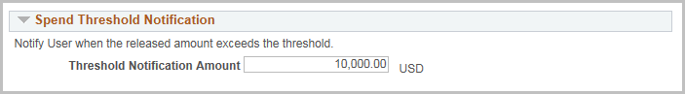
Notification Assignments
Field | Value
Notification Type | Drop down of available notifications
User ID | Select from valid user ids (internal and supplier will use email on profile)

To add multiple users click the +
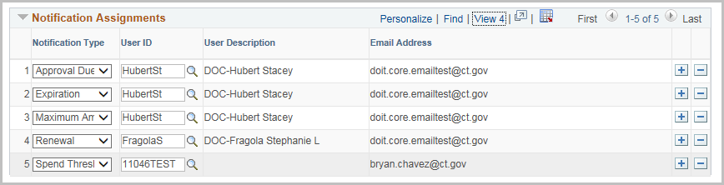
When a threshold is met, an email is generated and in the worklist
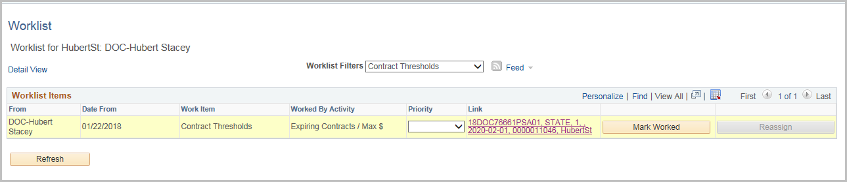

Sample E-mail
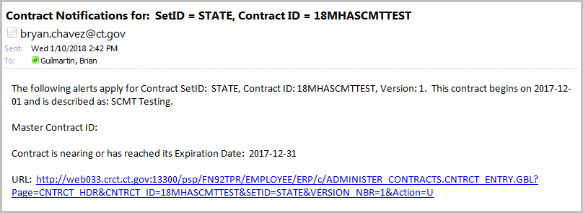
Notifications also appear in the Worklist

Amount Summary
These fields are populated based on the transactions against the contract. This section is also displayed on the Contract Entry page.
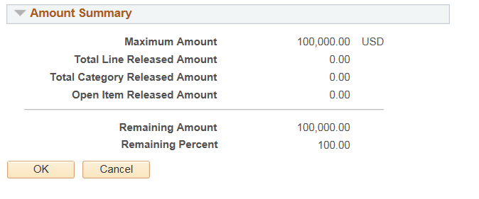
Click OK and return to the Contract Entry page.

SCMT Document Creation

User must have CT_F_A_SCMT_USER or CT_F_A_SCMT_ADMIN role

Define User Preference Supplier Contract Management
This page is for Core Support, each SCMT User or Admin role needs user preferences updated.

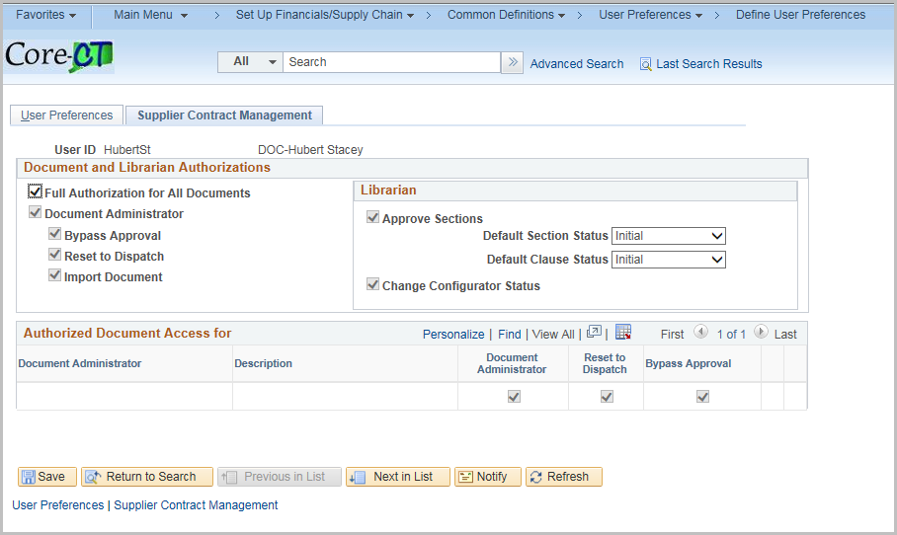

Navigation: Supplier Contracts > Create Contracts and Documents > Contract Entry
Or Procurement Contracts > Add/Update Contracts

(either Navigation will work)

Click the Find an Existing Value Tab
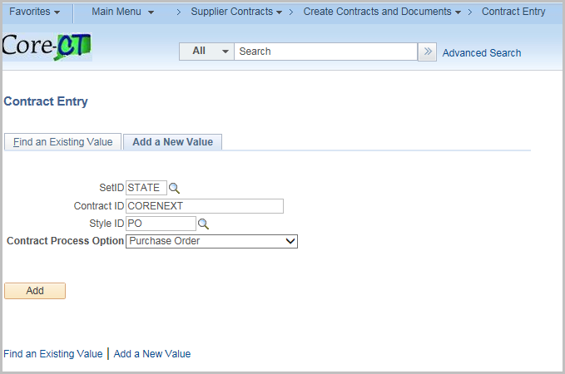
Enter contract id or search for the Contract
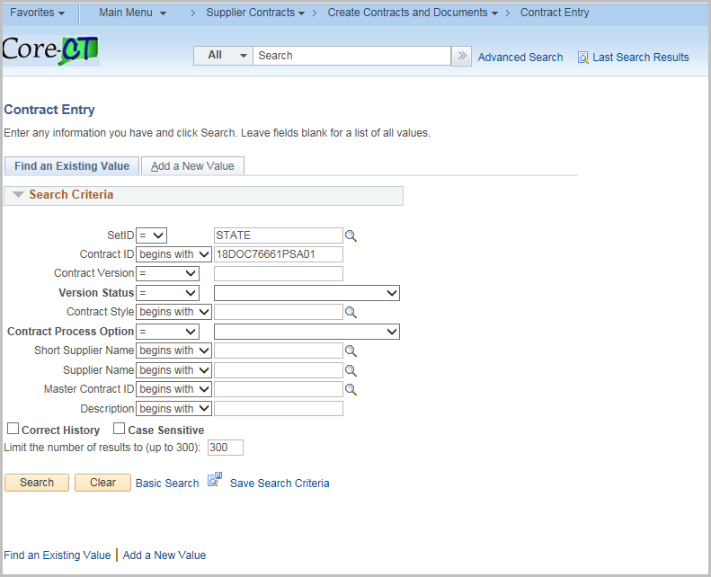
Click Search
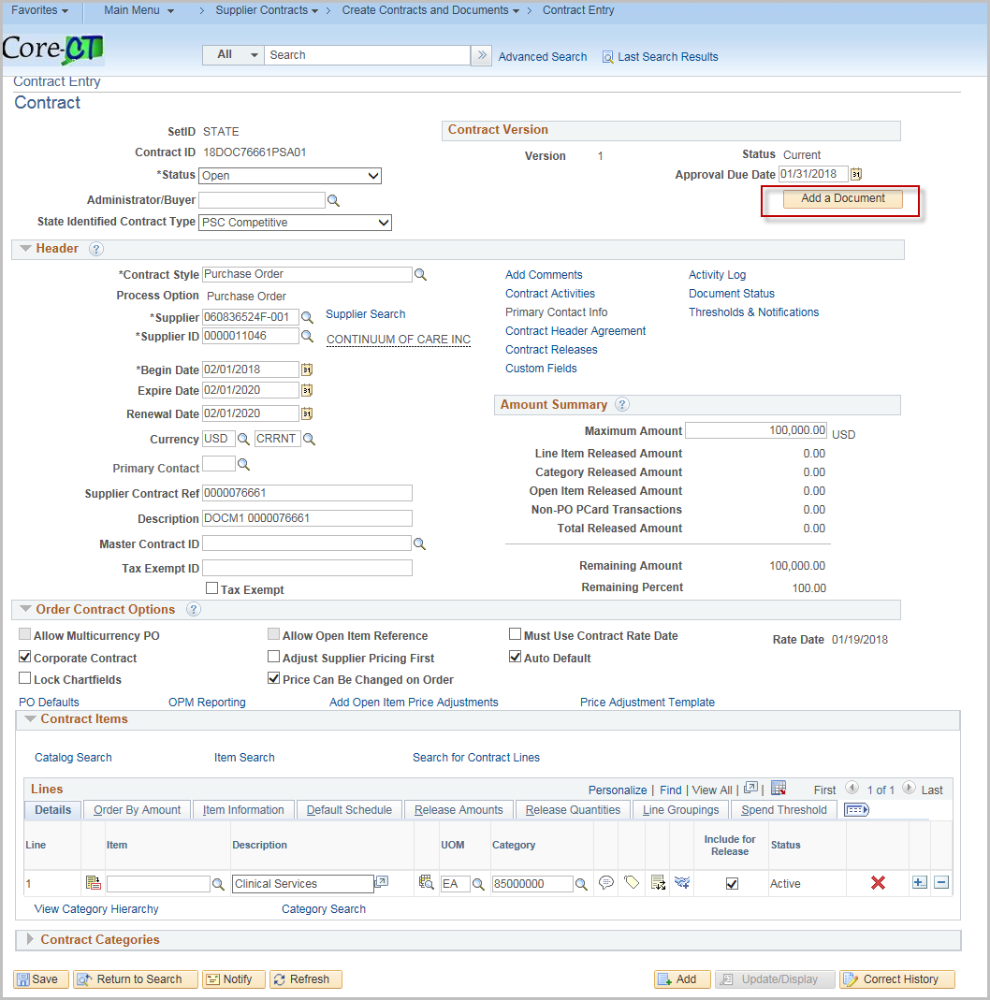

Click Add a Document
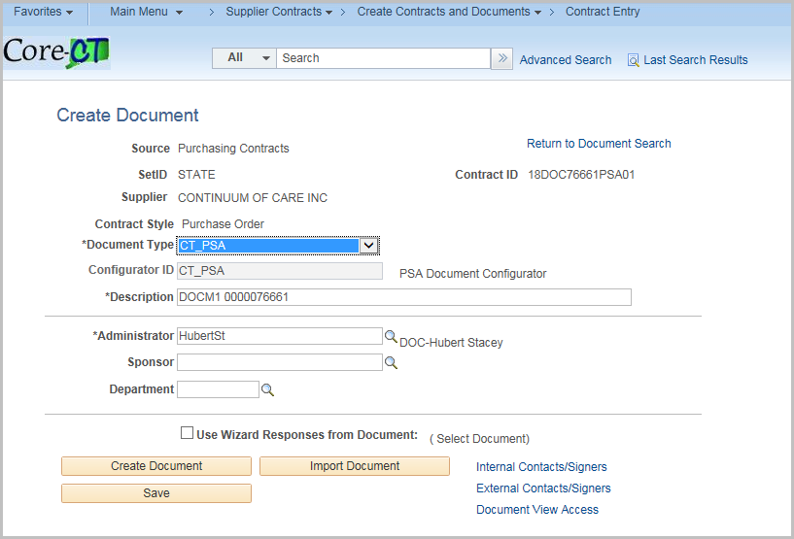
Select CT_PSA Document Type
Click Create Document – to launch the Wizard Execute – Document Creation
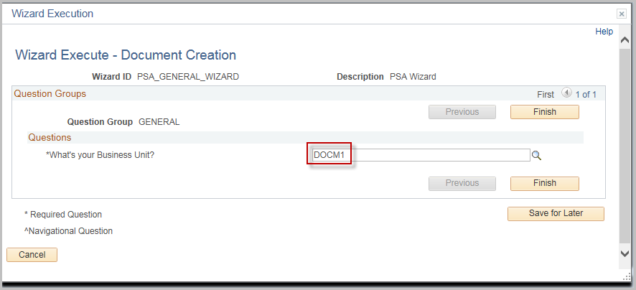
Enter the Business Unit

Click Finish

Document Management

User must have CT_F_A_SCMT_USER or CT_F_A_SCMT_ADMIN role

Click the return to Document Search to search for another contract

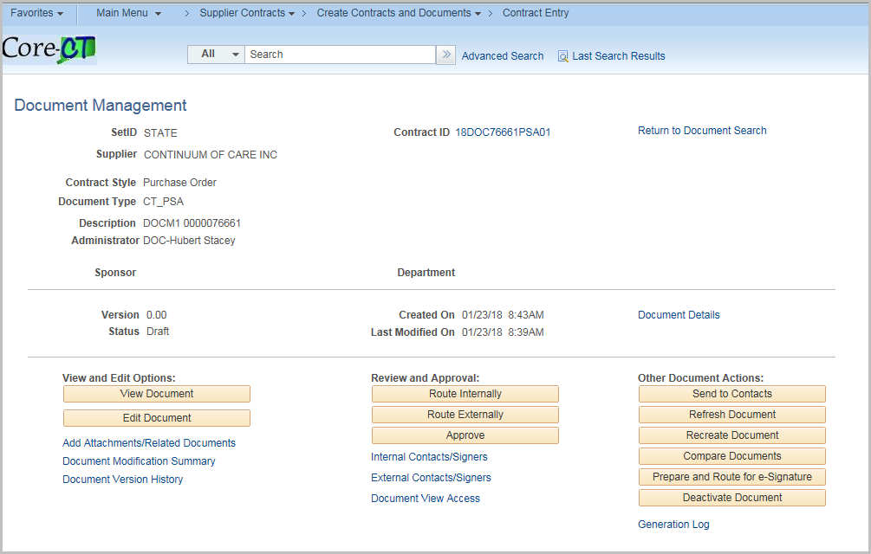

Once the Supplier Contract process has begun the Procurement Contract will update with the corresponding Supplier Contract Status/Version/Amendment.

To access the Supplier Contract click Maintain Document

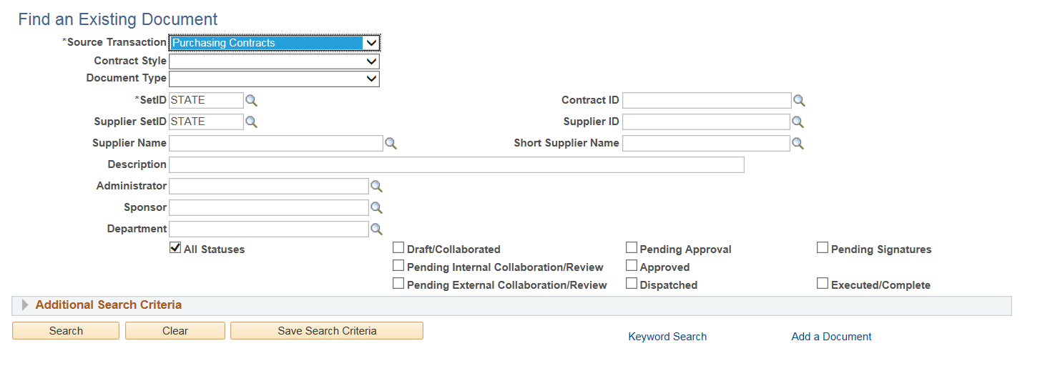
Change the Source Transaction to Purchasing contracts
Enter the criteria and click search
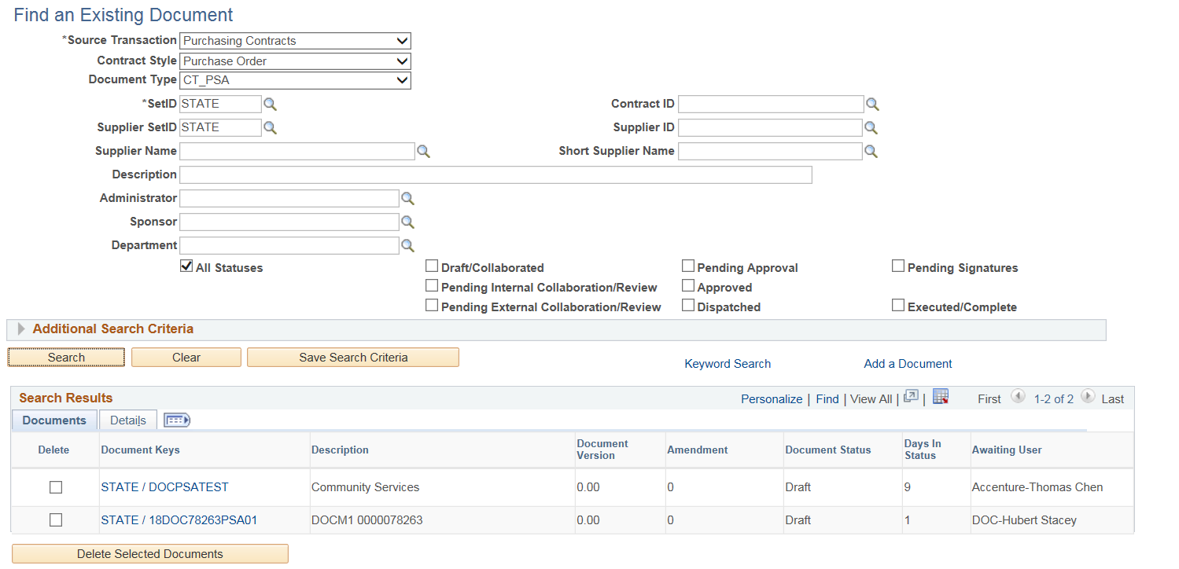

Choose the contract you want by clicking the Contract id under Document Keys.
This will take you to the Document Management Page
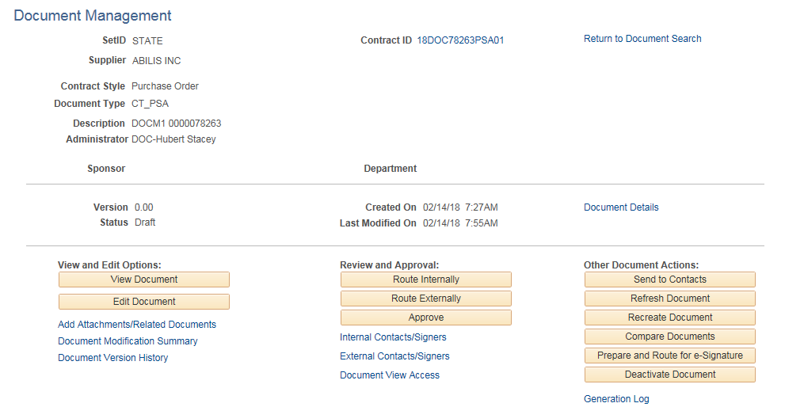

Document Details

Click Document Details link for an overview of the contract
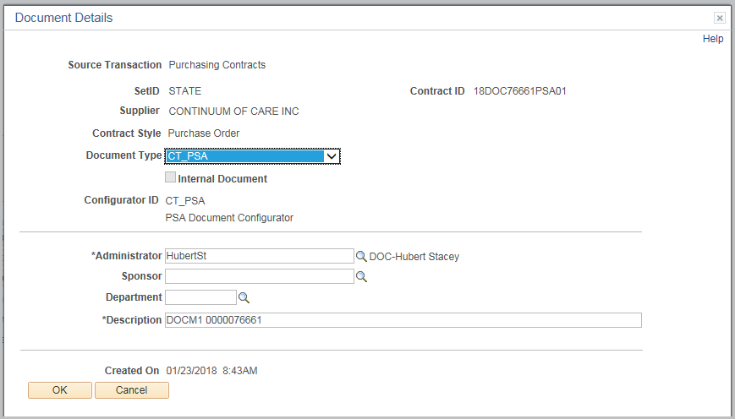
Click Ok

View and Edit Options

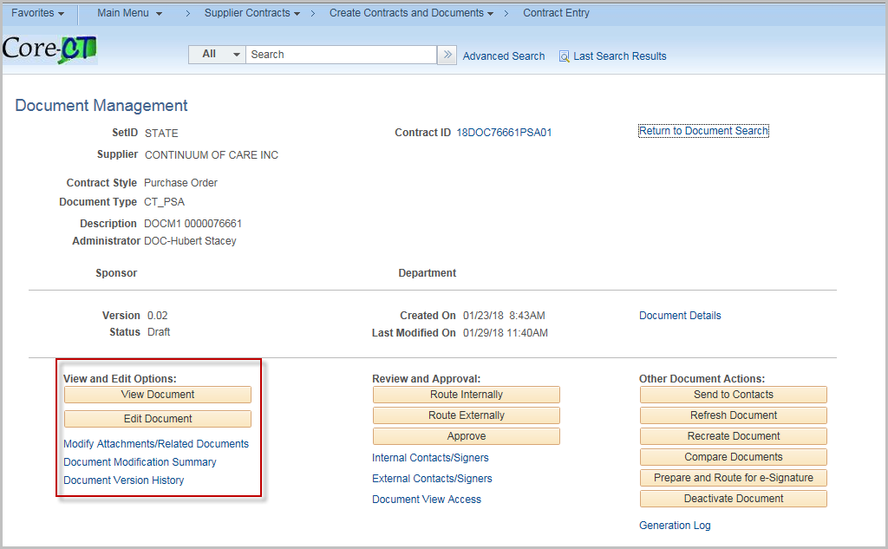

Note: Click Refresh Document to update custom bind variables.

View Document
Click on the View Document Button
Opens a word version of the document

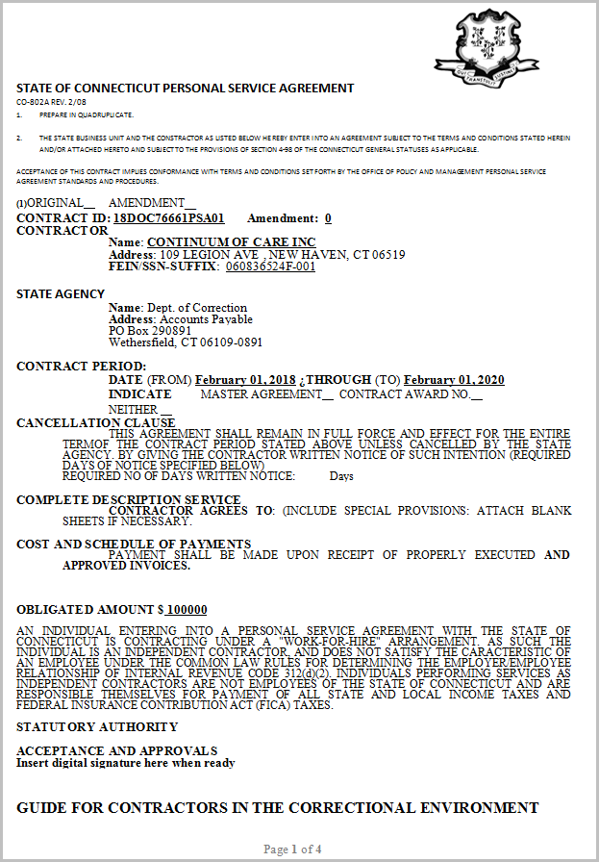

Edit Document
Click on the Edit Document Button
Checks out a word version of the document to edit

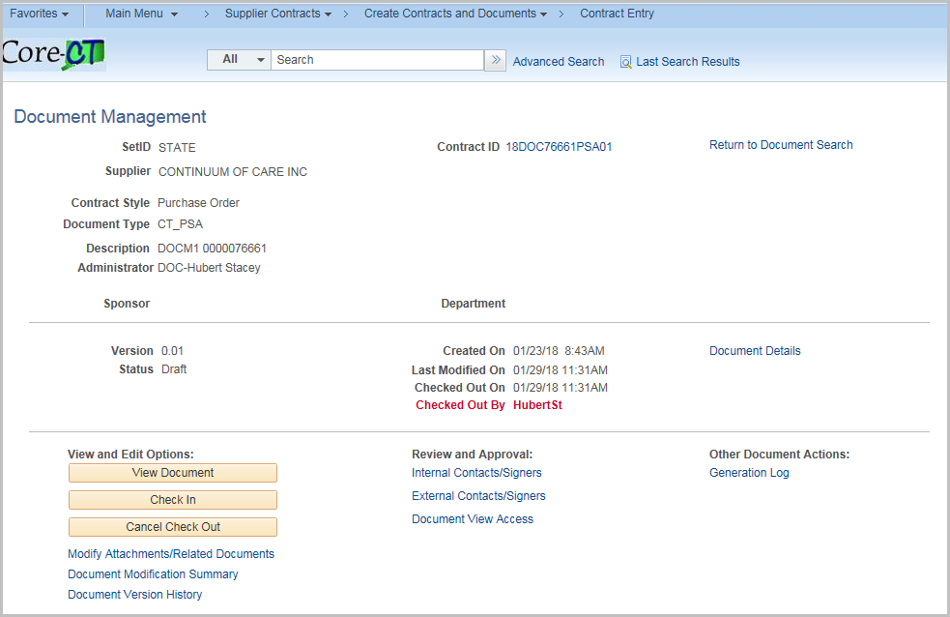

Once checked out, the page will update the status and add a Check In button as well as a Cancel Check Out button

On the document, click enable editing, make any changes as necessary then save the document.

Note: When saving DO NOT change the file type.

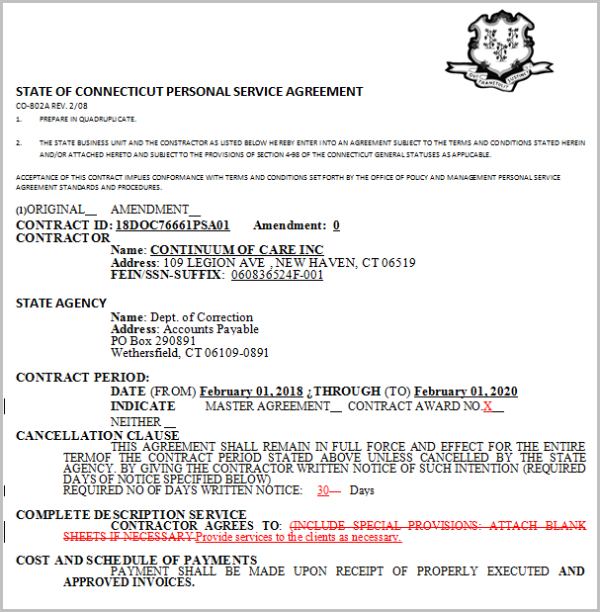

To check back in with the changes, click the Check In button

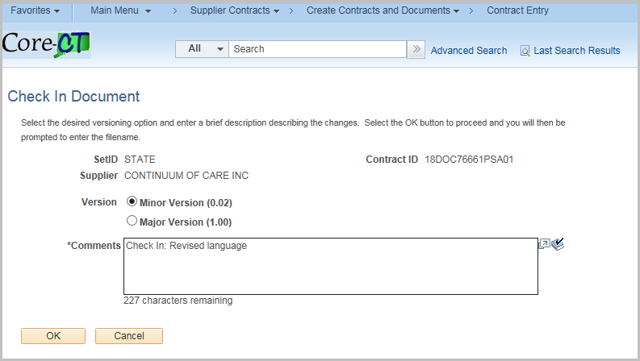

The version is defaulted to Minor. Click Major as appropriate.
Enter any comments needed.

Click OK

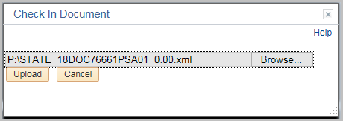

Click Browse and navigate to where you saved the document

Click Upload

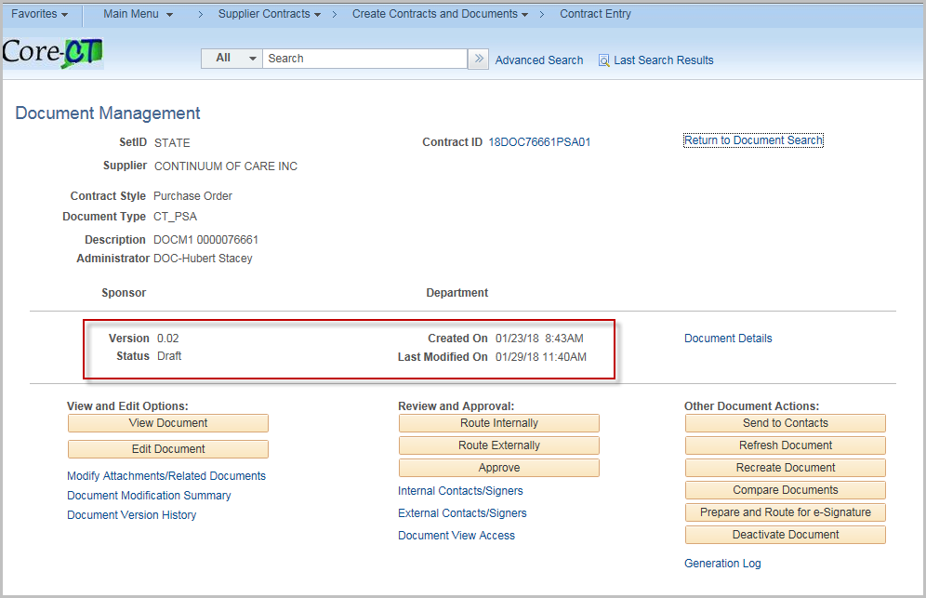

The document will be uploaded as the current version

Add Attachments/Related Documents
To add attachments and documents related to the main document
Click Upload a Document Attachment File

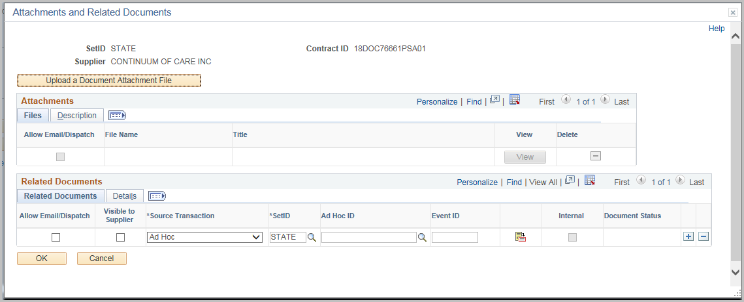

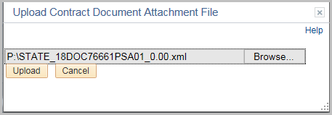

Click Browse and select a file you wish to attach

Click Upload

Check Allow Email/Dispatch if the document should be available to external contacts

Enter a Title for the File

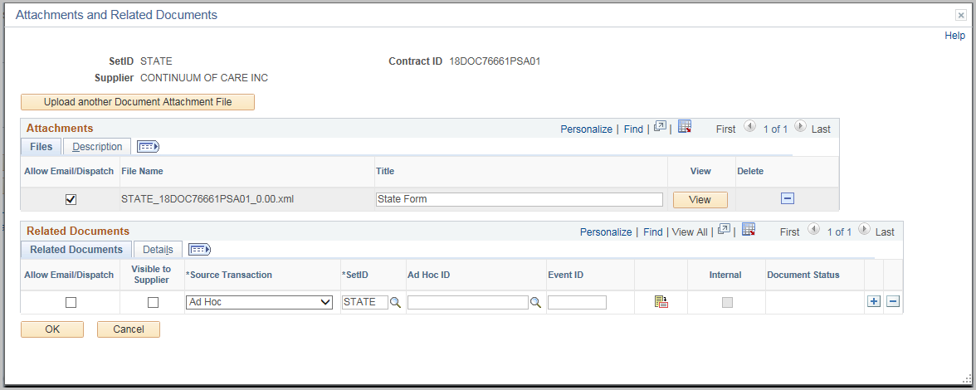
Click the Description Tab
Enter a Document Description for the attachment
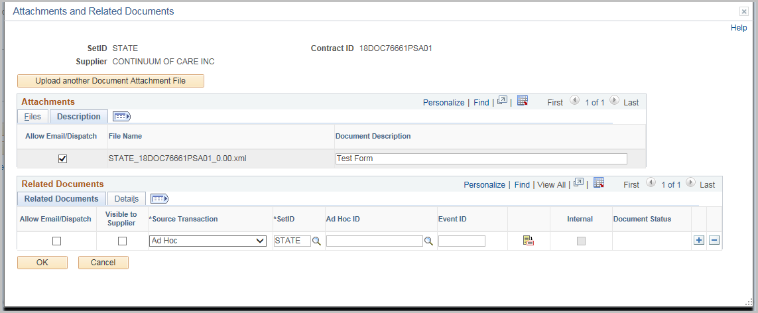
Click OK

If an attachment has been added to the Contract the hyperlink will change to Modify Attachments/Related Documents

Click Modify Attachments/Related Documents

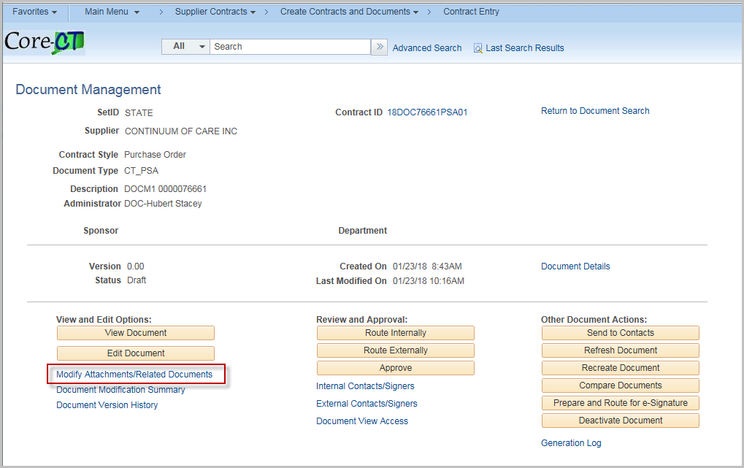
Enter a Related Document

Check Visible to Supplier if the document should be available to external contacts
Source Transaction will either be a purchasing contract or ad-hoc

Enter or search for the Contract ID to reference

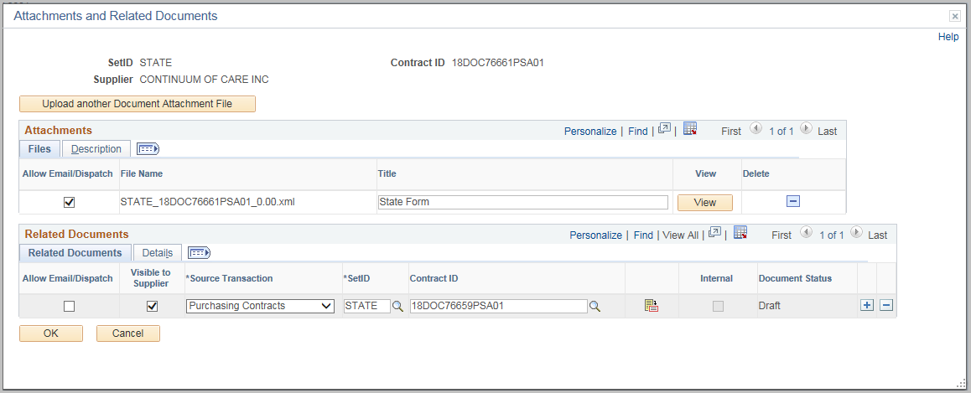

Click the Details Tab to view more information on the referenced contract

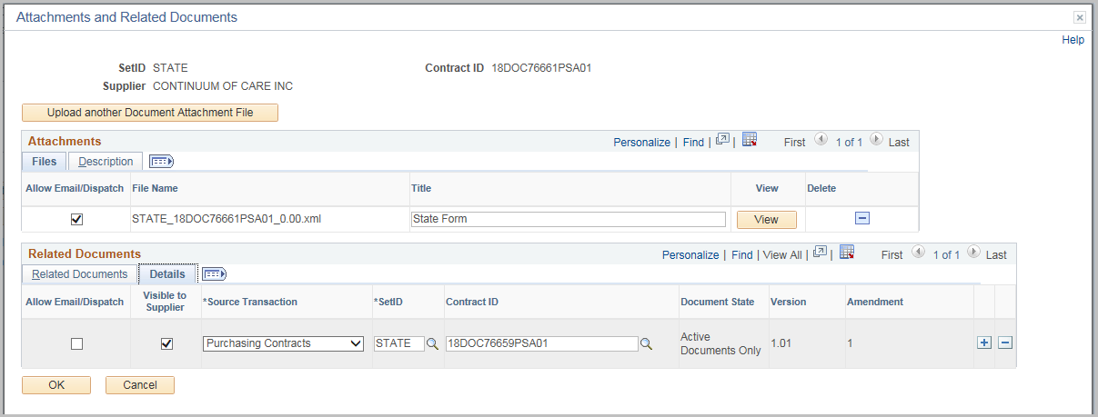

Click OK

Document Modification Summary

Click on the Document Modification Summary to view changes to the document.

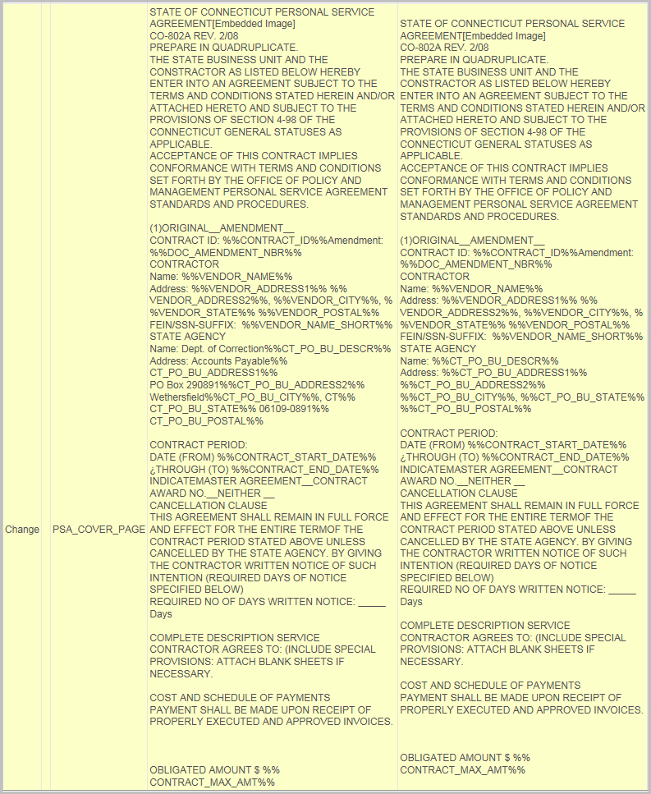

Document Version History
Use the Document Version History to view detailed change information
- Use the Document Action drop down to view specific actions
- Click on the View Source Version History hyperlink to view the version(s) of the document.
- Click on the version number hyperlink to view the document version
- Click the paperclip under View Attachments (when available) to view attached documents

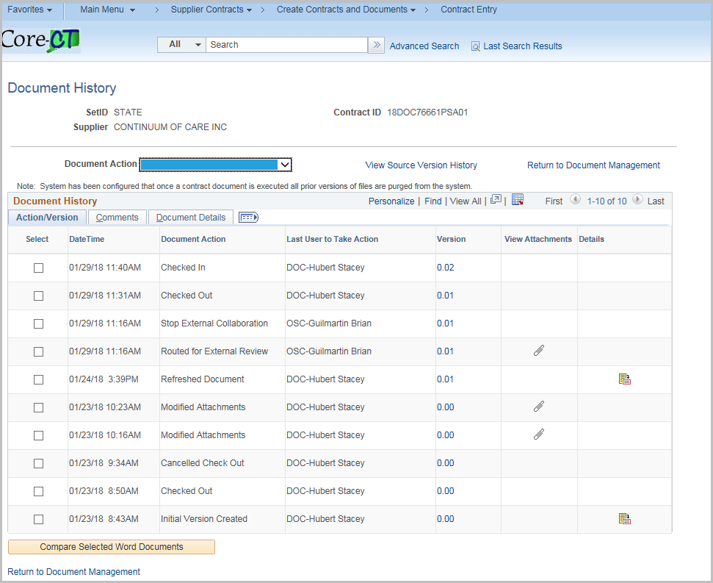

- Check document under select (must check 2 to compare), then click on Compare Selected Word Documents to compare changes between the two.

Changes will appear in red
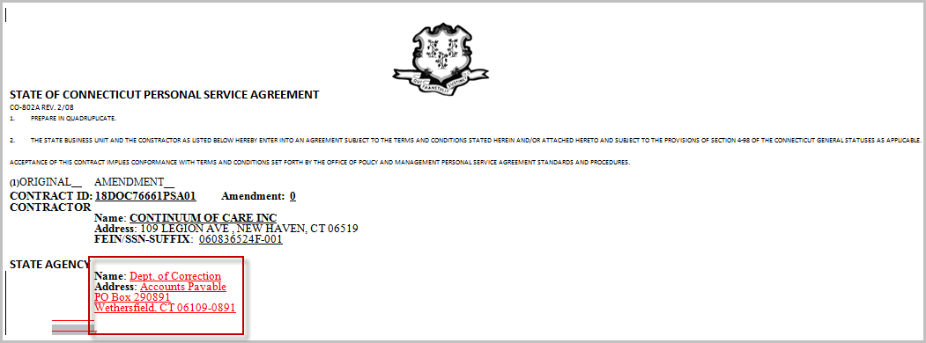

Click the Return to Document Management hyperlink

Review and Approval
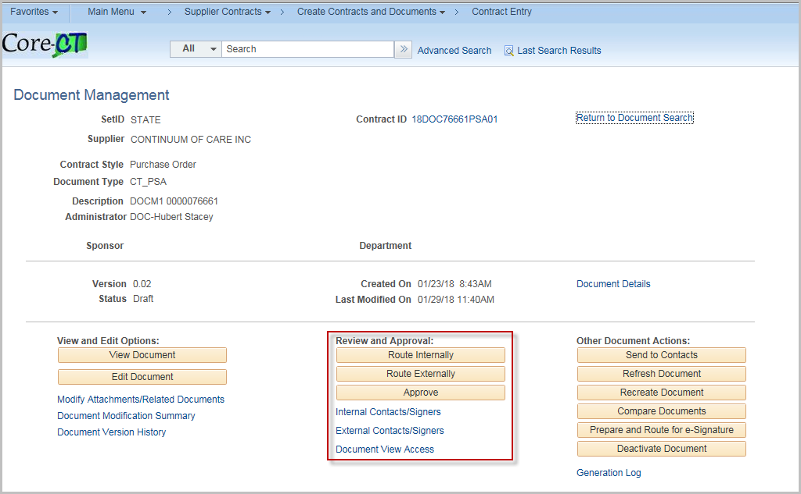

Route Internally
Click the Route Internally button to setup and start internal collaboration.
(Alternately Click Internal Contract/Signors to set up internal users)
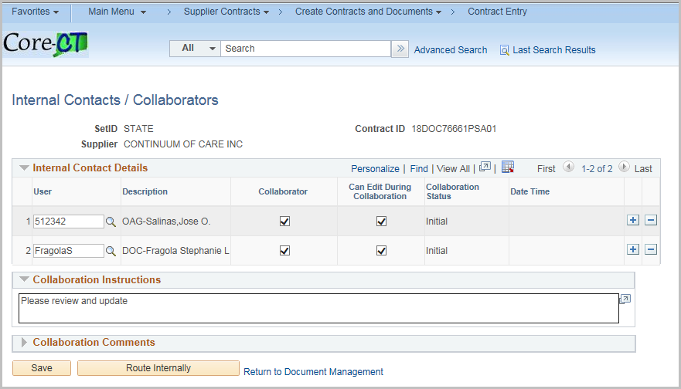
Enter or search for a valid User.
Check the Collaborator box if the user will be collaborating on the document
Check the Can Edit during Collaboration if the user can modify the document
Collaboration Instructions – Enter any special instructions

To add a Comment to the collaboration without routing, enter the comment

Click Save

Click Route Internally when you are ready to send.

NOTE: Any Collaboration Instructions will be sent to all collaborators

Internal Contacts/Signers
Click the Internal Contacts/Signors
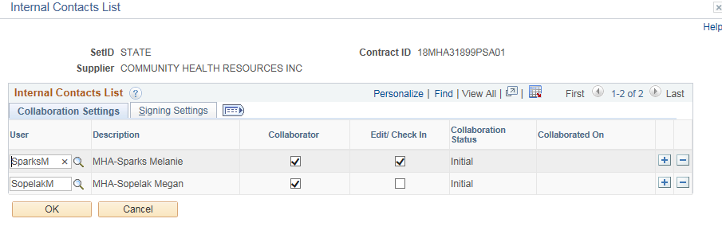
Click Signing Settings Tab
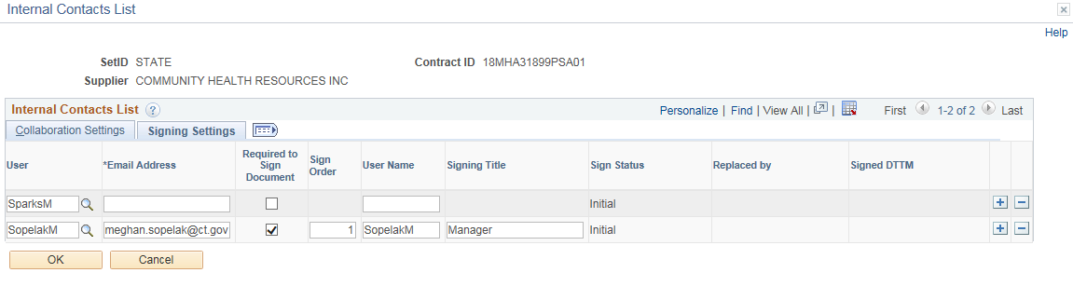
Enter in an email address
Check Required to Sign Document if they will sign
Enter the Sign Order
Enter the User Name
Enter the Signing Title
Click OK
At this point, provided you do not need to Cancel or Modify the Internal Collaboration (steps shown below) the document is routed to the appropriate users for Internal Collaboration.

During collaboration, certain features are disabled.

To cancel the Collaboration, click Cancel Collaboration

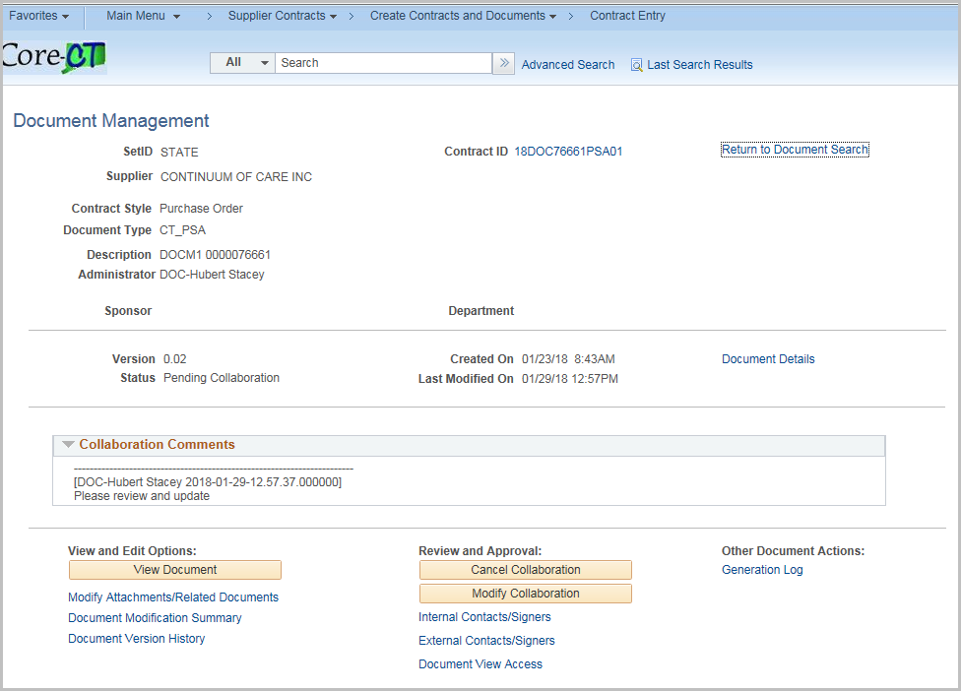

Enter a comment (required) and click OK

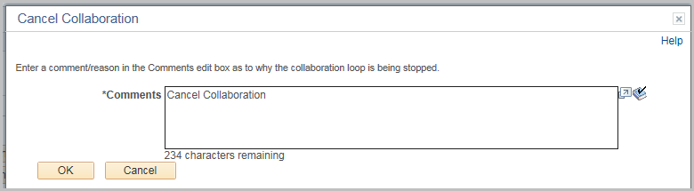

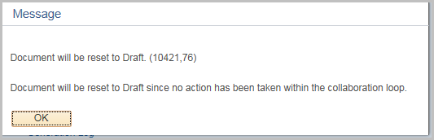

Click OK

In this instance the document is reset.

To modify the Collaboration, click Modify Collaboration

New users and instructions may be added.

Click Route Internally to update.

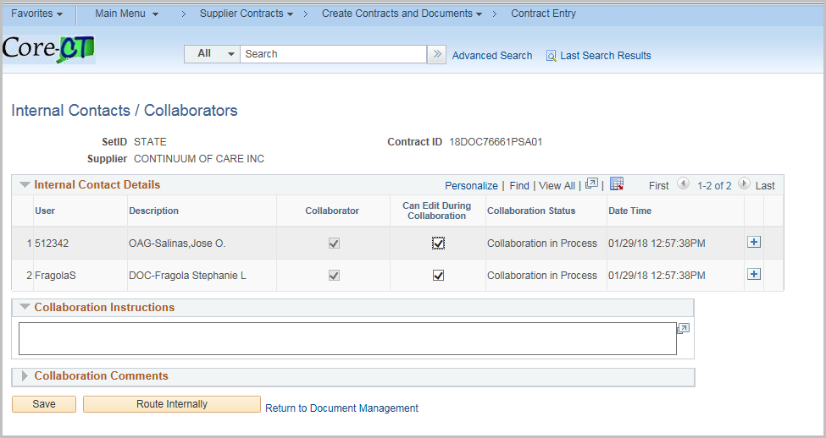

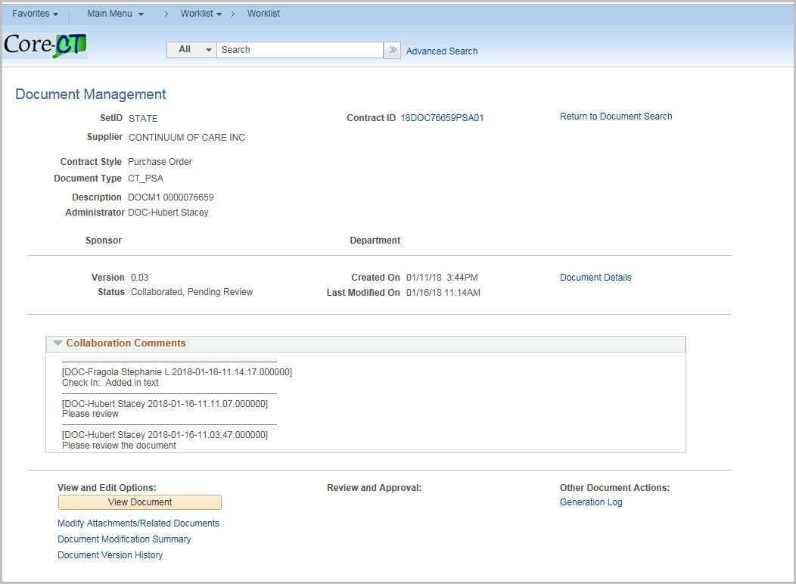

All collaborators will receive an email and can go directly to the Document Management page from the link in the email….

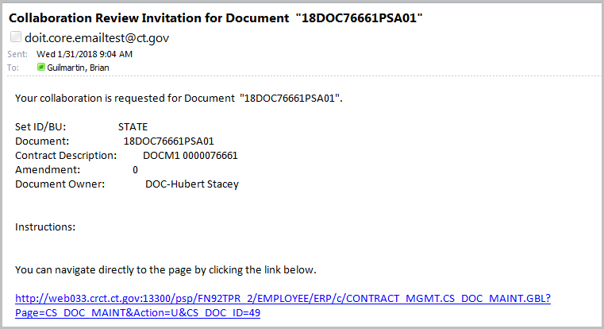

The collaboration request can also be accessed using the user’s worklist

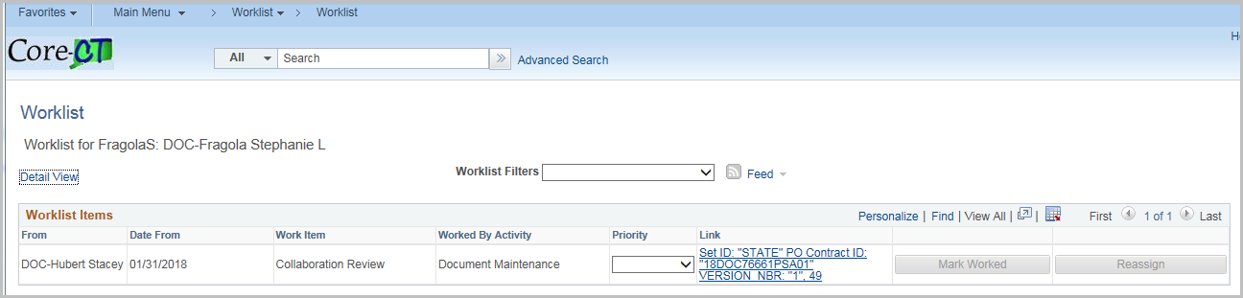

Clicking on either will bring the user to the document management page
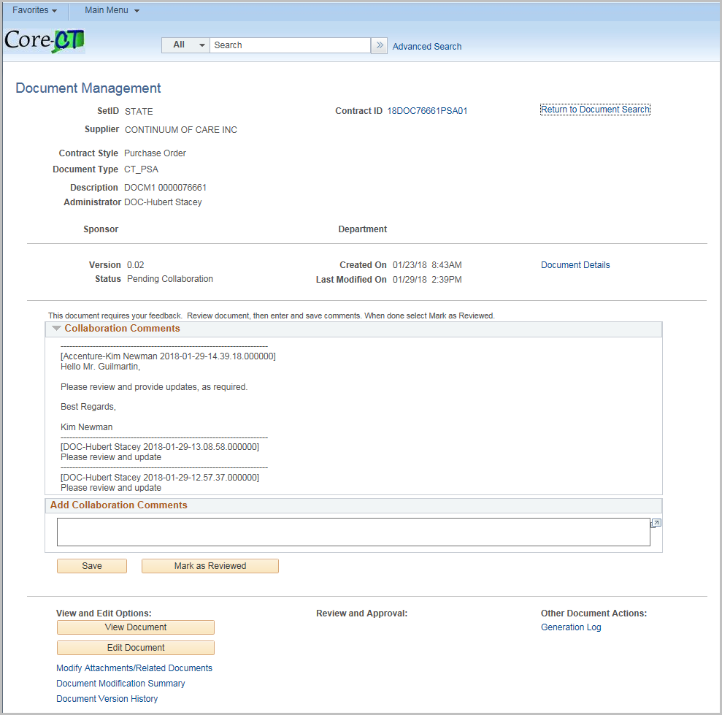
The user can view or edit the document and modify attachments. When editing you must save the document and then upload it with comments.
Enter in a comment in Add Collaboration Comments and click Mark as Reviewed
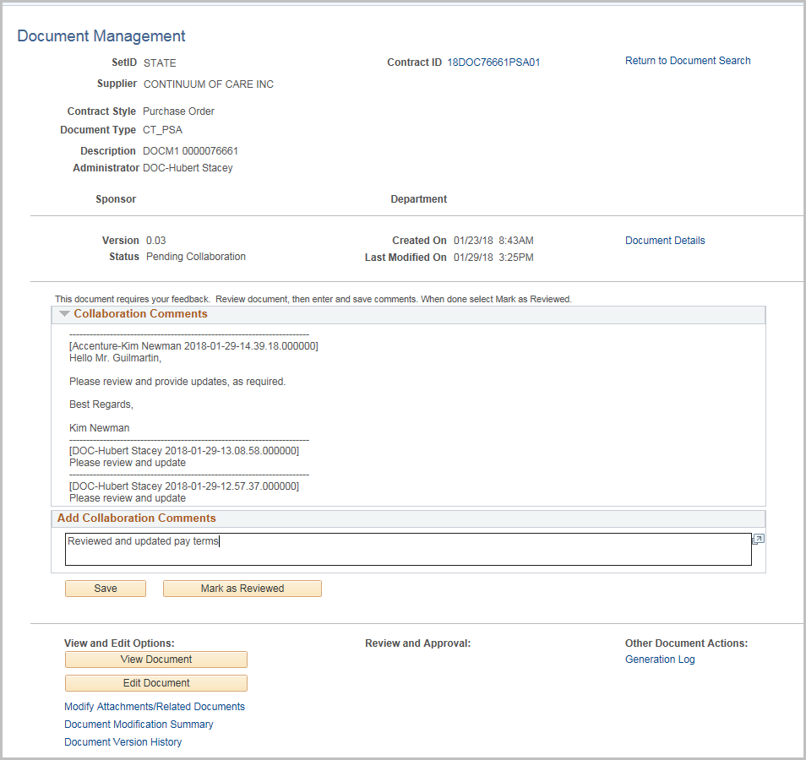

After all internal users have finished collaboration; the contract administrator will see the Collaboration Complete on their worklist

Click on the hyperlink in the worklist
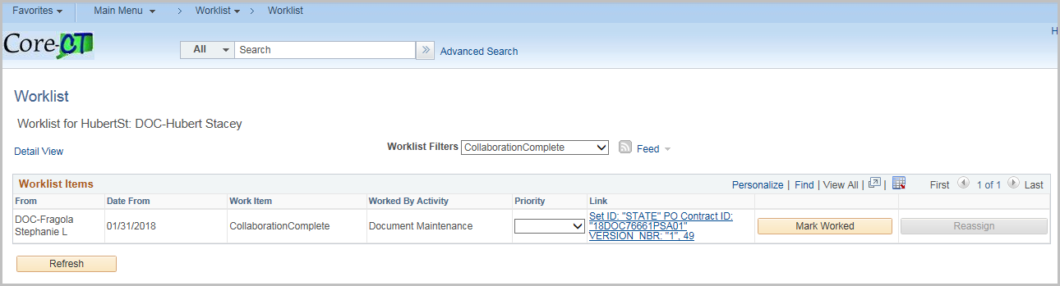Review the contract changes.
Once all changes are finished, click Finalize Collaboration
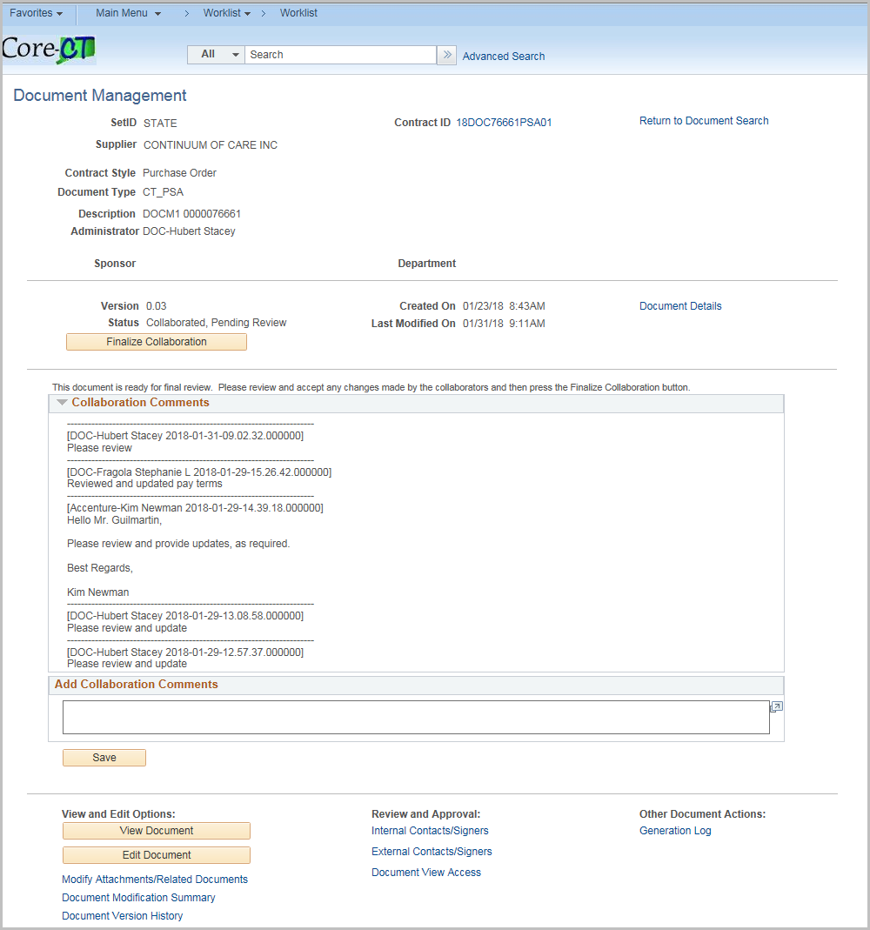
The status will be updated to Collaborated.
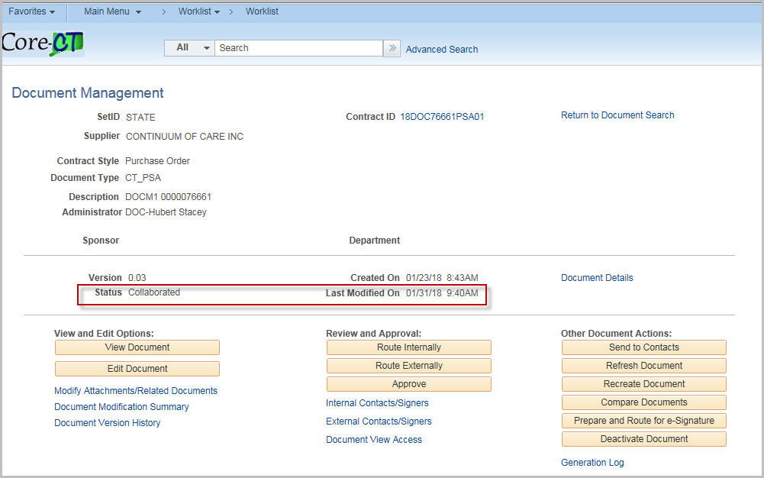

Route Externally
External contact must have the CT_F_SUPPLIER_SCMT_COLLAB role
NOTE: External Contacts must be setup under External Contact/Signers before starting External Collaboration.

Click External Contacts/Signers 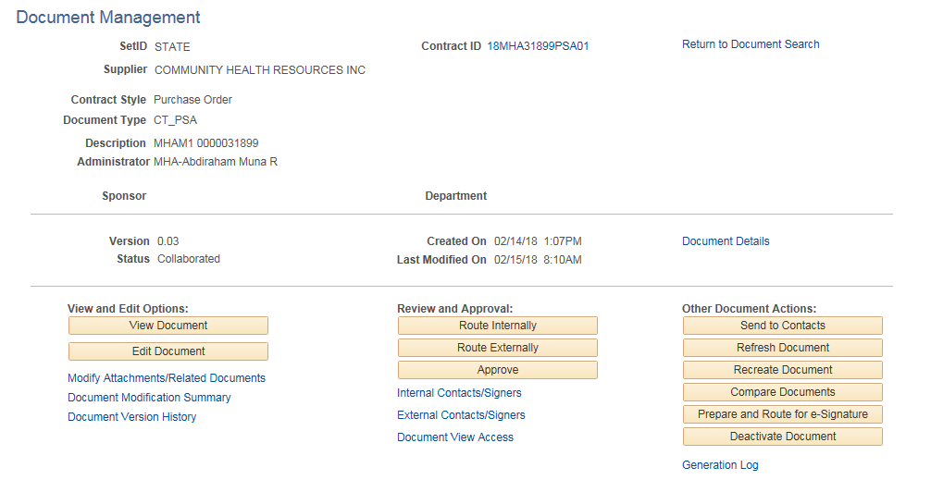

Click the Update From Supplier Contracts to pull all external contacts with the Contract Collaborator role into the external list.

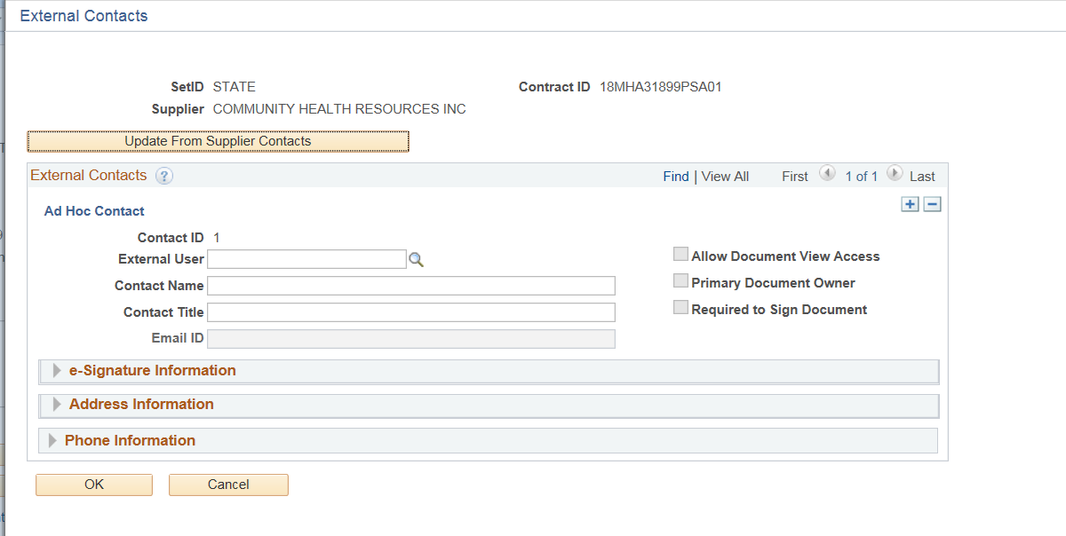
Enter the necessary Information for Supplier for External Collaboration

NOTE: clicking the gray triangle to the left of each section will open that section for input.

Enter or search for an External User
Enter a Contact Name
Enter a Contact Title
Enter an email id
Check Allow Document View Access to allow the contact view access to the document
Check the Primary Document Owner if the contact is the primary (Only one per Contract)
Check Required to Sign Document is they are a signer for the document
On the e-Signature Information enter the Sign Order
Enter the Address and Phone information as necessary
Click the + to add more contacts

Once completed click OK
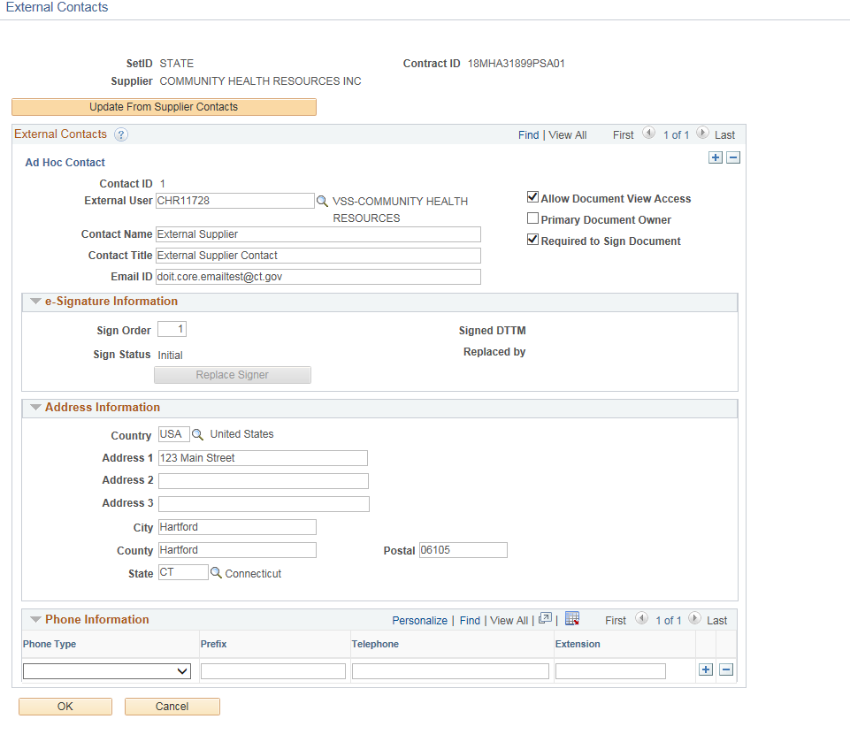

You will be returned to the Document Management page. Select Route Externally button.

Remember: External Contacts must be setup under External Contact/Signers before starting External Collaboration.
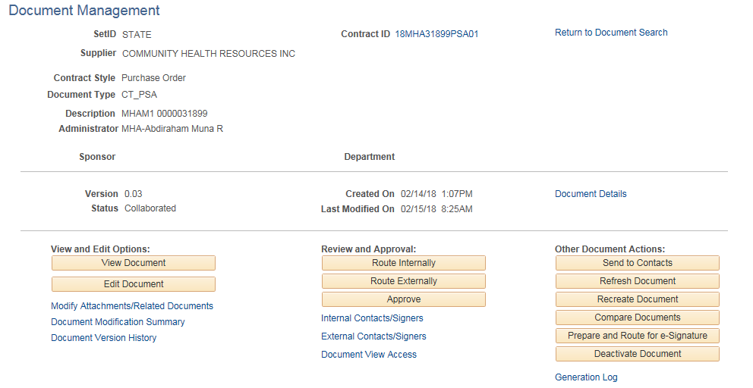
Owner for this Collaboration and Can Edit during Collaboration may be changed on this page.
Enter Collaboration Instructions and/or Collaboration Comments

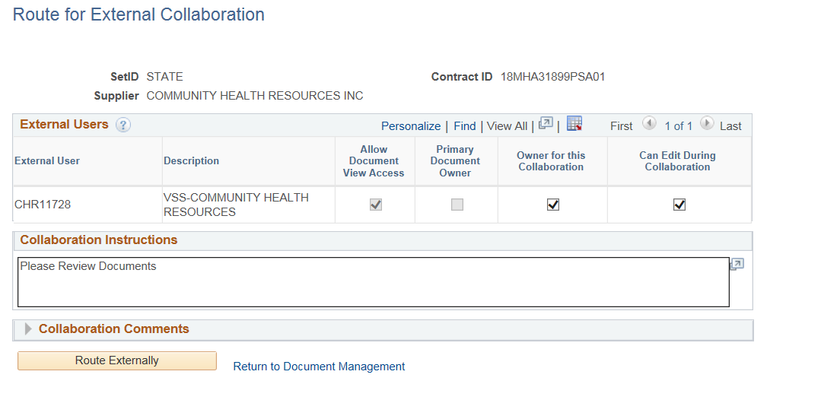

Click Route Externally when ready to collaborate.

NOTE: The Collaboration instructions will be sent to all external contacts.

The status will update to Pending External Collaboration

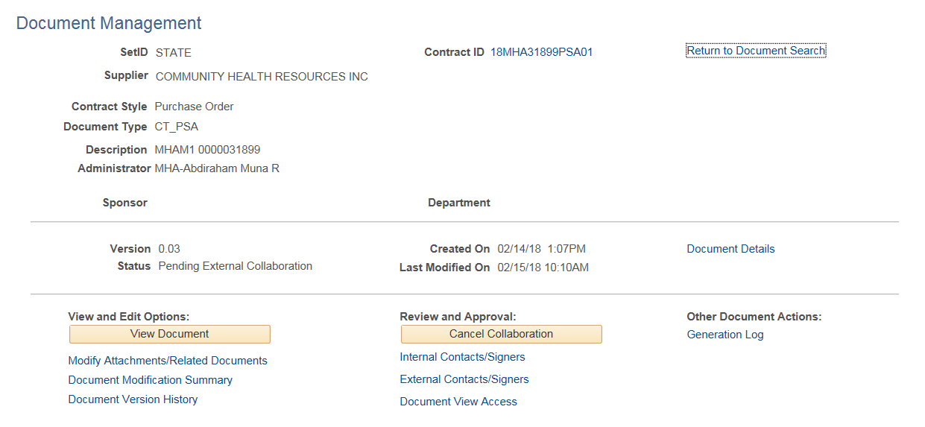

All external users will receive email notification

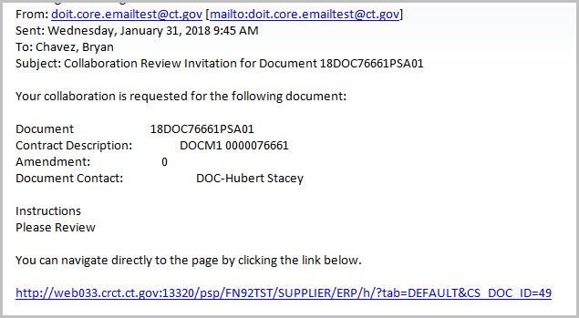

The collaboration review will also be in their worklist

Log in as Supplier/External Contact

Click on Worklist

Click on the hyperlink for the contract

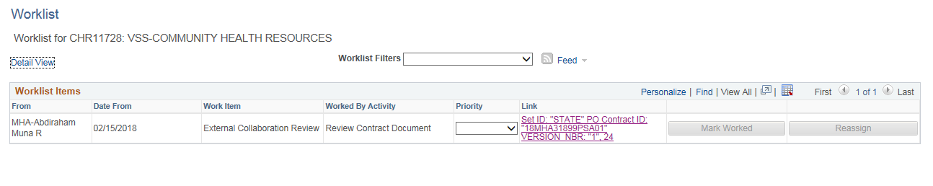
The supplier/external contact will be taken to the Document Management page to review the contract. There are instructions for the external contact on hwo to review and approve document.

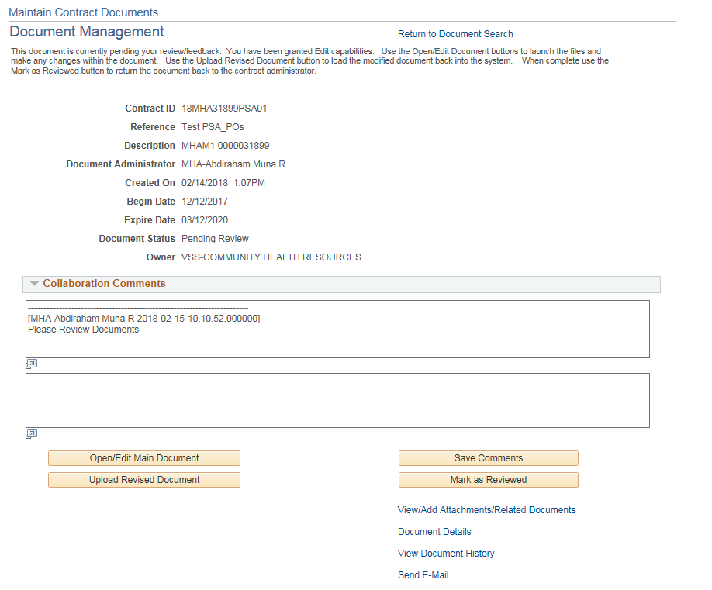

Only one Owner for this Collaboration – Can Edit During Collaboration

External Contacts can:

Click Open/Edit Main Document to review/make changes

Upload Revised Document if changes have been made
Only the External Owner has the ability to edit the main document (if granted).

Enter a Comment and click Save Comments

Click Mark as Reviewed when collaboration is complete

Send E-Mail link is limited to only the contract administrator and external collaborators for this contract.

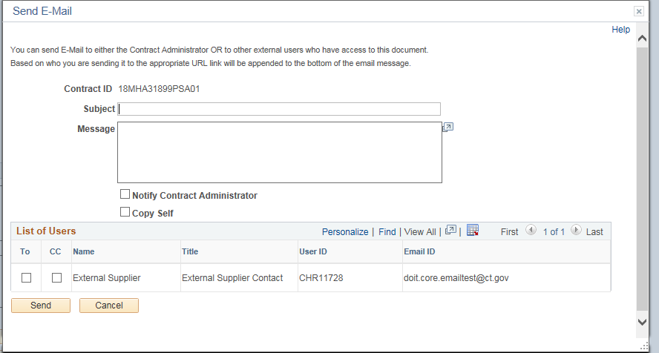

Once the External Collaboration is complete the Contract Administrator will navigate to their Worklist
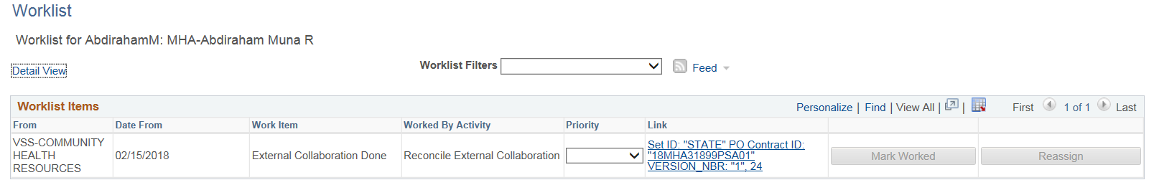
Click the contract link
The Document Management page will display
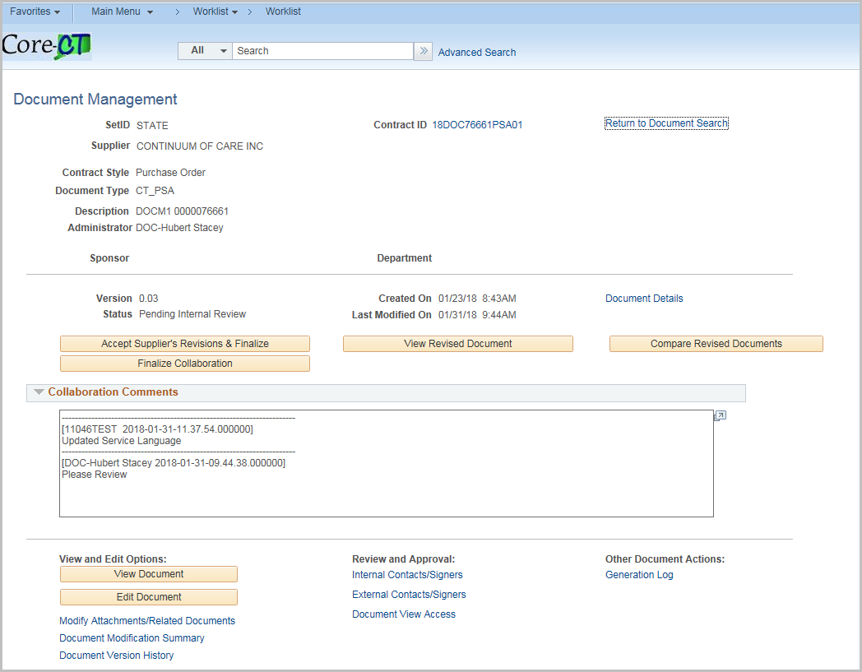

Accept Supplier's Revisions and Finalize
Click to accept the document updates made by the supplier and to set the document to Collaborated status. This button is available for the contract administrator after the supplier completes their external collaboration. This button is not available if the supplier did not check in an acceptable format for the file. For example, if they checked in a .doc file instead of an .xml file. In this case, the contract administrator must manually apply any valid changes.
When you click to Accept Supplier’s Revised Documents button, the system displays the Accept Supplier's Revised Documents page. Use this page to maintain the document version and to add comments about the document.

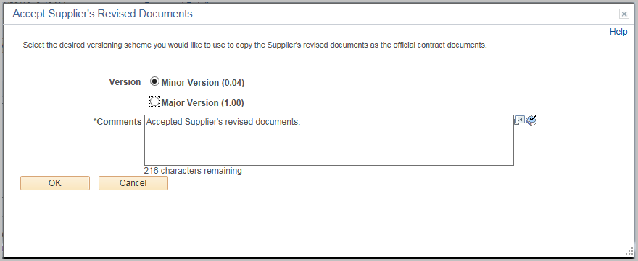
If the supplier made no changes the screen will be a little different and you would just Finalize Collaboration.
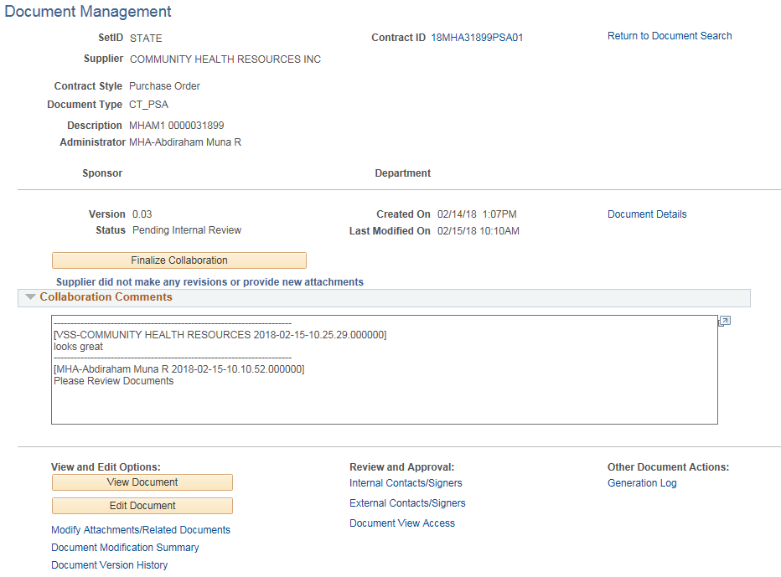

View Revised Document
Click to open a document that has been collaborated on with an external user (supplier).
This button appears on the contract owner’s Document Management page after the supplier has completed their review.
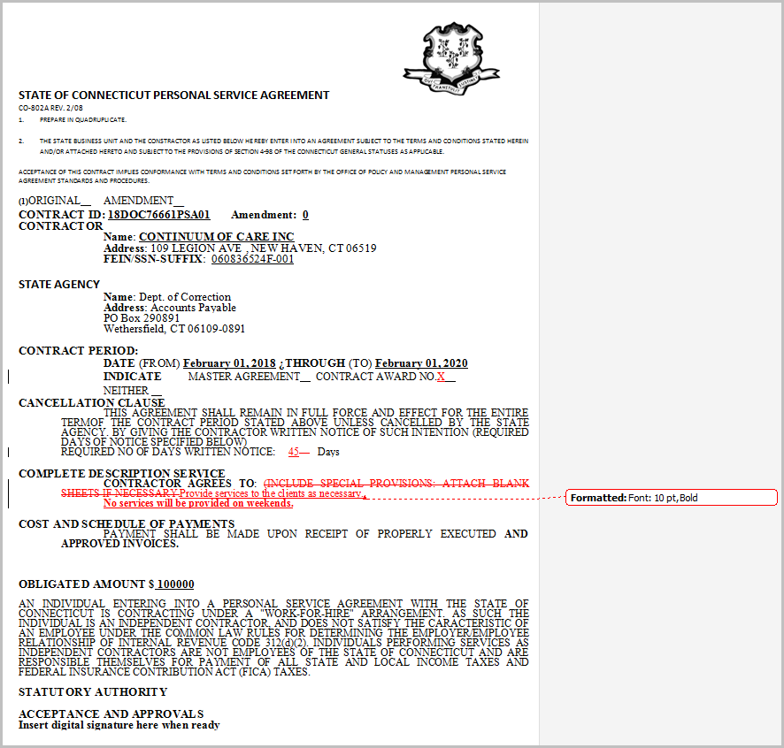

Compare Revised Documents
Click to compare a supplier revised document with the current version of the document. This enables you to better understand what changes may have been made by the supplier. The system opens a new temporary document that shows the changes, just as if you had compared the files using Microsoft Word compare functionality.

Finalize Collaboration
Click Finalize Collaboration to set the document to Collaborated status. This button becomes available for the contract administrator only after the supplier completes their collaboration.
Contract administrators use this option when you want to manually apply any suggested changes to the current version of the document using the Edit or Check In buttons at the bottom of the page. After making the manual changes click Finalize Collaboration to complete the collaboration process.
Once Completed the Status will update to Collaborated
Note: If you finalize collaboration without accepting the suppliers' revisions or attachments the revisions will be excluded from version control and kept only in the document history.

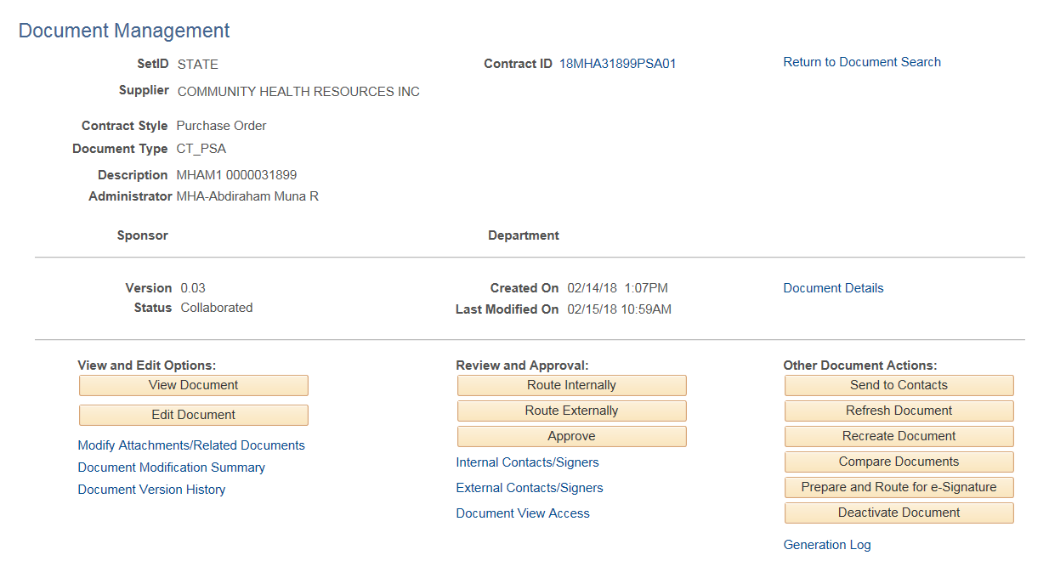

Prepare and Route for e-Signature

Before clicking the link
- Edit the Document and confirm all changes.

Click Edit Document
Click the enable editing
Update the changes – uncheck track changes when done.

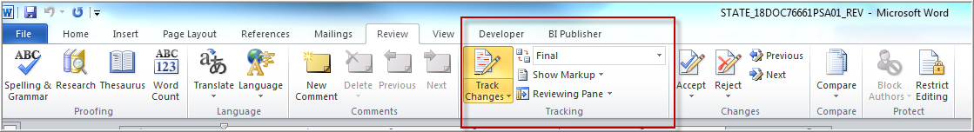

Save the document

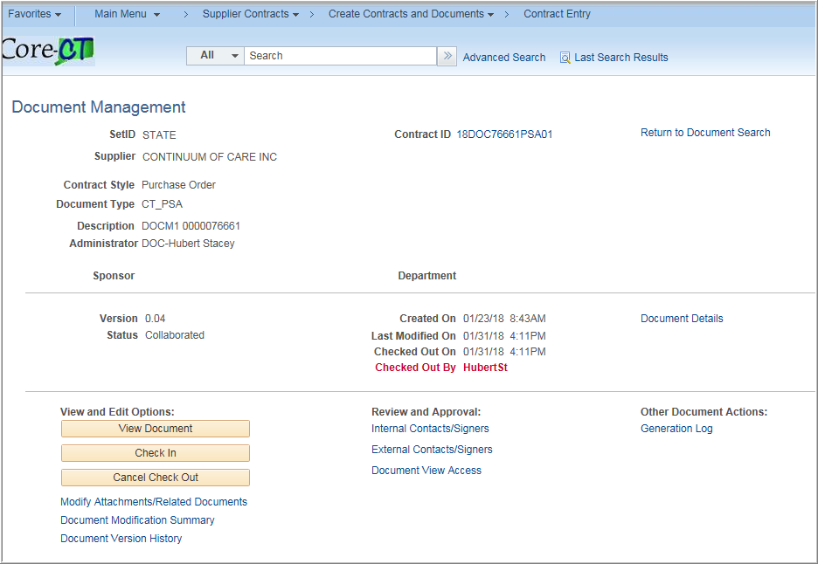

Check in the document
- Verify all signers (internal and external) are setup and are in the correct signing order (should have been set up before collaboration).

Internal Signing Settings
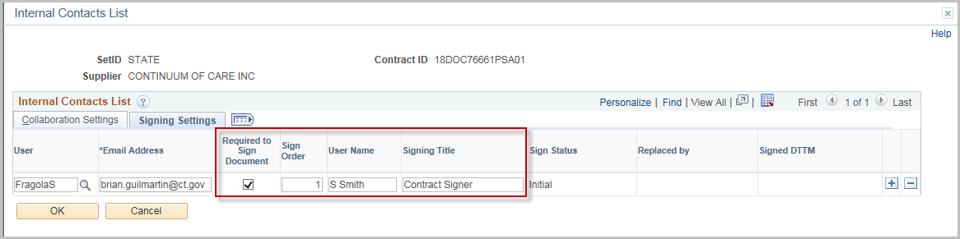

External Signing Settings
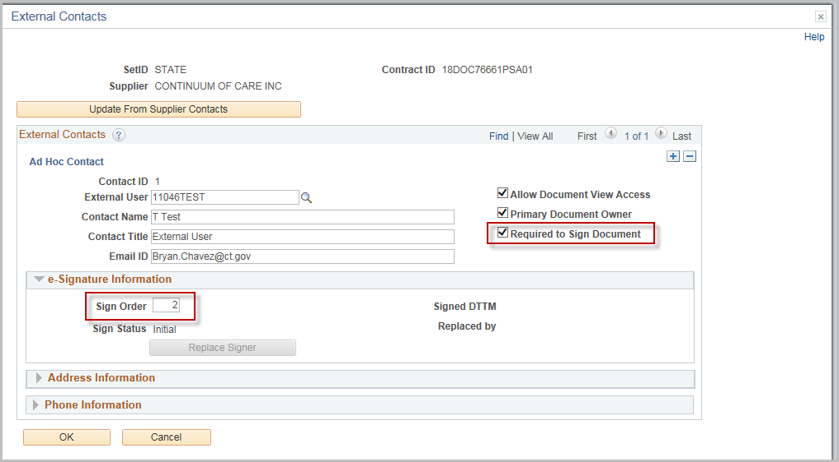

Once verified, click Prepare and Route for e-Signature

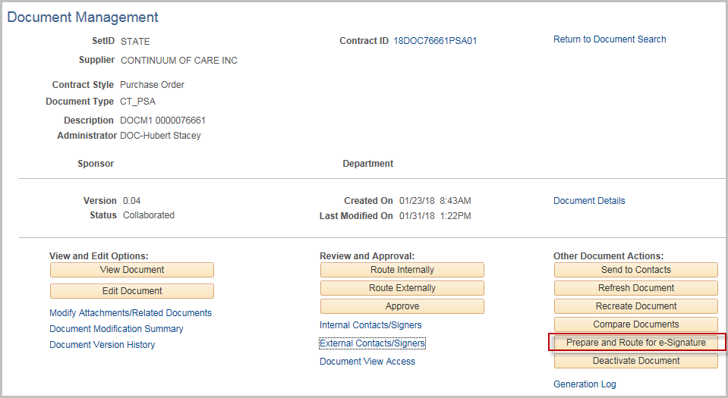

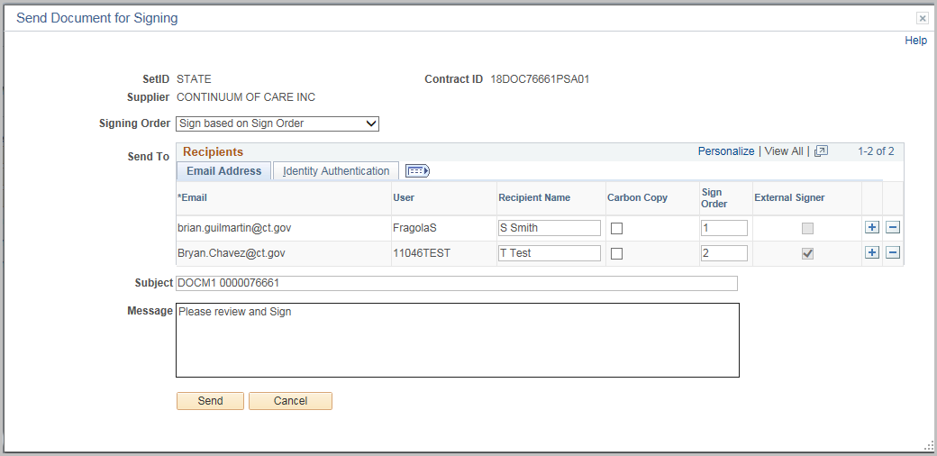

Signing order – The Default is to sign based on the sign order. This can be changed to sign in any order.

Any user identified as a signor will be brought in based on their setup. If necessary the sign order can be changed.

If additional signers are needed, click the + sign.

The subject will default with the description of the contract. It can be changed.

Enter a Message to send to all signers.

Optional - Click the Identity Authentication

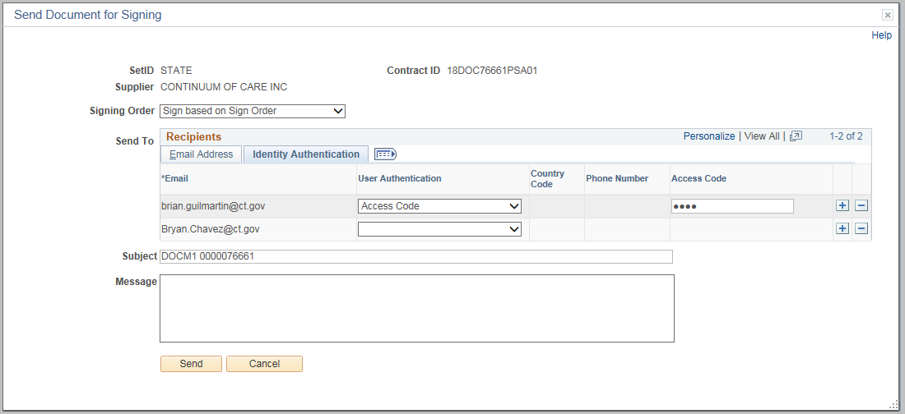
Available authentication methods

- Access Code: This option requires the signer to correctly enter an access code. The code can be up to 50 characters in length.
- ID Check: This option requires the signer to correctly identify personal information based on public data sources, such as a previous address.
- Phone Call: This option requires the signer to verify their identity by responding to a confirmation call.
- Text Message: This option requires the signer to verify their identity by responding to a confirmation text message.

Click Send when all information is complete

If using Sign based on Sign order, only the first signer will receive two emails.

Once that signer is done, an email will go the second signer etc.

The email/worklist item will generate as also.

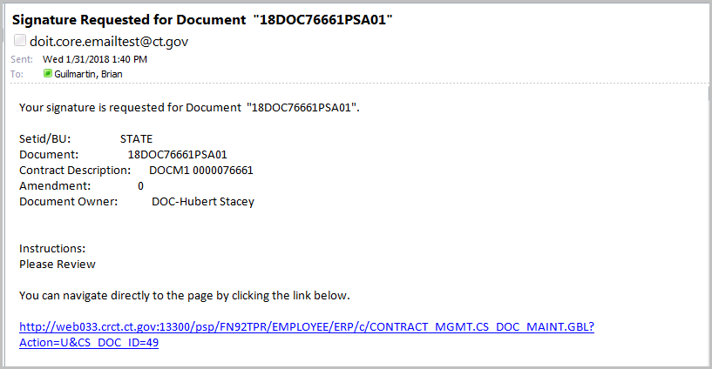

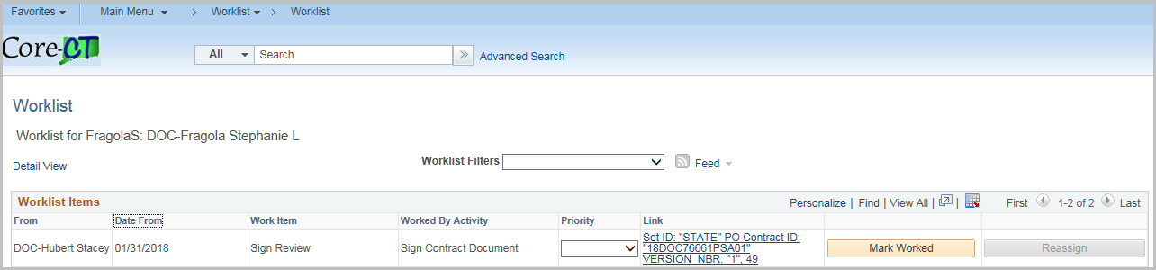

Clicking on the worklist will show the document status only
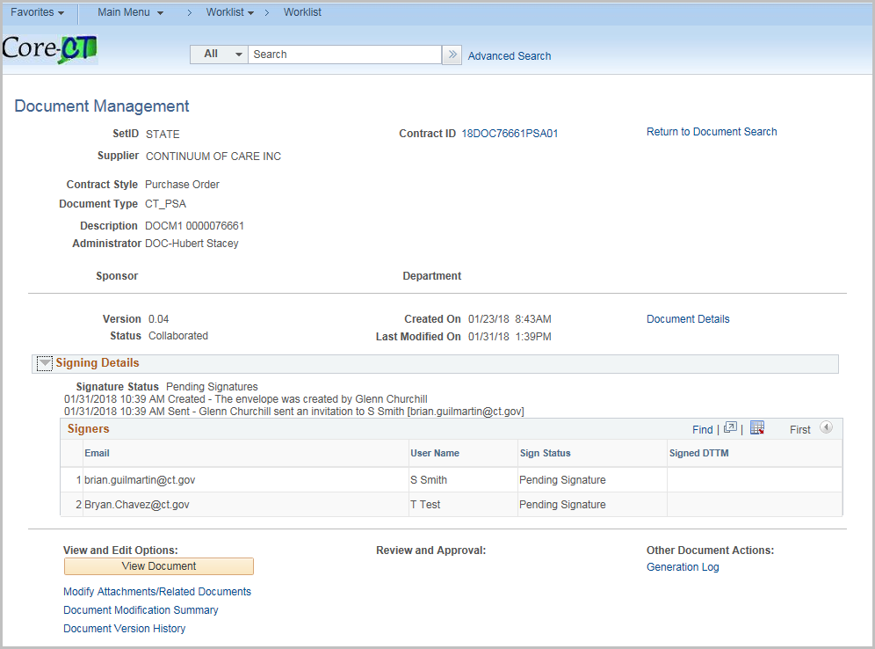

To Sign – Click on Review Document in the DocuSign email
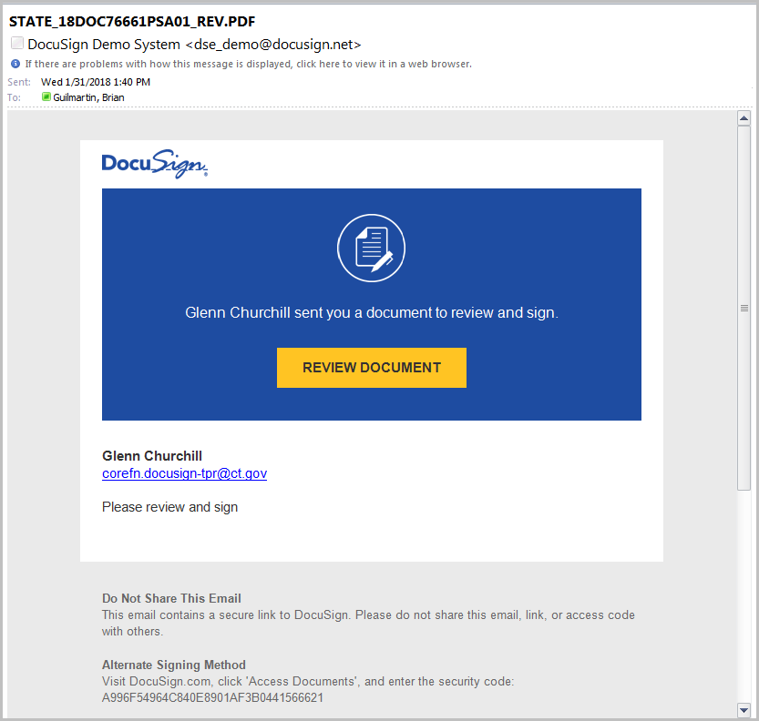

Enter the Access Code (If setup on the contract) and click validate

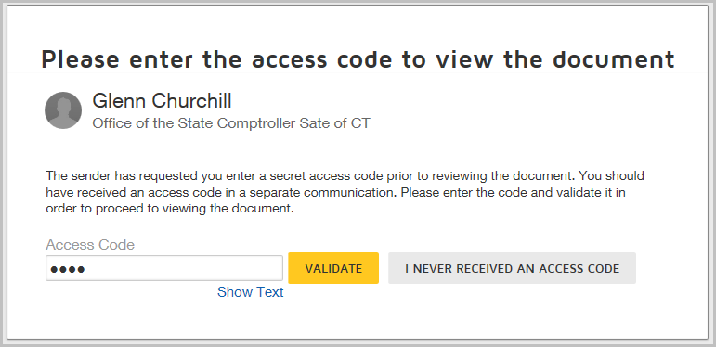

Check the box for I agree to use electronic records and Signature Disclosures

Click Continue
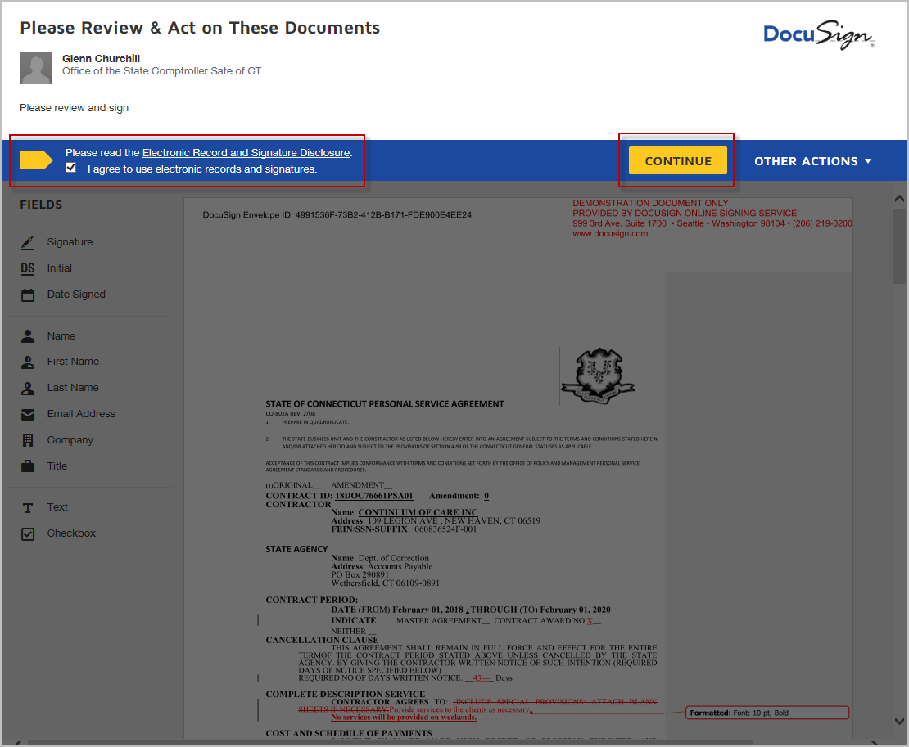

Review Document

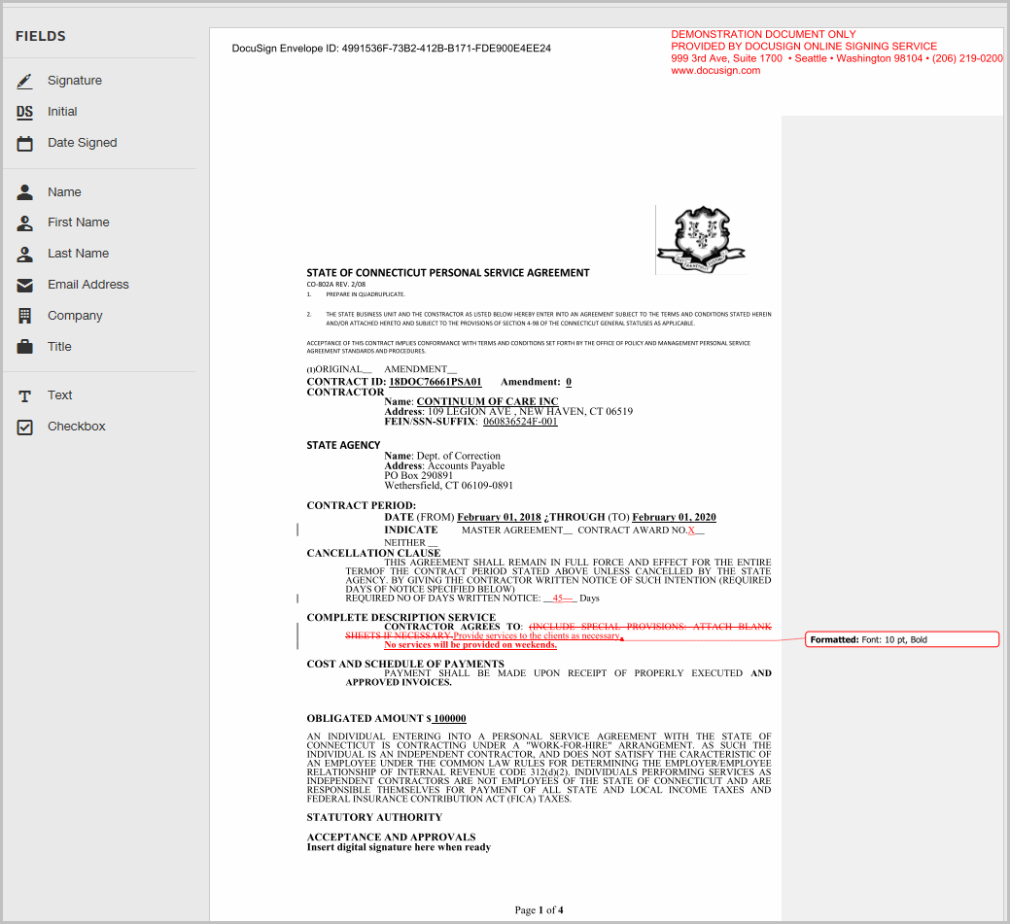

Scroll to the last page

Click the Signature Icon

Drag to the page

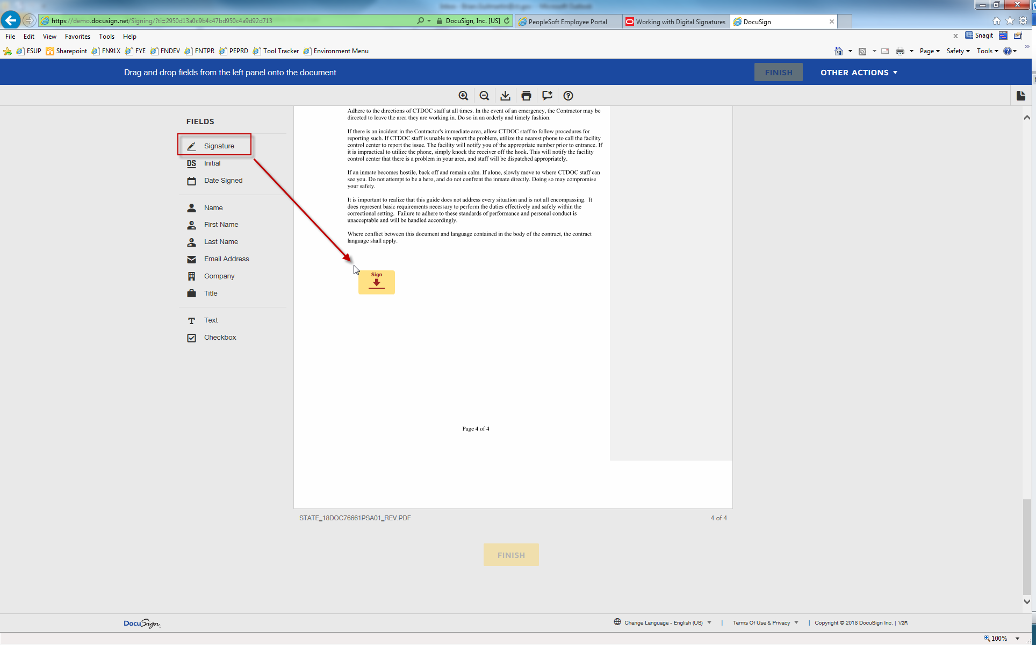

Left Click

Click Adopt and Sign
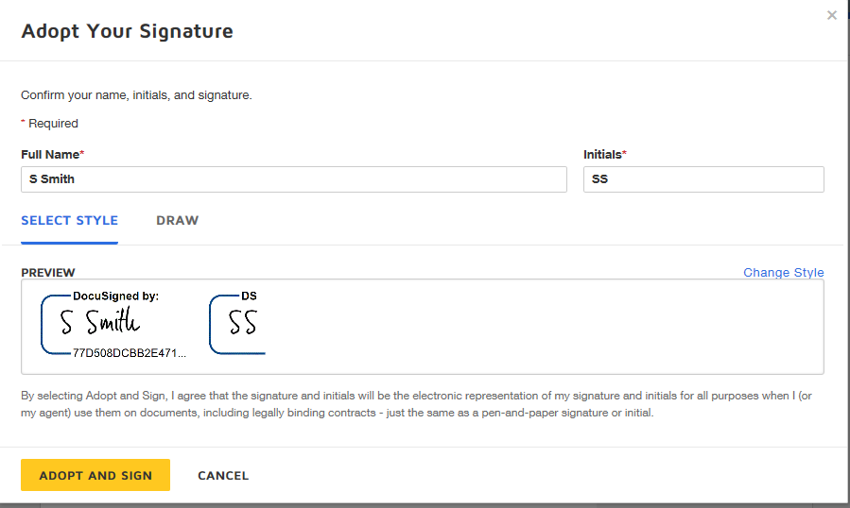

Optional Click and Drag Title and Date

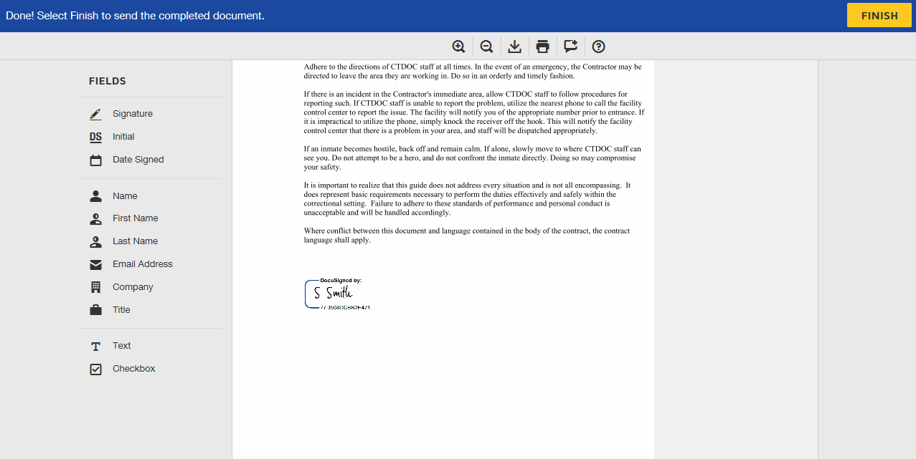

Click Finish

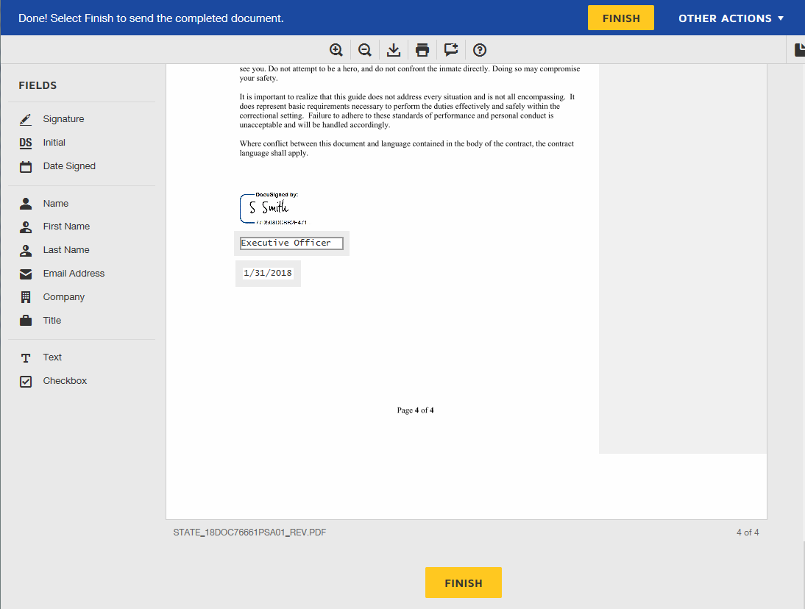

The Contract Administrator now signs into Core
Click the Signing Details Arrow
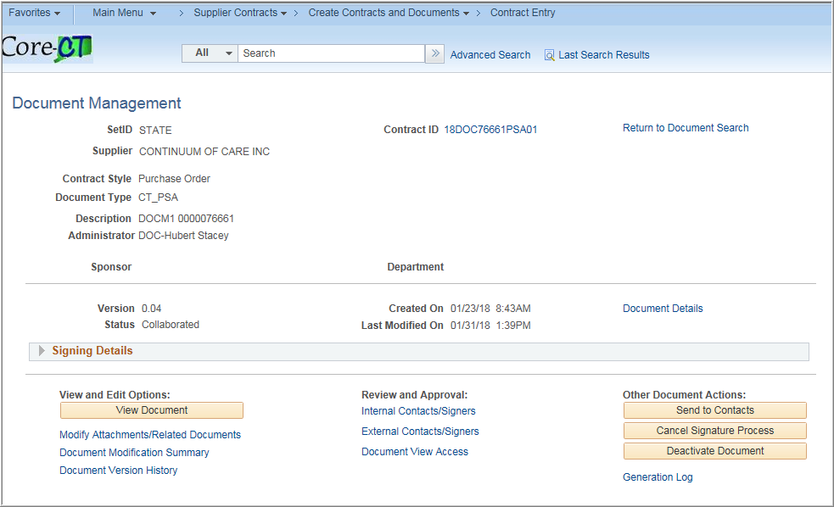
Click Get e-Signature Status to refresh
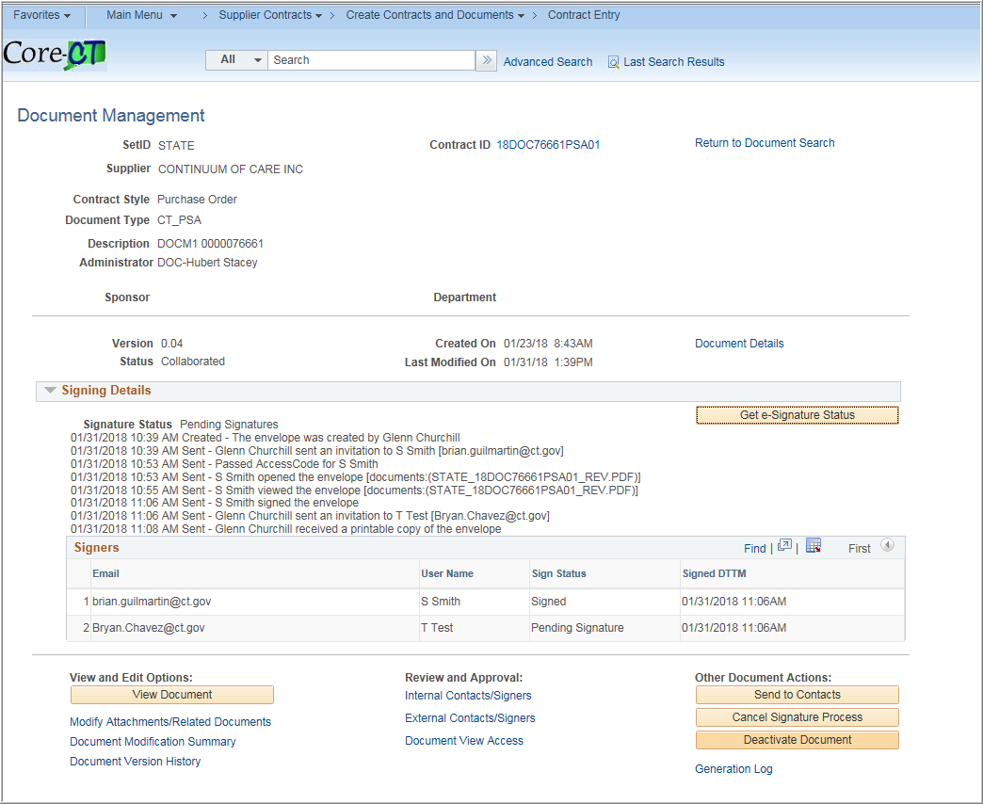
The next signer will automatically be emailed

Once all signatures have been recorded DocuSign will send an email with the completed document

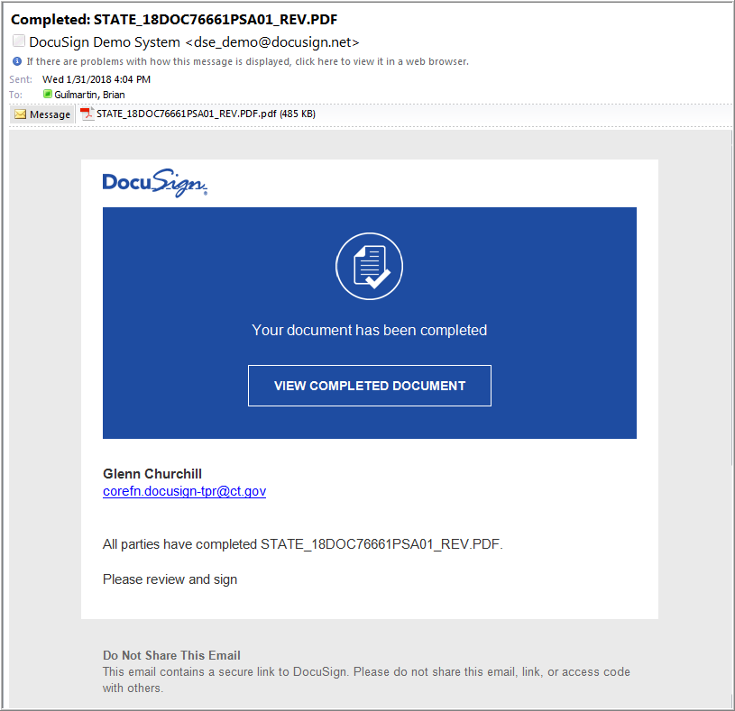

If the document needs to be changed after the signature process has started, click Cancel Signature Process to reset the document

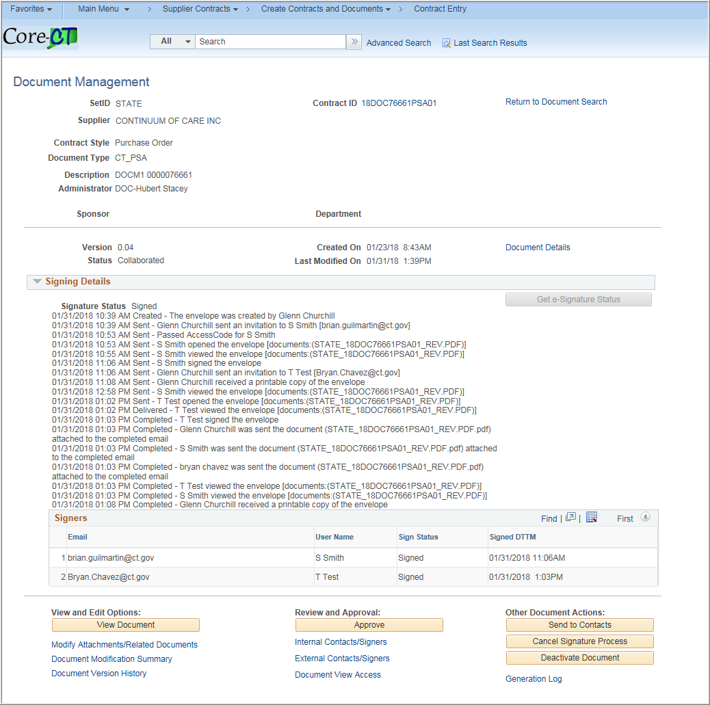

Enter any comments

Click OK
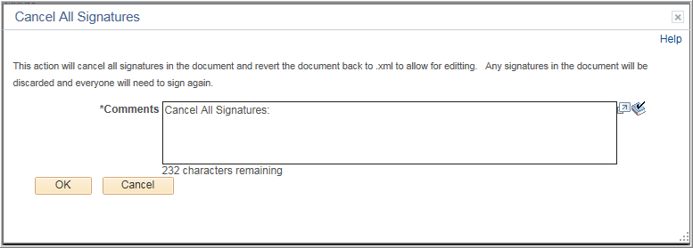

An email will be sent to any signers that the process has been canceled

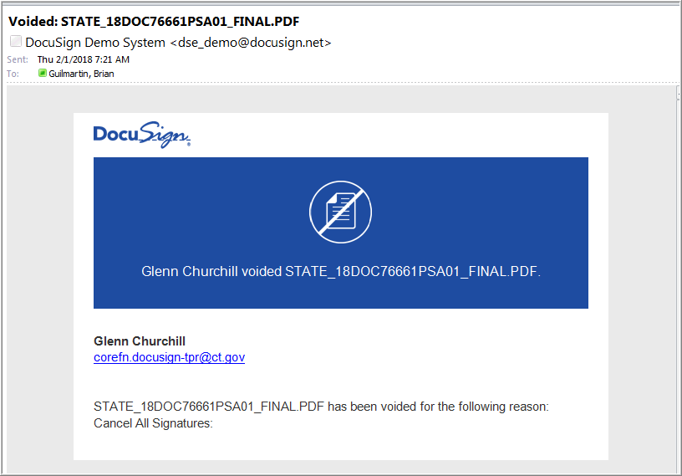

Approve
Once Collaboration and Signatures are completed, the contract administrator will click Approve.
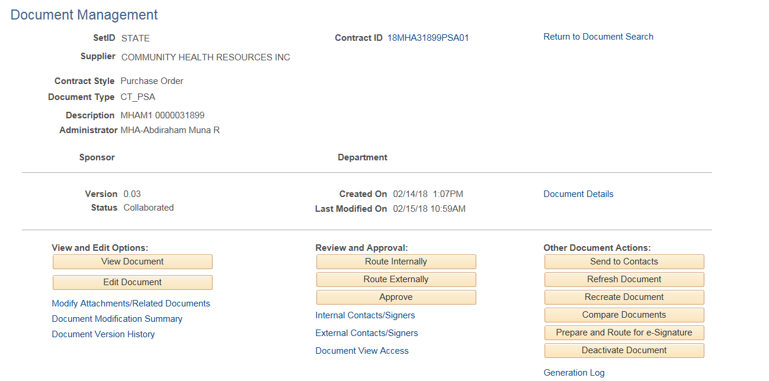
This will update the status to approved and activate the Dispatch button

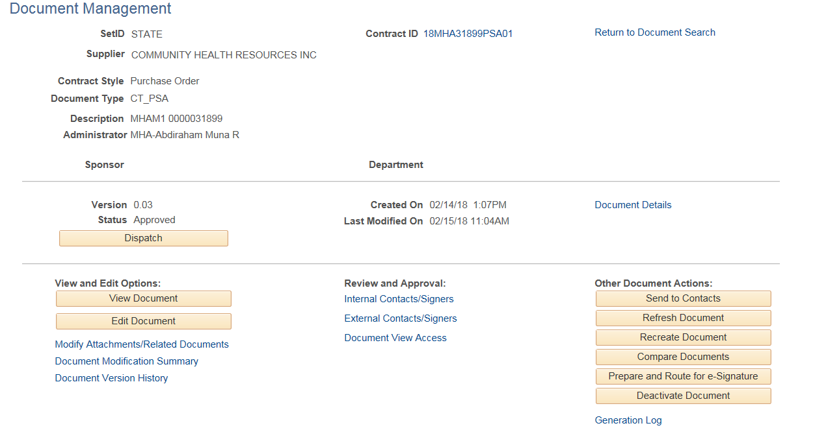

Dispatch
This button is not available until the Contract is approved.
Click on the Dispatch button
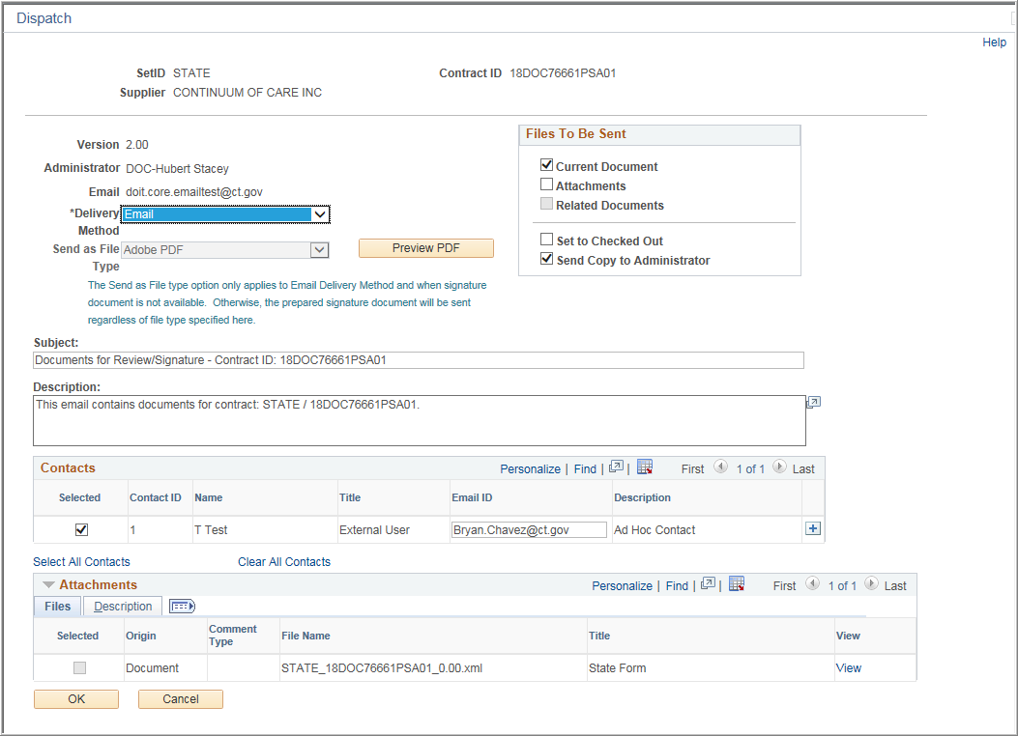
The default delivery method is Email, but can be changed to manually if needed.
The options are available to select the contract, attachments, and/or Related Documents and who will receive them.
The default subject and Description can be updated with any other information as necessary.
Click OK.
The buttons will update to Re-dispatch and the Execute Contract button will activate.
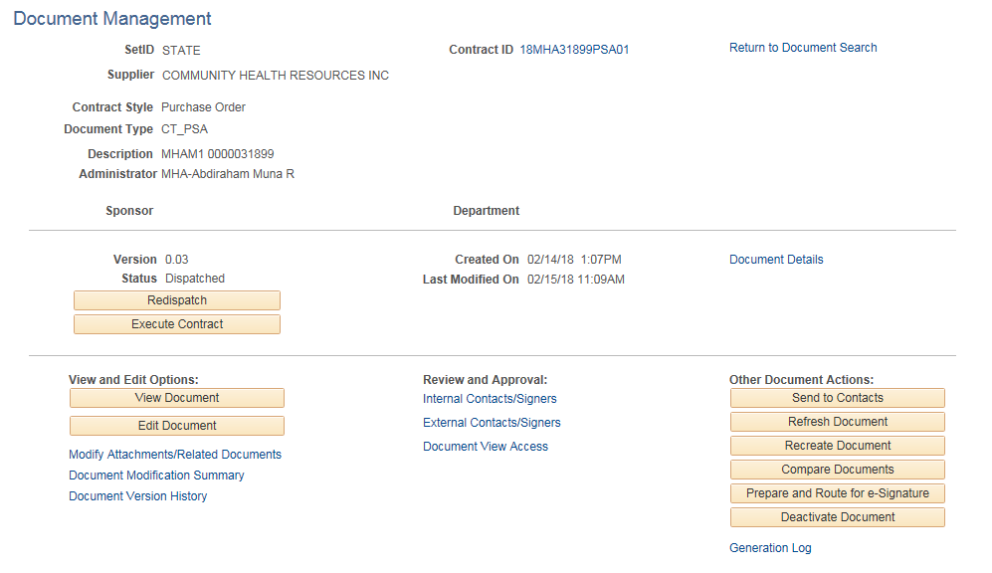
Each recipient will receive an email with the document attached as a PDF
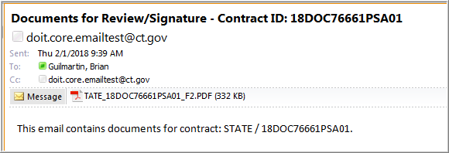

Execute

Click Execute Contract

Status will change from Dispatched to Executed

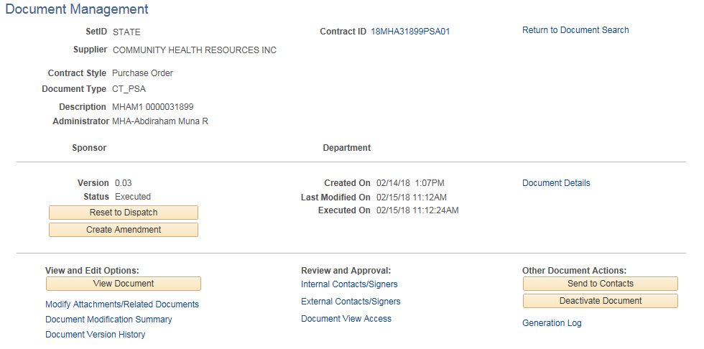

Document View Access
Provides a summary of all users (internal and external with access to the Document)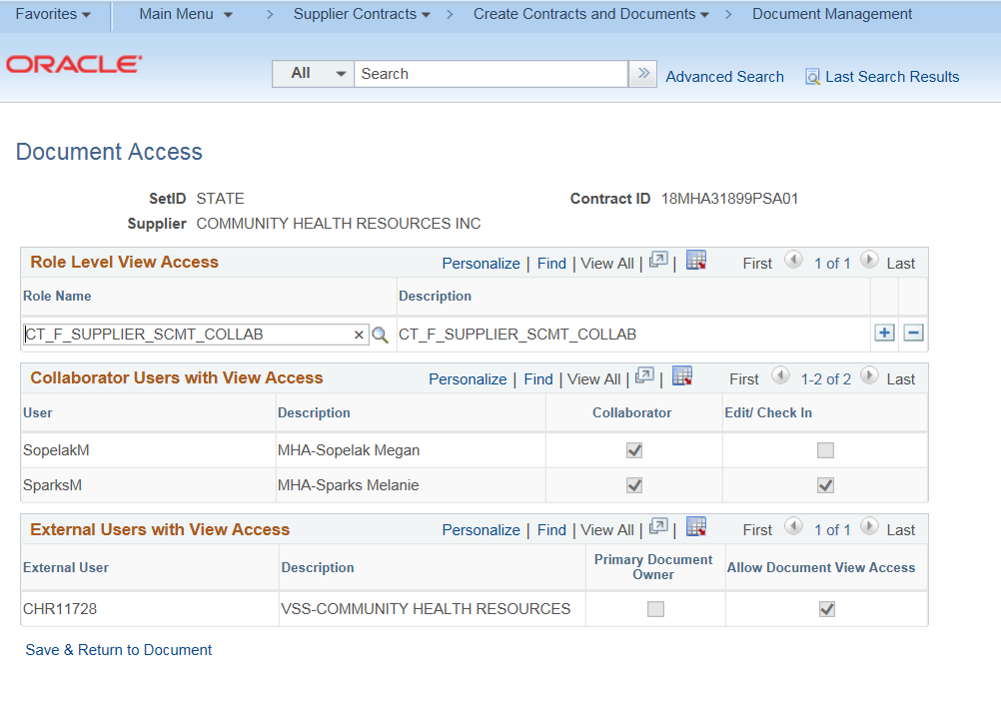
Other Document Actions
These buttons are for actions you may need to user during the process as they will not all be available once the document has been sent for Signatures Approved/Dispatched/Executed.

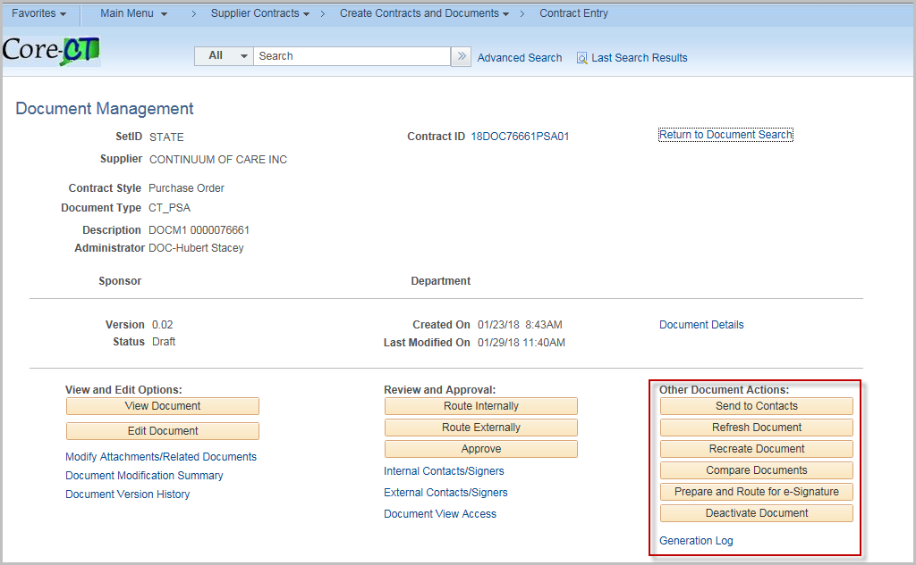
Send to Contacts
This is used to send a copy of the contract information to an external user. If available, attachments and related documents can be sent.
The document can be set to Checked Out and by default a copy is sent to the Administrator (This can be unchecked).
(Essentially this is an Ad-hoc version of external collaboration)

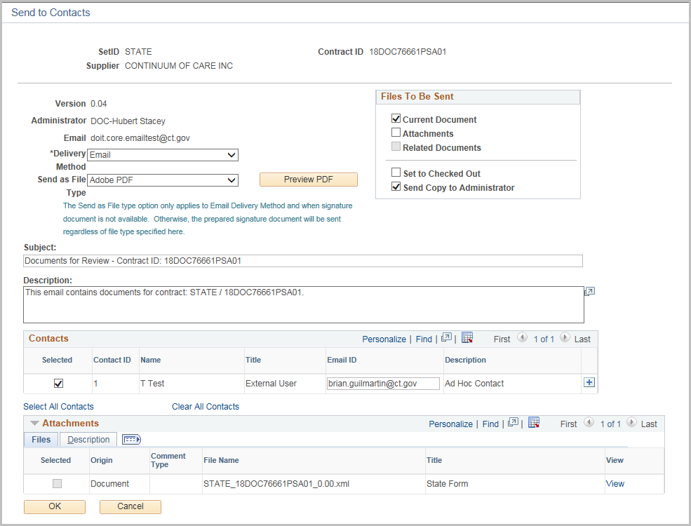

Refresh Document
Use the Refresh button when you want the content from the current generated version of the document to remain the same, but need to update changed bind variables, or wizard variables with their new values.
If repeat or rule binds do not change, the resulting contract should remain the same as the prior version, with the exception of the bind value changes. If a repeating or rule bind variable changes, the entire section that contains that variable will be rebuilt.
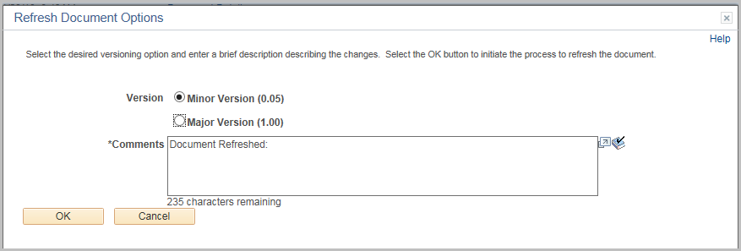
Click OK

Recreate Document
You can use the Recreate Document button to completely re-create the document. Re-creation is the same as creating a new document. Using re-creation, you can also change configurators to rebuild the document.
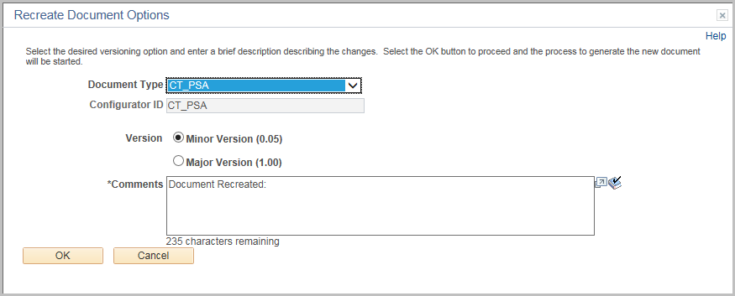
Click OK

Compare Documents
Use this page to select which version of a document you want to compare with a current document.
You use the Compare Against options to select which type of comparison you want to make.
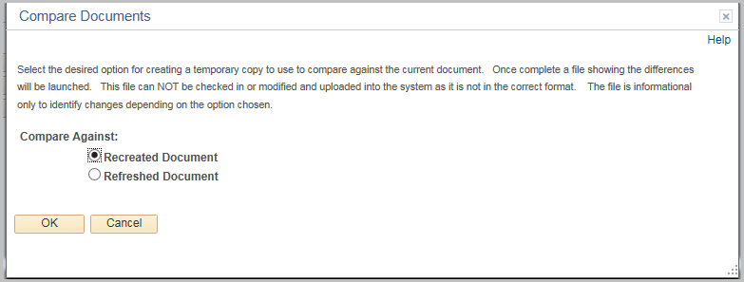
Click OK

Contract Amendment
After a Contract has been executed, a contract Amendment may be issued for changes.
User must have the CT_F_A_SCMT_ADMIN role

Navigation: Supplier Contracts > Create Contracts and Documents > Contract Entry
or Procurement Contracts > Add/Update Contracts
(either Navigation will work)

The Contract Entry page will display. Use the Find an Existing Value tab
Enter the Contract ID
Click Search.

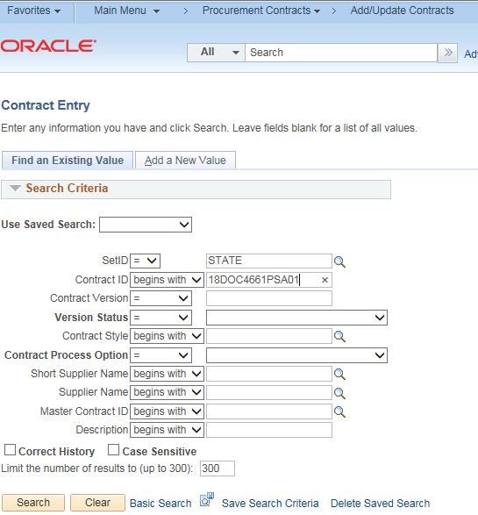

Amendments to the Supplier Contract can be entered by changing the Status of the Contract to Open.
Update any of the values (End Date, Maximum Amount etc.) that will be part of the amendment
Click Save
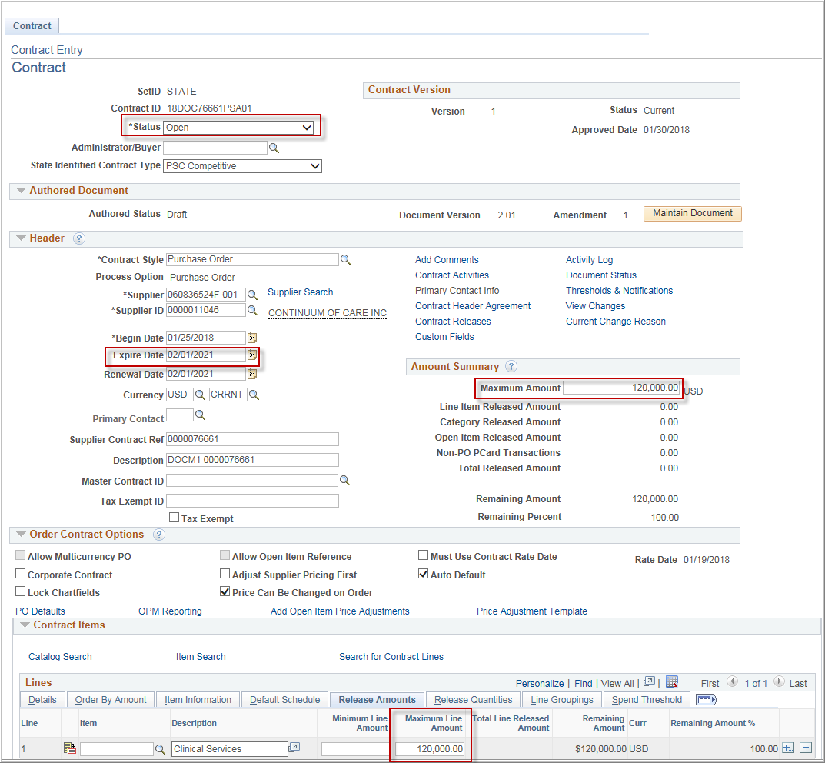

After making the necessary changes, click Maintain Document
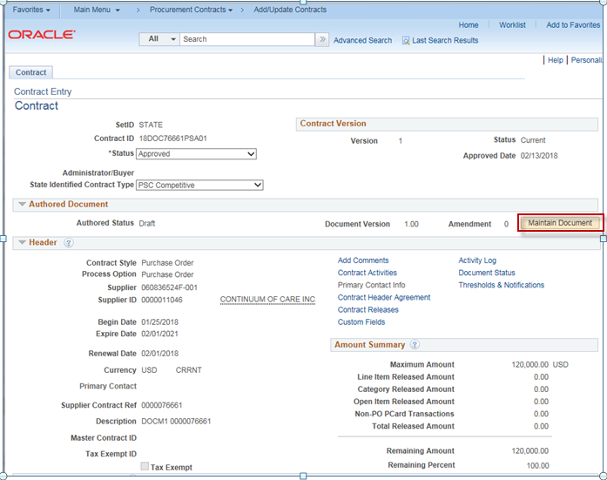

Click Create Amendment
Amendment Options:
- Amend Contract Only
- Amend Contract with Amendments
- Amendment Files Only

Amendment Configurator ID: Select from the available IDs
Version: Minor or Major
Enter in any comments needed
Click OK
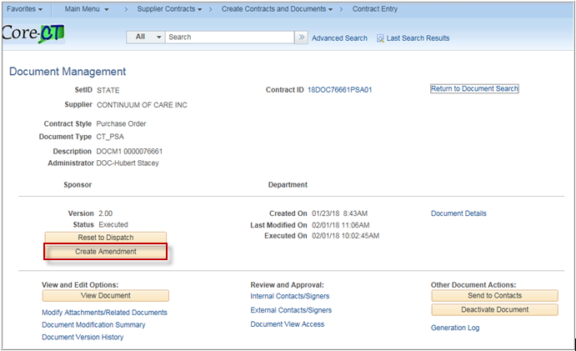

Below is an overview of each type of Amendment
Amend Contract Only:
Select to revise the contract and generate one amended document with all of the changes applied directly to the last executed contract.
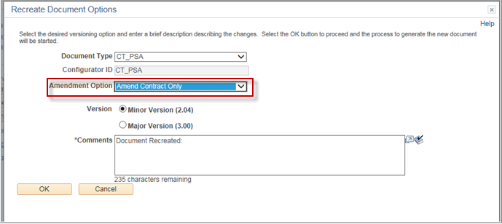
The Wizard will ask prompt for the Business Unit
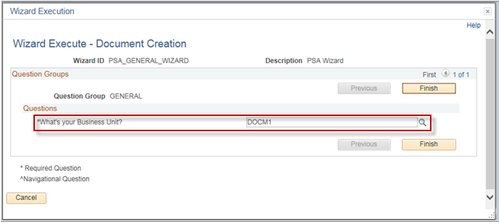
The Document Management Page is the same as before except the buttons are labeled with Amended.
Click View Amended Document
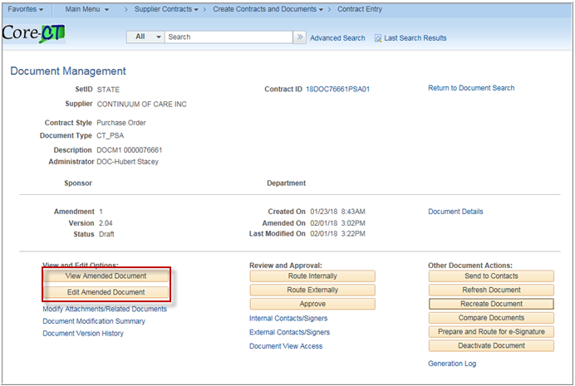
The entire PSA is recreated with the new values from the Contract.
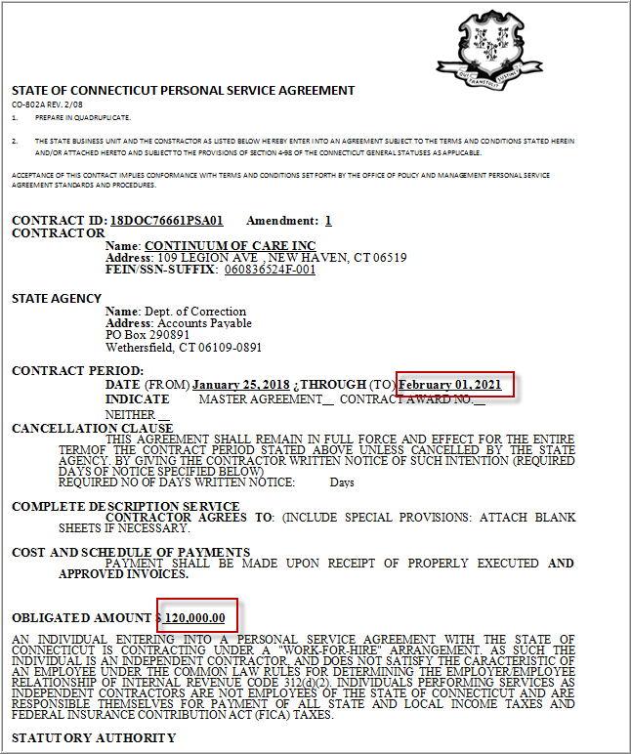
Amend Contract with Amendments:
Select to generate both a separate amendment file, as an appendix or addendum, and a copy of the last executed main contract document that you can revise to also include the changes specified in the amendment.
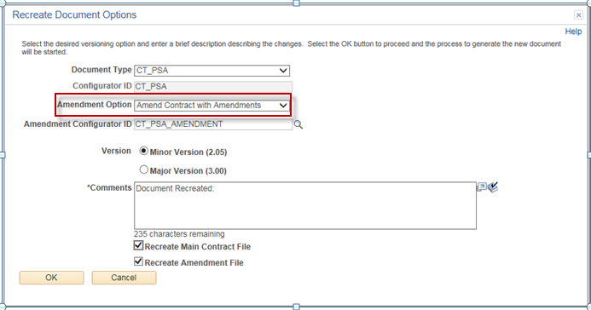
The wizard will ask you for the Business Unit
Click Finish
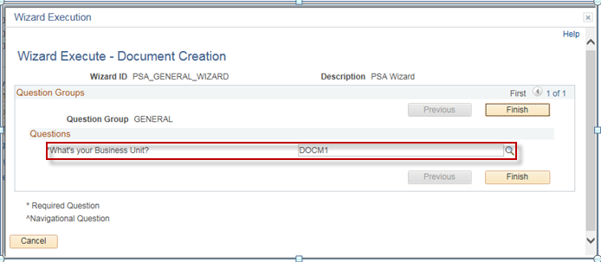

The Document Management Page is the same as before except there are buttons for both to view/edit the document or amendment.
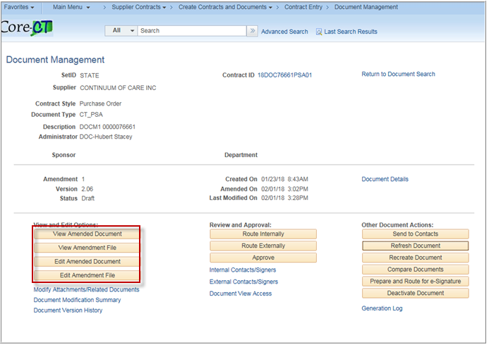

Amendment Files Only:
Select to generate just the amendment file. With this option, the executed contract remains as is and is not modified and all changes are only listed in the amendment file.
Click OK
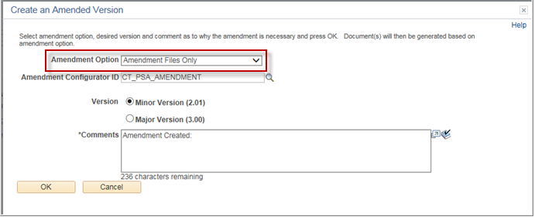
The Document Management Page is the same as before except the View/Edit buttons are labeled with Amendment and an additional button to view the original document.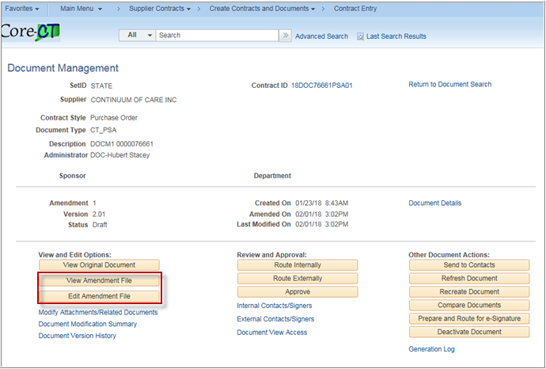

Define Protected Clauses

Navigation: Main Menu > Core-CT Financials > Supplier Contracts > Manage Contract Library > Clauses

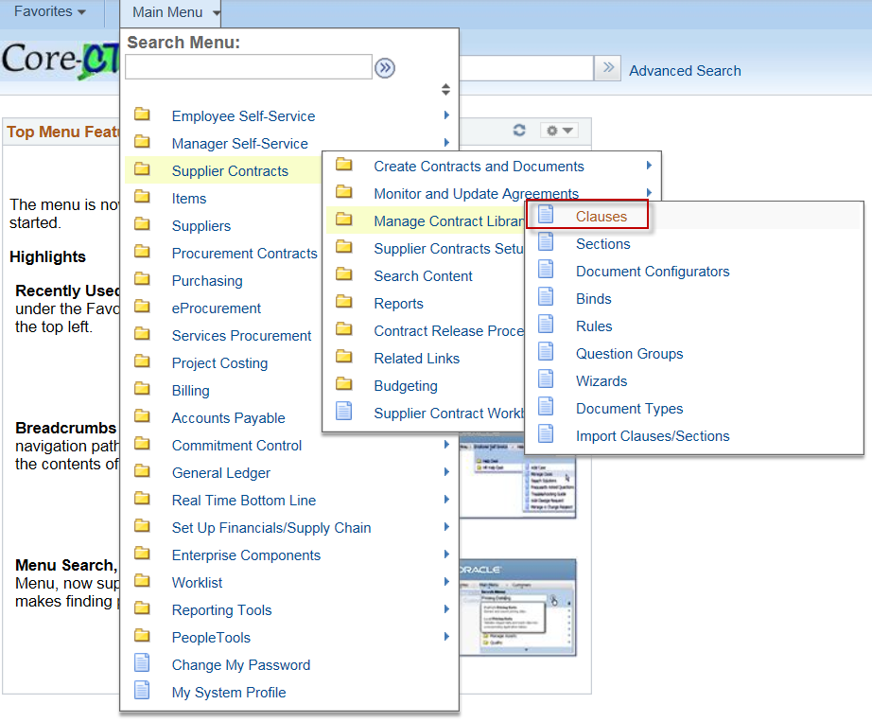

The Clauses Search page allows users to Find an Existing Clause, Search for a Clause or Add A New Value.
Click Add A New Value tab to enter a new clause.
Enter the Clause ID and click Add.

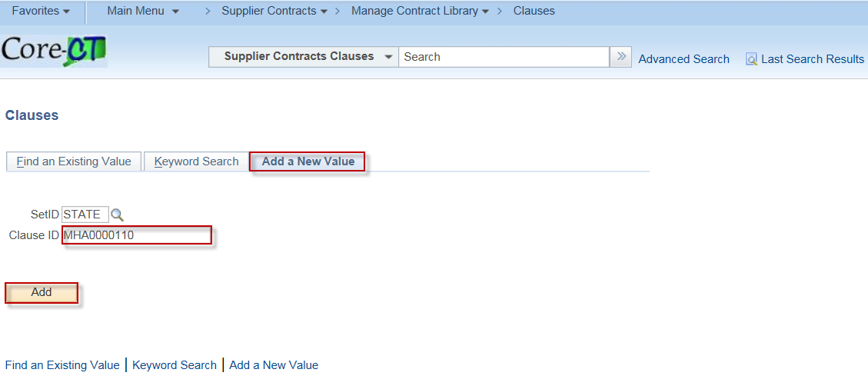

CS_CLAUSE_DEFN

Clause Definition page
Enter Description: Clause Definition
Library: MHAM1
Class Name: CT_PROCUREMENT

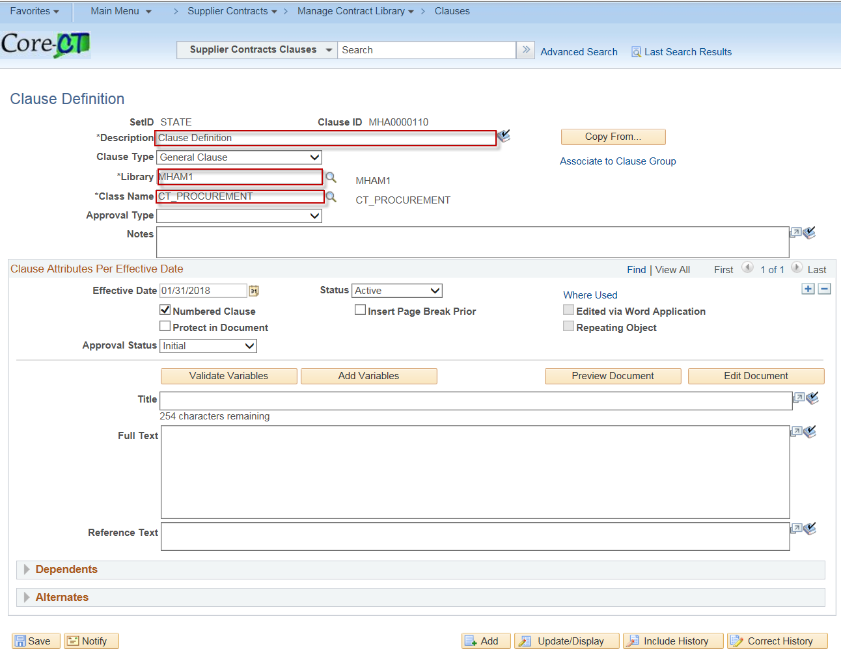

Select Protect in Document checkbox.
Enter Title: Clause Definition.

Click SAVE.

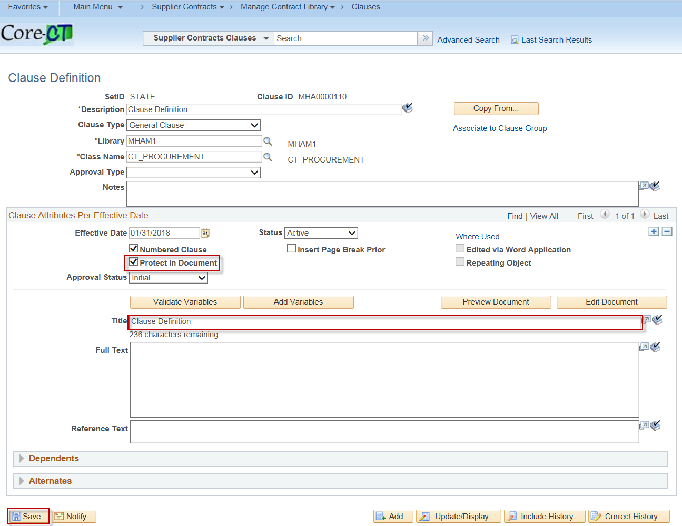

Document Configurator (to configure)

Navigation: Supplier Contracts > Manage Contract Library > Document Configurators

Click on the Add a New Value tab

Enter Configurator ID: Doc Configurator
Source Transaction: Multiple Sources.
Click Add.

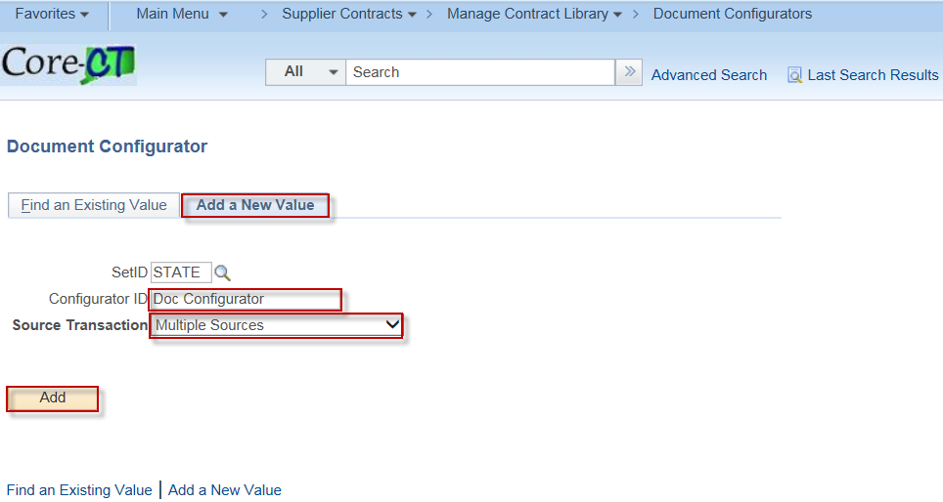

Enter Configurator Type: MHAM1_CNFG_TYPE
Description: Document Configurator Definition.

Select Purchasing Contract, Purchase Order and Sourcing Event

Select Add Multiple Objects by clicking on the under Content Elements.

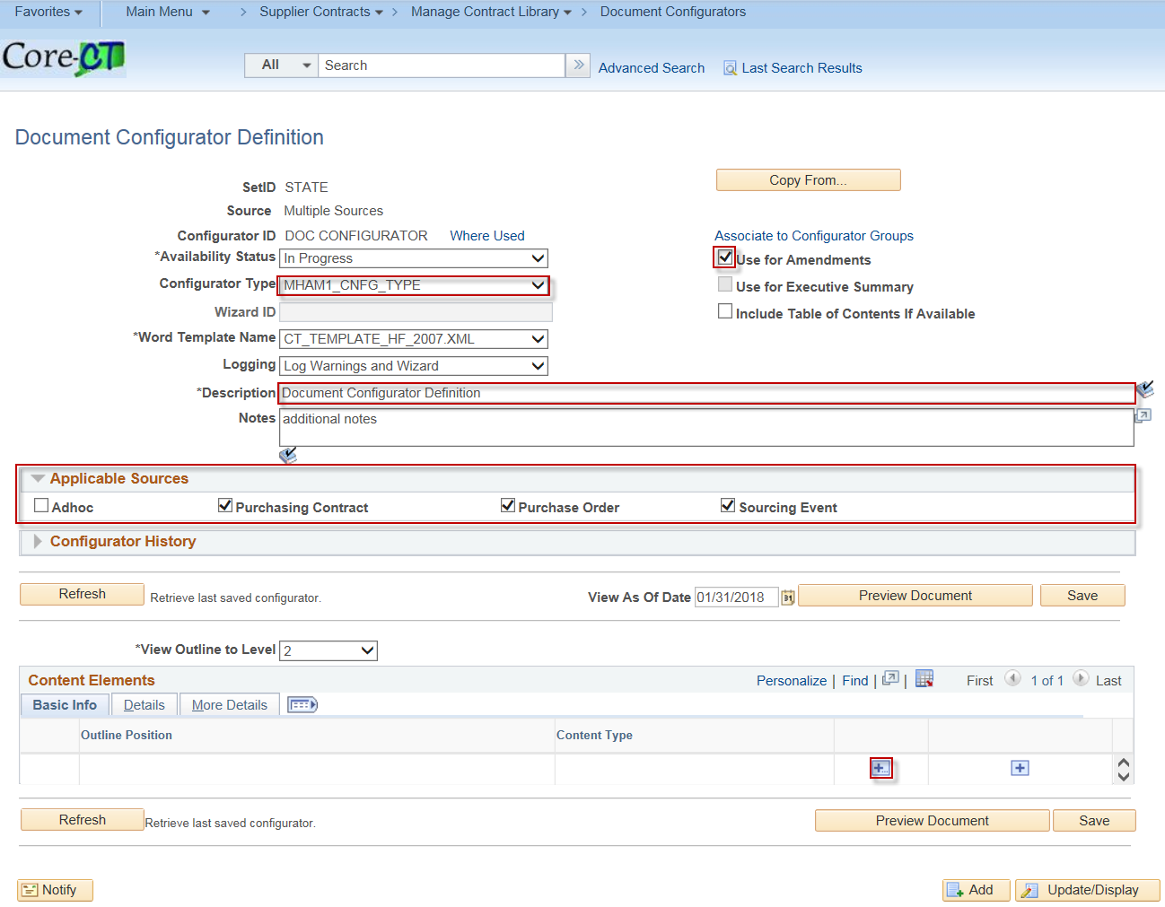

Select Content Type drop down box and select either Clause or Section

Click Search

Search results display number of documents based on criteria entered.

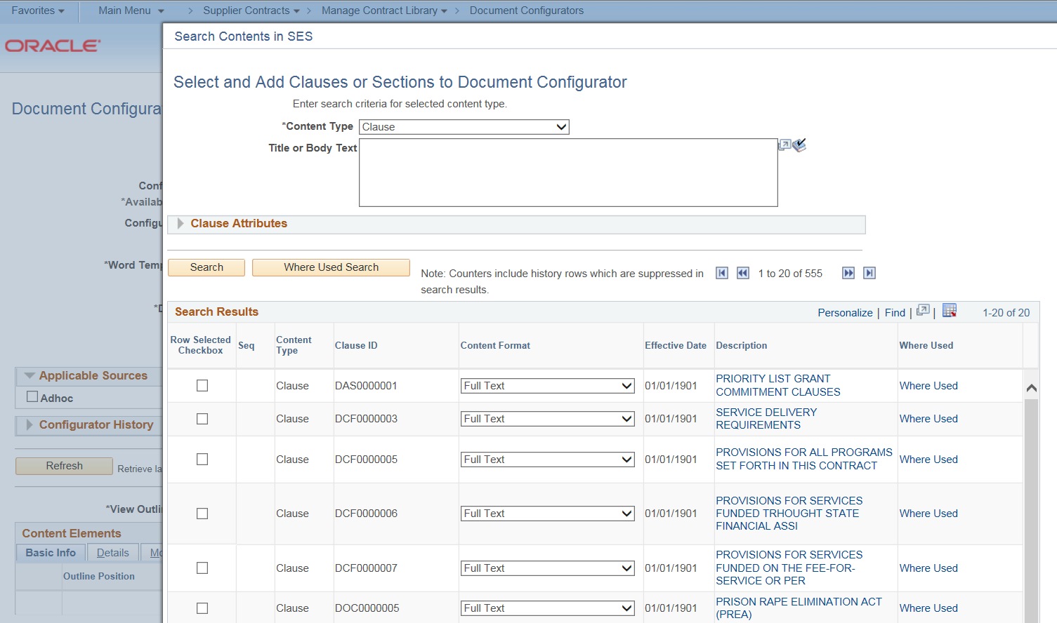

Select checkbox for clause to add.

Scroll to the bottom of the page click OK.

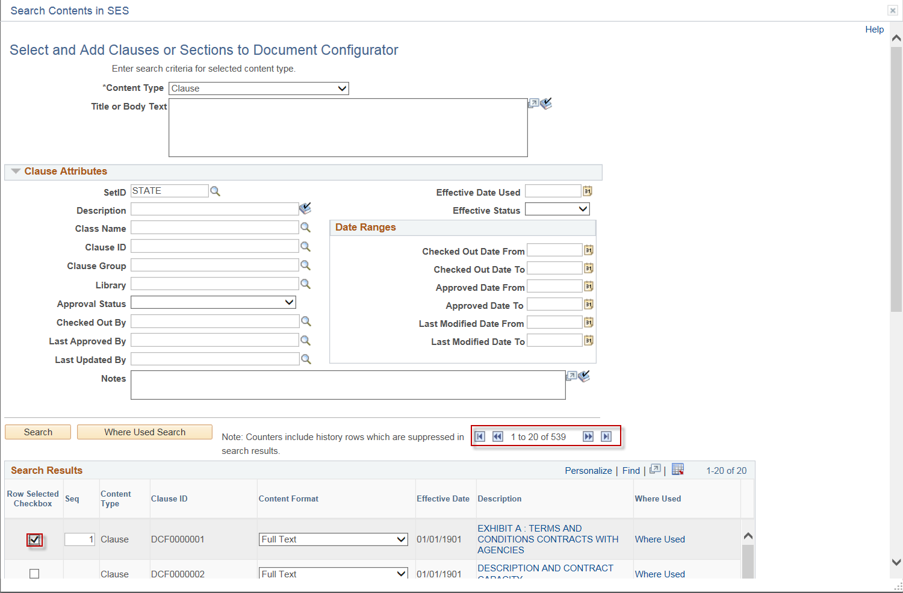

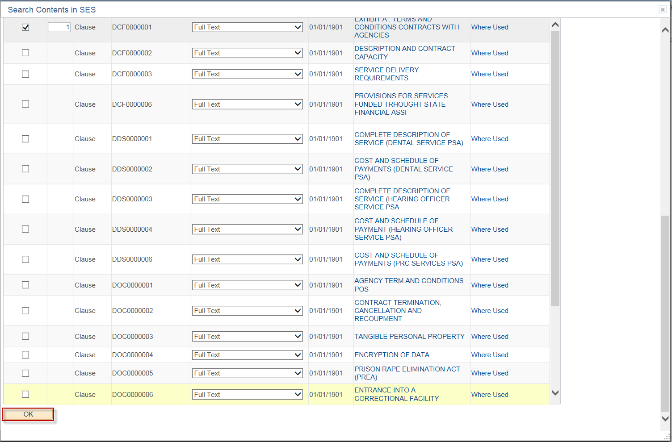

Change the Availability Status to Available

Click Save
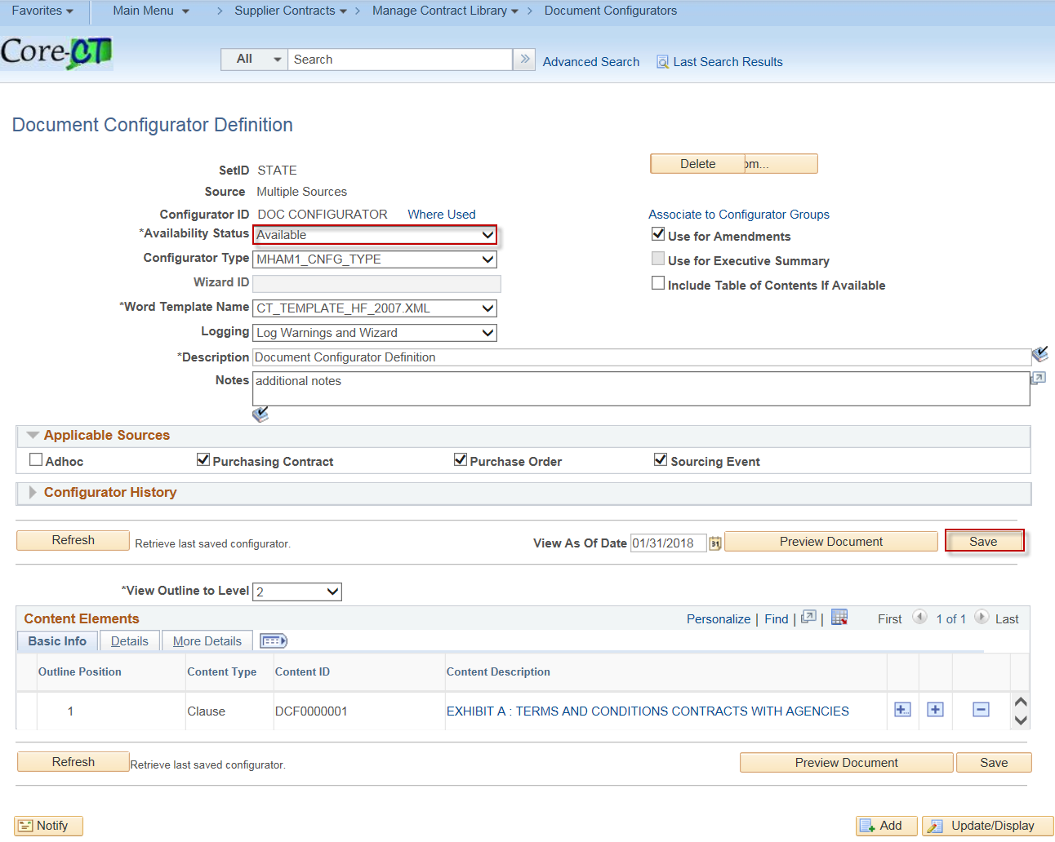

Use the clause in a new contract

Navigation: Supplier Contracts > Create Contracts and Documents > Contract Entry

Enter the Contract ID
Click Add

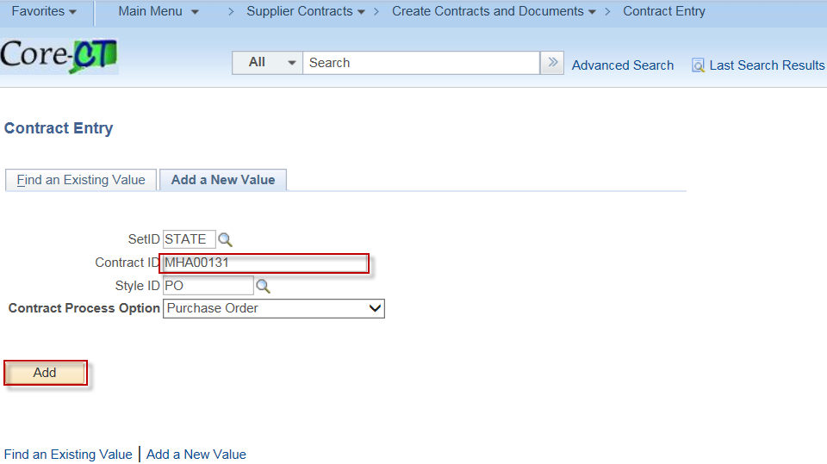

Enter the necessary Contract information
Click SAVE

Click Add a Documents button.
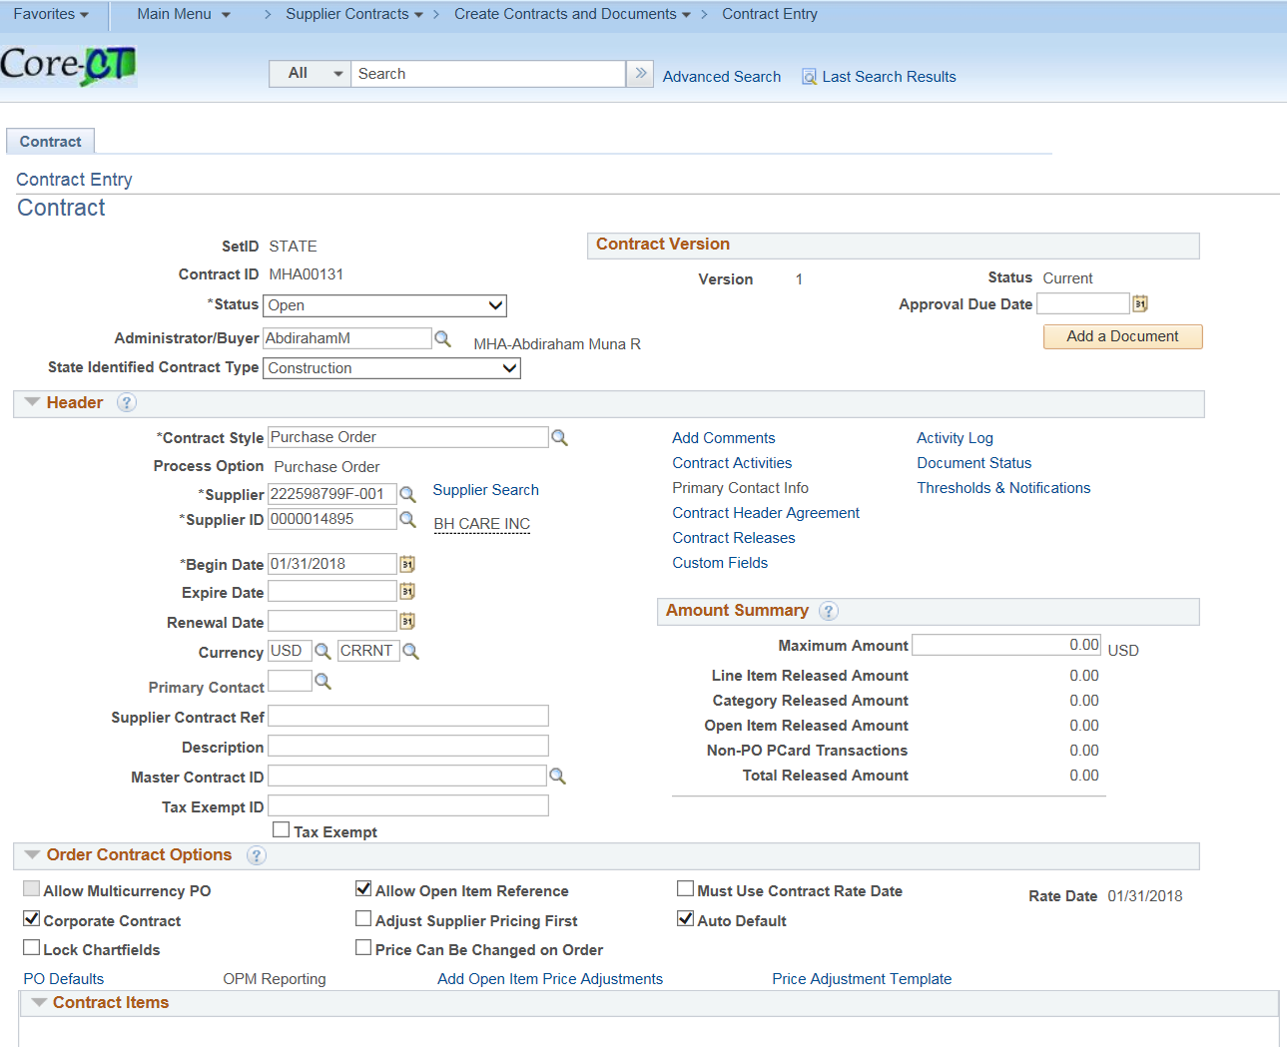

To add the clause to the contract

Enter the Document Type
Select Configurator ID identified.
Click Create Document

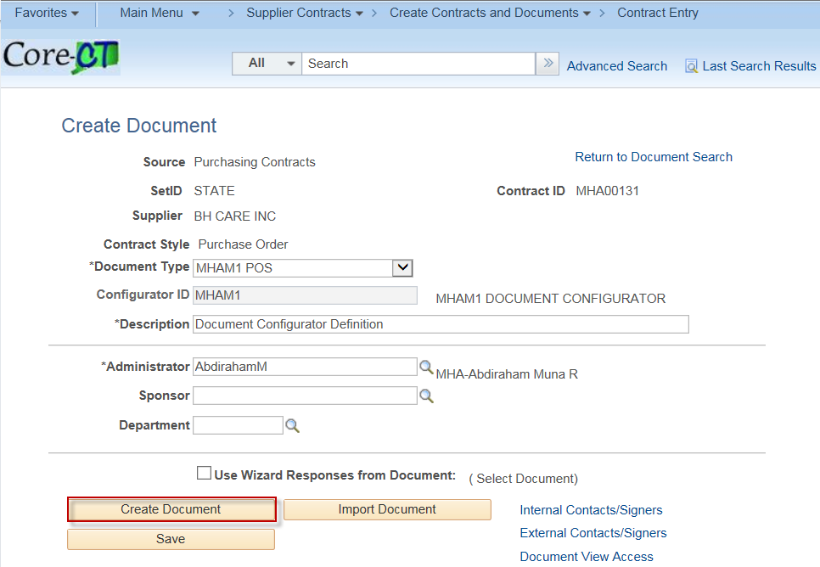

Select the scope of services using the appropriate check boxes

Click Finish

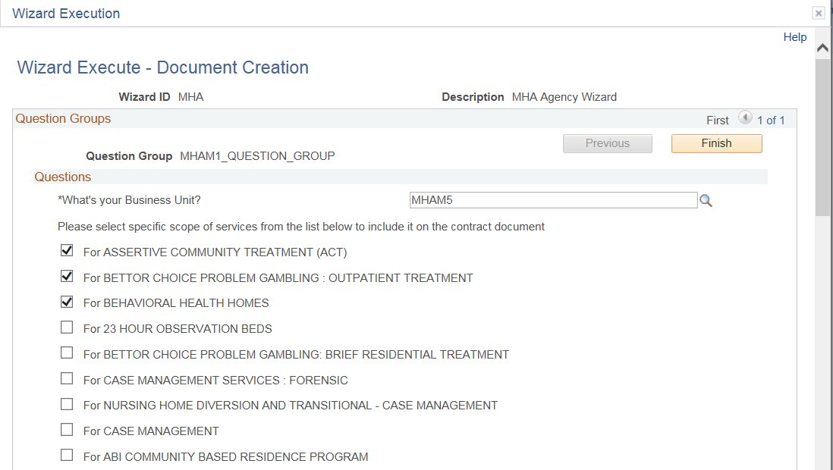

You are returned to the Document Management Page

Click Edit Document.

The Clause opens in Microsoft Word, verify Clause cannot be modified.

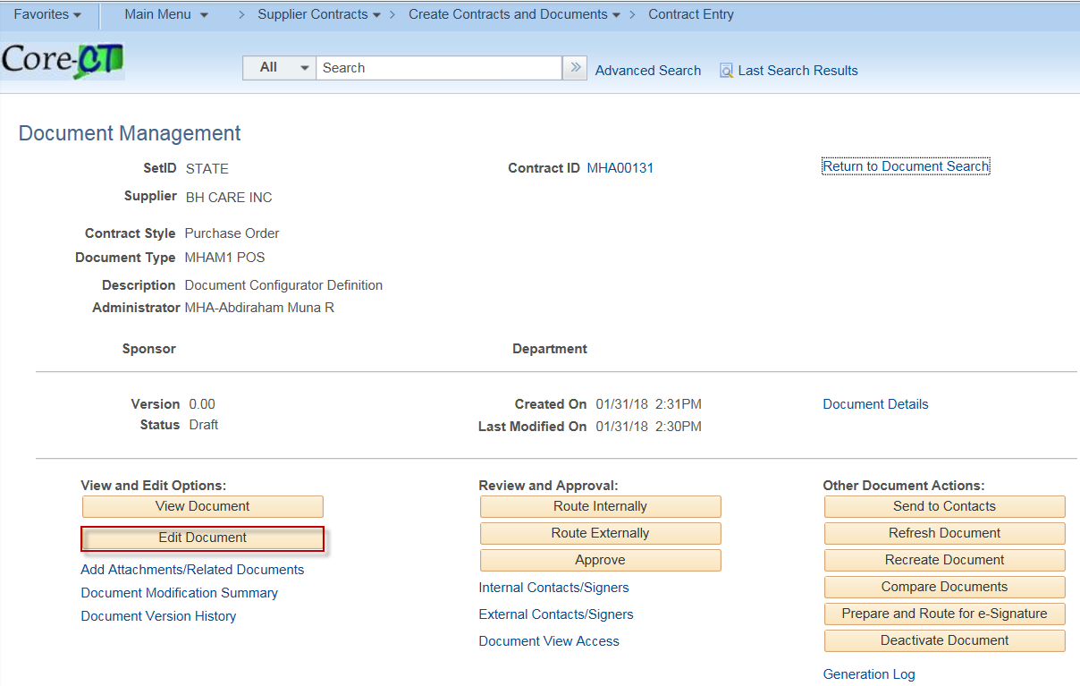
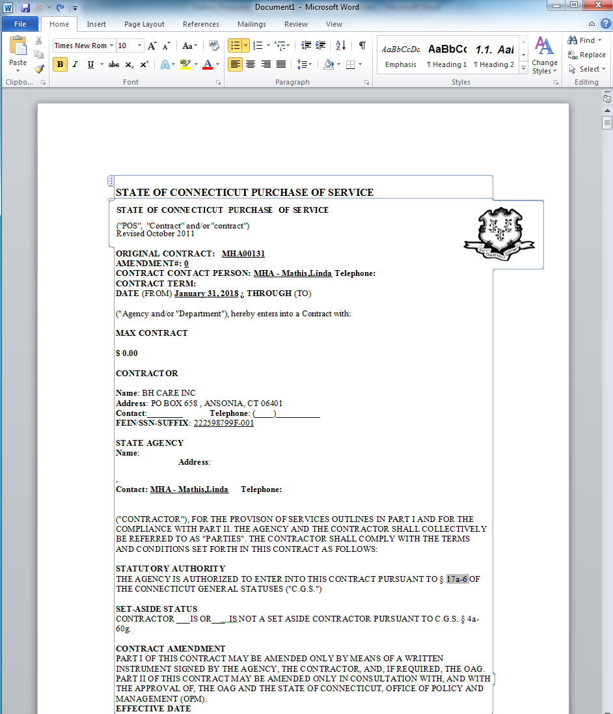

Contract Agreements

User must have CT_F_A_SCMT_USER or CT_F_A_SCMT_ADMIN role

You can assign predefined agreements to a contract at the header level or the line level. Header-level agreements are typically negotiated terms that apply to the entire contract. Line-level agreements are terms that apply only to a specific line item on the contract. When you select an agreement from the agreement library, the system provides the information defined on the agreement by default into the contract. You can modify the information associated with the contract without changing the data on the master agreement. As an alternative, you can also create ad hoc agreements at each level by defining them directly on the contract. Ad hoc agreements are not part of the agreement library, but exist only for the life of the contract for which they were created.

Setup Contract Agreements

Navigation: Supplier Contracts > Monitor and Update Agreements > Setup Agreements > Contract Agreement

Select the Add a New Value Tab
Enter an Agreement Code

Click Add

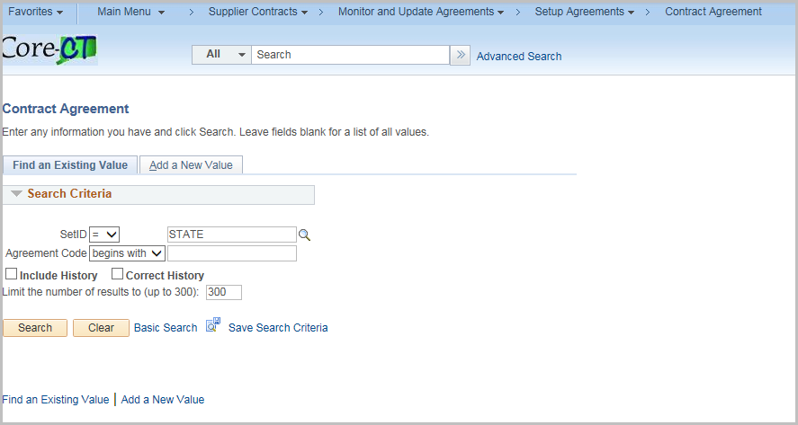

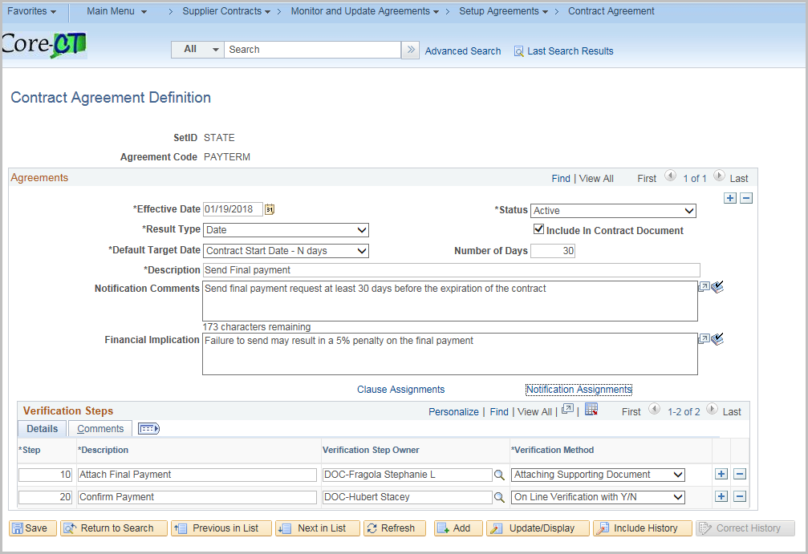

Enter the values for the definition

Field | Value
Effective Date | Defaults to current date
Status | Active is the default
Result Type | How the results of the agreement will be measured  Date, Metric, Monetary, None, Numeric, Text, Yes/No
Include in Contract Document | Select to include on the Contract and dispatch to the supplier  Unselect if this is an internal control
Default Target Date | How to calculate a due date for the agreement
Number of Days | Works with the Default Target date (Offset N)
Description | A brief description of the Agreement
Notification Comments | Description of the agreement that the system uses when it sends notifications – Maximum 254 characters
Financial Implication | What happens if the Agreement is compliant/non compliant. I.E. a bonus if compliant or a penalty if not compliant

Enter in values for the Verification Step
Use + to add additional Verification Steps

Verification Steps – Detail Tab
Field | Value
Step | Auto-numbers
Description | Description of the Step
Verification Step Owner | Who will be responsible for the Step
Verification Method | Attaching Supporting Document  Comments  Date/Time Stamp  Notify Only  System  Online Verification with Y/N

Verification Steps – Comments Tab

Field | Value
Notification Comments | Description of the agreement that the system uses when it sends notifications – Maximum 254 characters

Click the Clause Assignments hyperlink to assign clauses to contract agreements
Enter or search for the Clause ID
Click OK
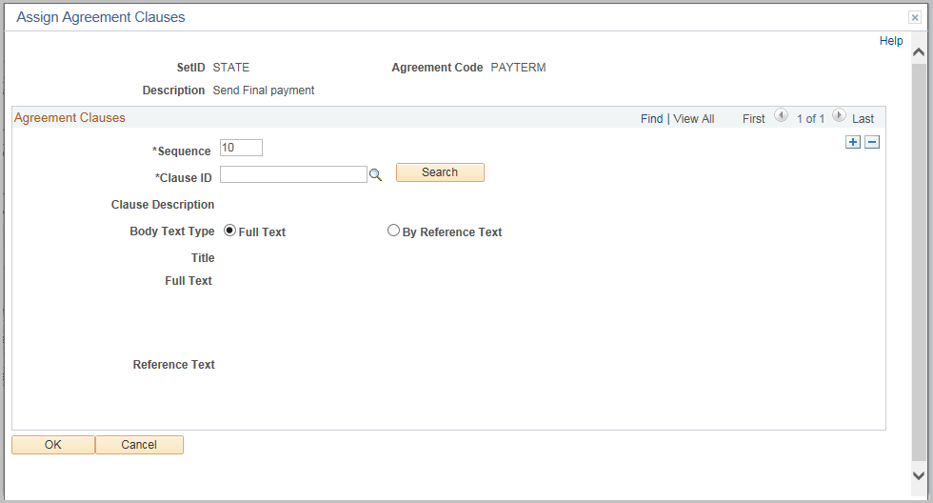
Click Notification Assignments hyperlink

Click on Notifications Tab

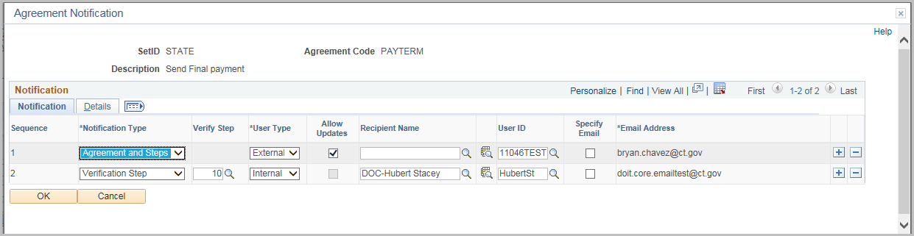

Field | Value
Notification Type | Agreement  Agreement and Step  Verification Step
Verify Step | Which verification step this notification applies
User Type | Internal or External
Allow Update | For external users to update the verification step
Receipient Name | For an external user not defined in the system
User ID | The User ID for this notification
Specify Email | Check to enter in an email address
Email Address | Will use the User ID default email unless the specify email is checked
Click on the Details Tab

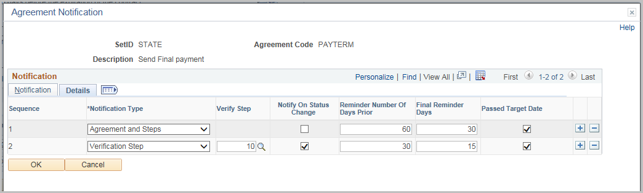

Field | Value
Warning Performance | Sends a warning about the performance
Unacceptable Performance | Sends a notification if the performance is unacceptable
Notify on Status Change | Sends a notification when the status of the verficiation step changes
Reminder Number of Days Prior | Sends a notification before the due date
Final Reminder Days | Sends one last notification before the target date
Passed Target Date | Sends a notification after the target date if the agreement is not set to compliant

Click OK

Click Save

Add a Contract Agreement

Navigation: Supplier Contracts > Create Contracts and Document > Contract Entry
Click the Find an Existing Value tab
Enter the Contract ID
Click Search

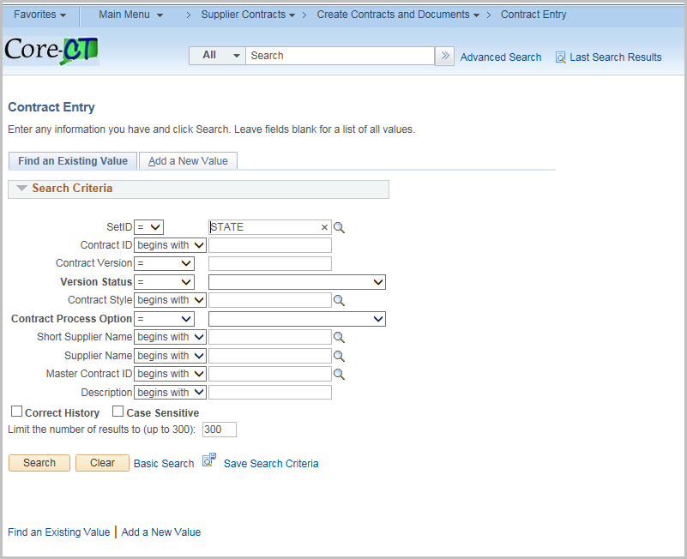

Click Contract Header Agreement hyperlink
or
the Contract Line Agreement 
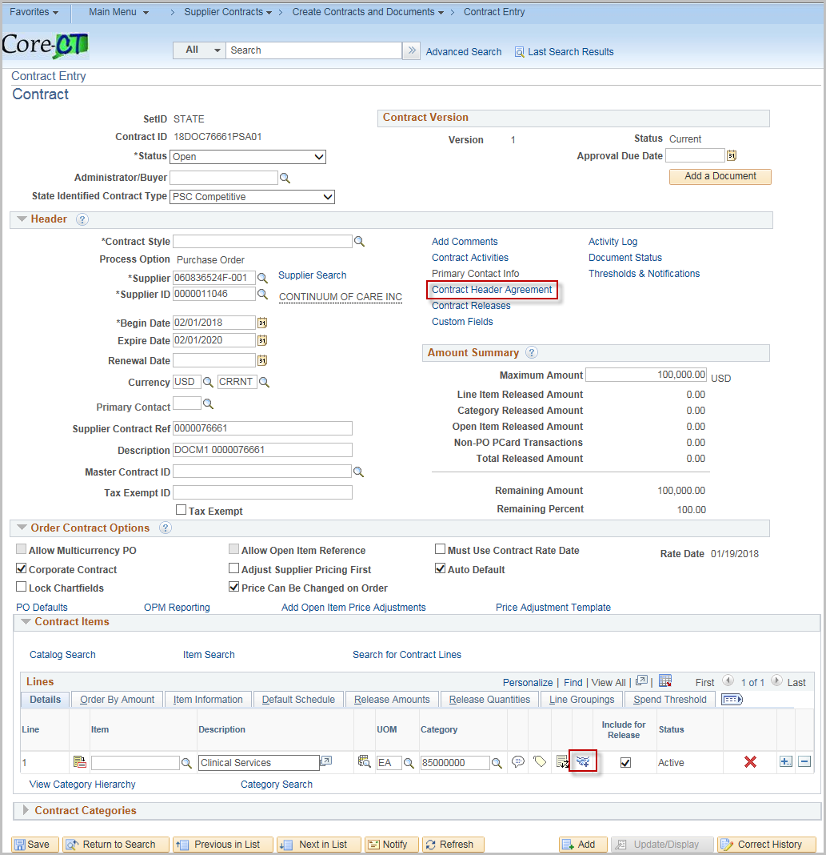

***Screenshots are for the Header level but they look the same for the Line Level***

For an existing Agreement, enter the agreement code or search for a code.
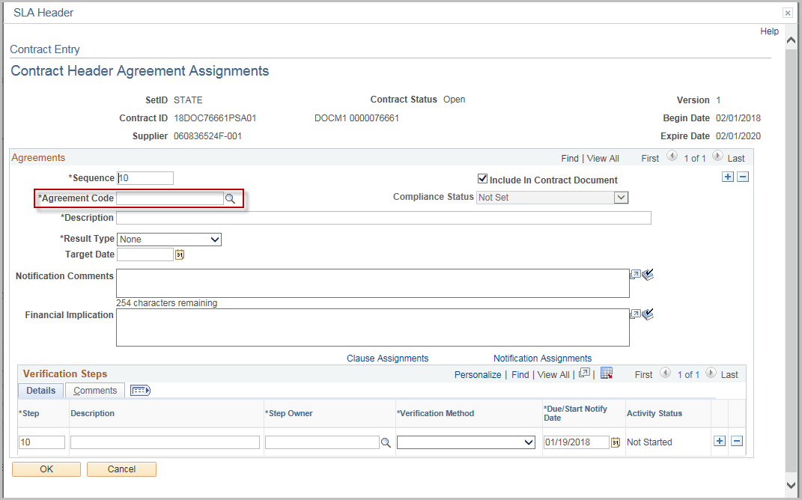
Verify that all information is correct.
Note: The agreement information may be customized for the individual contract
Enter Negotiated Result
Click OK
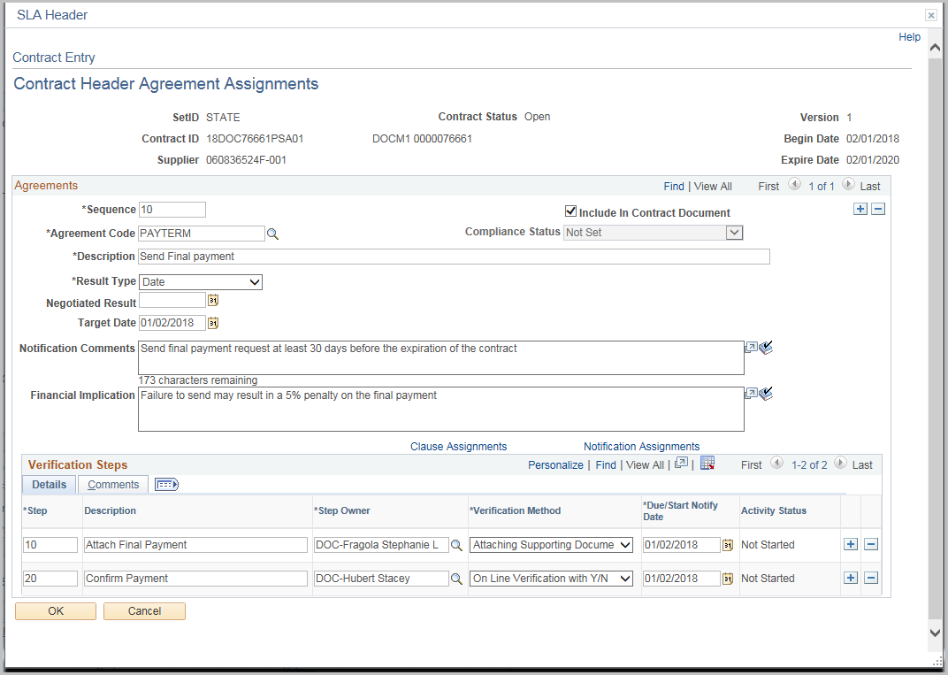

Add an Ad-Hoc Agreement

Navigation: Supplier Contracts > Create Contracts and Document > Contract Entry
Follow the same steps for adding a Contract agreement except enter a unique Agreement Code
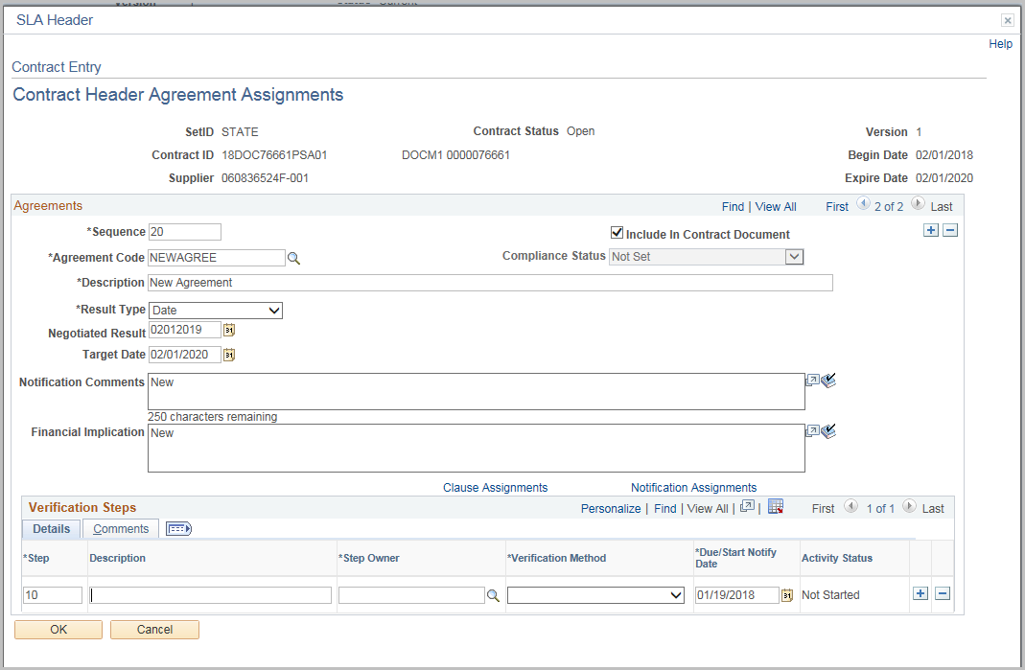
Fill out the information following the information for creating an Agreement
Click OK

Update Agreement Status
Navigation: Supplier Contracts > Monitor and Update Agreements > Update Agreement Statuses
Enter or Search for the Contract ID
Click Search
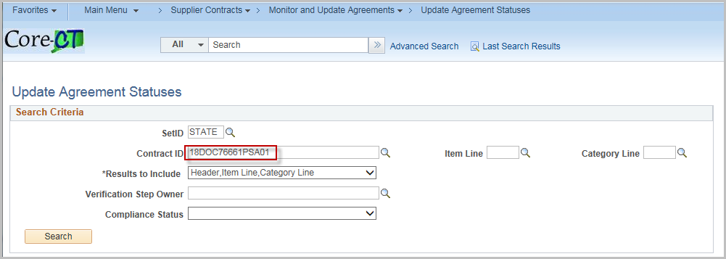
Click the Contract hyperlink

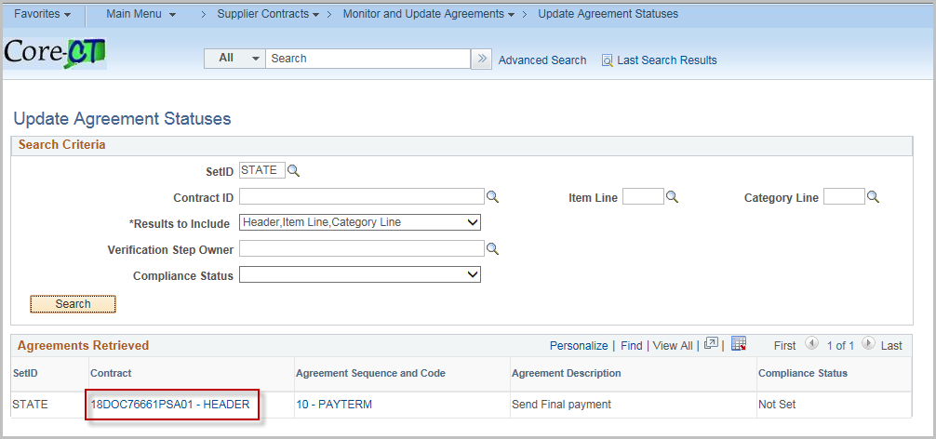

Update the Compliance Status, Actual Result, and comments.
Click Contract Step Verification link

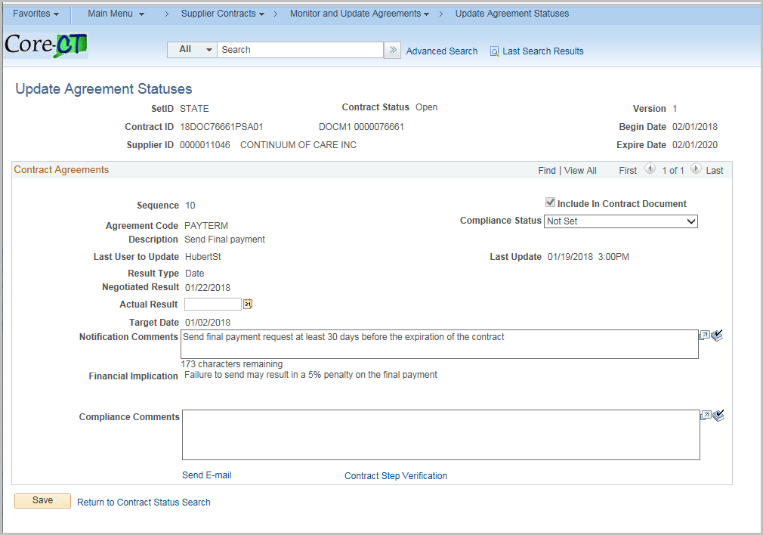

Update Activity Status, Verification (if applicable).
If necessary, click Upload a file (works like Attachments)
Note: Verification Steps should be completed before updating the Compliance Status on the agreement.
Click OK

Click Send E-mail link
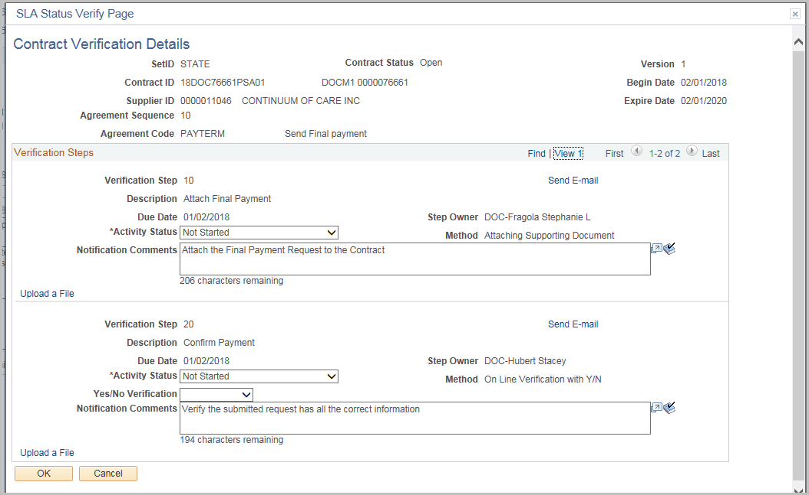
Enter in valid email addresses (separate multiple addresses with a semi-colon ;)
Note: Prepopulated Subject and Message can be edited as necessary.

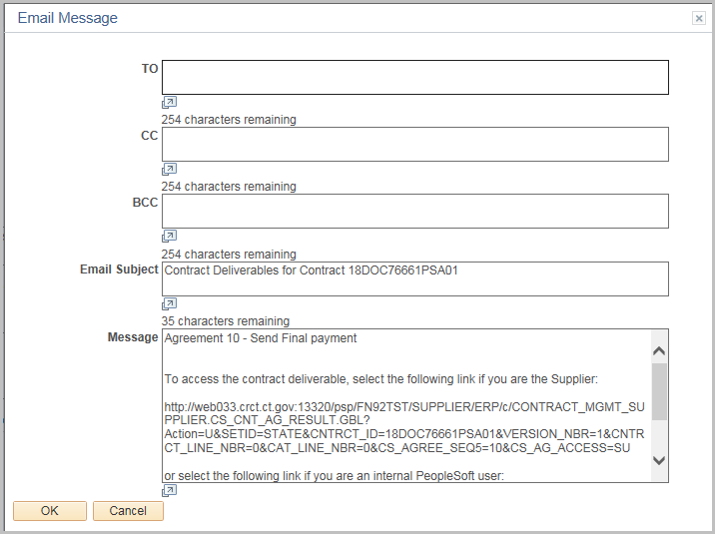

Sample Agreement Notification email
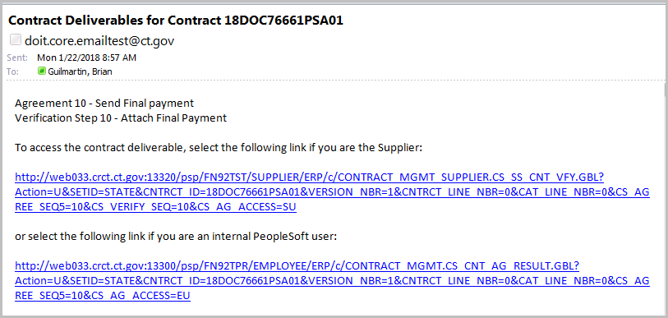

Monitor Agreement Compliance
Navigation: Supplier Contracts > Monitor and Update Agreements > Monitor Agreement Compliance
Click Search
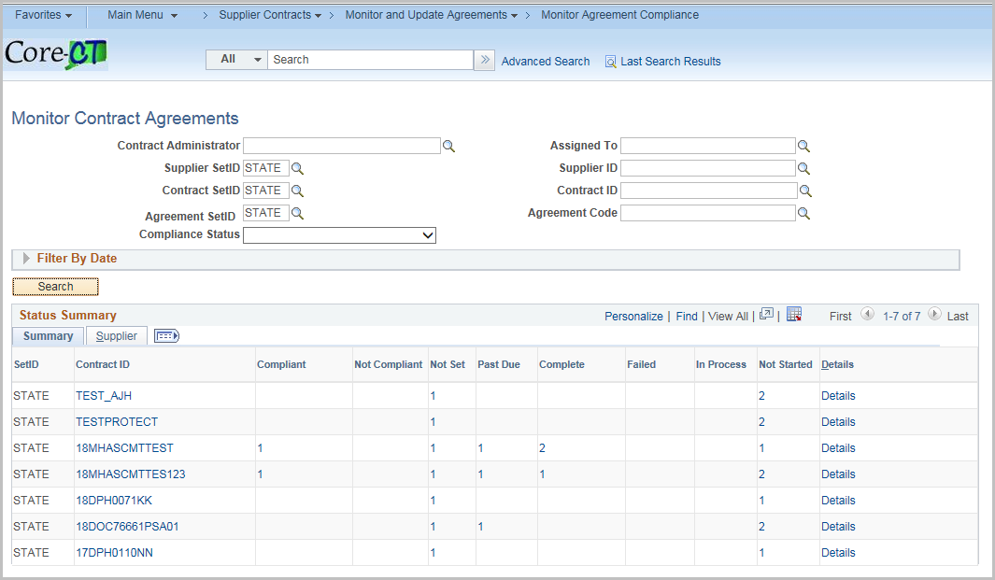
A list of each Contract with Agreements displays
Clicking on the Contract ID will display the Contract information
Clicking on the Individual count for the status will display the row(s) while clicking on Details will show all rows

Click the Results tab to see returned performance measurements
Click the Agreement Sequence and Code

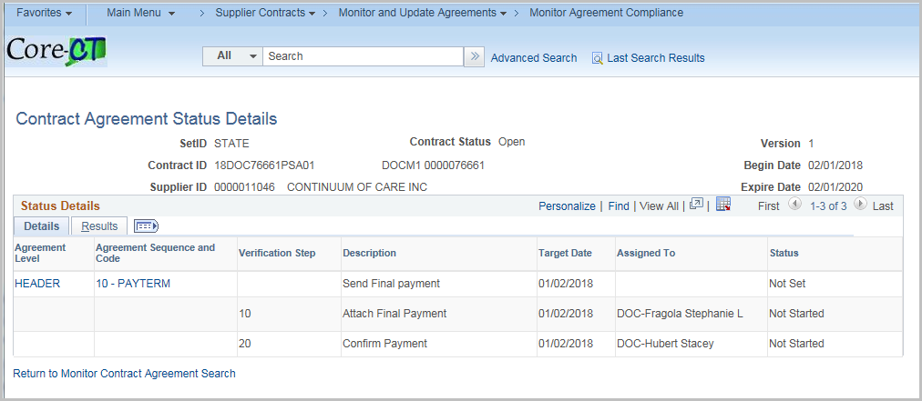

Click the Contract Step Verification
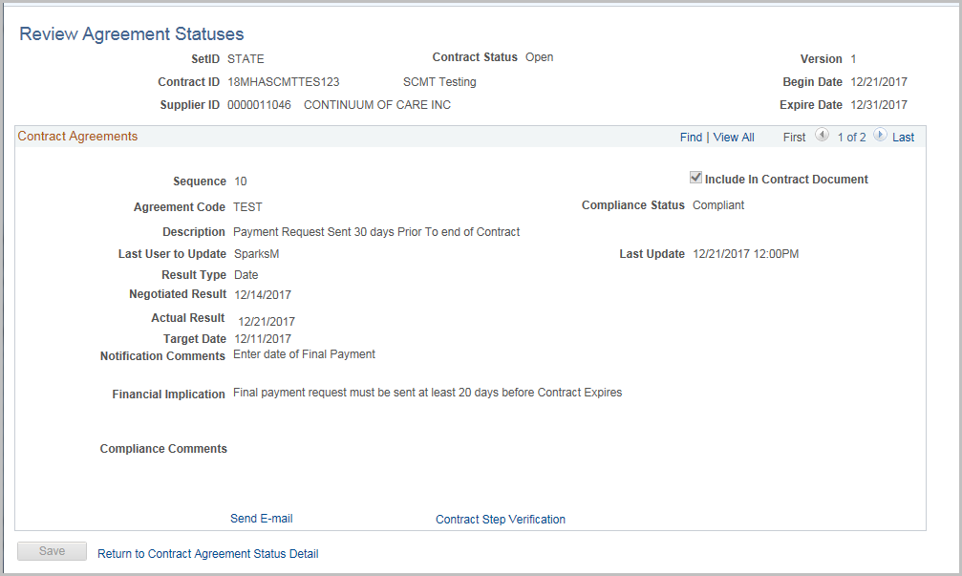
If a file has been attached, it can be viewed here
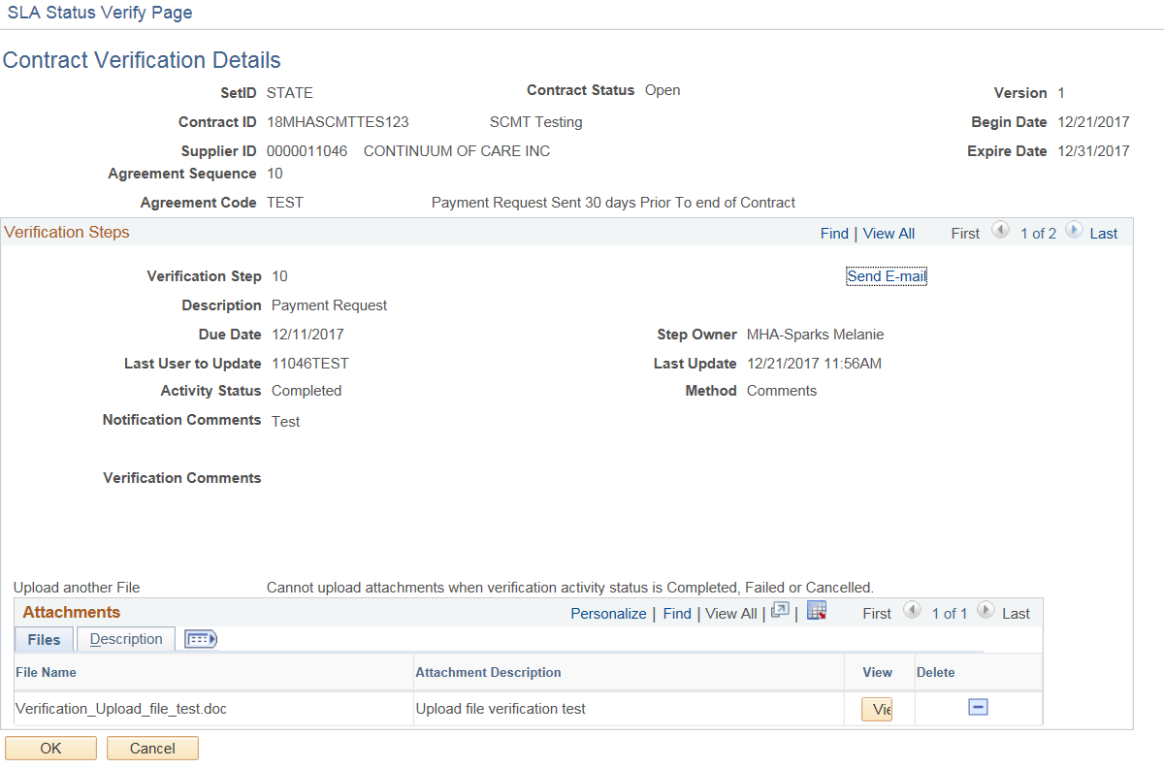
Click OK

Click Return to Contract Agreement Status Detail
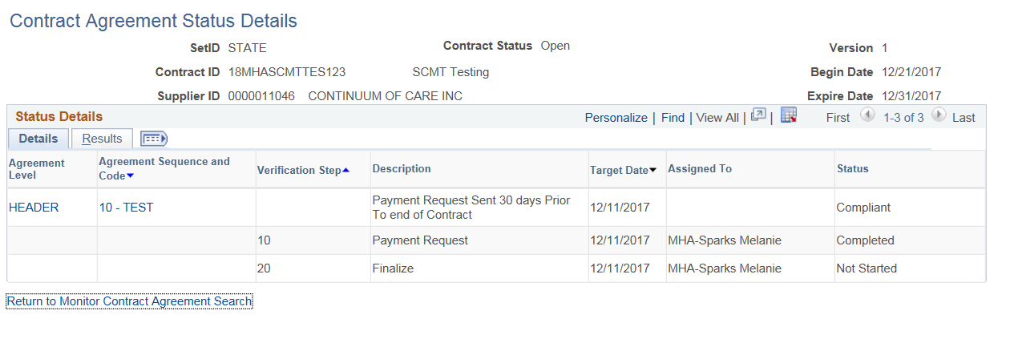

Deactivate Document
If the executed contract is complete and no amendments will be issued, the Supplier Contract Document may be deactivated.

Click Deactivate Document

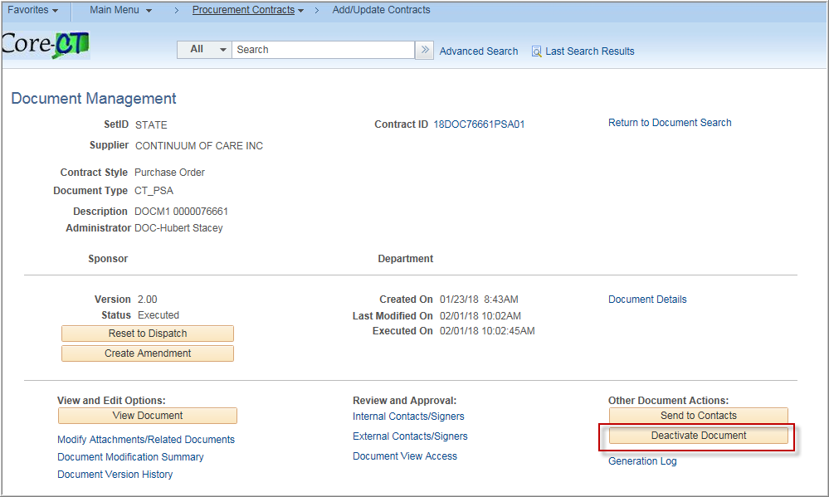

Enter any Comments

Click OK

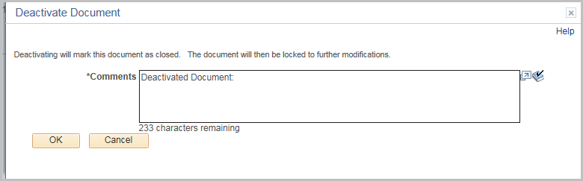

The document now displays that it has been deactivated.

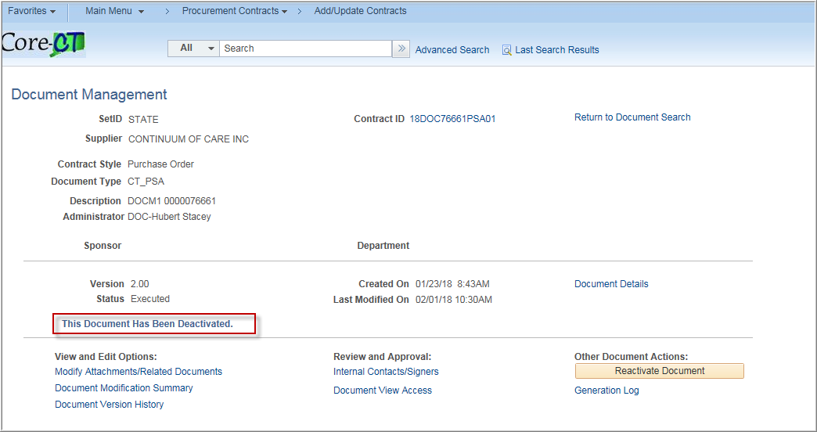

If necessary, the document may be reopened by clicking Reactivate Document.

