Contract Agreements

User must have CT_F_A_SCMT_USER or CT_F_A_SCMT_ADMIN role

You can assign predefined agreements to a contract at the header level or the line level. Header-level agreements are typically negotiated terms that apply to the entire contract. Line-level agreements are terms that apply only to a specific line item on the contract. When you select an agreement from the agreement library, the system provides the information defined on the agreement by default into the contract. You can modify the information associated with the contract without changing the data on the master agreement. As an alternative, you can also create ad hoc agreements at each level by defining them directly on the contract. Ad hoc agreements are not part of the agreement library, but exist only for the life of the contract for which they were created.

Setup Contract Agreements

Navigation: Supplier Contracts > Monitor and Update Agreements > Setup Agreements > Contract Agreement

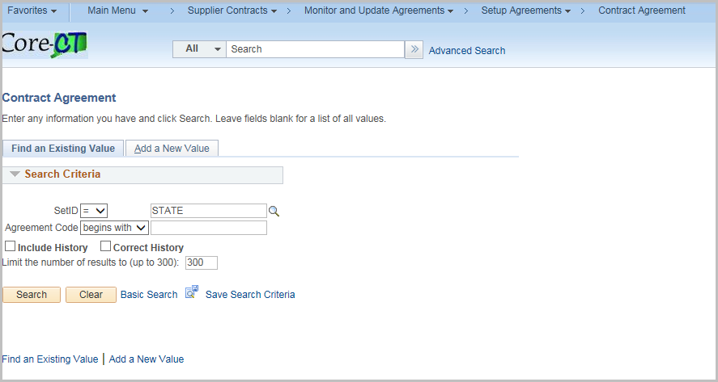

Click Add a New Value Tab

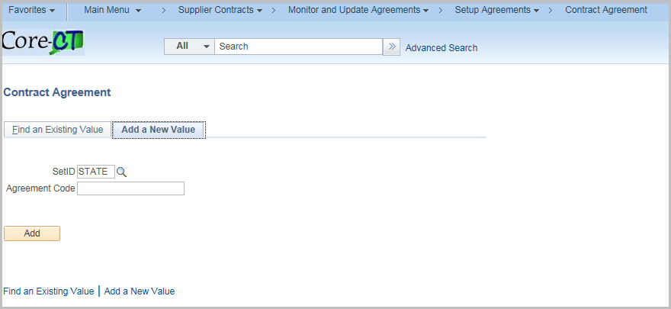

Enter an Agreement Code

Click Add

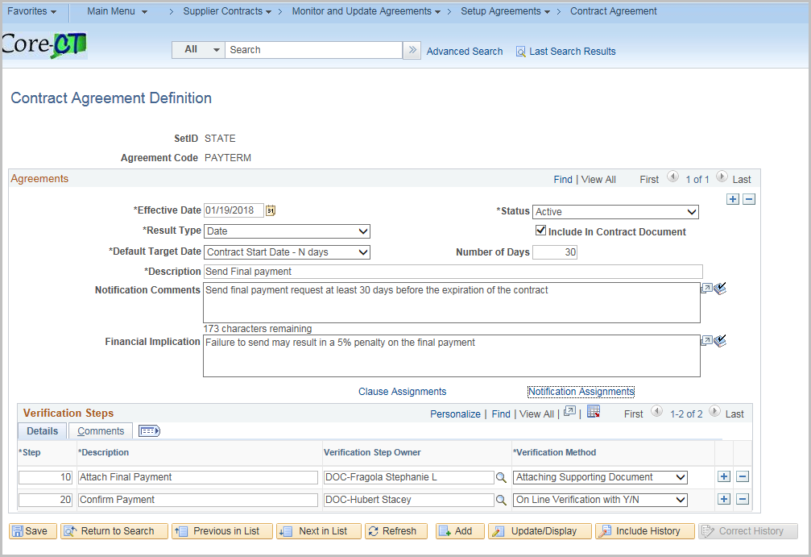

Enter in the values for the definition

Field | Value
Effective Date | Defaults to current date
Status | Active is the default
Result Type | How the results of the agreement will be measured  Date, Metric, Monetary, None, Numeric, Text, Yes/No
Include in Contract Document | Select to include on the Contract and dispatch to the supplier  Unselect if this is an internal control
Default Target Date | How to calculate a due date for the agreement
Number of Days | Works with the Default Target date (Offset N)
Description | A brief description of the Agreement
Notification Comments | Description of the agreement that the system uses when it sends notifications – Maximum 254 characters
Financial Implication | What happens if the Agreement is compliant/non compliant. I.E. a bonus if compliant or a penalty if not compliant

Enter in values for the Verification Step
Click + to add additional Steps

Verification Steps – Detail Tab
Field | Value
Step | Auto-numbers
Description | Description of the Step
Verification Step Owner | Who will be responsible for the Step
Verification Method | Attaching Supporting Document  Comments  Date/Time Stamp  Notify Only  System  Online Verification with Y/N

Verification Steps – Comments Tab

Field | Value
Notification Comments | Description of the agreement that the system uses when it sends notifications – Maximum 254 characters

Click the Clause Assignments hyperlink to assign clauses to contract agreements

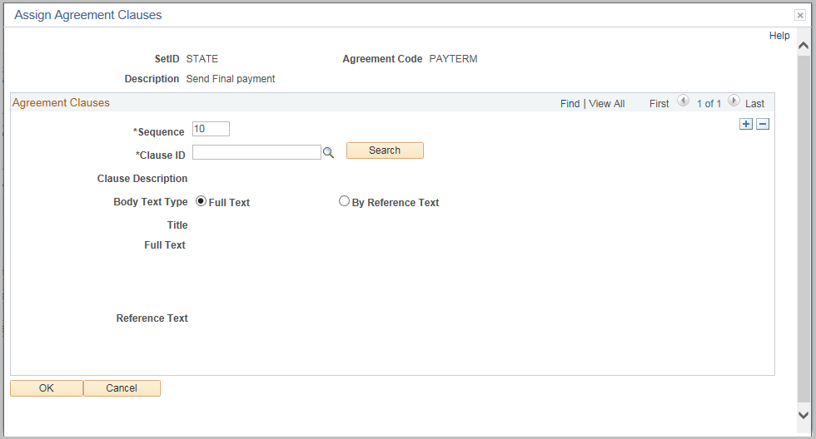
Enter or search for the Clause ID

Click OK

Click Notification Assignments hyperlink

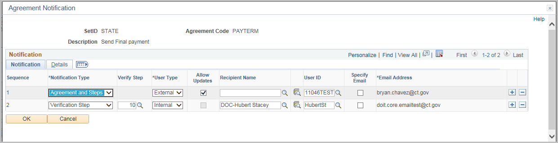
Notifications Tab

Field | Value
Notification Type | Agreement  Agreement and Step  Verification Step
Verify Step | Which verification step this notification applies
User Type | Internal or External
Allow Update | For external users to update the verification step
Receipient Name | For an external user not defined in the system
User ID | The User ID for this notification
Specify Email | Check to enter in an email address
Email Address | Will use the User ID default email unless the specify email is checked

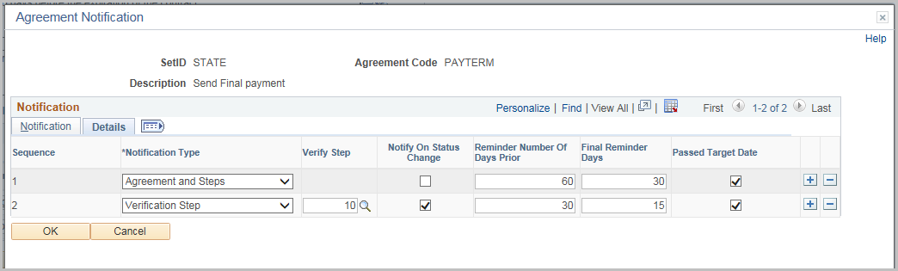

Details Tab

Field | Value
Warning Performance | Sends a warning about the performance
Unacceptable Performance | Sends a notification if the performance is unacceptable
Notify on Status Change | Sends a notification when the status of the verficiation step changes
Reminder Number of Days Prior | Sends a notification before the due date
Final Reminder Days | Sends one last notification before the target date
Passed Target Date | Sends a notification after the target date if the agreement is not set to compliant

Click OK

Click Save

Add a Contract Agreement

Navigation: Supplier Contracts > Create Contracts and Document > Contract Entry
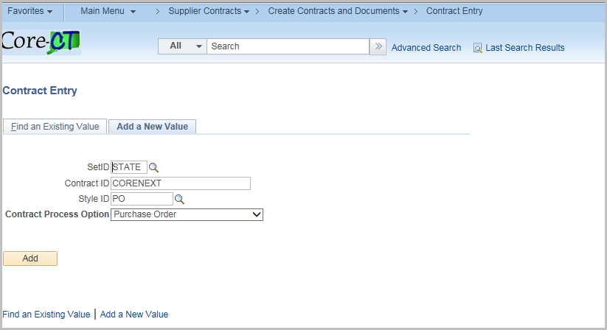

Click the Find an Existing Value tab
Enter the Contract
Click Search

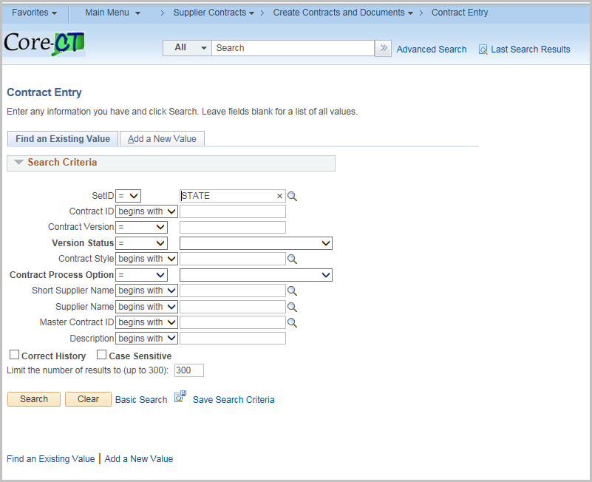

Click Contract Header Agreement hyperlink or the Contract Line Agreement

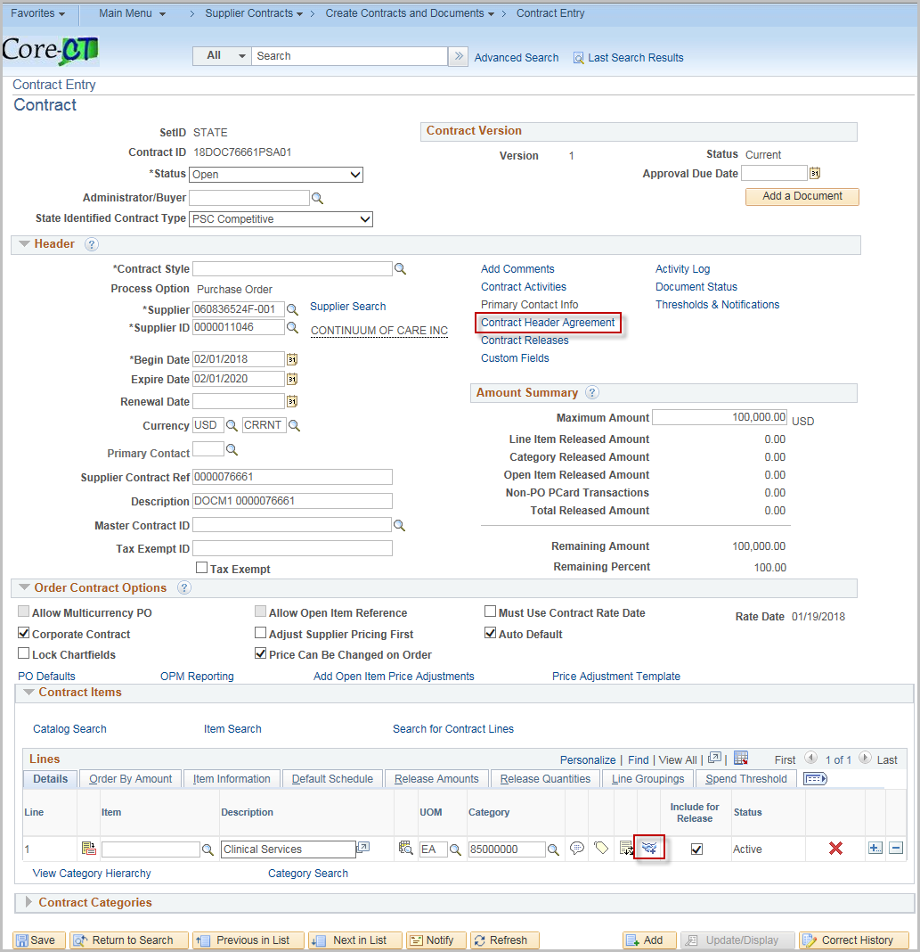

***Screenshots are for the Header level but they look the same for the Line Level***
For an existing Agreement, enter the agreement code or search for a code.

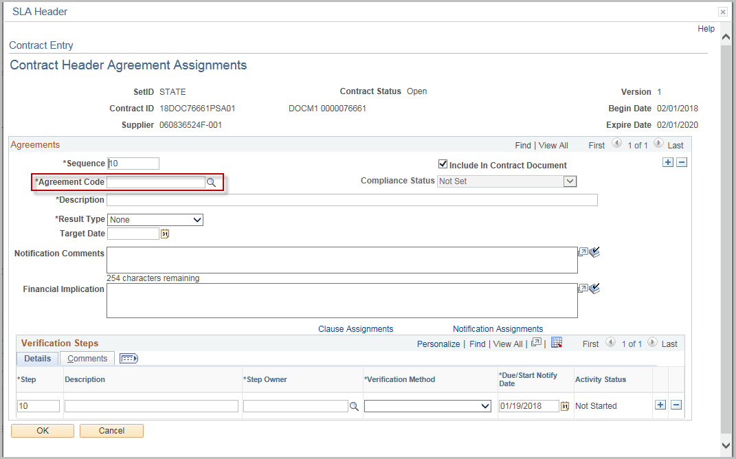

Verify all information is correct.
Note: The agreement information may be customized for the individual contract
Enter Negotiated Result
Click OK

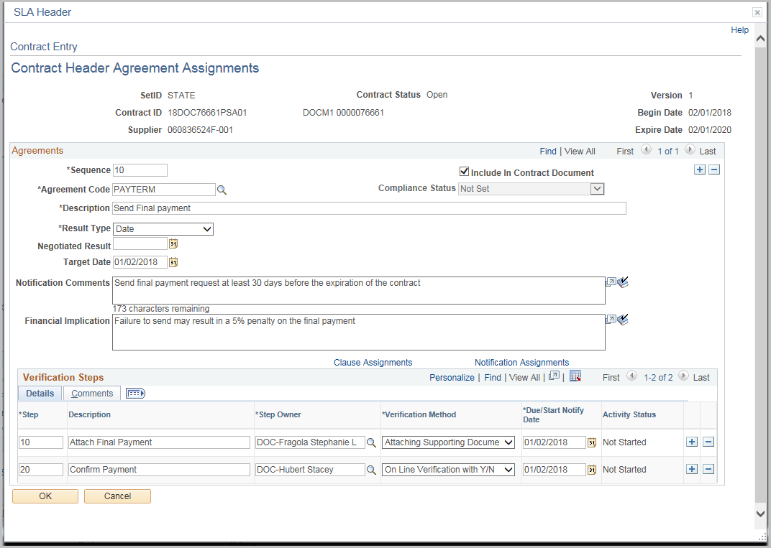

Add an Ad-Hoc Agreement

Navigation: Supplier Contracts > Create Contracts and Document > Contract Entry
Follow the same steps for adding a Contract agreement except enter a unique Agreement Code
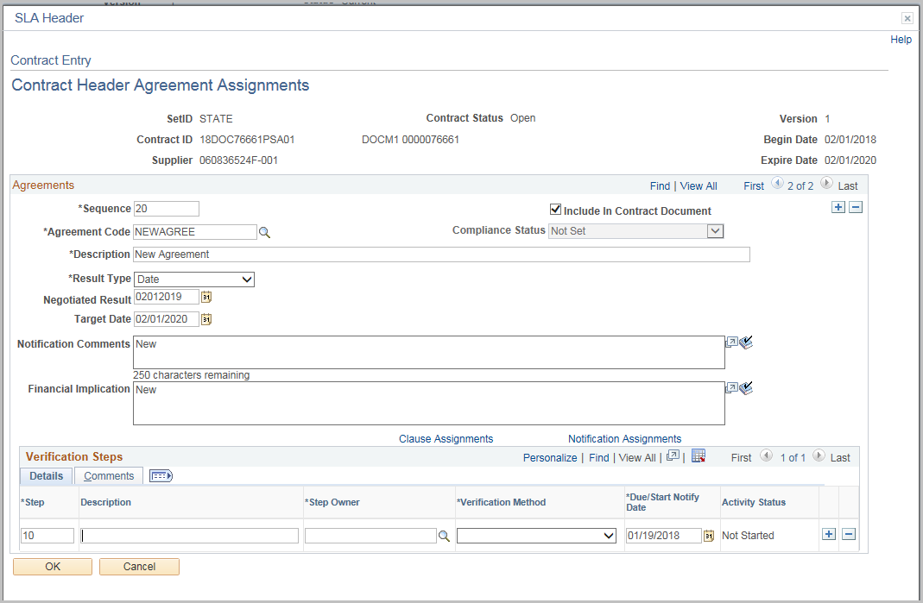
Fill out the information following the information for creating an Agreement
Click OK

Update Agreement Status
Navigation: Supplier Contracts > Monitor and Update Agreements > Update Agreement Status
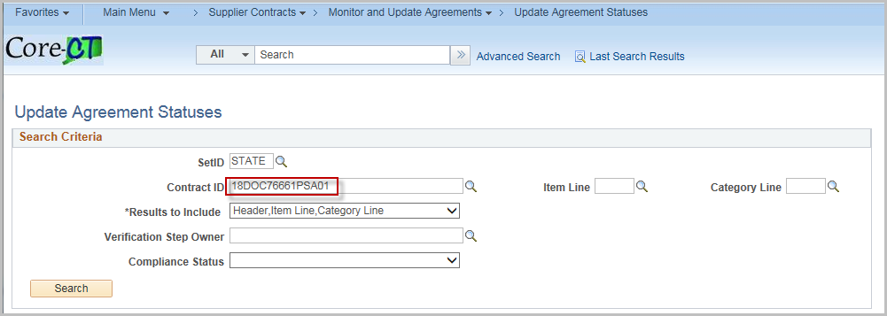
Enter or Search for the Contract ID
Click Search
Click the Contract hyperlink

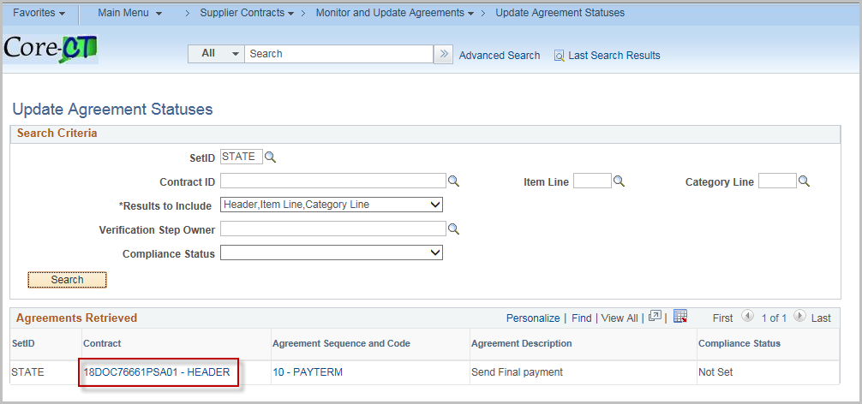

Update the Compliance Status, Actual Result, and comments.
Click Contract Step Verification

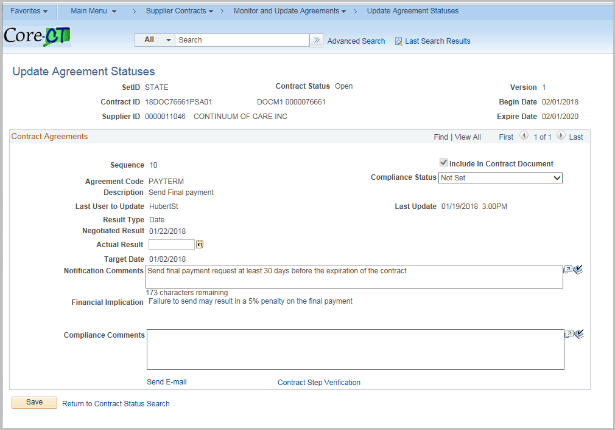

Update Activity Status, Verification (if applicable).
If necessary, click Upload a file (works like Attachments)
Note: Verification Steps should be completed before updating the Compliance Status on the agreement.
Click OK

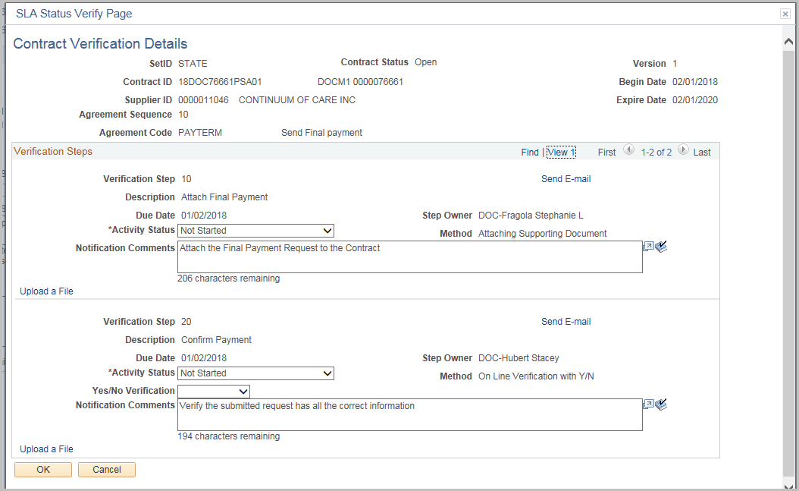

Click Send E-mail

Enter in valid email addresses (separate multiple addresses with a semi-colon ;)
Note: Prepopulated Subject and Message can be edited as necessary.

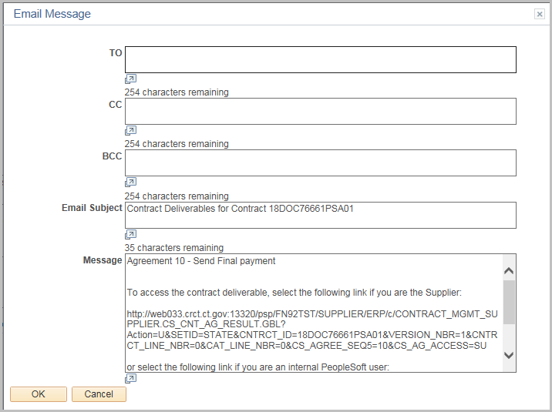

Sample Agreement Notification email
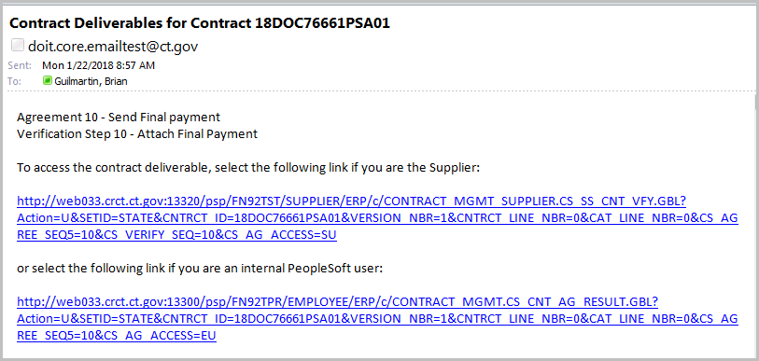

Monitor Agreement Compliance
Navigation: Supplier Contracts > Monitor and Update Agreements > Monitor Agreement Compliance
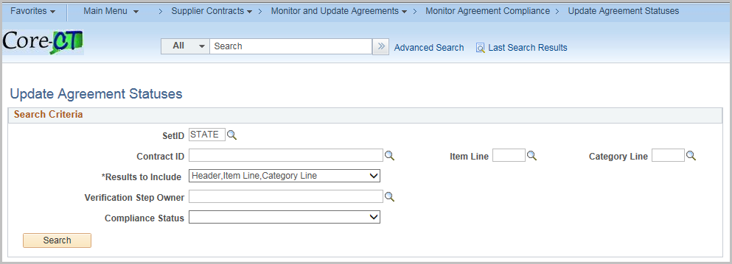
Click Search
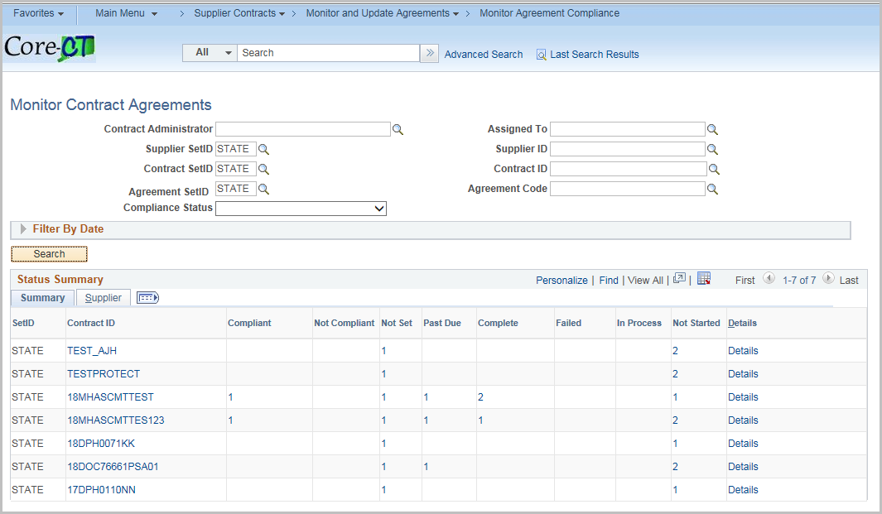
A list of each Contract with Agreements displays
Clicking on the Contract ID will display the Contract information
Clicking on the Individual count for the status will display the row(s) while clicking on details will show all rows
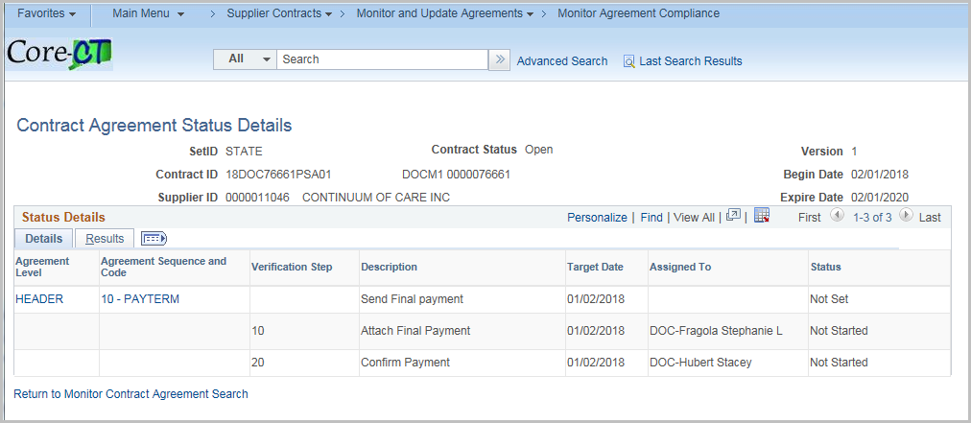
Click the Results tab to see returned performance measurements
Click the Agreement Sequence

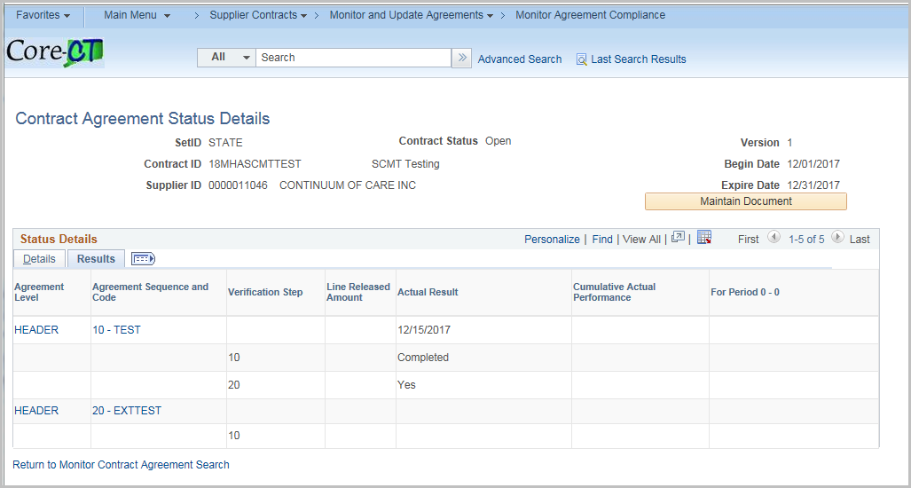

Click the Contract Step Verification

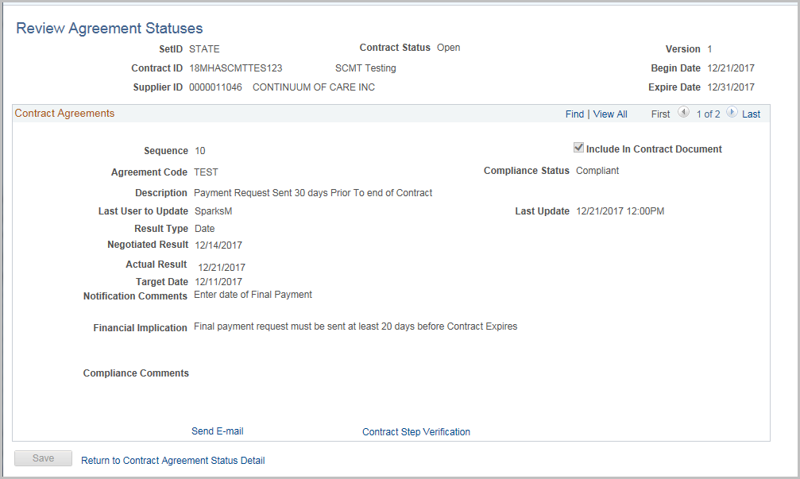

If a file has been attached, it can be viewed here
Click OK
Click Return to Contract Agreement Status Detail



