Budget Workbook for Agencies Job Aid
The process flow below outlines the steps which need to be completed in order for the Budget Definition to become a Budget Workbook.

Agency
Provider

*Provider Entity is not specifically tied to the Budget Workbook; the Provider completes this when they have access to the Supplier Portal.

Budget Definition Entry / Submission

In order to create a Budget Workbook, a Procurement Contract must have been created and be in either Open or Approved status.
The following shows how to create and submit a new Budget Definition.
Navigation: Supplier Contracts > Budgeting > Budget Definition

Click the Add a New Value Tab

Enter the Business Unit, Contract ID, and Funding Period
Note: The funding period cannot be Zero

Click Add

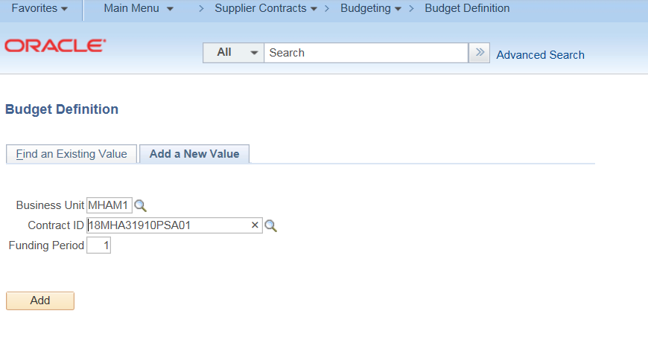

The Budget Definition Page will display

Enter the Funding Period begin and end dates
These dates must be within the contract begin and end dates.

Select the Reporting Requirement
(4, 8 Month & Final, 8 Month & Final, Bi-Monthly, Monthly or Quarterly)

Select the Payment Basis
(Expenditure – Cash Management, Fixed Periodic, Request – Cash Management)

NOTE: The Payment Basis field defaults as blank and does not have to be populated with a value if not required.
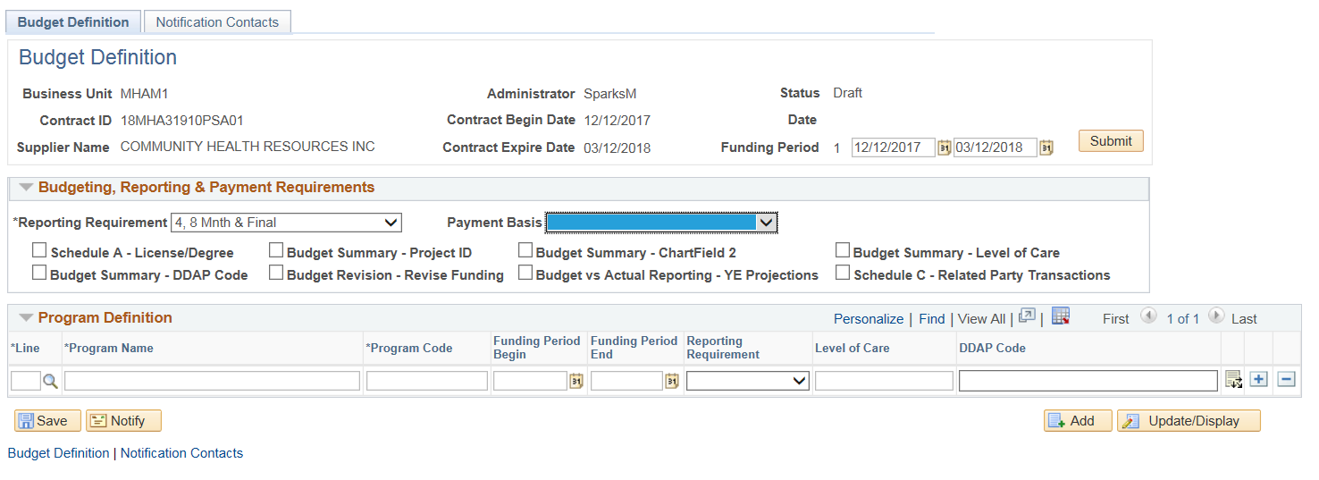
Select the checkboxes that will be used for this workbook. Each checkbox selected will make up the content of the Budget Workbook. These checkboxes can be modified up until the workbook has been accepted by the agency.
Enter the Line number or use the magnifying glass to search for available lines on the Procurement Contract. The line numbers do not have to match the Procurement Contract and more lines can be entered, if necessary.
Enter the Program Name. The description of the line will not be brought over from the Procurement Contract
Enter a Program Code. The Program Code will be used for the Column heading throughout the workbook.
Enter the program Funding Period Begin, Funding Period End, and Reporting Requirements ONLY IF they are different from the selection entered above

Enter the Level of Care, and DDAP Code as needed
NOTE: If your agency does not use Level of Care or DDAP code, these fields can optionally be used as additional text information about the program
Click the ‘+’ plus button to add additional Program lines
Click the Distribution icon at the end of the line to enter the coding for the Program
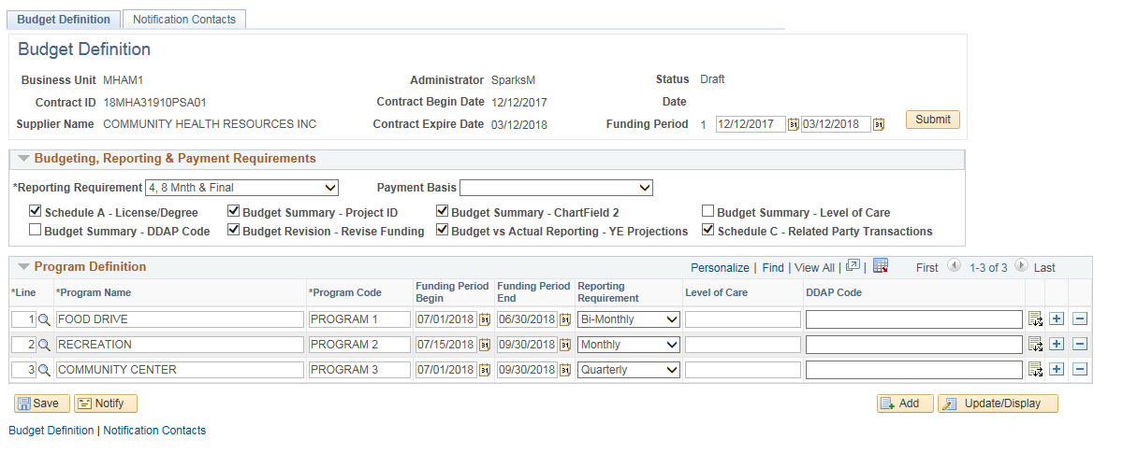
Enter the Funding Distribution for each Program Line:
Enter the Distribution Line number or use the magnifying glass to search for available lines on the Procurement Contract. The line numbers do not have to match the Procurement Contract.
If an existing Procurement Contract distribution is entered, the Amount, SID, ChartField 2, and Project fields will populate with the contract’s information. These fields can be overridden if necessary. If no values exist, enter the correct information.
Note: Clicking on the Refresh will reset the Amount, Sid, Chartfield 2 and Project to the values on the associated Procurement Contract distribution.
Do not click Refresh if you are manually entering these values.
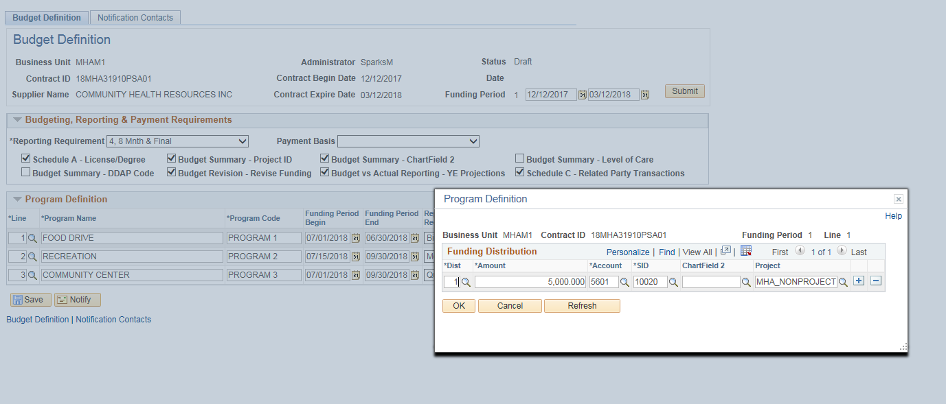
The Account field will not be brought over from the Contract. Instead, enter in the four digit UCOA code that identifies the funding source. Enter the code or click the magnifying glass to select the value.
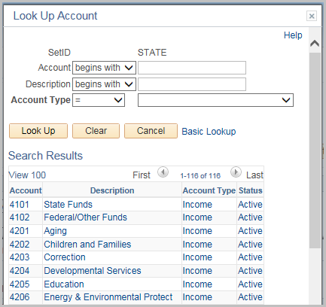
Click ‘+’ plus button to add additional distribution lines
Click OK
Repeat this step for each program line.

Once all distributions have been entered, click Save
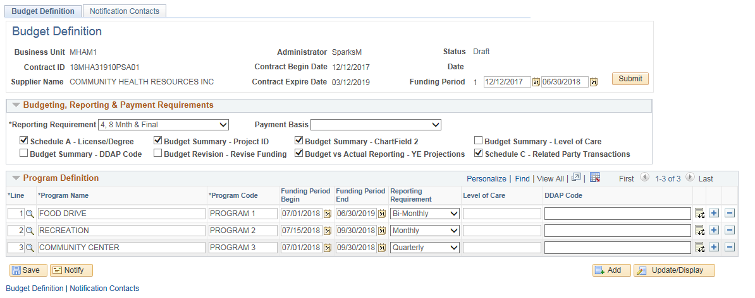

Click the Notification Contacts tab
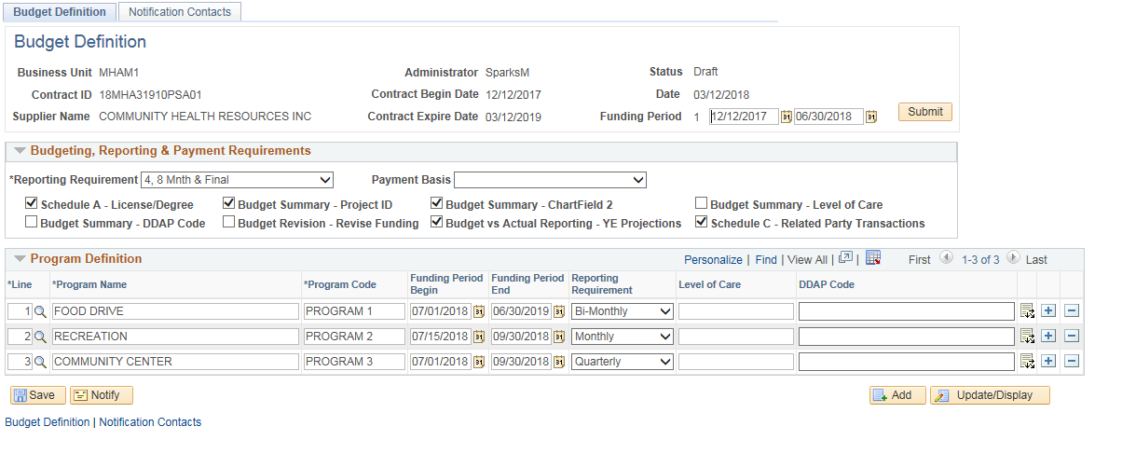
The Notification Contacts Tab is where all users (both Agency and Provider) will be added to receive notification about this workbook.
Click the ‘+’ plus button to add additional contacts.
For Provider Contacts:
Click the External checkbox and enter Provider’s User ID.
NOTE: The Provider Administrator will set up the User IDs for all provider staff. The Agency will need to submit a CO-1092 form for each user to grant access to the Budget Workbook. If the User ID does not work, contact the Provider Administrator to verify that a User ID has been setup.
For Agency Contacts:
Enter the agency Contact’s User ID.
The user creating the workbook should always add their user id as a contact.
Note: You can also use the magnifying glass to search for the user id.
When a User Id is selected, the description and the email address for both external and internal contacts will update automatically.
If the email address stays blank or is incorrect, it can be modified for this Workbook. However, the correction will not update the User ID’s profile. A request will need to be submitted to the appropriate personnel to update their profile with the correct information.
Click Save
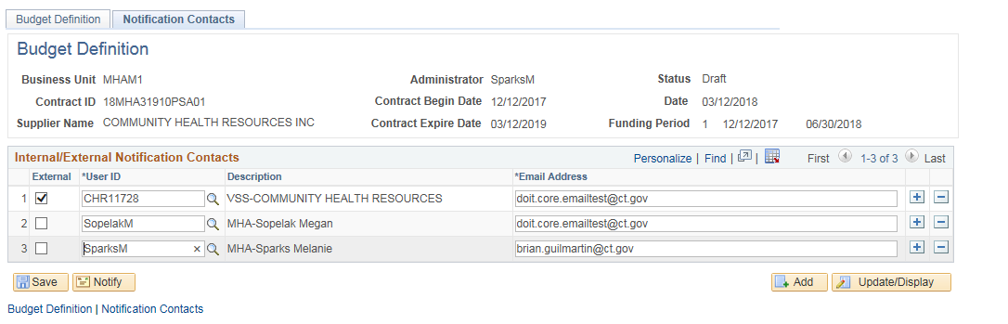
Return to the Budget Definition tab
Click Submit
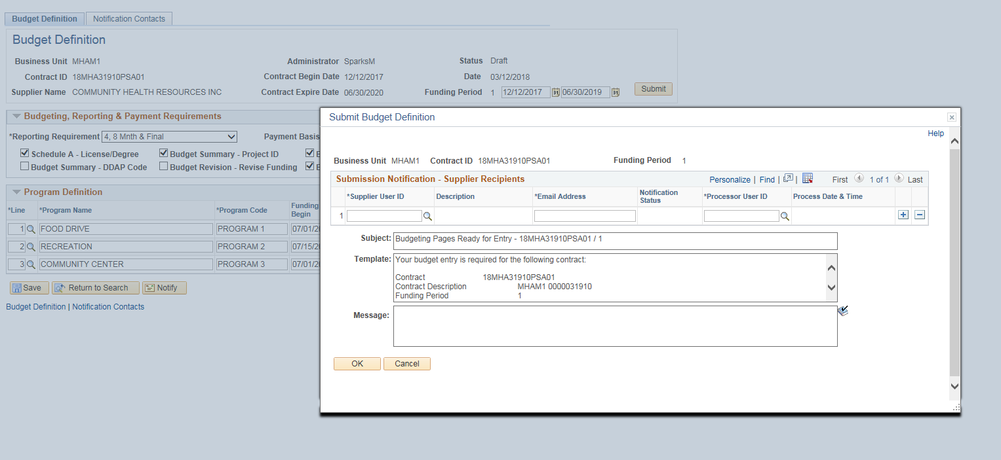
This will open up the Submission Notification screen where you will notify the Provider that the Budget Workbook is ready for collaboration.
Enter the Supplier (Provider) User ID (or use the magnifying glass to search) Description, Email address and Processor User id will automatically update.
Only users entered on the Notification Contacts tab will be available to select to receive a notification. If a user is missing go back to the Notification tab and add them. Review and/or update the Email Address if necessary.
Enter a message to be included in the email if needed and click OK.
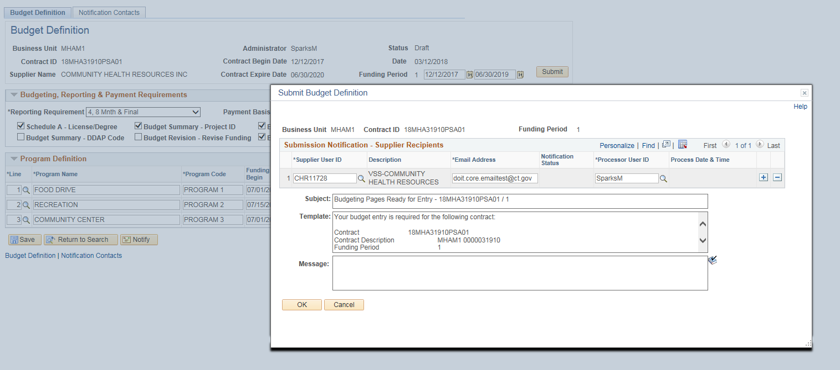
Click OK to the confirmation message.

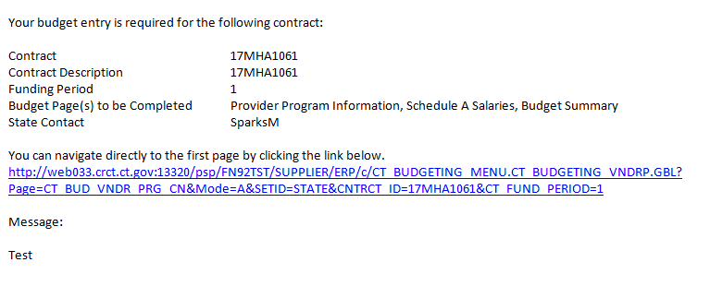
At this time, an email will be sent to the Provider. The Provider will now know what Budget Pages need to be completed and can click the hyperlink to begin that process.

Prior to accepting the Budget Summary, the Provider completes the following pages:
- Provider Entity Page
- Provider Program Information Page
- Schedule A Salaries
- Budget Summary Entry/Submission

Provider Entity Information Update
The following shows how to update Provider Entity Information.
The Provider Entity Information is not specifically tied to the Budget Workbook
However this is information the Provider completes when they have access to the Supplier Portal and can be viewed by the Agencies.

The Provider or the Agency can update information through Find an Existing Value Tab.
Navigation: Supplier Contracts > Budgeting > Provider Entity Information

The Entity Provider Information page will display.
Enter the Supplier ID, (or use the magnifying glass) or enter the Name of the Provider then click Search

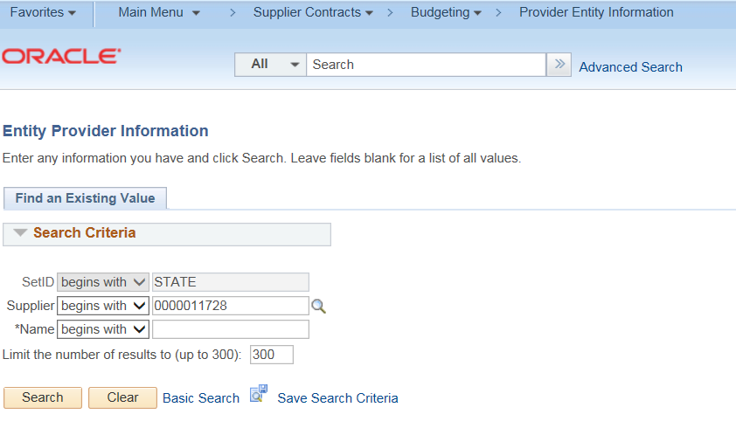

The Provider Entity Page is broken down into three tabs.
On the first tab (Provider Entity Information)
Enter the DUNS #
Enter the Provider Fiscal Year End (Month)
Enter the SAM (CAGE) No. and the SAM (CAGE) No. Expiration Date
Answer Yes/No for the 80 percent field
Answer Yes/No for the $25,000,000 field
Answer Yes/No for the Litigation Pending field. If Yes, the Comment field is required to be filled out.
Enter Accreditation List
Click Save 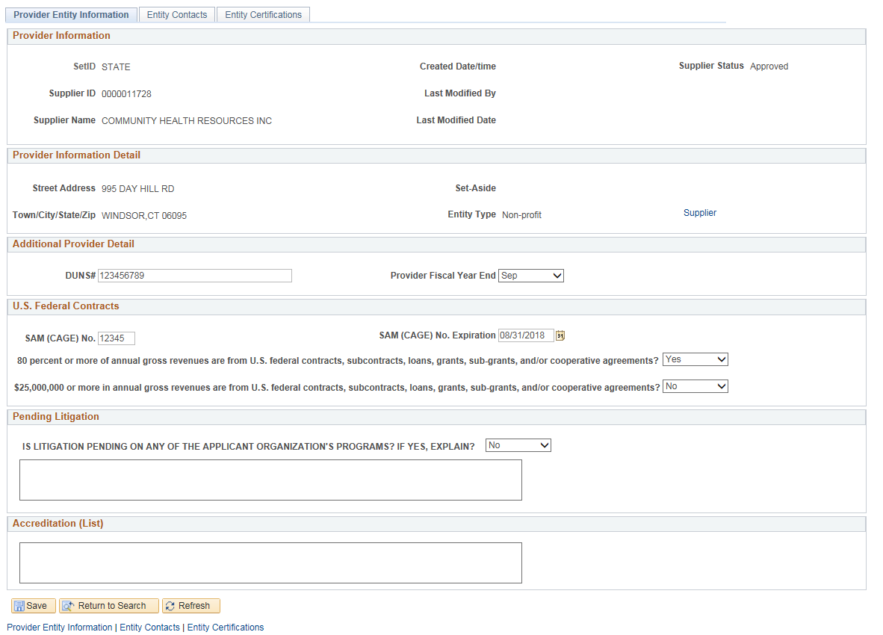

Click on the Entity Contacts tab
This will display a list of the current contacts and their information that have been setup by the Provider.
If changes need to be made, the Provider Administrator will have the Supplier Change Request Link available.
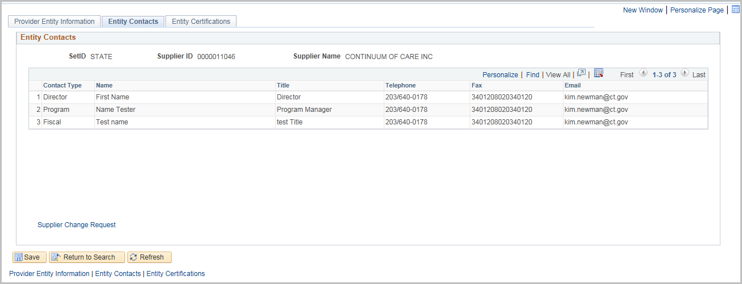
Click on the Entity Certifications tab
Select the Certification Type
Enter an ID Number and an Expiration Date
Click the + sign to add additional certifications
There are three links to other websites to assist with this section
(Biznet, The Office of Secretary of the State, or License Lookup)
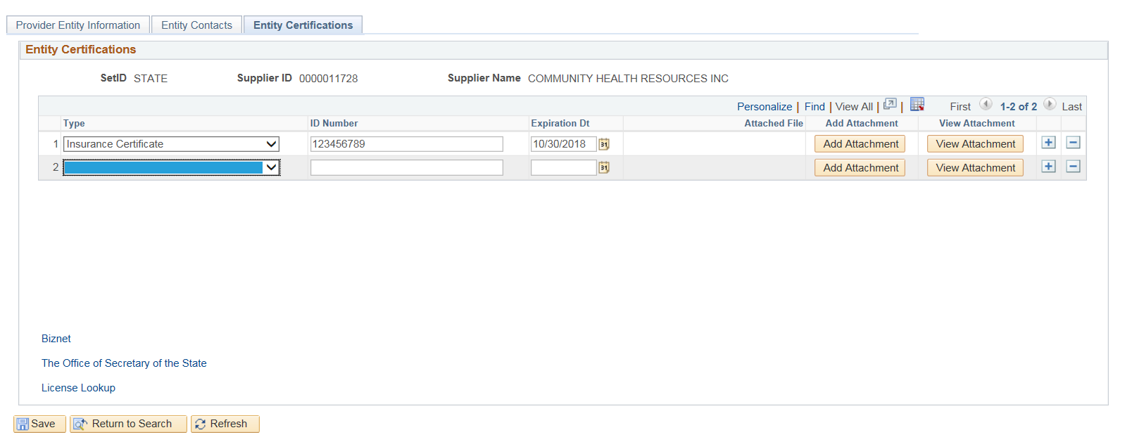
Click Add Attachment to attach copy of the certificate
Click Browse and select the file that is to be uploaded

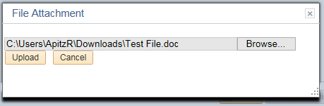
Click Upload

Click View Attachment
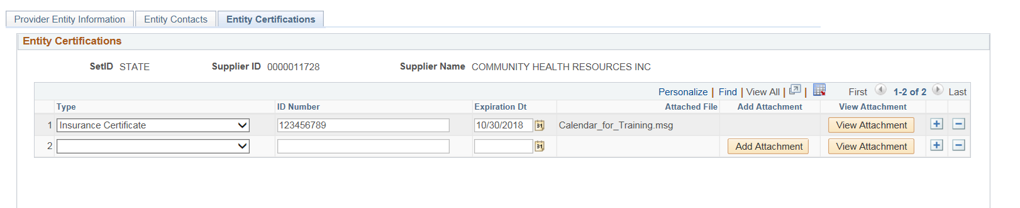
At the bottom of the screen, click Open to view the attachment.

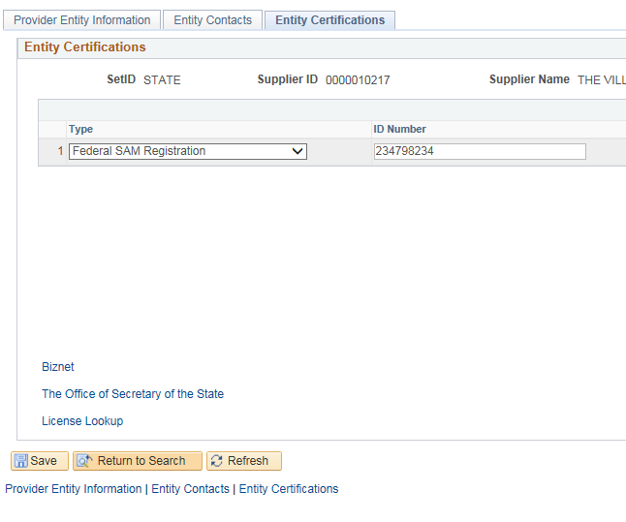
Click Save

Provider Program Information Entry
The following shows how to update the Provider Program Information.
Navigation: Supplier Contracts > Budgeting > Provider Program Information

The Provider Program Information page will display.

Enter or search for the Contract ID, Funding Period, or Supplier Name, and click Search

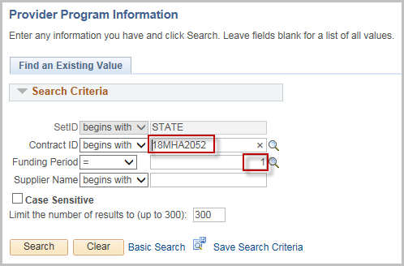
Select the Contract ID from the search results
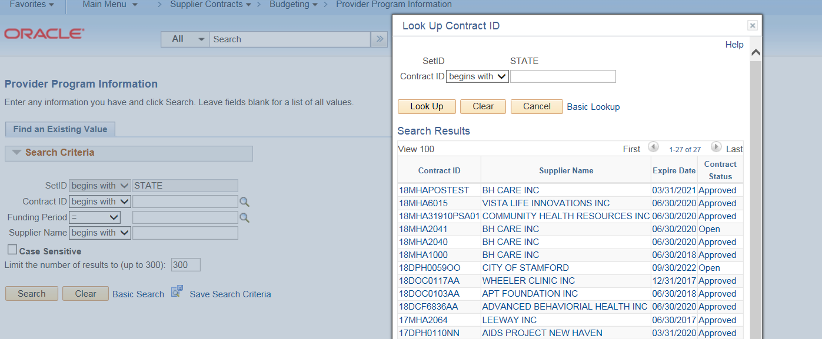

The Provider Program Information is broken down into three tabs
Select Yes/No for the Statewide field (The default is Yes)
If No is selected, enter at least one of the Catchment Areas, City/Town, or Region fields
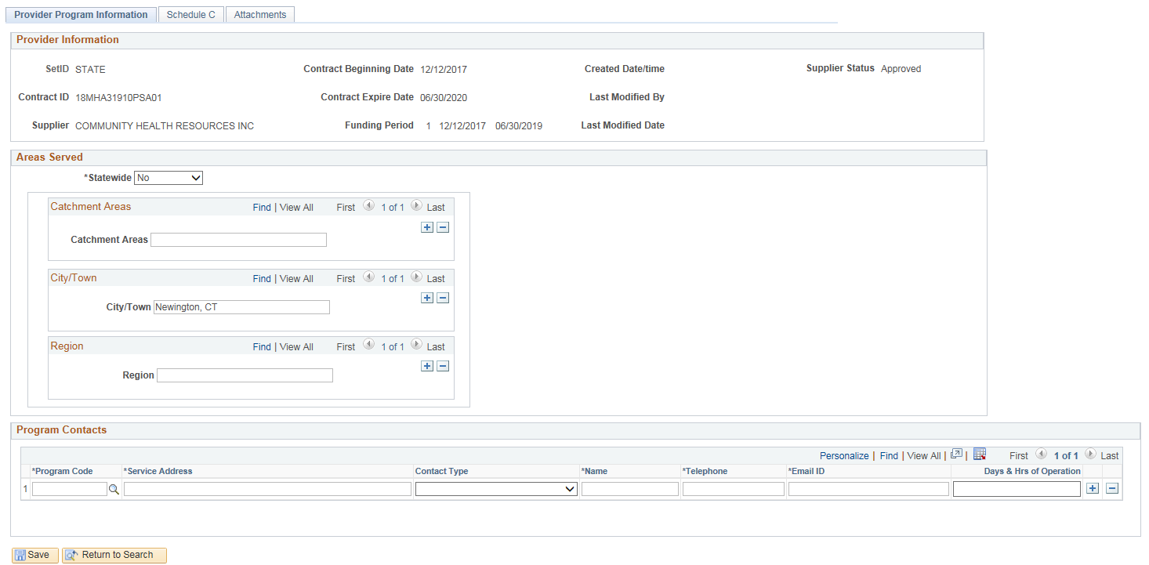
Enter in Program Contacts.
Look up the Program Code (using the magnifying glass). Only programs that were created on the Budget Definition can be selected.
Enter the Service Address
Select Contact Type
Enter Name, Telephone, Email ID, and Days & Hrs of Operation
Click on the + sign to add additional Contacts
Click Save
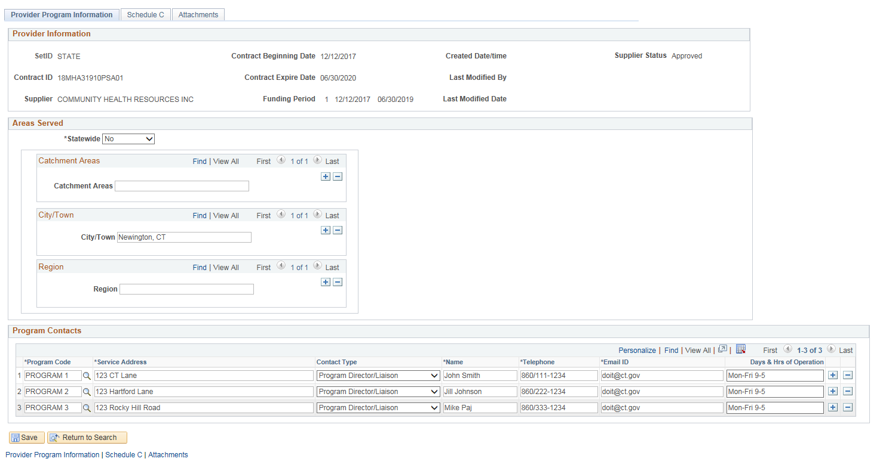
Click on the Schedule C tab
Note: The Schedule C tab will only appear if it has been checked on the Budget Definition Page.
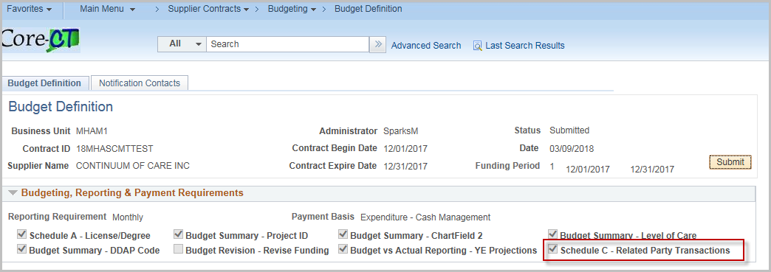

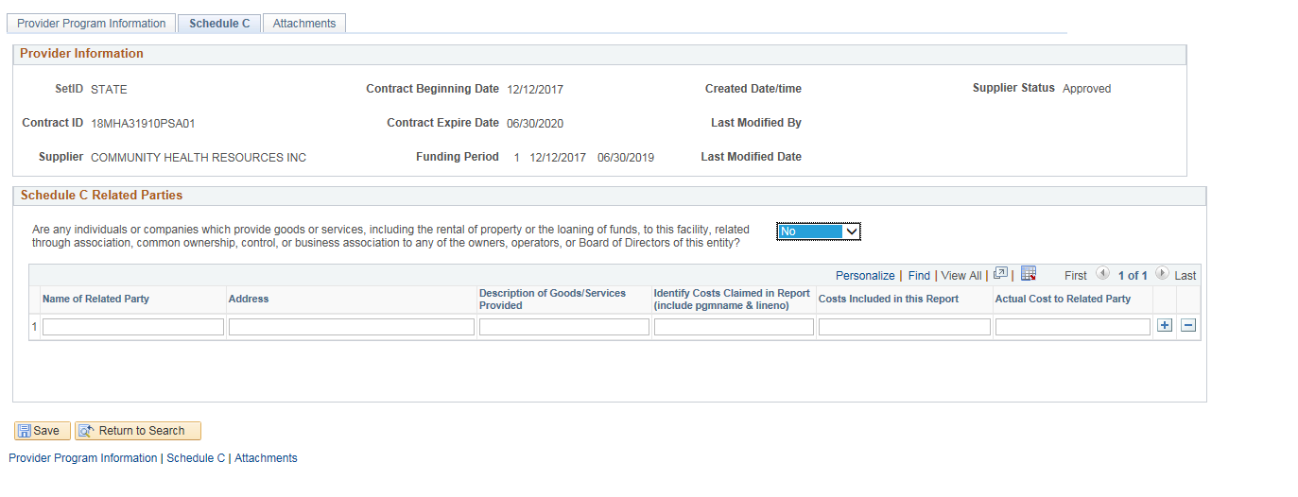
Select Yes/No to the question in the Schedule C Related Parties section
If Yes, enter Name of Related Party, Address, Description of Goods/Services Provided, Identify Costs Claimed in Report, Costs Included in this Report, and Actual Cost Related to Party fields.
Click Save
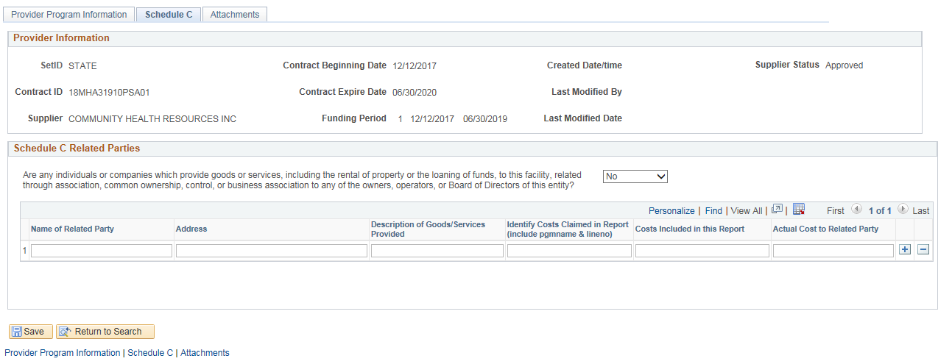

Click on the Attachments tab
The attachments tab can be used for any additional documentation.
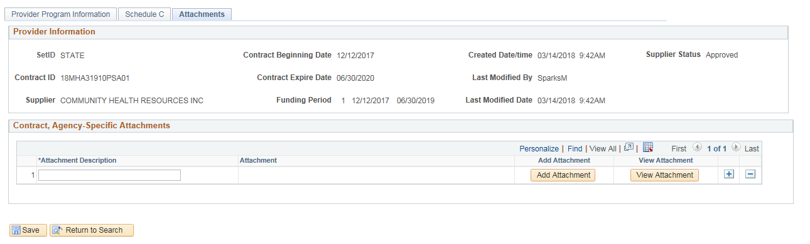
Enter the Attachment Description and click on Add Attachment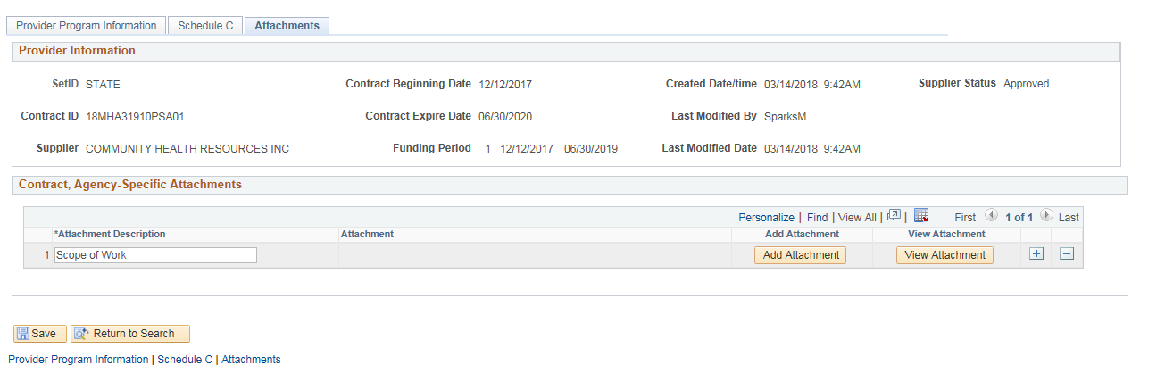
Click Browse

Select the attachment to be uploaded and click Upload
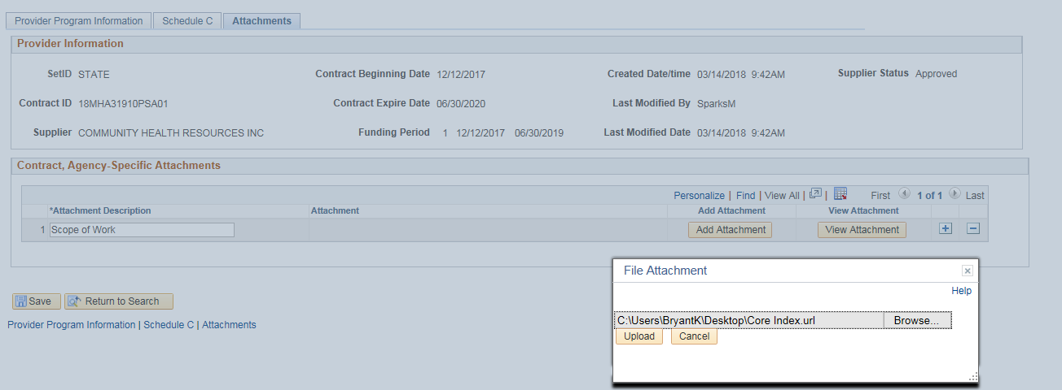
Click View Attachment to review the document
Use the + sign to add more attachments
Click Save
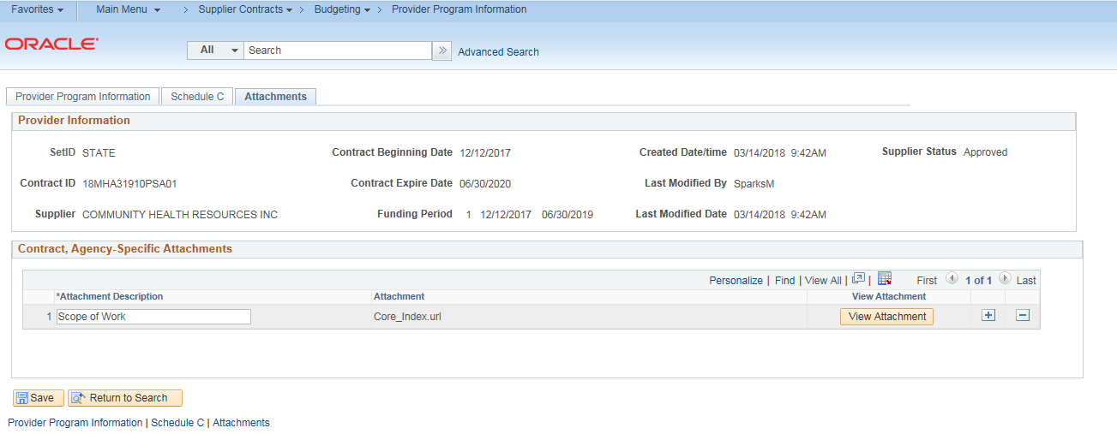

Schedule A Salaries Entry
The following shows how to enter Schedule A Salaries and submit the budget.
Although the Provider should be entering this information, the agency can enter it on their behalf.
Navigation: Supplier Contracts > Budgeting > Schedule A Salaries

The Schedule A Salaries page will display.
Enter or search for the Contract ID, Funding Period, or Supplier Name, and click Search

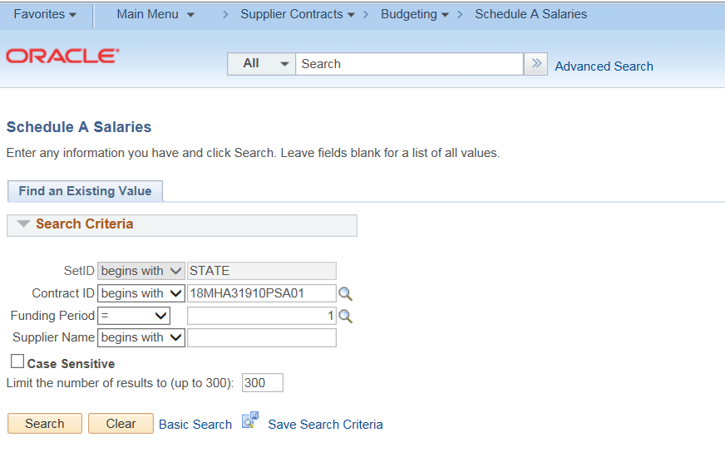

Check the Administrative checkbox if the A&G portion of this resource is an indirect expense.
Do not check the box if the A&G portion of the resource is a direct expense.
Enter Number of Resources. The Total Contract expense will be multiplied by this number to reflect the total for the group.
Enter the Position Title
Enter the Name
The Rate per hour is calculated automatically.
Enter the Degree / License (This will be available only if Schedule A – License/Degree is checked on the Budget Definition)
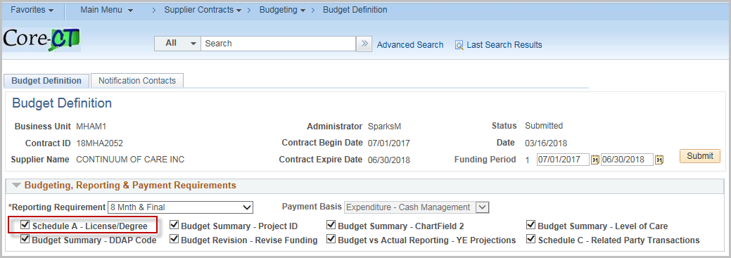
The Total Hours Per Week is defaulted to 40. Update if necessary.
Enter the Weeks Per Year (only if working for less than a year)
Enter the Base Annual Salary (scheduled wages only)
Enter the Fringe Benefits % (The Annual Fringe Benefits will calculate automatically)
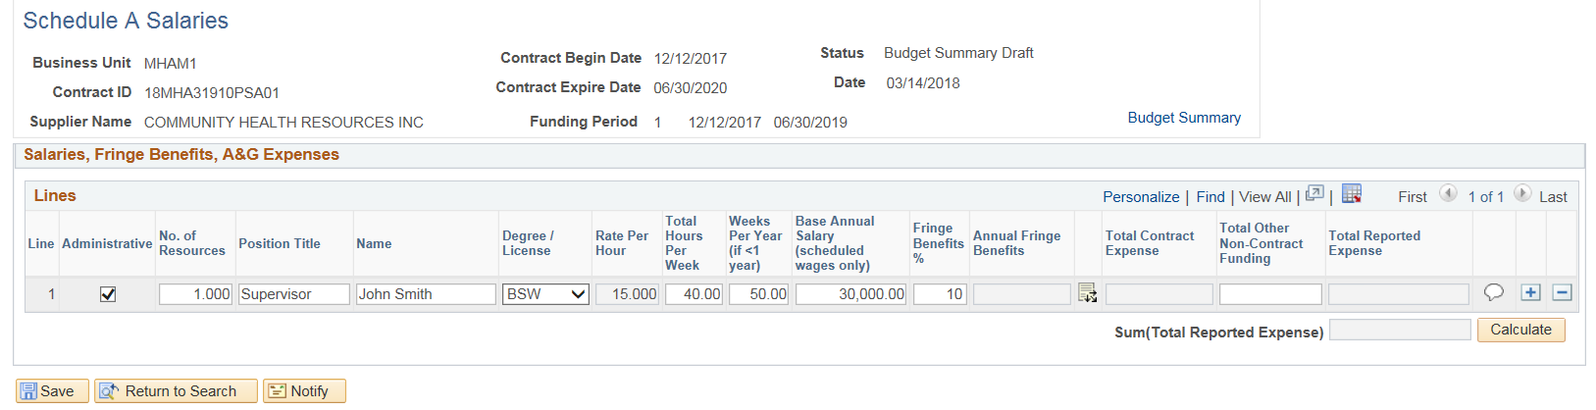
Click on the Distribution Icon 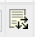to access Program/Service/AG Detail
Enter A & G Program % of Time (If none, leave blank)
Click the ‘+’ plus button to add additional Program Code rows if necessary. (Only programs entered on the Budget Definition can be selected)
Click OK
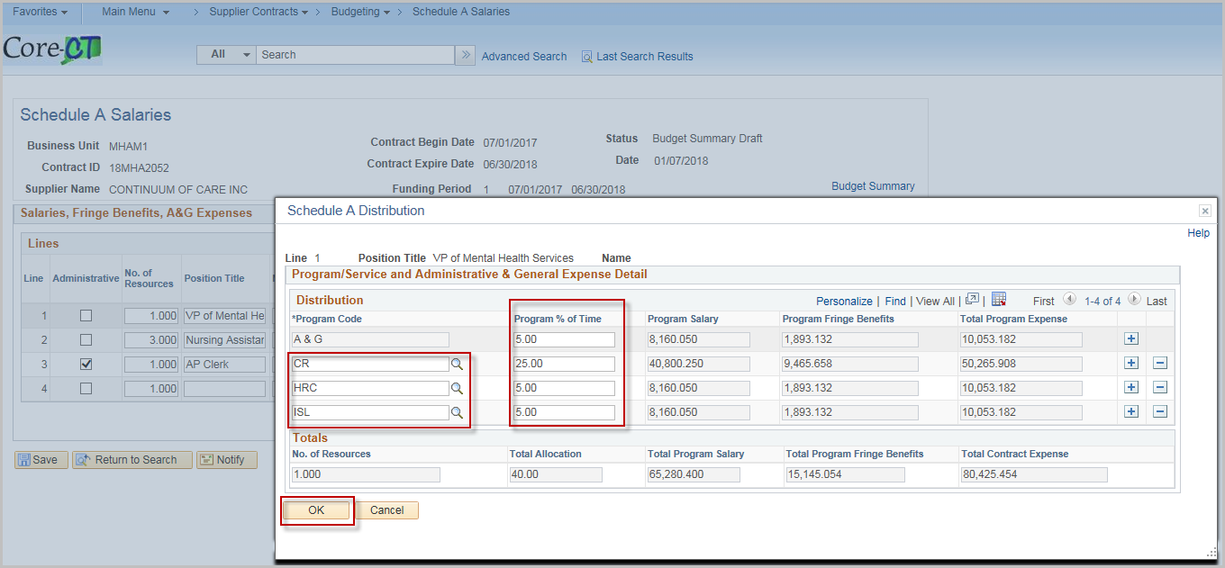
Once completed, the Total Contract Expense and Total Reported Expense will update automatically.
Enter the Total Other Non-Contract Funding (if applicable)
Click the Comment Bubble to enter a Justification
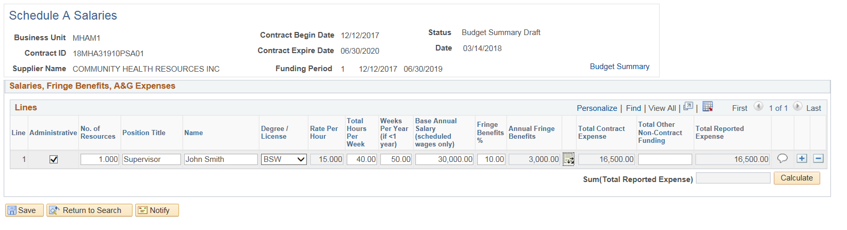
Provide a justification, and then click OK.

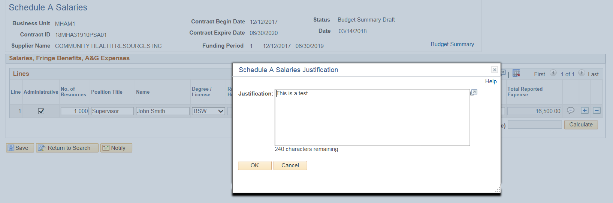
Click Save
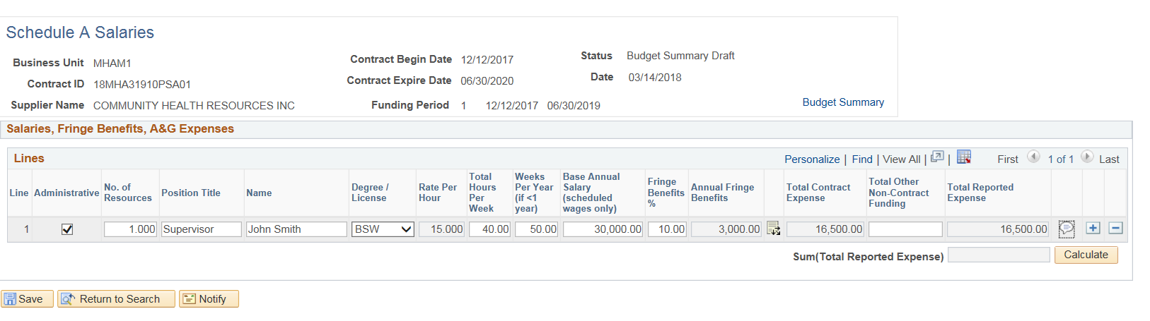
Justification is required for all rows. If a justification is not entered, the following message will display when clicking Save
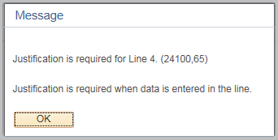

Budget Summary Entry & Submission

The following shows how to complete the Budget Summary Entry and Submit the Summary for acceptance by the agency.
Although the Provider should be entering this information, the agency can enter it on their behalf.
From the Schedule A Salaries page, you can click on the Budget Summary link
If not using the hyperlink on the Schedule A Salaries page

Navigation: Supplier Contracts > Budgeting > Budget Summary

The Budget Summary page will display.
Enter or search for the Contract ID, Funding Period, or Supplier Name, and click Search

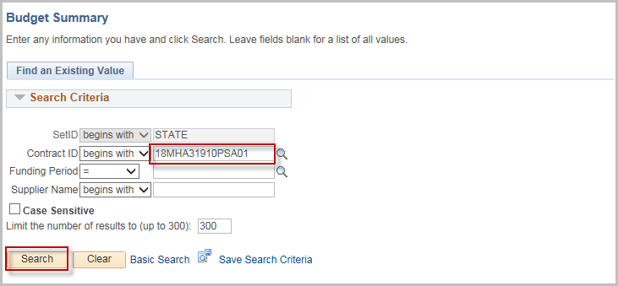

Chartfield 2 and Project will display on the Summary only if they were selected on the budget definition page.
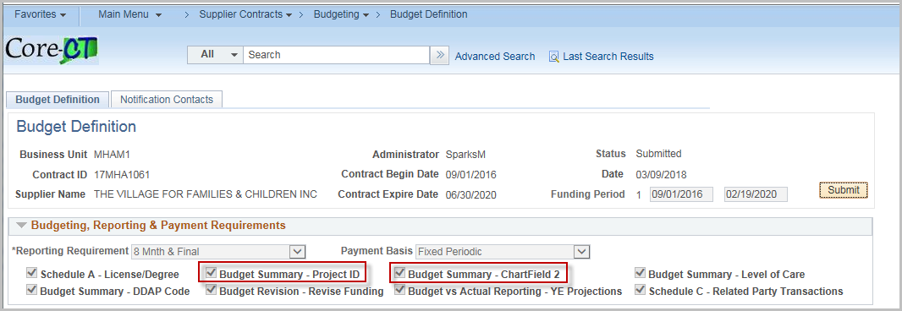
To add a UCOA Account, enter the number in the account box or use the magnifying glass to search for a value.
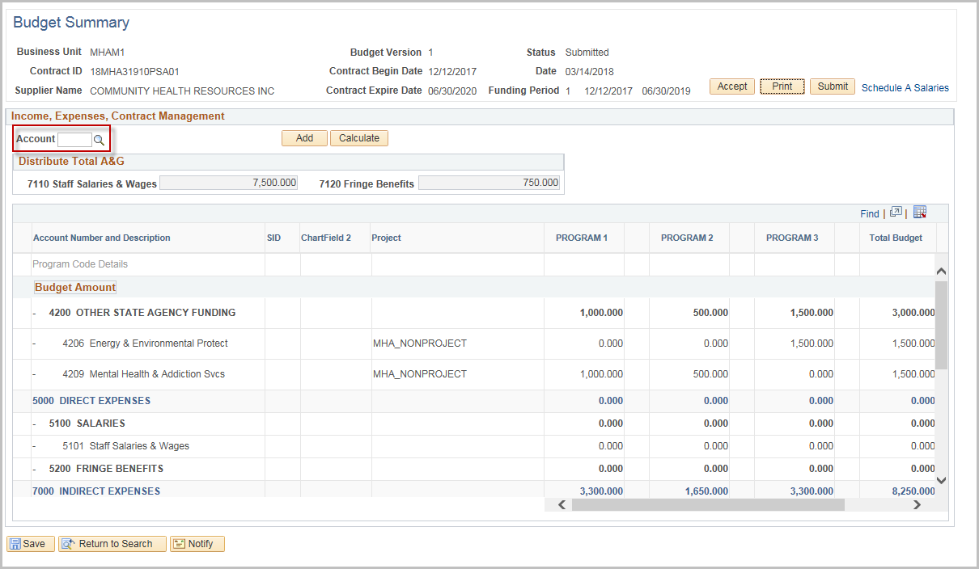

Click on the code

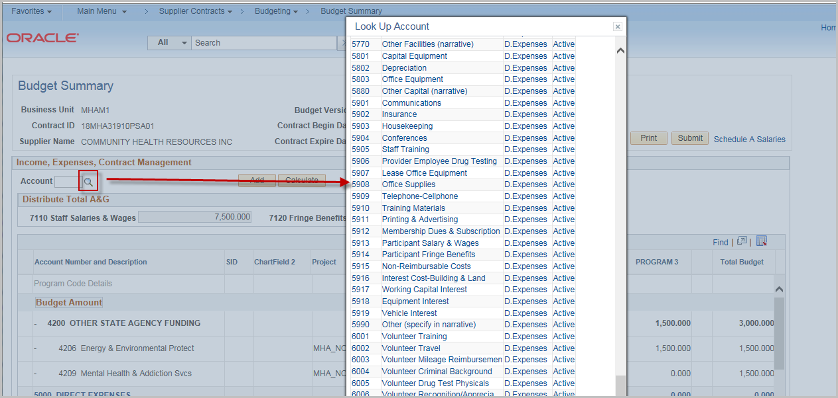

Click Add

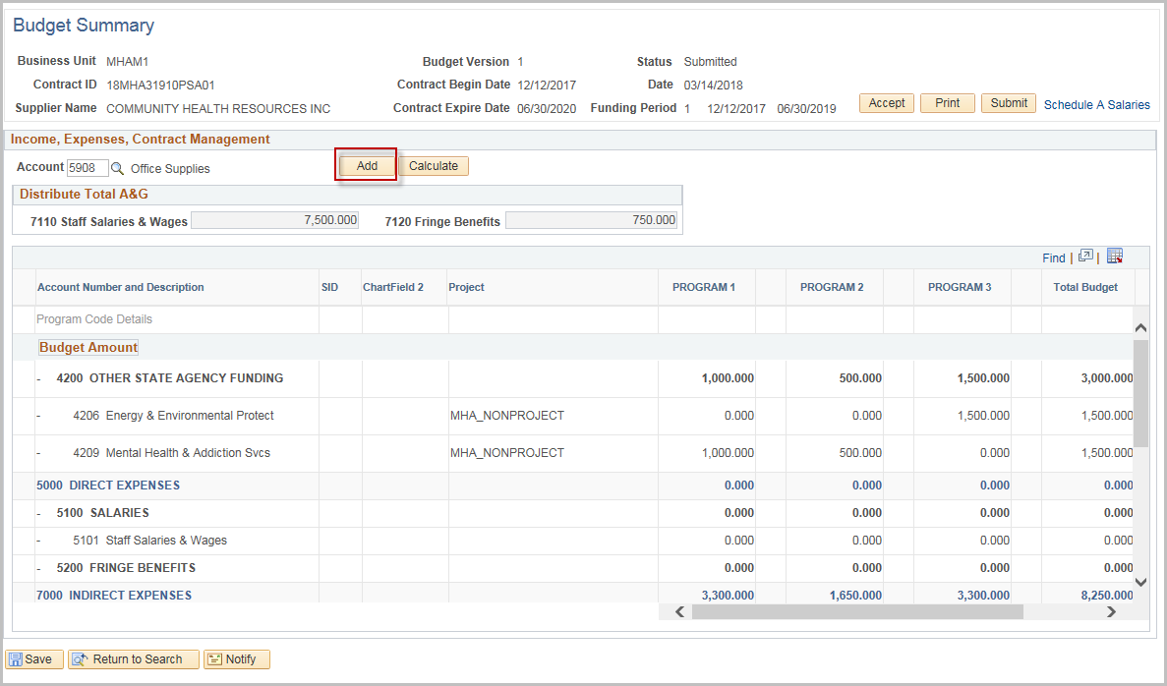

The Code will be added to the Program Code Details section under the appropriate Heading.

NOTE: Click the Minus next to the row if it needs to be removed.

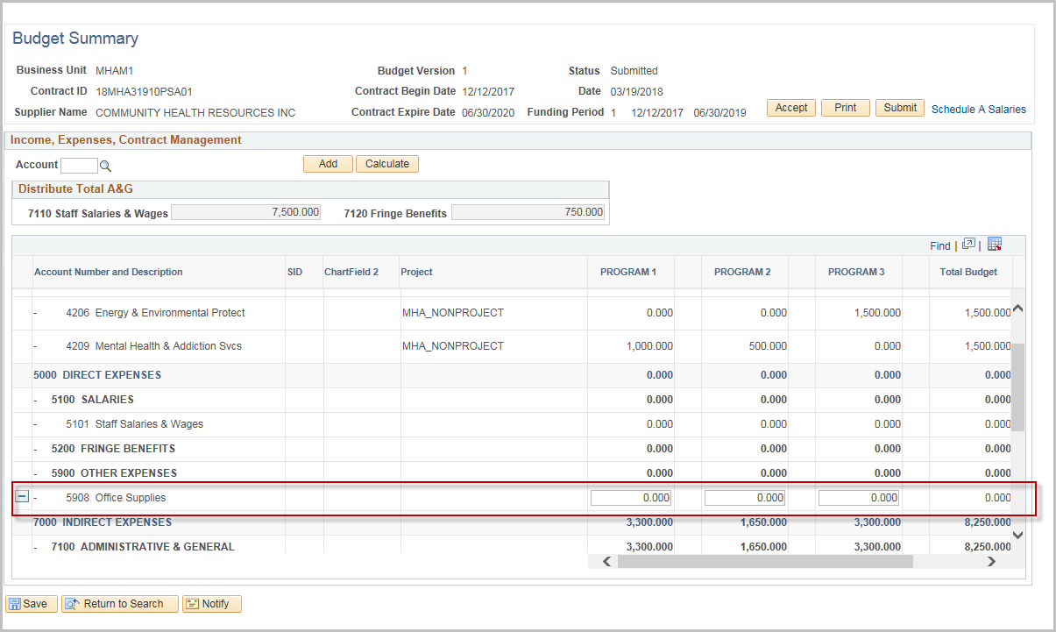

Enter the Funding and Expense amounts for each program

NOTE: The Totals for Staff Salaries and Wages and Fringe Benefits must equal the amount from Schedule A (Displayed at the top of the grid)

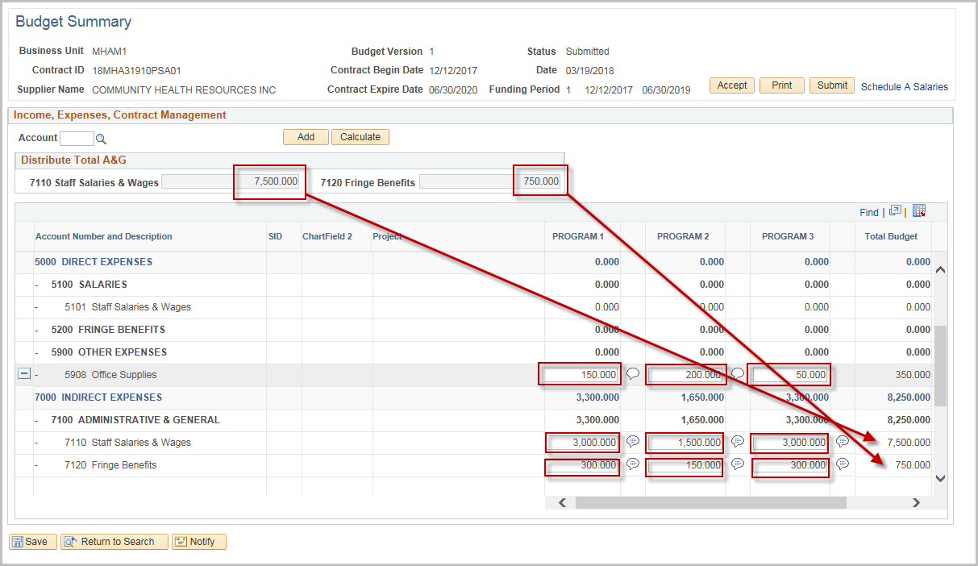

Click the Comment Balloon to provide justification for fields with entered values

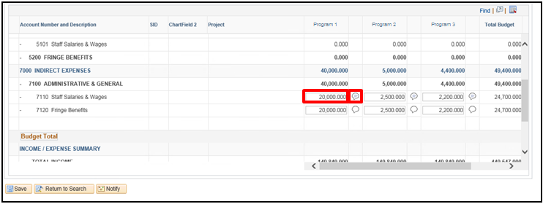
Justification is required for every entered amount. If the justification is not entered an error message will display.

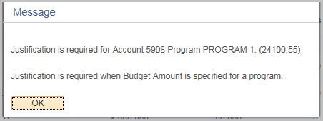
Click Calculate at any time to update the totals
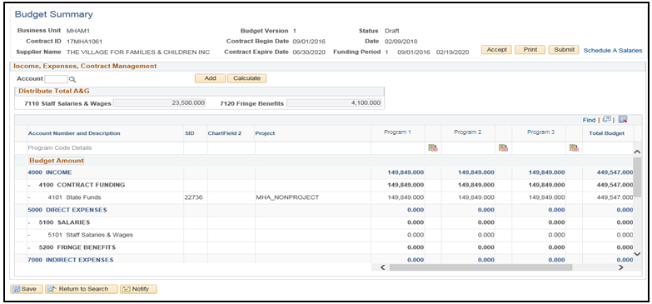

Scroll to the bottom to review the Totals
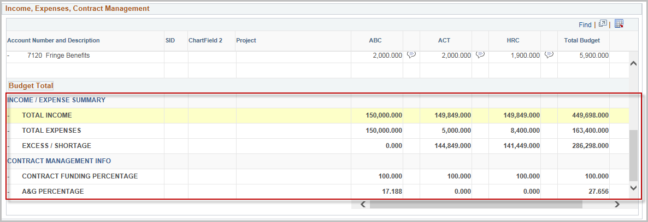
Click Save
Click OK to the confirmation message
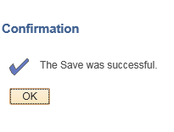

Click Submit

Enter or search for the Agency User ID (the user’s other identifying fields auto populate
Enter a message to be included in the email if needed
Click OK
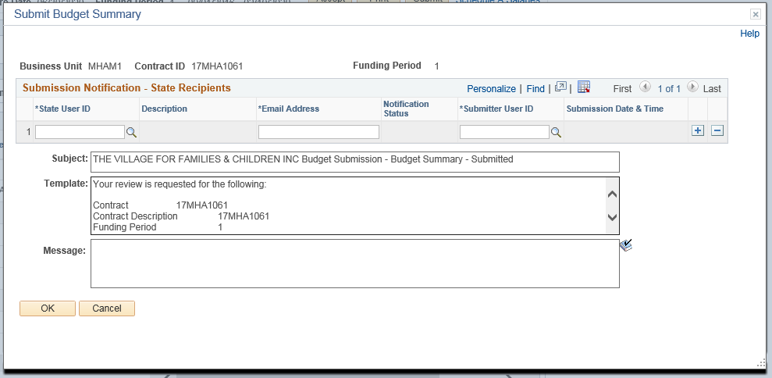

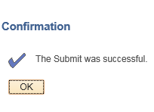
Click OK to the confirmation message that the Budget was submitted.

At this time, an email will be sent to the Agency. The Agency will be able to follow the hyperlink to approve the Budget Summary.
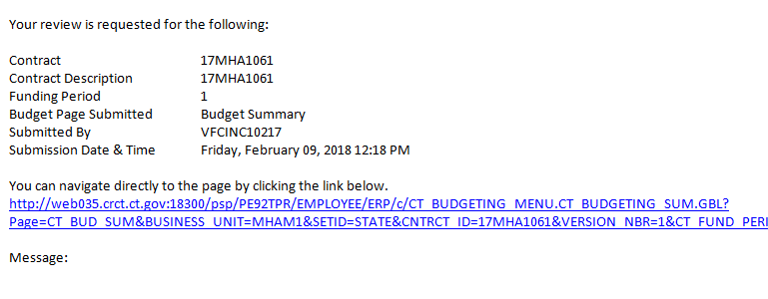

Once the Budget Summary is accepted by the Agency, it becomes a Final Budget.

Accept a Budget Summary

The following shows how to accept a Budget Summary.
Navigation: Supplier Contracts > Budgeting > Budget Summary

The Budget Summary page will display. Enter the Contract ID, Funding Period, or Supplier Name, and click Search

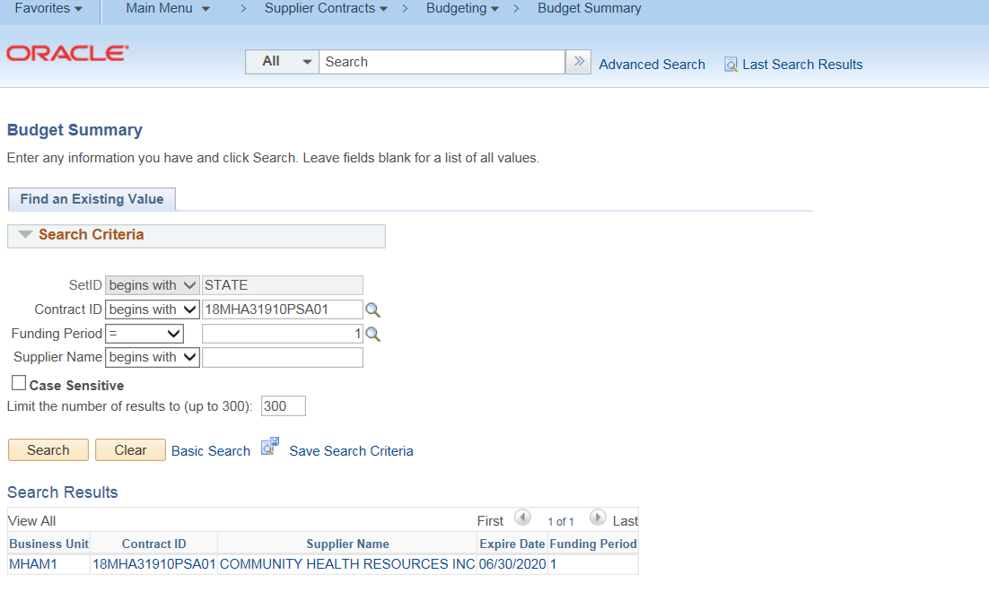
Once the page has opened up, the agency will review the submitted budget.
If there are any discrepancies or amounts that need to be update, DO NOT click Accept. Contact the Provider (either by email or using the Notify option in the appendix) to have them correct the entries.
Clicking Accept will lock all entries.

Click Accept. This will open up the Acceptance Notification screen where the user will notify the Provider that the Budget has been accepted.
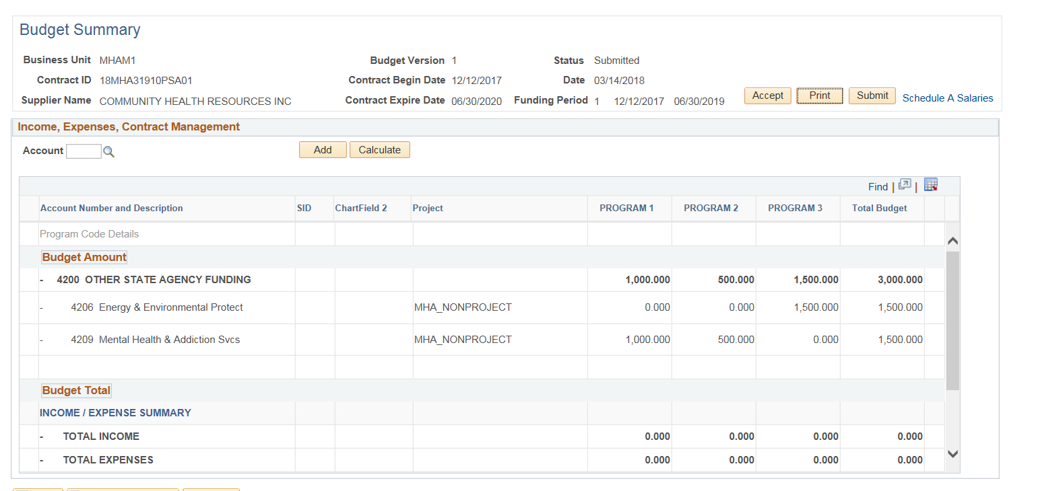
Enter Supplier User ID (use the magnifying glass to search)
Enter a message to be included in the email if needed
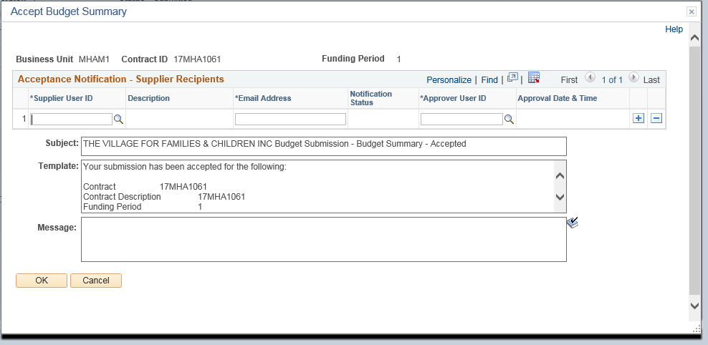
Click OK

Click OK to the confirmation message.
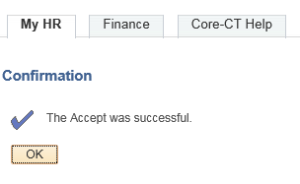

An email will now be sent to the selected users that the budget has been accepted.
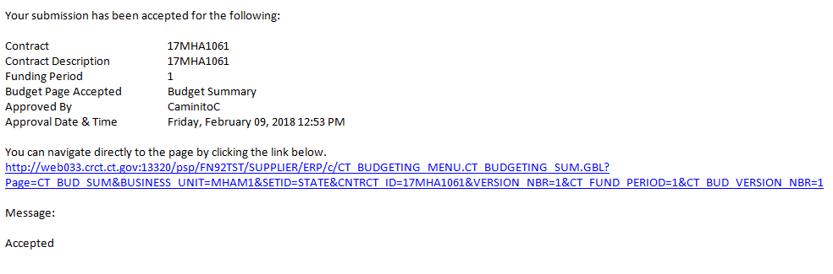

Printing the Budget Summary

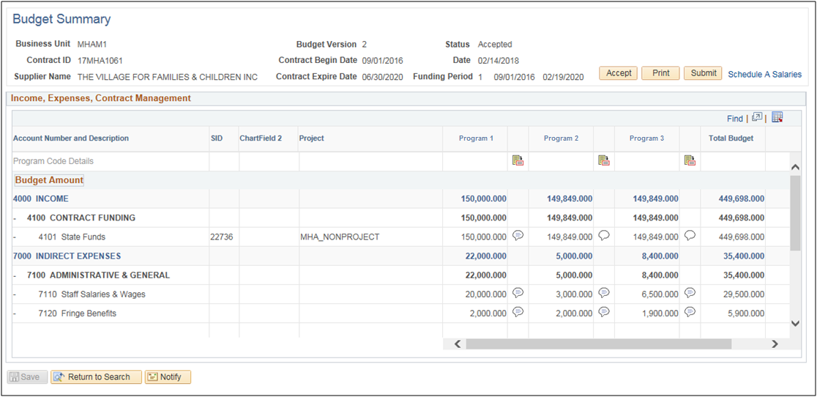
The Budget Summary may be printed by either the Agency or the Provider at any time.
Run the Contract Budget Report by clicking Print.

Select PDF or XLS depending on preference, and click Print
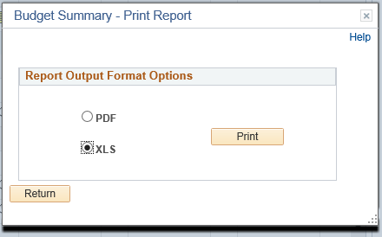

A new window will open up, showing the Contract Budget Report
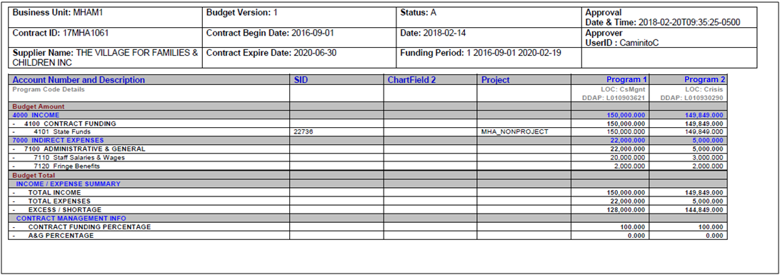
Note: If this budget has been accepted, the report will have the user, date, and time the budget was approved in the upper right hand corner. Otherwise this will be blank.

Budget Workbook Financial Reporting
This chart shows the different reports and the Provider/Agency roles with each.
Report Type | Provider Role | Agency Role
Multi-Year Contract Budget Report | Run the Report | Run the Report
Budget vs. Actual Reporting | Entry and Submission | Accept
Consolidated Financial Report | Run the Report | Run the Report
Salary Detail Actuals Reporting | Entry and Submission | Accept

Multi-Year Contract Budget Report
The following shows how to run a Multi-Year Contract Budget Report
Navigation: Supplier Contracts > Budgeting > Multi-Year Contract Bud Report

The Multi-Year Contract Bud Report page will display.

Select the Add a New Value tab
Create a new Run Control ID

When creating a Run Control ID, make sure it is something that will be easily identifiable when running future reports.

Click Add.

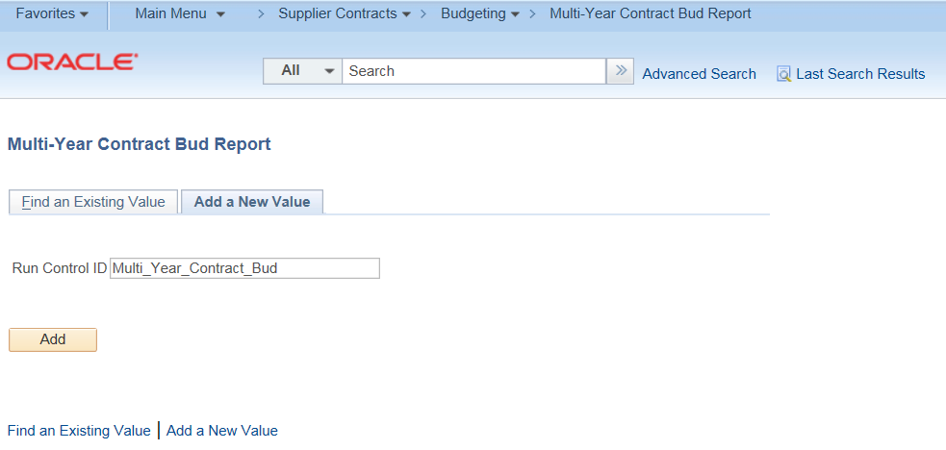

Enter the Contract ID, Funding Period Begin, and Funding Period End
(The Funding Periods for this report setup are the value (i.e. 1, 2, 3) not the actual dates.

Click Save and then click Run

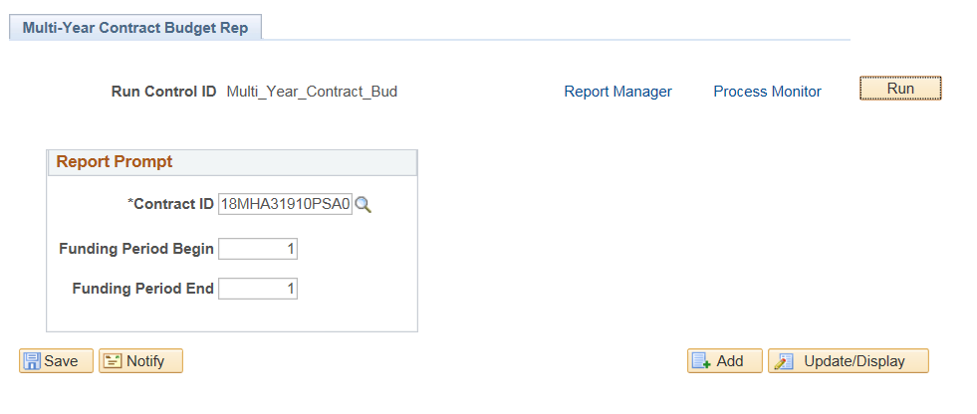

Select PDF or XLS under Format

Click OK
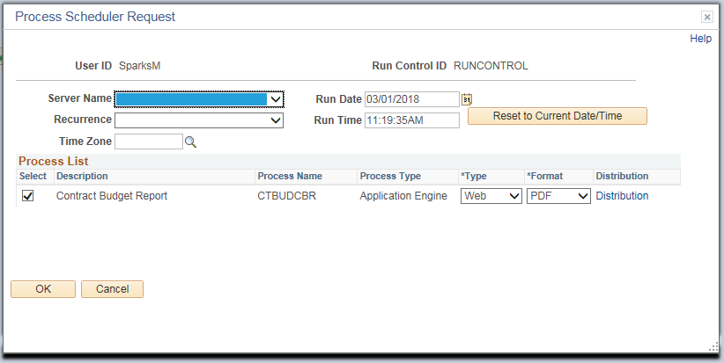

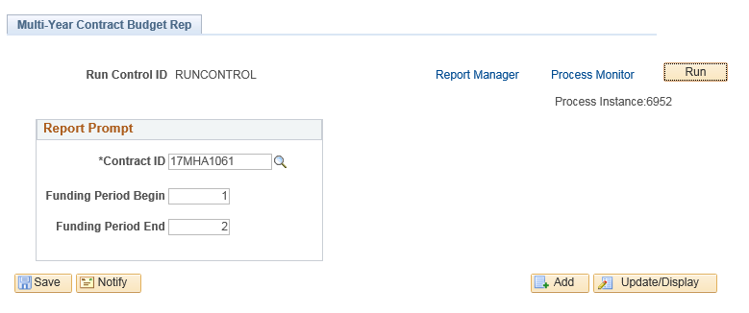
Click the Process Monitor link

Click Refresh until Run Status and Distribution Status shows Success and Posted
Click the Details link
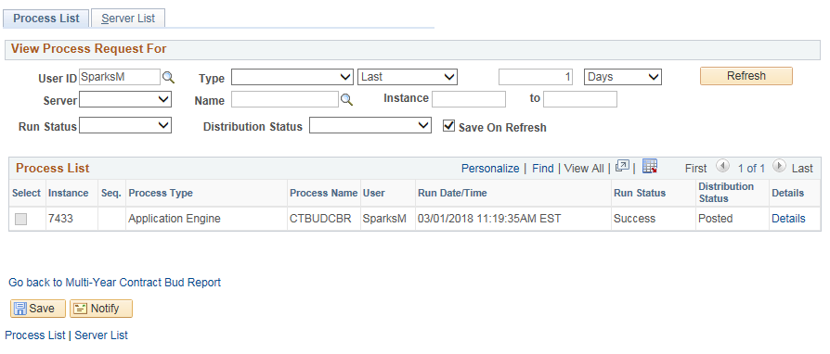

Click View Log/Trace
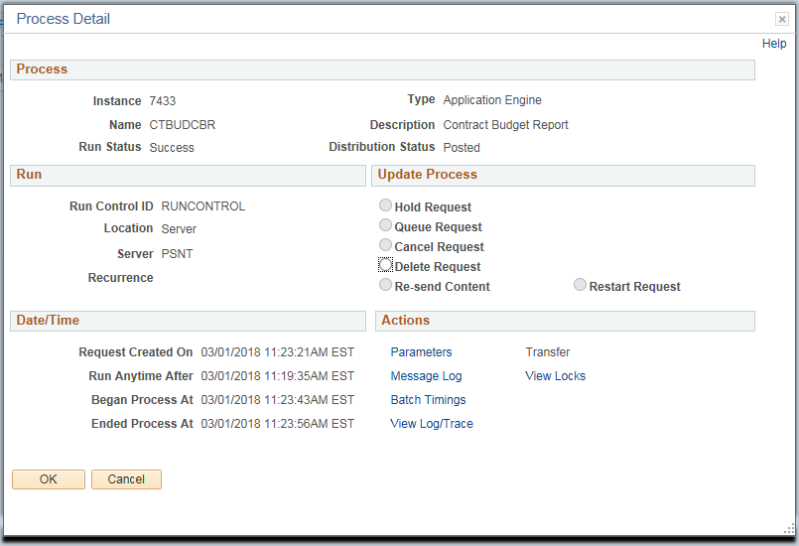

Select the file ending in “.pdf”
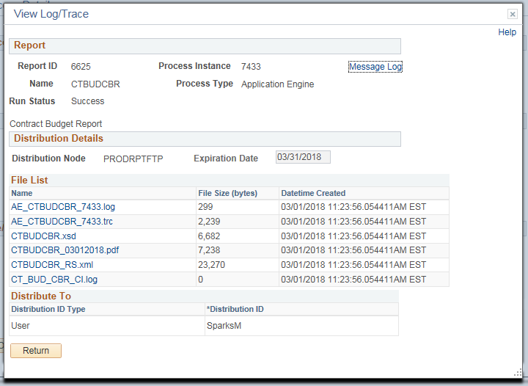

A sample Multi-Year Contract Budget Report is shown below
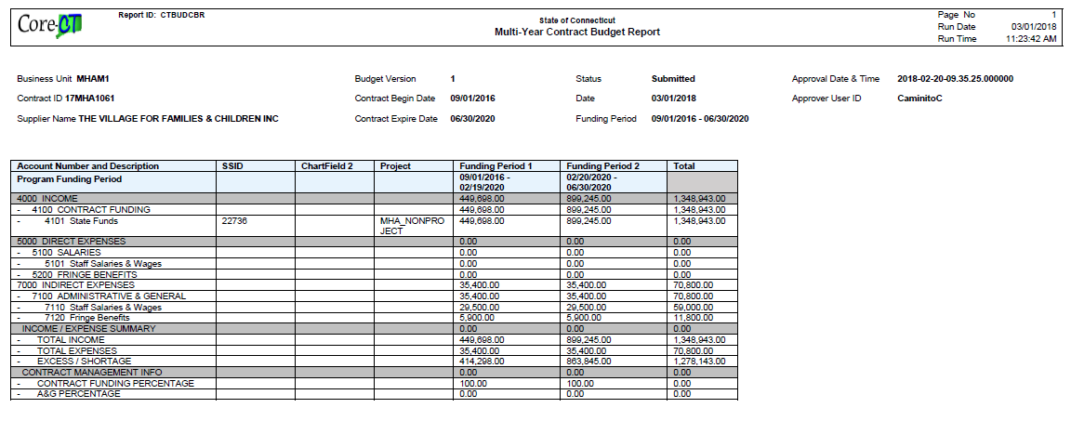
NOTE: This report combines all programs together under the funding period.

Budget vs Actual Reporting

The process flow below outlines the steps which need to be completed in order for the Budget vs Actual Report to become approved. The Provider will enter and submit the information, and the Agency will then approve.

Agency
Provider

Navigation: Supplier Contracts > Budgeting > Budget vs Actual Reporting

The Budget vs Actual Reporting page will display.
Enter Contract ID and click Search

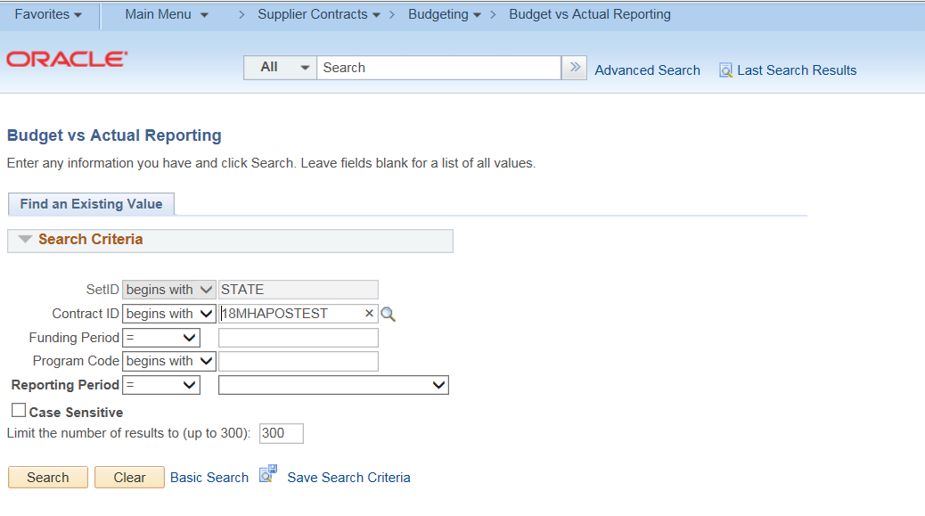

The system will display all reports for all programs based upon the report requirement selected on the budget definition page
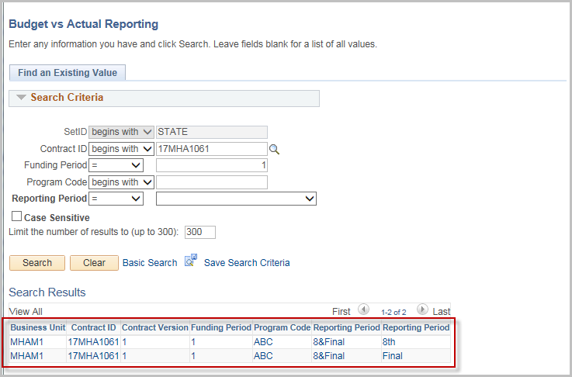
If a later version is selected in error, a message in red will display identifying that the previous report has not been accepted.
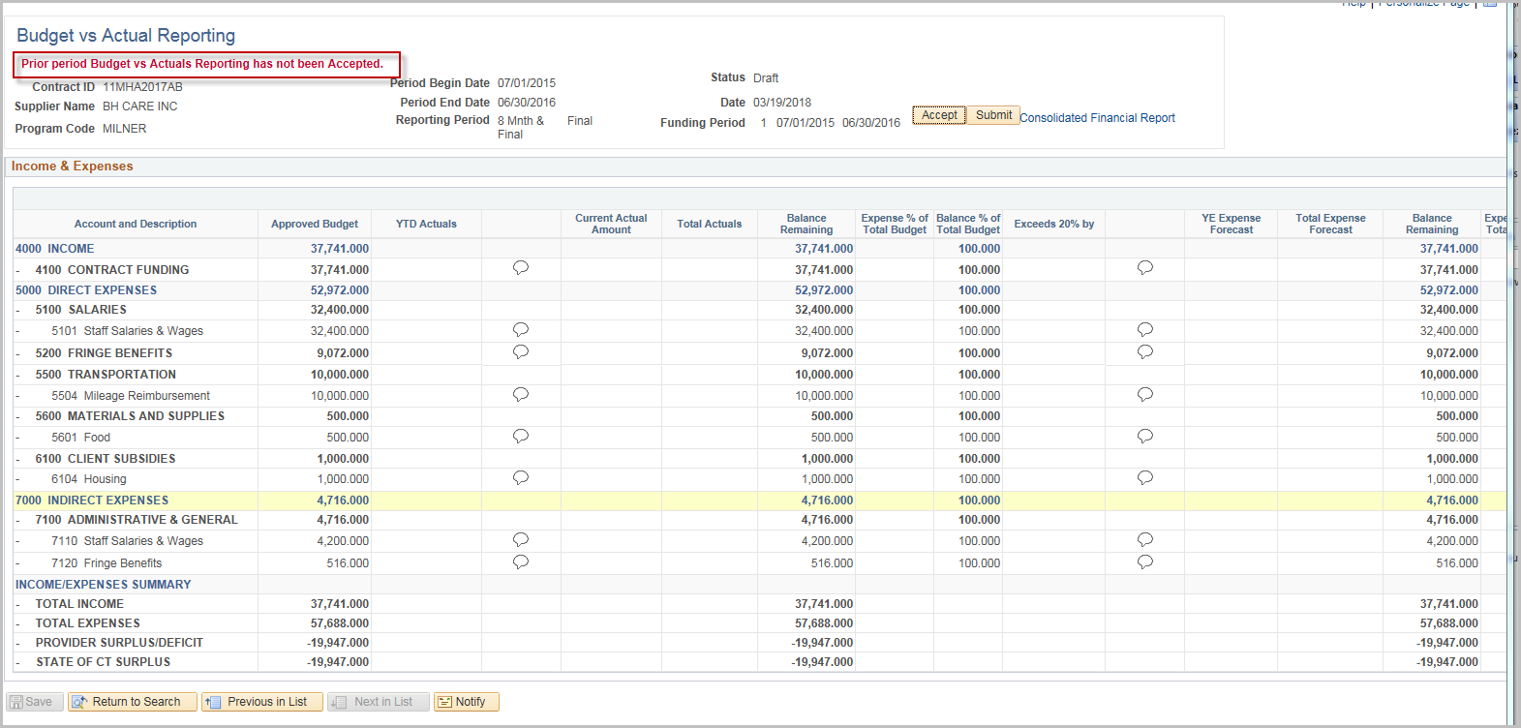
NOTE: New UCOA Account(s) may be added to the Report. It is up to the Agency to determine how these will be processed and if a Budget Revision will need to be entered prior to acceptance.
Enter the Current Actual Amount fields
Enter the YE Expense Forecast fields
Click the Comment Balloon to enter Justification for all fields with entered values

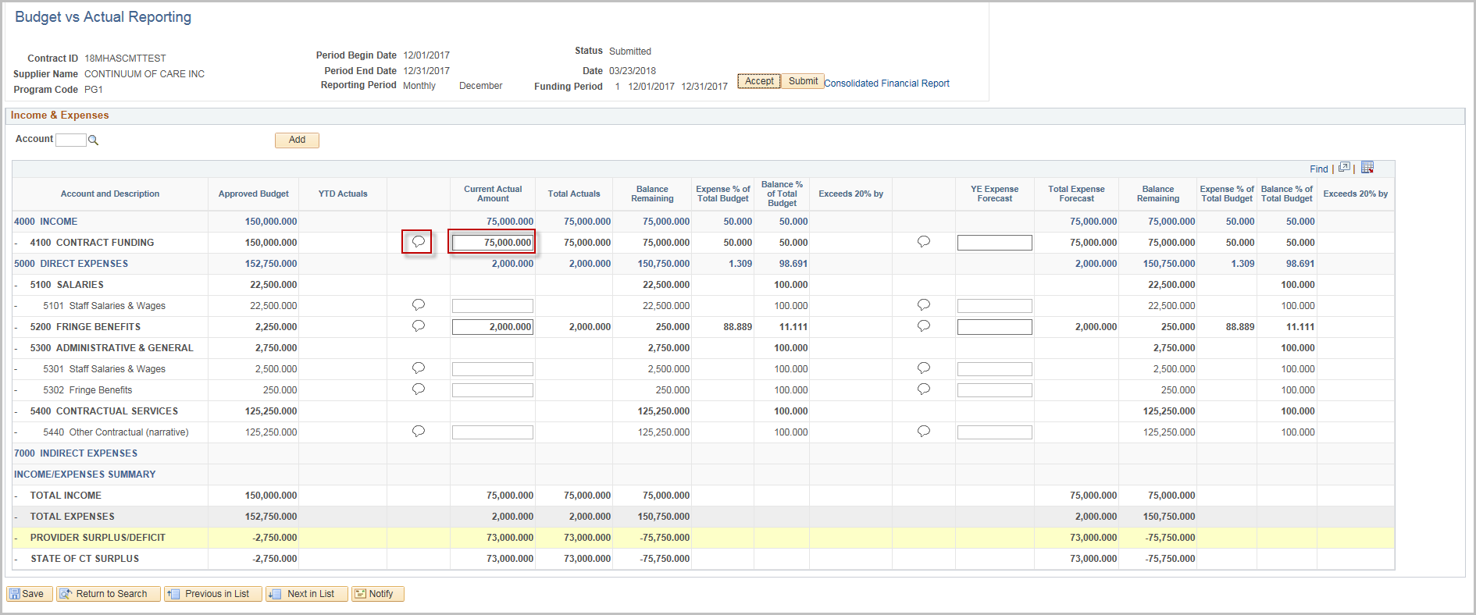
Enter the Justification comments
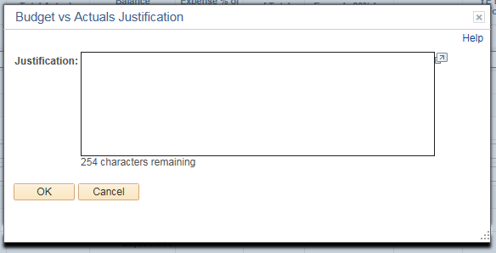
Click OK

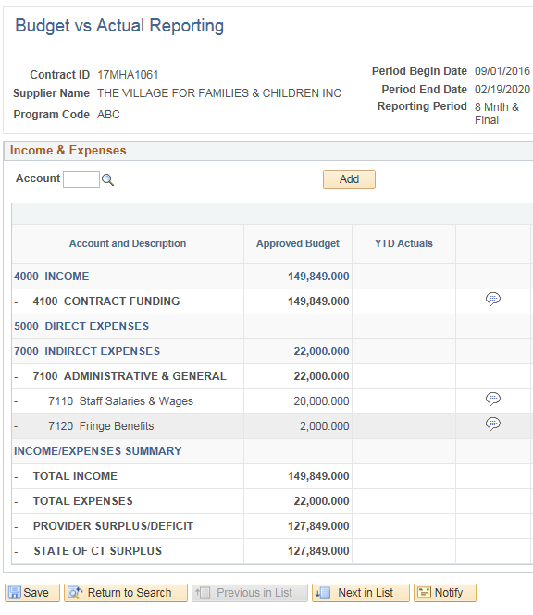
Click Save

Click Submit to submit the Budget vs Actual Report
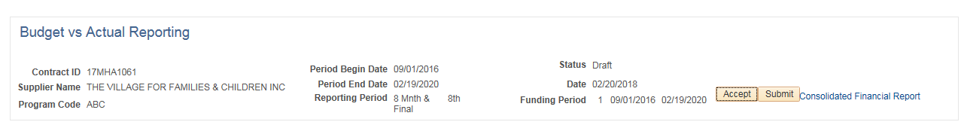

Enter State User ID (use magnifying glass to search)
Enter a message to be included in the email if needed
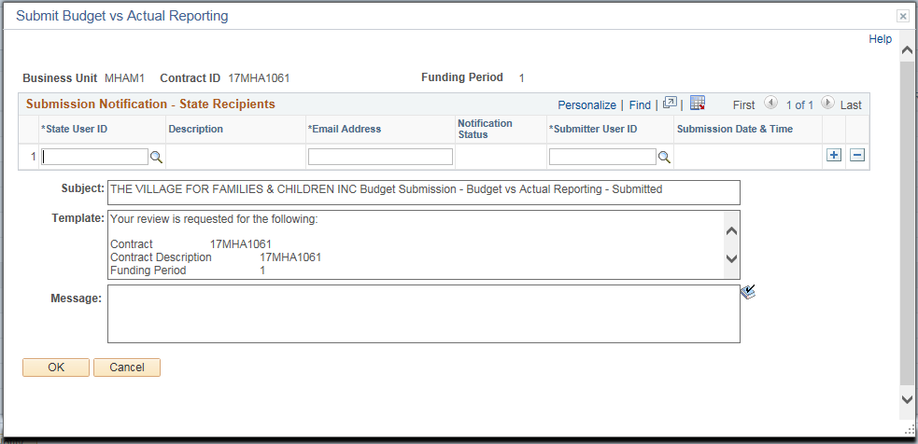
Click OK

Click OK to the confirmation message.

An email will be sent to the Agency. The Agency can click the hyperlink to approve the Budget vs Actual Report.
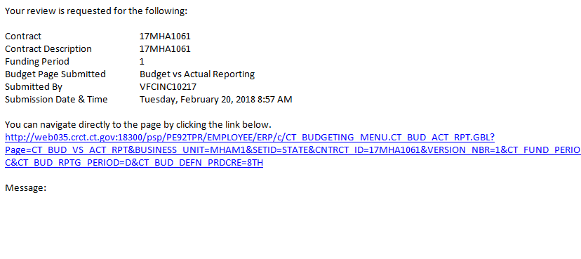

Accept the Budget vs. Actual Report
The process flow below outlines the steps which need to be completed in order to accept the Budget vs Actual Report. The Provider will enter and submit the information, and the Agency will then accept.

Agency
Provider

The following email will be received by the Agency once the Provider submits the Budget vs Actual Report.
If the Agency does not click the hyperlink, they can use the navigation below:

Navigation: Supplier Contracts > Budgeting > Budget vs Actual Reporting

The Budget vs Actual Reporting page will display.

Enter the contract id or click Search and select the Contract ID for the Budget Report that is to be accepted.
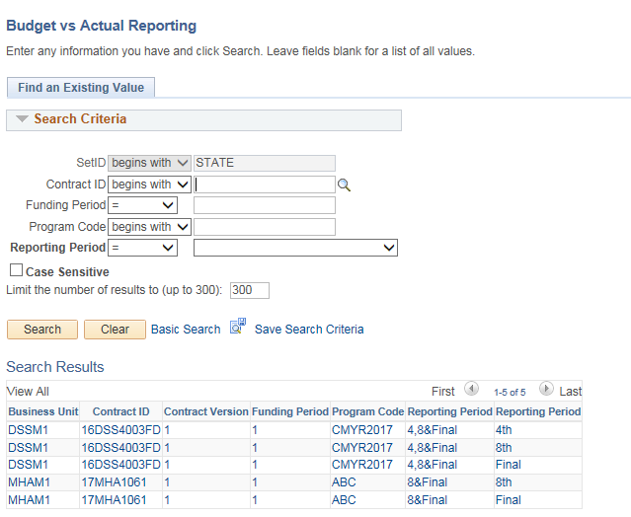

The search results will show all reports for each program of the contract.
If a later version is selected in error, a message in red will display identifying that the previous report has not been accepted.

Review the Budget vs Actuals information
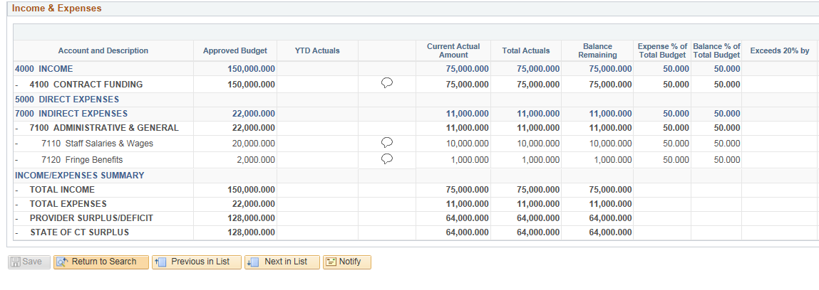
If there are any discrepancies or amounts that need to be update, DO NOT click Accept. Contact the Provider (either by email or using the Notify option in the appendix) to have them correct the entries.
Click Accept.
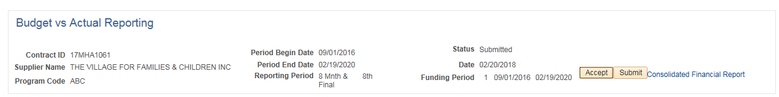
This will open up the Acceptance Notification screen where the user will notify the Provider that the Budget vs Actual Report has been accepted.
Enter the Supplier User ID or use the magnifying glass to search
Enter a message to be included in the email if needed
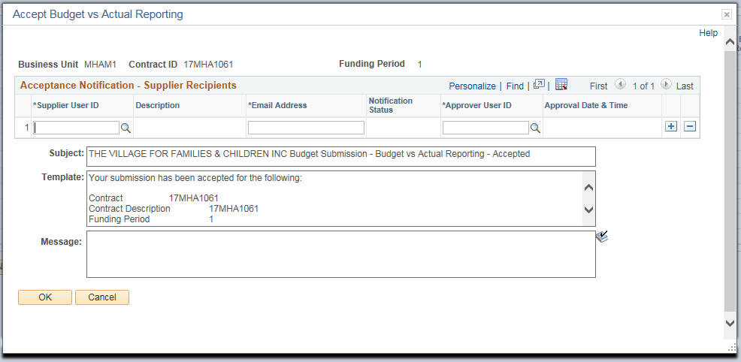
Click OK
Click OK to the confirmation message.

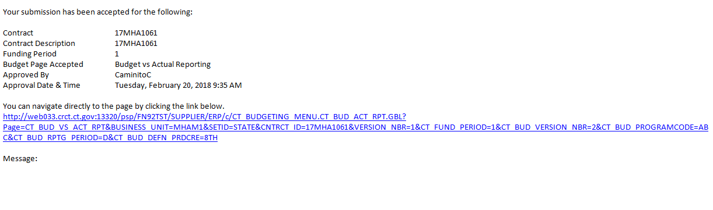
An email will be sent to the Provider. The Provider will now know that the Budget vs Actual Report has been accepted.

Consolidated Financial Report
The following shows how to run a Consolidated Financial Report
Navigation: Supplier Contracts > Budgeting > Consolidated Financial Report

The Consolidated Financial Report page will display.

Select the Add a New Value tab
Create a new Run Control ID

When creating a Run Control ID, make sure it is something that will be easily identifiable when running future reports.

Click Add.
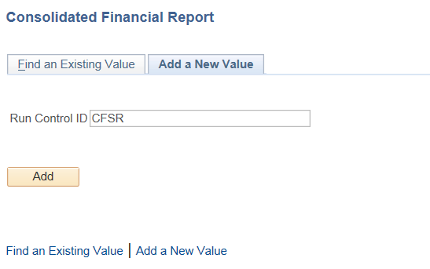

Enter or search for the Contract ID
Enter the Funding Period
(The Funding Periods for this report setup are the value (i.e. 1, 2, 3) not the actual dates.

Select the Report Detail
If Summary is selected the next two options will not be available.

If Detail is selected
Select the Report Type (Program or All)
If Program is selected you must enter the Program Code.
Click Save
Click Run
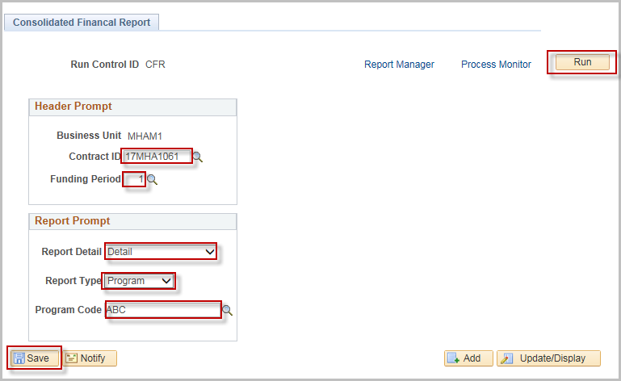
Click OK
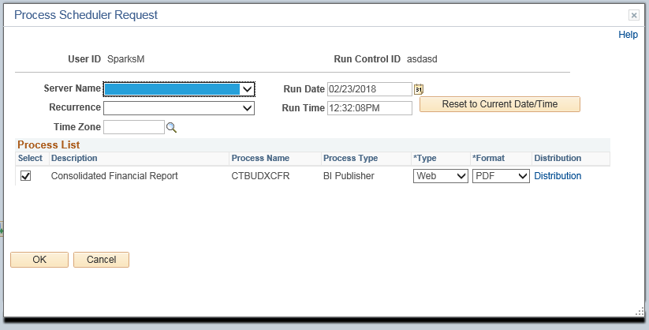

Click the Process Monitor link
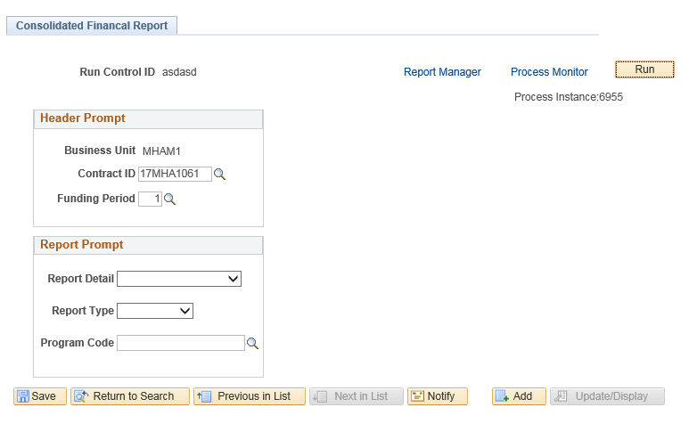

Click Refresh until Run Status and Distribution Status reads Success and Posted
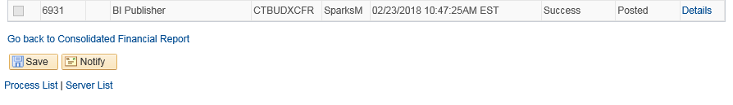
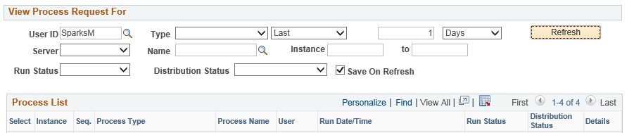
Click the Details link

Click the View Log/Trace link
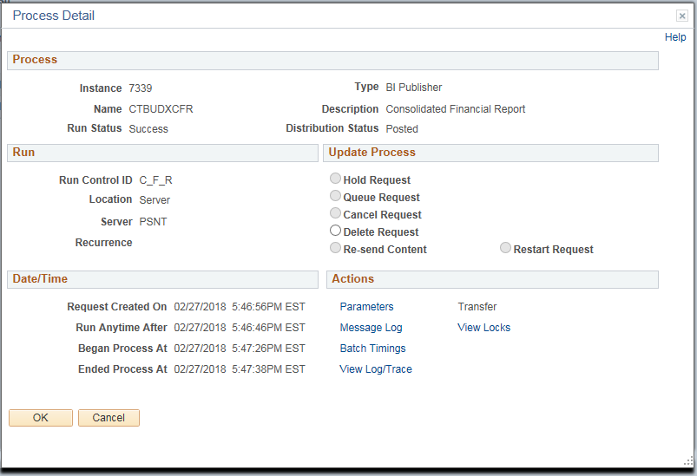

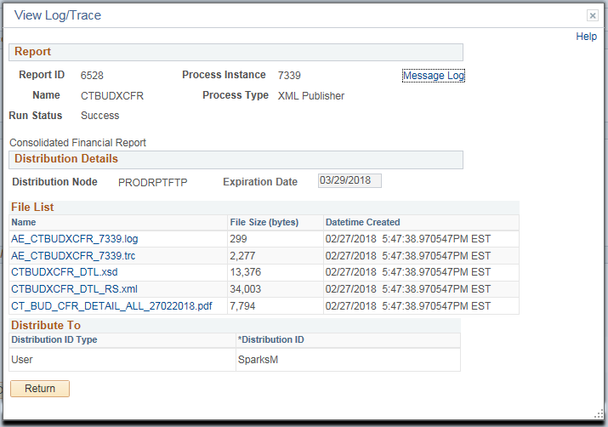
Click the “.pdf” file to view the report

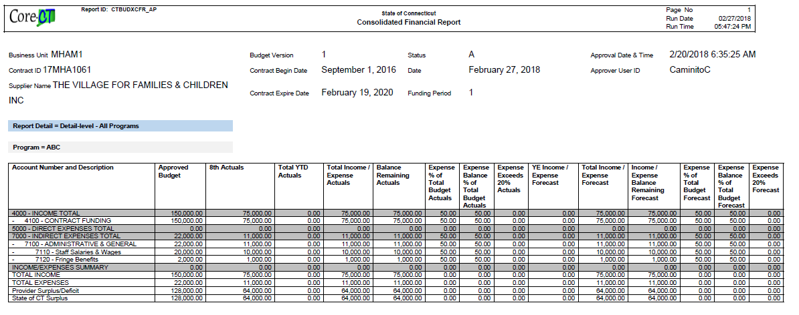
A sample Consolidated Financial Report is shown below

Salary Detail Actuals Reporting

The process flow below outlines the steps which need to be completed in order for the Salary Detail Actuals Report to become approved. The Provider will enter and submit the information, and the Agency will then approve.

Agency
Provider
Navigation: Supplier Contracts > Budgeting > Salary Detail Actuals

The Salary Detail Actuals page will display.
Enter the Contract ID (or use the magnifying glass)
Click Search.

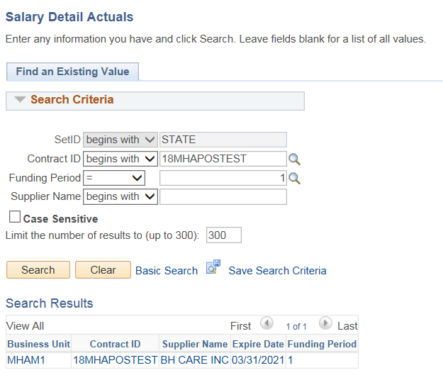

The Salary details page will display with the values from the last accepted Schedule A Salaries.

Update any of the editable fields that need to be changed.
Click on the Funding Distribution icon

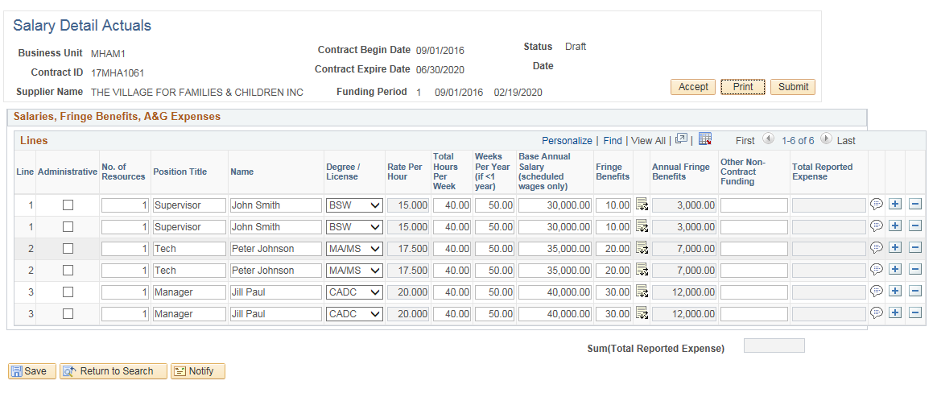

Update any of the Program Code(s) that need to be changed
Click OK
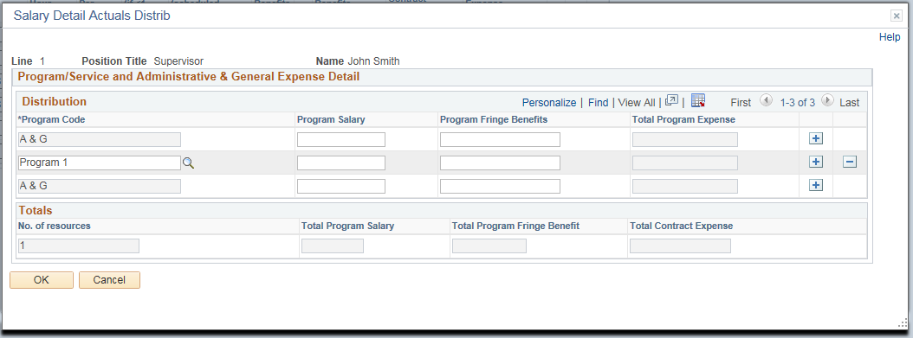

Repeat this process for all lines that need to be updated

Click Submit
Enter the State User ID or use the magnifying glass to search
Enter a message to be included in the email if needed
Click OK
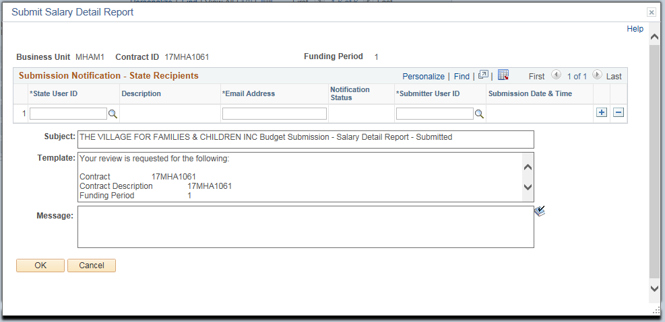

Click OK to the confirmation message.

An email will be sent to the Agency. The Agency can click the hyperlink to approve the Salary Detail Actuals Report.
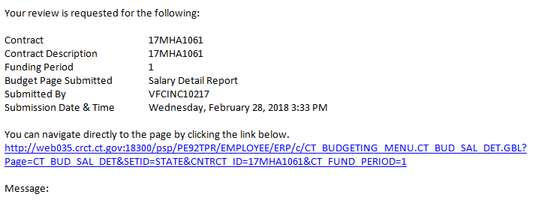

Accept a Salary Detail Actuals Report

Agency
Provider

An email will be received by the Agency once the Provider submits the Salary Detail Actuals Report.
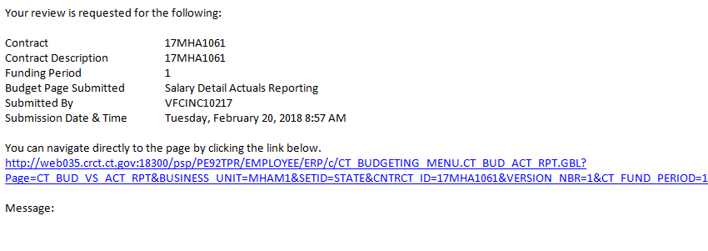
The Agency can click the hyperlink or use the navigation below:

Navigation: Supplier Contracts > Budgeting > Salary Detail Actuals

The Salary Detail Actuals page will display.

Enter the Contract ID (or use the magnifying glass) for the Budget Report that is to be accepted

Enter the Funding Period

Click Search

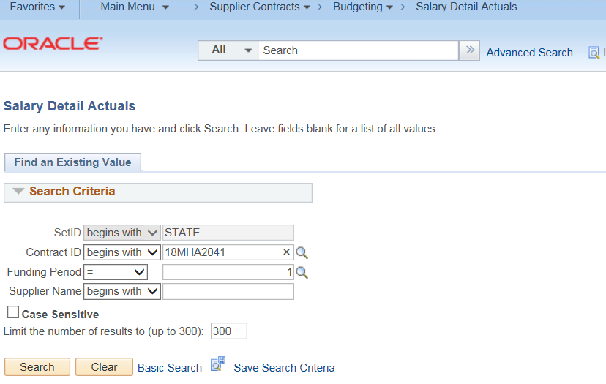
Review the Submitted Salary Details
If there are any discrepancies or amounts that need to be update, DO NOT click Accept. Contact the Provider (either by email or using the Notify option in the appendix) to have them correct the entries.
Click Accept.
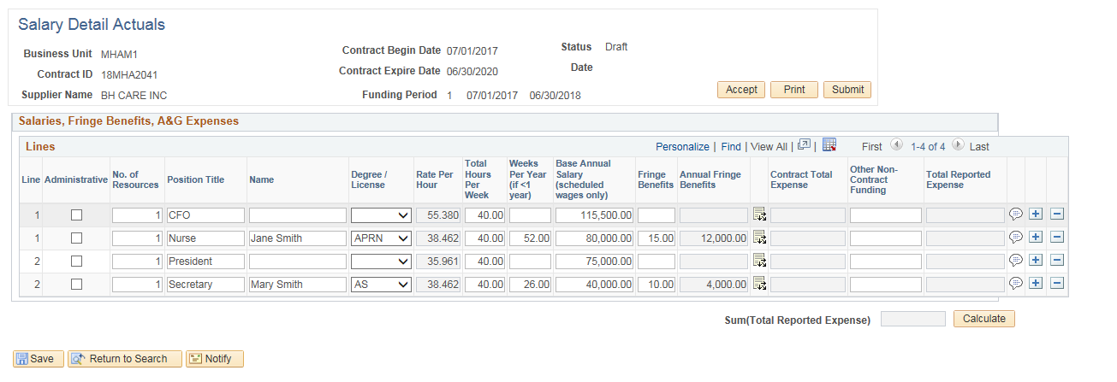
This will open up the Acceptance Notification screen where the Provider will be notified that the Salary Details Actual Report has been accepted.

Enter the Supplier User ID or use the magnifying glass to search
Enter message to be included in the email if needed
Click OK

Click OK to the Confirmation message.

An email will be sent to the Provider. The Provider will now know that the Salary Detail Actuals Report has been accepted.
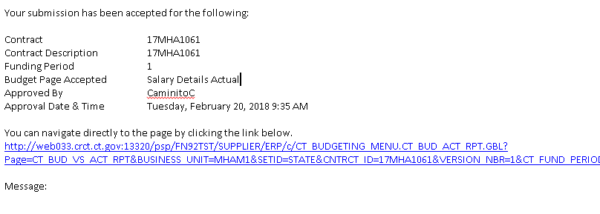

Enter a Budget Revision

The process flow below outlines the steps which need to be completed in order to accept a Budget Revision. The Provider will enter and submit the information, and the Agency will then approve.

Agency
Supplier
Navigation: Supplier Contracts > Budgeting > Budget Revision

The Budget Revision page will display.

Enter Contract ID.
Click Search

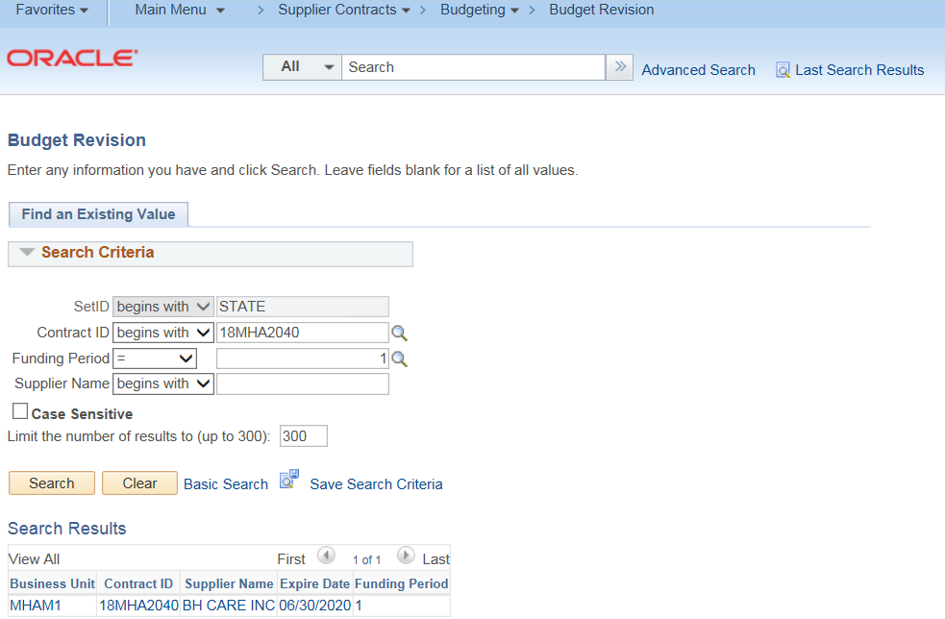

To begin a budget revision click Start
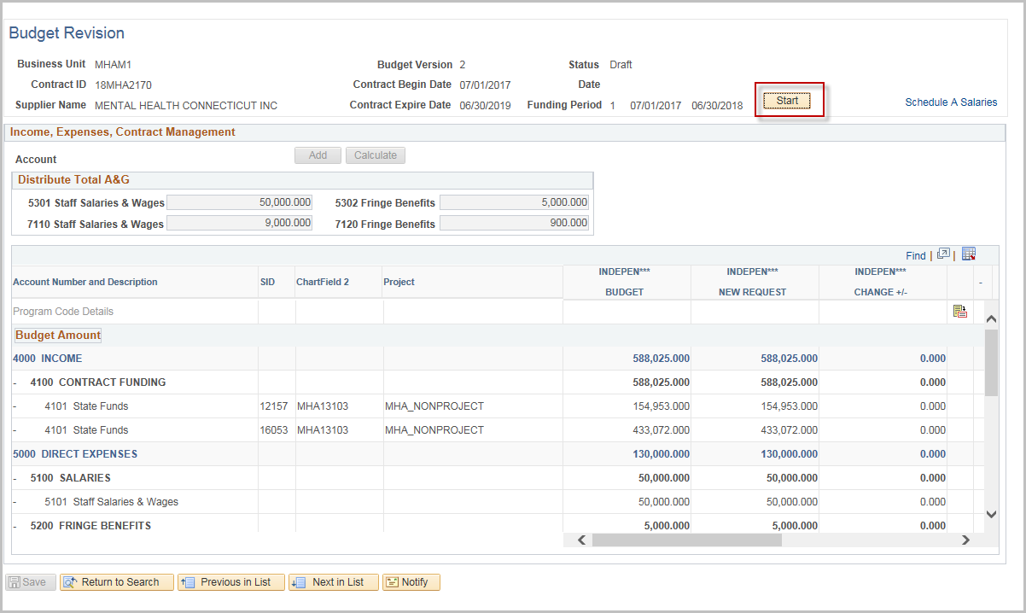
This will open up the Program values so they can be modified.
Enter the new values under the New Request column as needed
If needed, a new account may be added.
Use the Scroll bar to enter any other revisions needed in the New Request fields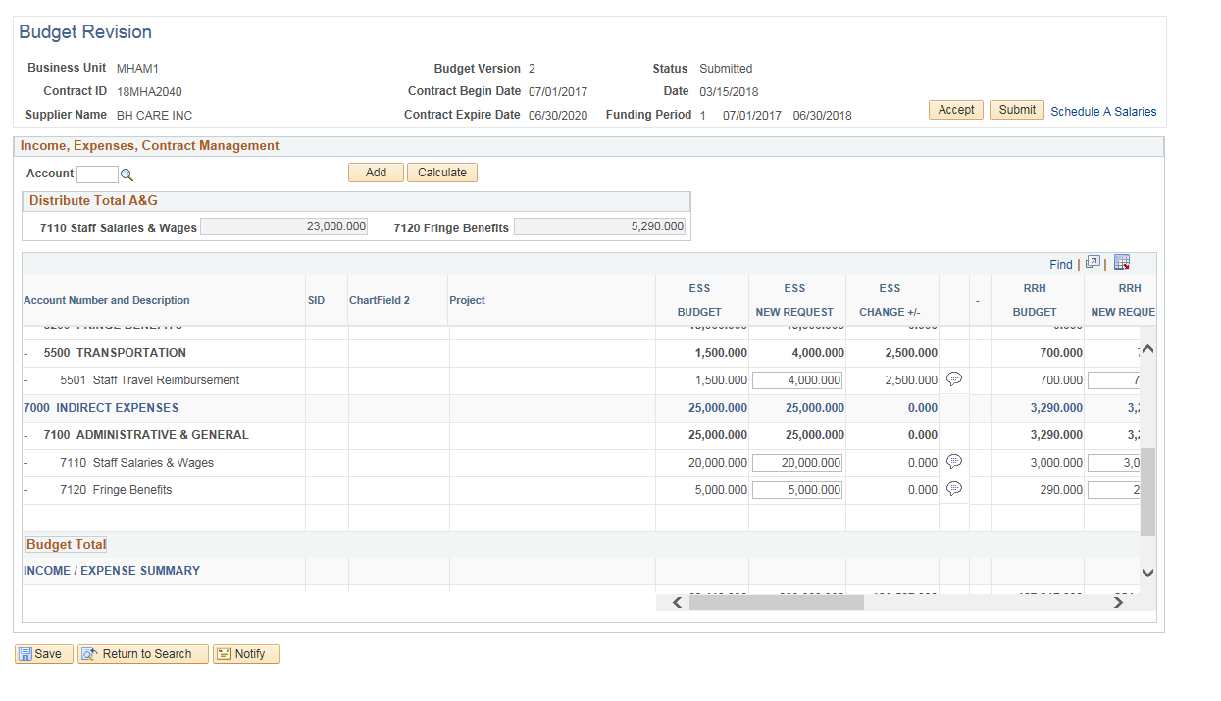
Click on the Comment Balloon to enter Justification comments
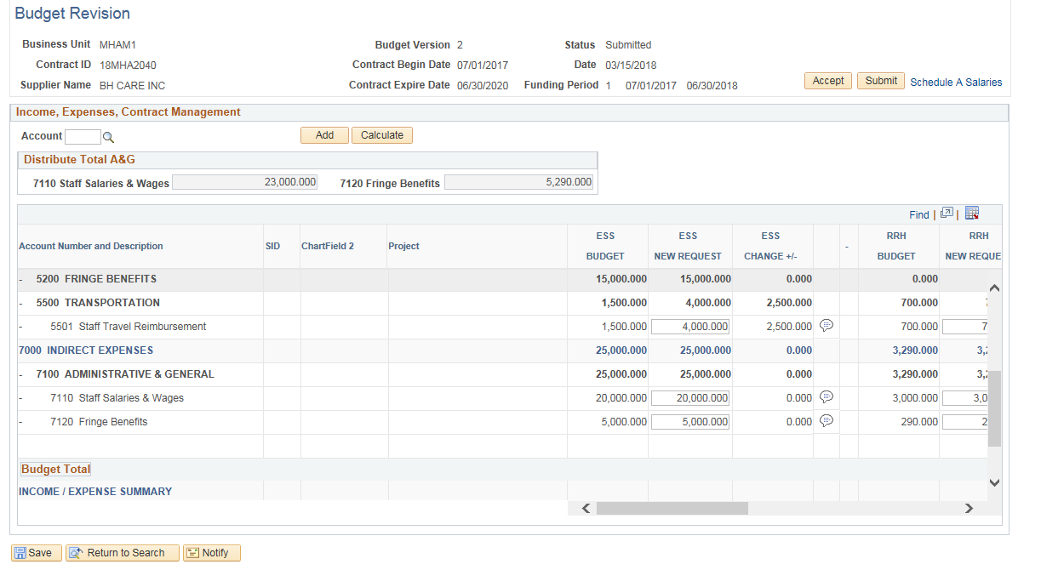
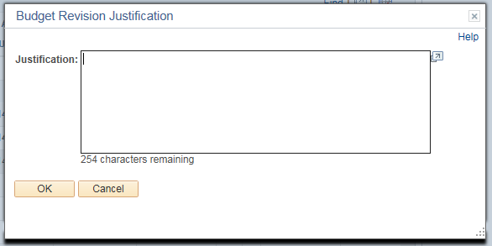
Provide Justification for each revision

If the salaries need to be revised, click the Schedule A Salaries hyperlink
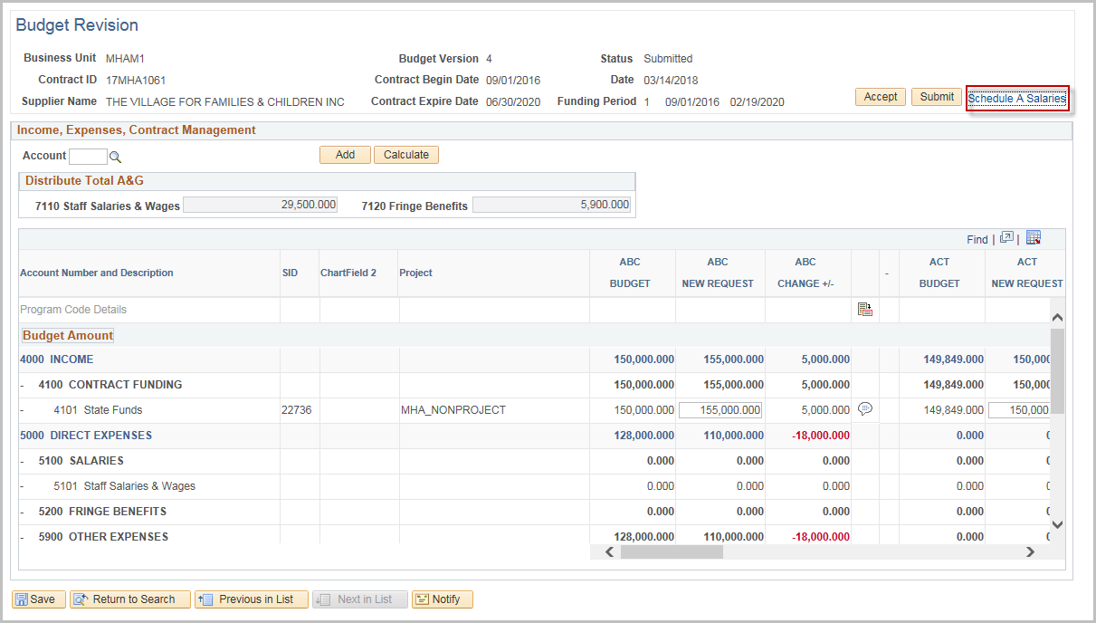
Make the changes and update the justifications
Click the Budget Summary hyperlink to return to the Budget Summary page
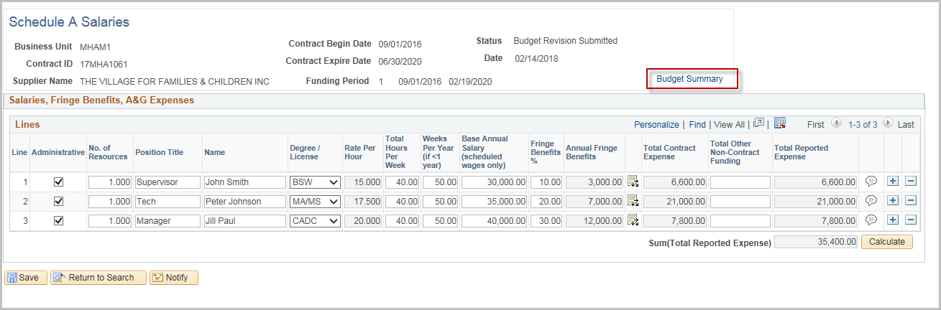
Confirm that the revised Salaries and Fringe Benefits for all programs equal the Totals allocated from the “Schedule A Salaries” page
Click Save
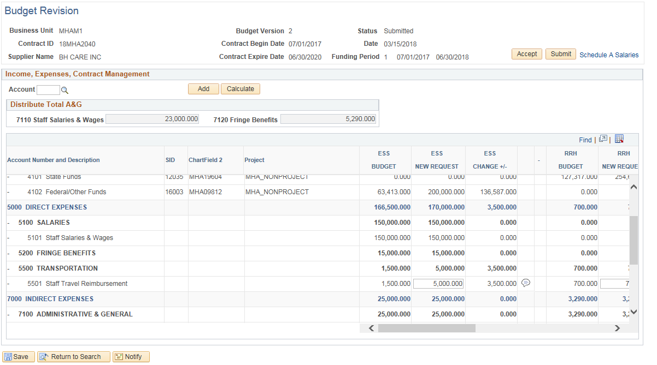
Click OK to the Confirmation message.

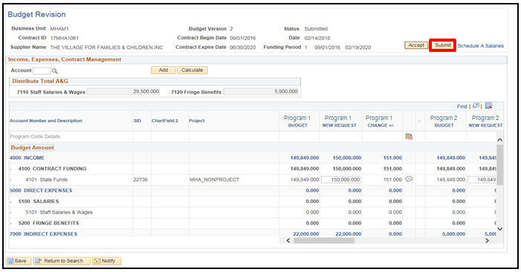
Click Submit.

After submitting the Submission Notification screen will open where the Provider will notify the user that the Budget has been submitted for revision.
Enter a message in the email if necessary.
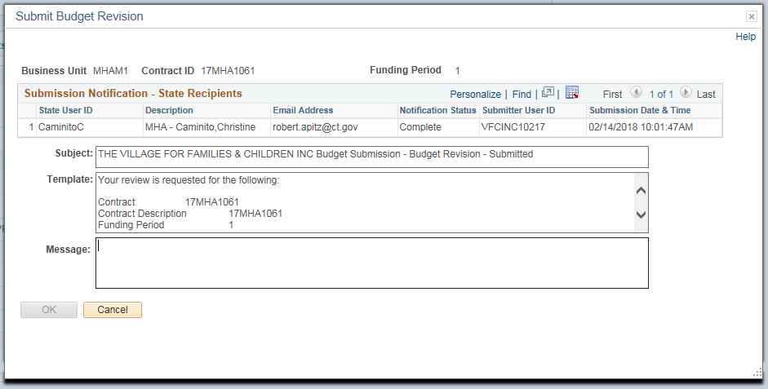
Click OK

Click OK to the confirmation message.

An email will be sent to the Agency. They will be able to follow the hyperlink in the email shown below to begin the process to accept the Budget Revision.
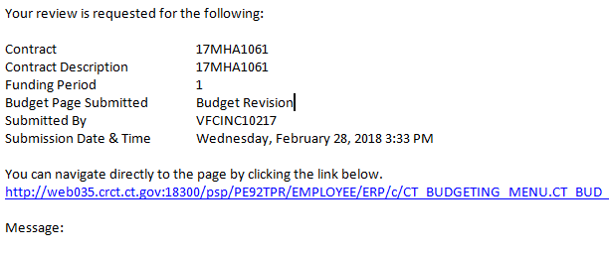

Accept a Budget Revision
Agency
Supplier
Navigation: Supplier Contracts > Budgeting > Budget Revision

The Budget Revision page will display.

Enter Contract ID
Click Search
Select the Contract ID that is to be accepted

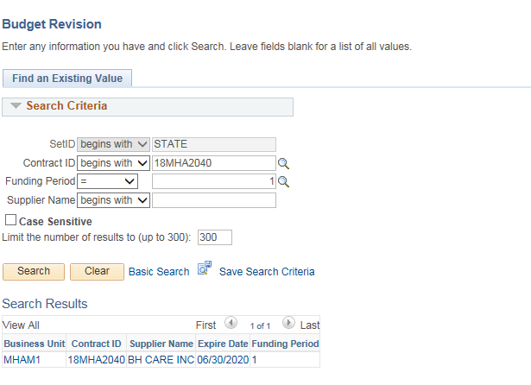

Review the Revisions that have been made by the Provider.
Click the Schedule A Salaries link to review any changes to the Salaries.
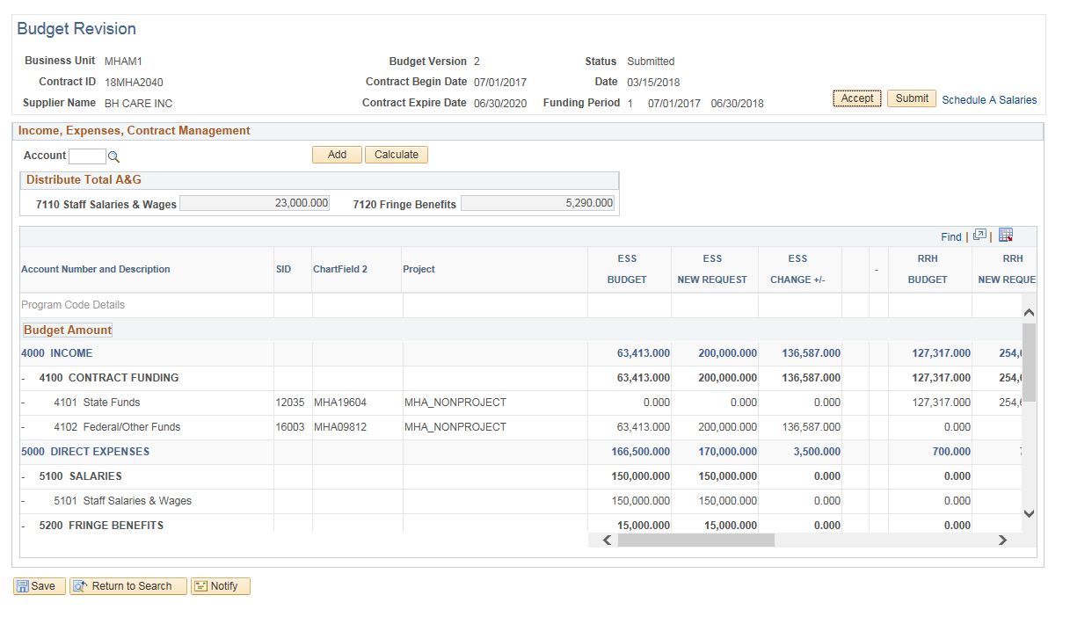
If there are any discrepancies or amounts that need to be update, DO NOT click Accept. Contact the Provider (either by email or using the Notify option in the appendix) to have them correct the entries.
Click the Budget Summary hyperlink to return to the Budget Summary page

Click Accept.
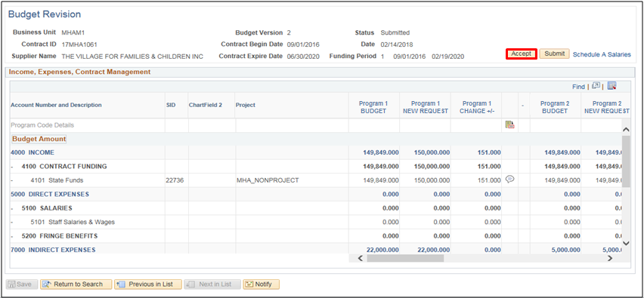
This will open up the Acceptance Notification screen where the user will notify the Provider that the Budget revision has been accepted.
Enter Supplier User ID or use the magnifying glass to search
Enter a message to be included in the email if needed
Click OK
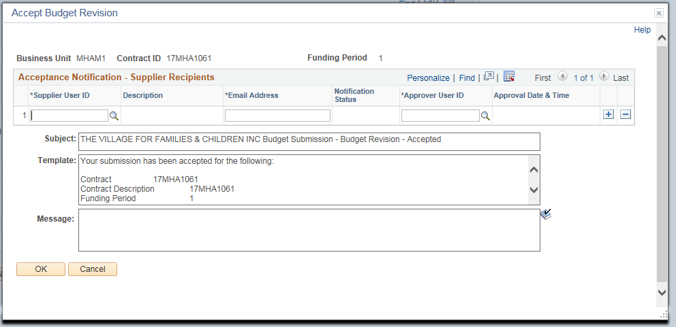

Click OK to the Confirmation message.
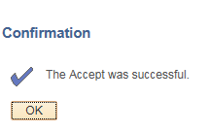

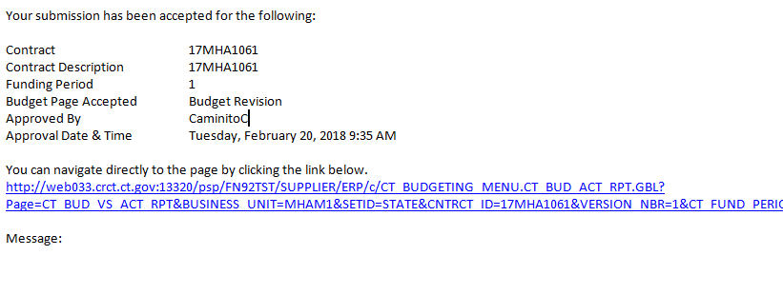
An email will be sent to the Provider. The Provider will now know that the Budget Revision has been accepted.

The status is Accepted and all the lines are un-editable
The plus and minus buttons that are normally present will not be there.

Reset the Funding Period

The following shows how to create Funding Period Budget Workbook Pages.
Navigation: Supplier Contracts > Budgeting > Reset Funding Period

The Reset Funding Period page will display.

Select the Add a New Value Tab

Enter the Run Control ID

When creating a Run Control ID, make sure it is something that will be easily identifiable when using this process in the future.

Click Add
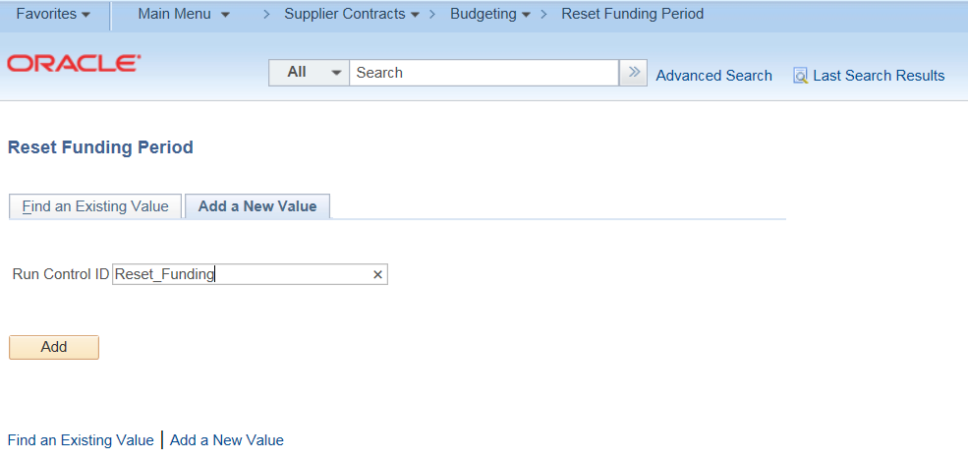
Enter Business Unit
Enter Contract ID (or use the magnifying glass)
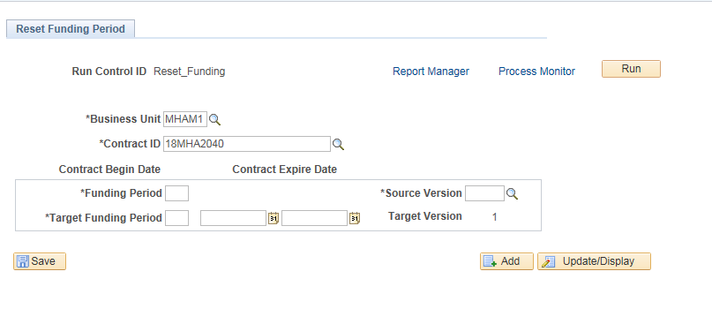
The Funding Period dates populate from the contract
The Source Version defaults to the maximum version of the Accepted Budget Summary. However, the field is editable based on the versions available for the specified funding period.
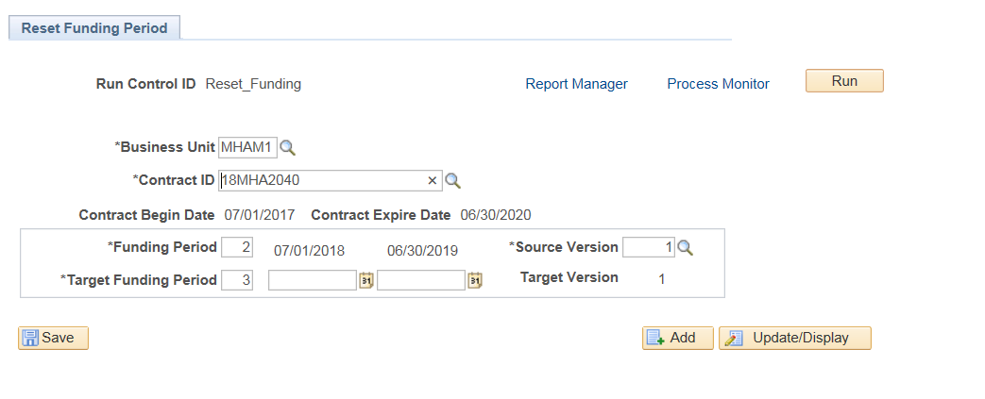
The Target Funding Period will populate with the next available funding period
Enter the new Target Funding Period dates (The dates must still be within the begin and expiration dates of the contract)

Click Save
Click Run
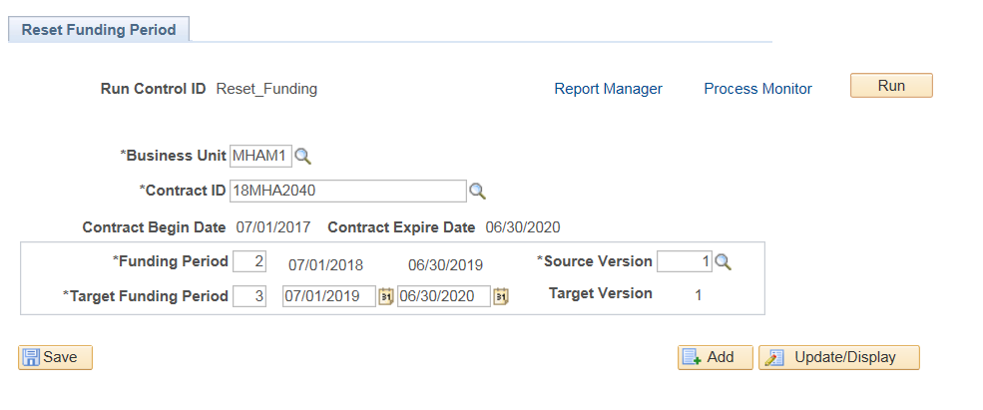

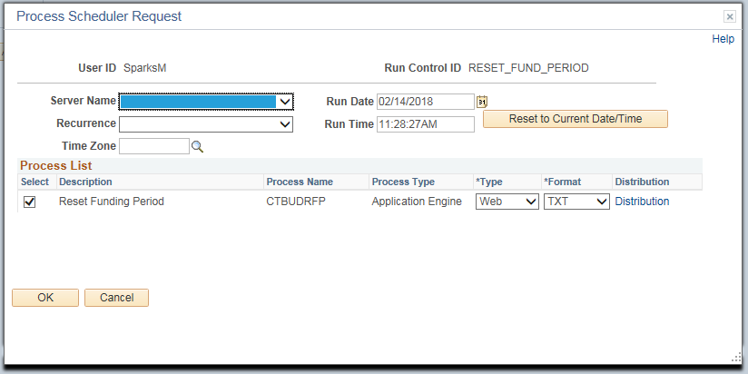
Click OK

Click on the Process Monitor link
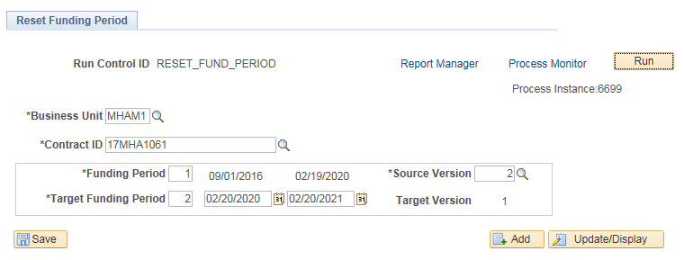

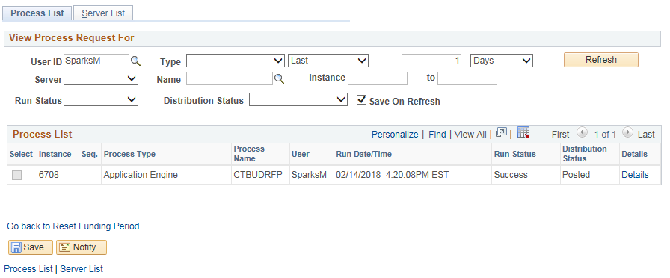
Click Refresh until Run Status and Distribution Status displays Success and Posted

Navigate back to the Budget Definition page to submit the new Budget Summary

Navigation: Supplier Contracts > Budgeting > Budget Definition

The Budget Definition page will display.
Enter the Business Unit, or Contract ID
Click Search

Select the created contract that contains the next number in the Funding Period sequence and “Draft” status in the Budget Definition Status column

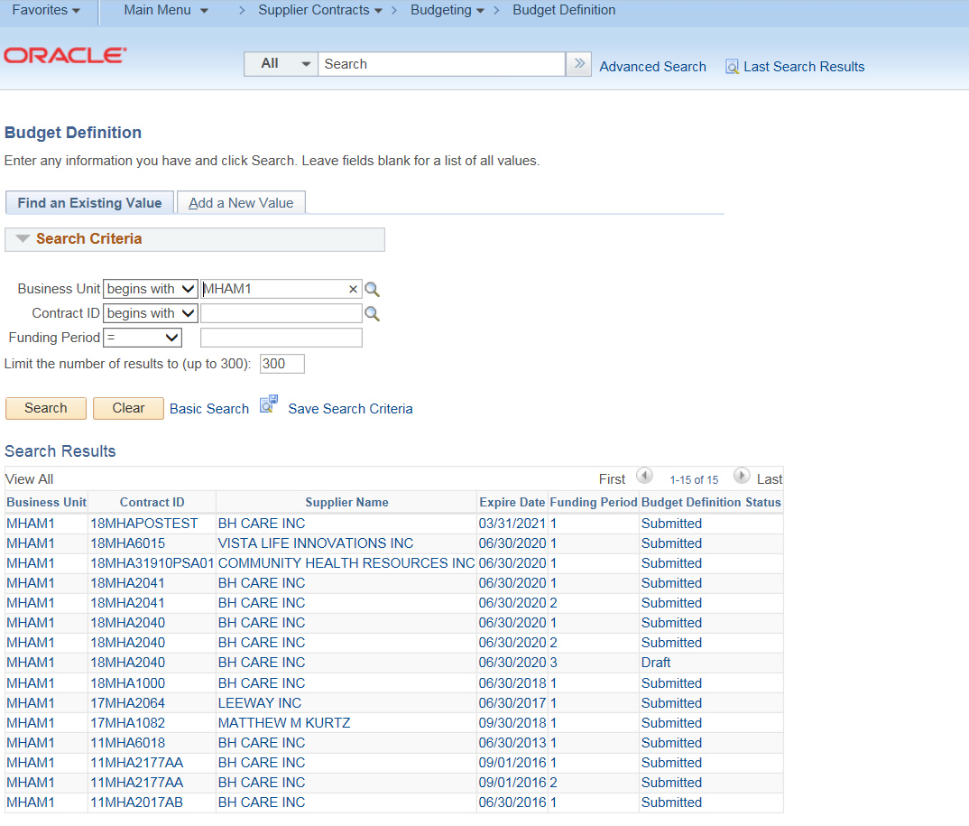
All the original information including the notification contacts have been copied over to the new funding period.
Review and update any information as necessary.
Click Submit.
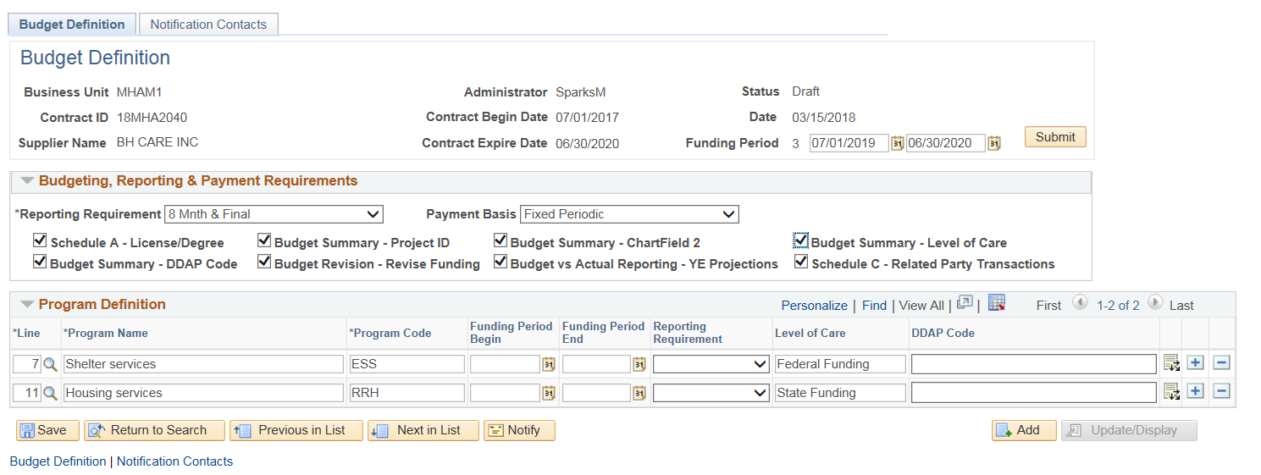
This will open up the Submission Notification screen where the user will notify the Provider that the Budget’s funding period has been changed
Enter Supplier User ID or use the magnifying glass to search
Enter a message to be included in the email if needed and click OK.
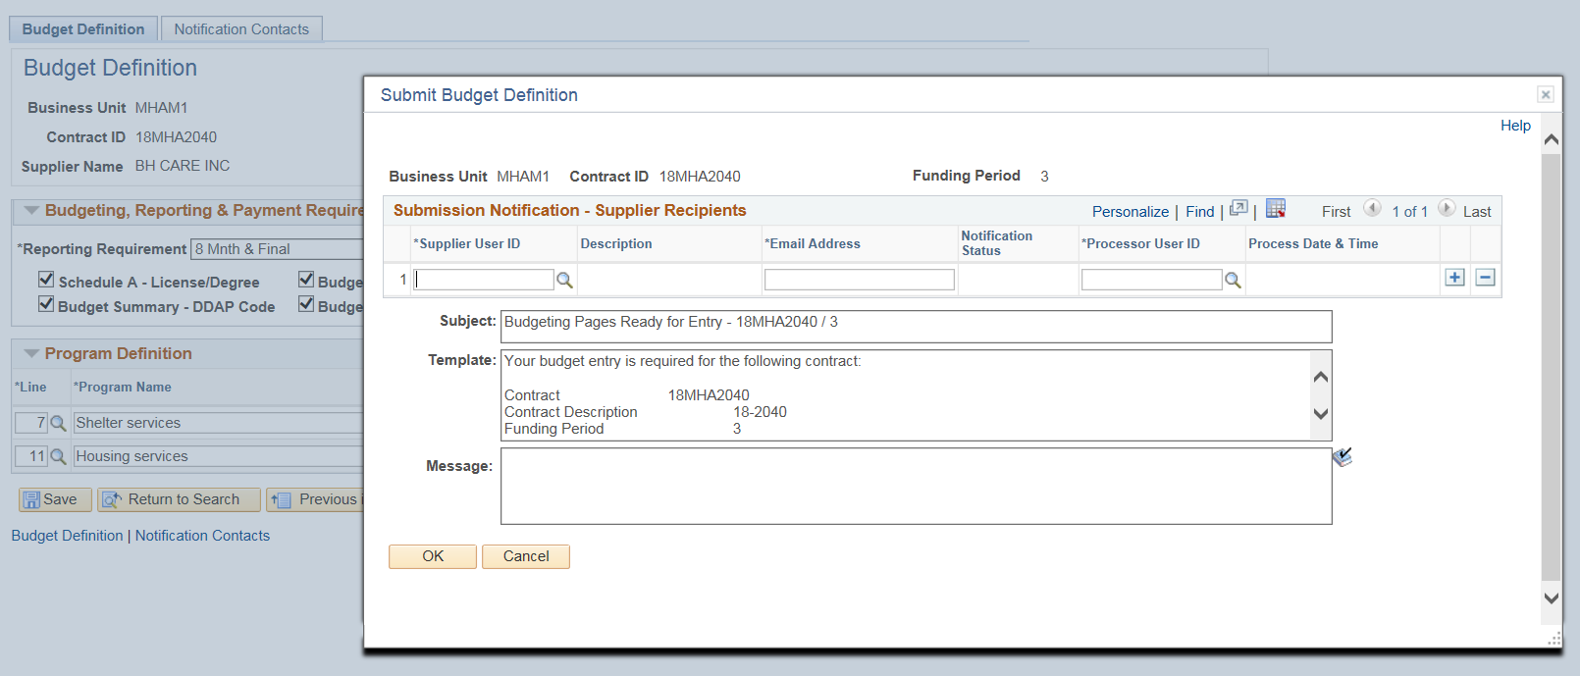

Click OK to the Confirmation message.

An email shown below will be sent to the Provider. From here the user can confirm/update the data in the Provider Program Information, Schedule A Salaries, and Budget Summary pages.
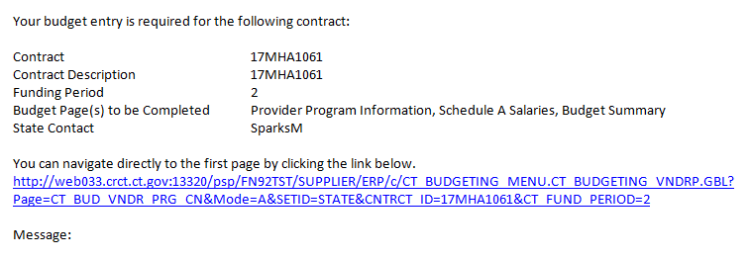

Notify Agency Contact
The following shows how to notify Contacts about the Budget Workbook.
The navigation below shows one example where the Notify button is available. This button is available on multiple pages to be used whenever communication is needed between the provider and agency contacts.
Navigation: Supplier Contracts > Budgeting > Budget Definition

Enter Contract ID

Click Search
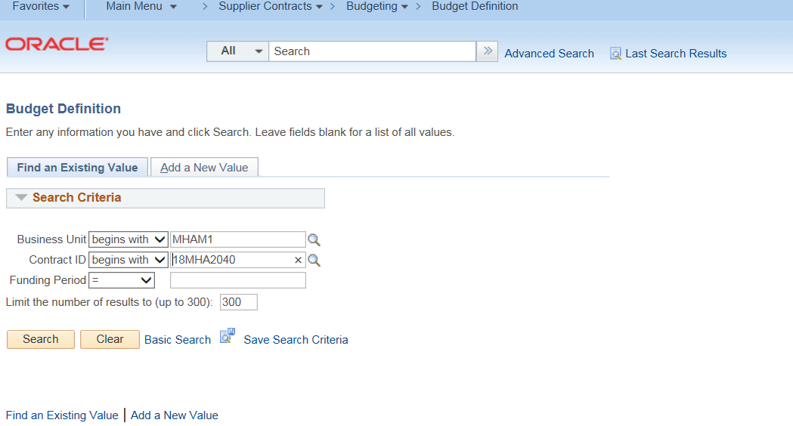

Click on the Notification Contacts tab

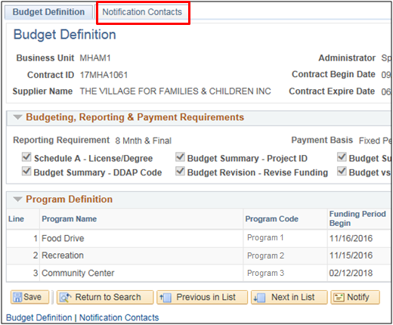

Click Notify
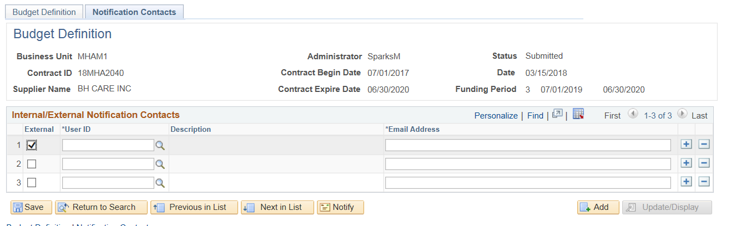
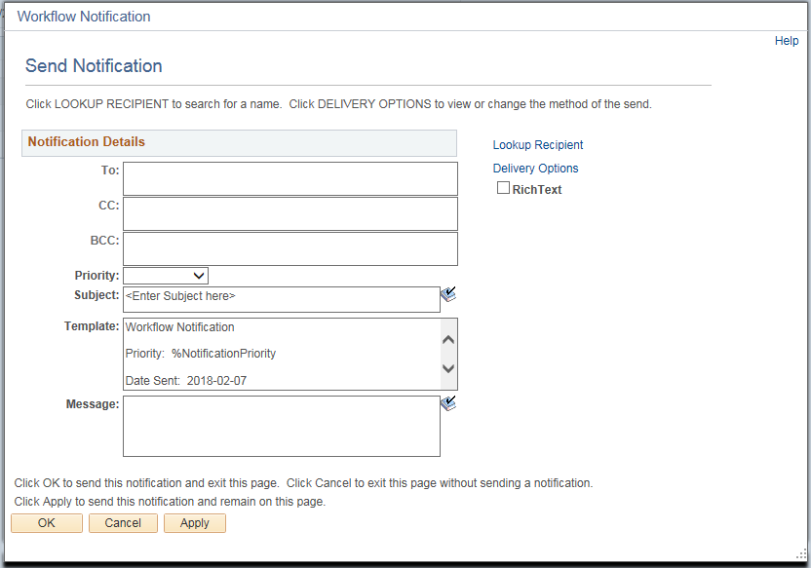
Click Lookup Recipient

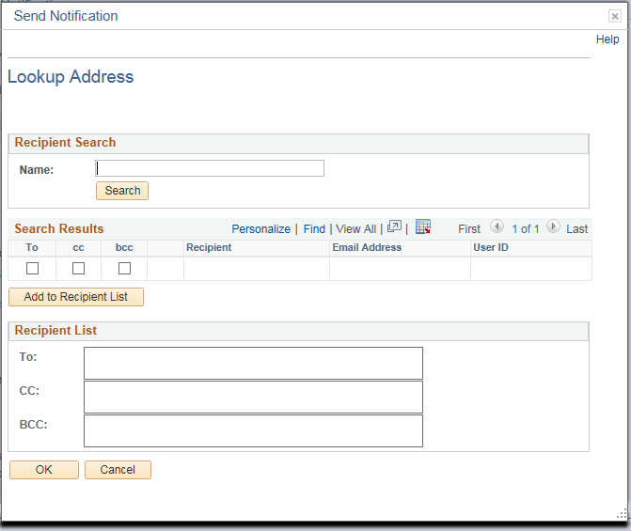
Click Search

Click the “To” checkboxes for the recipients of the notification
The “cc” and “bcc” are also options for recipients
NOTE: When adding contacts, if you add yourself under “CC”, you will receive a copy in your mailbox.
Click Add to Recipient List
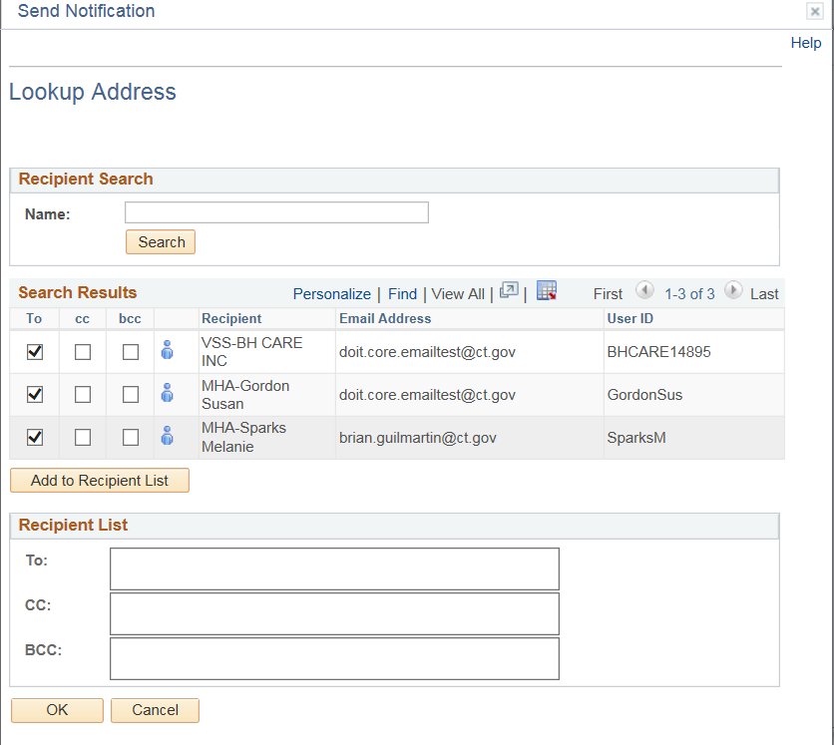
Click OK
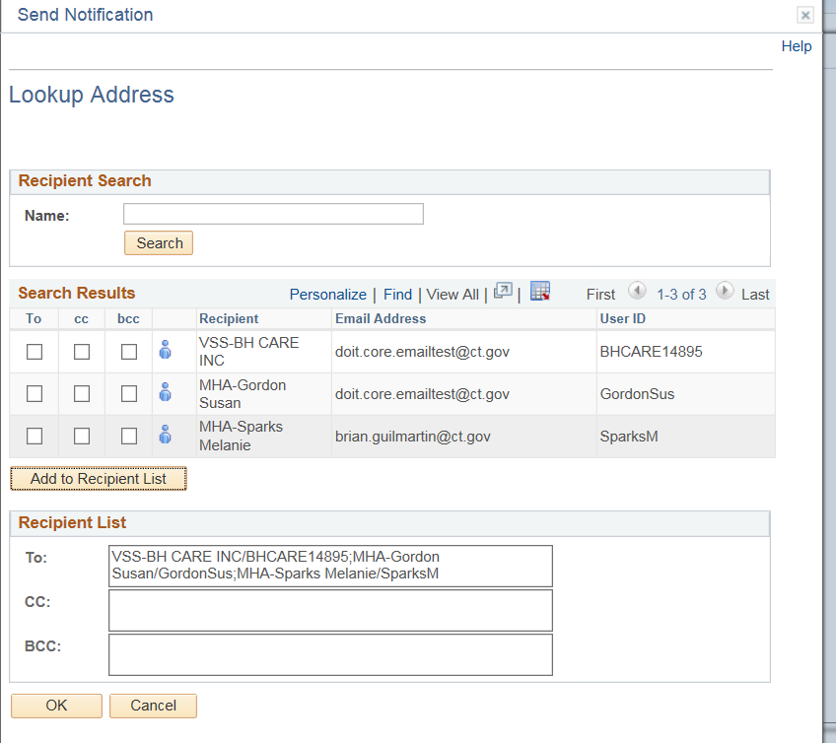
Select a Priority (High, Medium or Low)
Enter a Subject
Enter a message to be included in the email if needed
Click OK
