Budget Workbook for Agencies Job Aid
The process flow below outlines the steps which need to be completed in order for the Budget Definition to become a Budget Workbook.

Agency
Provider

*Provider Entity is not specifically tied to the Budget Workbook; the Provider completes this when they have access to the Supplier Portal.

Budget Definition Entry / Submission

In order to create a Budget Workbook, a Procurement Contract must have been created and be in either Open or Approved status.
The following shows how to create and submit a new Budget Definition.
Navigation: Supplier Contracts > Budgeting > Budget Definition

Click the Add a New Value Tab

Enter the Business Unit, Contract ID, and Funding Period
Note: The funding period cannot be Zero

Click Add

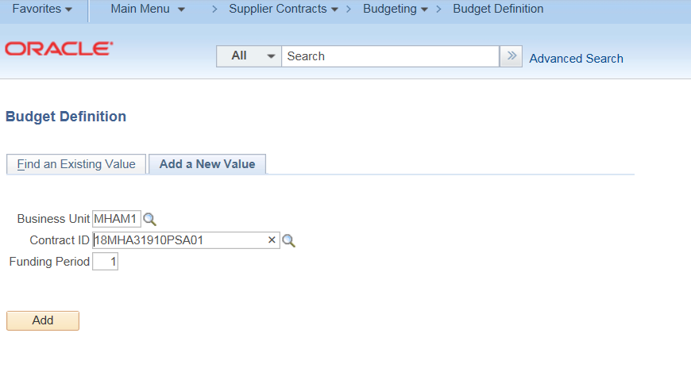

The Budget Definition Page will display

Enter the Funding Period begin and end dates
These dates must be within the contract begin and end dates.

Select the Reporting Requirement
(4, 8 Month & Final, 8 Month & Final, Bi-Monthly, Monthly or Quarterly)

Select the Payment Basis
(Expenditure – Cash Management, Fixed Periodic, Request – Cash Management)

NOTE: The Payment Basis field defaults as blank and does not have to be populated with a value if not required.
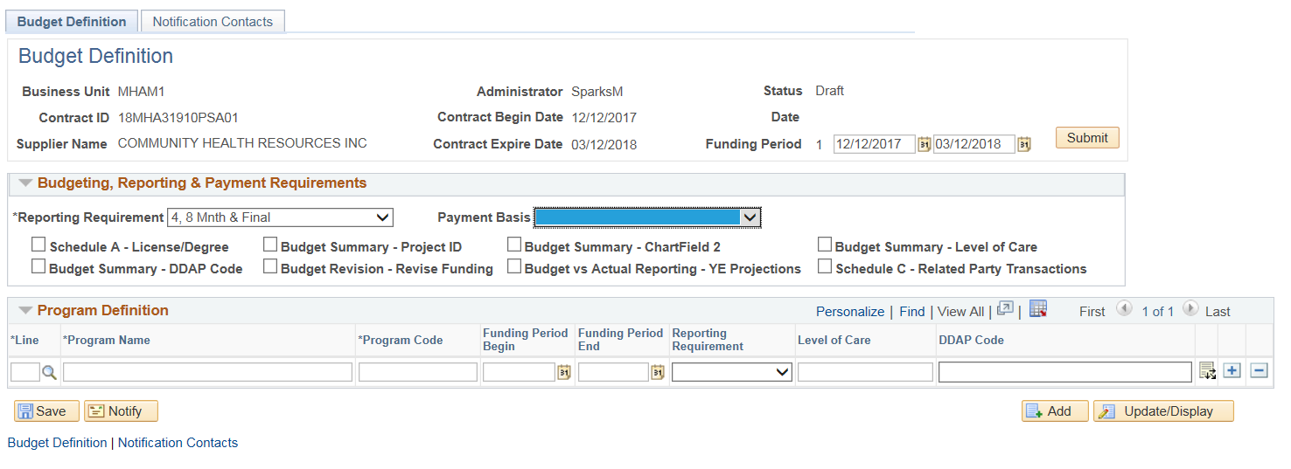
Select the checkboxes that will be used for this workbook. Each checkbox selected will make up the content of the Budget Workbook. These checkboxes can be modified up until the workbook has been accepted by the agency.
Enter the Line number or use the magnifying glass to search for available lines on the Procurement Contract. The line numbers do not have to match the Procurement Contract and more lines can be entered, if necessary.
Enter the Program Name. The description of the line will not be brought over from the Procurement Contract
Enter a Program Code. The Program Code will be used for the Column heading throughout the workbook.
Enter the program Funding Period Begin, Funding Period End, and Reporting Requirements ONLY IF they are different from the selection entered above

Enter the Level of Care, and DDAP Code as needed
NOTE: If your agency does not use Level of Care or DDAP code, these fields can optionally be used as additional text information about the program
Click the ‘+’ plus button to add additional Program lines
Click the Distribution icon at the end of the line to enter the coding for the Program
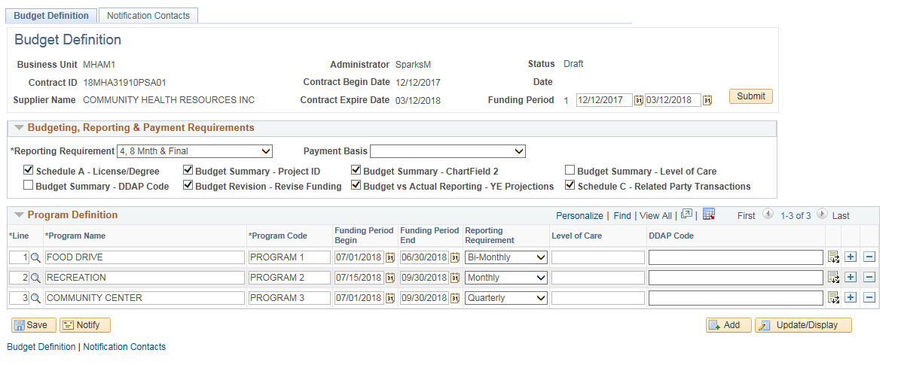
Enter the Funding Distribution for each Program Line:
Enter the Distribution Line number or use the magnifying glass to search for available lines on the Procurement Contract. The line numbers do not have to match the Procurement Contract.
If an existing Procurement Contract distribution is entered, the Amount, SID, ChartField 2, and Project fields will populate with the contract’s information. These fields can be overridden if necessary. If no values exist, enter the correct information.
Note: Clicking on the Refresh will reset the Amount, Sid, Chartfield 2 and Project to the values on the associated Procurement Contract distribution.
Do not click Refresh if you are manually entering these values.
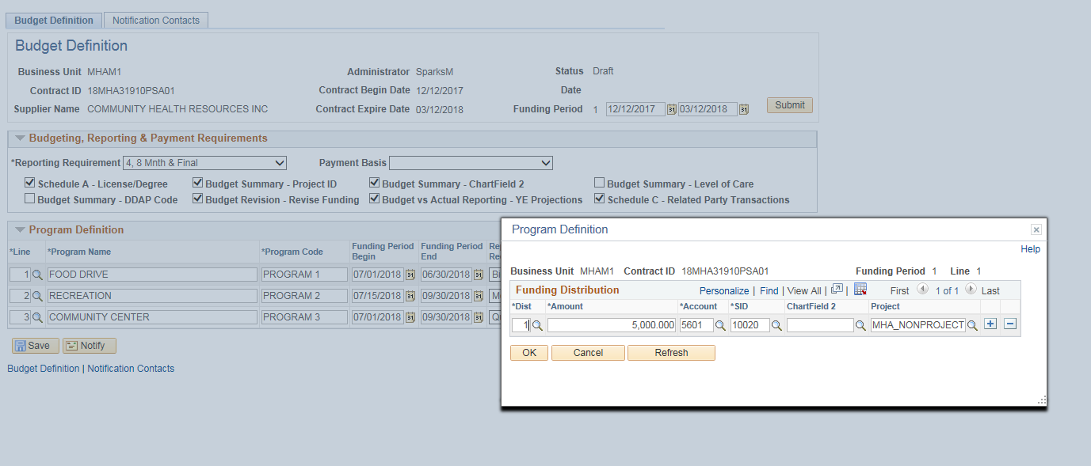
The Account field will not be brought over from the Contract. Instead, enter in the four digit UCOA code that identifies the funding source. Enter the code or click the magnifying glass to select the value.
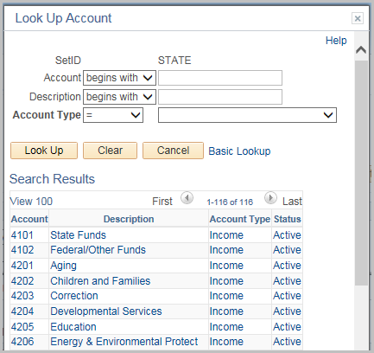
Click ‘+’ plus button to add additional distribution lines
Click OK
Repeat this step for each program line.

Once all distributions have been entered, click Save
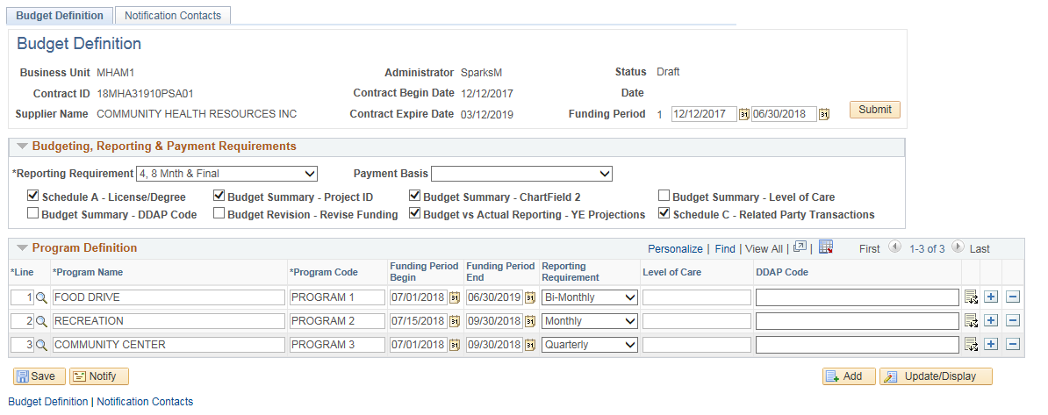

Click the Notification Contacts tab
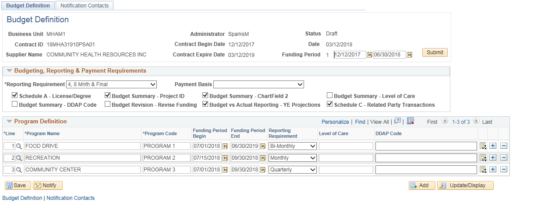
The Notification Contacts Tab is where all users (both Agency and Provider) will be added to receive notification about this workbook.
Click the ‘+’ plus button to add additional contacts.
For Provider Contacts:
Click the External checkbox and enter Provider’s User ID.
NOTE: The Provider Administrator will set up the User IDs for all provider staff. The Agency will need to submit a CO-1092 form for each user to grant access to the Budget Workbook. If the User ID does not work, contact the Provider Administrator to verify that a User ID has been setup.
For Agency Contacts:
Enter the agency Contact’s User ID.
The user creating the workbook should always add their user id as a contact.
Note: You can also use the magnifying glass to search for the user id.
When a User Id is selected, the description and the email address for both external and internal contacts will update automatically.
If the email address stays blank or is incorrect, it can be modified for this Workbook. However, the correction will not update the User ID’s profile. A request will need to be submitted to the appropriate personnel to update their profile with the correct information.
Click Save
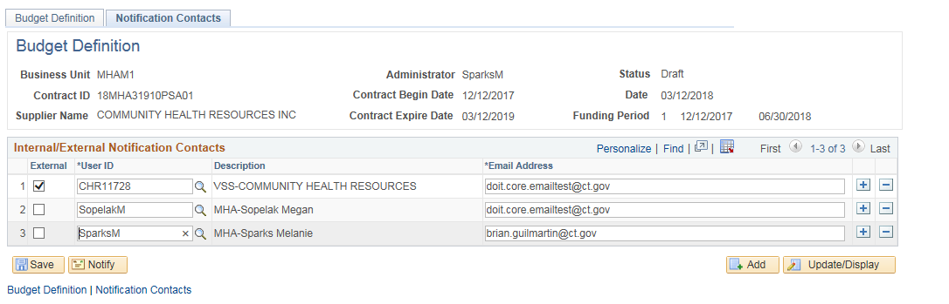
Return to the Budget Definition tab
Click Submit
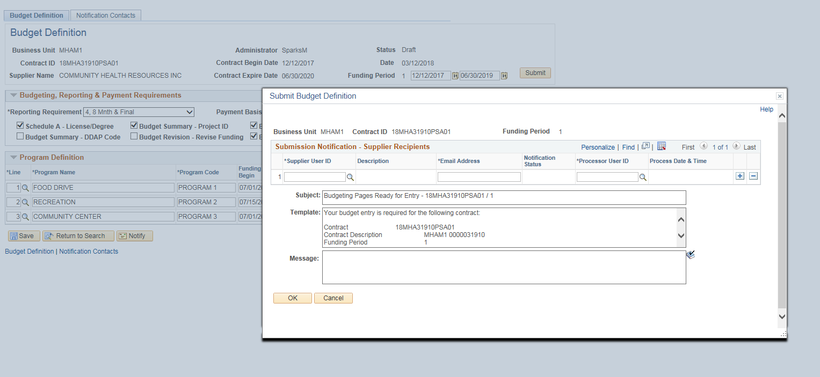
This will open up the Submission Notification screen where you will notify the Provider that the Budget Workbook is ready for collaboration.
Enter the Supplier (Provider) User ID (or use the magnifying glass to search) Description, Email address and Processor User id will automatically update.
Only users entered on the Notification Contacts tab will be available to select to receive a notification. If a user is missing go back to the Notification tab and add them. Review and/or update the Email Address if necessary.
Enter a message to be included in the email if needed and click OK.
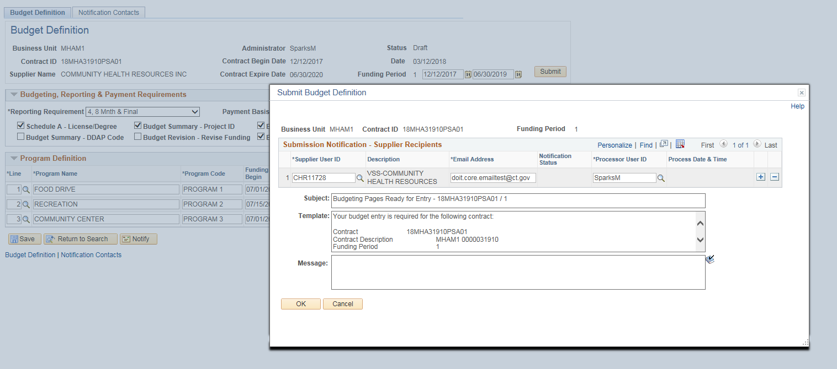
Click OK to the confirmation message.

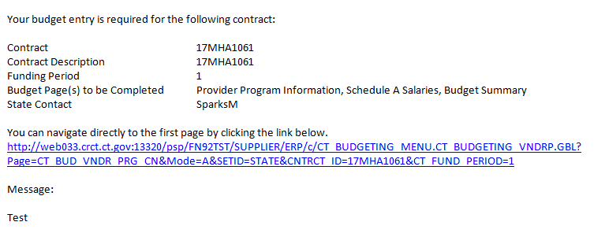
At this time, an email will be sent to the Provider. The Provider will now know what Budget Pages need to be completed and can click the hyperlink to begin that process.

Prior to accepting the Budget Summary, the Provider completes the following pages:
- Provider Entity Page
- Provider Program Information Page
- Schedule A Salaries
- Budget Summary Entry/Submission

