Budget Workbook for Agencies Job Aid
The process flow below outlines the steps which need to be completed in order for the Budget Definition to become a Budget Workbook.

Agency
Provider

*Provider Entity is not specifically tied to the Budget Workbook; the Provider completes this when they have access to the Supplier Portal.

Provider Entity Information Update
The following shows how to update Provider Entity Information.
The Provider Entity Information is not specifically tied to the Budget Workbook
However this is information the Provider completes when they have access to the Supplier Portal and can be viewed by the Agencies.

The Provider or the Agency can update information through Find an Existing Value Tab.
Navigation: Supplier Contracts > Budgeting > Provider Entity Information

The Entity Provider Information page will display.
Enter the Supplier ID, (or use the magnifying glass) or enter the Name of the Provider then click Search

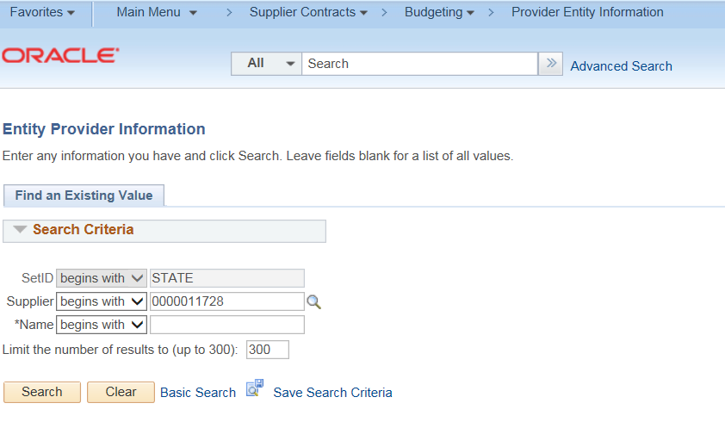

The Provider Entity Page is broken down into three tabs.
On the first tab (Provider Entity Information)
Enter the DUNS #
Enter the Provider Fiscal Year End (Month)
Enter the SAM (CAGE) No. and the SAM (CAGE) No. Expiration Date
Answer Yes/No for the 80 percent field
Answer Yes/No for the $25,000,000 field
Answer Yes/No for the Litigation Pending field. If Yes, the Comment field is required to be filled out.
Enter Accreditation List
Click Save 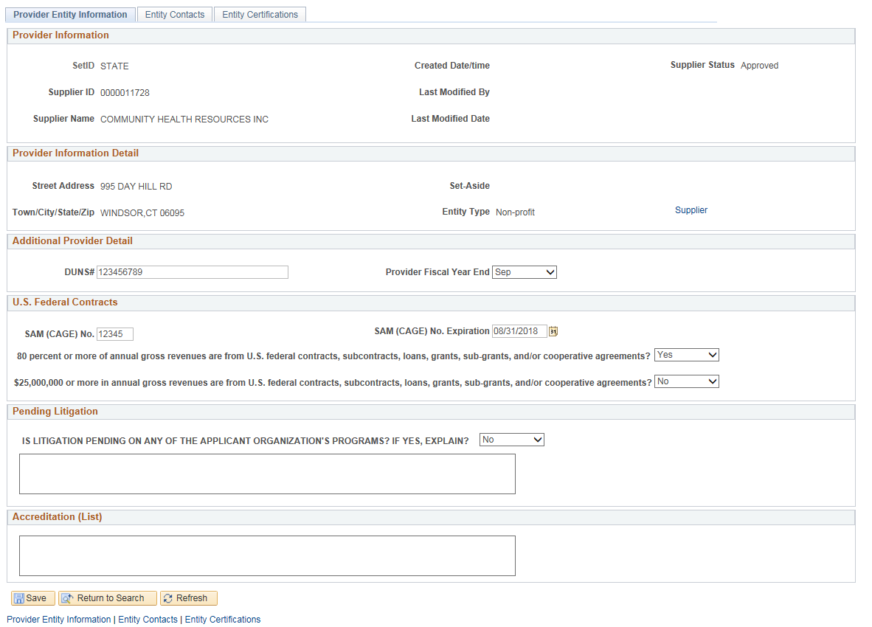

Click on the Entity Contacts tab
This will display a list of the current contacts and their information that have been setup by the Provider.
If changes need to be made, the Provider Administrator will have the Supplier Change Request Link available.
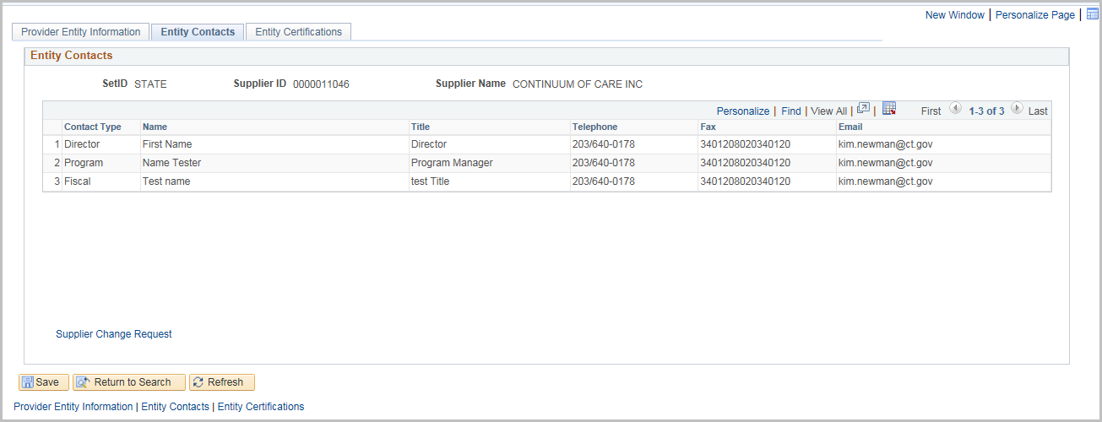
Click on the Entity Certifications tab
Select the Certification Type
Enter an ID Number and an Expiration Date
Click the + sign to add additional certifications
There are three links to other websites to assist with this section
(Biznet, The Office of Secretary of the State, or License Lookup)
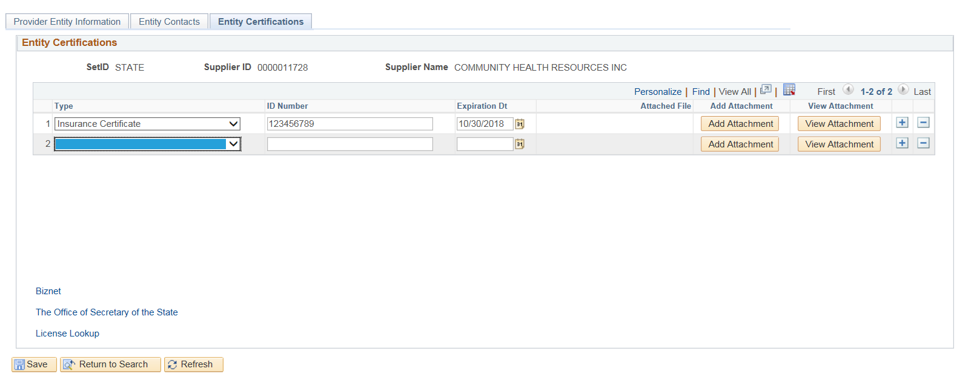
Click Add Attachment to attach copy of the certificate
Click Browse and select the file that is to be uploaded

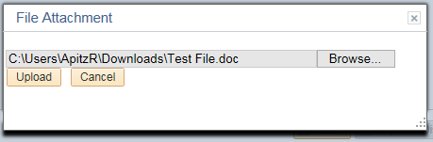
Click Upload

Click View Attachment
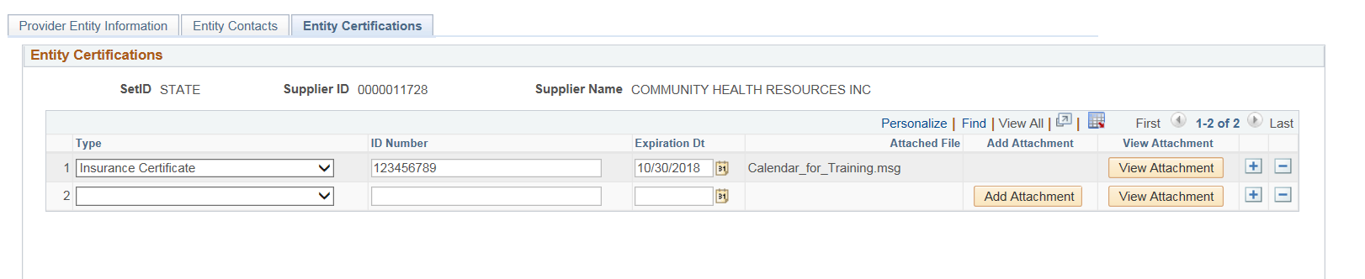
At the bottom of the screen, click Open to view the attachment.

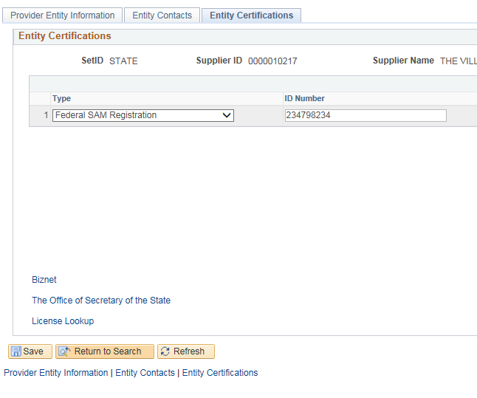
Click Save

