Budget Workbook for Agencies Job Aid
The process flow below outlines the steps which need to be completed in order for the Budget Definition to become a Budget Workbook.

Agency
Provider

*Provider Entity is not specifically tied to the Budget Workbook; the Provider completes this when they have access to the Supplier Portal.

Provider Program Information Entry
The following shows how to update the Provider Program Information.
Navigation: Supplier Contracts > Budgeting > Provider Program Information

The Provider Program Information page will display.

Enter or search for the Contract ID, Funding Period, or Supplier Name, and click Search

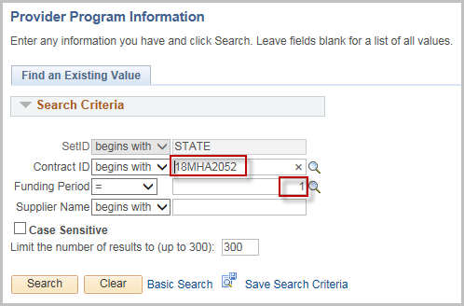
Select the Contract ID from the search results
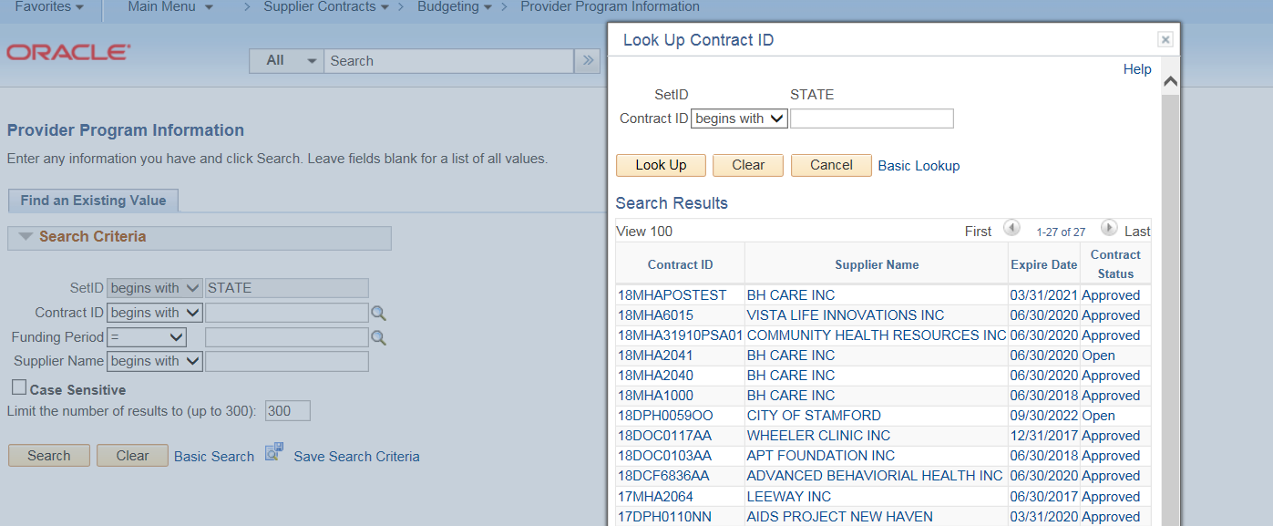

The Provider Program Information is broken down into three tabs
Select Yes/No for the Statewide field (The default is Yes)
If No is selected, enter at least one of the Catchment Areas, City/Town, or Region fields
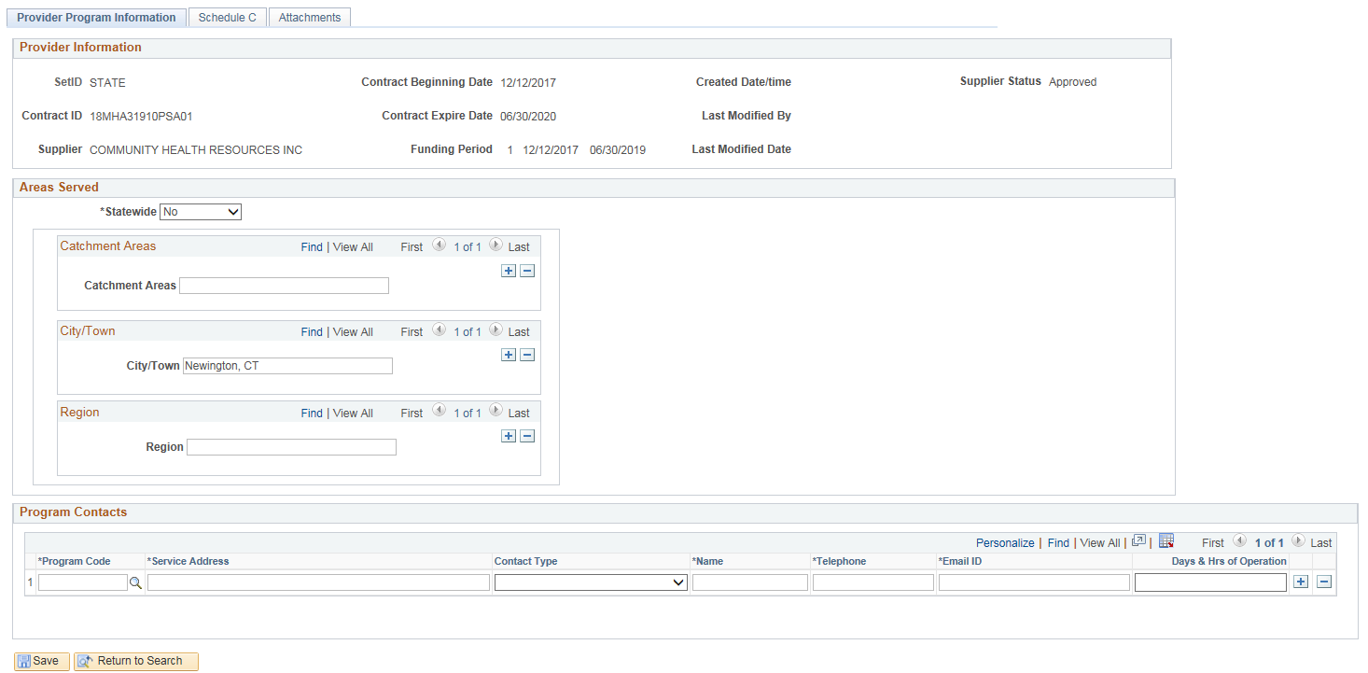
Enter in Program Contacts.
Look up the Program Code (using the magnifying glass). Only programs that were created on the Budget Definition can be selected.
Enter the Service Address
Select Contact Type
Enter Name, Telephone, Email ID, and Days & Hrs of Operation
Click on the + sign to add additional Contacts
Click Save
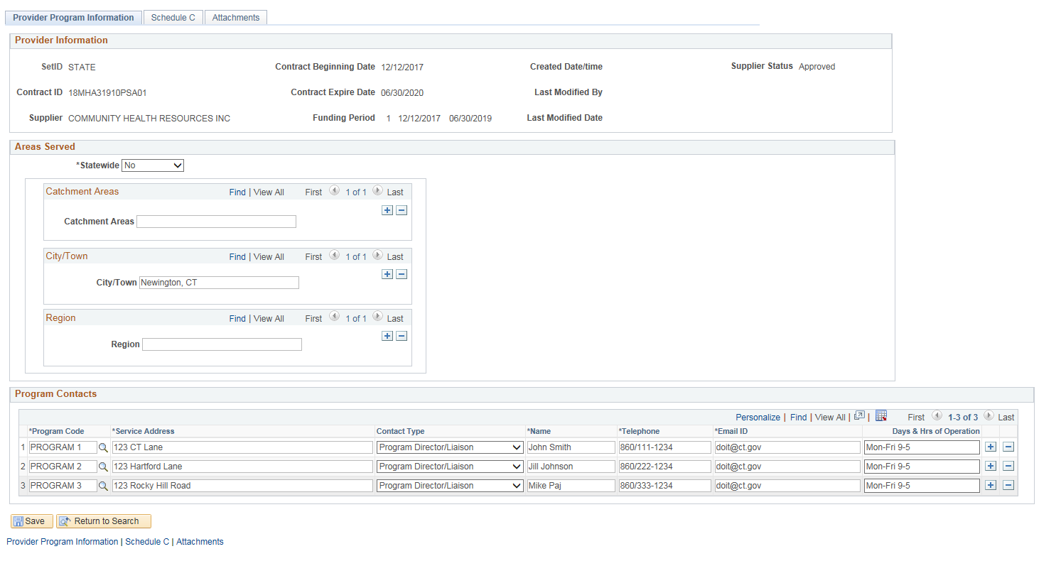
Click on the Schedule C tab
Note: The Schedule C tab will only appear if it has been checked on the Budget Definition Page.
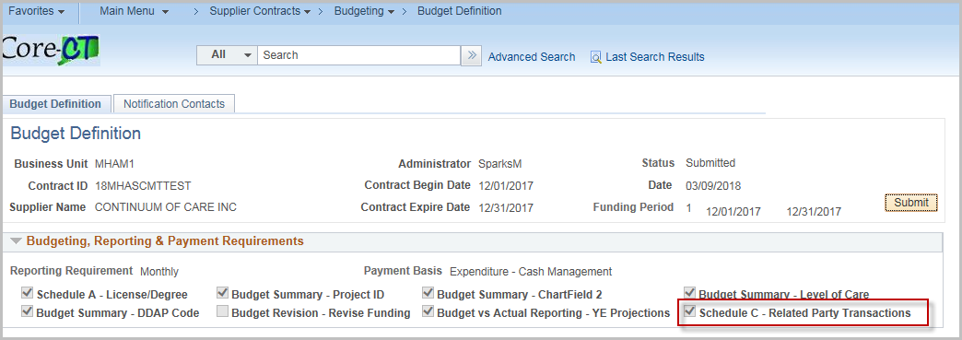

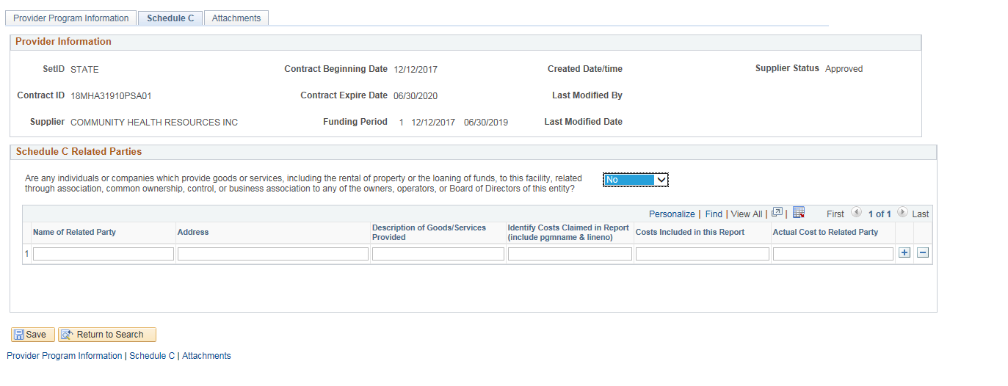
Select Yes/No to the question in the Schedule C Related Parties section
If Yes, enter Name of Related Party, Address, Description of Goods/Services Provided, Identify Costs Claimed in Report, Costs Included in this Report, and Actual Cost Related to Party fields.
Click Save
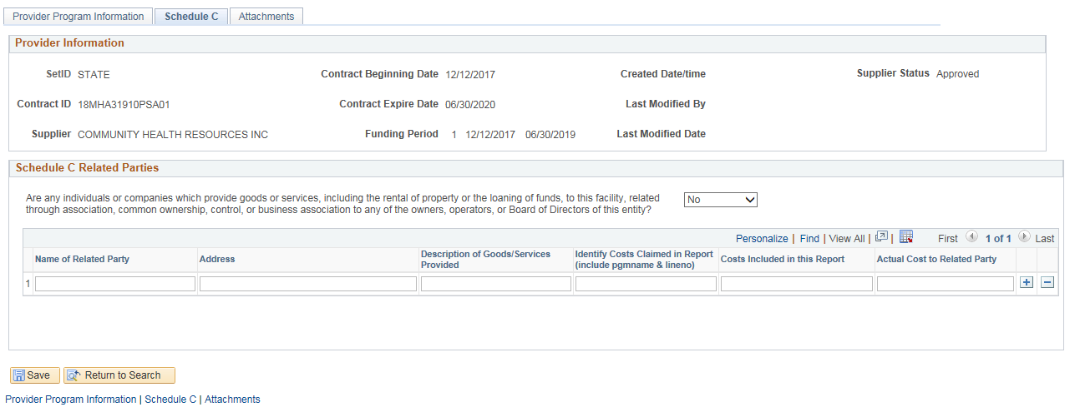

Click on the Attachments tab
The attachments tab can be used for any additional documentation.
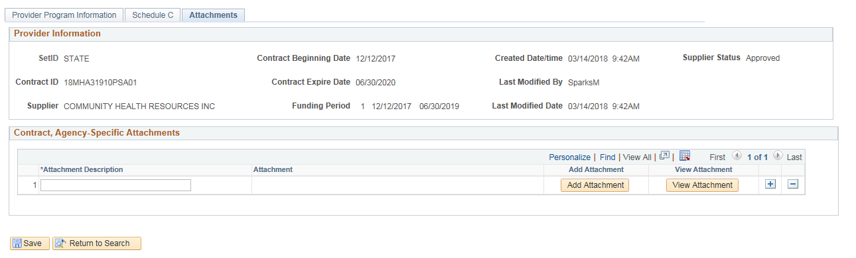
Enter the Attachment Description and click on Add Attachment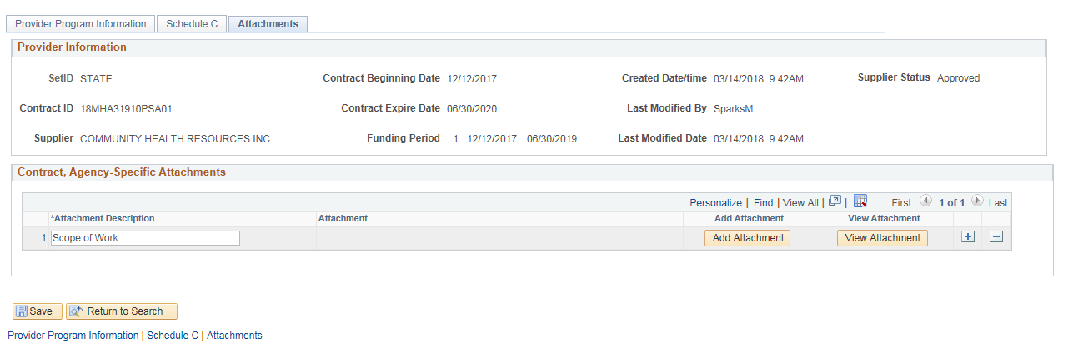
Click Browse

Select the attachment to be uploaded and click Upload
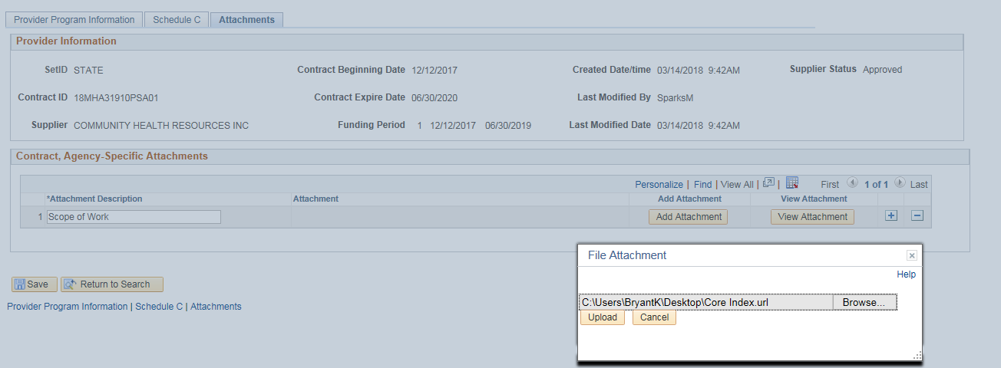
Click View Attachment to review the document
Use the + sign to add more attachments
Click Save
