Budget Workbook for Agencies Job Aid
The process flow below outlines the steps which need to be completed in order for the Budget Definition to become a Budget Workbook.

Agency
Provider

*Provider Entity is not specifically tied to the Budget Workbook; the Provider completes this when they have access to the Supplier Portal.

Schedule A Salaries Entry
The following shows how to enter Schedule A Salaries and submit the budget.
Although the Provider should be entering this information, the agency can enter it on their behalf.
Navigation: Supplier Contracts > Budgeting > Schedule A Salaries

The Schedule A Salaries page will display.
Enter or search for the Contract ID, Funding Period, or Supplier Name, and click Search

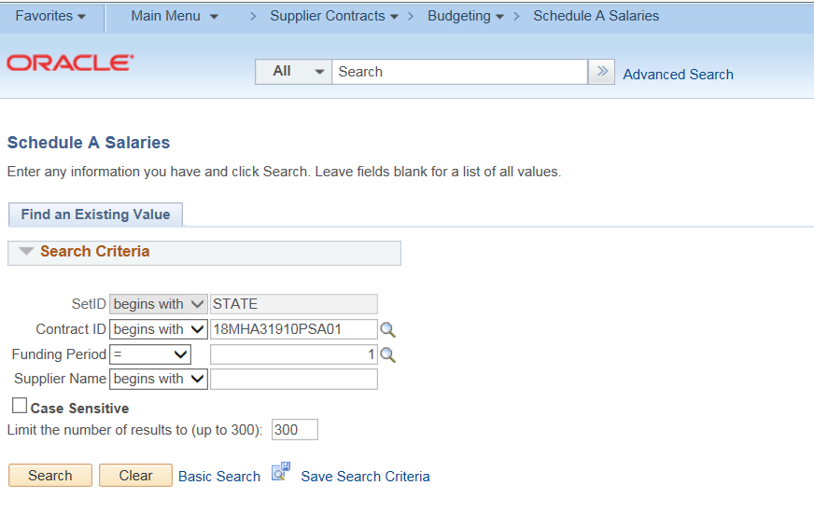

Check the Administrative checkbox if the A&G portion of this resource is an indirect expense.
Do not check the box if the A&G portion of the resource is a direct expense.
Enter Number of Resources. The Total Contract expense will be multiplied by this number to reflect the total for the group.
Enter the Position Title
Enter the Name
The Rate per hour is calculated automatically.
Enter the Degree / License (This will be available only if Schedule A – License/Degree is checked on the Budget Definition)
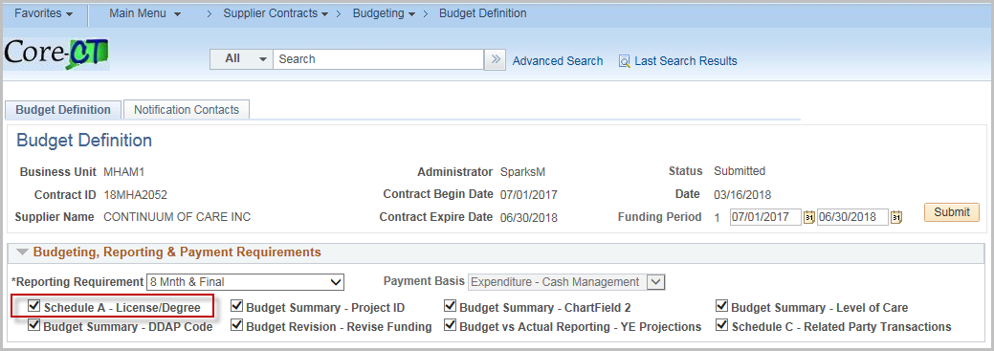
The Total Hours Per Week is defaulted to 40. Update if necessary.
Enter the Weeks Per Year (only if working for less than a year)
Enter the Base Annual Salary (scheduled wages only)
Enter the Fringe Benefits % (The Annual Fringe Benefits will calculate automatically)
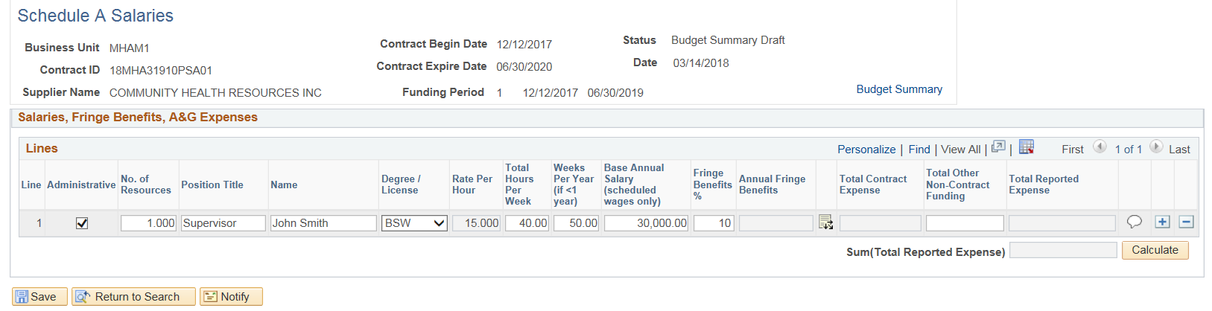
Click on the Distribution Icon 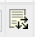to access Program/Service/AG Detail
Enter A & G Program % of Time (If none, leave blank)
Click the ‘+’ plus button to add additional Program Code rows if necessary. (Only programs entered on the Budget Definition can be selected)
Click OK
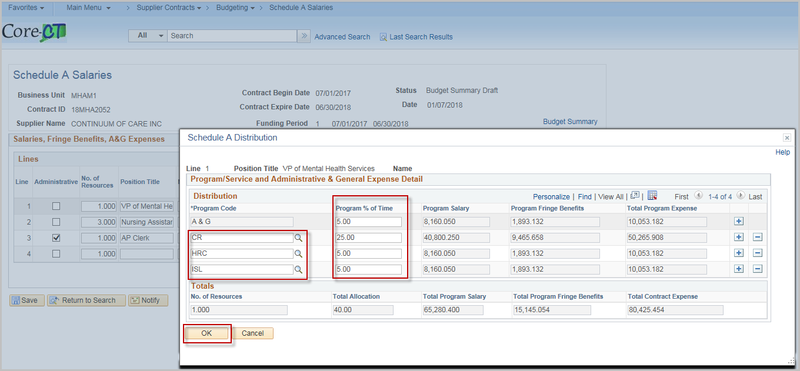
Once completed, the Total Contract Expense and Total Reported Expense will update automatically.
Enter the Total Other Non-Contract Funding (if applicable)
Click the Comment Bubble to enter a Justification
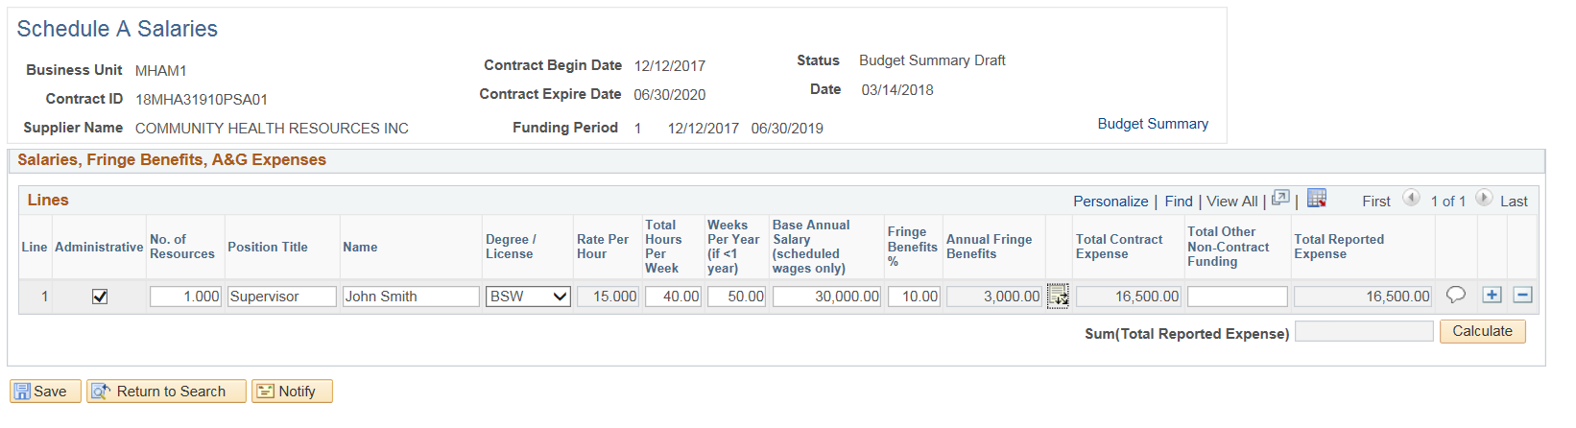
Provide a justification, and then click OK.

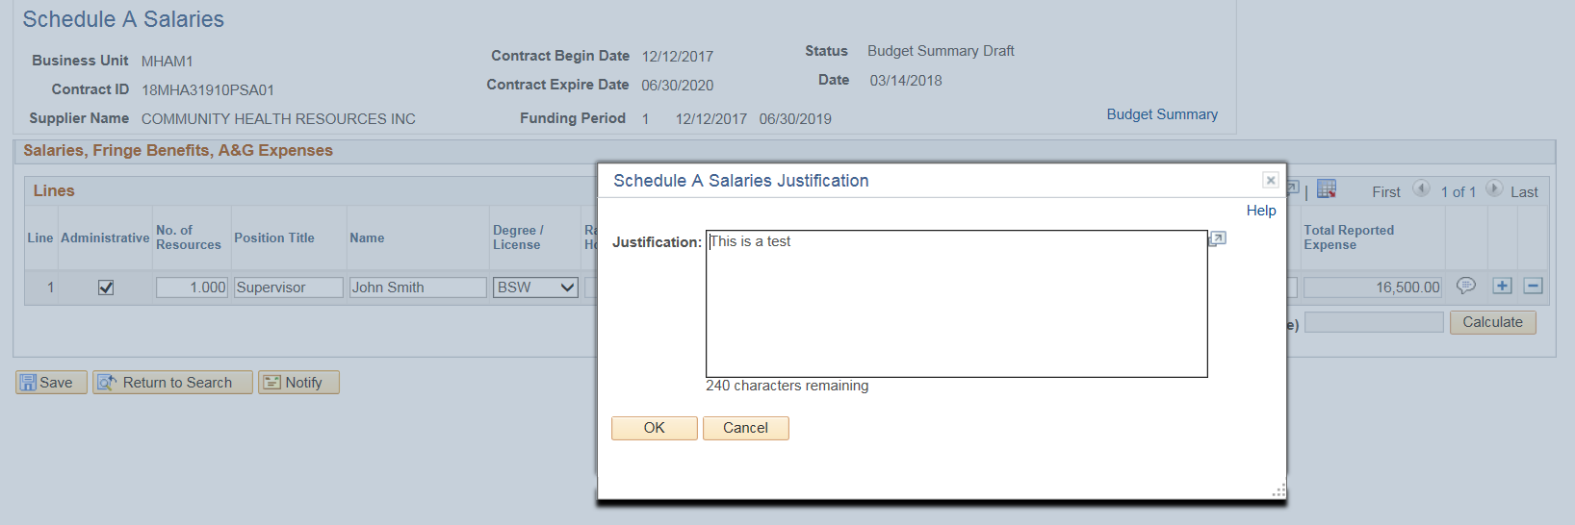
Click Save
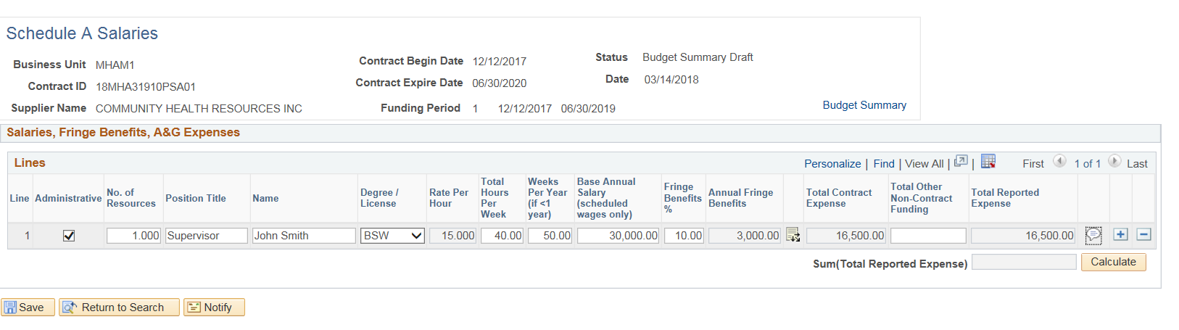
Justification is required for all rows. If a justification is not entered, the following message will display when clicking Save
