Budget Workbook for Agencies Job Aid
The process flow below outlines the steps which need to be completed in order for the Budget Definition to become a Budget Workbook.

Agency
Provider

*Provider Entity is not specifically tied to the Budget Workbook; the Provider completes this when they have access to the Supplier Portal.

Budget Summary Entry & Submission

The following shows how to complete the Budget Summary Entry and Submit the Summary for acceptance by the agency.
Although the Provider should be entering this information, the agency can enter it on their behalf.
From the Schedule A Salaries page, you can click on the Budget Summary link
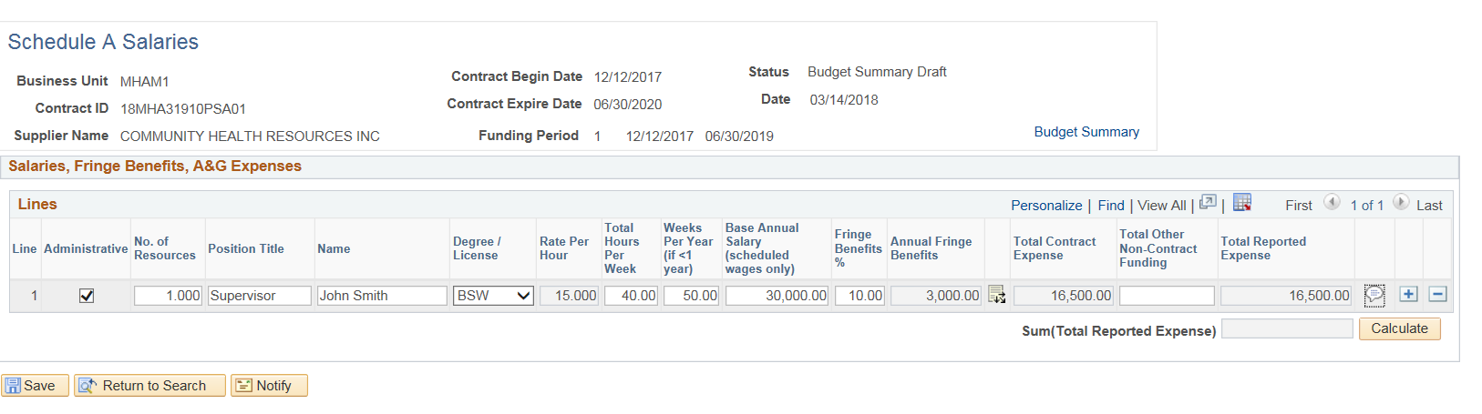
If not using the hyperlink on the Schedule A Salaries page

Navigation: Supplier Contracts > Budgeting > Budget Summary

The Budget Summary page will display.
Enter or search for the Contract ID, Funding Period, or Supplier Name, and click Search

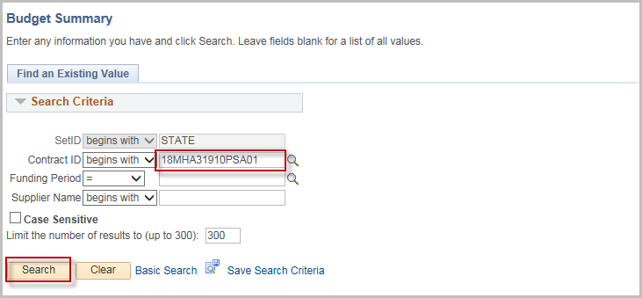

Chartfield 2 and Project will display on the Summary only if they were selected on the budget definition page.
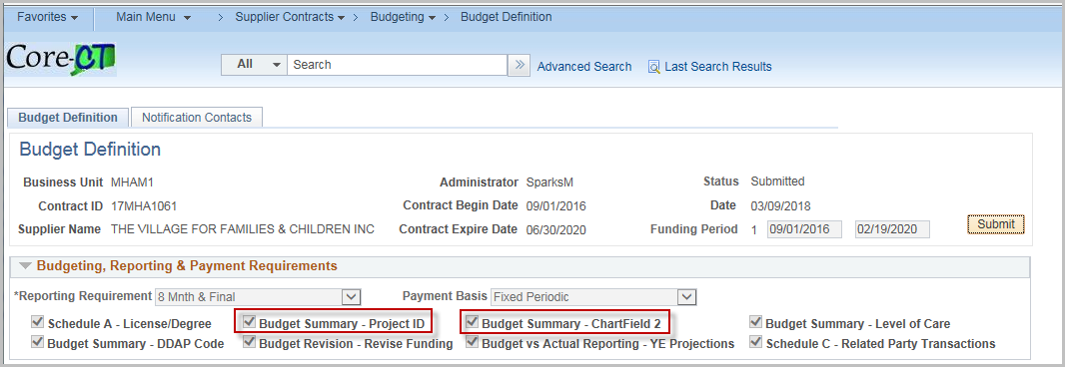
To add a UCOA Account, enter the number in the account box or use the magnifying glass to search for a value.
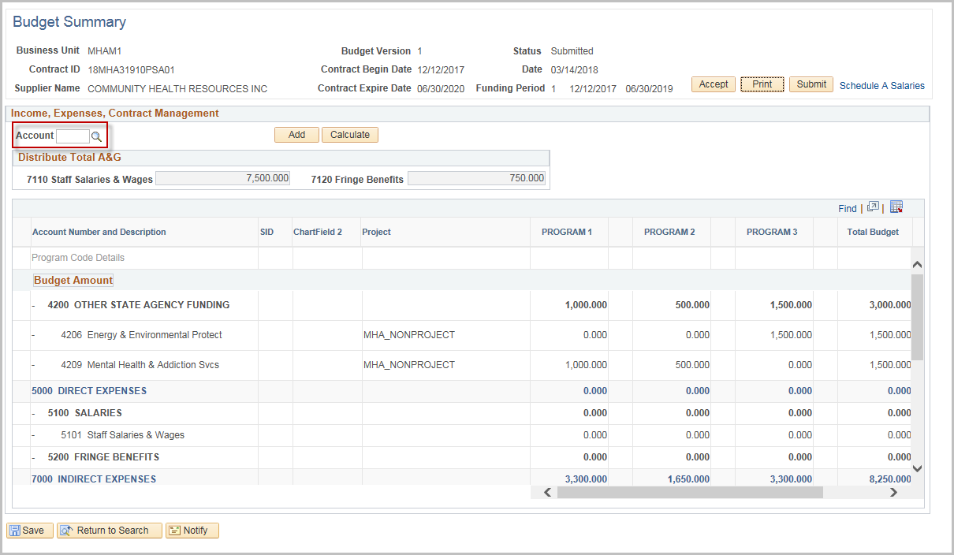

Click on the code

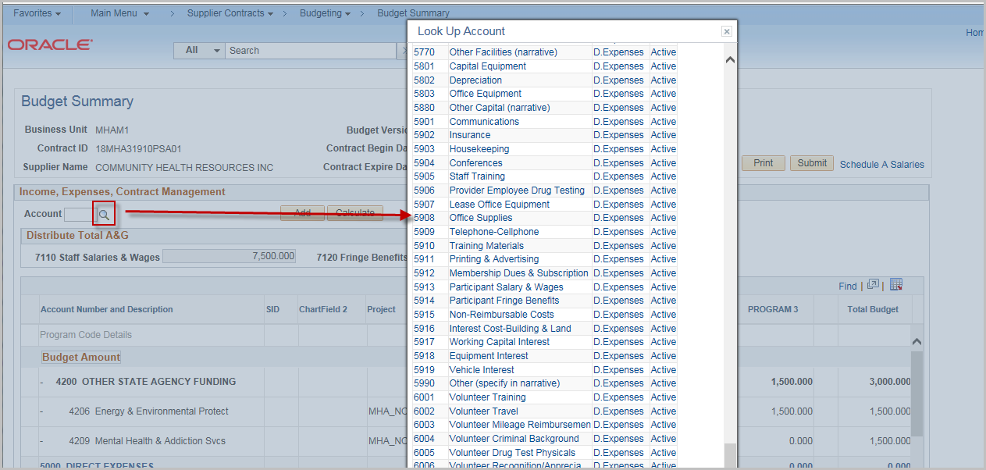

Click Add

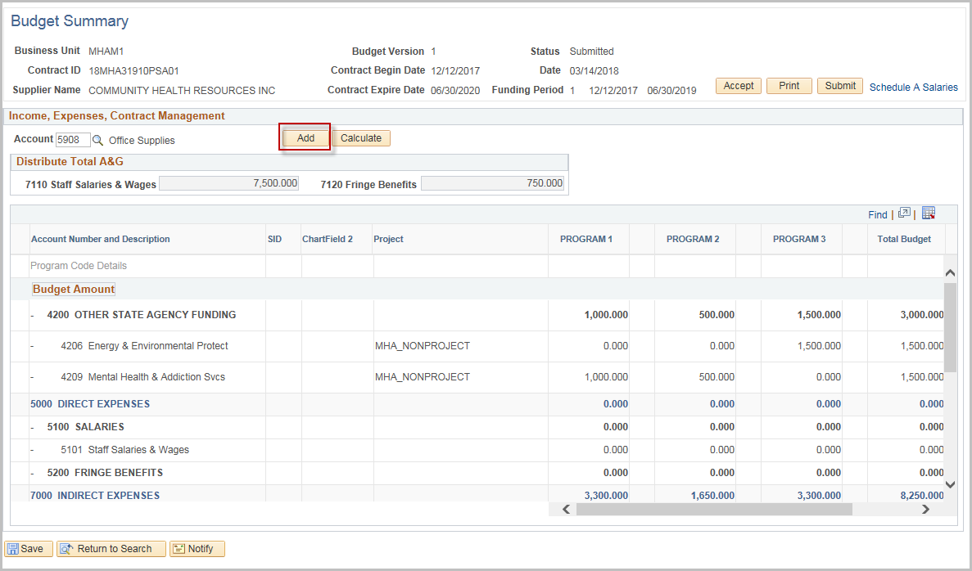

The Code will be added to the Program Code Details section under the appropriate Heading.

NOTE: Click the Minus next to the row if it needs to be removed.

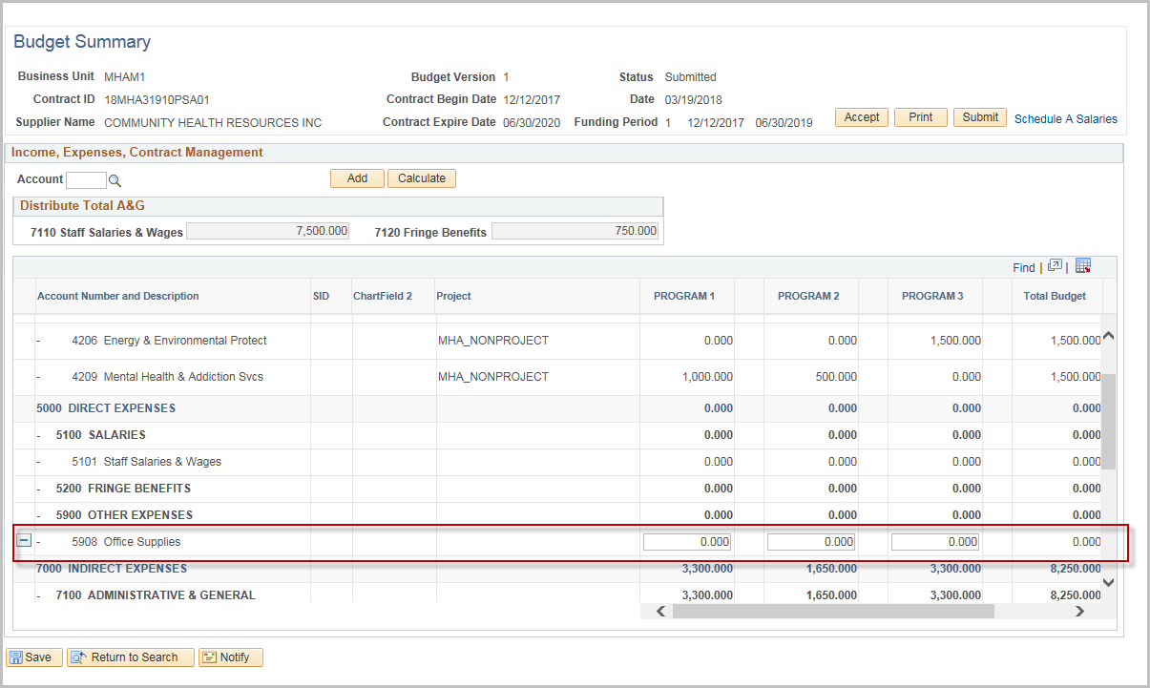

Enter the Funding and Expense amounts for each program

NOTE: The Totals for Staff Salaries and Wages and Fringe Benefits must equal the amount from Schedule A (Displayed at the top of the grid)

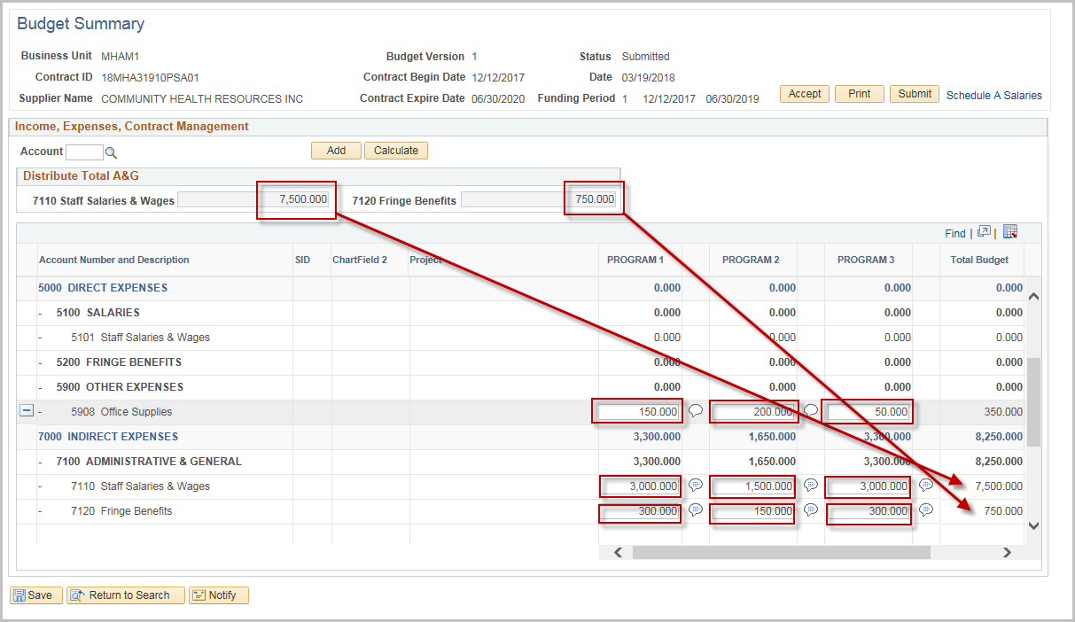

Click the Comment Balloon to provide justification for fields with entered values

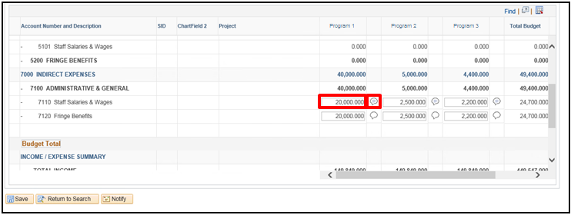
Justification is required for every entered amount. If the justification is not entered an error message will display.

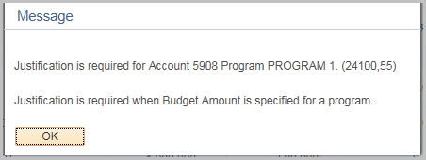
Click Calculate at any time to update the totals
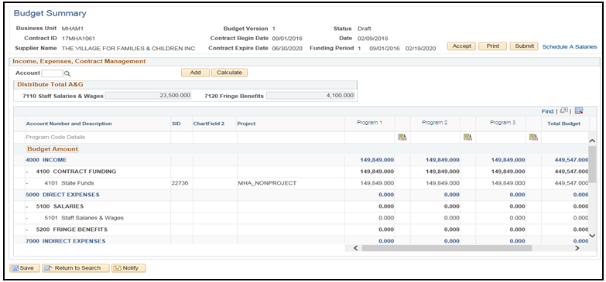

Scroll to the bottom to review the Totals
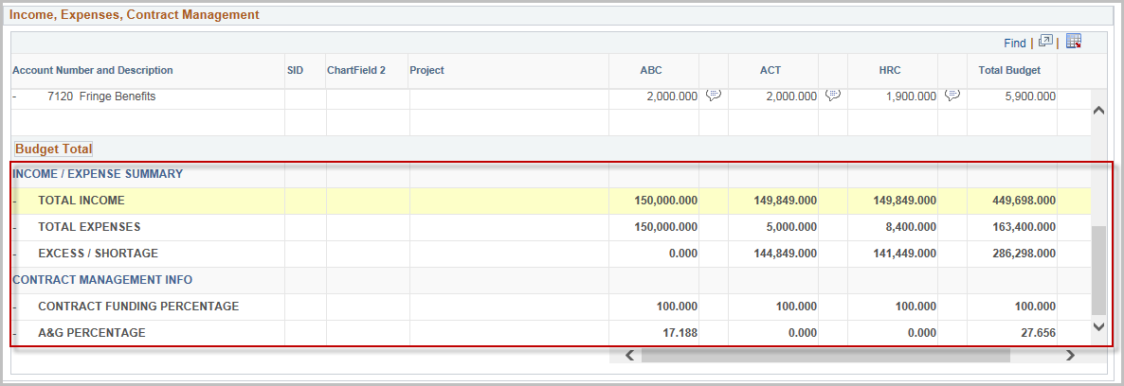
Click Save
Click OK to the confirmation message
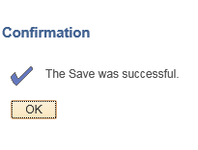

Click Submit

Enter or search for the Agency User ID (the user’s other identifying fields auto populate
Enter a message to be included in the email if needed
Click OK
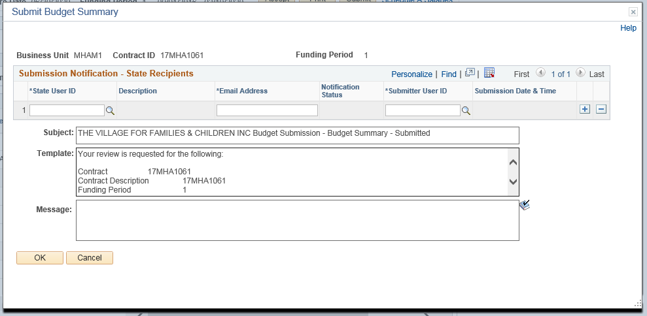

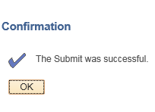
Click OK to the confirmation message that the Budget was submitted.

At this time, an email will be sent to the Agency. The Agency will be able to follow the hyperlink to approve the Budget Summary.
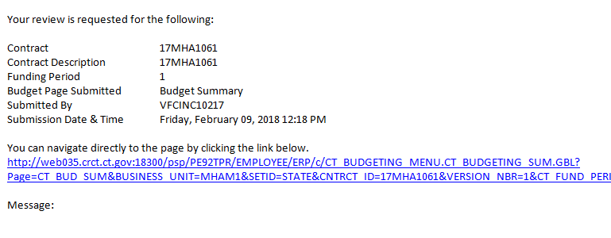

Once the Budget Summary is accepted by the Agency, it becomes a Final Budget.

Accept a Budget Summary

The following shows how to accept a Budget Summary.
Navigation: Supplier Contracts > Budgeting > Budget Summary

The Budget Summary page will display. Enter the Contract ID, Funding Period, or Supplier Name, and click Search

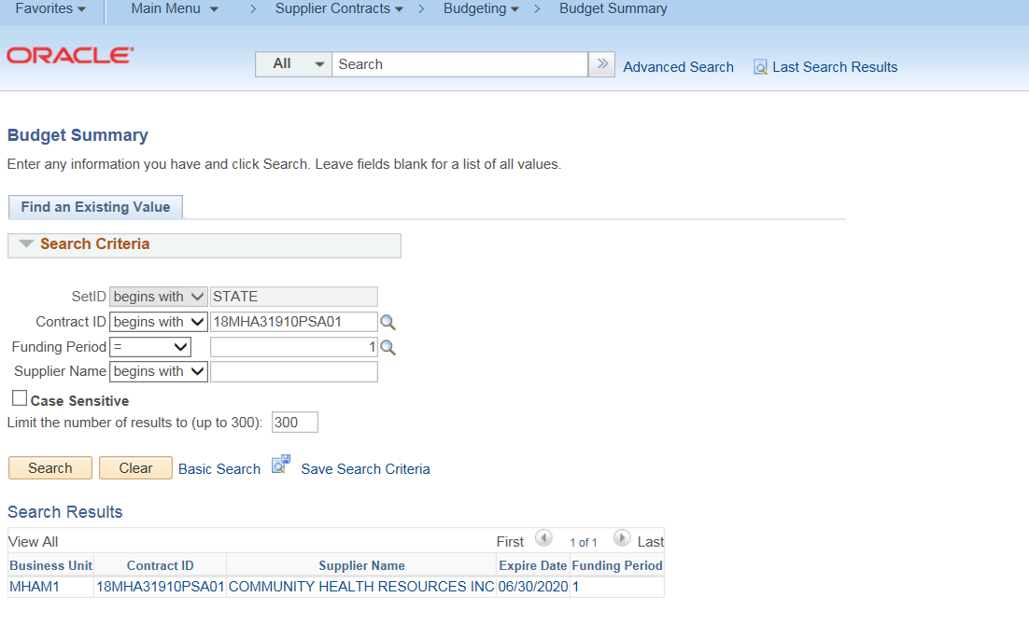
Once the page has opened up, the agency will review the submitted budget.
If there are any discrepancies or amounts that need to be update, DO NOT click Accept. Contact the Provider (either by email or using the Notify option – Refer to the separate job aid Notify Contact) to have them correct the entries.
Clicking Accept will lock all entries.

Click Accept. This will open up the Acceptance Notification screen where the user will notify the Provider that the Budget has been accepted.
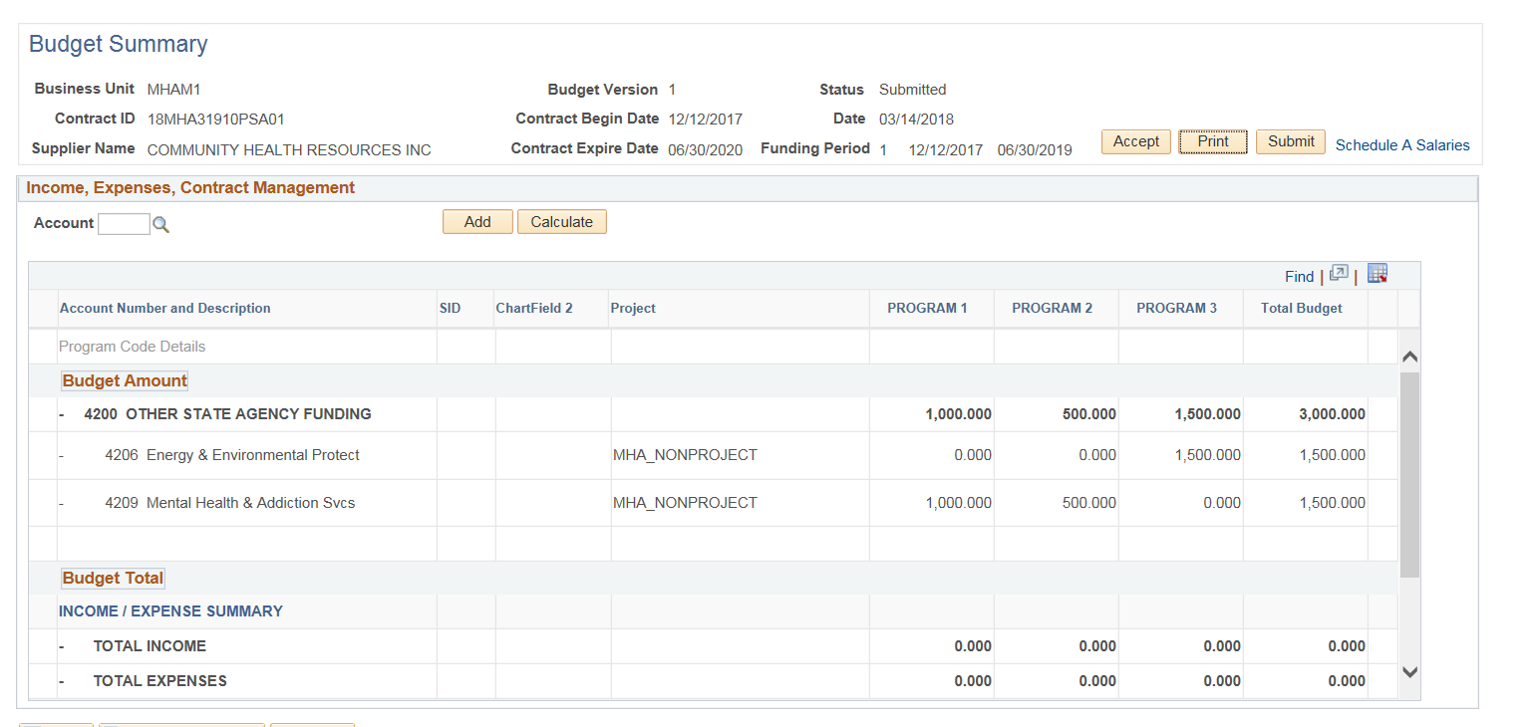
Enter Supplier User ID (use the magnifying glass to search)
Enter a message to be included in the email if needed
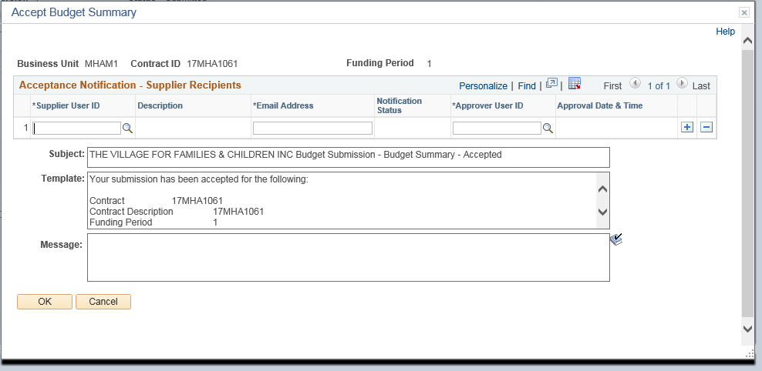
Click OK

Click OK to the confirmation message.
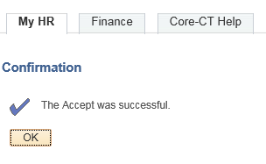

An email will now be sent to the selected users that the budget has been accepted.
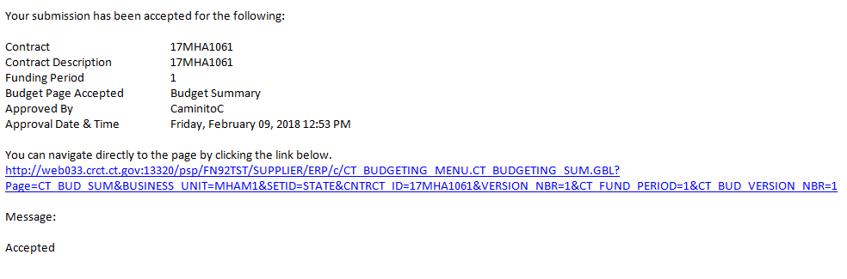

Printing the Budget Summary

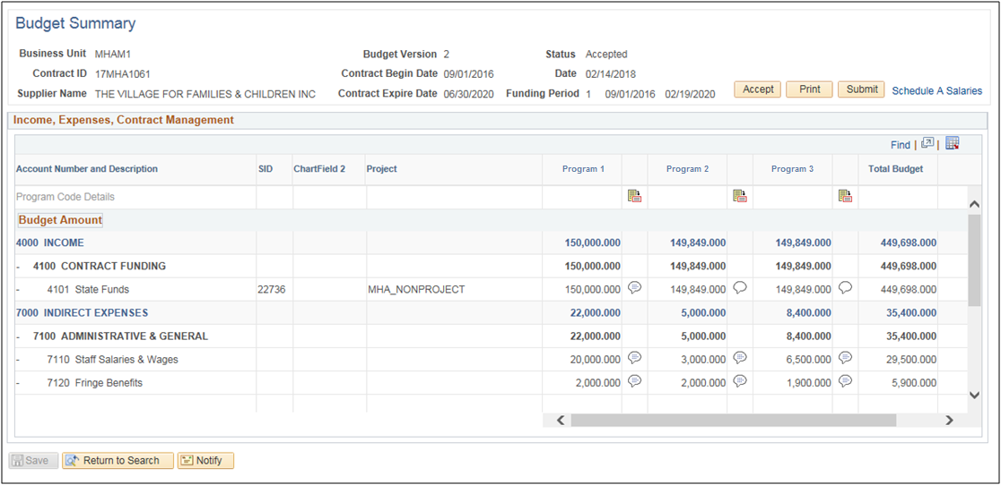
The Budget Summary may be printed by either the Agency or the Provider at any time.
Run the Contract Budget Report by clicking Print.

Select PDF or XLS depending on preference, and click Print
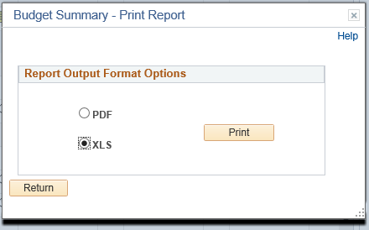

A new window will open up, showing the Contract Budget Report
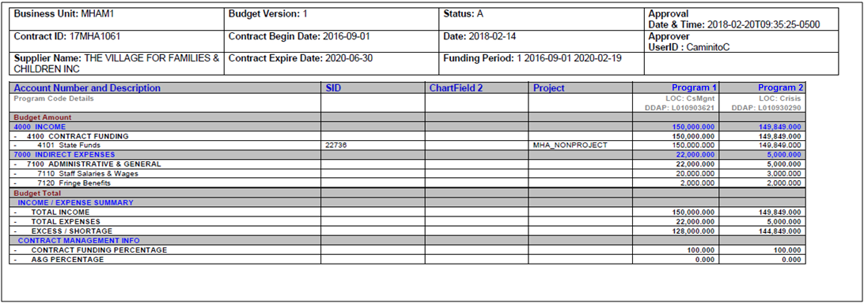
Note: If this budget has been accepted, the report will have the user, date, and time the budget was approved in the upper right hand corner. Otherwise this will be blank.

