Budget Workbook Financial Reporting

Multi-Year Contract Budget Report
The following shows how to run a Multi-Year Contract Budget Report
Navigation: Supplier Contracts > Budgeting > Multi-Year Contract Bud Report

The Multi-Year Contract Bud Report page will display.

Select the Add a New Value tab
Create a new Run Control ID

When creating a Run Control ID, make sure it is something that will be easily identifiable when running future reports.

Click Add.

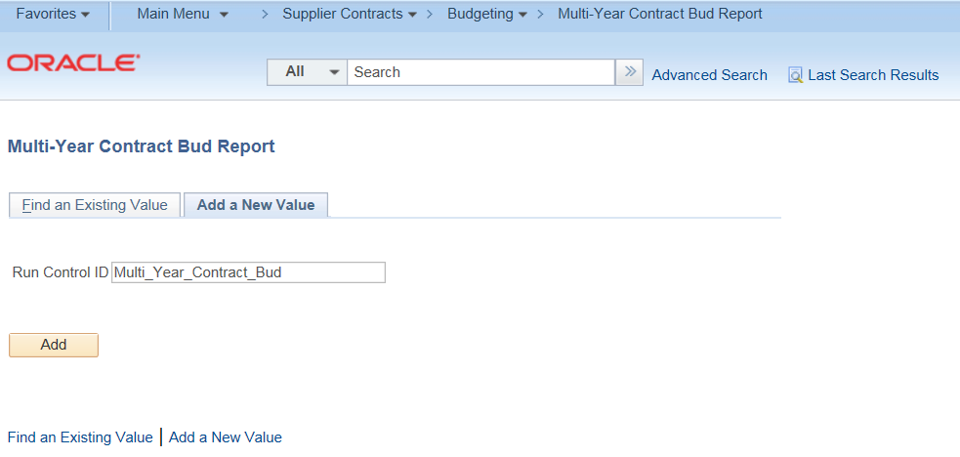

Enter the Contract ID, Funding Period Begin, and Funding Period End
(The Funding Periods for this report setup are the value (i.e. 1, 2, 3) not the actual dates.

Click Save and then click Run

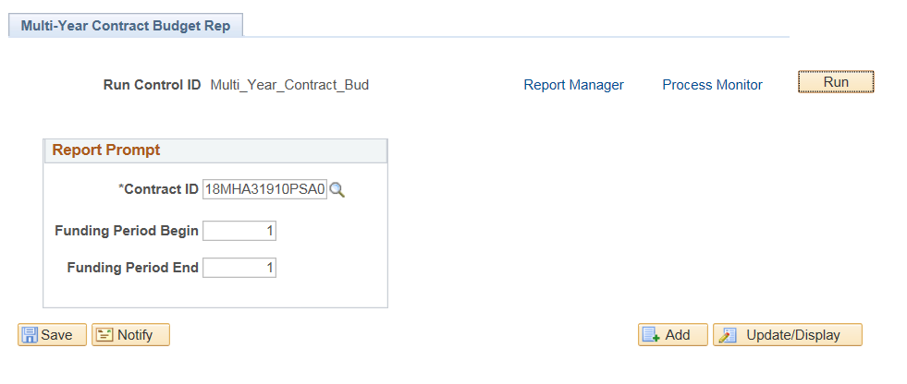

Select PDF or XLS under Format

Click OK
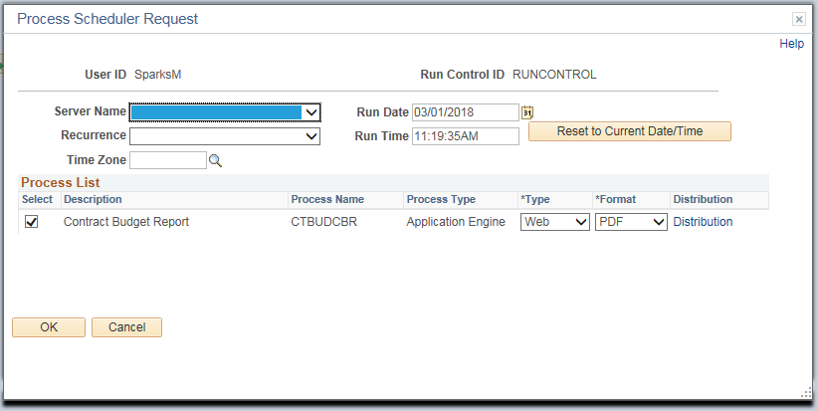

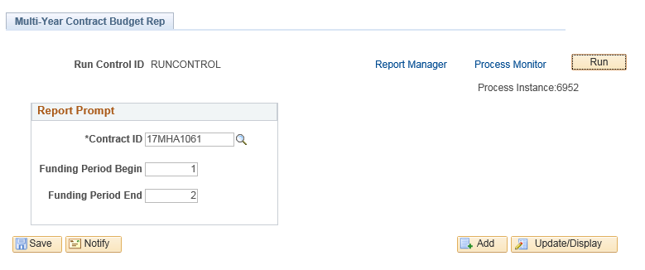
Click the Process Monitor link

Click Refresh until Run Status and Distribution Status shows Success and Posted
Click the Details link
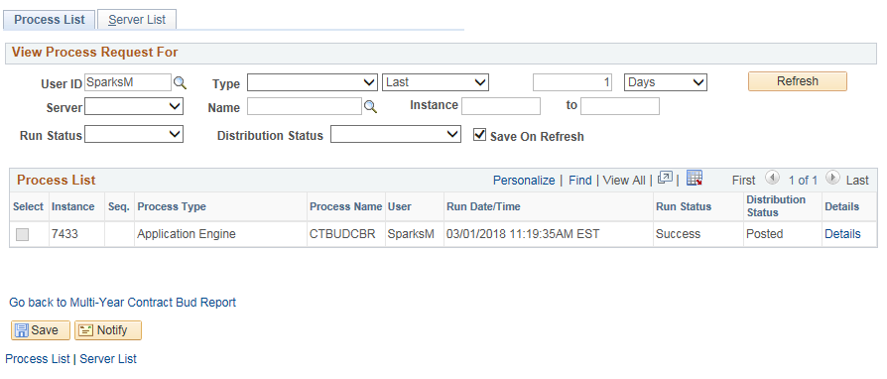

Click View Log/Trace
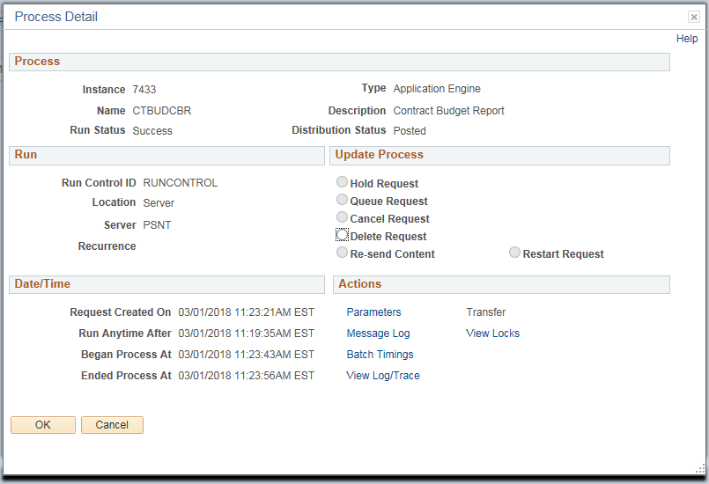

Select the file ending in “.pdf”
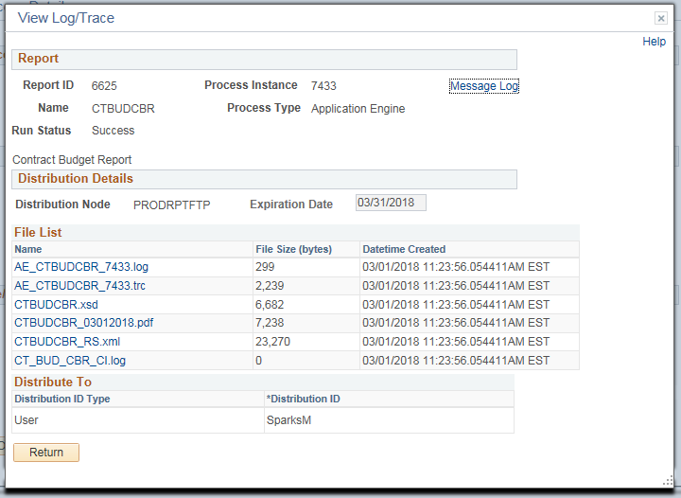

A sample Multi-Year Contract Budget Report is shown below
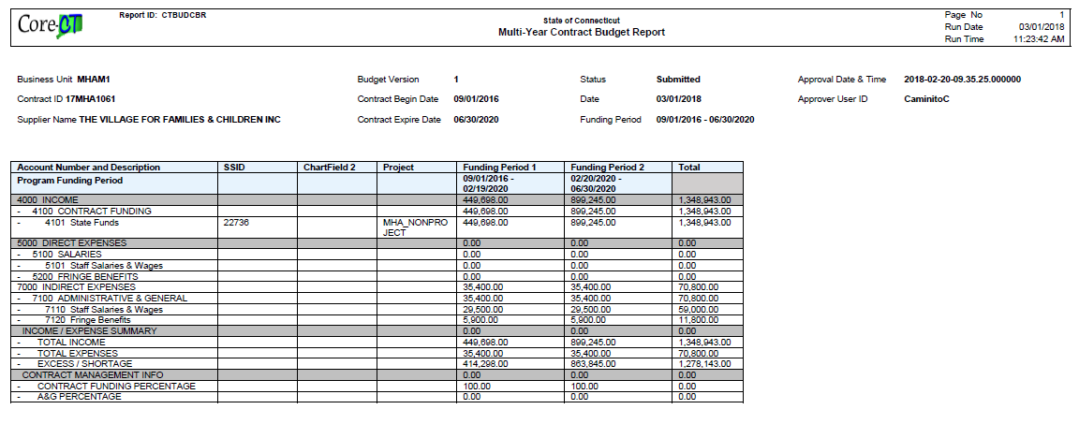
NOTE: This report combines all programs together under the funding period.

