Budget Workbook Financial Reporting

Budget vs Actual Reporting

The process flow below outlines the steps which need to be completed in order for the Budget vs Actual Report to become approved. The Provider will enter and submit the information, and the Agency will then approve.

Agency
Provider

Navigation: Supplier Contracts > Budgeting > Budget vs Actual Reporting

The Budget vs Actual Reporting page will display.

Enter Contract ID and click Search

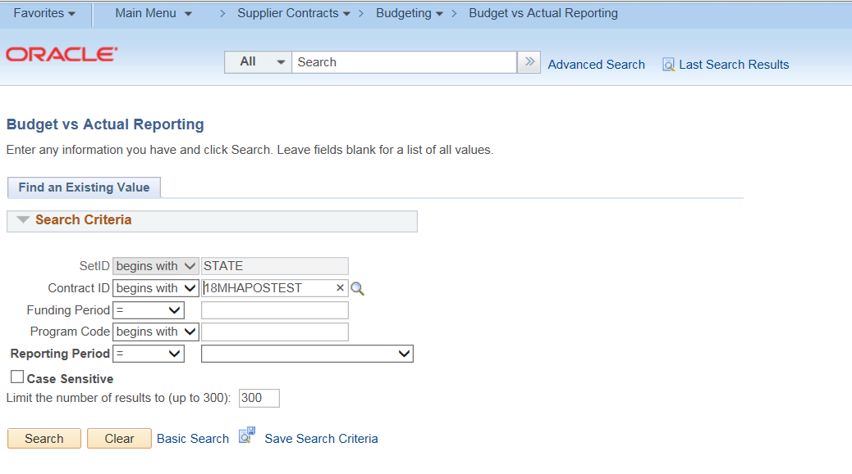
The system will display all reports for all programs based upon the report requirement selected on the budget definition page
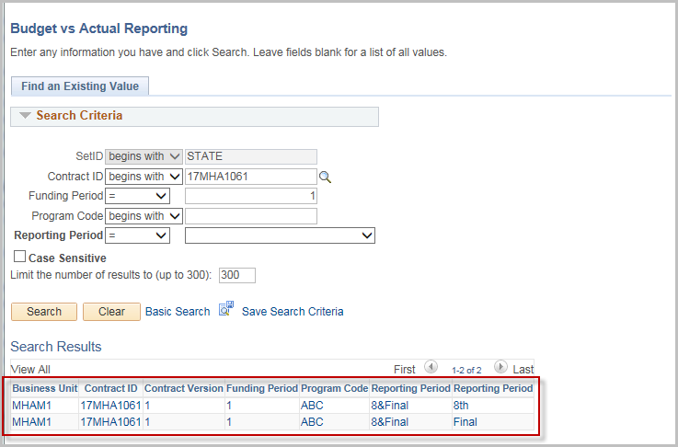
If a later version is selected in error, a message in red will display identifying that the previous report has not been accepted.
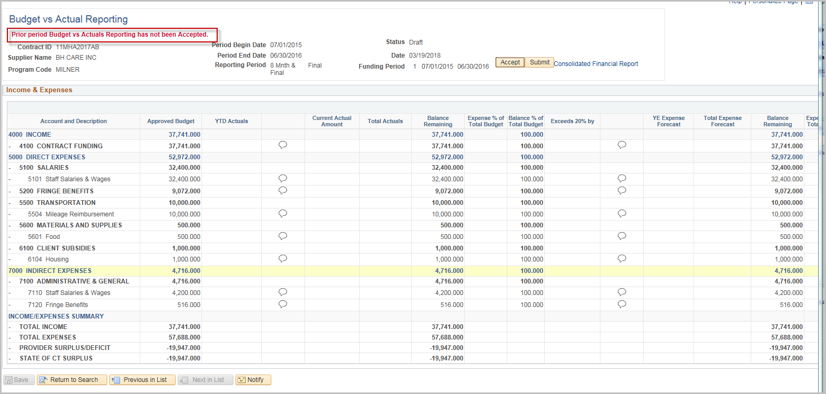
NOTE: New UCOA Account(s) may be added to the Report. It is up to the Agency to determine how these will be processed and if a Budget Revision will need to be entered prior to acceptance.
Enter the Current Actual Amount fields
Enter the YE Expense Forecast fields
Click the Comment Balloon to enter Justification for all fields with entered values

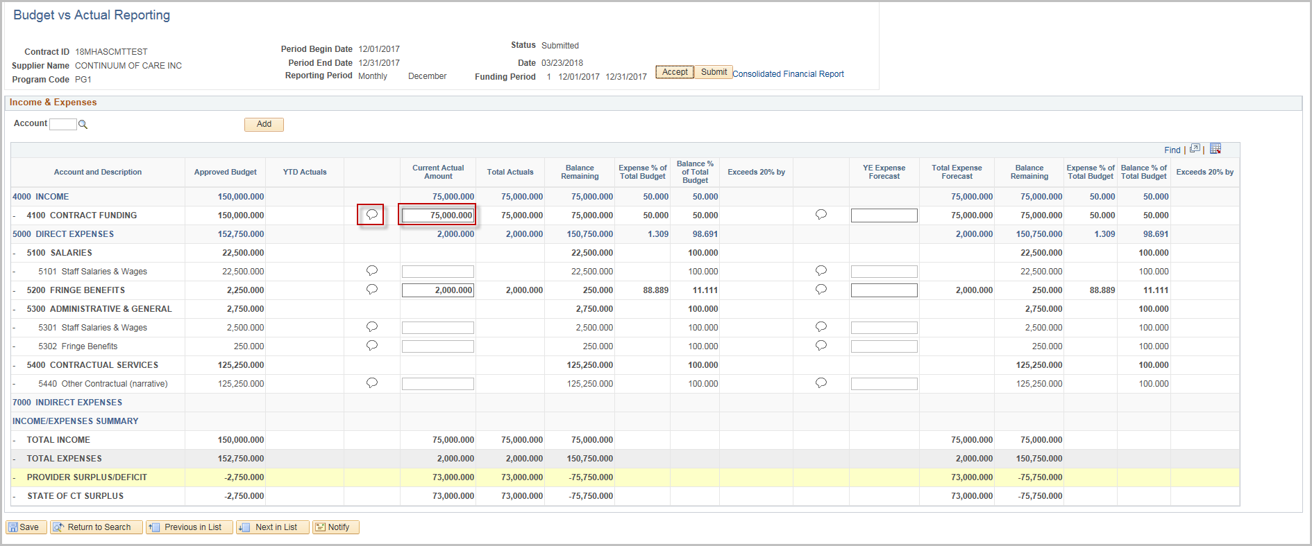

Enter the Justification comments
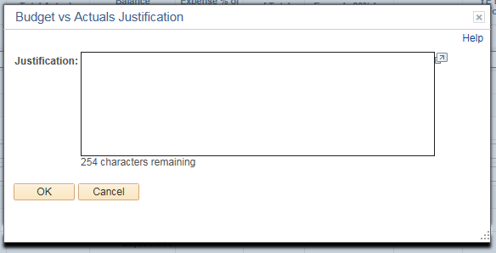
Click OK

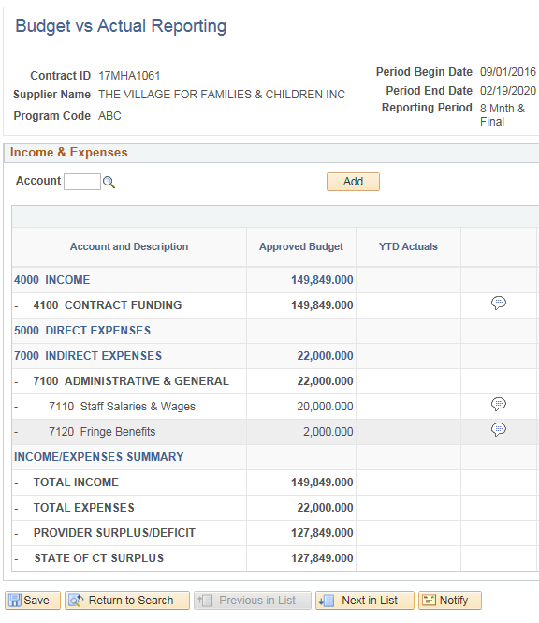
Click Save

Click Submit to submit the Budget vs Actual Report
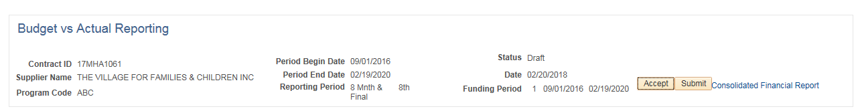

Enter State User ID (use magnifying glass to search)
Enter a message to be included in the email if needed
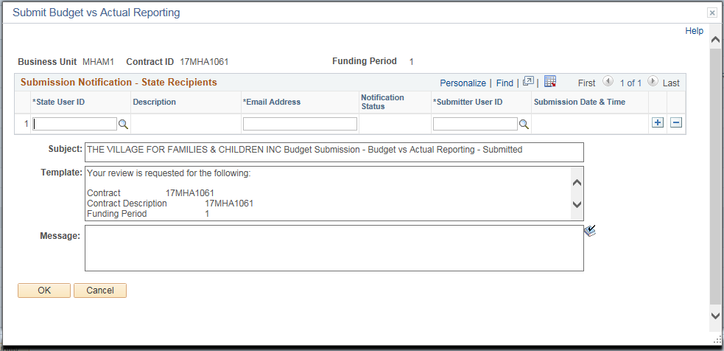
Click OK

Click OK to the confirmation message.
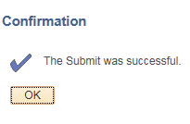

An email will be sent to the Agency. The Agency can click the hyperlink to approve the Budget vs Actual Report.
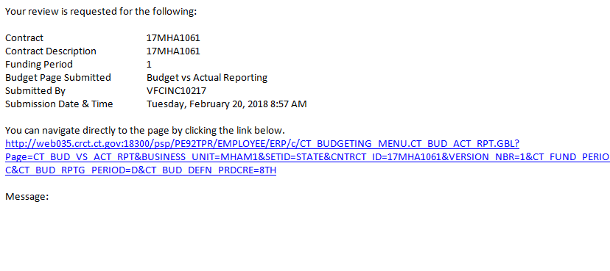

Accept the Budget vs. Actual Report
The process flow below outlines the steps which need to be completed in order to accept the Budget vs Actual Report. The Provider will enter and submit the information, and the Agency will then accept.

Agency
Provider

The following email will be received by the Agency once the Provider submits the Budget vs Actual Report.
If the Agency does not click the hyperlink, they can use the navigation below:

Navigation: Supplier Contracts > Budgeting > Budget vs Actual Reporting

The Budget vs Actual Reporting page will display.

Enter the contract id or click Search and select the Contract ID for the Budget Report that is to be accepted.
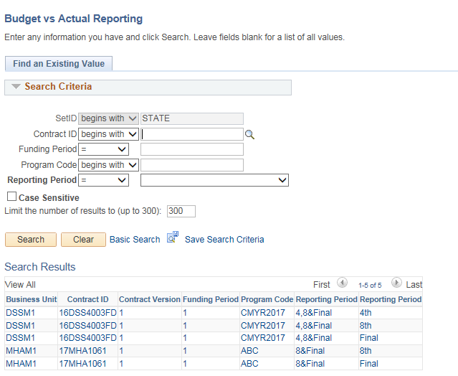

The search results will show all reports for each program of the contract.
If a later version is selected in error, a message in red will display identifying that the previous report has not been accepted.

Review the Budget vs Actuals information
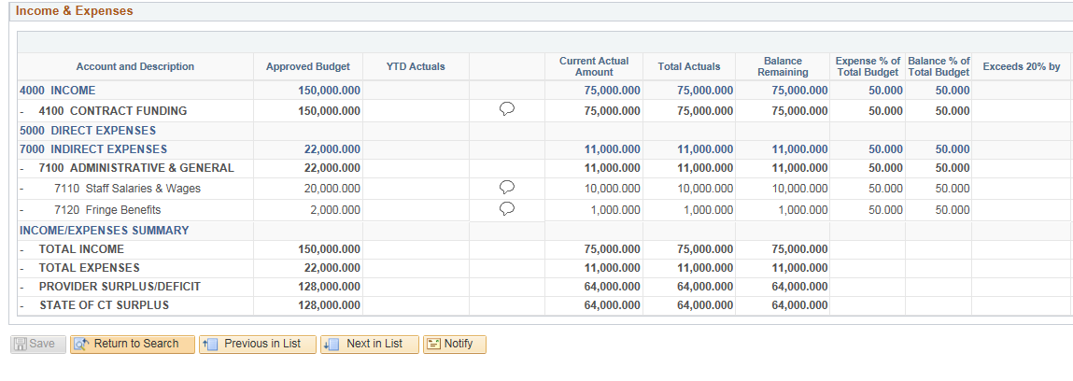
If there are any discrepancies or amounts that need to be update, DO NOT click Accept. Contact the Provider (either by email or using the Notify option – Refer to the separate job aid Notify Contact) to have them correct the entries.
Click Accept.
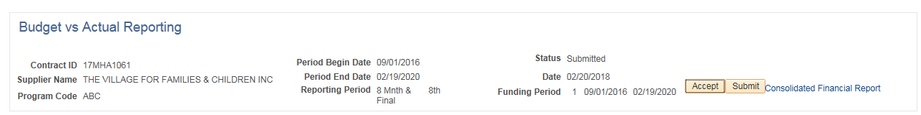
This will open up the Acceptance Notification screen where the user will notify the Provider that the Budget vs Actual Report has been accepted.
Enter the Supplier User ID or use the magnifying glass to search
Enter a message to be included in the email if needed
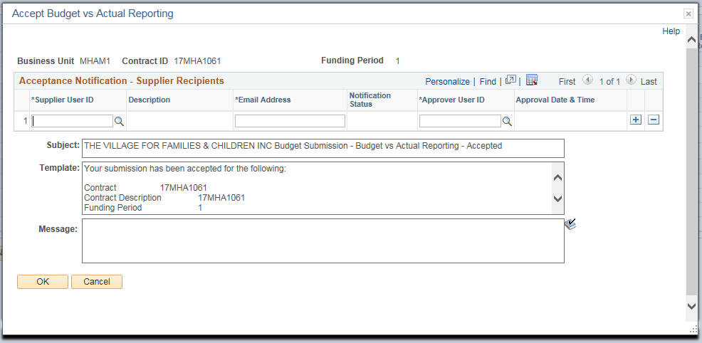
Click OK
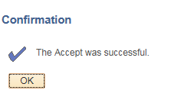
Click OK to the confirmation message.

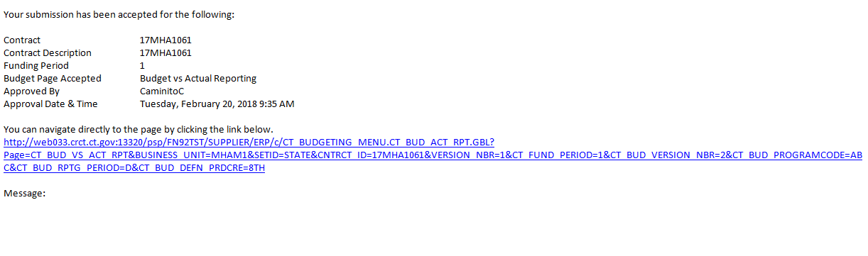
An email will be sent to the Provider. The Provider will now know that the Budget vs Actual Report has been accepted.

