Budget Workbook Financial Reporting

Consolidated Financial Report
The following shows how to run a Consolidated Financial Report
Navigation: Supplier Contracts > Budgeting > Consolidated Financial Report

The Consolidated Financial Report page will display.

Select the Add a New Value tab
Create a new Run Control ID

When creating a Run Control ID, make sure it is something that will be easily identifiable when running future reports.

Click Add.
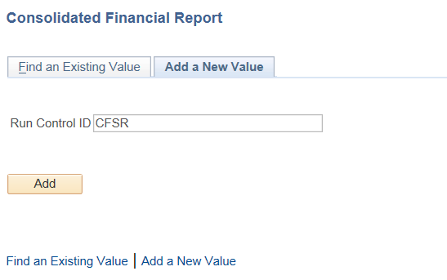

Enter or search for the Contract ID
Enter the Funding Period
(The Funding Periods for this report setup are the value (i.e. 1, 2, 3) not the actual dates.

Select the Report Detail
If Summary is selected the next two options will not be available.

If Detail is selected
Select the Report Type (Program or All)
If Program is selected you must enter the Program Code.
Click Save
Click Run
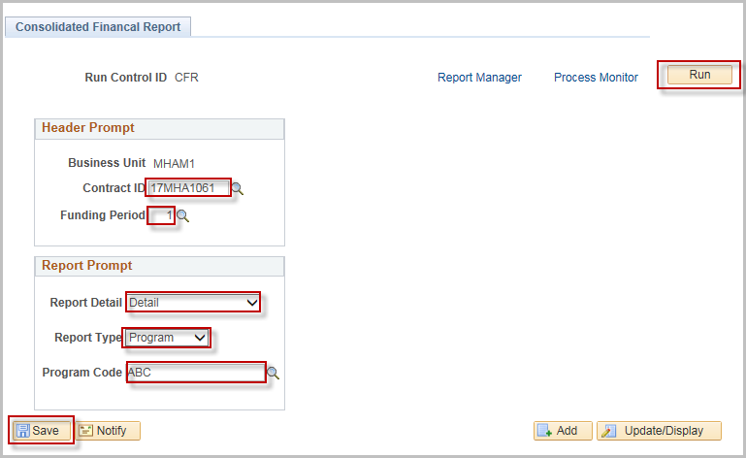
Click OK
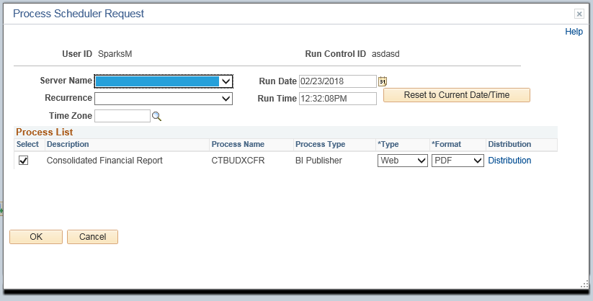

Click the Process Monitor link
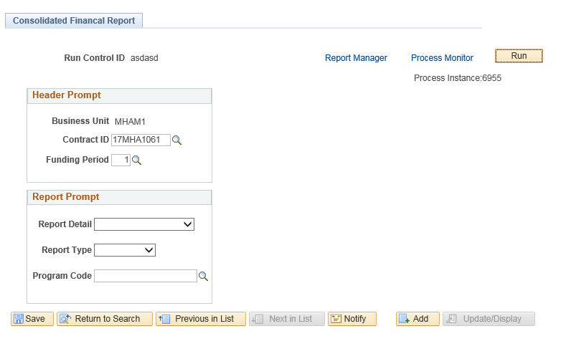

Click Refresh until Run Status and Distribution Status reads Success and Posted
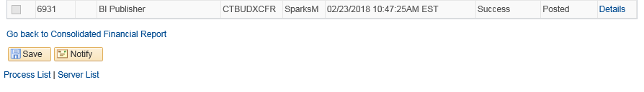
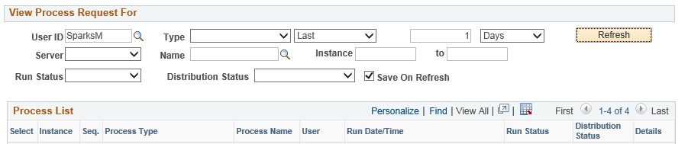
Click the Details link

Click the View Log/Trace link
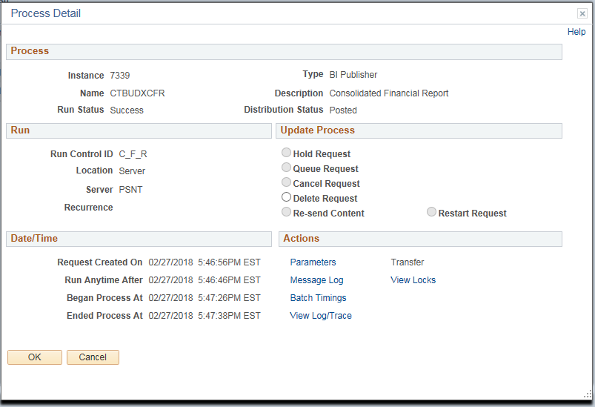

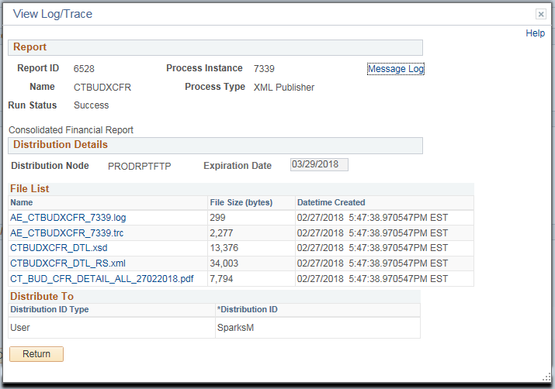
Click the “.pdf” file to view the report

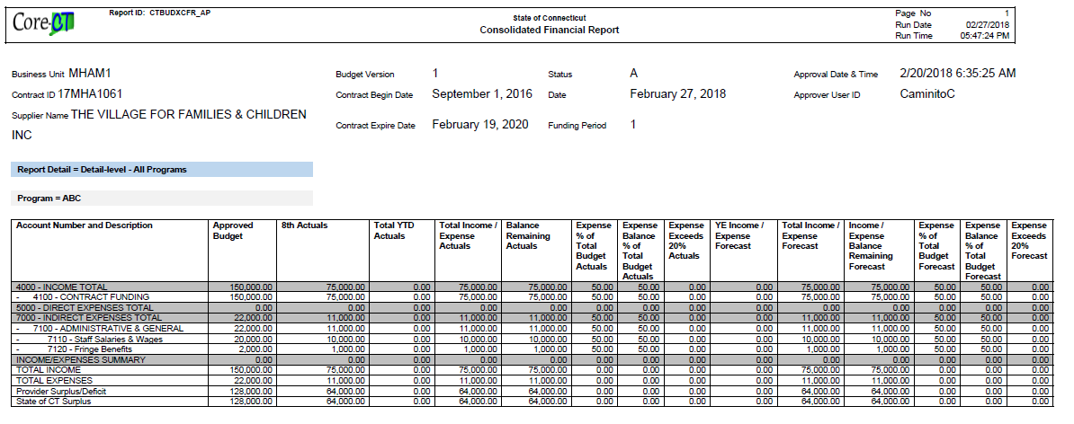
A sample Consolidated Financial Report is shown below

