Create a Requisition for POS/PSA Authorization
User must have the CT PSA_POS_REQUESTOR and CT_F_A_PSA_POS_SUBMITTER role
Navigation:

eProcurement > Requisition

- Enter Business Unit

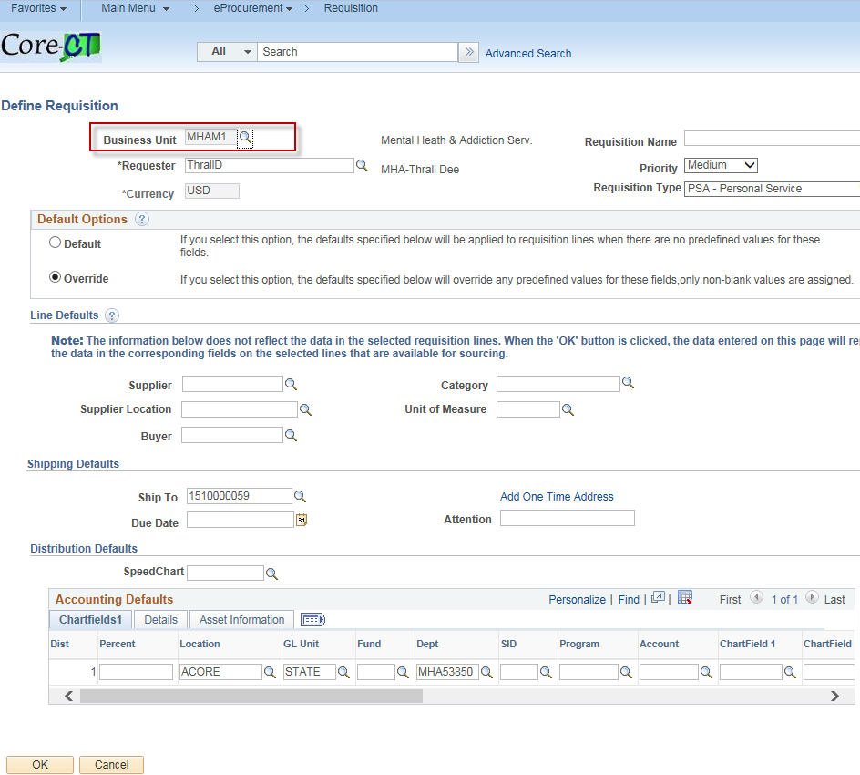

- Enter Requisition Name

- Enter Requisition Type - PSA – Personal Service

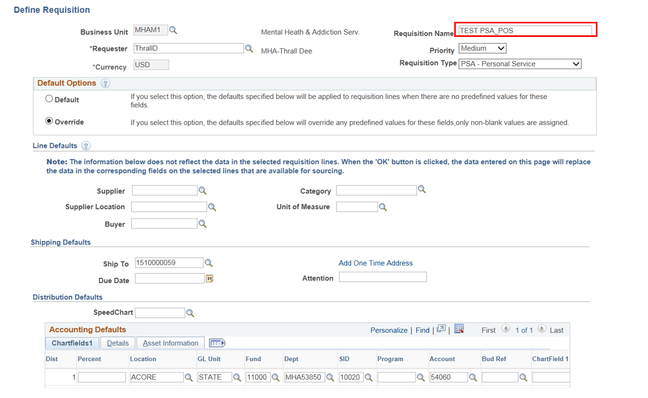

- Enter the Supplier ID

- Enter the Buyer ID

- Enter the Category

- Enter the Unit of Measure

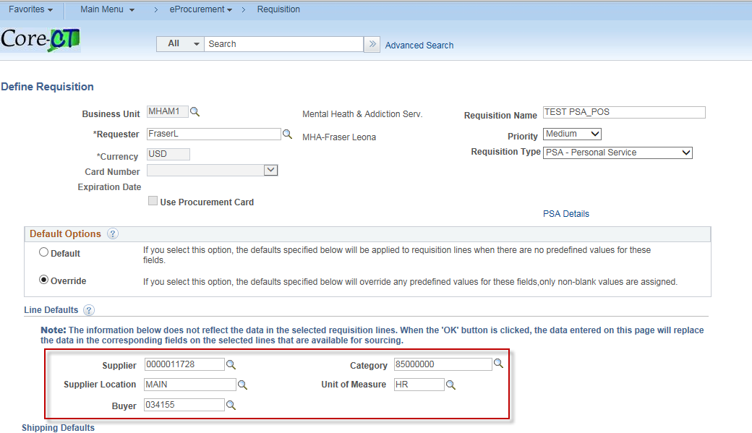

- Enter Chartfields – If the chartfields are defaulted skip this step.

- Click OK

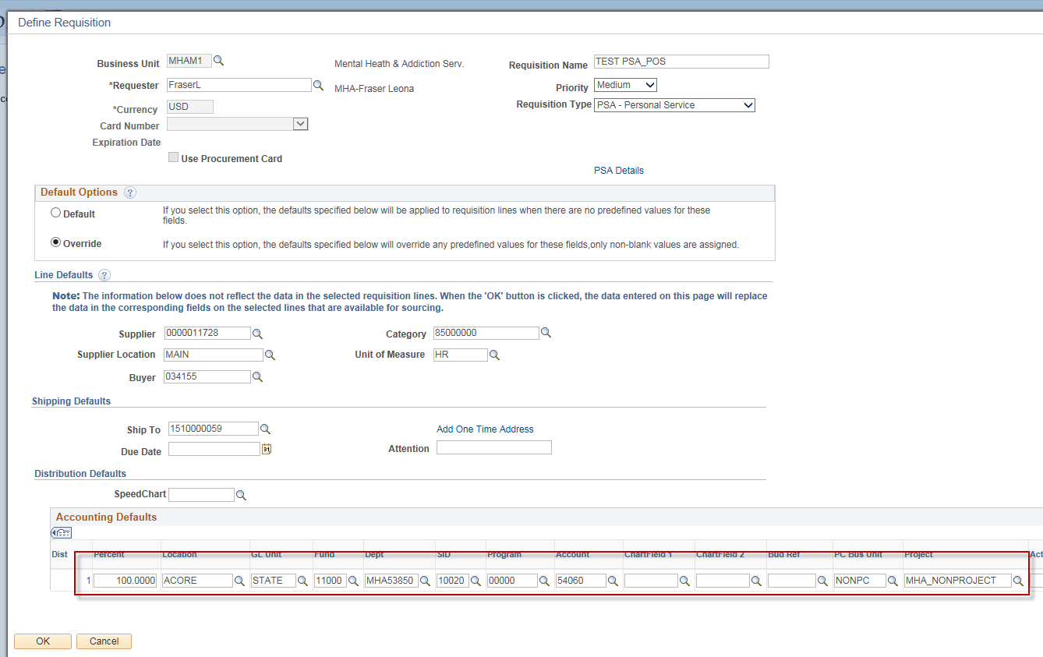

- Click Fixed Cost Service link

Note: The Category, Supplier ID, Supplier Name & Unit of Measure fields populated with values entered on the Define Requisitions page.

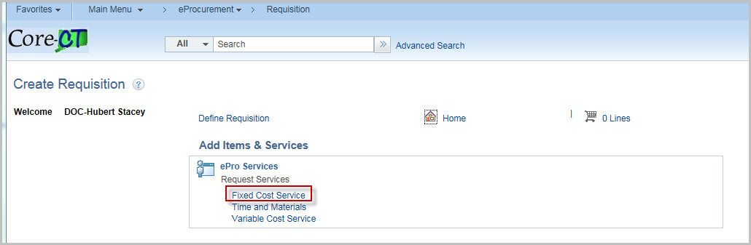

- Enter Item Description
- Enter Value of Service
- Enter Start Date
- Enter End Date

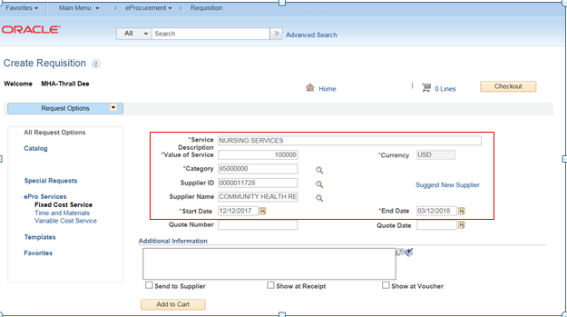

- Click Add to Cart

Note: Repeat the process for additional services you wish to place on your requisition.

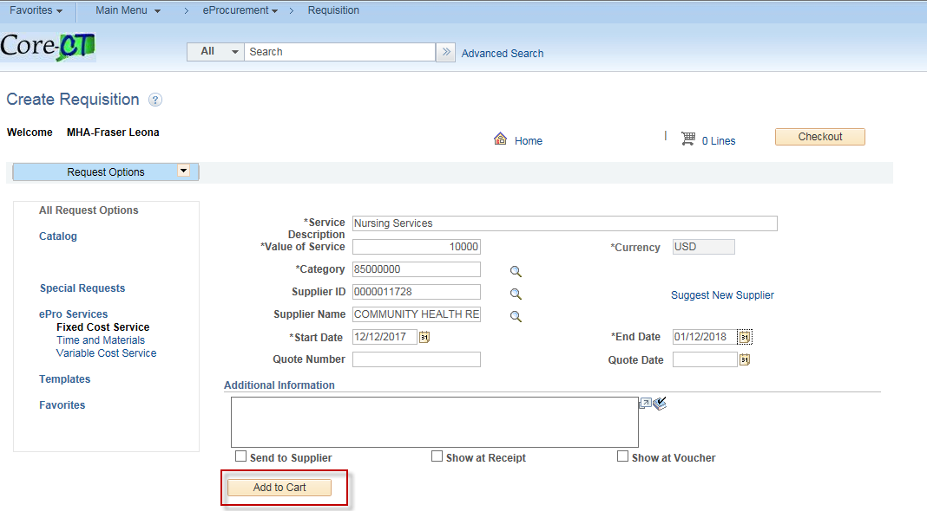

- The Shopping Cart displays on the right hand side of your screen.

- Click Checkout

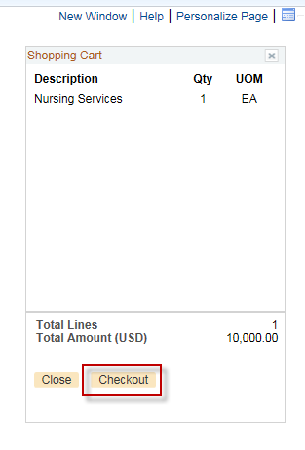

- Click on the PSA Details Link

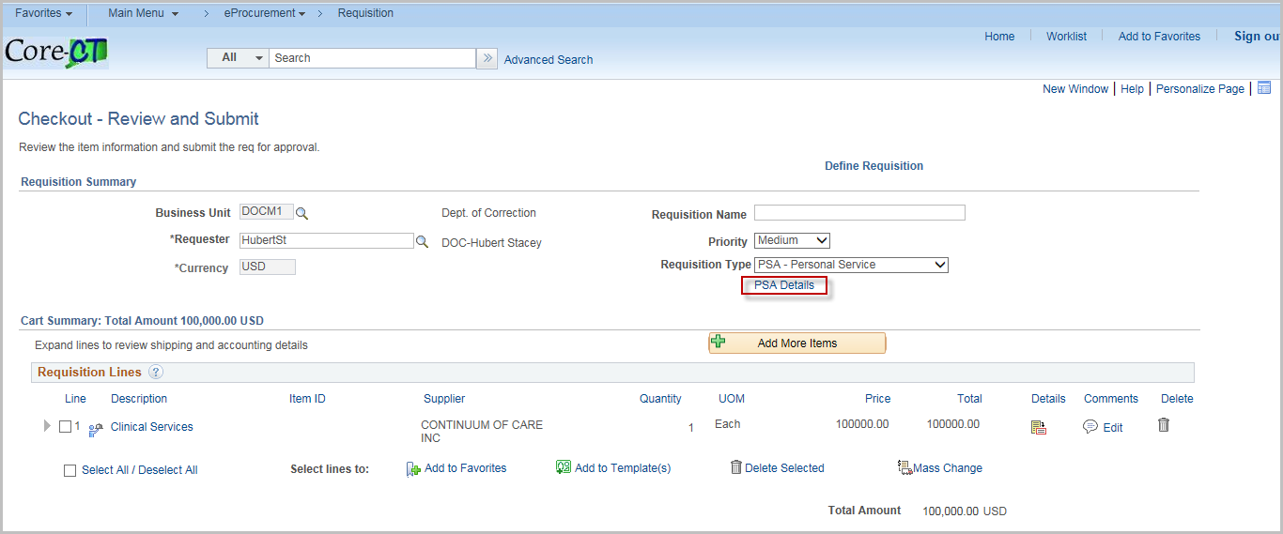

- Click the Hyperlink that pertains to your Personal Service Agreement

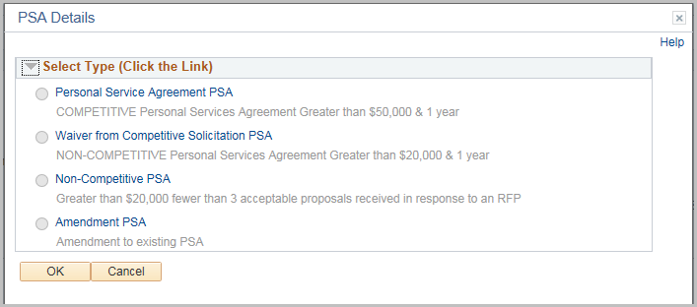

- Change default values as required

- Click OK
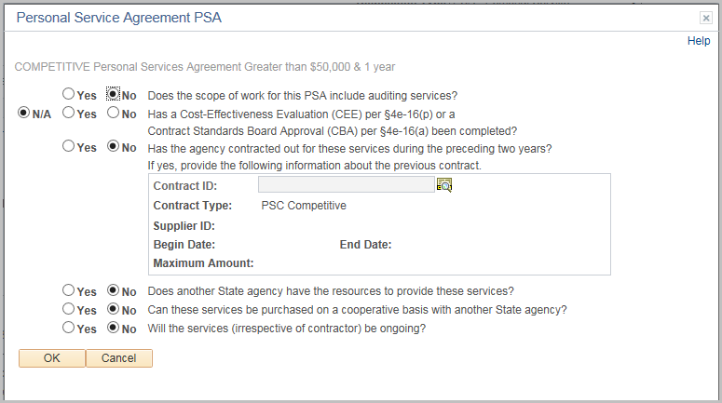

- Click OK

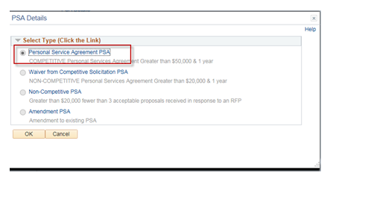
- Click on the Comments bubble

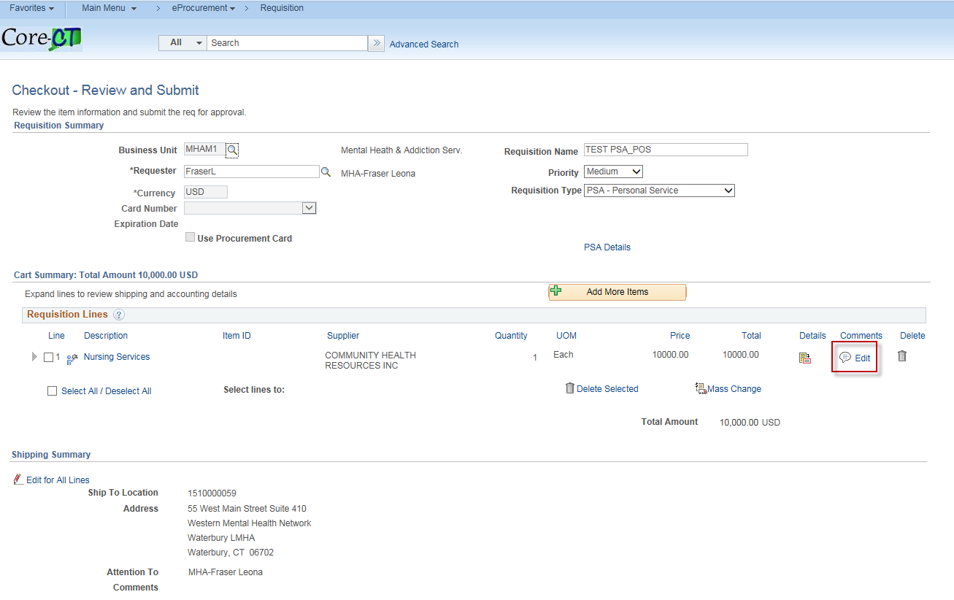

- Add Comments

- Add attachments as needed
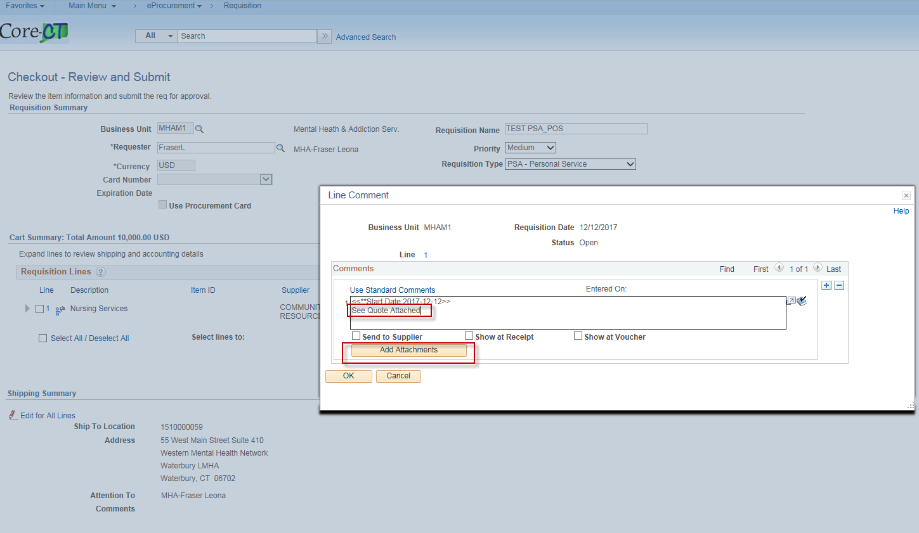

- Click Save and Submit

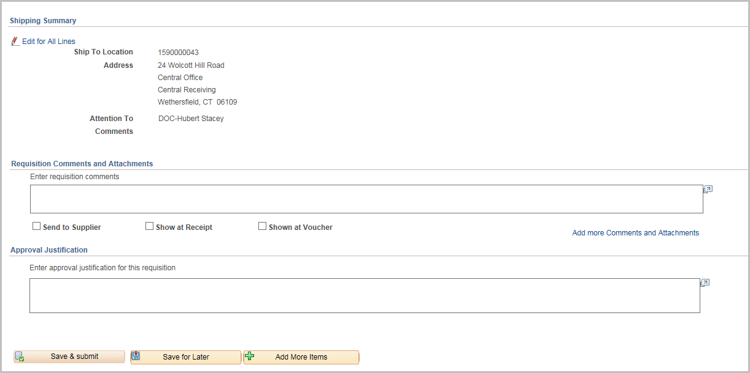

- Click OK
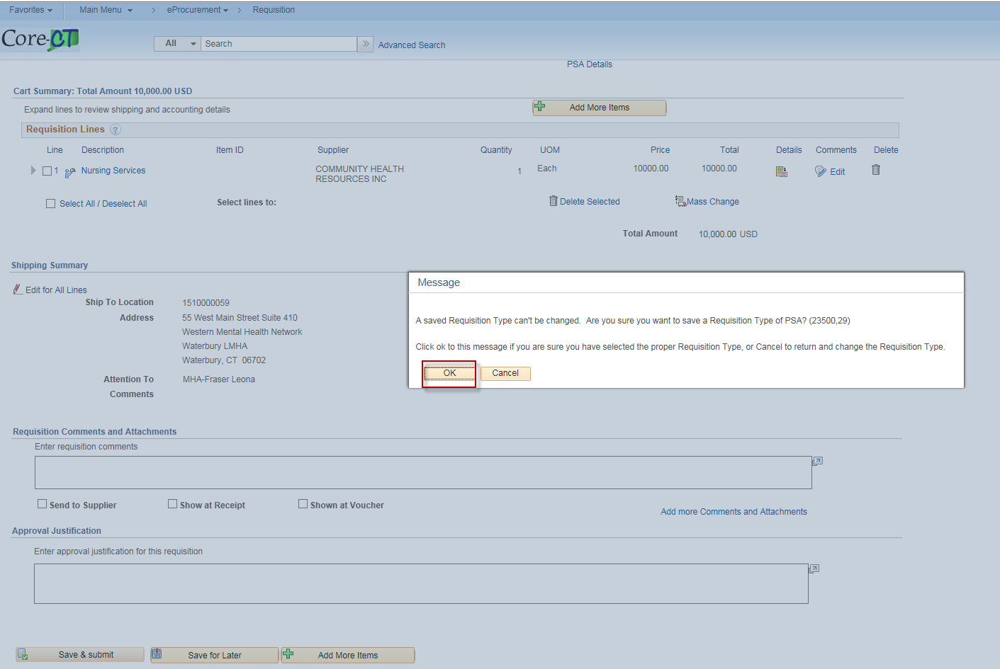

- The requisition has been submitted to PSA_POS workflow and is in pending status.
- The requisition number displays on the header.
- The Bid/Contract ID starts with the year, agency acronym & requisition number. This field is editable when converting the req to a contract.
- Default for this requisition is Amount Only. If you need to change to QTY un-check the Amount Only Box in the line details.

(Once the requisition is converted into a contract, the Contract ID will have a suffix added to it of either PSA-01 or POS-01 depending upon which requisition type was chosen).
To approve PSA/POS requisitions the users must have one of the following roles:

CT AGY SERVICE APPROVER
CT OPM BUDGET APPROVER 1
CT OPM BUDGET APPROVER 2
CT OPM FINAL APPROVER
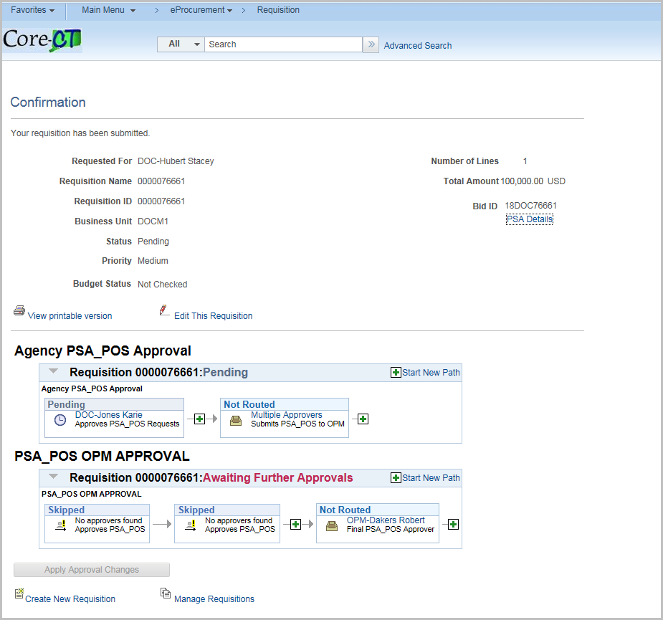

Create a Requisition for POS/PSA Authorization

User must have the CT PSA_POS_REQUESTOR and CT_F_A_PSA_POS_SUBMITTER role

Navigation:
eProcurement > Requisition
- Enter Business Unit

- Enter Requisition Name
- Enter Requisition Type - PSA – Personal Service

- Enter the Supplier ID
- Enter the Buyer ID
- Enter the Category
- Enter the Unit of Measure

- Enter Chartfields – If the chartfields are defaulted skip this step.
- Click OK

- Click Fixed Cost Service link

Note: The Category, Supplier ID, Supplier Name & Unit of Measure, fields populated with values entered on the Define Requisitions page.

- Enter Item Description
- Enter Value of Service
- Enter Start Date
- Enter End Date

- Click Add to Cart
Note: Do this process for additional services you wish to place on your requisition.

- The Shopping Cart displays
- Click Checkout

- Click on the PSA Details Link

- Click the Hyperlink that pertains to your Personal Service Agreement

- Change default values as required

- Click OK

- Click OK

- Click on the Comments bubble

- Add Comments

- Add attachments as needed

- Click Save and Submit

- Click OK

- The requisition has been submitted to PSA_POS workflow and is in pending status.
- The requisition number displays on the header.
- The Bid/Contract ID starts with the year, agency acronym & requisition number. This field is editable when converting the req to a contract.
- Default for this requisition is Amount Only. If you need to change to QTY un-check the Amount Only Box in the line details.
(Once the requisition is converted into a contract, the Contract ID will have a suffix added to it of either PSA-01 or POS-01 depending upon which requisition type was chosen).
To approve PSA/POS requisitions the users must have one of the following roles:

CT AGY SERVICE APPROVER
CT OPM BUDGET APPROVER 1
CT OPM BUDGET APPROVER 2
CT OPM FINAL APPROVER

Convert Requisition to Procurement Contract
User must have the CT REQ BID CONTRACT CREATOR role

Navigation:
eProcurement > Convert REQ to Contract

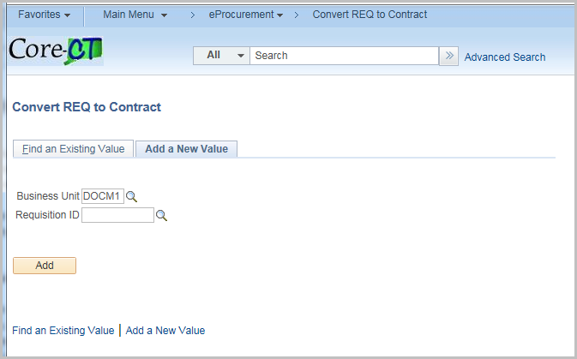

Enter the Requisition number or click on magnifying glass to locate requisition

Click Add

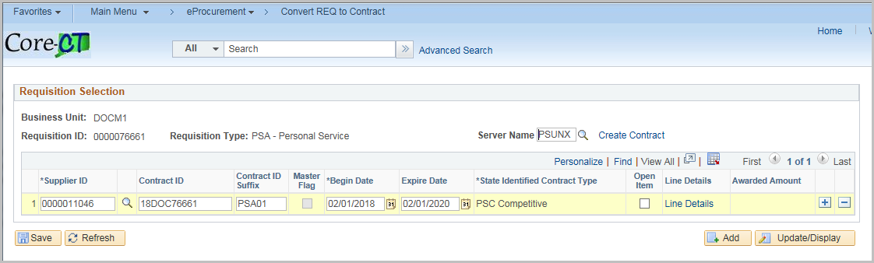

The System will default the Contract ID suffix and the Contract ID/Bid ID, Begin Date, Expire Date and State Identified Contract Type will come from the Requisition.

Note: You may change the Contract ID at this point in the process.

Click Line Details link
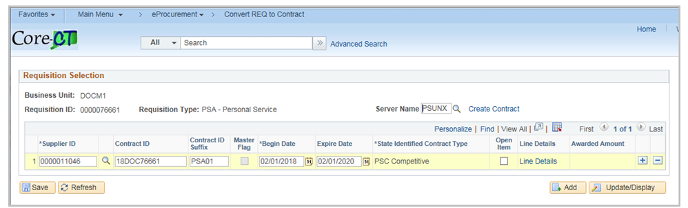

Line Details will default from the Requisition

Click OK

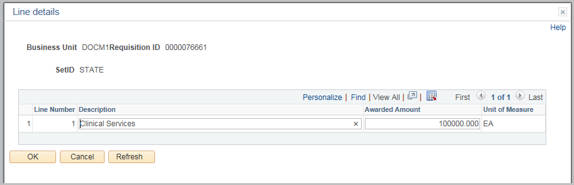

Click Create Contract

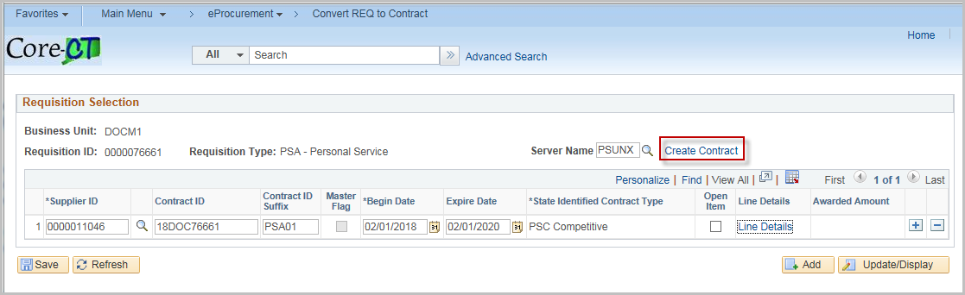

Click Yes to Continue

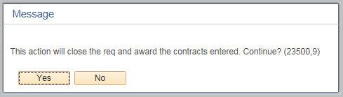

Click Yes

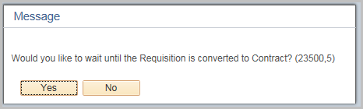

Click OK



