Budget Workbook Financial Reporting

Salary Detail Actuals Reporting

The process flow below outlines the steps which need to be completed in order for the Salary Detail Actuals Report to become approved. The Provider will enter and submit the information, and the Agency will then approve.

Agency
Provider
Navigation: Supplier Contracts > Budgeting > Salary Detail Actuals

The Salary Detail Actuals page will display.
Enter the Contract ID (or use the magnifying glass)
Click Search.
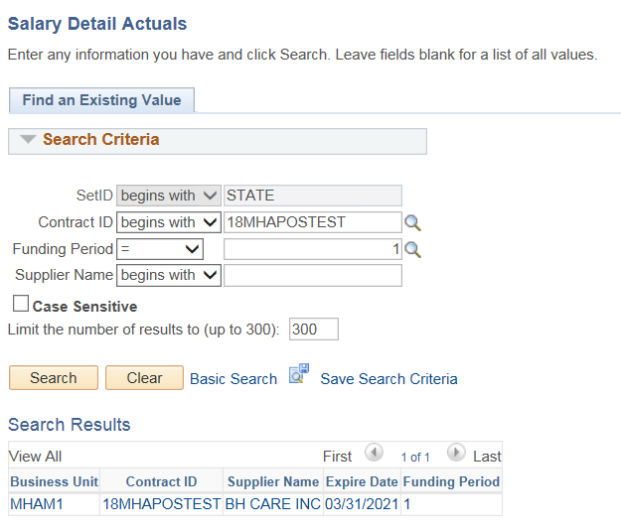
The Salary details page will display with the values from the last accepted Schedule A Salaries.

Update any of the editable fields that need to be changed.
Click on the Funding Distribution icon

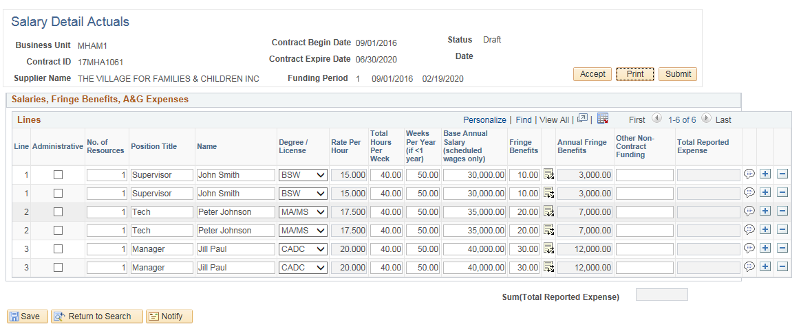

Update any of the Program Code(s) that need to be changed
Click OK
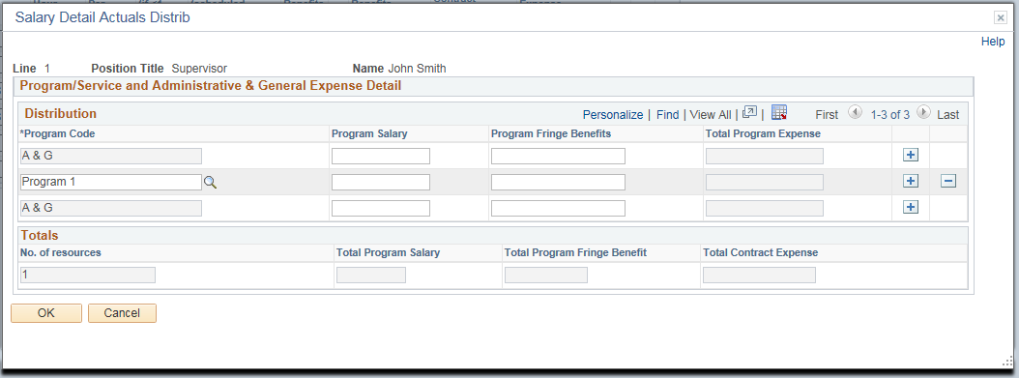

Repeat this process for all lines that need to be updated

Click Submit
Enter the State User ID or use the magnifying glass to search
Enter a message to be included in the email if needed
Click OK
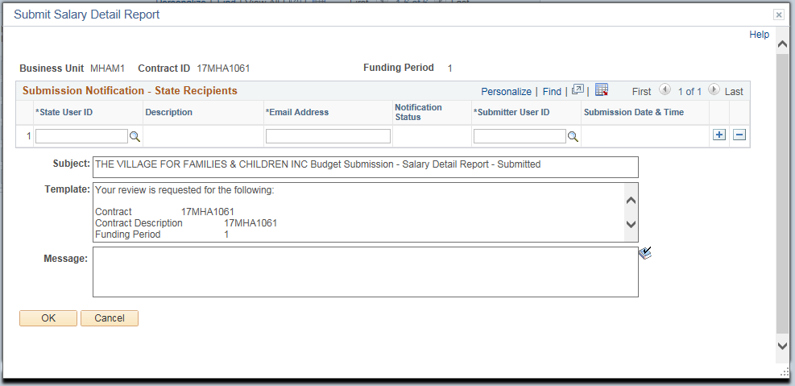

Click OK to the confirmation message.

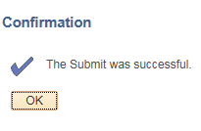

An email will be sent to the Agency. The Agency can click the hyperlink to approve the Salary Detail Actuals Report.
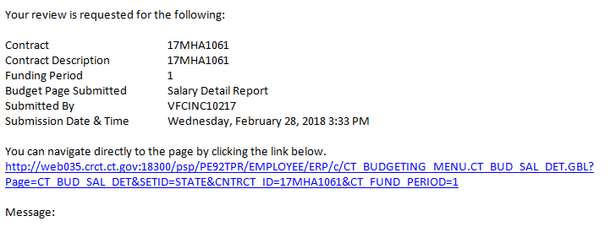

Accept a Salary Detail Actuals Report

Agency
Provider

An email will be received by the Agency once the Provider submits the Salary Detail Actuals Report.
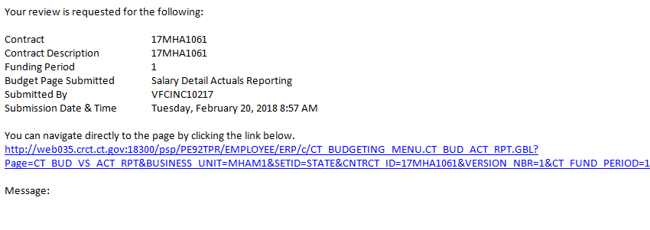
The Agency can click the hyperlink or use the navigation below:

Navigation: Supplier Contracts > Budgeting > Salary Detail Actuals

The Salary Detail Actuals page will display.

Enter the Contract ID (or use the magnifying glass) for the Budget Report that is to be accepted

Enter the Funding Period

Click Search

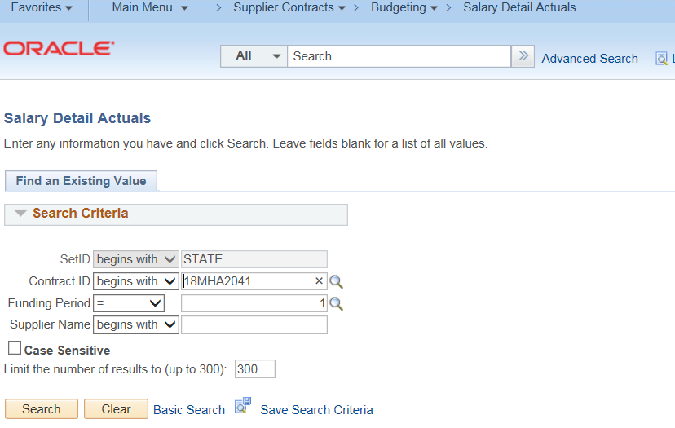
Review the Submitted Salary Details
If there are any discrepancies or amounts that need to be update, DO NOT click Accept. Contact the Provider (either by email or using the Notify option – Refer to the separate job aid Notify Contact) to have them correct the entries.
Click Accept.
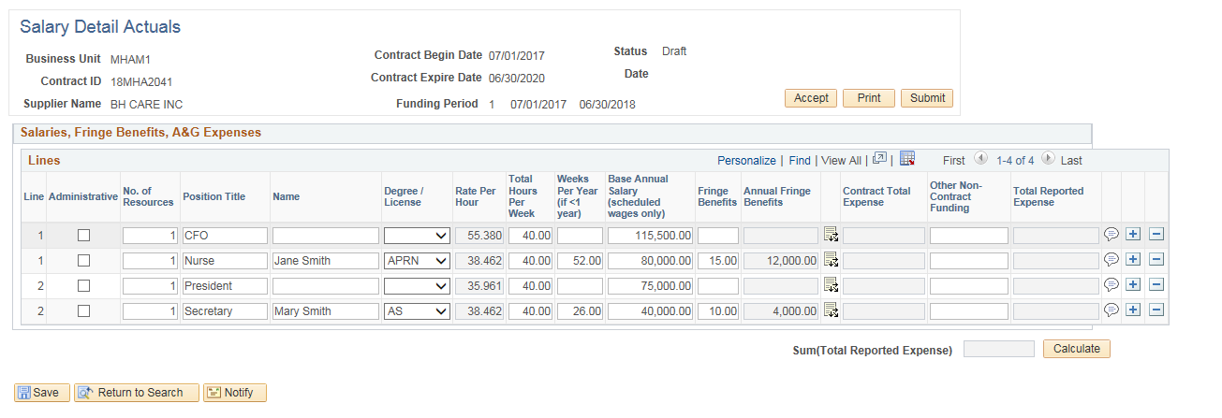
This will open up the Acceptance Notification screen where the Provider will be notified that the Salary Details Actual Report has been accepted.

Enter the Supplier User ID or use the magnifying glass to search
Enter message to be included in the email if needed
Click OK
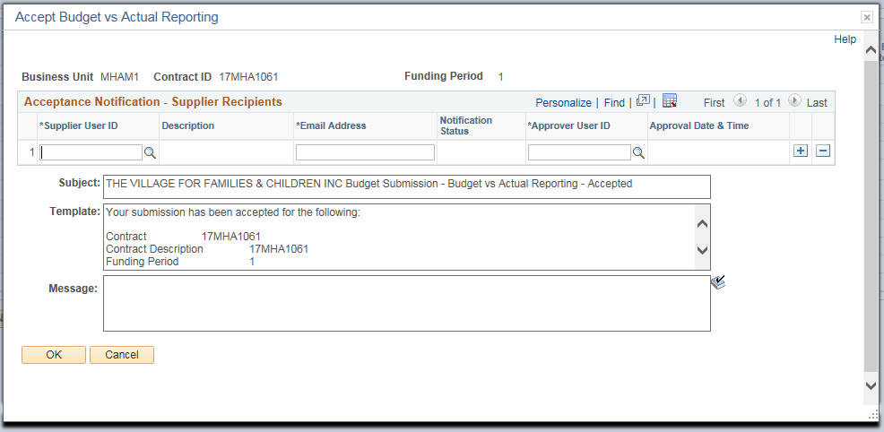

Click OK to the Confirmation message.
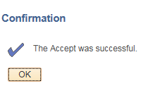

An email will be sent to the Provider. The Provider will now know that the Salary Detail Actuals Report has been accepted.
