Agency Budget Revision Job Aid
Once an Accepted Budget Summary exists, the agency budget processor may initiate a Budget Revision. The Budget Revision job aid provides the steps to complete a Contract Budget revision based on two Budget Definition configuration scenarios:
- Budget Definition > Budgeting, Reporting & Payment Requirements > Budget Revision – Revise Funding checkbox is UNCHECKED.
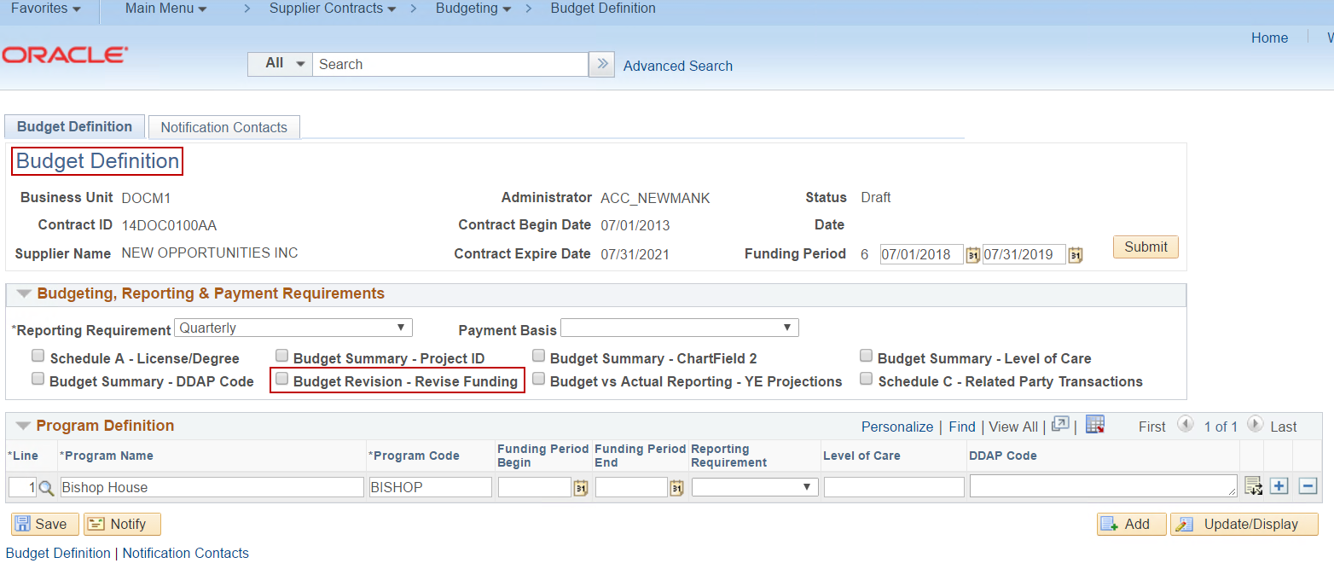
- Budget Definition > Budgeting, Reporting & Payment Requirements > Budget Revision – Revise Funding checkbox is CHECKED.
*Checking the Budget Revision – Revise Funding checkbox gives both the agency processor and provider user the ability to re-allocate existing 4100 CONTRACT FUNDING values on the Budget Revision page.
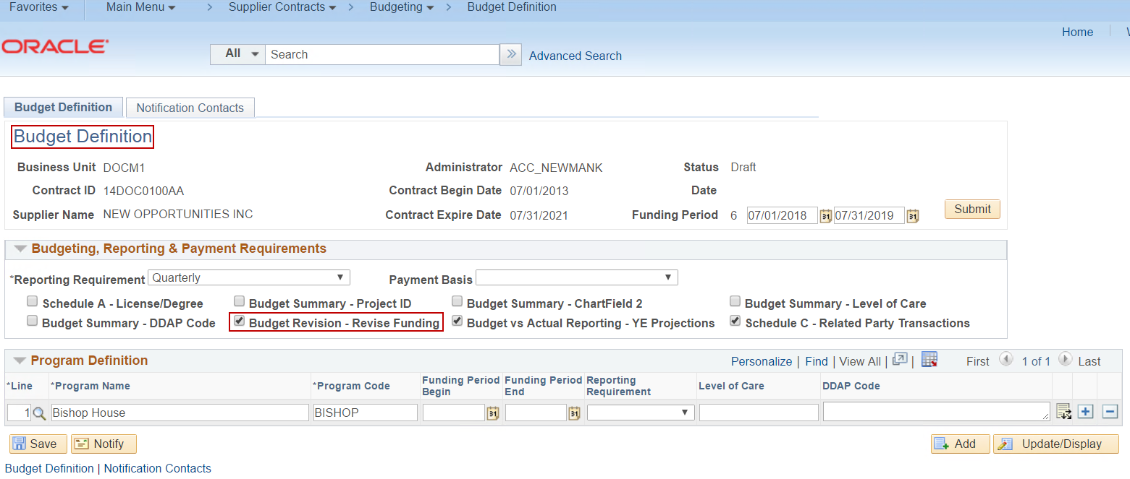
Scenario 1: Budget Definition > Budgeting, Reporting & Payment Requirements > Budget Revision – Revise Funding checkbox is UNCHECKED.
Step 1: Navigate to Budget Revision page.
Navigation: Supplier Contracts > Budgeting > Budget Revision

- Budget Revision Search page is displayed.
- Click the Search button for all available Contract IDs to appear in the Search Results, or
- Enter a Contract ID, or
- Enter a Contract ID and Funding Period.
- Click the Search button.
- Click on correct Search Result.

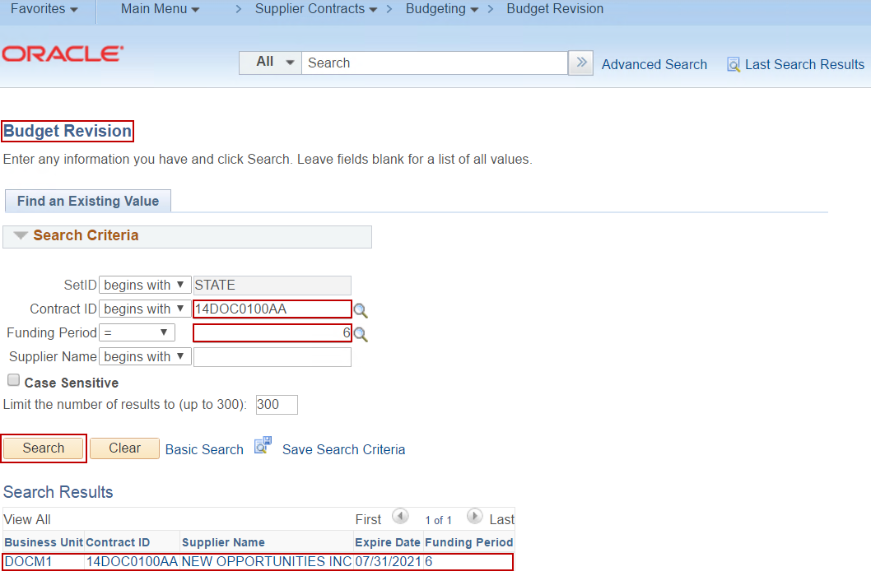

Step 2: Start Budget Revision.
- Budget Revision page is displayed.
- Click the Start button.
- Start button initiates the Budget Revision, making the Budget Revision New Request fields, Schedule A Salaries, and Budget Definition editable.

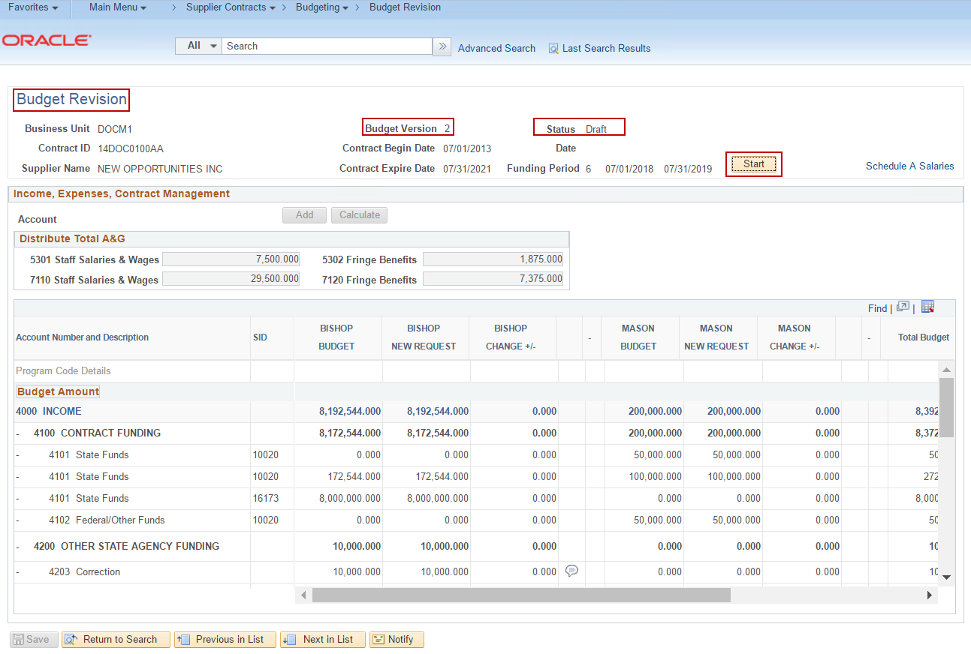

Step 3: Re-allocate existing and/or add new 4200 OTHER STATE AGENCY FUNDING, 4300 OTHER INCOME, 5000 DIRECT EXPENSES, and 7000 INDIRECT EXPENSES accounts/values.
**Adjustments to 5100 SALARIES, 5200 FRINGE BENEFITS, 5300 A&G (DIRECT), and 7100 A&G (INDIRECT) accounts and values must be completed in Schedule A Salaries. Specifically for A&G updates, the values must be updated in Schedule A Salaries and then manually re-distributed between Program(s) in the NEW REQUEST column(s) in Budget Revision.
- Re-allocate existing account values in the NEW REQUEST column(s).
- Click Justification icon and enter Justification for each edited field.
- Click Calculate button to update TOTALS.
- Add new Accounts and values using the Account lookup field and Add button.
- Click Justification icon and enter Justification for each added field.
- Click Calculate button to update TOTALS.
- Click Save.
- If Schedule A Salaries updates are required, navigate to Schedule A Salaries via the link on Budget Revision or directly through the menu.

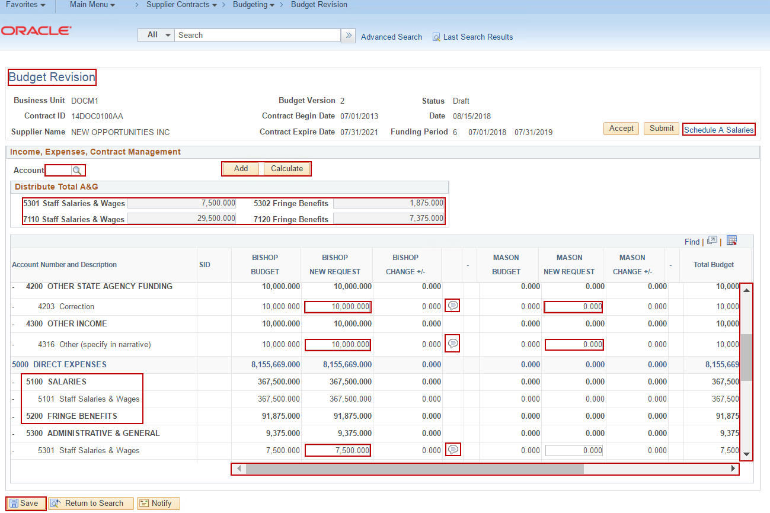

- Schedule A Salaries page is displayed.
- Update/add/delete Line(s) and fields.
- Click Save.
- Click Distribution icon to update/add/delete Distribution Line(s).
- Click OK.
- Click Justification icon to update comments for edited/added Lines.
- Click Save.
- Navigate back to Budget Revision by clicking on the open Budget Revision tab.

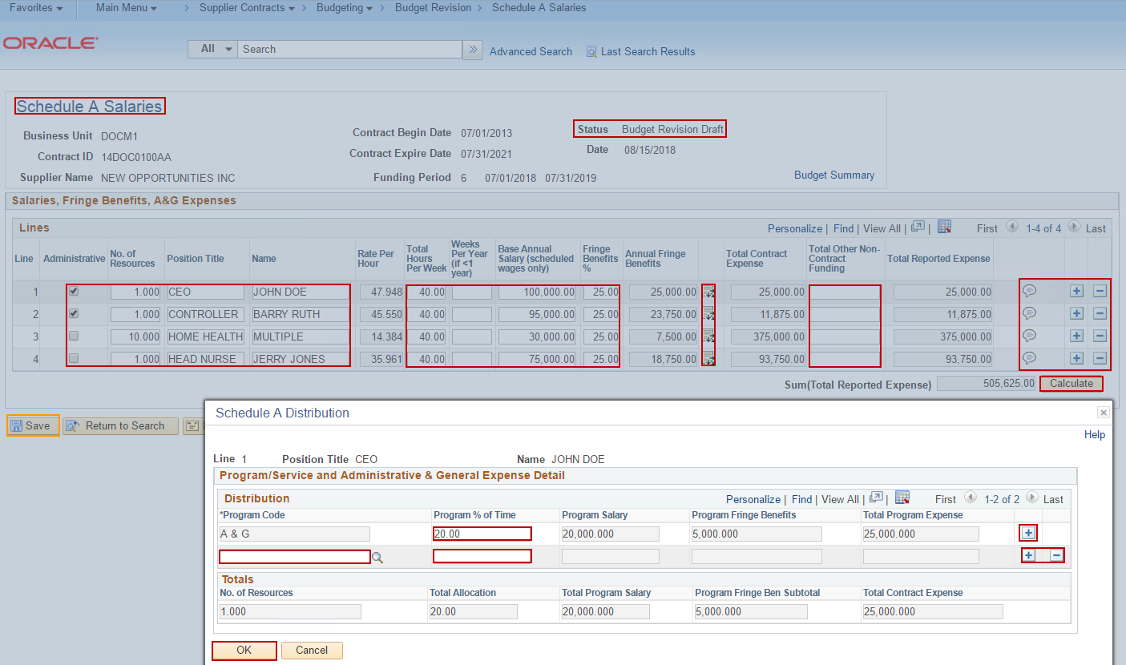

- Budget Revision page is displayed.
- Click Calculate button.
- Click Justification icon and enter Justification for edited/added fields.
- Click Save.

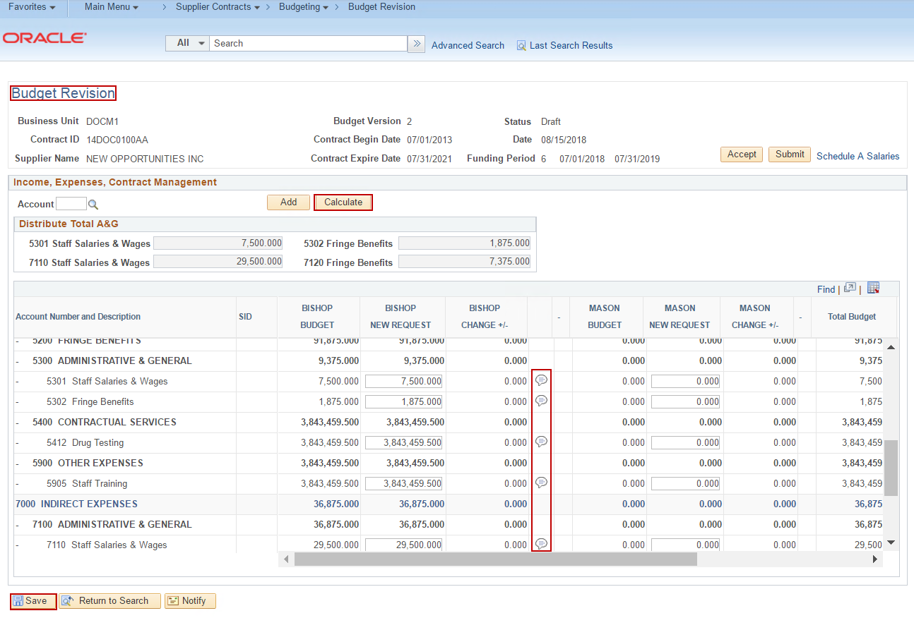

Step 4: Re-allocate 4100 CONTRACT FUNDING values between Existing Accounts or add New Accounts and/or add New Program Codes by navigating to the Submitted Budget Definition page.
**Adjustments to 4100 CONTRACT FUNDING accounts and values must be completed via the Budget Definition page due to the Budget Revision – Revise Funding checkbox not being checked on the Submitted Budget Definition.
Navigation: Supplier Contracts > Budgeting > Budget Definition
- Budget Definition Search page is displayed.
- Click the Search button for all available Contract IDs to appear in the Search Results, or
- Enter a Business Unit, and/or
- Enter a Contract ID, or
- Enter a Contract ID and Funding Period.
- Click the Search button.
- Click on correct Search Result.

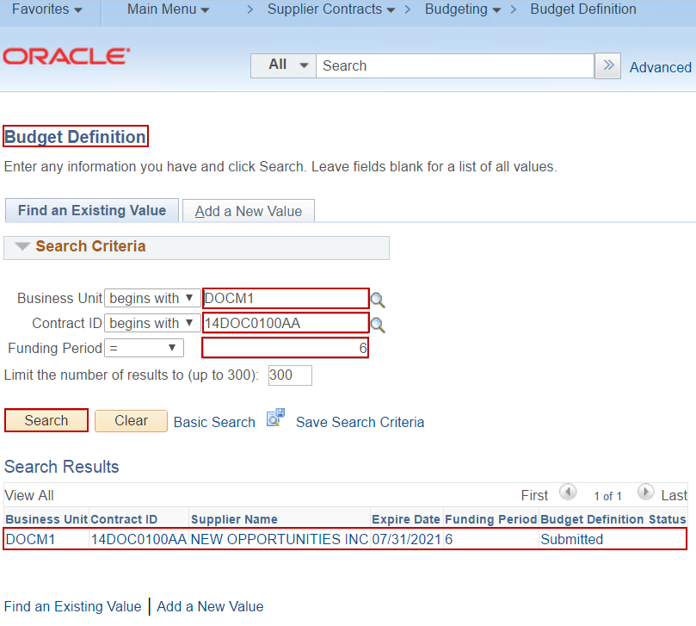

- Budget Definition page is displayed.
- Update/add Line(s) and fields.
- Click Save.
- Click Distribution icon to update/add Distribution Line(s).
- Click OK.
- Click Save.
- Navigate back to Budget Revision through the Menu navigation.

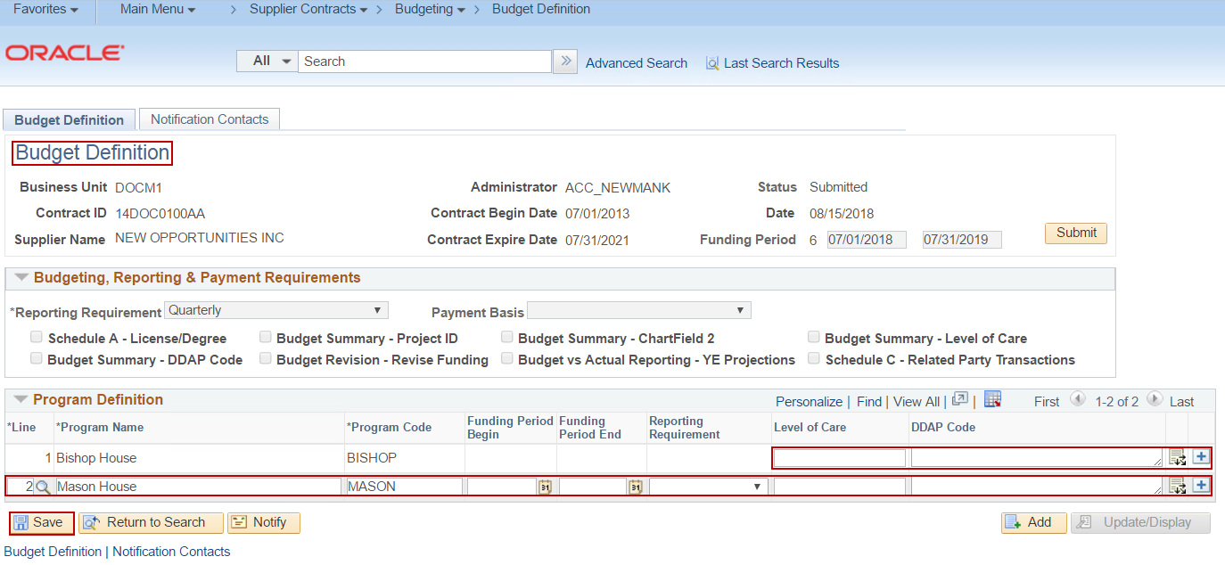
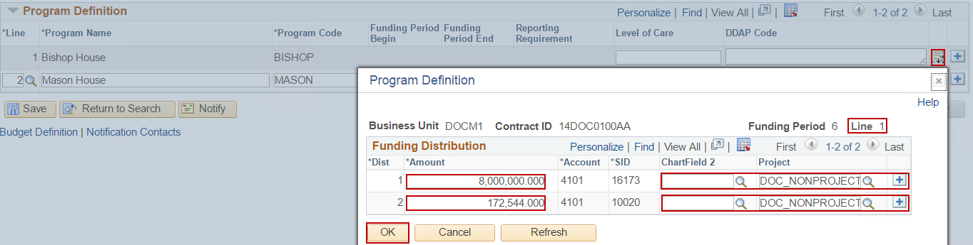
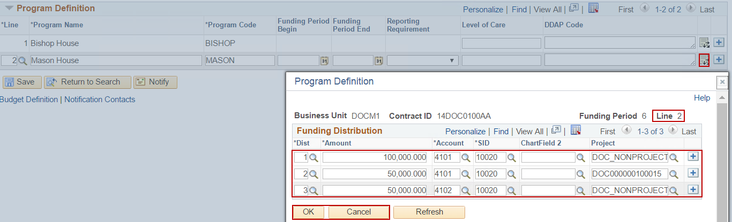

- Budget Revision page is displayed.
- Click Calculate button.
- Click Justification icon and enter Justification for edited/added fields.
- Click Save.

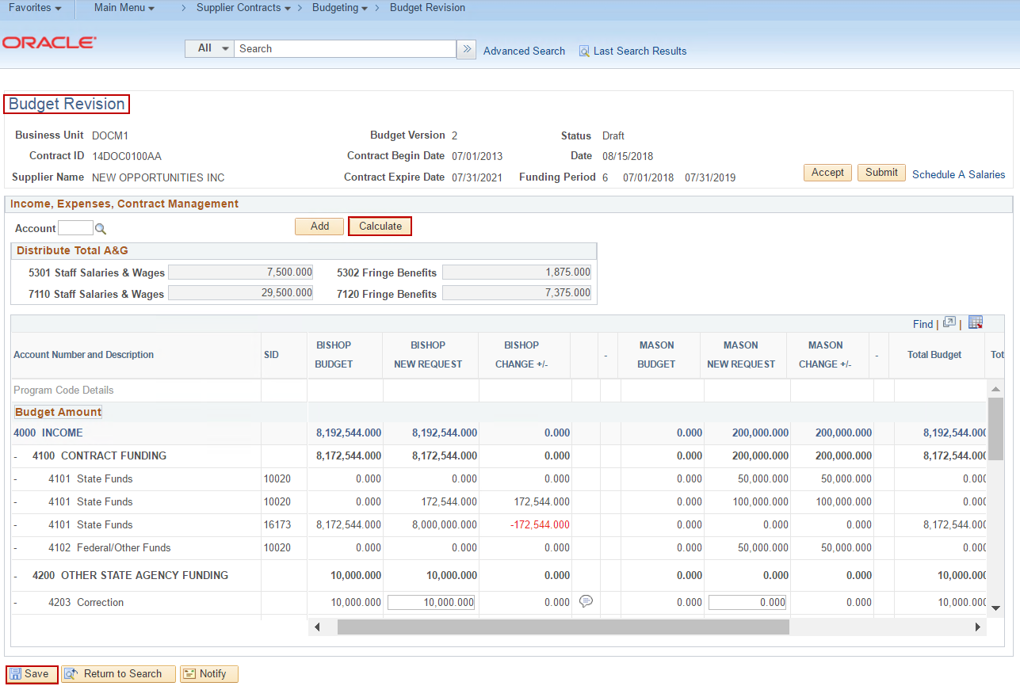

Step 5: Submit Budget Revision.
- Click Submit button.

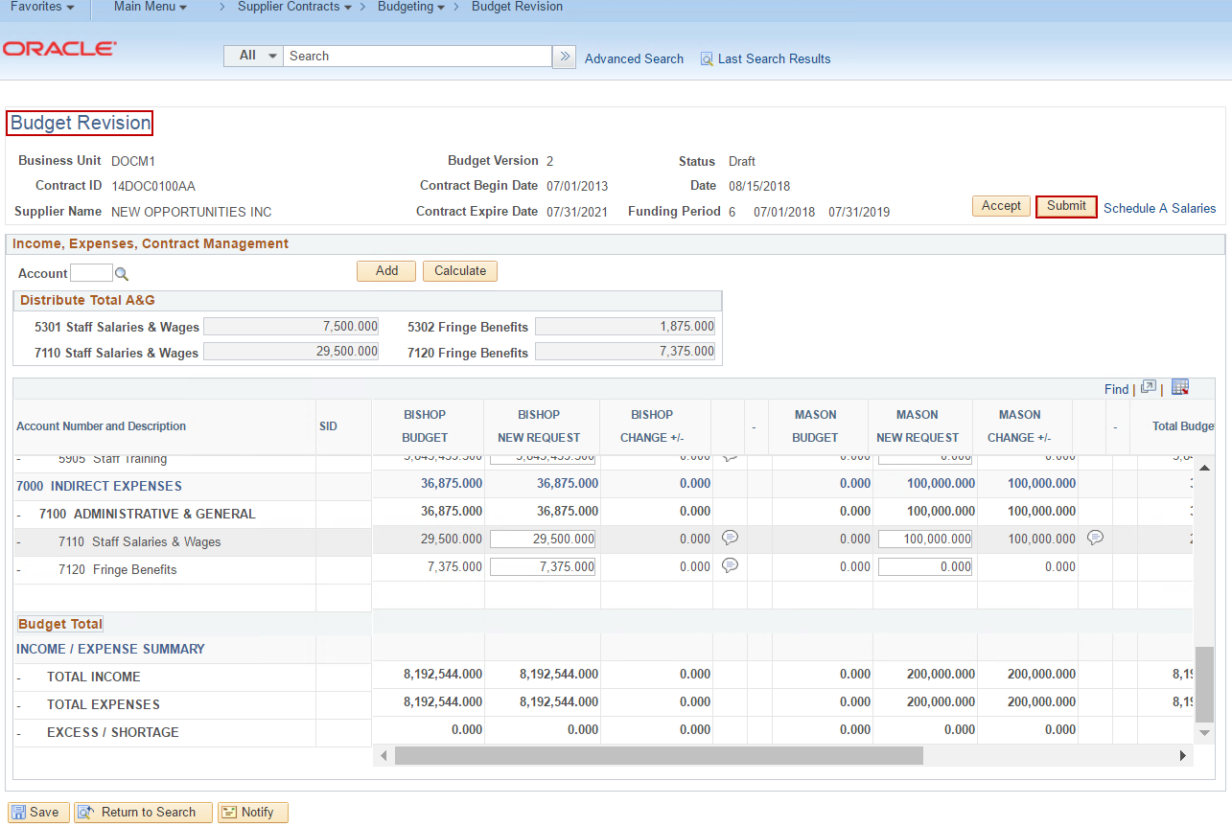
- Submit Budget Revision page is displayed.
- Enter/update fields as required.
- Click OK.

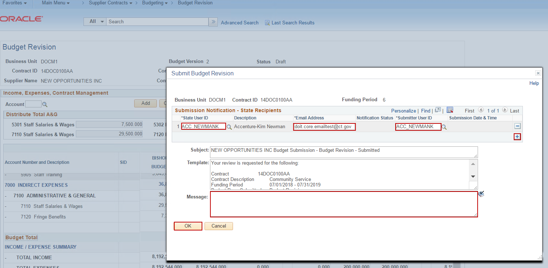

Step 6: Accept Budget Revision.
- Click Accept button.

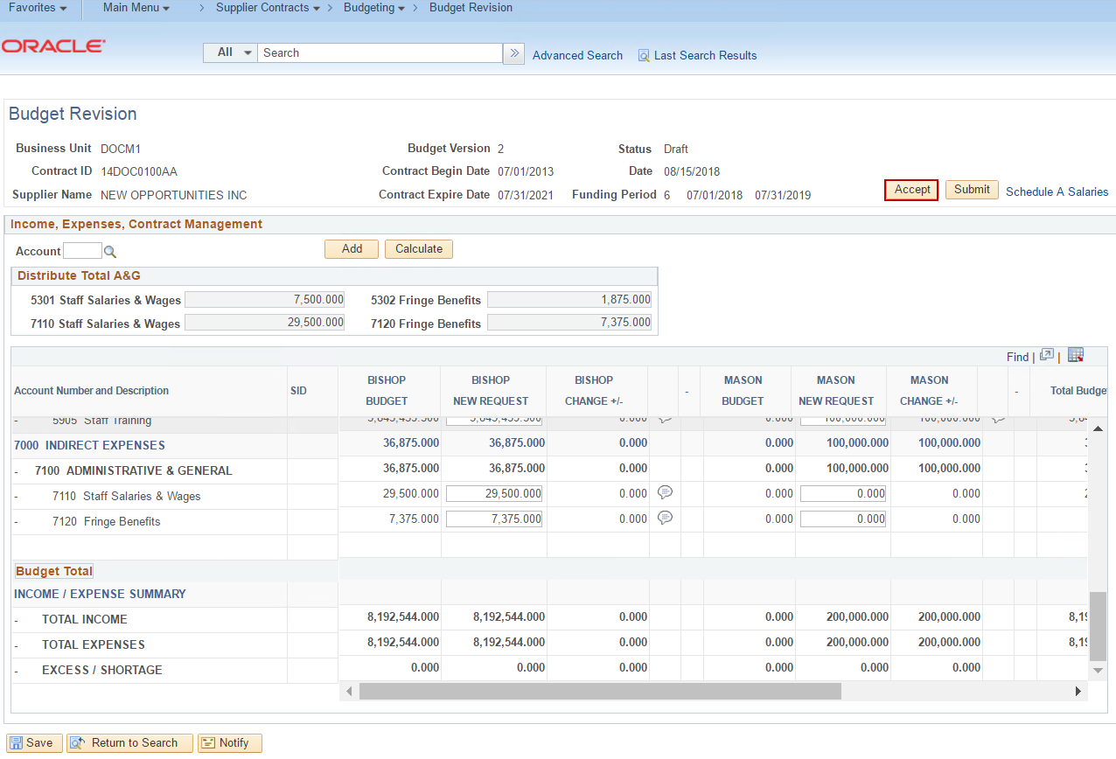
- Accept Budget Revision page is displayed.
- Enter/update fields as required.
- Click OK.

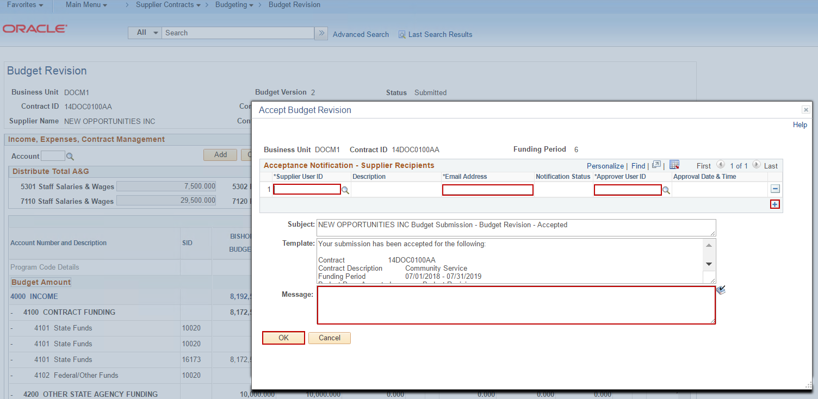

- New version of Budget Summary is in Accepted status and un-editable.

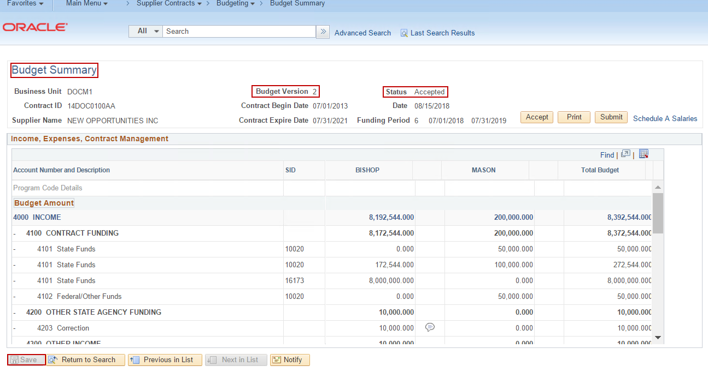
- Schedule A Salaries is in Accepted status and un-editable.

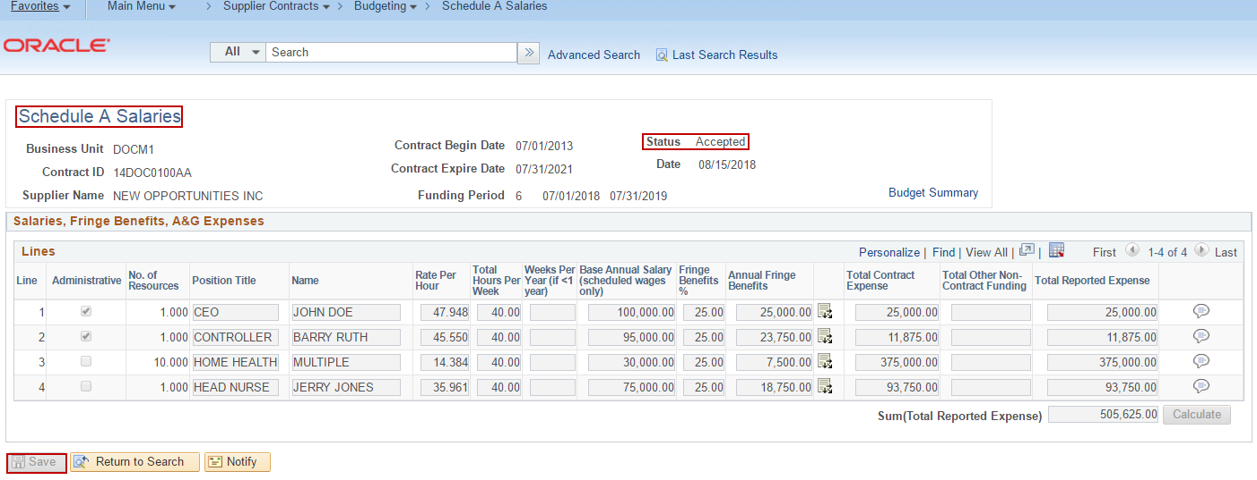

- Budget Definition is un-editable.

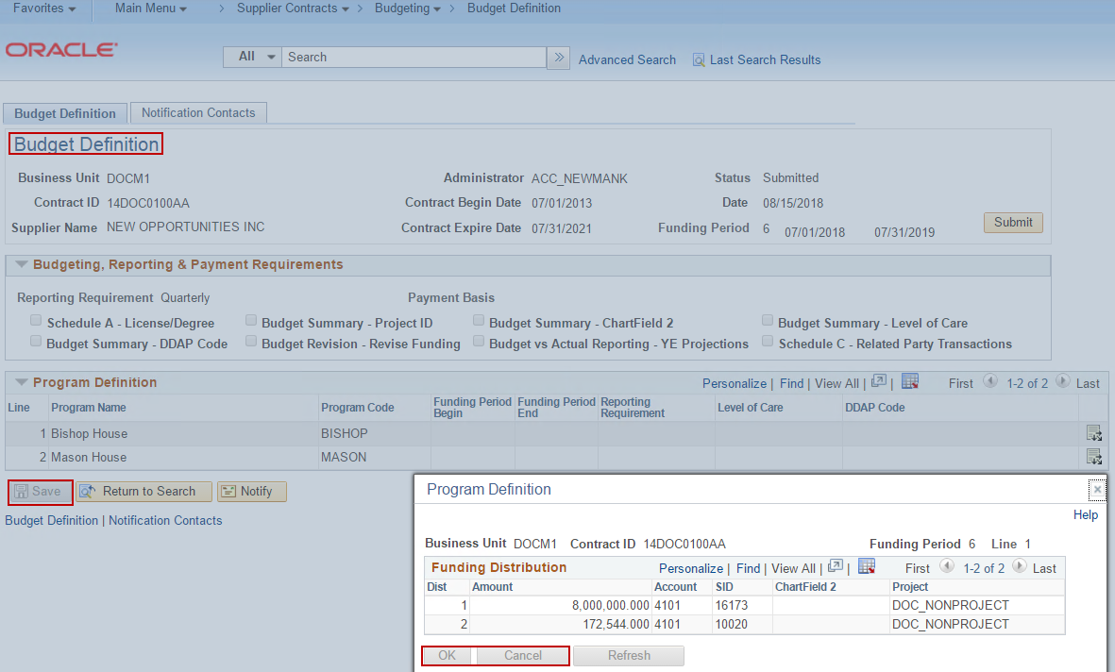

Scenario 2: Budget Definition > Budgeting, Reporting & Payment Requirements > Budget Revision – Revise Funding checkbox is CHECKED.
Step 1: Navigate to Budget Revision page.
Navigation: Supplier Contracts > Budgeting > Budget Revision

- Budget Revision Search page is displayed.
- Click the Search button for all available Contract IDs to appear in the Search Results, or
- Enter a Contract ID, or
- Enter a Contract ID and Funding Period.
- Click the Search button.
- Click on correct Search Result.

Step 2: Start Budget Revision.
- Budget Revision page is displayed.
- Click the Start button.
- Start button initiates the Budget Revision, making the Budget Revision New Request fields, Schedule A Salaries, and Budget Definition editable.

Step 3: Re-allocate existing and/or add new 4100 CONTRACT FUNDING, 4200 OTHER STATE AGENCY FUNDING, 4300 OTHER INCOME, 5000 DIRECT EXPENSES, and 7000 INDIRECT EXPENSES accounts/values.
**Adjustments to 5100 SALARIES, 5200 FRINGE BENEFITS, 5300 A&G (DIRECT), and 7100 A&G (INDIRECT) accounts and values must be completed in Schedule A Salaries. Specifically for A&G updates, the values must be updated in Schedule A Salaries and then manually re-distributed between Program(s) in the NEW REQUEST column(s) in Budget Revision.
***If new Programs or updates to ChartFields need to be made on a Budget Revision, then the updates must be completed in the Budget Definition.
- Re-allocate existing account values in the NEW REQUEST column(s).
- Click Justification icon and enter Justification for each edited field.
- Click Calculate button to update TOTALS.
- Add new Accounts and values using the Account lookup field and Add button.
- Click Justification icon and enter Justification for each added field.
- Click Calculate button to update TOTALS.
- Click Save.
- If Schedule A Salaries updates are required, navigate to Schedule A Salaries via the link on Budget Revision or directly through the menu.

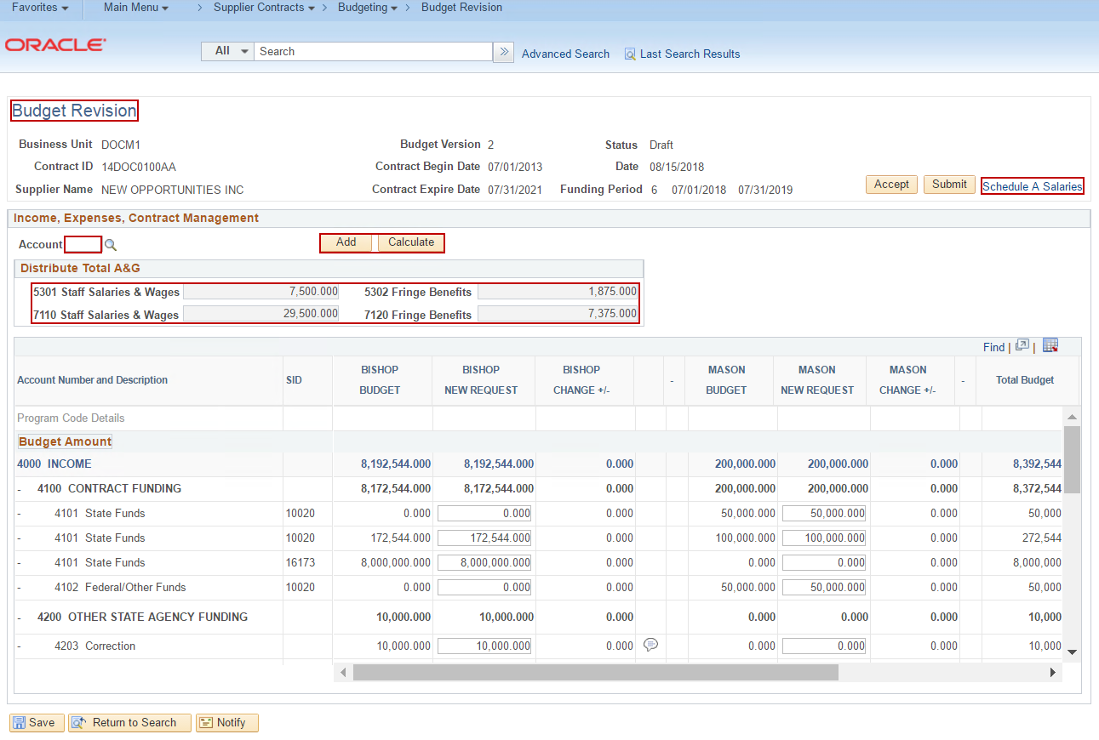

- Schedule A Salaries page is displayed.
- Update/add/delete Line(s) and fields.
- Click Save.
- Click Distribution icon to update/add/delete Distribution Line(s).
- Click OK.
- Click Justification icon to update comments for edited/added Lines.
- Click Save.
- Navigate back to Budget Revision by clicking on the open Budget Revision tab.

- Budget Revision page is displayed.
- Click Calculate button.
- Click Justification icon and enter Justification for edited/added fields.
- Click Save.

Step 4: Add New Program Lines, new Distribution Lines, and/or update ChartFields by navigating to the Submitted Budget Definition page.
**All existing 4100 CONTRACT FUNDING account value re-allocations must be completed on the Budget Revision page. Only new Program Lines, new Distribution Lines, and updates to existing ChartFields should be made in the Budget Definition page since the Budget Revision – Revise Funding checkbox is checked on the Submitted Budget Definition.
Navigation: Supplier Contracts > Budgeting > Budget Definition
- Budget Definition Search page is displayed.
- Click the Search button for all available Contract IDs to appear in the Search Results, or
- Enter a Business Unit, and/or
- Enter a Contract ID, or
- Enter a Contract ID and Funding Period.
- Click the Search button.
- Click on correct Search Result.

- Budget Definition page is displayed.
- Add new Program Line(s) and/or update LOC/DDAP Code for existing Lines.
- Click Save.
- Click Distribution icon to update existing Distribution Line ChartField2 or Project ID fields and/or add new Distribution Line(s).
- Click OK.
- Click Save.
- Navigate back to Budget Revision through the Menu navigation.

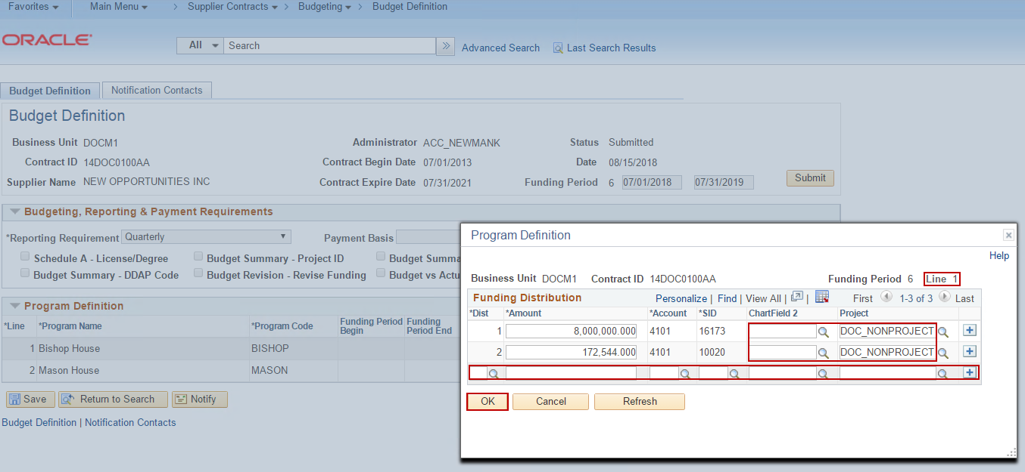

- Budget Revision page is displayed.
- Click Calculate button.
- Click Justification icon and enter Justification for edited/added fields.
- Click Save.

Step 5: Submit Budget Revision.
- Click Submit button.

- Submit Budget Revision page is displayed.
- Enter/update fields as required.
- Click OK.

Step 6: Accept Budget Revision.
- Click Accept button.

- Accept Budget Revision page is displayed.
- Enter/update fields as required.
- Click OK.

- New version of Budget Summary is in Accepted status and un-editable.

- Schedule A Salaries is in Accepted status and un-editable.

- Budget Definition is un-editable.

