Reset the Funding Period

The following shows how to create Funding Period Budget Workbook Pages.
Navigation: Supplier Contracts > Budgeting > Reset Funding Period

The Reset Funding Period page will display.

Select the Add a New Value Tab

Enter the Run Control ID

When creating a Run Control ID, make sure it is something that will be easily identifiable when using this process in the future.

Click Add
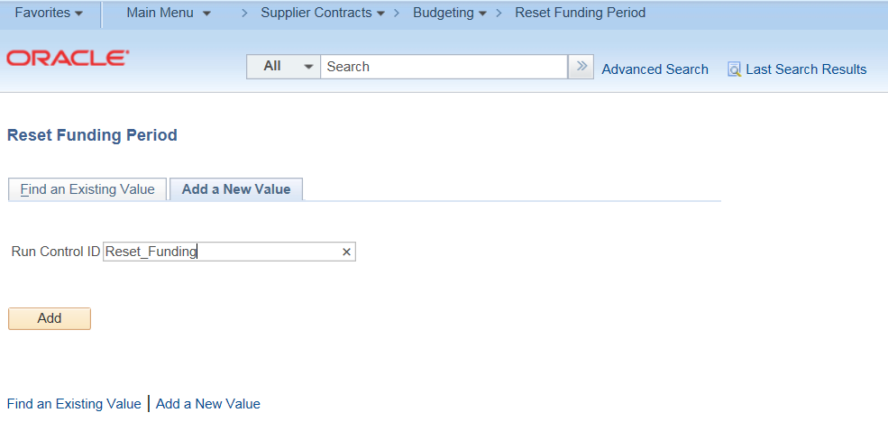
Enter Business Unit
Enter Contract ID (or use the magnifying glass)
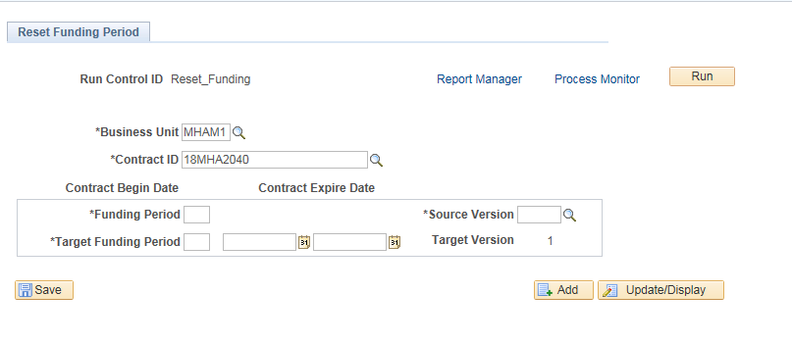
The Funding Period dates populate from the contract
The Source Version defaults to the maximum version of the Accepted Budget Summary. However, the field is editable based on the versions available for the specified funding period.
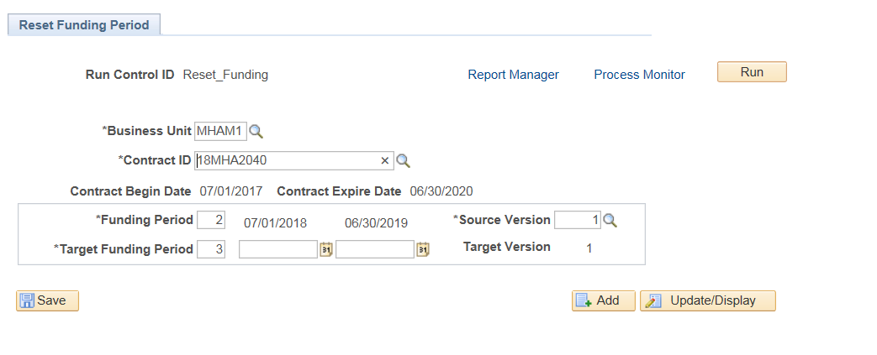
The Target Funding Period will populate with the next available funding period
Enter the new Target Funding Period dates (The dates must still be within the begin and expiration dates of the contract)

Click Save
Click Run
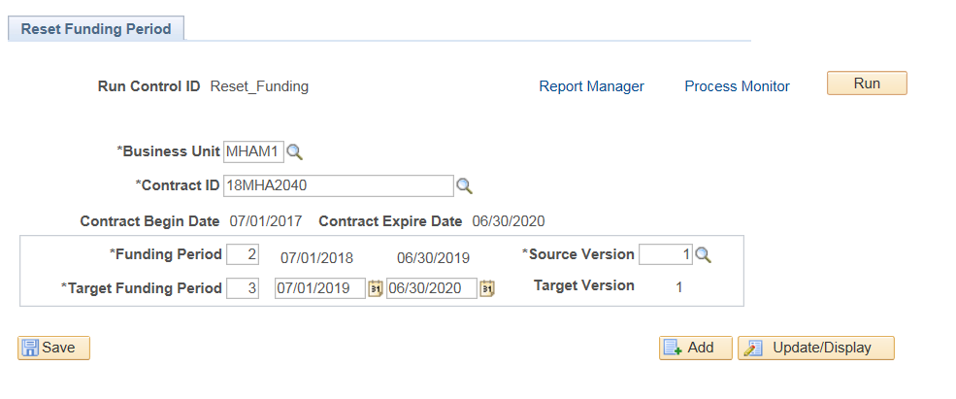

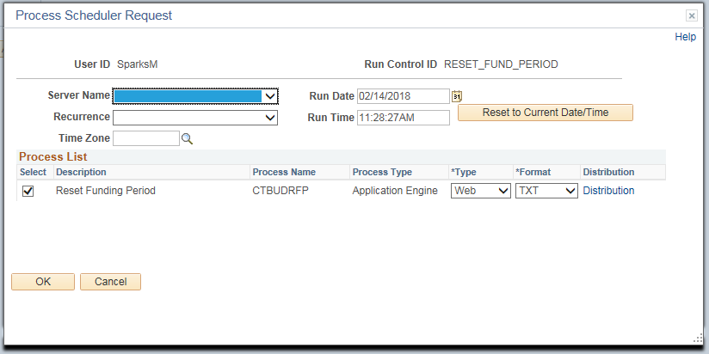
Click OK

Click on the Process Monitor link
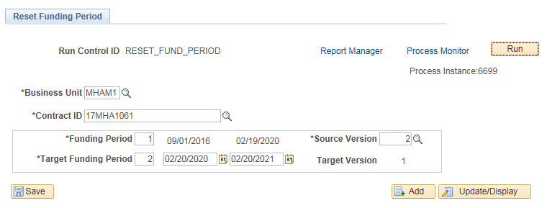

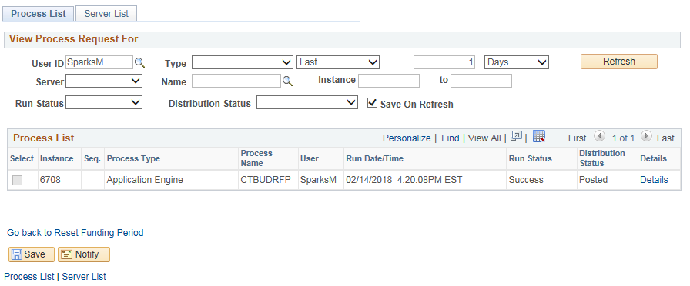
Click Refresh until Run Status and Distribution Status displays Success and Posted

Navigate back to the Budget Definition page to submit the new Budget Summary

Navigation: Supplier Contracts > Budgeting > Budget Definition

The Budget Definition page will display.
Enter the Business Unit, or Contract ID
Click Search

Select the created contract that contains the next number in the Funding Period sequence and “Draft” status in the Budget Definition Status column

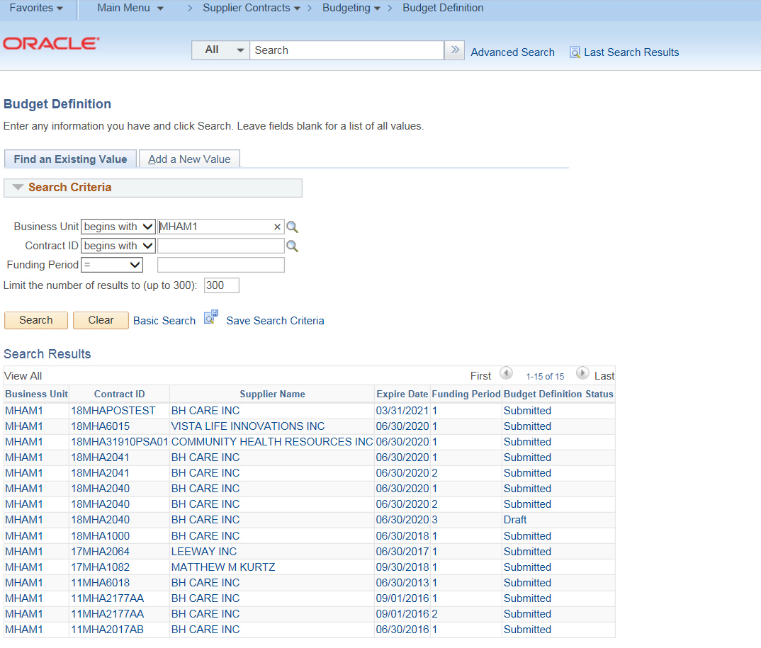
All the original information including the notification contacts have been copied over to the new funding period.
Review and update any information as necessary.
Click Submit.
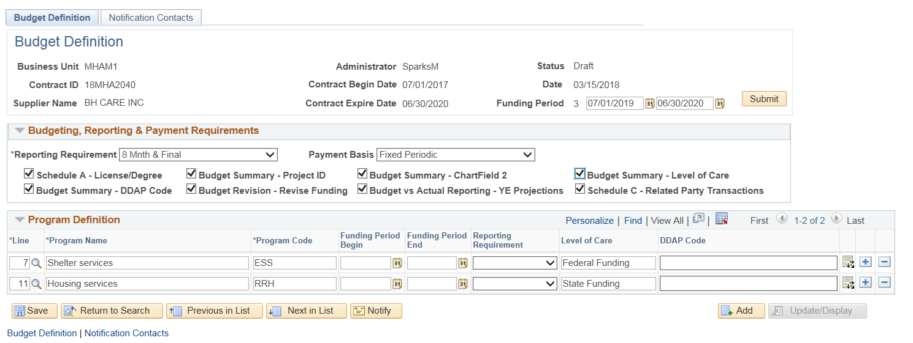
This will open up the Submission Notification screen where the user will notify the Provider that the Budget’s funding period has been changed
Enter Supplier User ID or use the magnifying glass to search
Enter a message to be included in the email if needed and click OK.
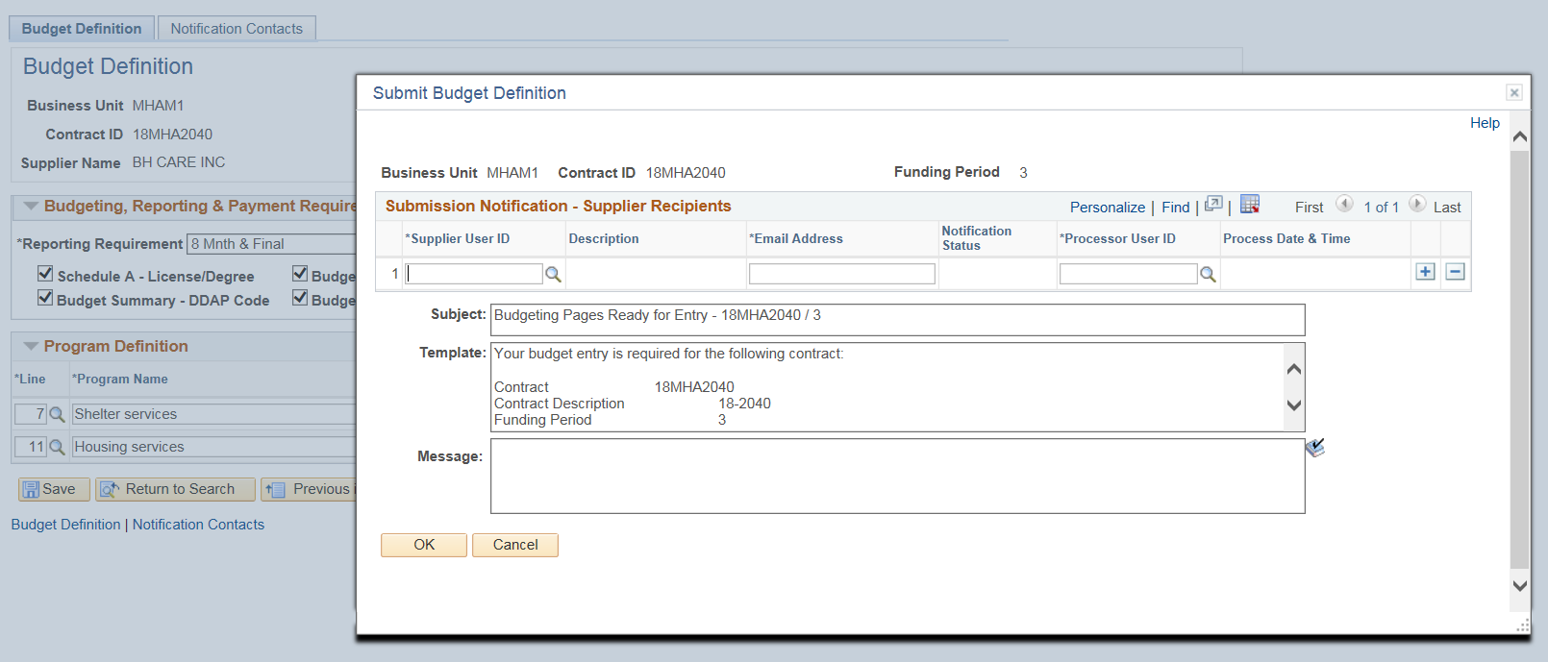

Click OK to the Confirmation message.

An email shown below will be sent to the Provider. From here the user can confirm/update the data in the Provider Program Information, Schedule A Salaries, and Budget Summary pages.
