Notify Contact
The following shows how to notify Contacts about the Budget Workbook.
The navigation below shows one example where the Notify button is available. This button is available on multiple pages to be used whenever communication is needed between the provider and agency contacts.
Navigation: Supplier Contracts > Budgeting > Budget Definition

Enter Contract ID

Click Search
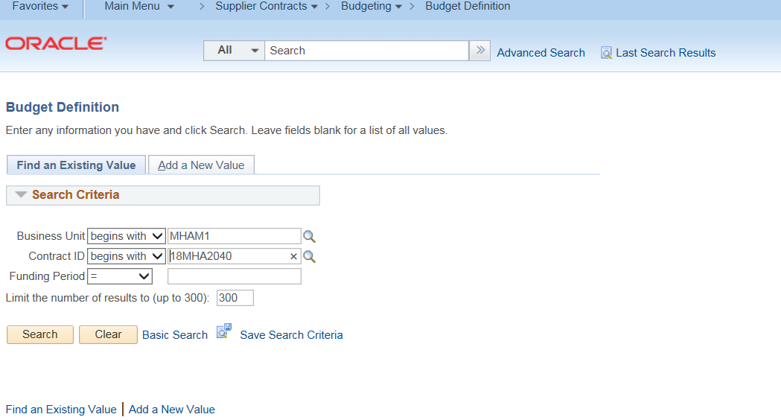

Click on the Notification Contacts tab

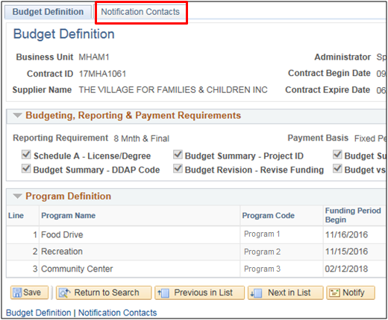

Click Notify
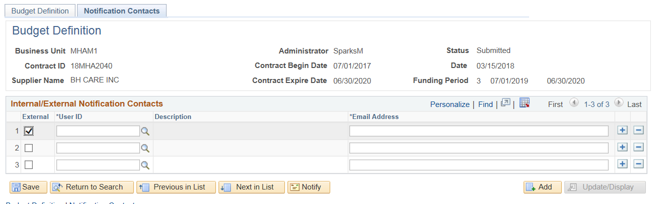
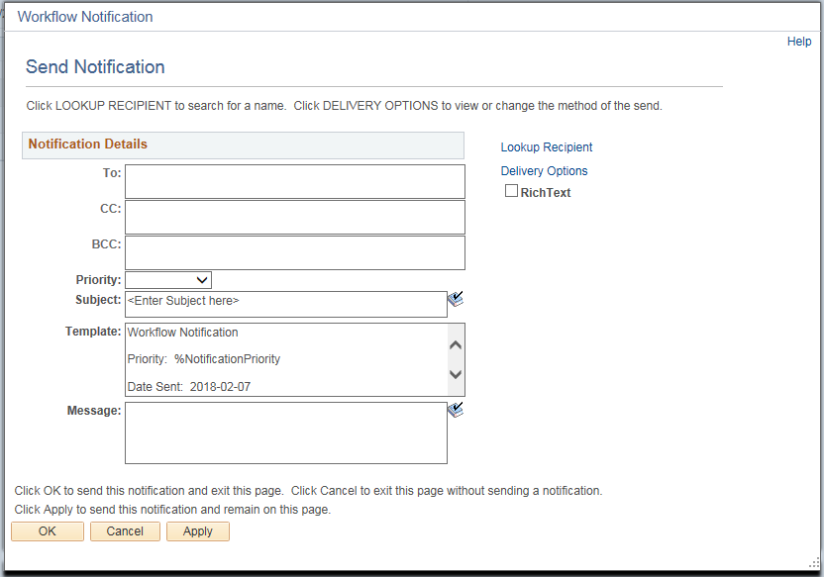
Click Lookup Recipient

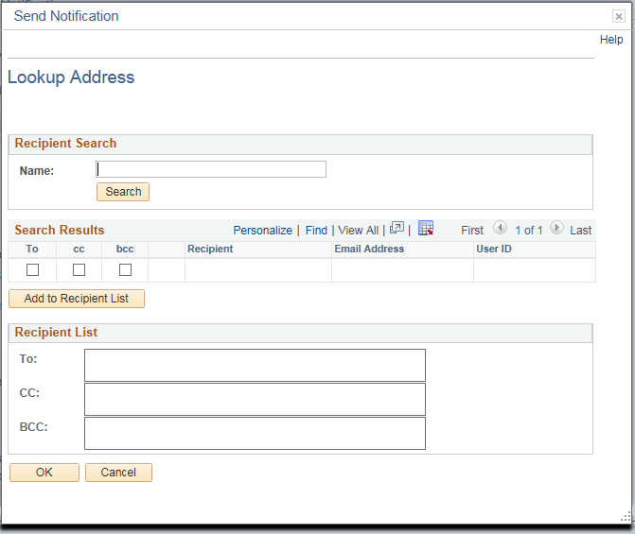
Click Search

Click the “To” checkboxes for the recipients of the notification
The “cc” and “bcc” are also options for recipients
NOTE: When adding contacts, if you add yourself under “CC”, you will receive a copy in your mailbox.
Click Add to Recipient List
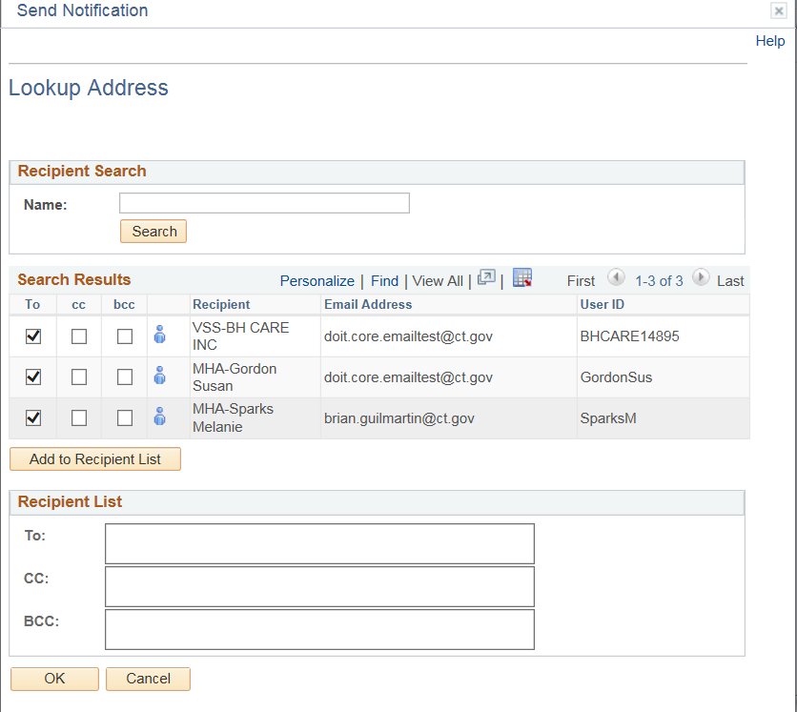

Click OK
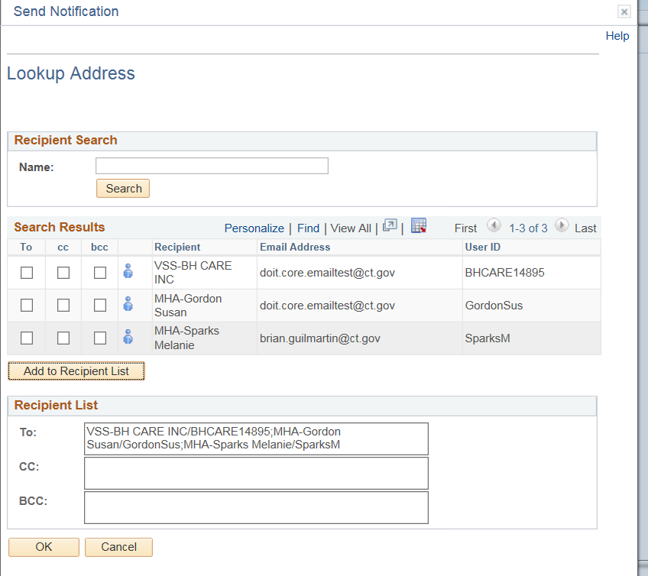
Select a Priority (High, Medium or Low)
Enter a Subject
Enter a message to be included in the email if needed
Click OK
