**Import Contract Documents**

**Navigation:**

Supplier Contracts > Create Contracts Documents > Contract Entry

Enter the Search criteria and select the approved contract:

* Use the magnifying glass to select a **SetID**.
* Enter a **Contract ID**.
* Use the magnifying glass to select a **Contract Style**.
* Use the magnifying glass to select a **Supplier Name**.

Click the **Search** button.

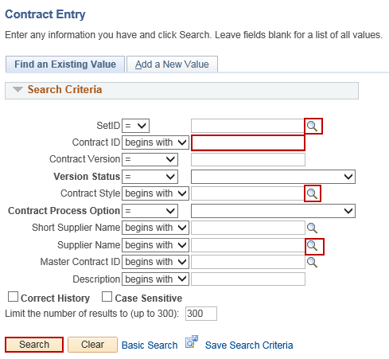

Click the **Add a Document** button.

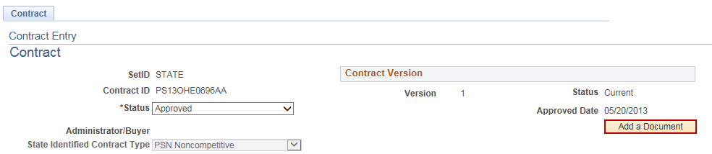

Enter necessary information.

* Select a **Document Type** from the dropdown menu.
* Use the magnifying glasses to select **Administrator**, **Sponsor** and **Department**.

Click the **Import Document** button.

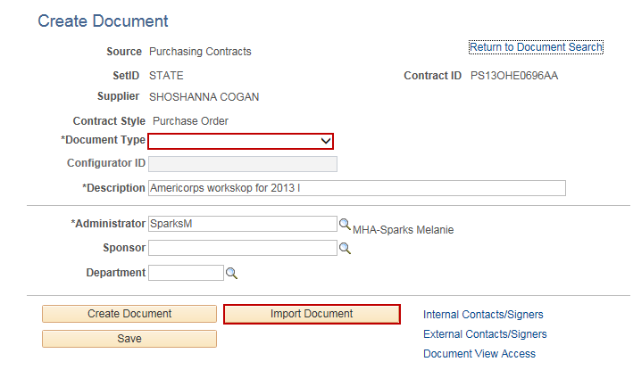

Choose **Option** under **Import Option**.

**NOTE:** **This depends in what kind of Contract Document it is.**

Enter necessary information in the **Current Version** section:

* Enter the **Version**, **Status**, **Status Date**, and **Status Time** in the **Current Version** section.

Click the **Upload** button.

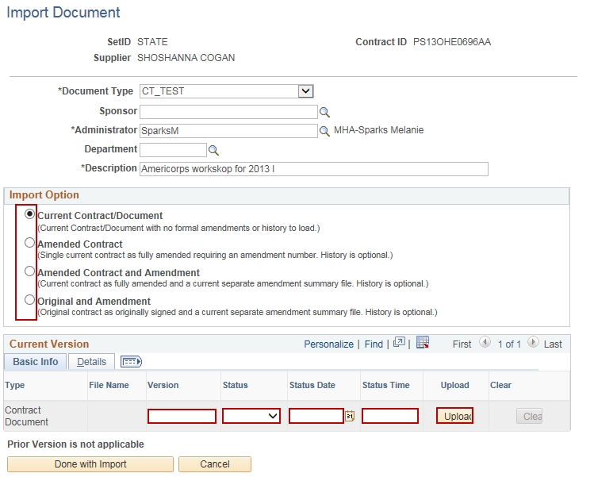

Click the **Browse** button.

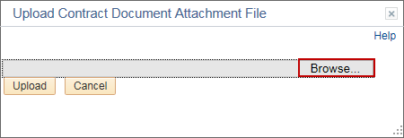

Select file to upload and click **Open**.

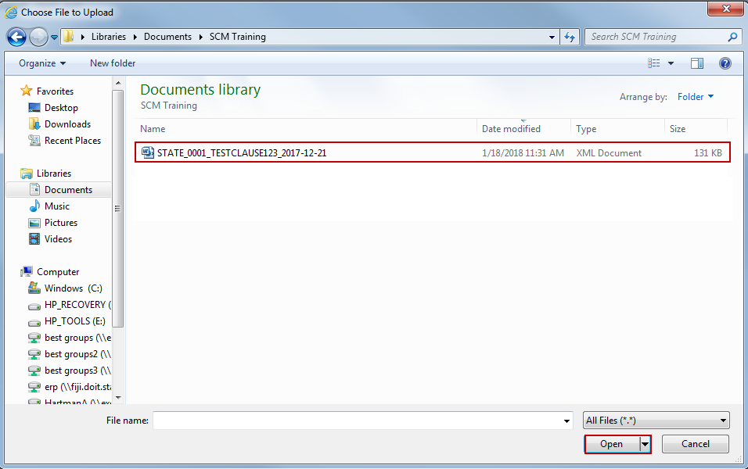

**NOTE**: 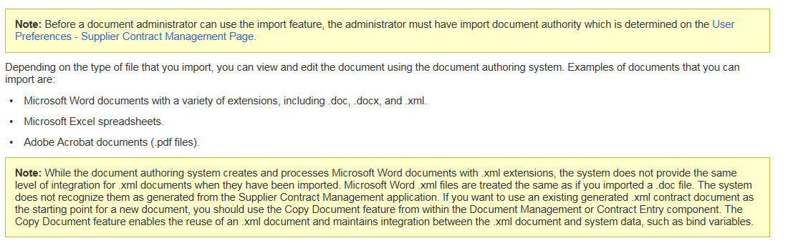

Click the **Upload** button.

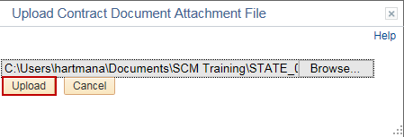

Click the **Done with Import** button.

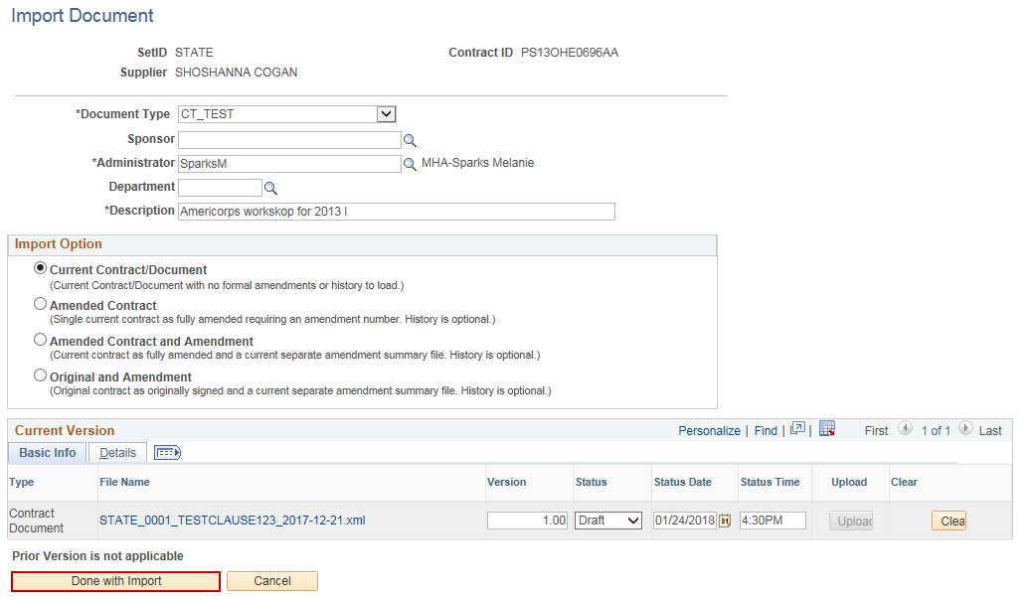

Click **Yes** to continue.

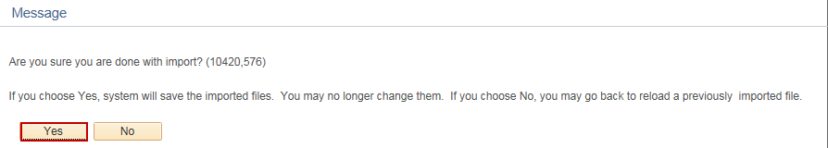

Click the **View Document** button.

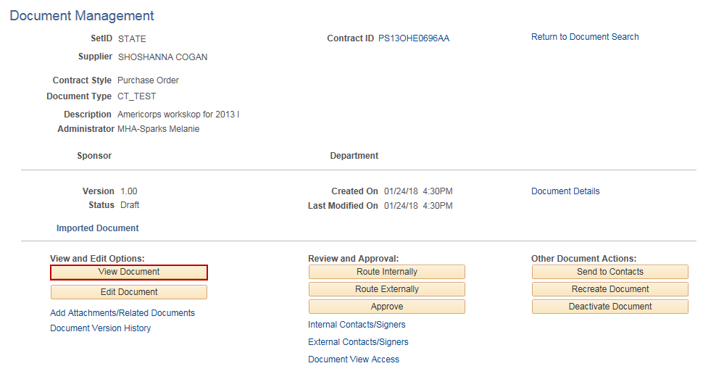

Click the **Open** button in the popup.



Review that the imported document is accurate and close the document.

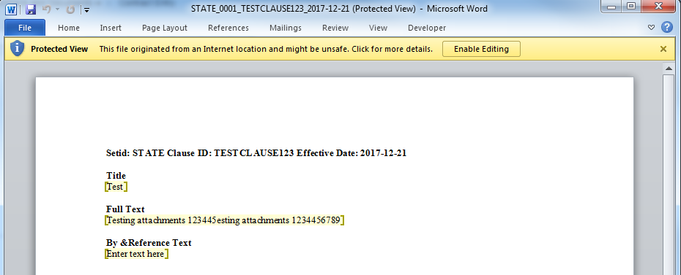

You are now able to **View** or **Edit** the document, **Route Internally** and **Externally** for Collaboration of eSignatures.

