Review and Complete Procurement Contract

Navigation: Supplier Contracts > Create Contracts and Documents > Contract Entry
or Procurement Contracts > Add/Update Contracts
(either Navigation will work)

Must have a Contract Creator role to access the Procurement Contract

(Navigation from the Go To Contract link when converting requisition to contract will also work)

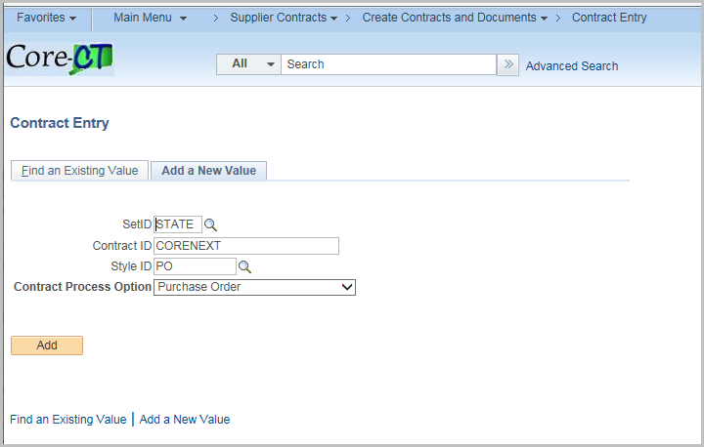

Click Find an Existing Value

Enter the Contract ID

Click Search

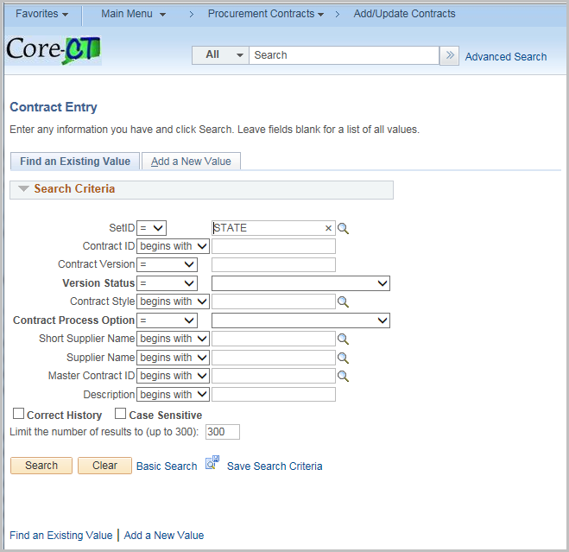

Review and update any values as necessary for the particular contract

Below is a brief explanation of the fields created on the Contract
Field | Value
Status | Defaults to Open
Administrator/Buyer | Enter the Contract Administrator - Optional
State Identified Contract Type | Defaults from the Requisition
Contract Style | Select PO
Supplier | Defaults from the Requistion
Begin Date | Defaults from the Requistion
Expire Date | Defaults from the Requistion
Supplier Contract Ref | Defaults from the Requistion
Description | Defaults from the Requistion
Maximum Amount | Defaults from the Requistion
Corporate Contract | If checked, the contract can be used Statewide  Default is checked
Price Can be Changed on Order | If checked, the line amount may be modified on the purchase order  Default is checked
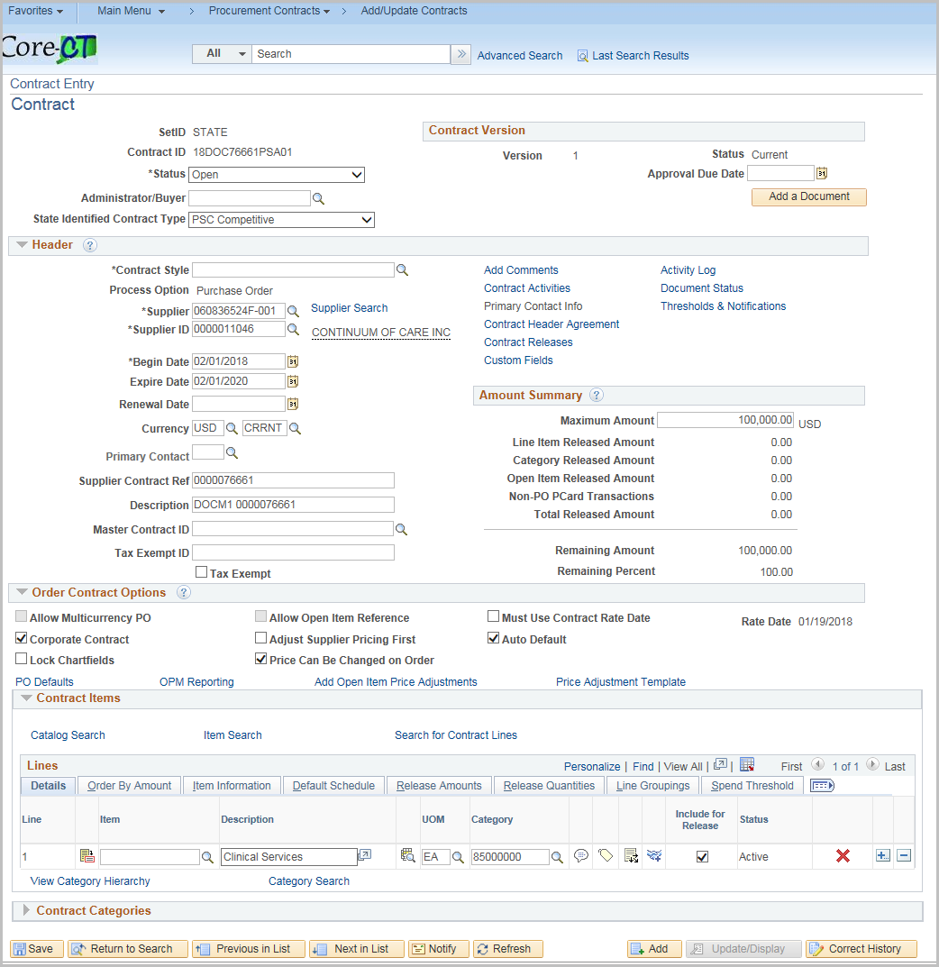

Click the PO Defaults hyperlink

Review and update any values as necessary for the particular contract

Field | Value
Business Unit | Defaults from the Requistion  When the Corporate Contract checkbox is unchecked, this is the only Business Unit that can use this Contract. If more than one business unit is needed, click the + to add more.
Buyer | Defaults from the Requisition
Origin | Defaults from the Requisition

Click OK

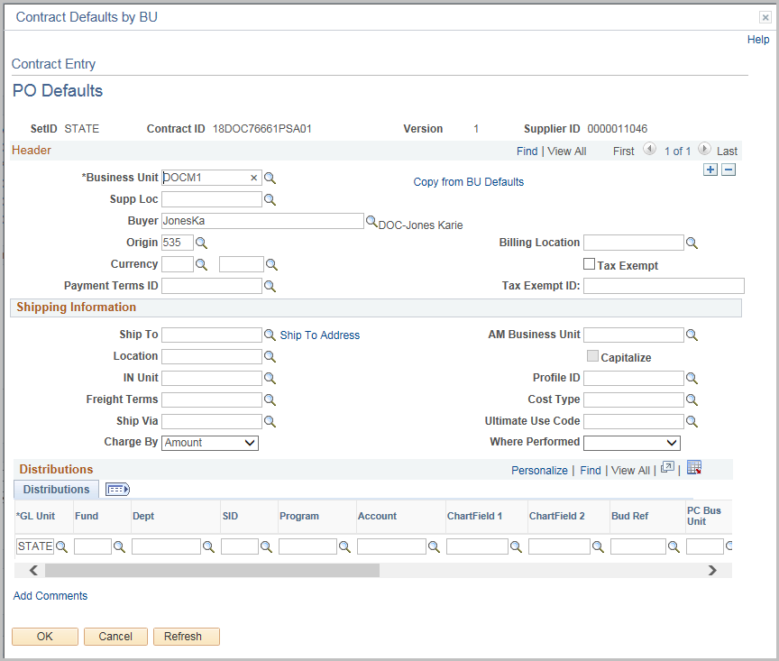

Click the OPM Reporting Link 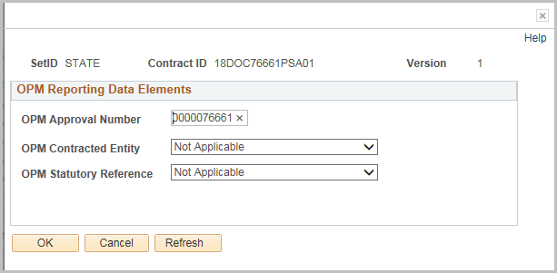
The OPM Approval Number is the Requisition number

Update the OPM Contracted Entity and OPM Statutory Reference as needed.

Click OK (you will be returned to the Main Page of the Contract.)

Contract Lines are defaulted from the Requistion
Click the Line Details Icon to view Details for each line
Alternately you can Click the Tab(s) across the Top to view specific fields displaying all lines

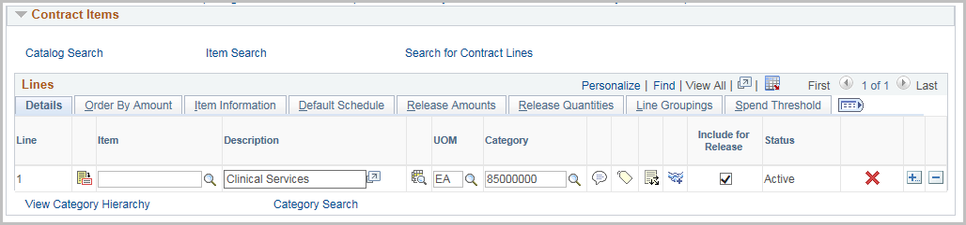

Field | Value
Physical Nature | This value is defaulted from the requisition
Maximum Line Amount | Enter the Maximum amount for the Line  This is used to calculate the remaining balance
Price Can Be Changed on Order | Default is Checked
Amount Only | This defaults from the requisition

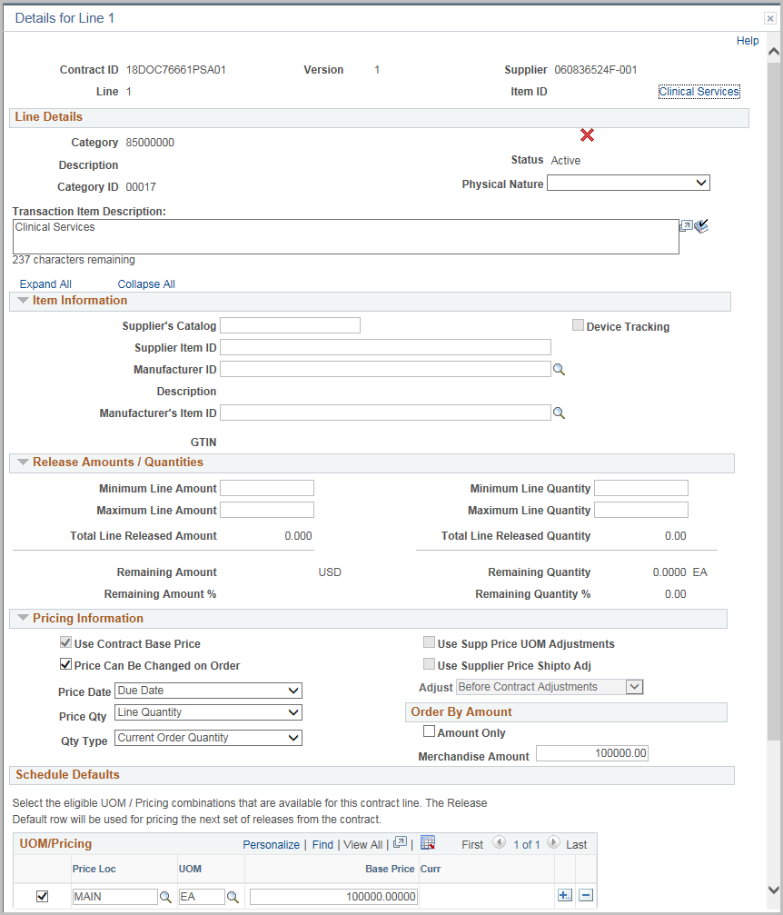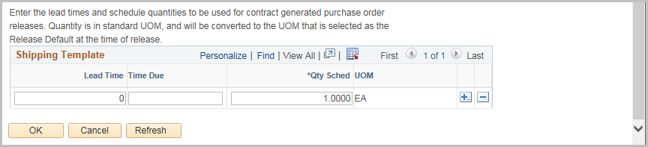

Click OK

Click the PO Distibution Details icon 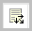

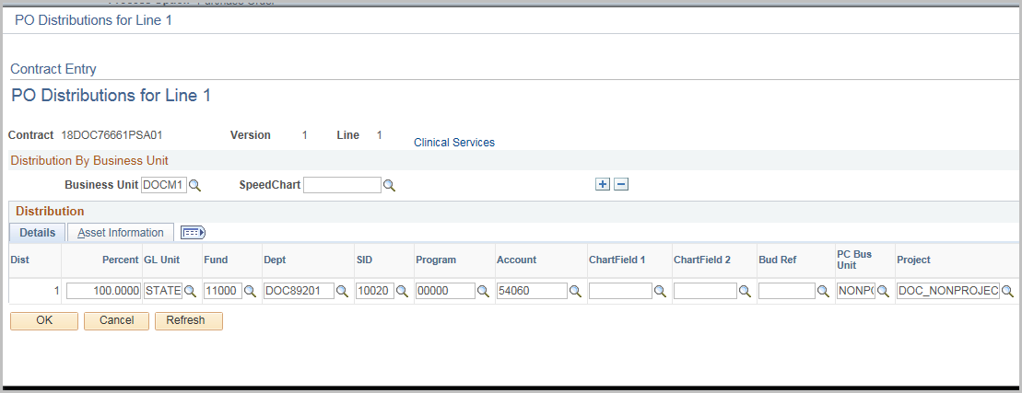

The PO Distributions are copied over from the Requistion

Click OK

Comments and Attachments will copy over from the Requisition

You can see what requisition was used to create the contract in the comments for the line and can view the requistion Schedule and Distribution line summary page by clicking on the link.
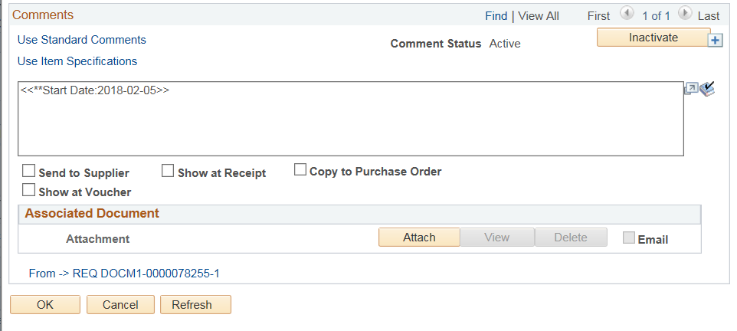

Once the Supplier Contract process has begun the Procurement Contract will update the corresponding Supplier Contract Status/Version/Amendment.

Until the Contract authored status is executed (i.e. the legal document is complete and signed off) the contract should remain in Open Status.

This will prevent creating purchase orders against the Contract.

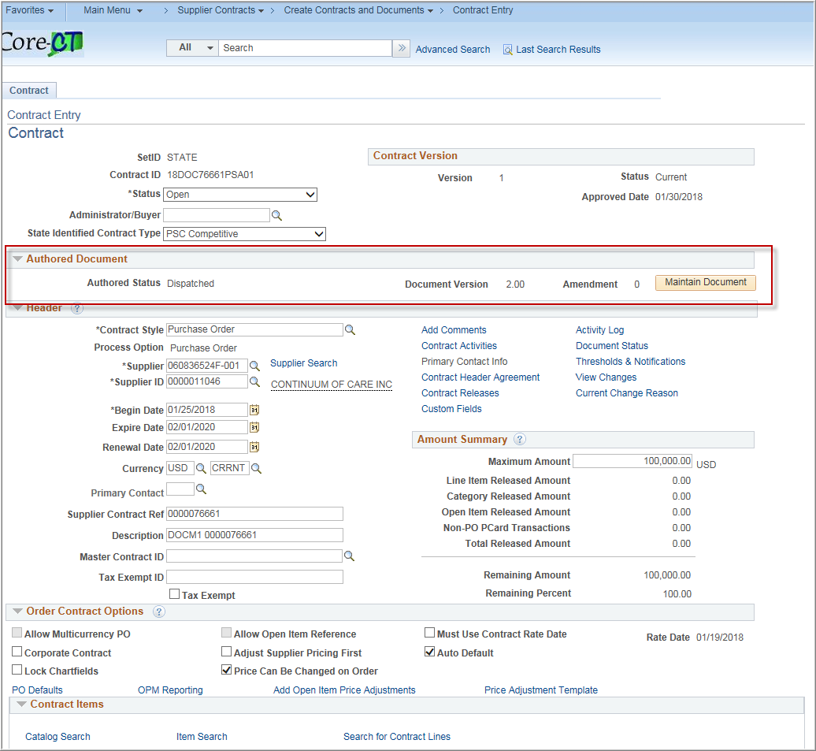

Update the Contract Status to Approved once the Supplier contract portion is completed
Security Note: User must have the Approve Contracts check box checked in their User Preferences to Approve contracts
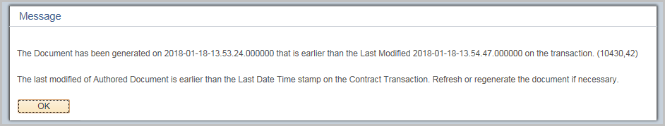
Click OK and Save the Contract
Purchase Orders may now be created using this contract.
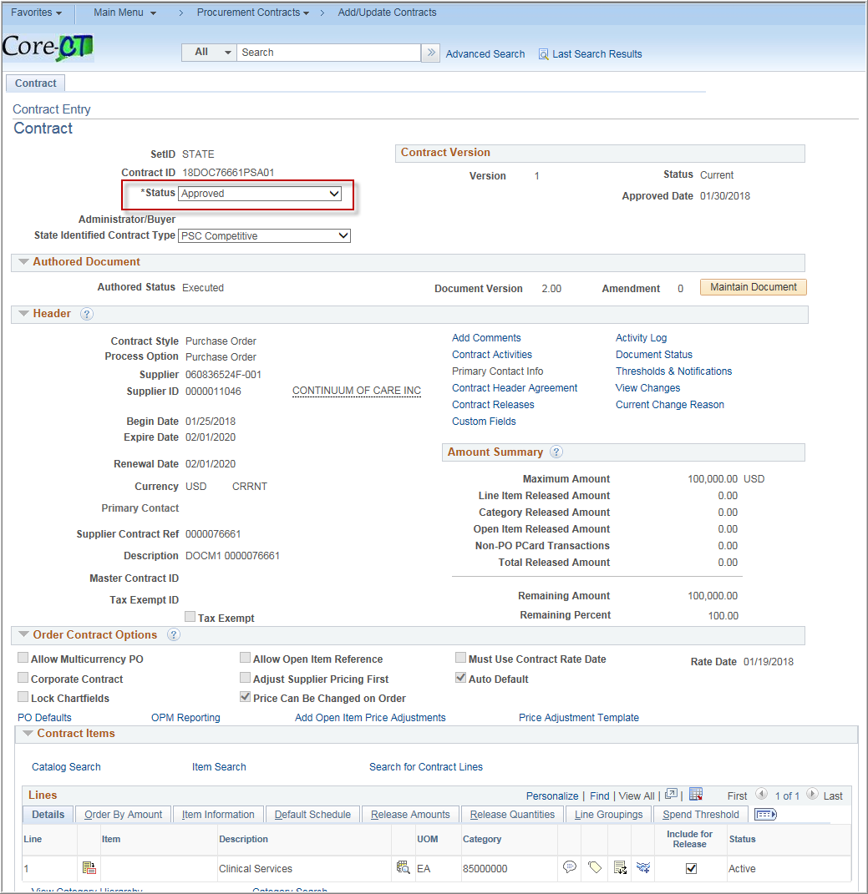

Thresholds & Notifications

Navigation: 1. Supplier Contracts > Create Contracts and Documents > Contract Entry
2. Procurement Contracts > Add/Update Contracts

(either Navigation will work)

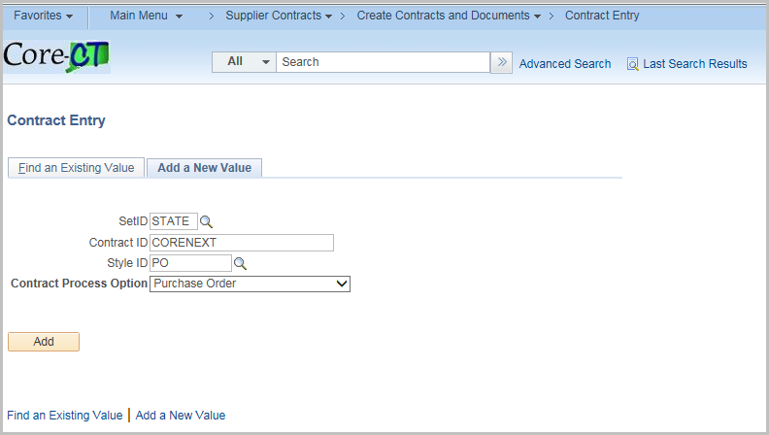
Click the Find an Existing Value Tab
Enter or Search for the Contract Id
Click Search
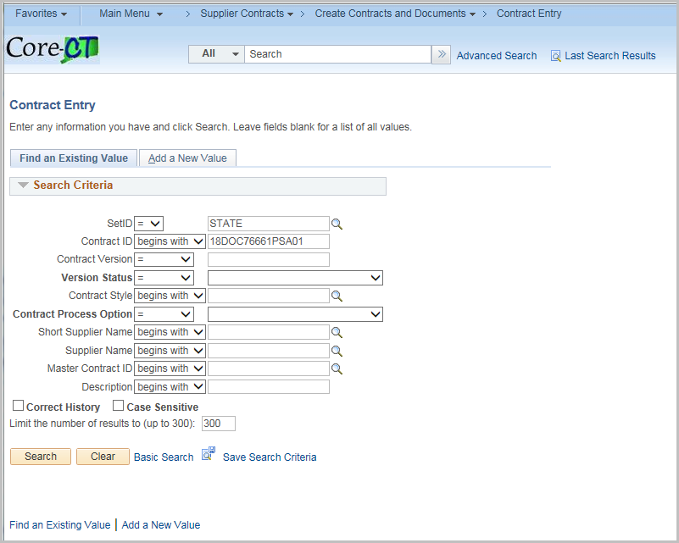
Notifications can be tied to the Approval Due Date.
To use this, enter the Approval Due Date on the Contract.
Click the Thresholds & Notifications hyperlink
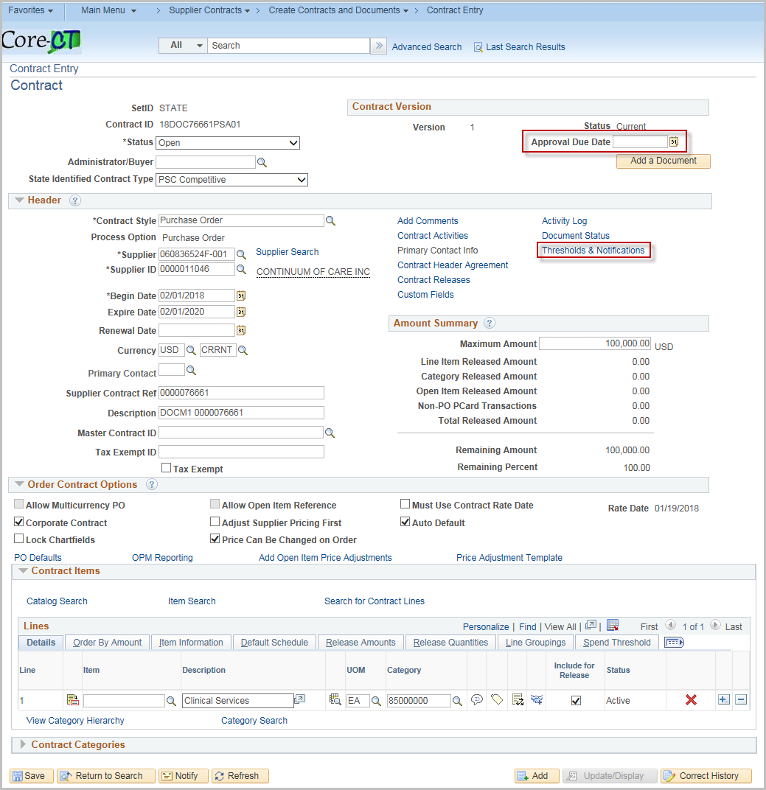

Click Expand All

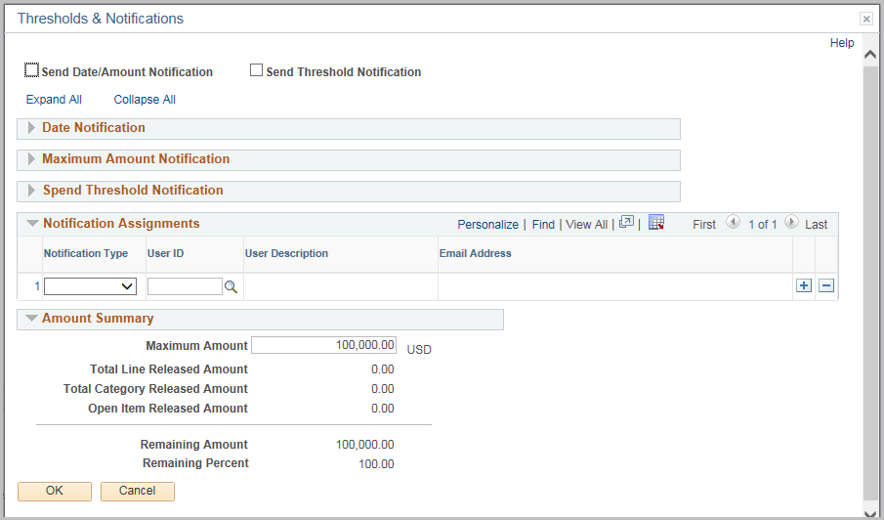
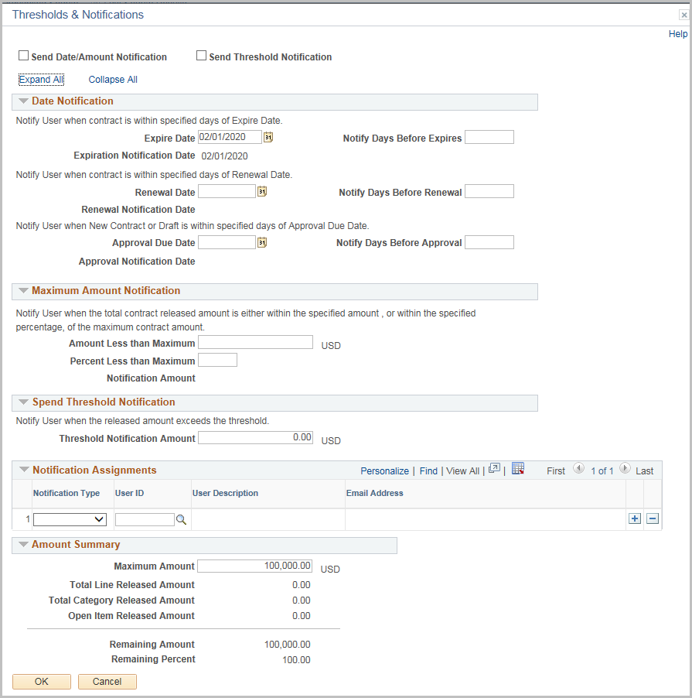

Complete the page based upon the types of threshold and notifications needed
Field | Value
Send Date/Amount Notification | Select to notify when a Contract will expire or reaches the maximum amount
Send Threshold Notification | Select to notify when a contract reaches or exceeds a spend threshold

Date Notification
Field | Value
Expire Date | Defaults from the Contract Page
Notify Days Before Expires | Enter the number of days before to send notification
Renewal Date | Defaults from the Contract Page
Notify Days Before Renewal | Enter the number of days before to send notification

*In each case the system will calculate and display the notification date
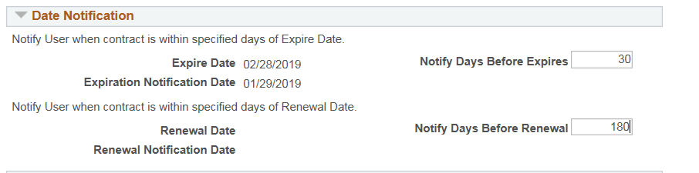
Note: Updating any of these days on the notification page will update the values on the Contract
Maximum Amount Notification
Field | Value
Amount Less than Maximum | Enter a value below the maximum to send a notification  Entering an amount will automatically calculate the percentage
Percent Less than Maximum | Enter a percentage below the maximum to send a notification  Entering a percentage will automatically calculate the amount
*Once entered, the system will calculate and display the notification amount
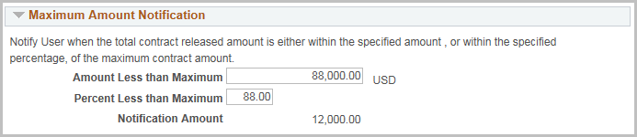
Spend Threshold Notification
Field | Value
Threshold Notification Amount | Enter a value to send a notification

*This will apply to each line on the contract
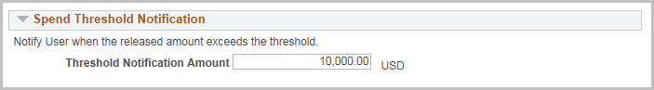
Notification Assignments
Field | Value
Notification Type | Drop down of available notifications
User ID | Select from valid user ids (internal and supplier will use email on profile)

To add multiple users click the +
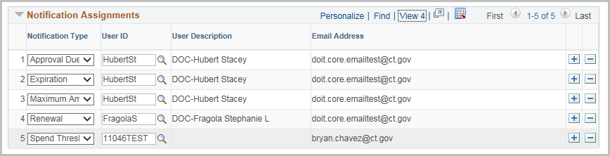
When a threshold is met, an email is generated and in the worklist
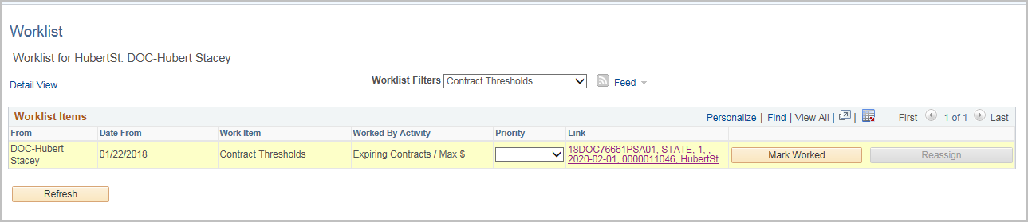

Sample E-mail
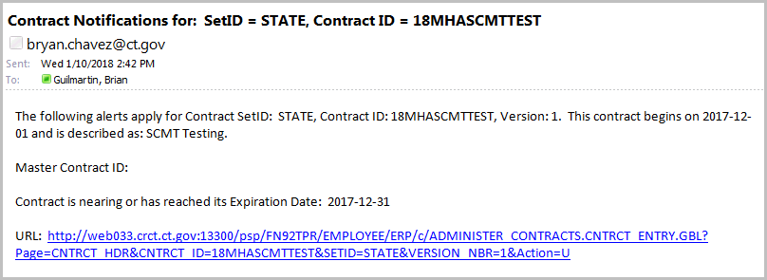
Notifications also appear in the Worklist

Amount Summary
These fields are populated based on the transactions against the contract. This section is also displayed on the Contract Entry page.
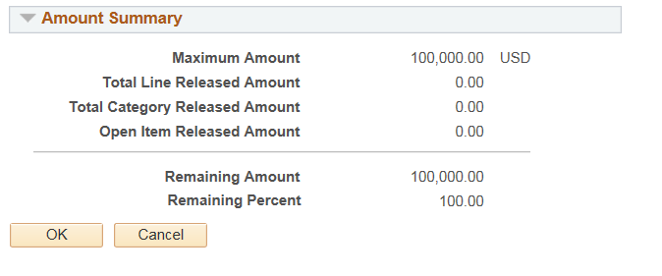
Click OK and return to the Contract Entry page.

