Procurement Contract Creation

Navigation: Main Menu > Core-CT Financials > Supplier Contracts > Create Contracts and Documents > Contract Entry

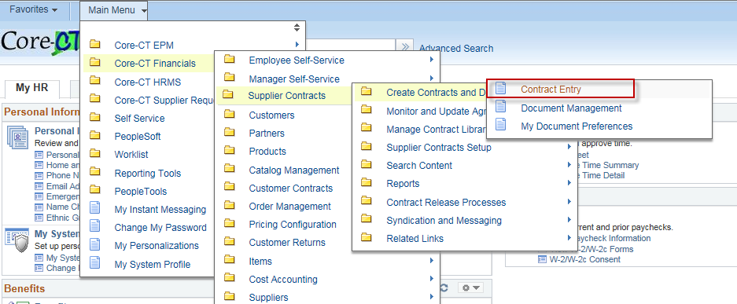

The Contract Entry page will display and the Add a New Value Tab will be active.

Manually enter the contract number in the Contract ID field using the Core-CT numbering schema: two numbers to represent the calendar year, three characters to represent the Agency, four sequential numbers to represent the contract number, and two alphas to represent the vendor.

- The first 2 characters are numeric for the calendar year that the contract is being created in. The example, if the contract is being created in calendar year 2018, the numeric is 18.

- The three characters to represent the Agency: if this contract was being created by the Department of Mental Health, the user would input MHA.

- The four sequential numbers represent the contract number, such as 1111.

- The 2 alpha characters to represent the vendor. In the event that more than one vendor is awarded this contract, these letters differentiate between vendors. The first alphas used would be AA, followed by AB, AC, etc.

In this example the contract number would be: 18MHA1111AA. If there was an additional vendor awarded on this contract the next contract number to be used would be: 18MHA1111AB.
The use of this numbering schema will provide consistency of data entry for all state Business Units.

You have multiple options for the Style ID. The most commonly used are GN (General) and PO (Purchase Order).

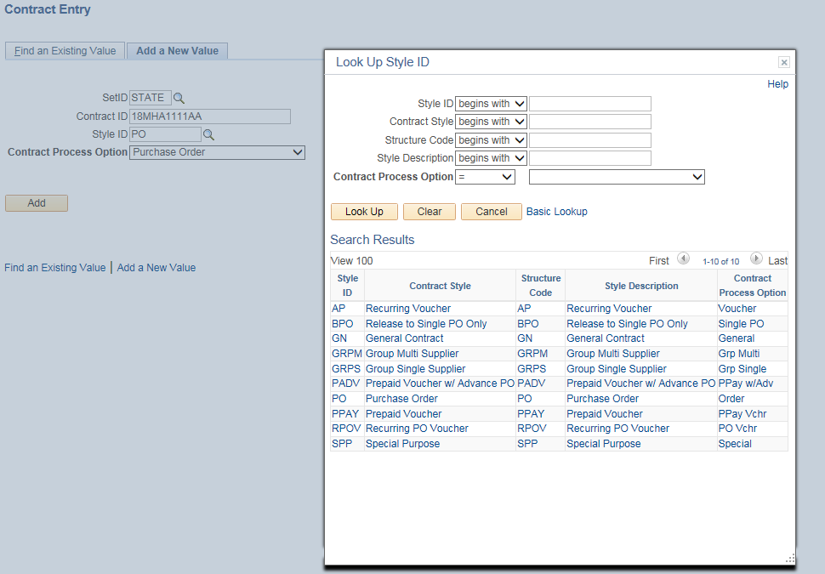

For the Contract Process Option, select Purchase Order from the drop down menu.
Click the button.

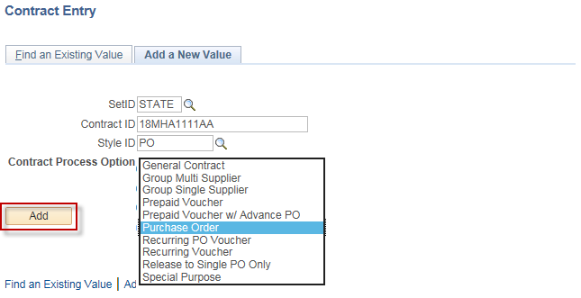

This will take you to the Contract Entry Page. The Contract Entry Page is comprised of five sections: the Contract, the Header, Order Contracts Options, Contract Items, and Contract Categories.

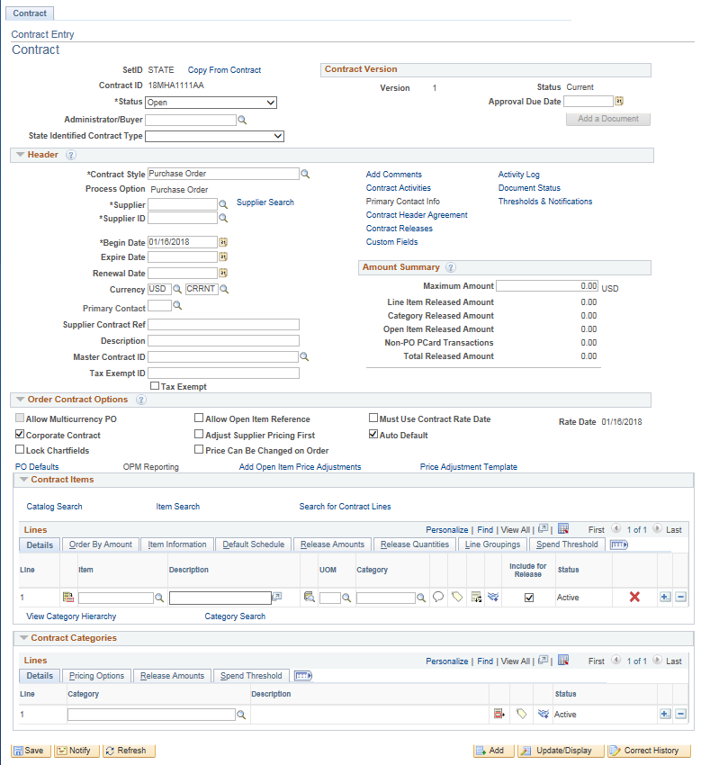
1. In the Contract section, you have the option to copy from a previously created contract. Click on. If you are not going to copy from a contact, skip down to Status.

NOTE: The contract process option must be the same as the contract you are copying from (i.e. General to General or Purchase Order to Purchase Order).

This will open a new screen where you can search for an existing contract by Contract ID, Supplier, or Supplier ID. Use the search icon to look for existing values. Once you have found the contract you are looking for, click .

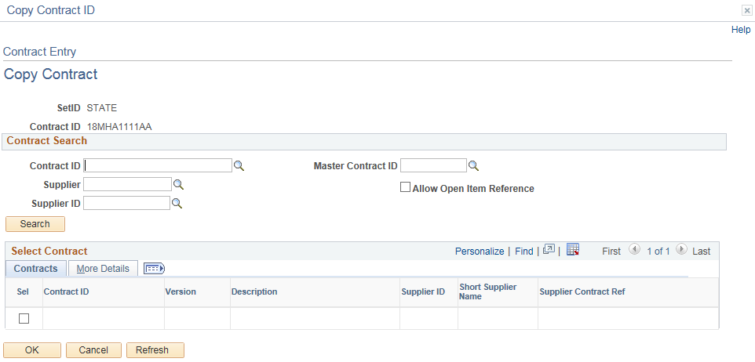

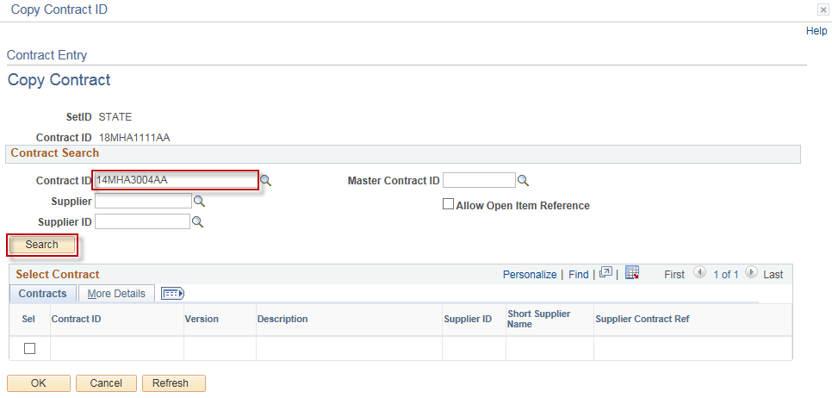
This will bring the contract information down to the Select Contract section. Check the box next to the contract, then click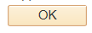.

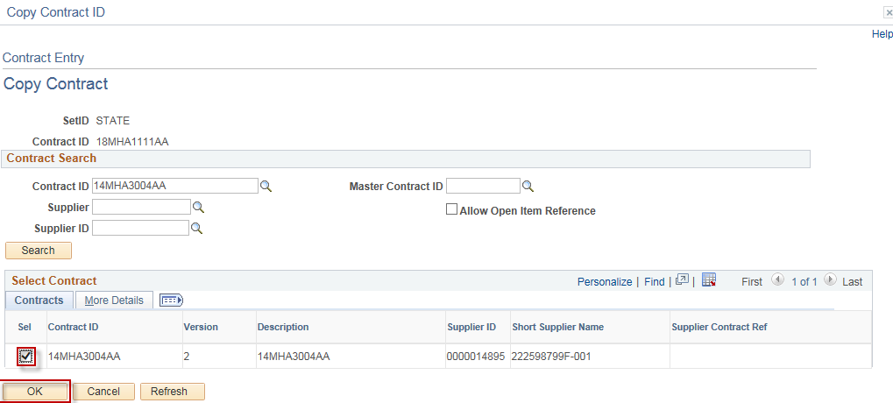

The information from the contract you selected has been copied over. Continue on and make any changes to the fields, if needed.

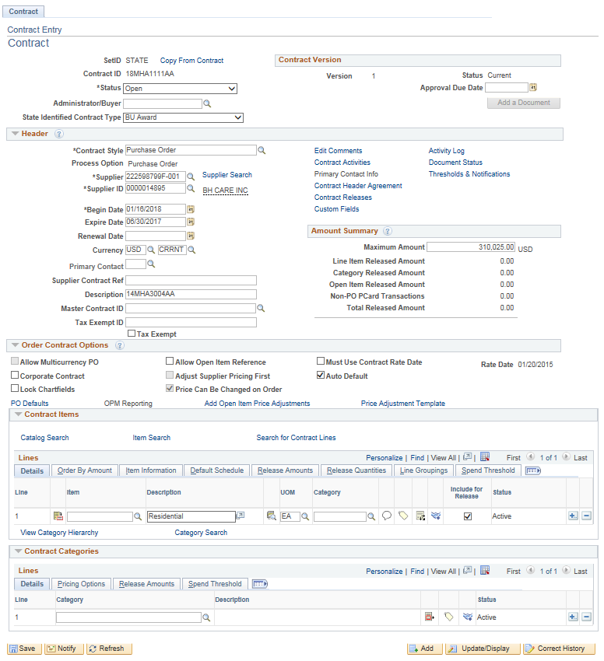

Status: The status of the Contract is Open, since this is a new Contract.

Administrator/Buyer: The originator of the Contract. Enter in the employee’s User ID or search by clicking the search icon.

Contract Version: Effective 07/2017 we no longer use versioning. Since this is a new contract, the value will always be one.You may enter an approval due date if applicable. The following fields must be entered in the Header section:

State Identified Contract Type: There are several types of contracts for selection and this step is very important to identify correctly. Contract Type has an impact on the PO type to be selected on your Purchase Order Header Details Page.

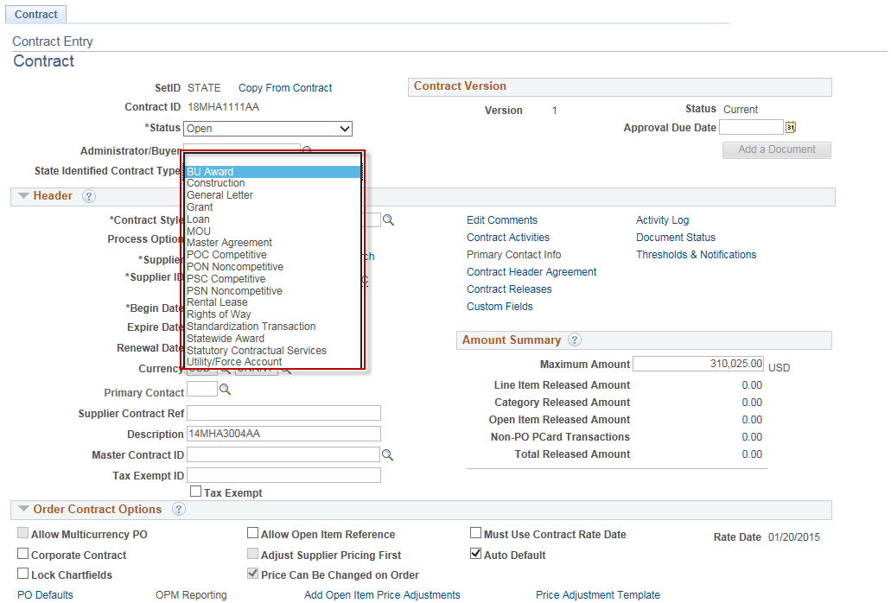

- BU Award - Business Unit Award is a contract that an agency establishes based on statutory purchasing authorities or delegated statutory purchasing authorities. DAS procurement could use this value if they are establishing a contract for a single agency to use (they would need to restrict the business unit to the agency that the contract was developed for on the PO defaults page).

- Constr. - Construction - a contract established by DOT, DCS or any agency that has a construction contract.

- GL – General Letter - (GL71a, b, c, d, e , f, g) used when GL is the delegated purchasing authority.

- Grant – used when a grant award is either budgeted or federally funded between the state and another entity such as another state agency, municipality or not for profit business.

- Loan - used by ECD for the purpose of tracking their loan related contracts.

- MOU – Memorandum of Understanding - used when an agency creates a contract previously known as a Memorandum of Understanding or Memorandum of Agreement.

- MA – Master Agreement - used to contract goods or services resulting from an RFP (Request for Proposal).

- POC Comp - POS Competitive - used by the Social Service Agencies for their Purchase of Services contracts that were competitively bid. Once selected, an OPM Reporting link will become active for use in entering additional required contract information. OPM reporting requires users to enter all the lines for the services provided for this contract type.

- PON Noncom - PON Noncompetitive - used by the Social Service Agencies for their Purchase of Services contracts that were not competitively bid. Once selected, an OPM Reporting link will become active for use in entering additional required contract information. OPM reporting requires users to enter all the lines for the services provided for this contract type.

- PSC Comp - PSA Competitive - used by any agency when Personal Service Agreement contracts that were competitively bid. Once selected, an OPM Reporting link will become active for use in entering additional required contract information. OPM reporting requires users to enter all the lines for the services provided for this contract type.

- PSN Noncom - PSA Noncompetitive - used by any agency when Personal Service Agreement contracts that were not competitively bid. Once selected, an OPM Reporting link will become active for use in entering additional required contract information. OPM reporting requires users to enter all the lines for the services provided for this contract type.

- Rental Lease - Rental Lease - used for Building Leasing or Real Property contracts.

- Rights of Way - Rights of Way - used by DOT for their right of way contracts.

- Stand Tran – Standardization Transaction - used when requesting the waiver of the bid or proposal requirement in accordance with CGS 4a-58. Approval must be obtained by DAS before using this value.

- Statewide - Statewide Award - used by DAS when creating a contract that all agencies can use.

- SCS – Statutory Contractual Services – used by DAS and DOT only for statutory contractual services. Once selected, an OPM Reporting link will become active for use in entering additional required contract information. OPM reporting requires users to enter all the lines for the services provided for this contract type.

- UFA – Utility Force Account - used by DOT for their Utility Force Account.

Once a POC/N, PSC/N or SCS Contract Type is selected, the OPM Reporting link is activated (See section 3 for details on OPM Reporting).

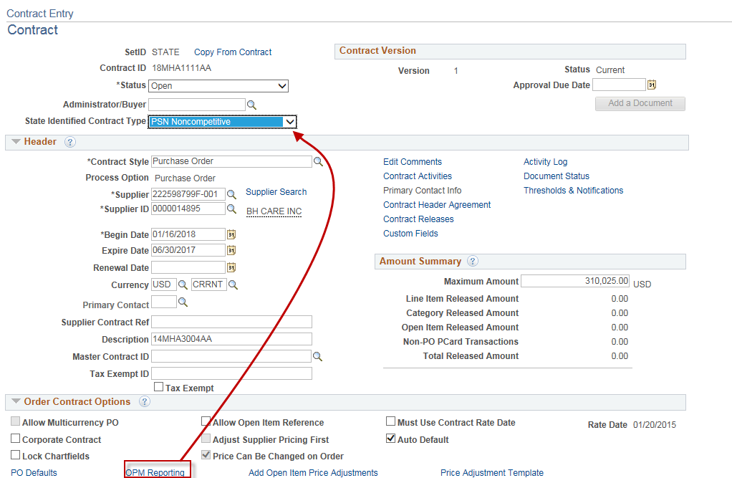

Complete the fields with appropriate information (See section 3 for details on OPM Reporting).

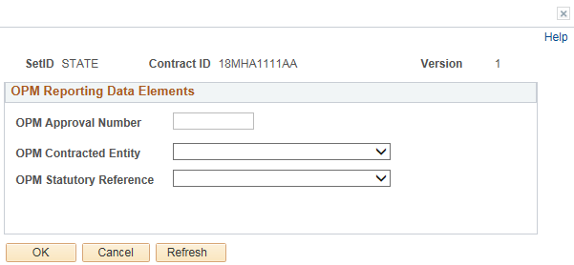

2. In the Header Section - If the Copy from Contract option was not used enter the Supplier. Use the link to find the supplier to be associated with this contract.

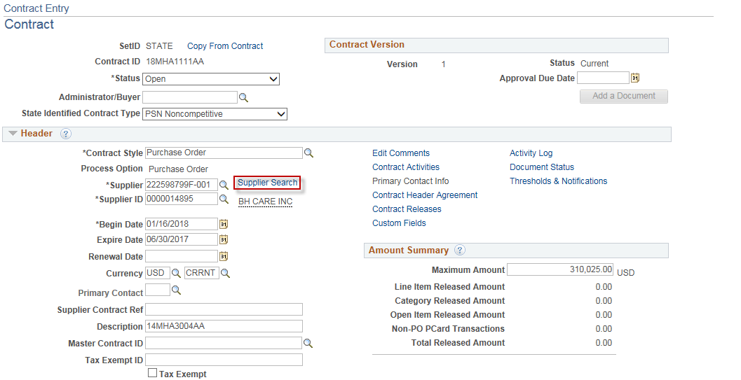

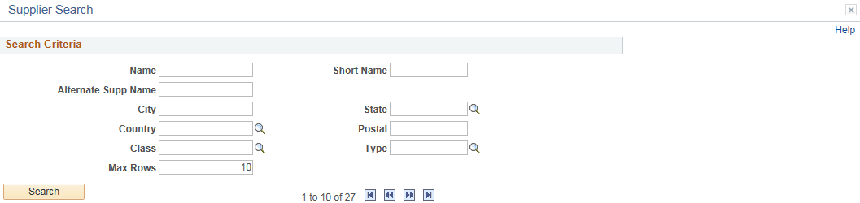Fill in any of the fields to retrieve the supplier and then click. Results returned will show in the Search Results view.

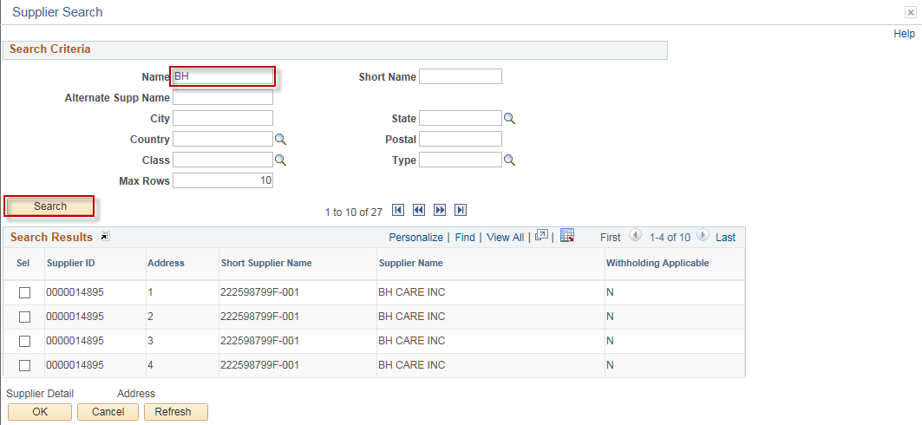

To view information about the supplier; place a check in the Sel checkbox, and click or.

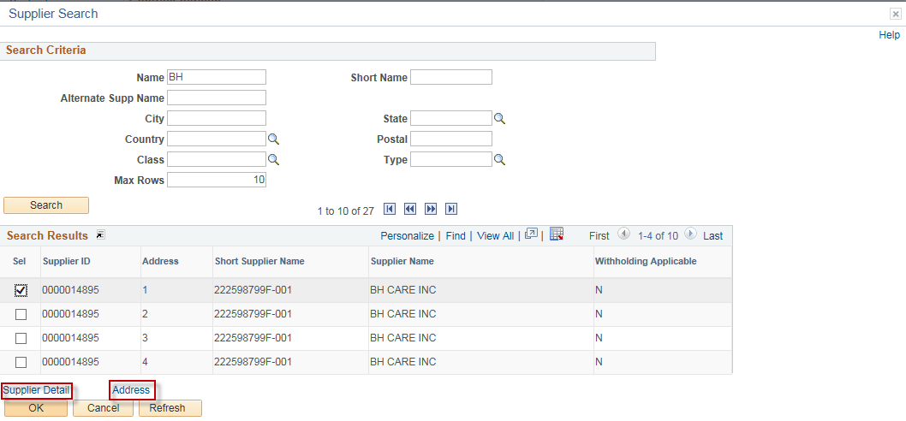

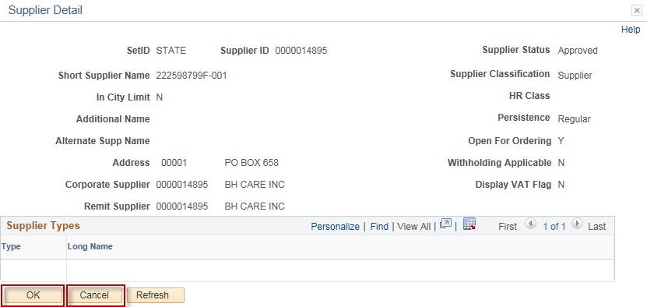

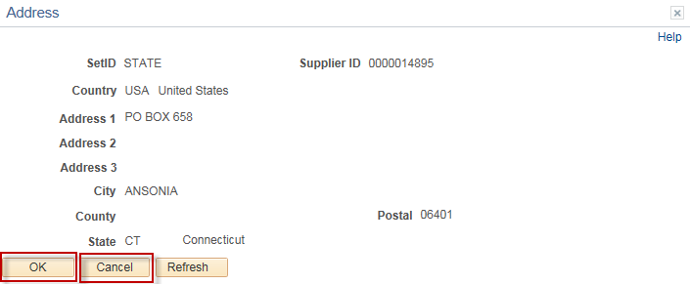

Click or to return you to the previous screen, so you can select the supplier for the Contract.
Select the supplier by placing a check in the Sel checkbox and click the 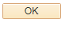 button. This will bring the supplier data onto the Contract Header page.

If the supplier does not exist in the Core-CT system, please contact OSC for the necessary forms to request an addition to the supplier file. This process is now done in Core please refer to the Core website for job aid.

Continue entering Header Information:
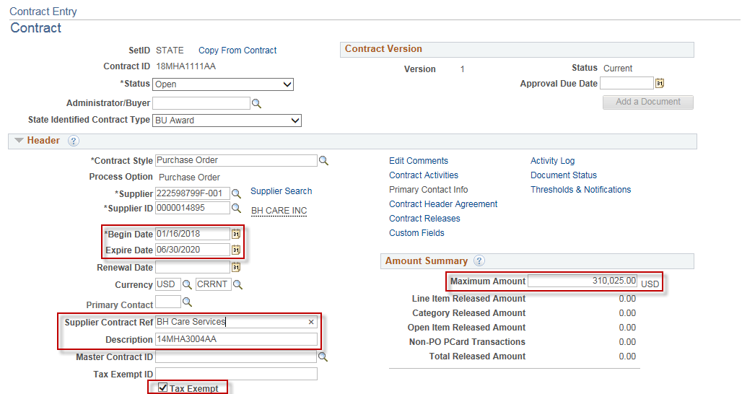

Begin Date: The Begin Date of the contact defaults in with today’s date. If you enter a future begin date, this contract will not be available for selection in the Contract ID field of Purchase Orders until the begin date.

Expire Date: This is the date that the contract ends. After that expiration date has passed, the contract is no longer available for selection in the Contract ID field of Purchase Orders. In the future, this field will also be used to archive data off of the system.

Renewal Date: This field is optional. The date the contract is up for renewal.

Supplier Contract Ref: This field is optional. The field size is 30 characters.

Description: The Description field is optional for use. The field size is 30 characters. This field is viewable when searching the supplier contracts field in online PO creation. It is good practice to utilize the Description field to assist in identifying the contract.

Master Contract ID: This field is not used.

Tax Exempt: You can copy the tax exempt information from the PO Defaults.

Maximum Amount: Enter the maximum amount that can be released and paid against this contract.

3. The following fields need to be entered or updated in the Order Contracts Options Section:

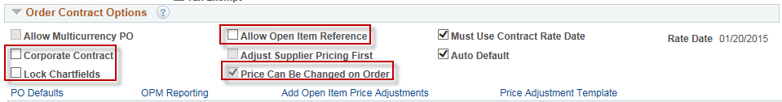

- If the contract that you are creating is only for your agency’s use, uncheck the Corporate Contract checkbox (the Corporate Contract checkbox is used for DAS statewide contracting. Selecting this checkbox allows all Business Units to utilize the contract and the Business Unit on the PO Defaults link is set to DASM1).

- Select Lock Chartfields if you do not want the chartfields on your PO to be different than what you entered in your contract.

- The Allow Open Item Reference should NEVER be selected for POC/N, PSC/N or SCS contracts types, if selected you will not be able to save the contract. For other contract types, selecting this checkbox would allow the purchase of all items from this supplier within the scope of the procurement contract.

- Select the Price Can Be Changed on Order checkbox; this will allow PO change orders to be created for POs associated with this contract.

For PSC/N, POC/N and SCS type contracts click on the OPM Reporting Link.

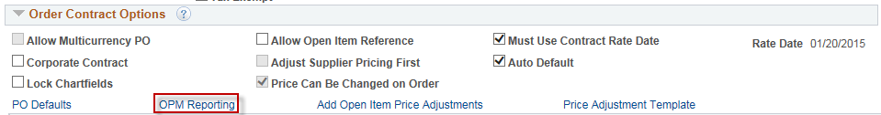

OPM Approval Number: enter the log number from the approved OPM PSC/N or POC/N Request form. (e.g., 2018-0116) If your contract falls below the dollar thresholds, and OPM Approval is not required, type Not Reqd in this field.
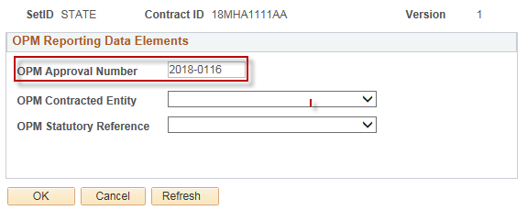

Select the appropriate OPM Contracted Entity from the dropdown list.

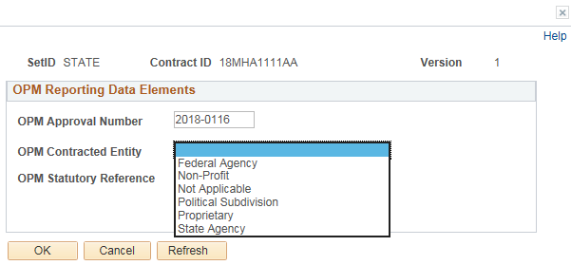

Select the appropriate OPM Statutory Reference from the dropdown list.

CGS 13B-20B Consultant Services, DOT
CGS 4A-50 Contractual Services
CGS 4B-55 Consultant Services, Construction
CGS 4D-2 Consultant Services, use w/contract type SCS only
Not Applicable When the Statutory Reference is not one of selections listed above.

Please refer to the statutes for a more detailed explanation.
Click  once you have entered data in the three required fields.

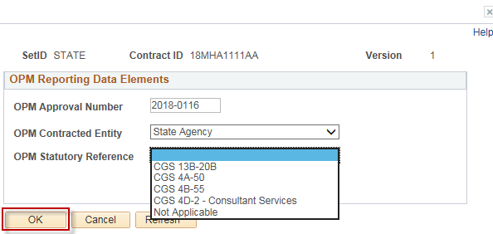

In the Order Contract Options section click on (this is mandatory, even if you are not entering defaults here).

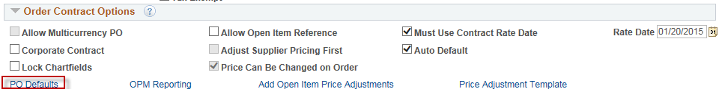

The PO Defaults page will open. Verify that your agency business unit has defaulted in the Business Unit field. If DASM1 defaults in, you will need to change this to your agency’s business unit.

Your AM Business Unit may default in. If not, enter manually if needed. You will only have to update this field if DASM1 defaults in instead of your agency business unit.

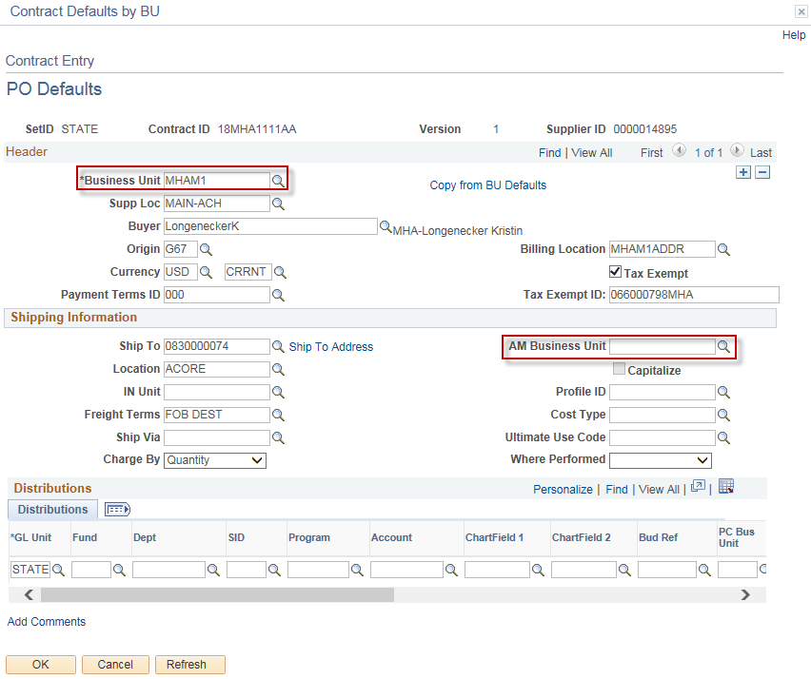

If your agency has multiple Business Units that should transact utilizing this contract, use the plus button to add additional Business Units.

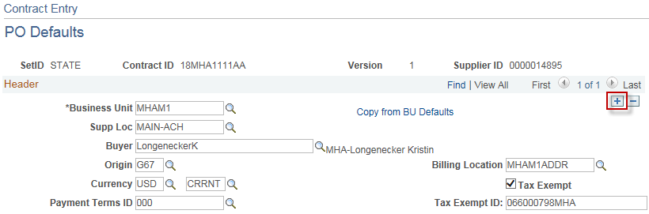

You will see that your Tax Exempt ID populates. You should copy this information back into the Header Information section on the Contract Entry page.

Note: You will also have to check the Tax Exempt box.

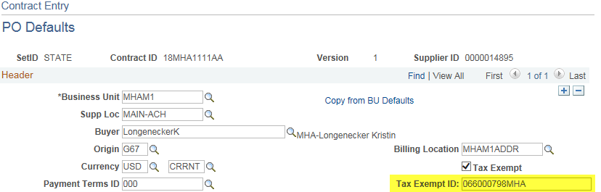

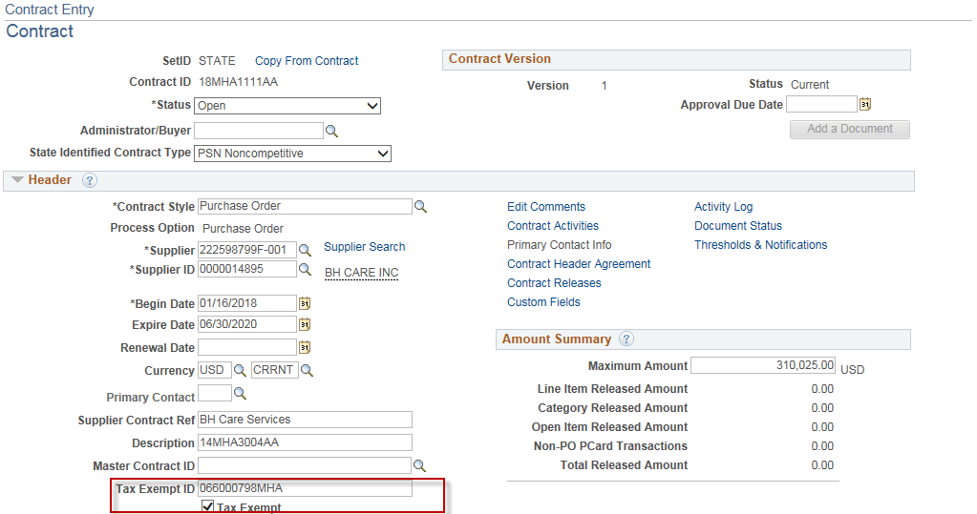

The Payment Terms ID is populated with 000 (Due Immediately – No Discount). If your supplier has offered a different pay term select the appropriate pay term from the list.

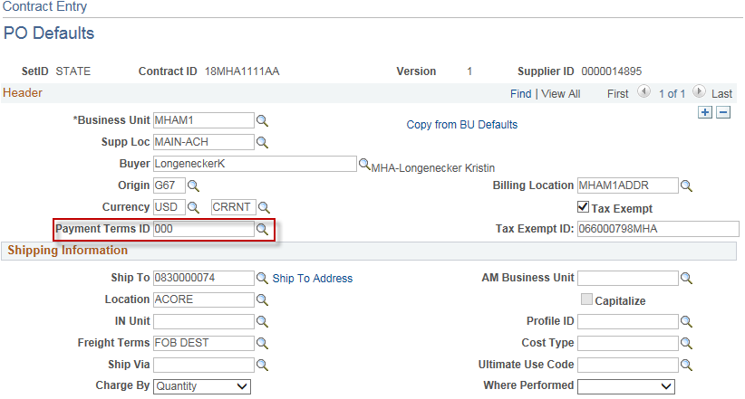

If the pay term offered is not included in the list, please refer to the Core website for the form to use and create a Footprints ticket for CoreCT help desk to enter in CoreCT.

If your PO from this contract is to be amount only, then you would need to change the Charge By field from Quantity to Amount.
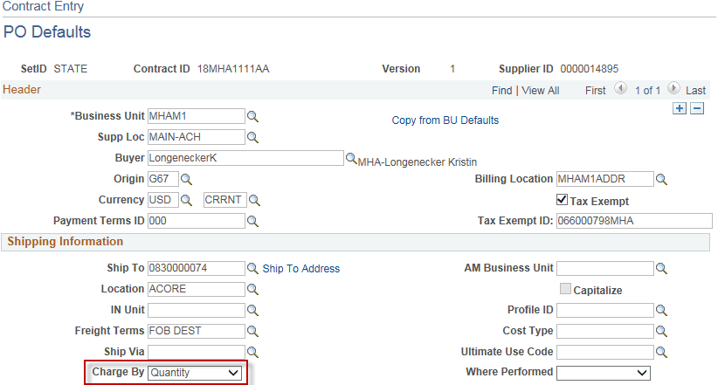

Do not enter Chartfield information on the PO defaults page. Enter it directly on the distribution for each contract line that is entered.

Click

You will return to the Contract Entry Page.

4. Go to Contract Items.

Enter a clear description of 10 words or less of the good or service contracted for in the Description field (max 254 characters). Agencies can reference their program tree to assist in a standard description. For PSC/N, POC/N and SCS CT Contract Types, these are required fields. You will not be able to save your contract if these fields are not entered. Add an additional line for each contracted service.
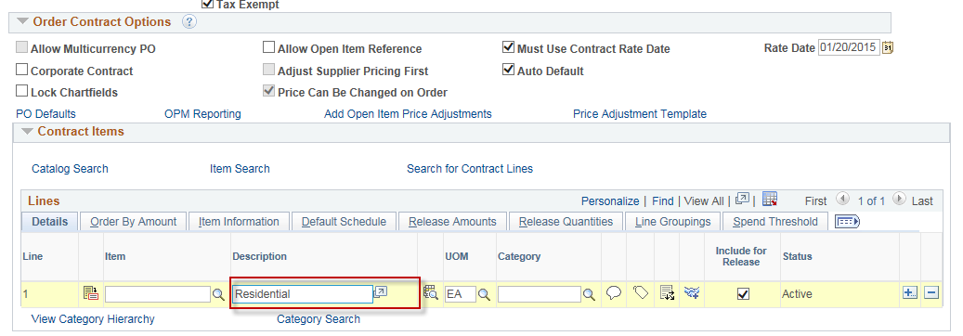

(To view the entire description, click. This will open an expaned window view.)

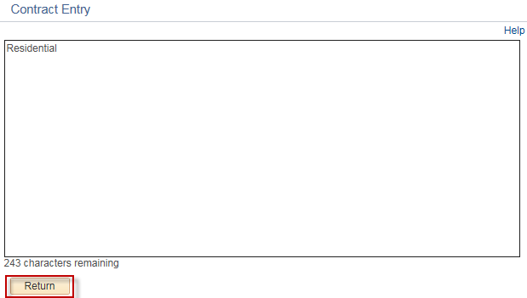

Click to return back to Contract Entry.

Enter the UOM - Unit of Measure. This field must be entered.

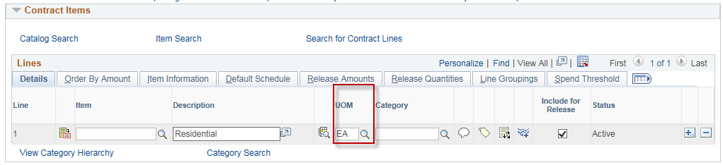

Enter the correct Category. This will bring in the account on the PO. This can be changed if necessary.

Use of the category 00000000 or CT_UNSPSC is unacceptable on any contract, PO or requisition. These values were included for use by requesters on requisitions if they did not know the correct category. It is the responsibility of the Purchasing Approvers to apply the correct category code prior to approving.

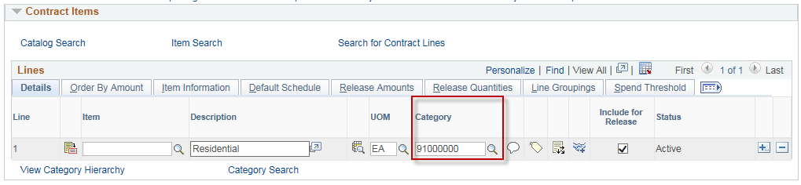

Click the Line Details Icon to access all tabs.

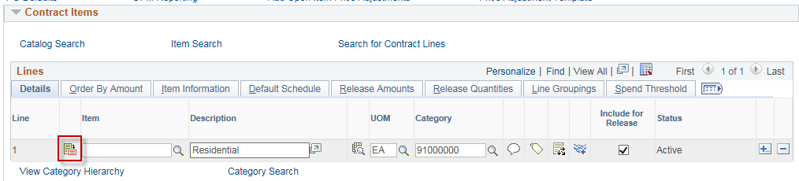

Select to view all Details for Line 1.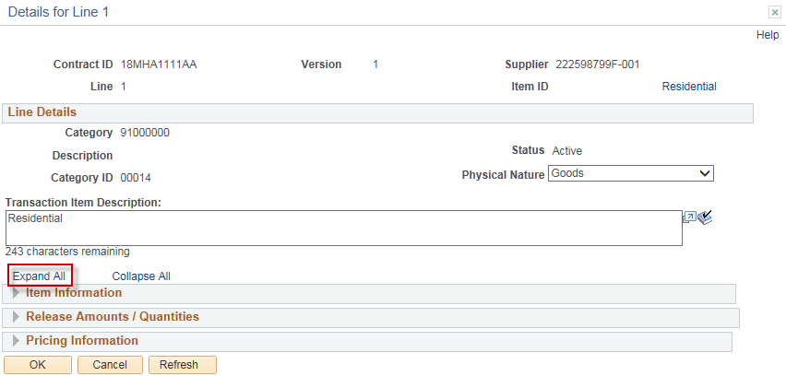
Select the appropriate choice (Goods or Services) in the Physical Nature field.

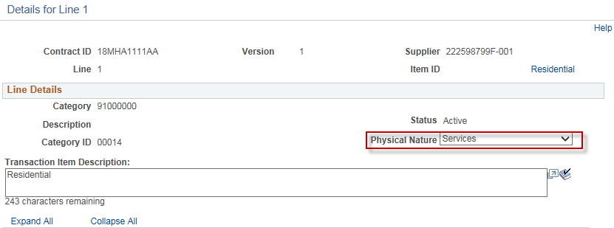

Place a check in the checkbox for Price Can Be Changed on Order.

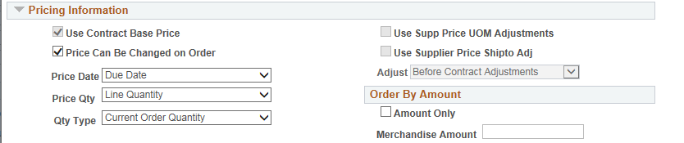

FOR AN AMOUNT ONLY CONTRACT:

Order By Amount - If this is amount only, check the Amount Only checkbox.
Reconfirm that you have selected Amount in the Charge By field on the PO Defaults.

Merchandise Amt - enter the amount for the line.

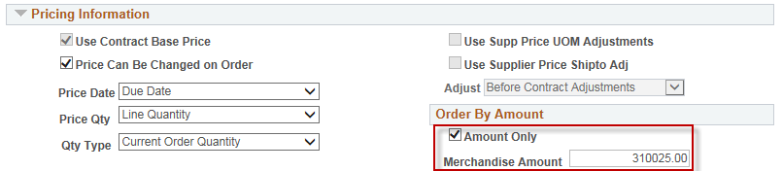

FOR A QUANTITY CONTRACT:
UOM/Pricing – enter a Base Price equal to the price for this line.
Review the Price Loc (Pricing Location). This should default from Contract Entry page.
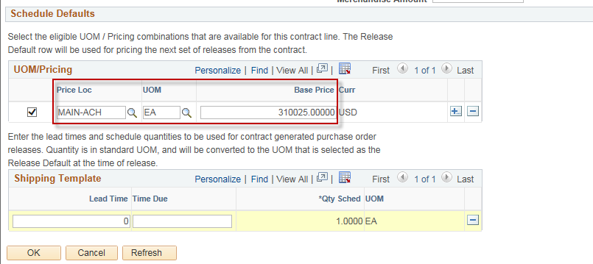

Click.

You will be returned to the Contract Entry Page.

Repeat the steps above for each contract line entered.

Click on the PO Distributions Details icon.

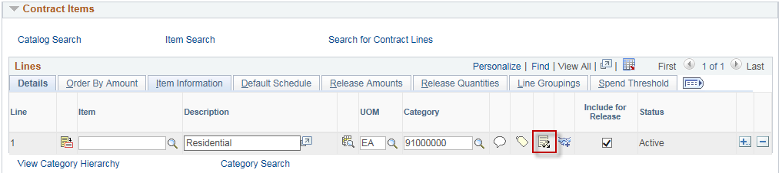

Fill in the appropriate chartfield information here.

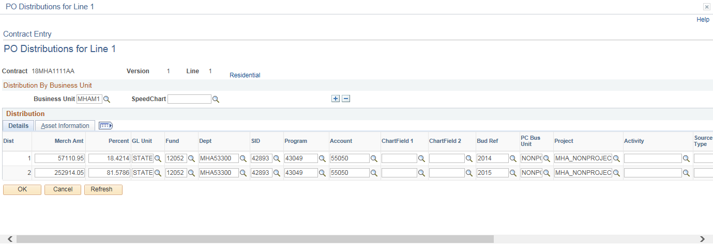

Select to add additional distribution lines.

Repeat this step for each contract line entered. It is mandatory that agencies enter Chartfield values on the distribution line for each line of the contract.

This will copy to the PO when utilizing the Copy from Contract feature when creating an online purchase order.

Click when you are done.

You will be taken back to the Contract Entry Page.
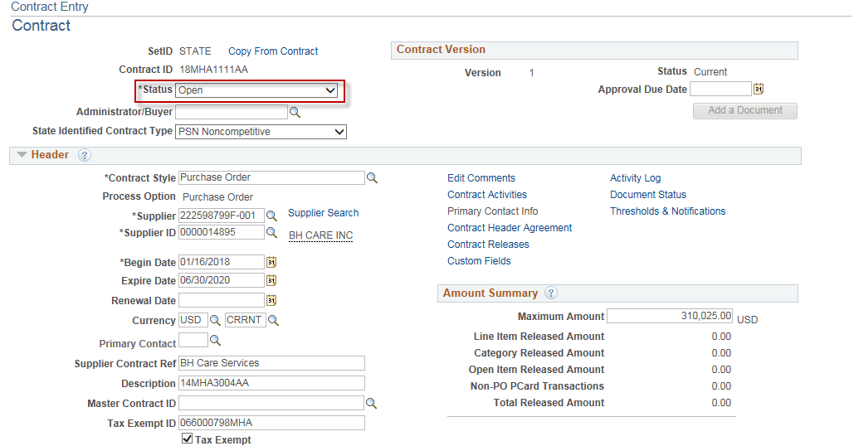

Place the contract in approved status by updating the Status field if you have the authority to do so. If you do not have the authority to approve a contract, leave the contract in Open status and contact the appropriate person in your agency who can approve this contract.

Click to save the contract.

