SCMT Document Creation
User must have CT_F_A_SCMT_USER or CT_F_A_SCMT_ADMIN role

Define User Preference Supplier Contract Management

This page is for Core Support, each SCMT User or Admin role needs user preferences updated.

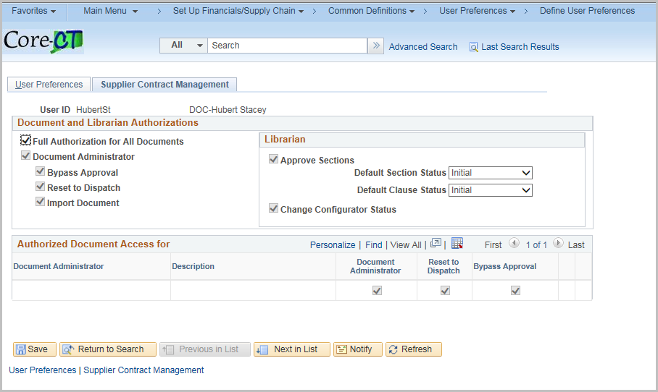

Navigation: 1st Supplier Contracts > Create Contracts and Documents > Contract Entry
2nd Procurement Contracts > Add/Update Contracts

(either Navigation will work)

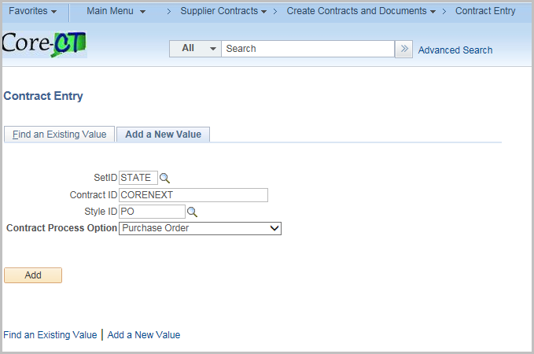
Click the Find an Existing Value Tab
Enter or search for the Contract
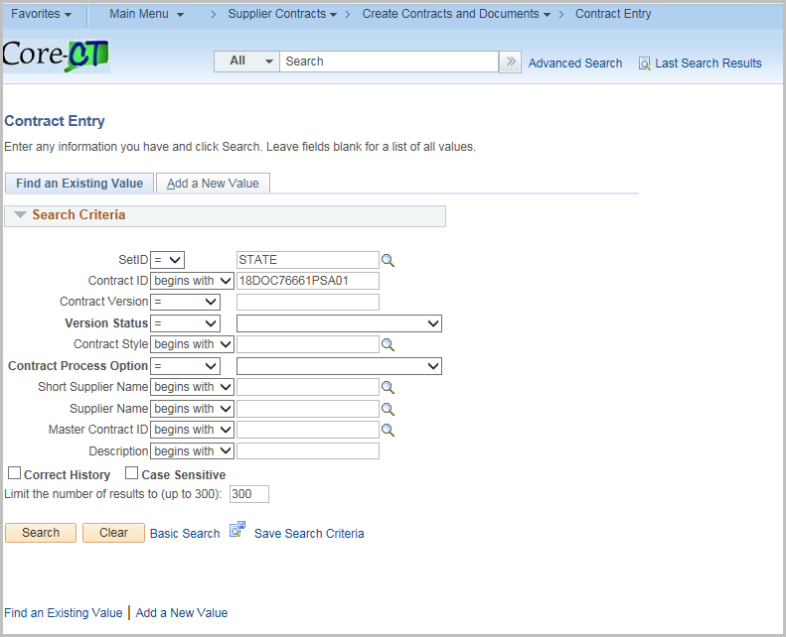
Click Search
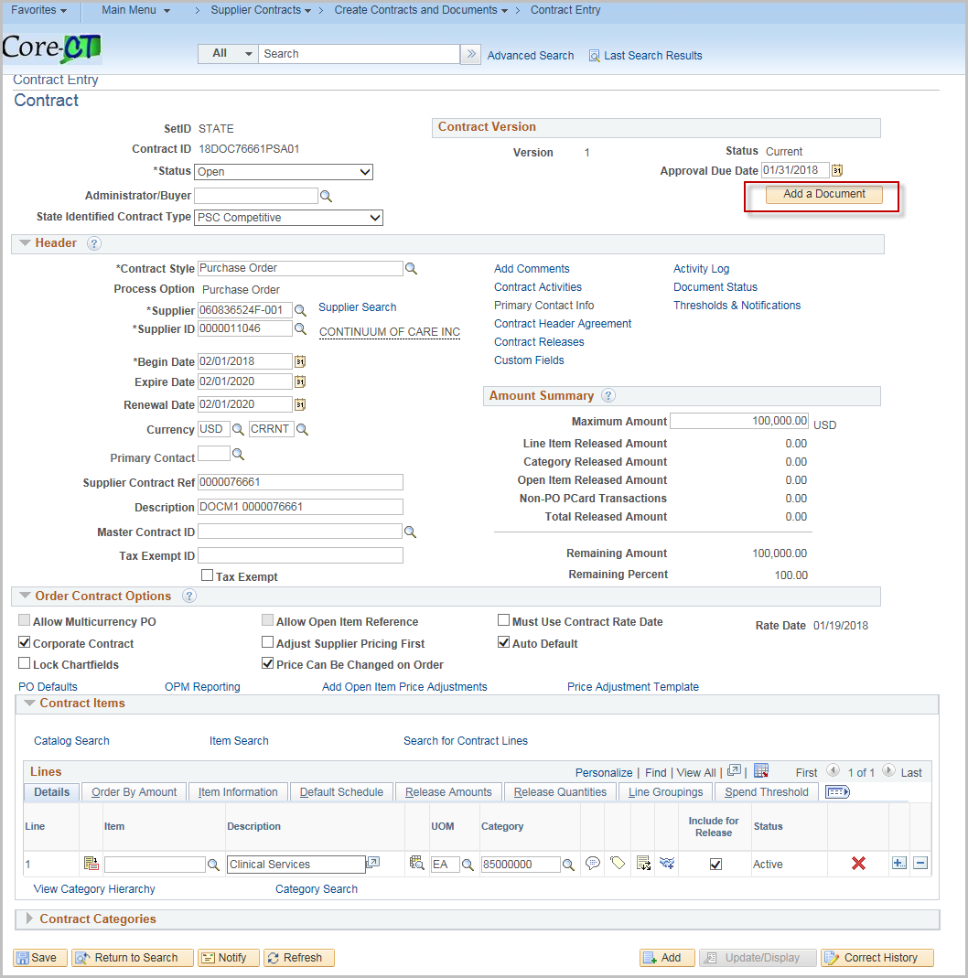
Click Add a Document
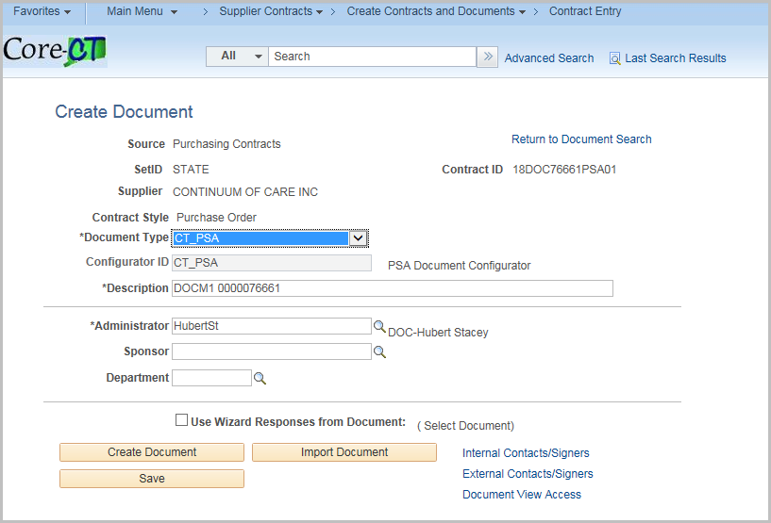
Select CT_PSA Document Type
Click Create Document – to launch the Wizard Execute – Document Creation
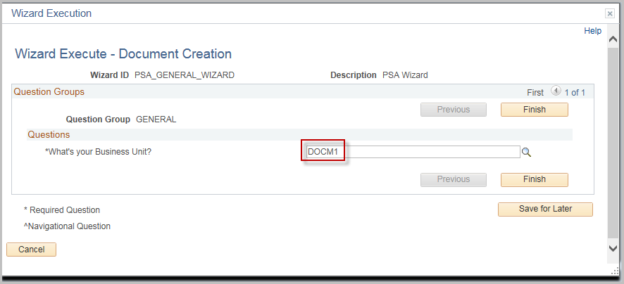
Enter the Business Unit

Click Finish

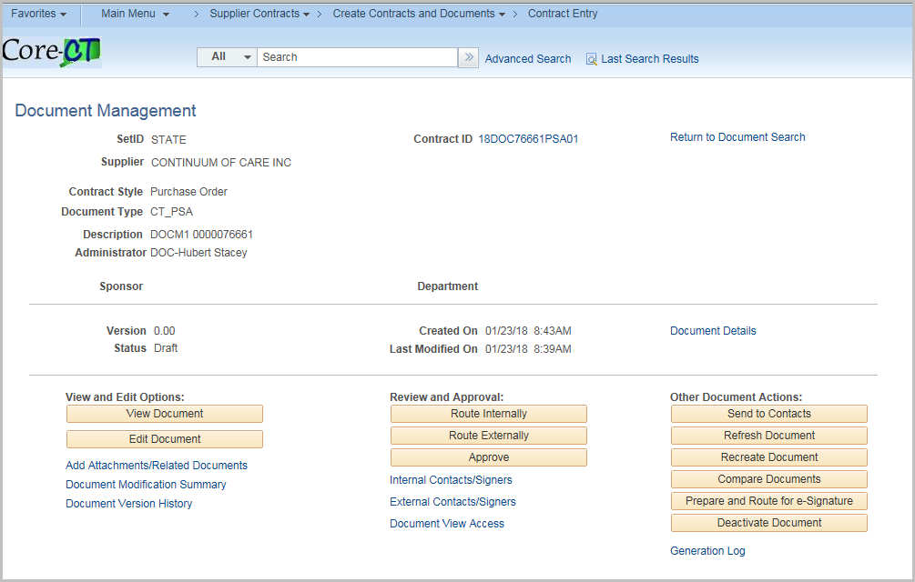

Once the Supplier Contract process has begun the Procurement Contract will update with the corresponding Supplier Contract Status/Version/Amendment.

To access the Supplier Contract click Maintain Document

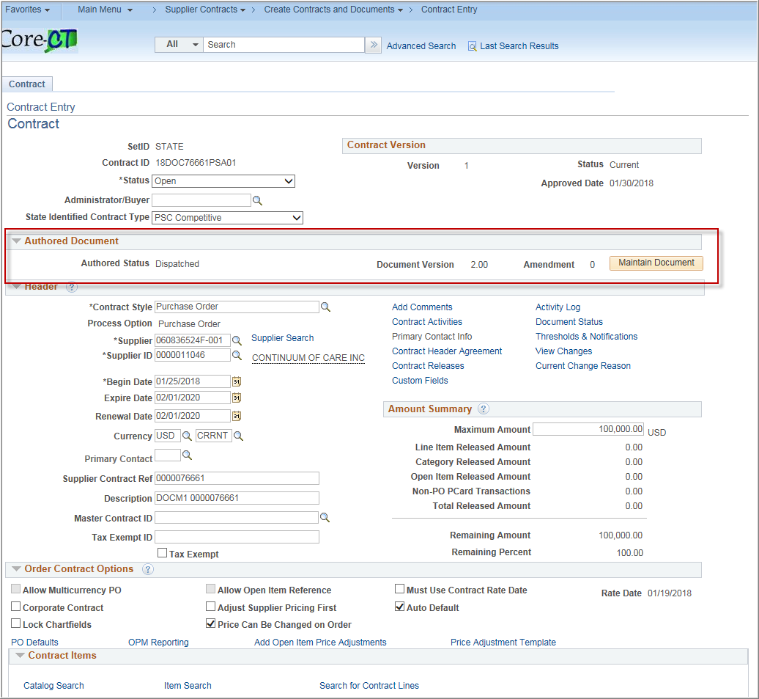

Document Management
User must have CT_F_A_SCMT_USER or CT_F_A_SCMT_ADMIN role

Return to Document Search
Click the return to Document Search to search for another contract

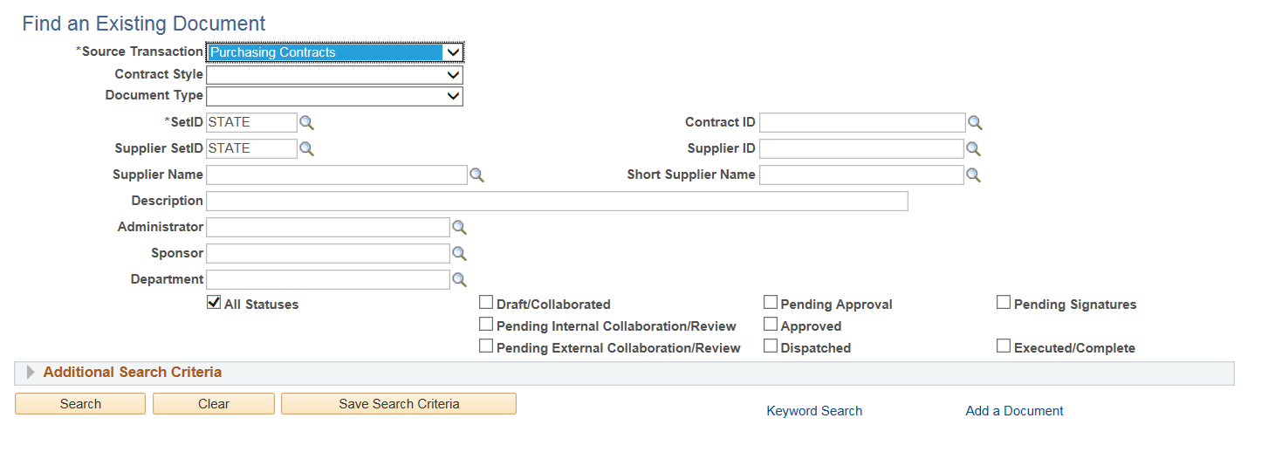
Change the Source Transaction to Purchasing contracts
Enter the criteria and click search
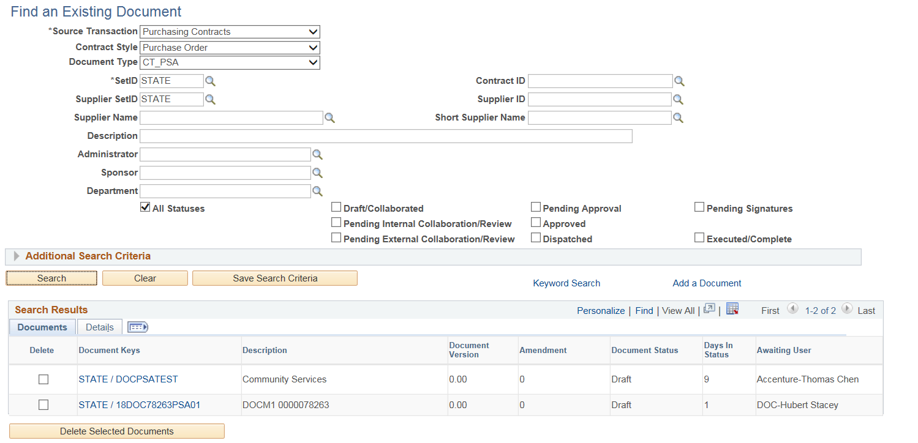
Choose the contract you want by clicking the Contract id under Document Keys. This will take you to the Document Management Page
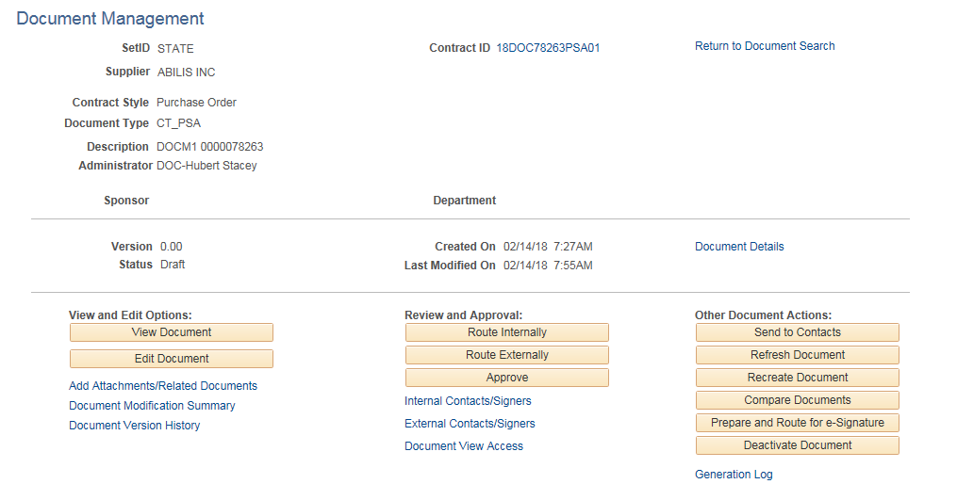

Document Details
Click Document Details for an overview of the contract
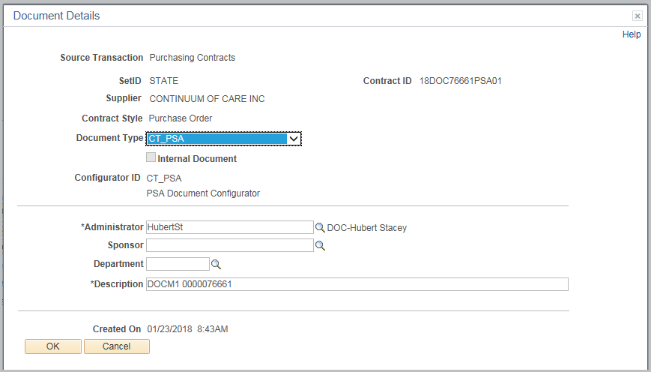
Click Ok

