Internal and External Collaboration

Click the Route Internally button to setup and start internal collaboration.

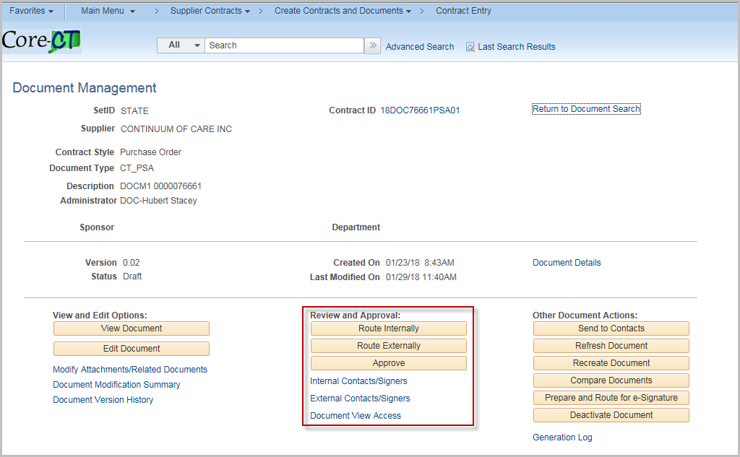
(Alternately Click Internal Contract/Signors to set up internal users)
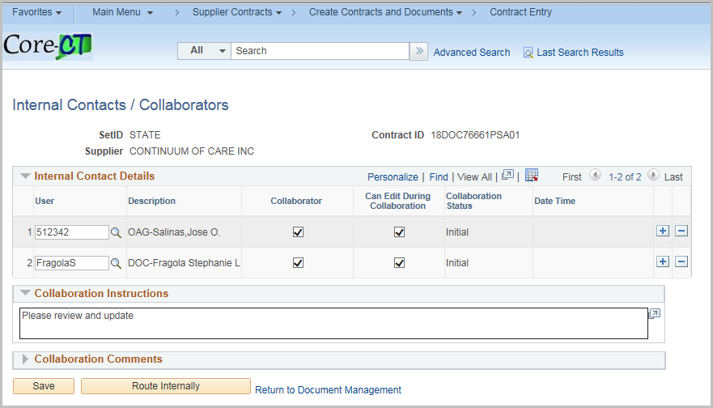
Enter or search for a valid User.
Check the Collaborator box if the user will be collaborating on the document
Check the Can Edit during Collaboration if the user can modify the document
Collaboration Instructions – Enter any special instructions

To add a Comment to the collaboration without routing, enter the comment

Click Save

Click Route Internally when you are ready to send.

NOTE: Any Collaboration Instructions will be sent to all collaborators

Internal Contacts/Signers

Click the Internal Contacts/Signors
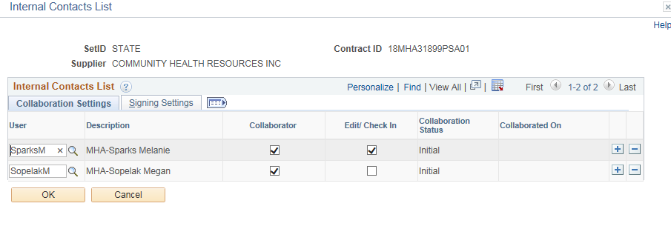
Click Signing Settings Tab
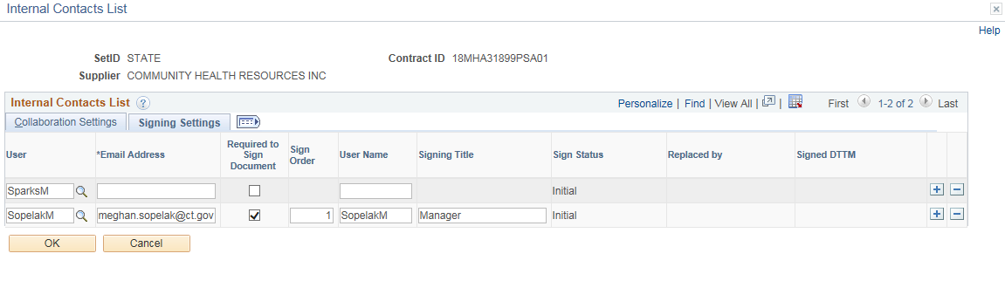
Enter in an email address
Check Required to Sign Document if they will sign
Enter the Sign Order
Enter the User Name
Enter the Signing Title
Click OK

At this Point provided you do not need to Cancel or Modify the Internal Collaboration (steps shown below) the document is routed to the appropriate users for Internal Collaboration.
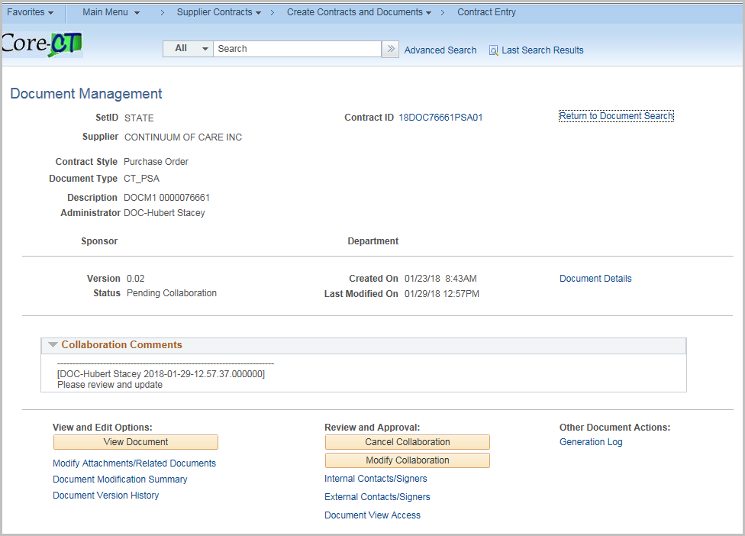

During collaboration, certain features are disabled.

To cancel the Collaboration, click Cancel Collaboration

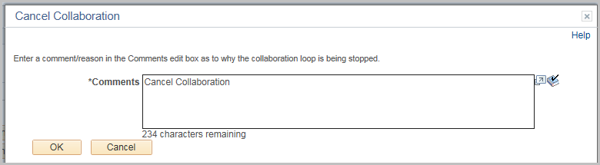

Enter a comment (required) and click OK

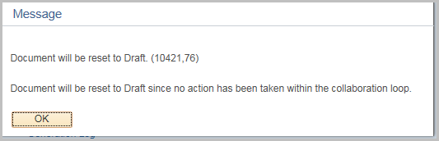

Click OK

In this instance the document is reset.

To modify the Collaboration, click Modify Collaboration
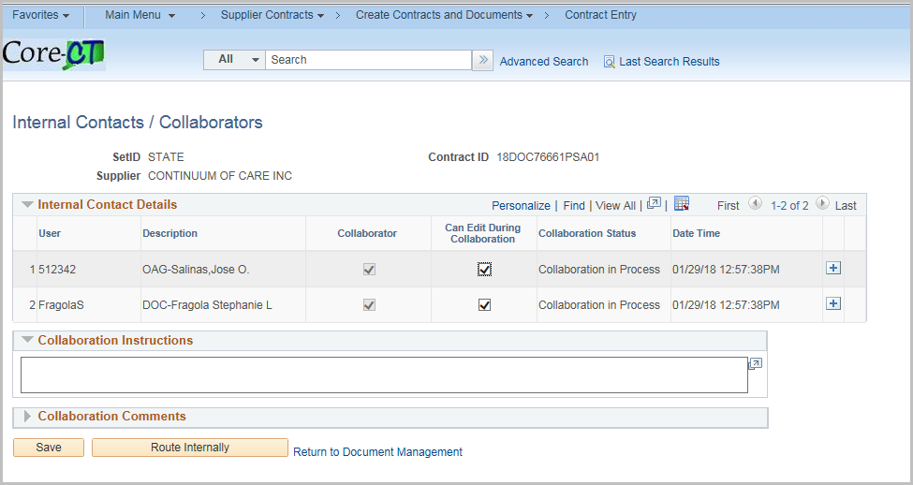
New users and instructions may be added.

Click Route Internally to update.

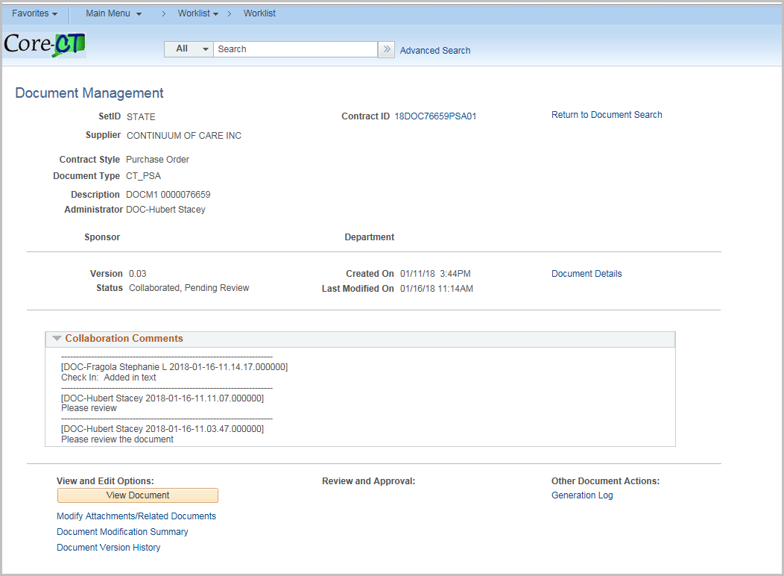

All collaborators will receive an email and can go directly to the Document Management page for the link in the email….
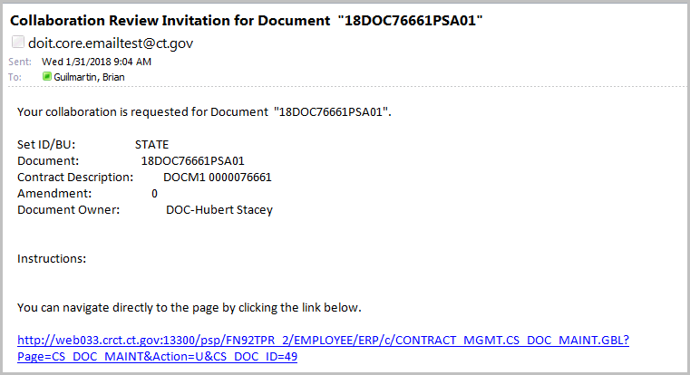
Or the collaboration request can be accessed in the user’s worklist

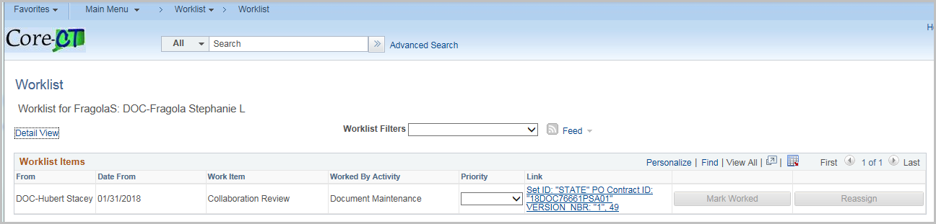

Clicking on either will bring the user to the document management page
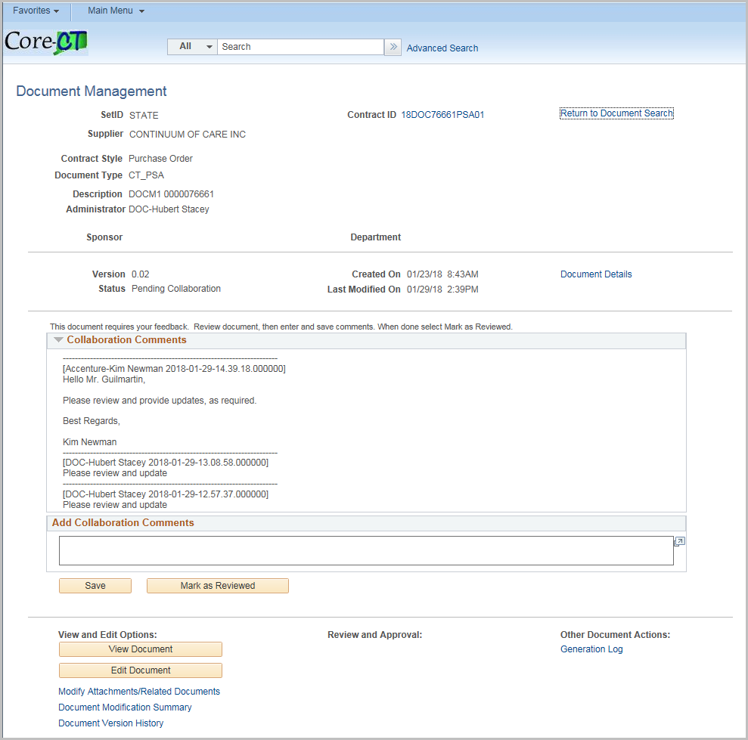
The user can view or edit the document and modify attachments. When editing you must save the document and then upload it with comments.
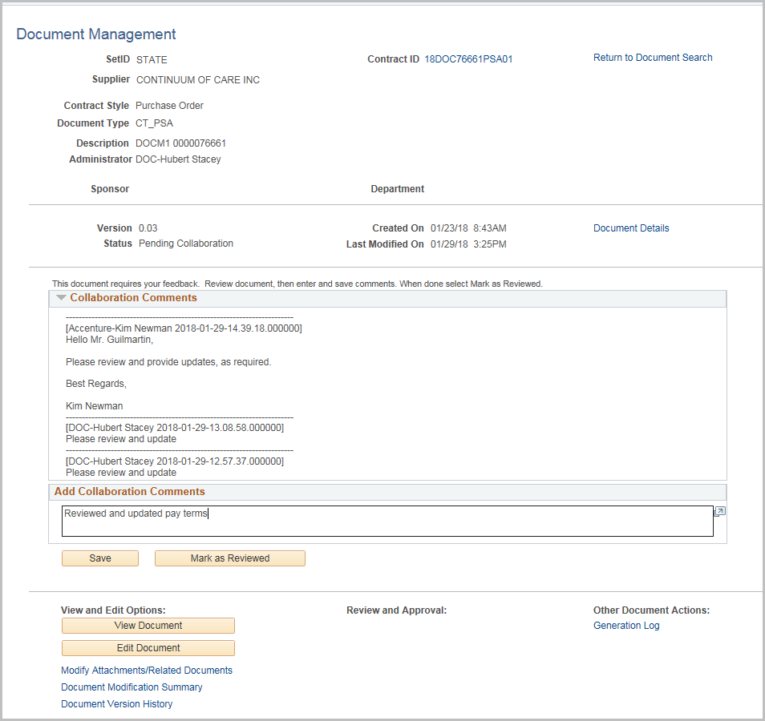
Enter in a comment and click Mark as Reviewed
After all internal users have finished collaboration; the contract administrator will see the Collaboration Complete on their worklist
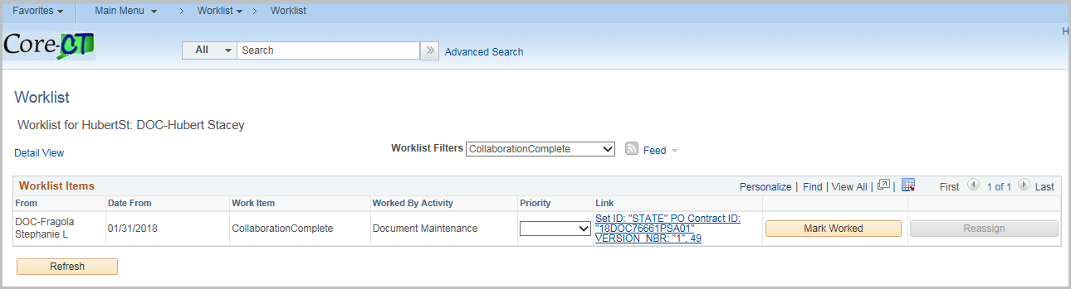
Click on the hyperlink 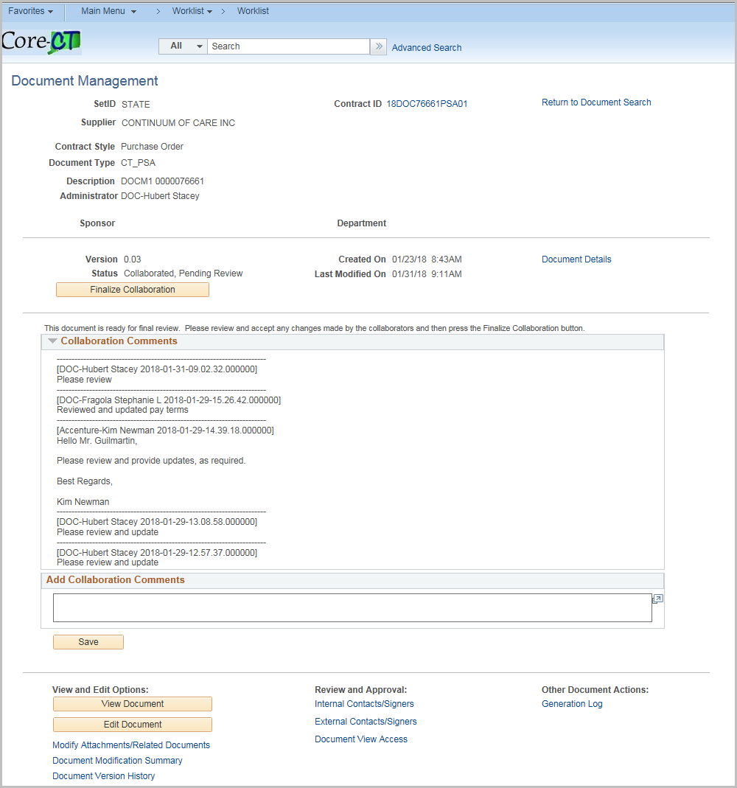
Review the contract changes.
Once all changes are finished, click Finalize Collaboration
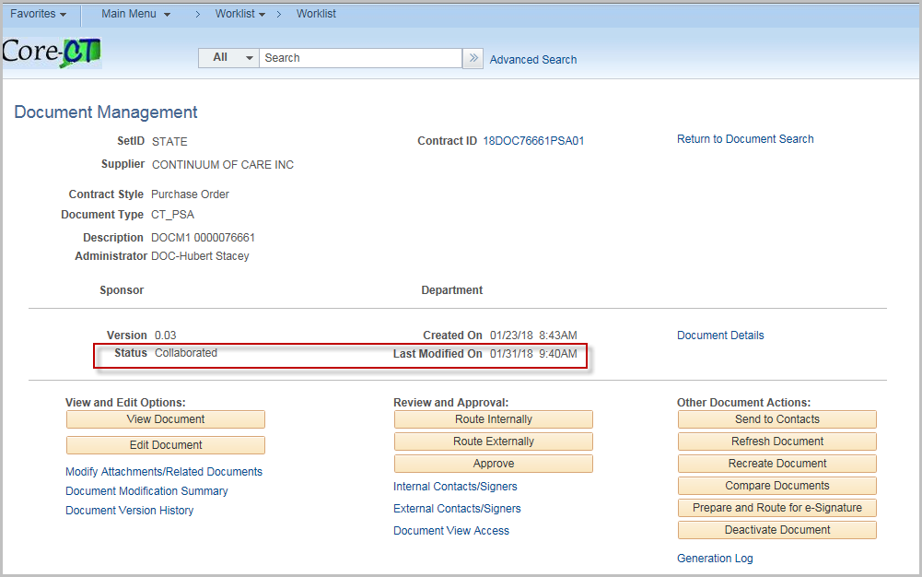
The status will be updated to Collaborated.

Route Externally

External contact must have the CT_F_SUPPLIER_SCMT_COLLAB role
NOTE: External Contacts must be setup under External Contact/Signers before starting External Collaboration.
Click External Contacts/Signers 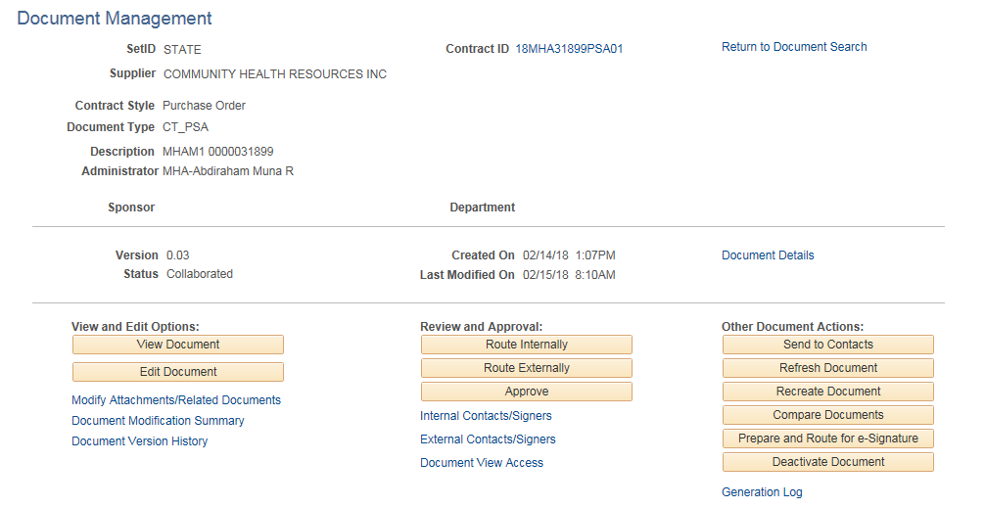

Click the Update From Supplier Contracts to pull all external contacts with the Contract Collaborator role into the external list.

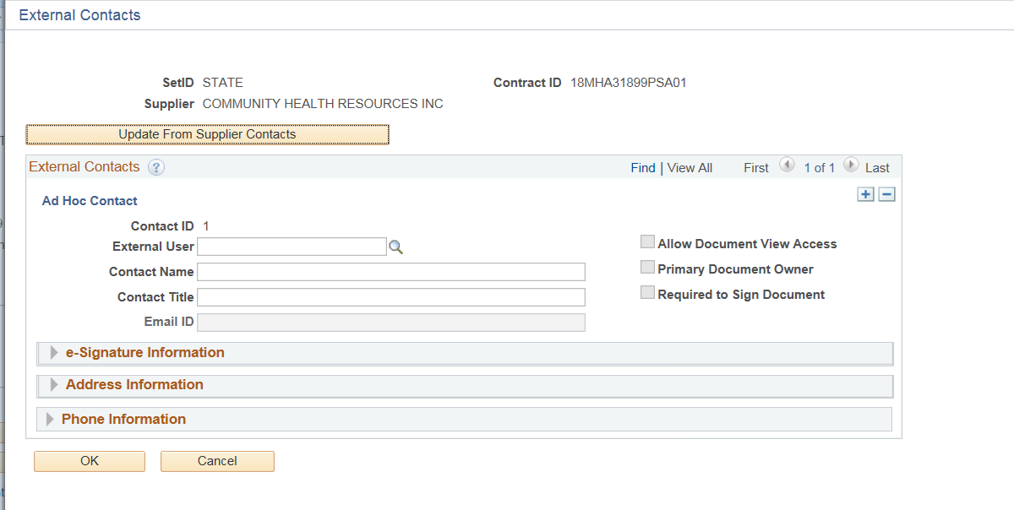

INPUT Necessary Information for Supplier for External Collaboration

Enter or search for an External User
Enter a Contact Name
Enter a Contact Title
Enter an email id
Check Allow Document View Access to allow the contact view access to the document
Check the Primary Document Owner if the contact is the primary (Only one per Contract)
Check Required to Sign Document is they are a signer for the document
On the e-Signature Information enter the Sign Order
Enter the Address and Phone information as necessary
Click the + to add more contacts

Once completed click OK
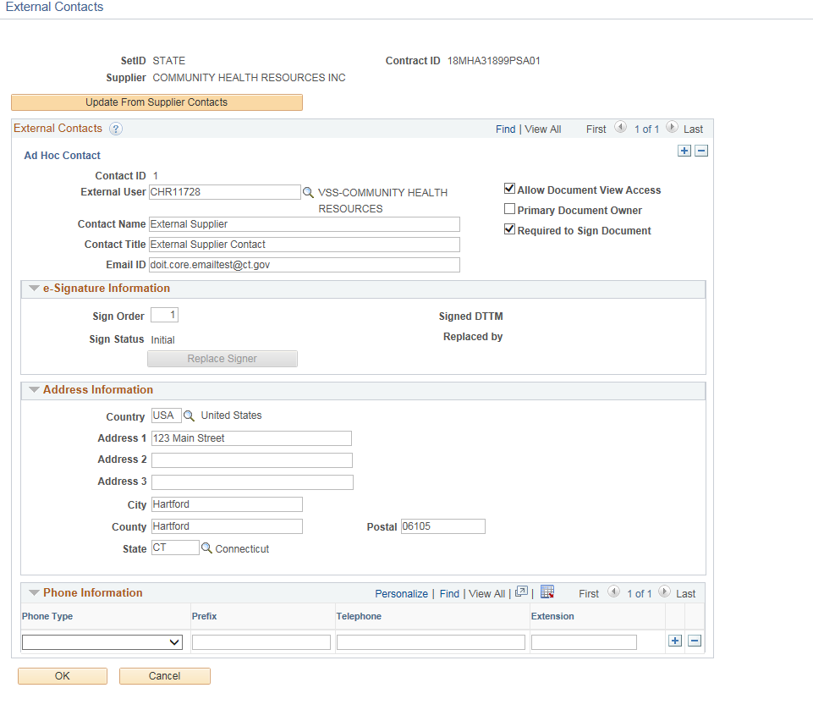

You will be returned to the Document Management page. Select Route Externally button.

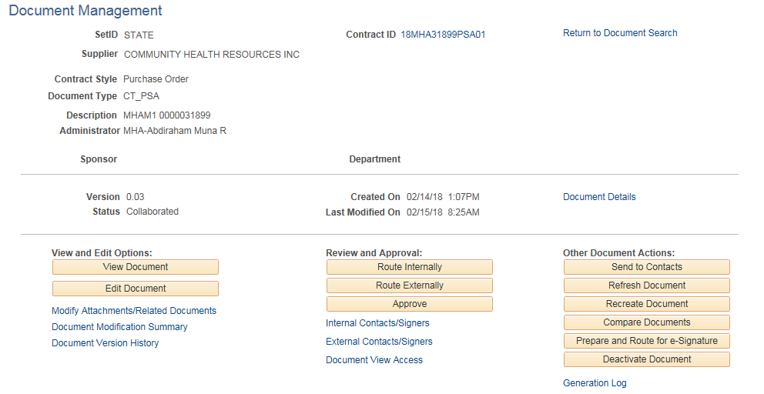
Owner for this Collaboration and Can Edit during Collaboration may be changed on this page.
Enter Collaboration Instructions and/or Collaboration Comments

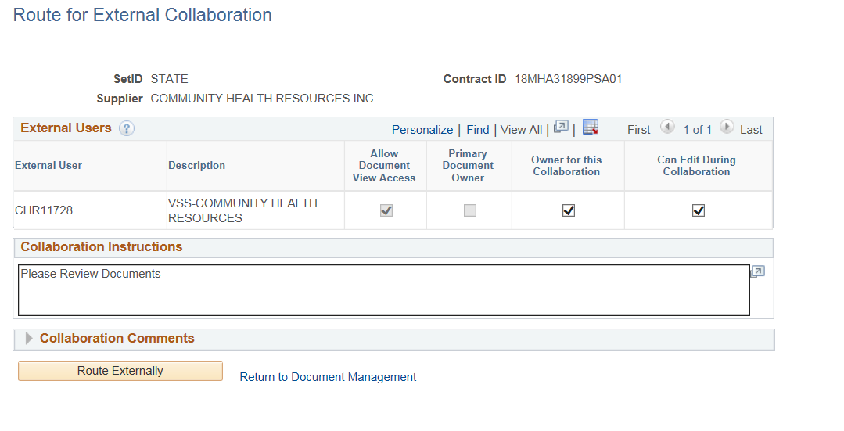

Click Route Externally when ready to collaborate.

Note: The Collaboration instructions will be sent to all external contacts.

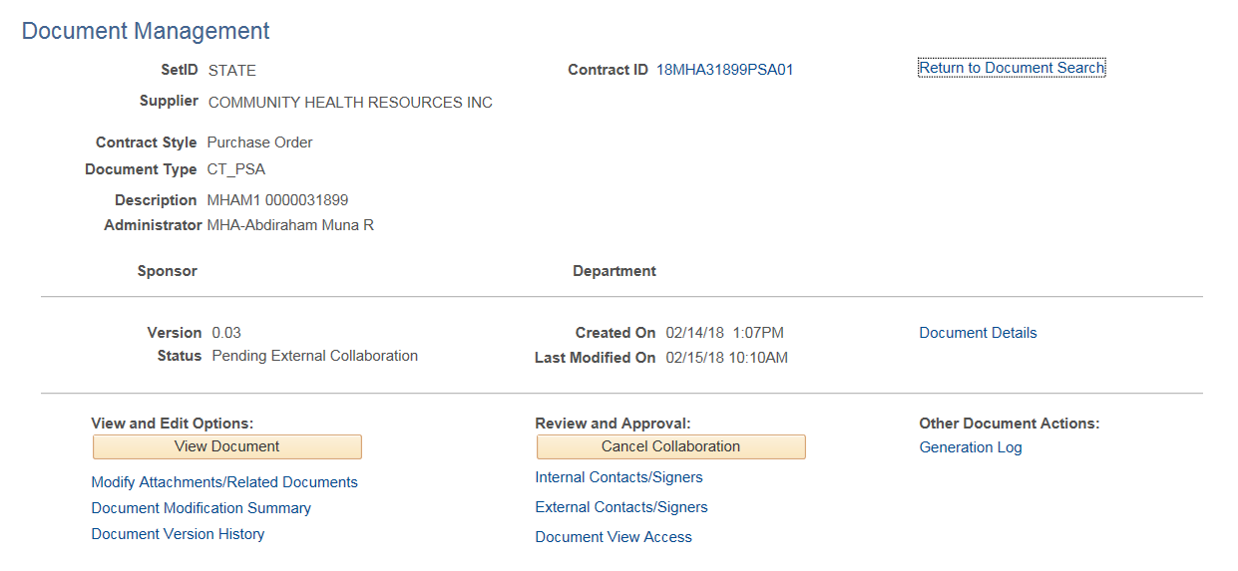

The status will update to Pending External Collaboration

All external users will receive email notification

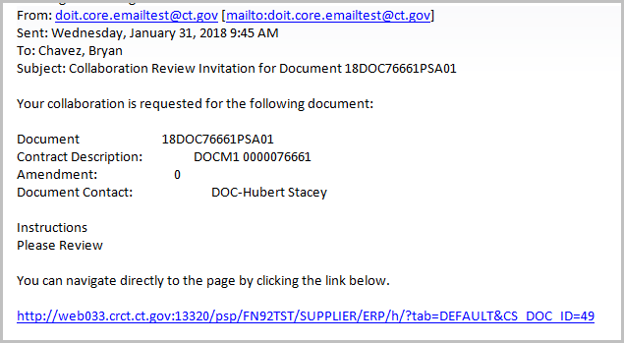

The collaboration review will also be in their worklist

Log in as Supplier
Click on Worklist

Click on the hyperlink for the contract

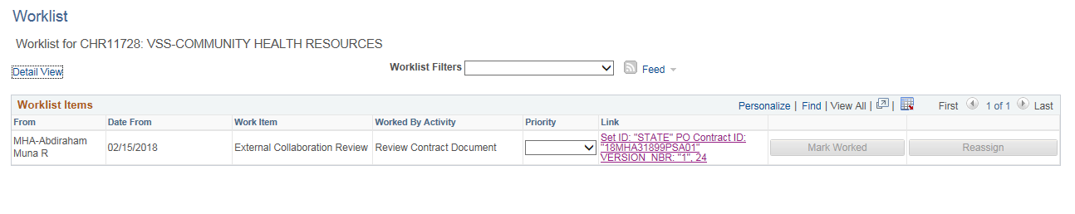
You will be taken to the Document Management page to review the contract

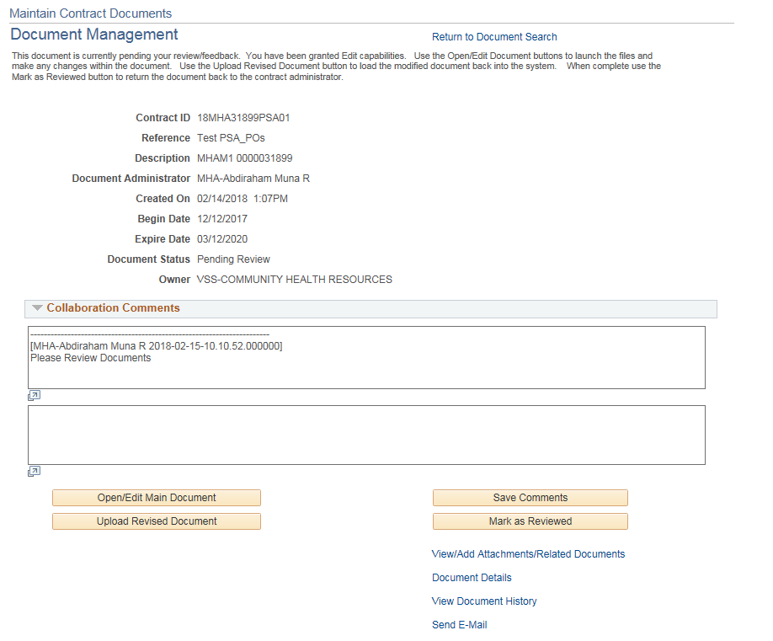

Only one Owner for this Collaboration – Can Edit During Collaboration

Click Open/Edit Main Document to review/make changes

Upload Revised Document if changes have been made
Only the External Owner has the ability to edit the main document (if granted).

Enter a Comment and click Save Comments

Click Mark as Reviewed when collaboration is complete

Send E-Mail is limited to only the contract administrator and external collaborators for this contract.

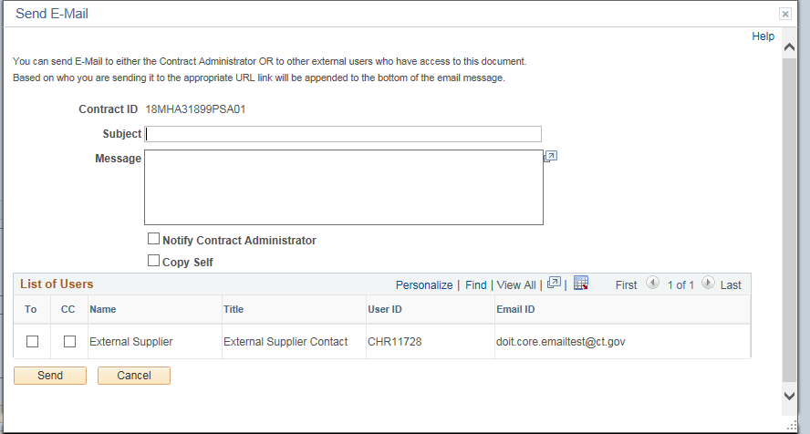

Log in as the Contract Administrator and navigate to the Worklist
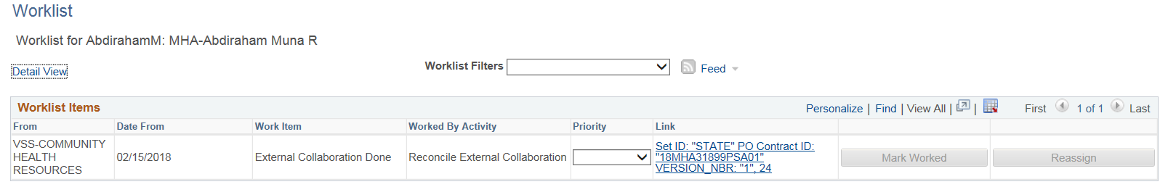
Click the contract link
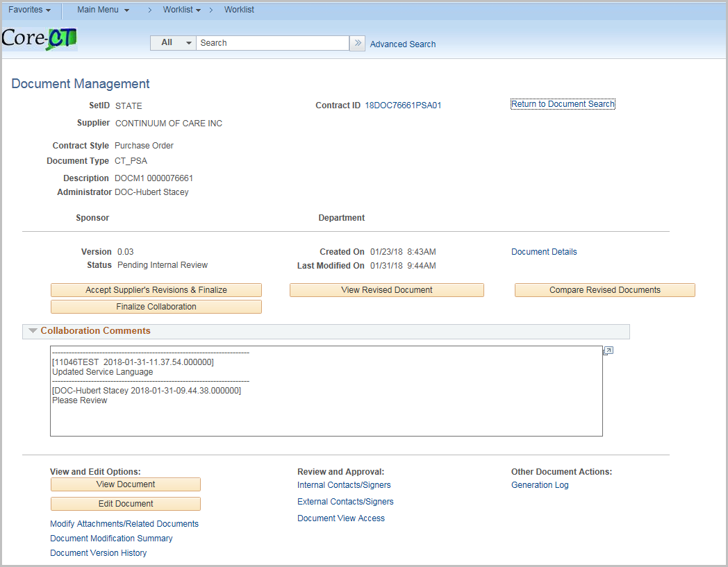

Accept Supplier's Revisions and Finalize
Click to accept the document updates made by the supplier and to set the document to Collaborated status. This button is available for the contract administrator after the supplier completes their external collaboration. This button is not available if the supplier did not check in an acceptable format for the file. For example, if they checked in a .doc file instead of an .xml file. In this case, the contract administrator must manually apply any valid changes.
When you click to Accept Supplier’s Revised Documents button, the system displays the Accept Supplier's Revised Documents page. Use this page to maintain the document version and to add comments about the document.

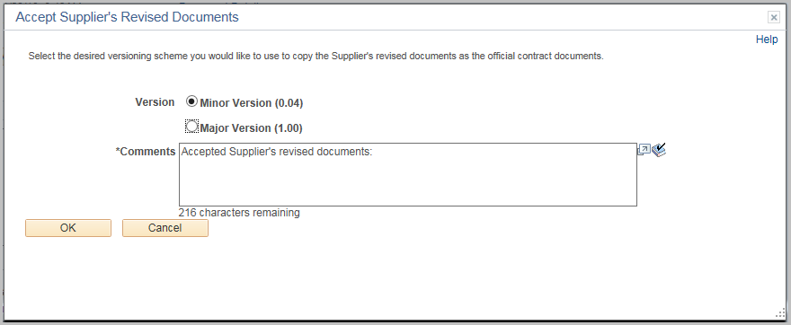
If the supplier made no changes the screen will be a little different and you would just Finalize Collaboration.
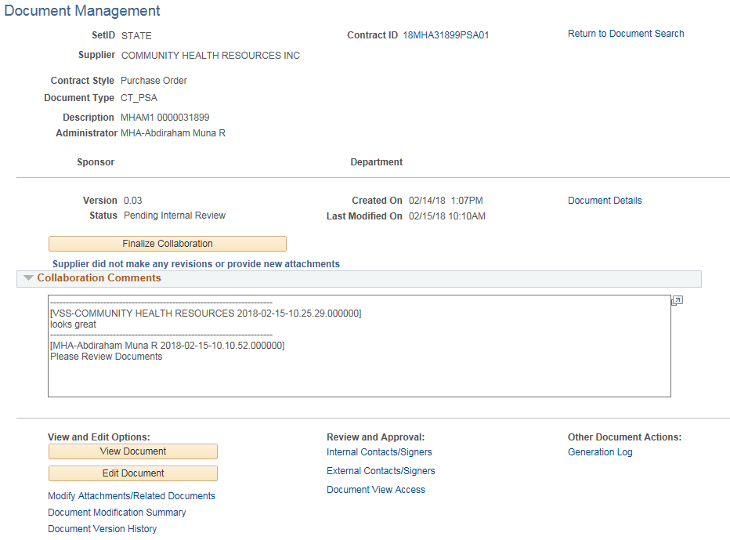

View Revised Document
Click to open a document that has been collaborated on with an external user (supplier). This button appears on the contract owner's Document Management page after the supplier has completed the review. 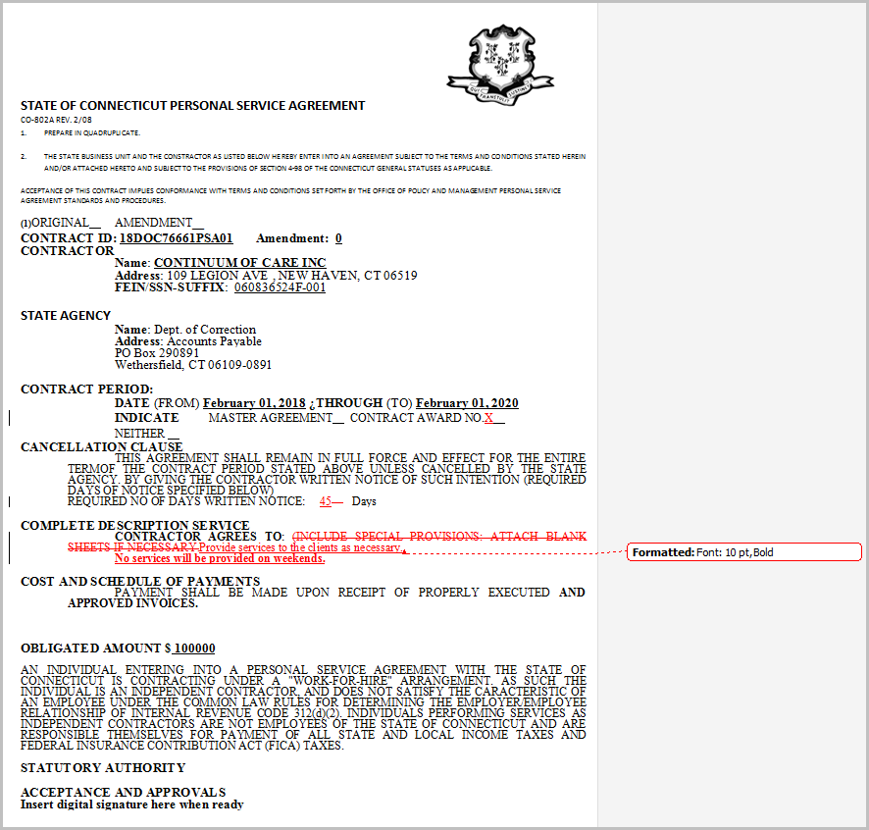
Compare Revised Documents
Click to compare a supplier revised document with the current version of the document. This enables you to better understand what changes may have been made by the supplier. The system opens a new temporary document that shows the changes, just as if you had compared the files using Microsoft Word compare functionality.
Finalize Collaboration
Click Finalize Collaboration to set the document to Collaborated status. This button becomes available for the contract administrator after the supplier completes their collaboration.
Contract administrators use this option when you want to manually apply any suggested changes to the current version of the document using the Edit or Check In buttons at the bottom of the page. After making the manual changes click Finalize Collaboration to complete the collaboration process.
Once Completed the Status will update to Collaborated
Note: If you finalize collaboration without accepting the suppliers' revisions or attachments the revisions will be excluded from version control and kept only in the document history.

