Contract Amendment
After a Contract has been executed, a contract Amendment may be issued for changes.
User must have the CT_F_A_SCMT_ADMIN role

Navigation: Supplier Contracts > Create Contracts and Documents > Contract Entry
Procurement Contracts > Add/Update Contracts (either Navigation will work)

The Contract Entry page will display. On the Find an Existing Value page enter the Contract ID and click Search.

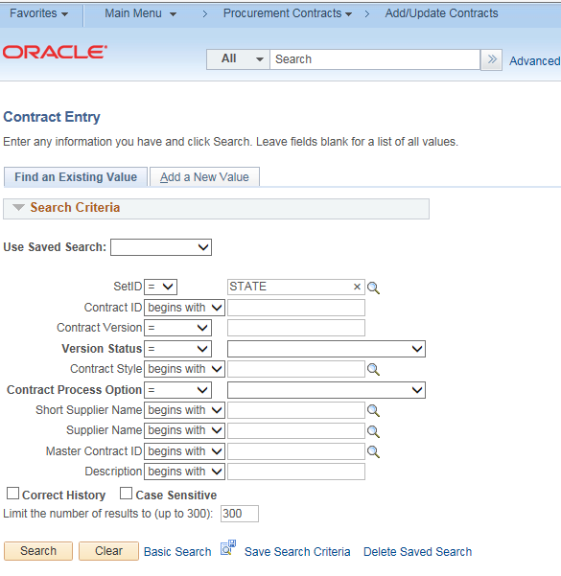

Enter the Contract number

Click Search

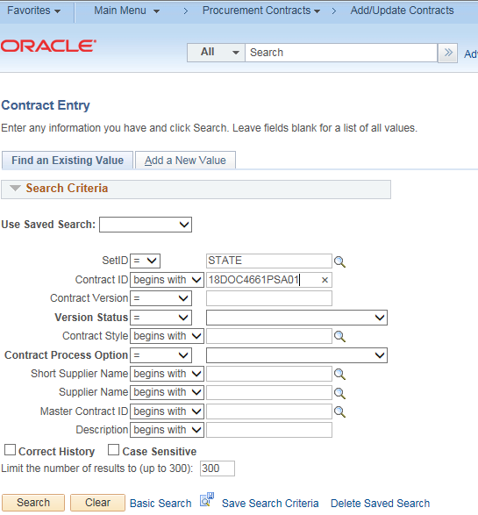

Amendments to the Supplier Contract can be entered by changing the Status of the Contract to Open.
Update any of the values (End Date, Maximum Amount etc.) that will be part of the amendment
Click Save
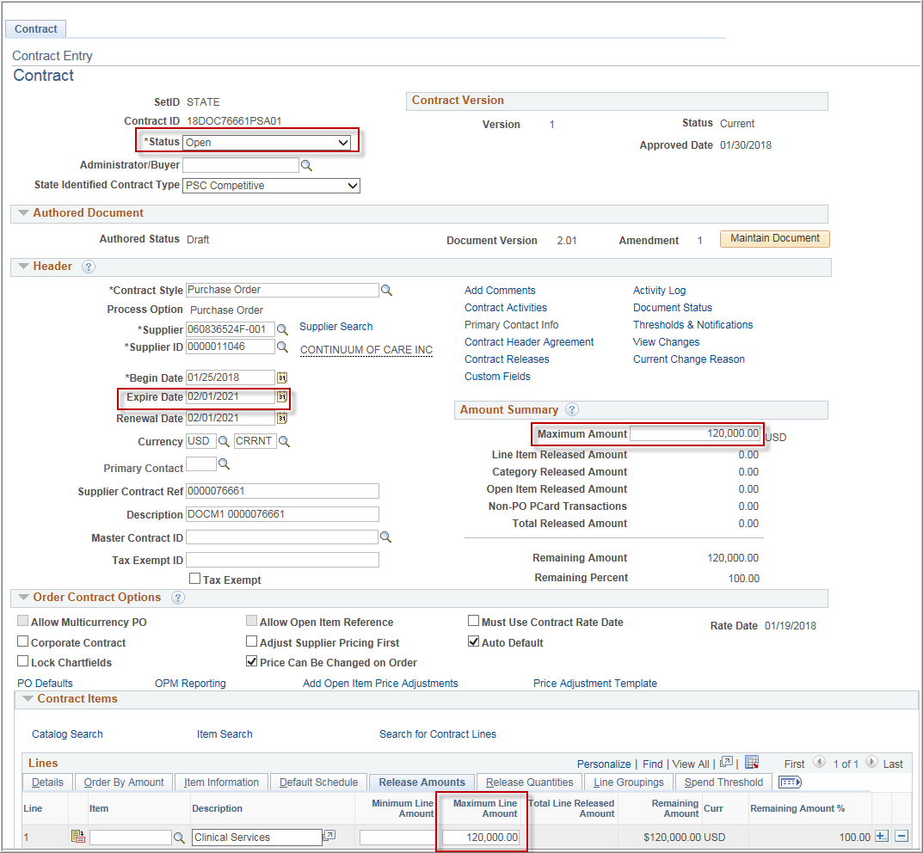

Make the necessary changes and click Maintain Document
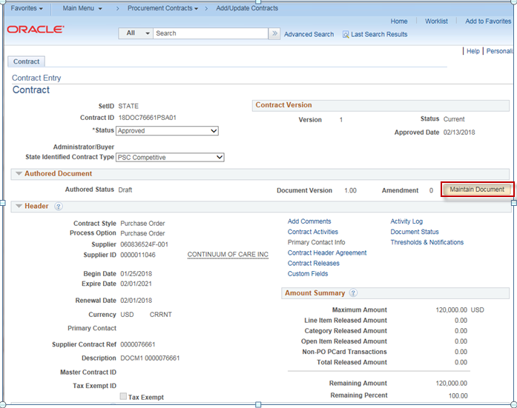

Click Create Amendment
Amendment Options:
- Amend Contract Only
- Amend Contract with Amendments
- Amendment Files Only

Amendment Configurator ID: Select from the available IDs
Version: Minor or Major
Enter in any comments
Click OK
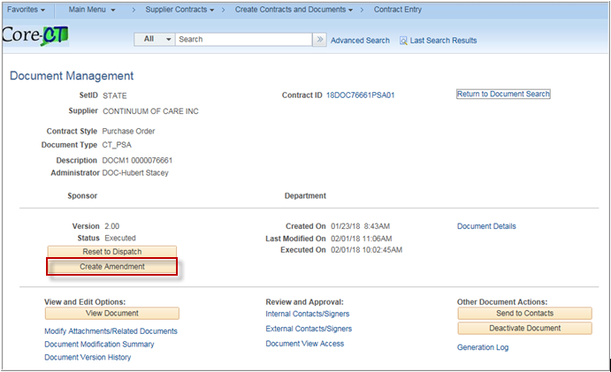

Below is an overview of each type of Amendment
Amend Contract Only: Select to revise the contract and generate one amended document with all of the changes applied directly to the last executed contract.
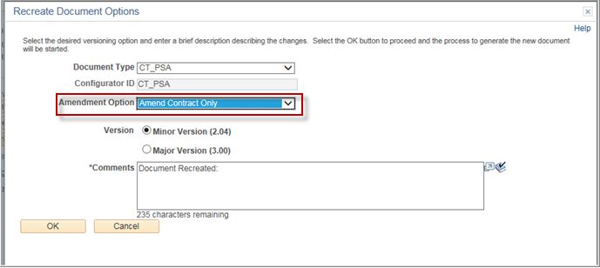

The Wizard will ask prompt for the Business Unit
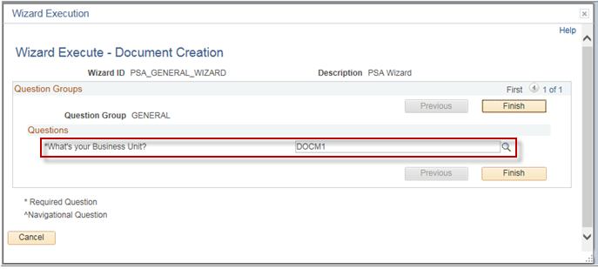

The Document Management Page is the same as before except the buttons are labeled with Amended.
Click View Amended Document
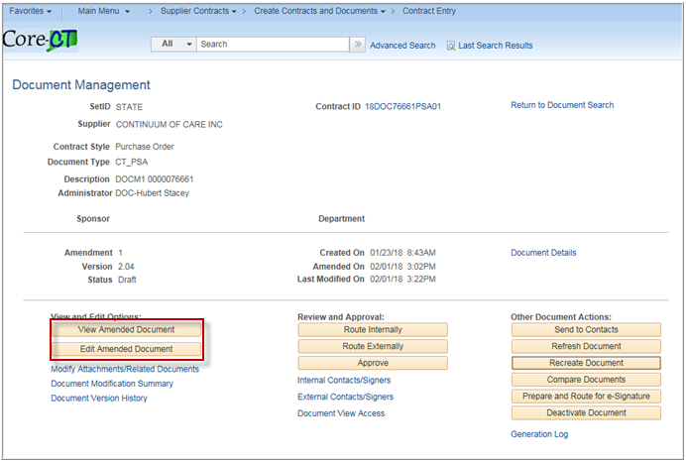

The entire PSA is recreated with the new values from the Contract.
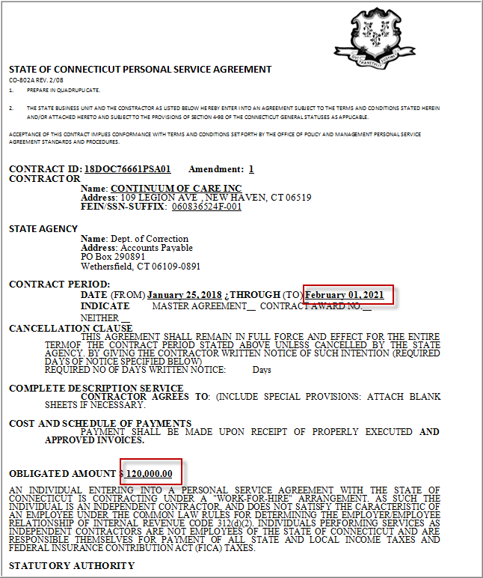
Amend Contract with Amendments: Select to generate both a separate amendment file, as an appendix or addendum, and a copy of the last executed main contract document that you can revise to also include the changes specified in the amendment.
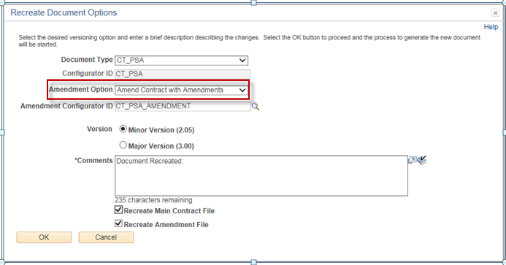
The wizard will ask you for the Business Unit
Click Finish
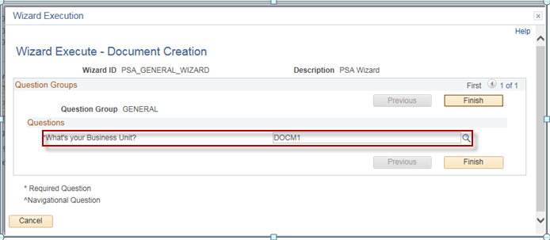

The Document Management Page is the same as before except there are buttons for both to view/edit the document or amendment.
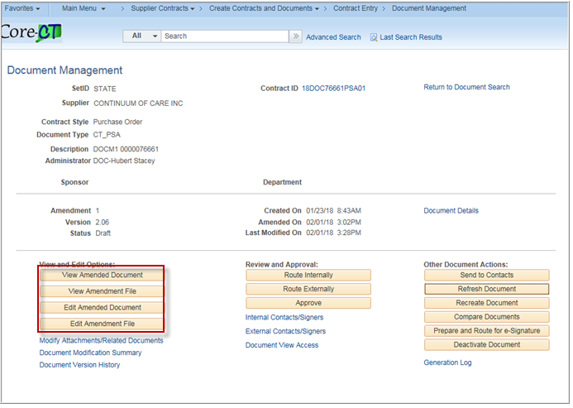

Amendment Files Only: Select to generate just the amendment file. With this option, the executed contract remains as is and is not modified and all changes are only listed in the amendment file.
Click OK
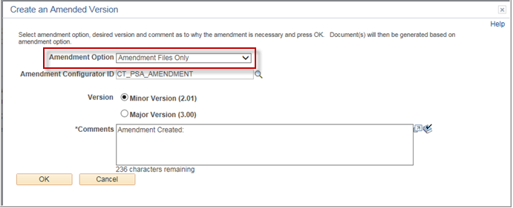

The Document Management Page is the same as before except the View/Edit buttons are labeled with Amendment and an additional button to view the original document.
