Library Administrator Job Aid

Add a New Clause:
The following shows how to add a new clause.
Navigation:
Core-CT Financials > Supplier Contracts > Manage Contract Library > Clauses
- Click on the Add a New Value tab.
- Select STATE as the SetID.
- Enter the Clause ID (Naming convention is to start with the agencies acronym).
- Click the Add button.
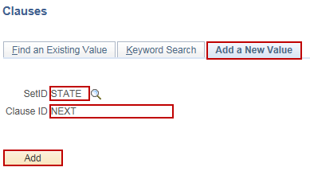

- Enter the Description, Clause Type, Library, and Class Name.
  - Clause Type: General Clause
  - Library: Will depend on Business Unit
  - Class Name: CT_Procurement

- Enter the Effective Date.
- Enter the Status.
- Uncheck the Numbered Clause checkbox.
- To protect the clause, check the Protect in Document checkbox. If this checkbox is checked, the clause will not allow editing.
- Click the Edit Document button.

- Click the OK button.
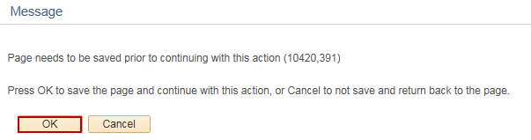

- In the popup, click the Open button.

- In Word, click the Enable Editing button and enter the clause Full Text. Include the Title of the clause in the Full Text section.
- Save and close the Word Document.
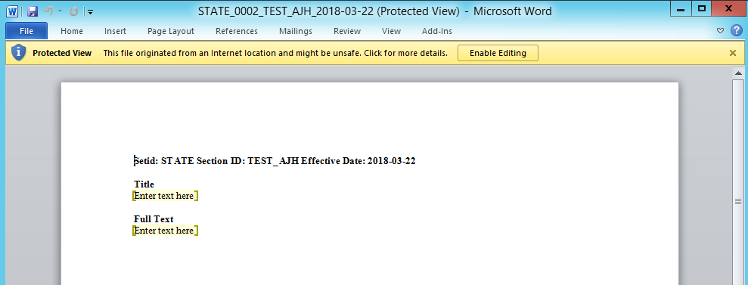

- Click the Check In button.
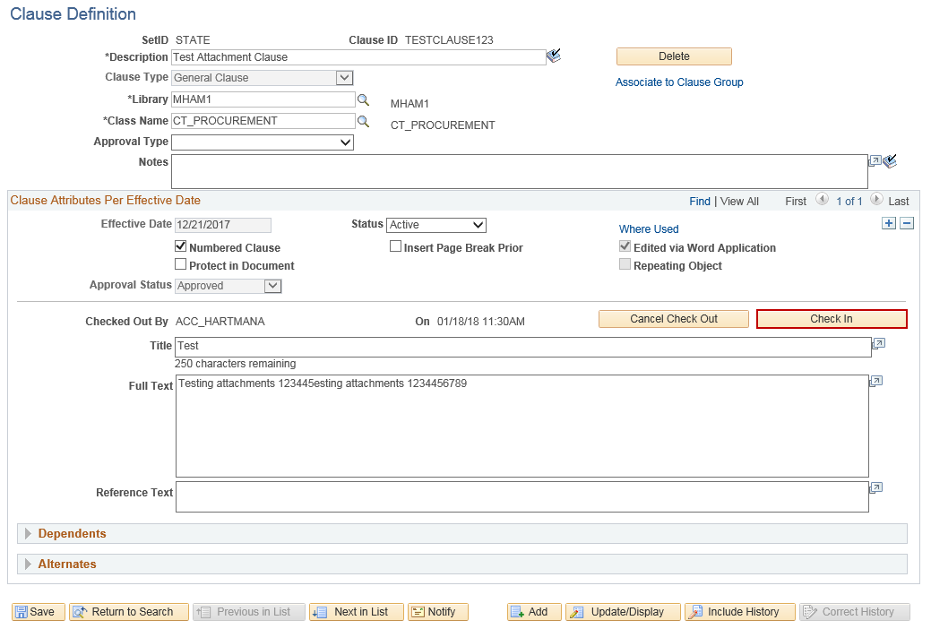

- Click the Browse button.

- Select the file to upload and click the Open button.
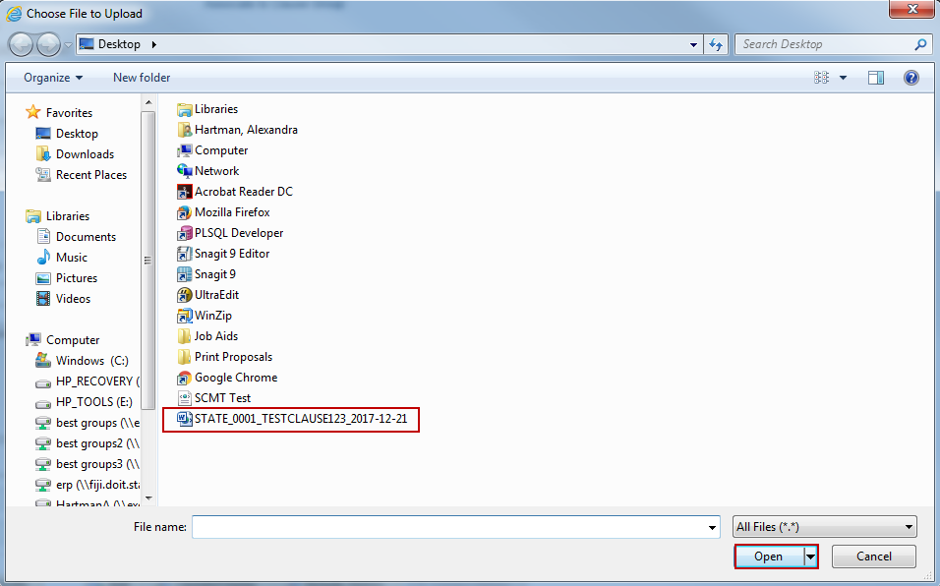

- Click the Upload button.
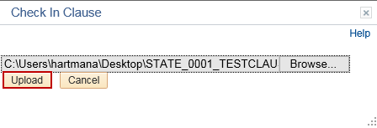

- Click the Preview Document button to verify that the format and document uploaded correctly.

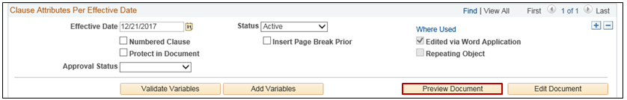

- Update the Approval Status to Approved.
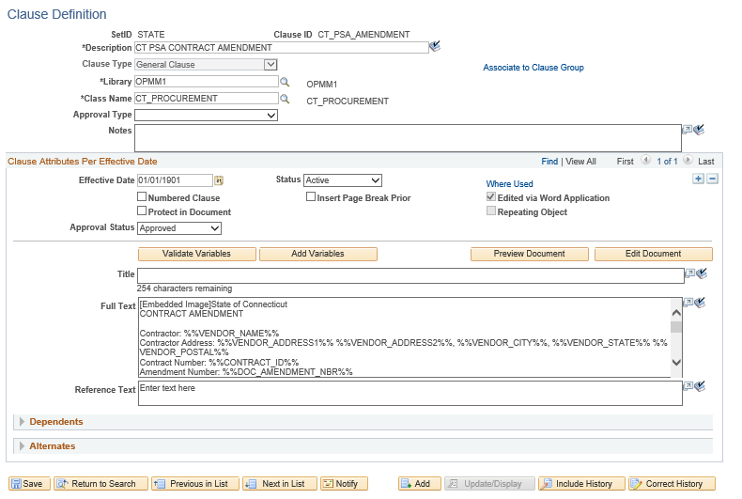
- Click the Save button.

Copy a Clause
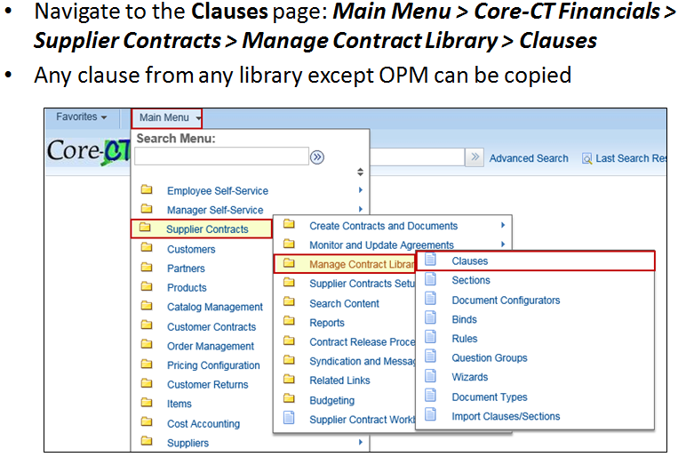

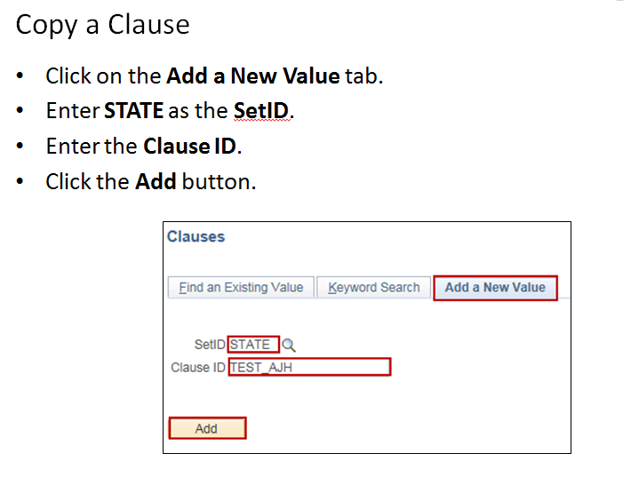

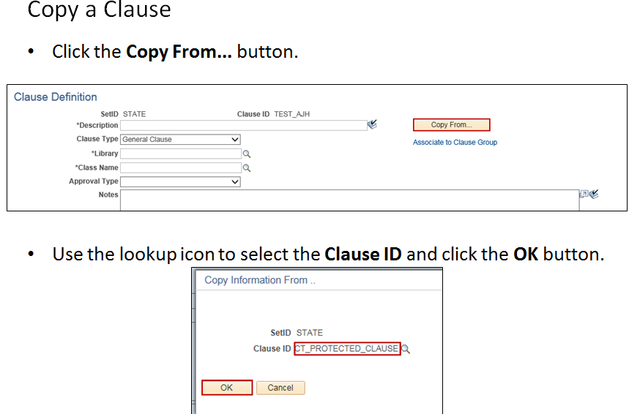

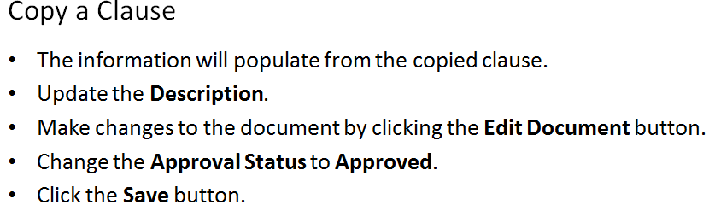
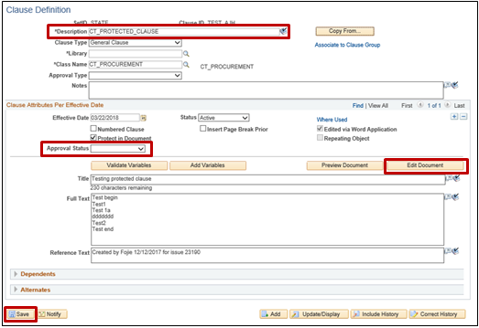

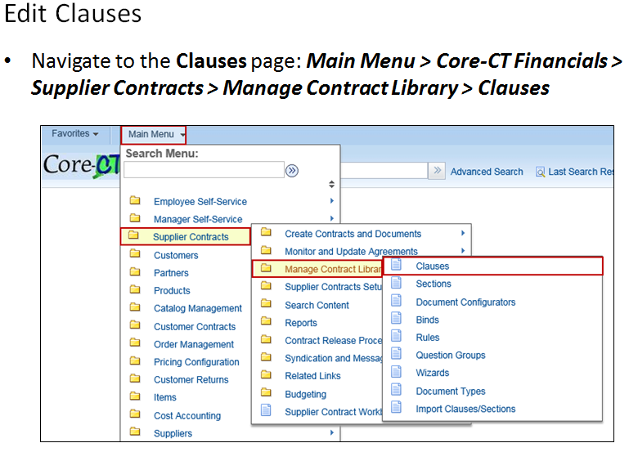

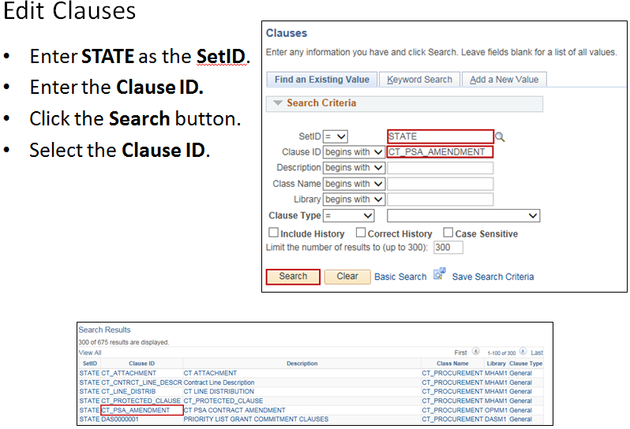

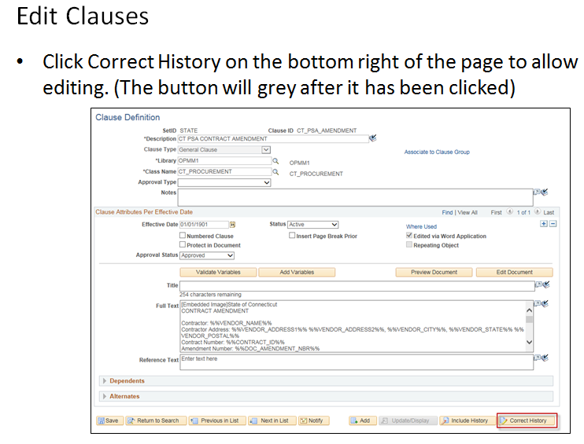

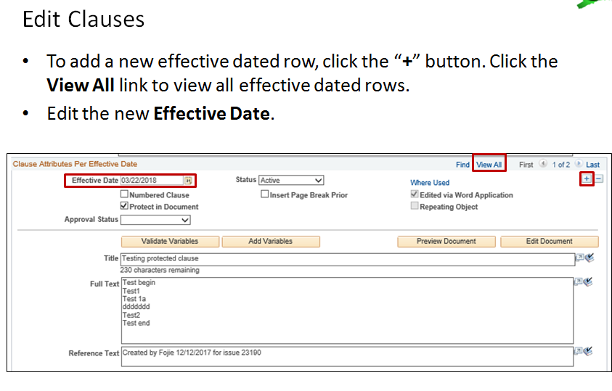

Editing Clause Text

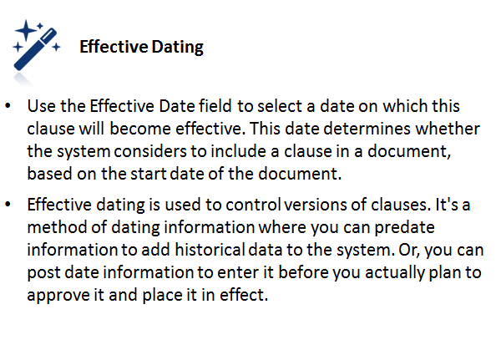

Editing Clause Text
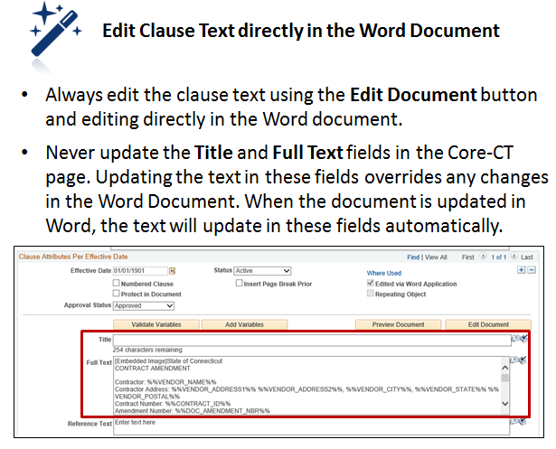

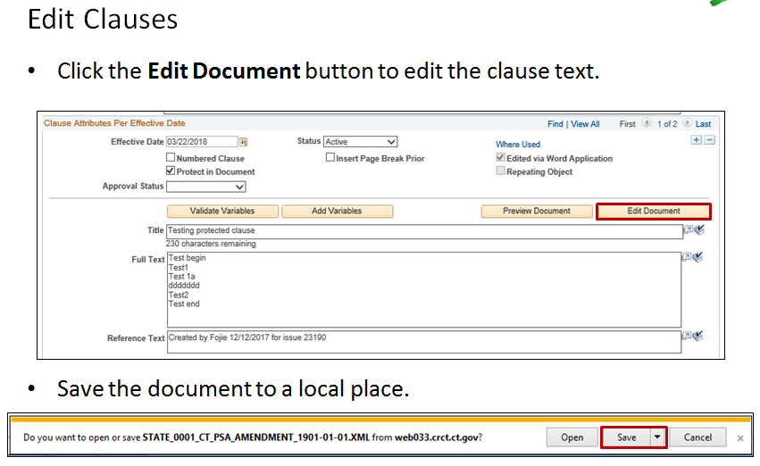

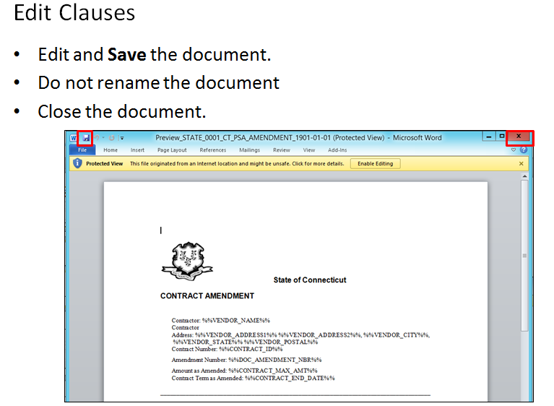

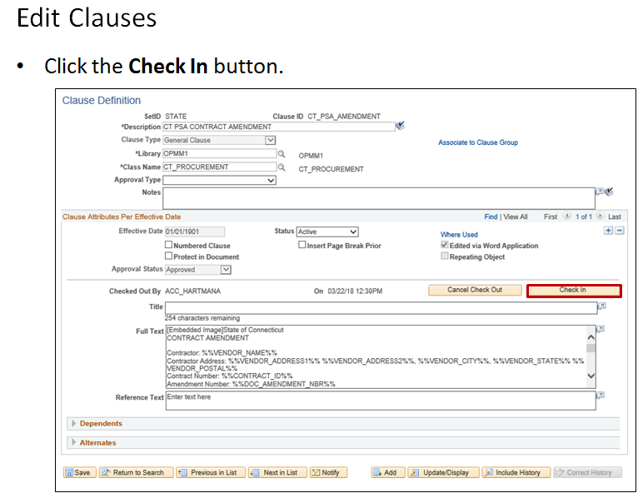

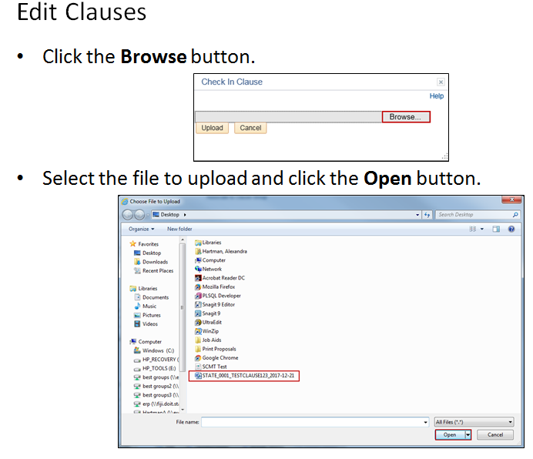

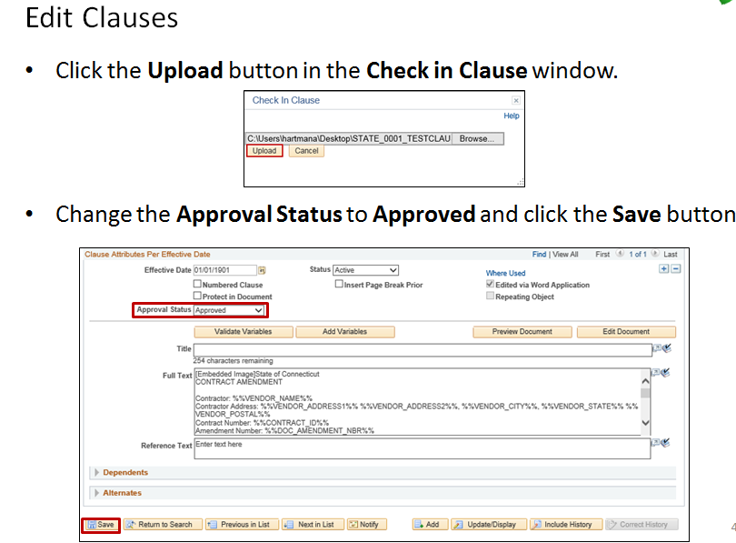

Create Bind Definitions:
The following shows how to create bind definitions.
Bind variables are used to add a new question to the wizard as part of the contract creation process. Bind variables, rules, and questions will need to be set up to be able to pull in applicable clauses into the Contract Document later on.
Bind variables are used as placeholders for other values and are set up in Core-CT first.
For example, a department has a new program that they want to add as an option for contract creation. Setting up this option as a bind variable will allow the system to pull in the applicable associated clause(s) into the Contract Document.
Navigation:
Core-CT Financials > Supplier Contracts > Manage Contract Library > Binds
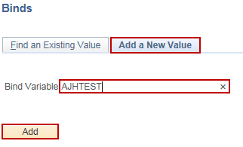
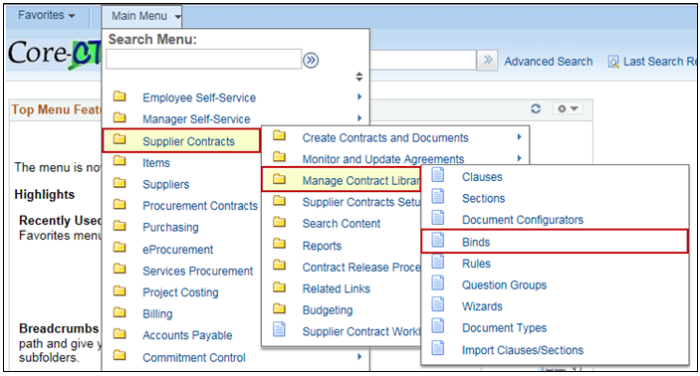

- Enter Description, Bind Type (Transactional or Wizard) and Field Type (Checkbox, Date, Date/Time, Decimal, Integer, String, Yes/No), and Display Format (if applicable).

- Click the Save button.

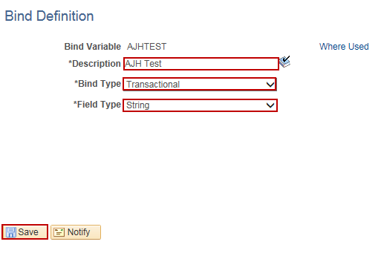

Set Up Contract Rules:
The following shows how to set up contract rules.
Contract Rules are the questions that correspond to the bind variable.
For example, “Are you setting up a new contract for this new program?”
Contract Rules are variable specific.
Navigation:
Core-CT Financials > Supplier Contracts > Manage Contract Library > Rules
- Click on the Add a New Value tab.
- Enter STATE as the SetID.
- Enter the Rule (Naming convention is to start with the agencies acronym).
- Click the Add button.

- Enter Description and Rule Type (Standard or Alternate).
- In the Rules Definitions section, enter the Effective Date and Status.
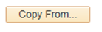

- In the Basic Criteria section, enter the Bind Variable, Operator and Value.
- In the Content Elements section, enter in the Sequence, Content Type (Clause or Section), Content ID and Content Format.
  - Click the ‘+’ button to add additional Content IDs.
- Click the Save button.

Set Up Question Groups for Contract Wizard:
The following shows how to set up question groups for the contract wizard.
Question Groups allow question(s) to be grouped together when setting up the wizard.
For example, if you are adding a new program into the wizard, you will want to ask a set of questions depending on that specific program.
- What is your Business Unit?
- Are you creating a new contract for this program?
Navigation:
Core-CT Financials > Supplier Contracts > Manage Contract Library > Question Groups
- Click on the Add a New Value tab.
- Enter STATE as the SetID.
- Enter the Question Group (Naming convention is to start with the agencies acronym).
- Select the Wizard Type from the dropdown menu (Document Creation or Configurator Selection).
- Click the Add button.
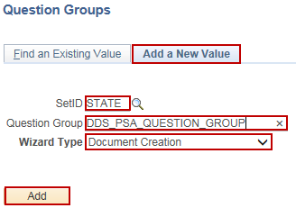

- Enter in a Description and Instructional Text (optional).
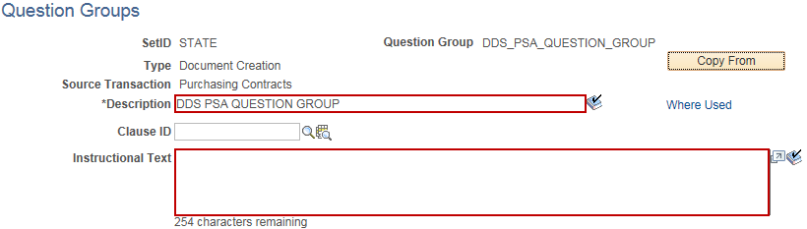

- In the Questions section, check the Reqd checkbox if the Question is required. Enter in the Question/Information Text.

- Use the lookup icon to select the Bind Variable, if applicable.

  - This is where the bind variable will pull into the wizard and therefore, the document configurator and later on, the contract document.

- Click the ”+” button to add additional questions to the Question Group.

- Click the Save button.
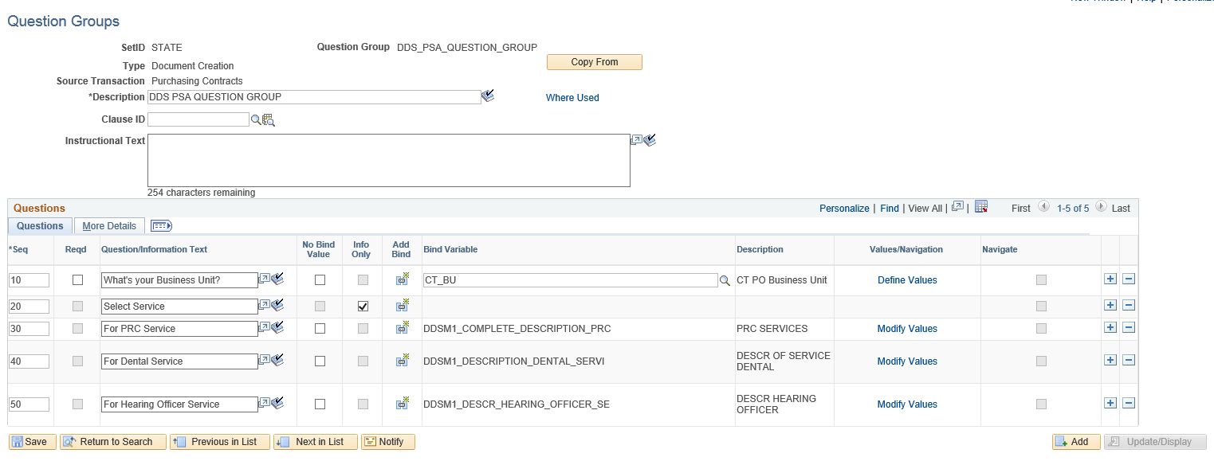

Update Existing Wizard:
The following shows how to update an existing wizard.
Navigation:
Core-CT Financials > Supplier Contracts > Manage Contract Library > Wizards
- Enter STATE as the SetID.
- Enter the Wizard ID.
- Click the Search button.
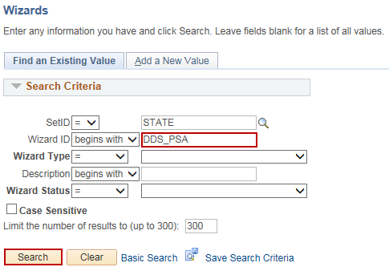

- Click the “+” button to add additional Question Groups.
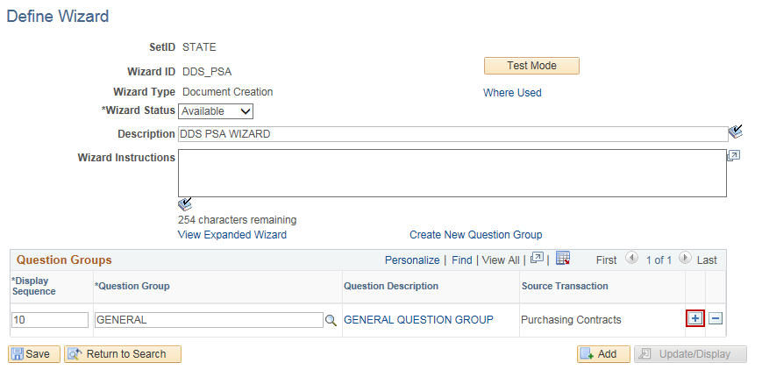

- Click the Question Group look up button.
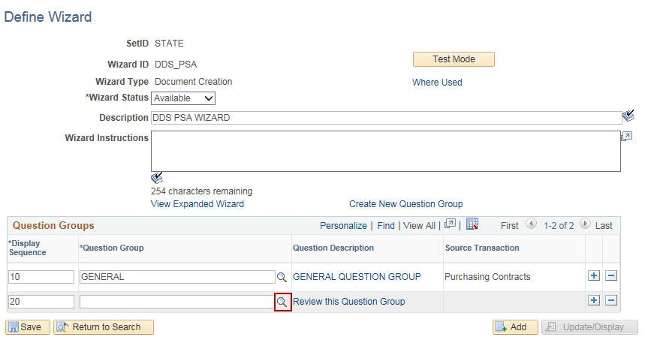

- Select the Question Group that is to be added.
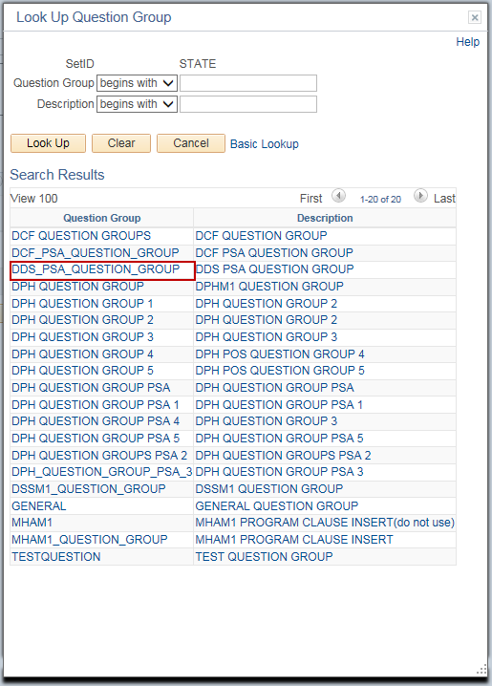

- Repeat steps 4-6 for any additional question groups that will be added.

- Click Save.
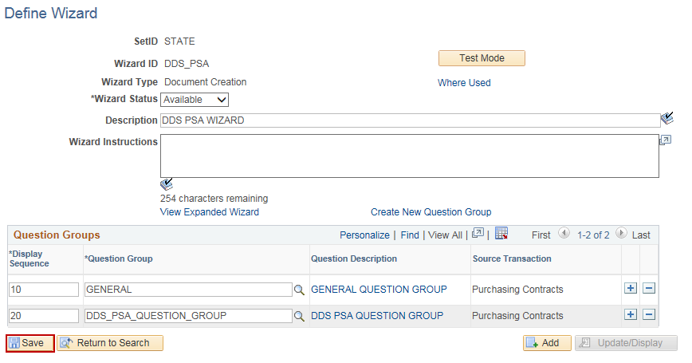

Update Existing Document Configurator:
The following shows how to update an existing document configurator.
Navigation:
Core-CT Financials > Supplier Contracts > Manage Contract Library > Document Configurators
- Enter STATE as the SetID.
- Enter the Configurator ID.
- Click the Search button.
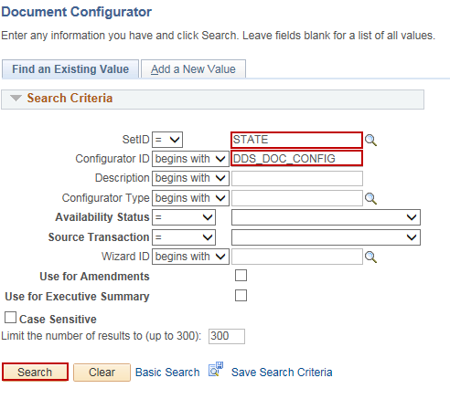

- Click the Refresh button.
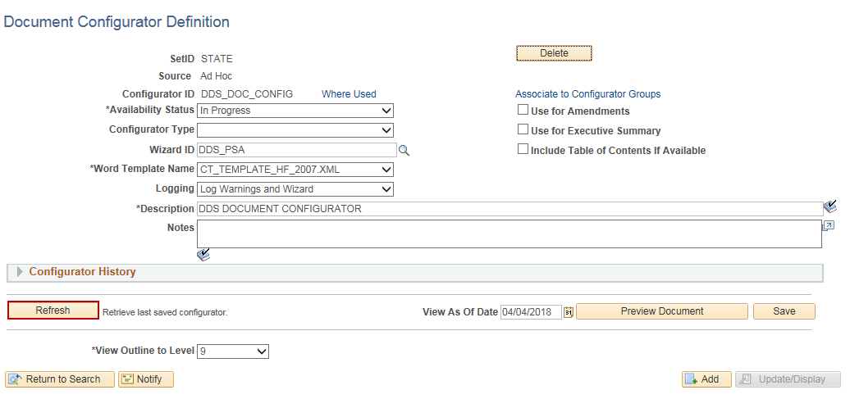

- Click the “+” button to add additional lines to the Content Elements section.
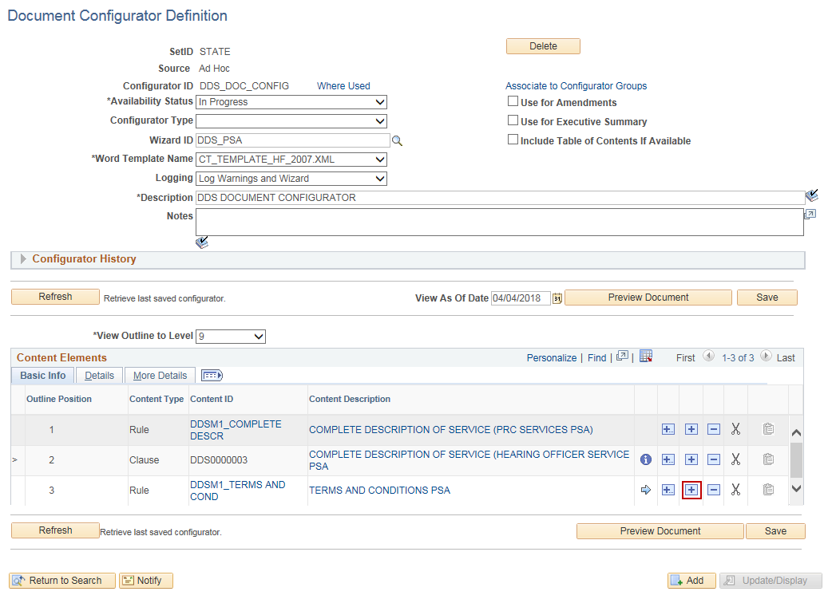

Add Multiple Object: Used to insert more than one clause or section into the Document Configurator.

Insert: Inserts the next content row on the line under the Insert button selected.

Delete: Deletes the row of the line selected.
Cut: Takes the row that has been cut and temporarily holds it.

Paste Row After: This button becomes available after Cut has been used. This button will place the cut row after the line selected.

- Select the Content Type (Section, Rule, Clause, or Ad Hoc Clause).
- Click the Content ID look up button.

- Click OK.
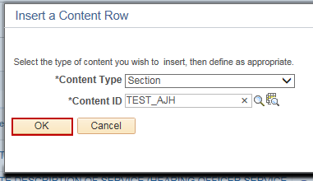

- Click the ”+” button to add as many lines as necessary.

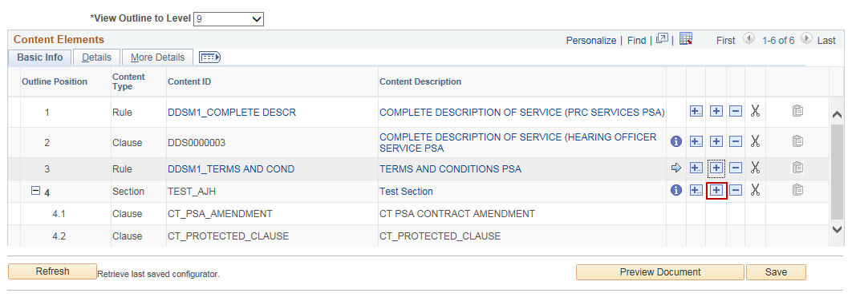

- Click Save.

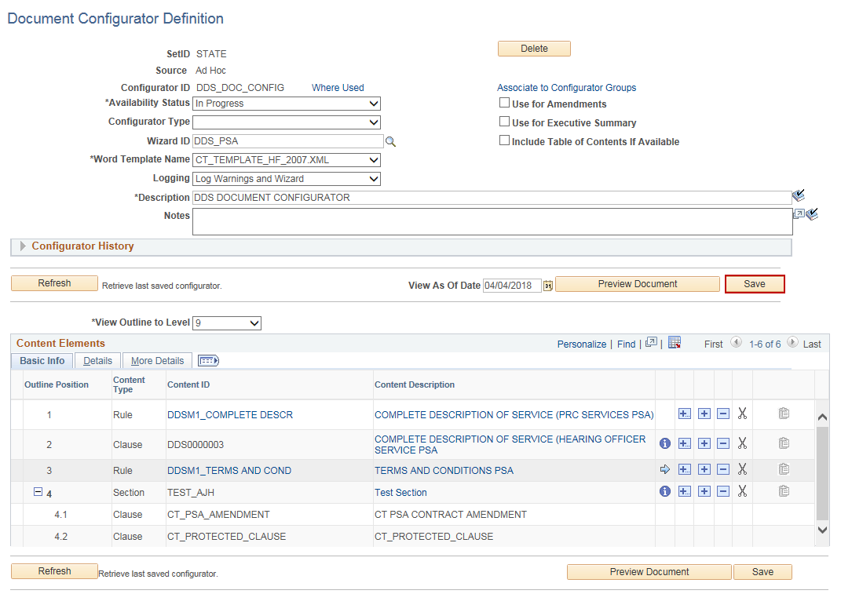

Supplier Contract Management Process
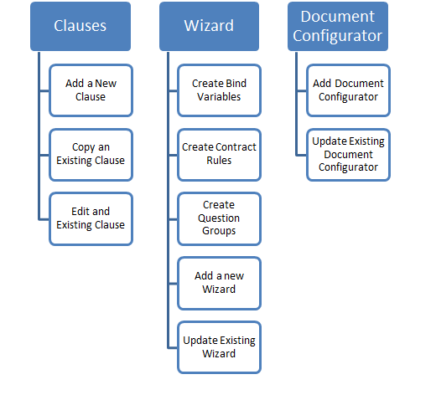

Key Terminology
