New User First Time Sign On Job Aid

Using the link provided in your password email, navigate to the Supplier Portal. Enter the User Name and current Password. If you do not have a current password, a temporary password is provided in the email. Click Sign In.
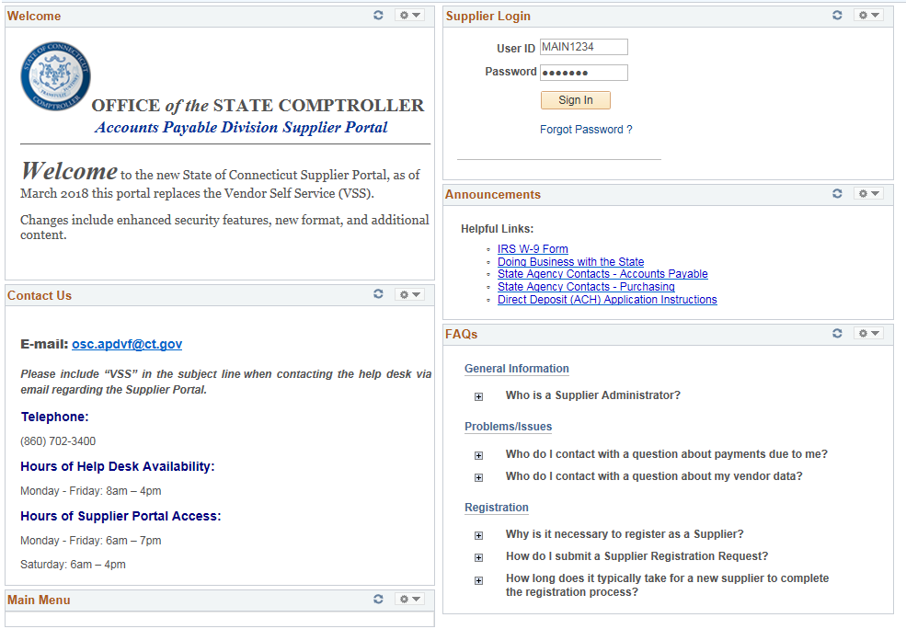
The system will provide a link to change your password. Click on Sign Out to Change Password link.
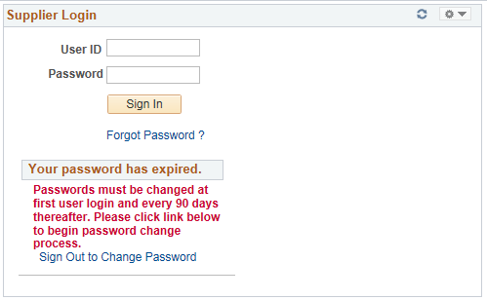

Re-Enter you User ID and Password on the Oracle PeopleSoft Screen and click Sign In.
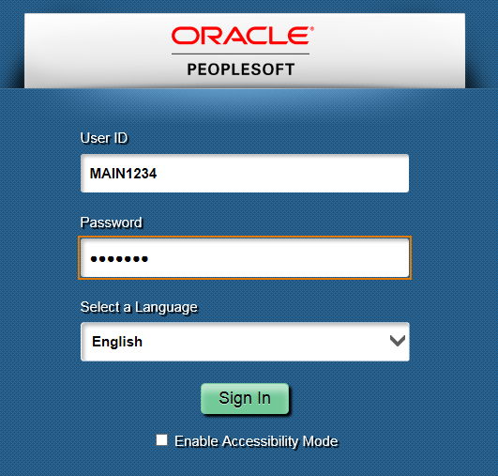

Click the Click here to change your password link.
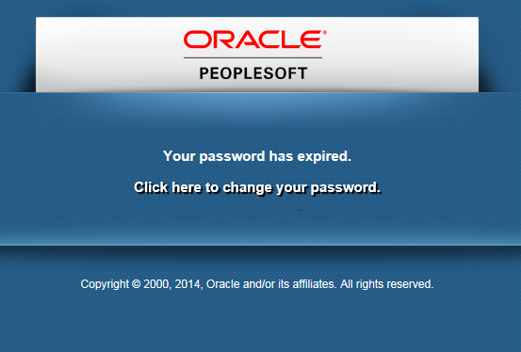

Enter your temporary password, then enter your new password and confirm the new password. Click on Change Password.
Your password is case sensitive and . . .
Must be a minimum length 8 characters
Must contain at least 3 numbers
May use special characters (@,*,%)
May use upper and lower case letters
Will expire every 90 days
Will warn of expiration 15 days in advance
Will lock your account at 5 failed log-ons
May not reuse any of the last 6 passwords

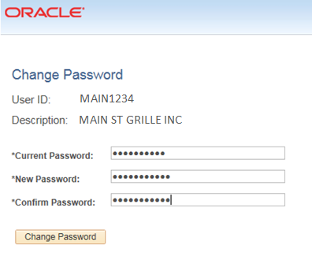

Click OK to access the supplier homepage.
