Vendor Self Service Overview
This job aid provides an overview of the new Vendor Self Service functionality, and describes the main pages the Suppliers will be using when they log in.
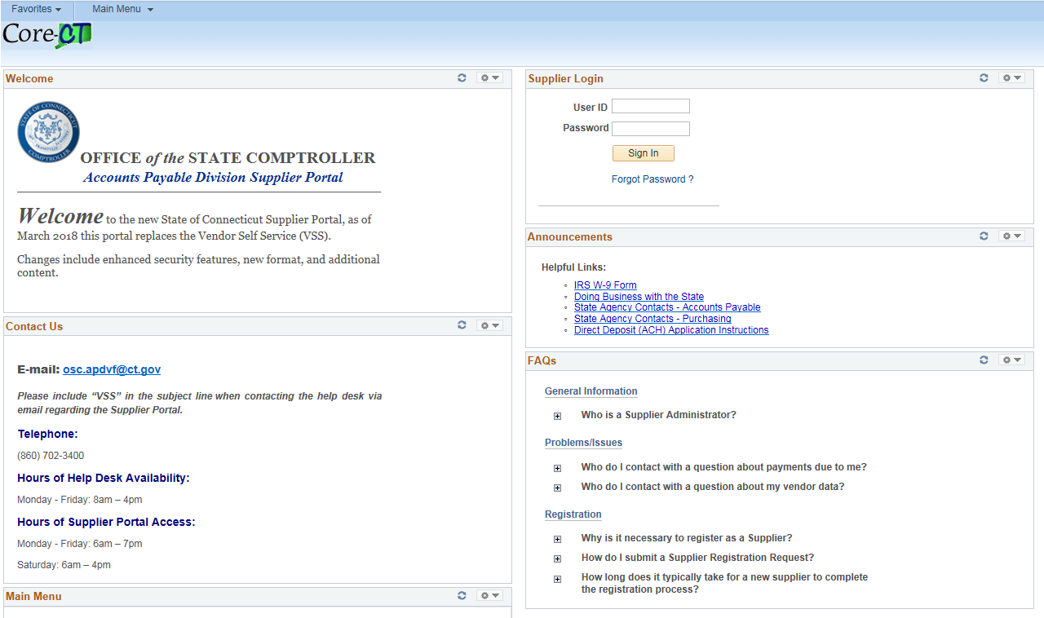

2
1
3

Shown above is the Vendor Self Service Homepage.
- Contact Us - Contains the email address, telephone number, and hours of availability of the help desk
- Announcements – Contains a link to the Supplier Homepage (next page), also contains a Helpful Links Section
- FAQs – Contains frequently asked questions about general information, as well as a link to the job aids and training.

Clicking on the Supplier Homepage will bring the Supplier to the following screen
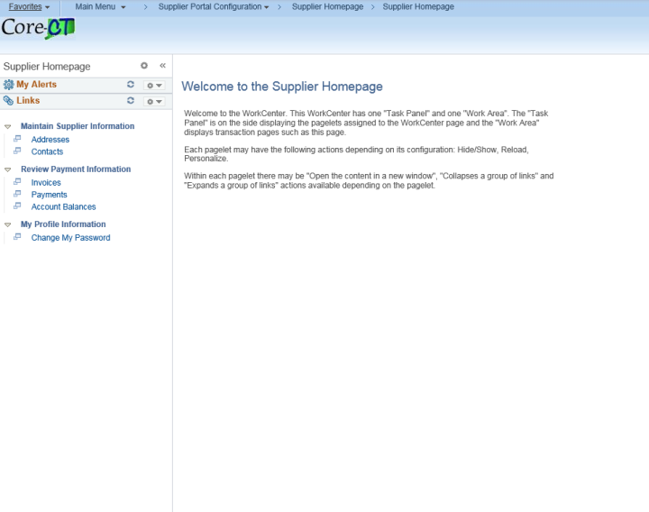
2
1

The Work Center is broken down into a Task Panel (1) and a Work Area (2). The Task Panel is what is shown as a column on the left side of the page. Clicking on any of the links in the Task Panel will bring up a Work Area associated with that link. The Work Area will take up the majority of the screen where Suppliers can complete different tasks.

The following screenshots will show what appears in the Work Area when clicking each link from the Task Panel:

Addresses
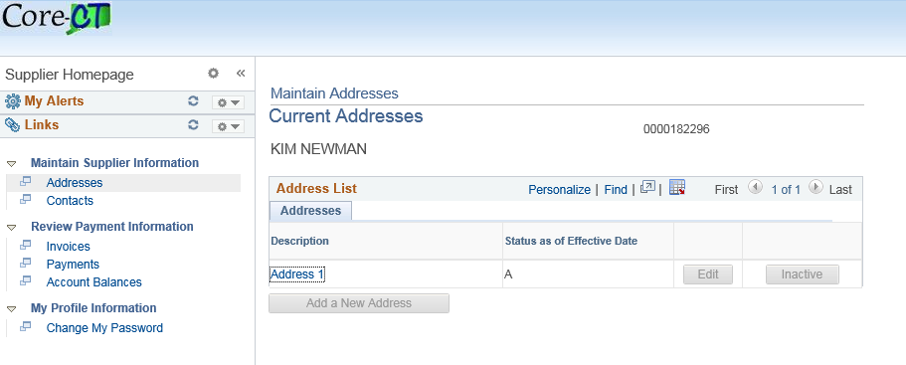
Clicking on the Address 1 link in the description section displays the address of the Supplier.
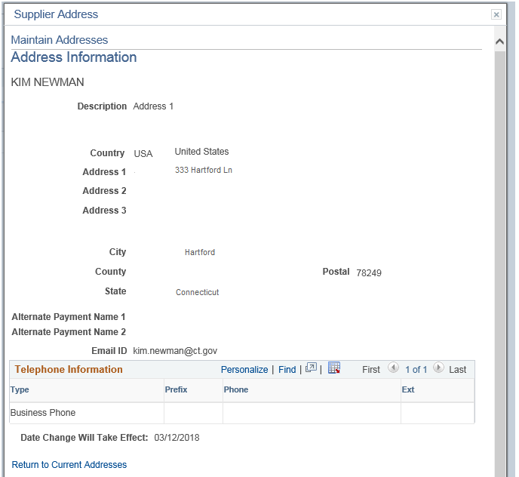

Contacts
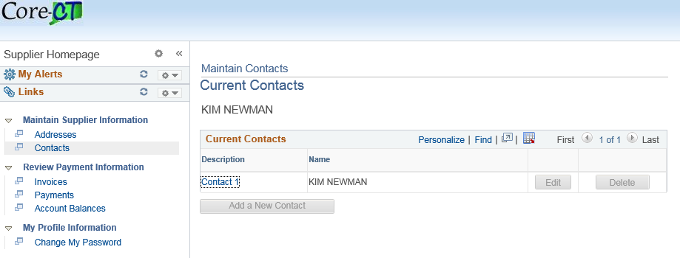

Clicking on the Contact 1 link in the description section displays the contact information of the Supplier.
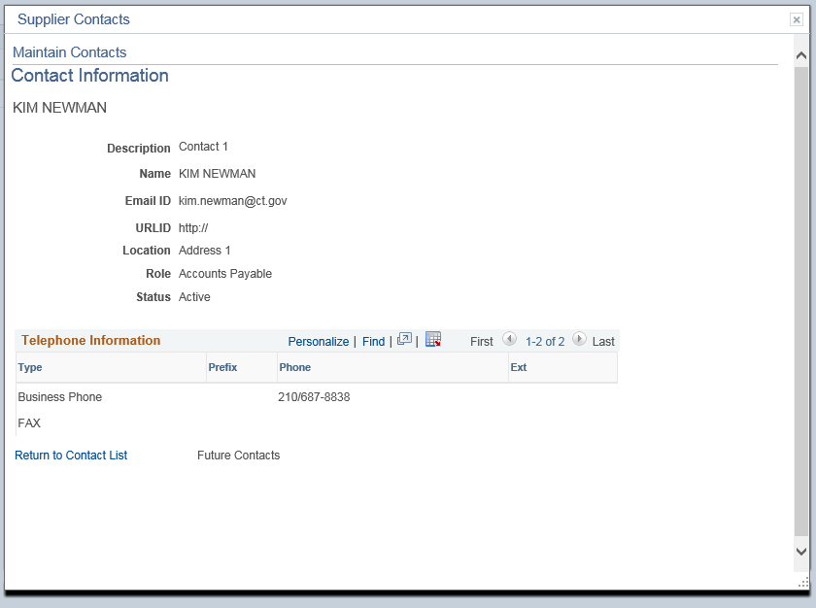

Invoices
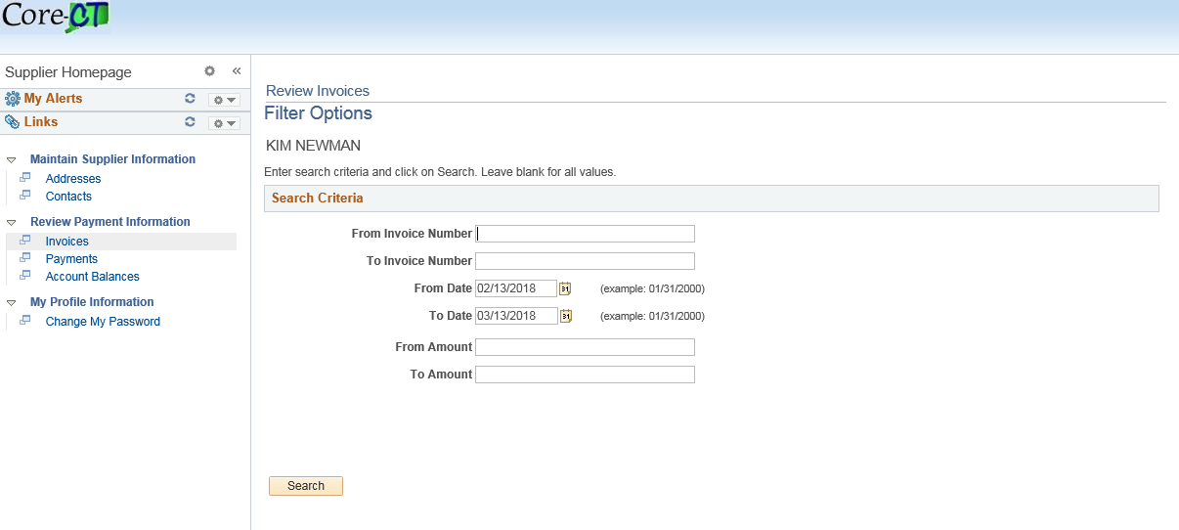
Suppliers can search for a range of invoices or a specific invoice. When the Supplier clicks Search, the following page displays the invoices gathered from the search query.
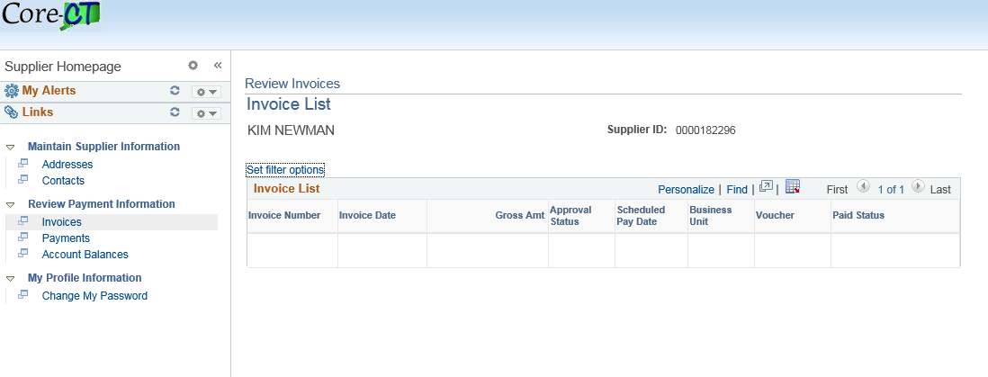

Payments
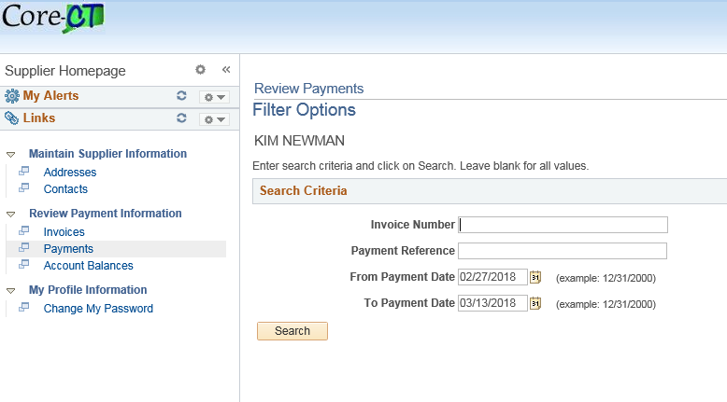

Suppliers can search for payments based on Invoice Number or Payment Reference. When the Supplier clicks Search, the following page displays the payment gathered from the search query.
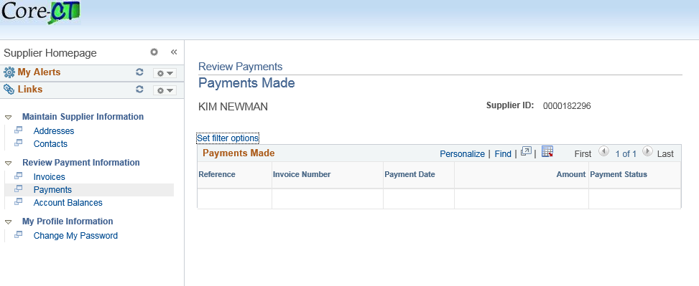

Account Balances
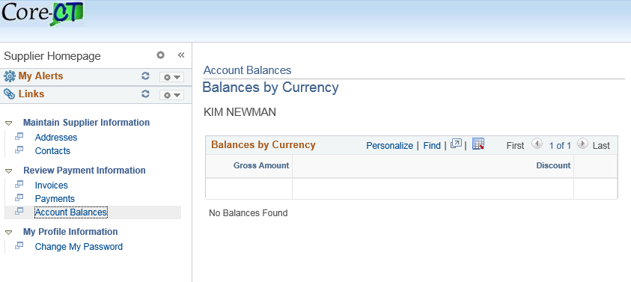

The balances would be displayed in the Work Area above.
Change My Password
