The Monthly Vacant Position Report is a report that is run by the Agency Position Specialists to assist in reviewing vacant positions by characteristics and funding within their agency. This report may be run by any current or historical ‘As Of Date’ from October 17, 2003 to present.

This job aid is to assist agencies in producing and analyzing the Monthly Vacant Position Report. It also provides additional methods of reviewing vacant positions by using the Monthly Position Status Report and/or on-line inquires.

To produce the Monthly Vacant Position Report:

- The Agency Position Specialist navigates to: Main Menu> Core-CT HRMS>Organizational Development > Position Management > Position Reports> Monthly Vacant Position Report
- Select an existing Run Control ID by clicking on button or enter a new Run Control ID by clicking on the Add a New Value link and pressing the button

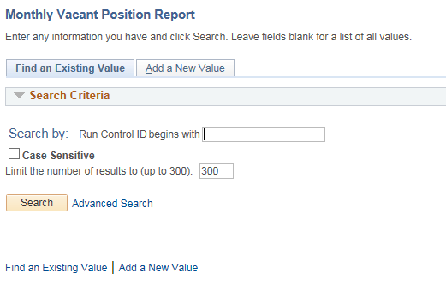

The Report Request Parameters box will appear.
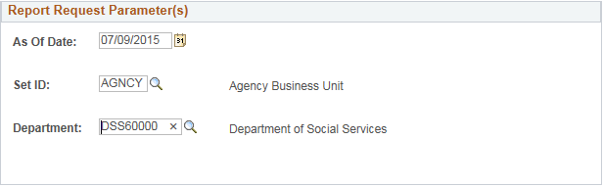

- Enter the As Of Date
- Enter the SETID (AGNCY, UNIVS, LEGMN, JUDCL)
- Enter the Department (For agencies with multiple departments use the parent code for the entire agency or any individual department code for only those sections)
- Once completed, press the button

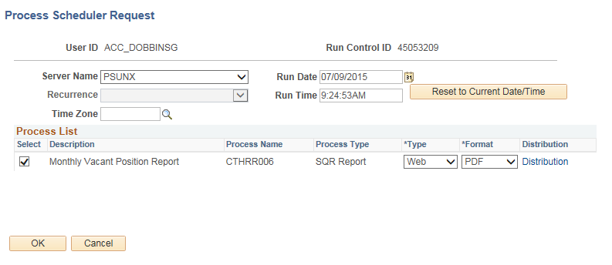

- The Process Scheduler Request page appears. The Server Name should be “PSUNX” the Type should be “Web” and the Format should be “PDF”
- Click
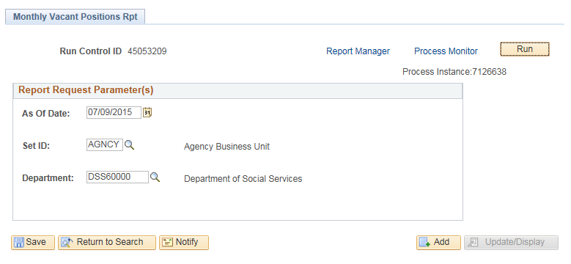

- The Report Request Parameters box appears with the Process Instance number for the report. To view the report and/or check on the progress or processing status click Process Monitor link

- In Process Monitor, click on the button every 30 seconds or so to update the page until the Run Status is set to “Success” and Distribution Status is set to “Posted”

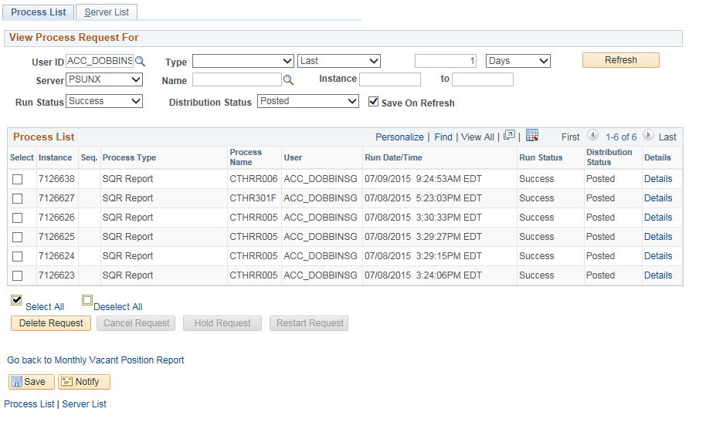

- Once the Distribution Status is set to “Posted”, click on the Details link for the Process Name which includes “RR006” 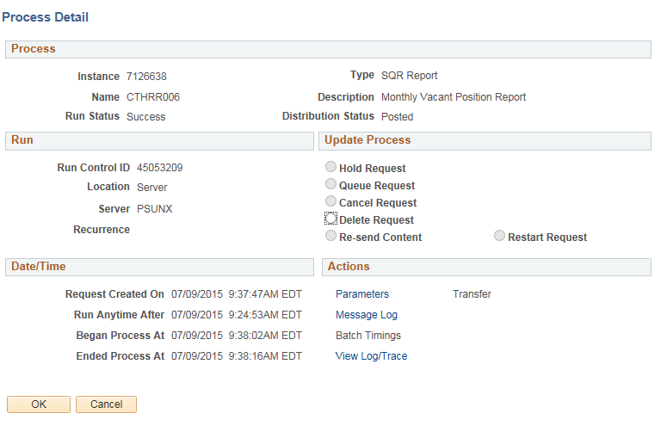
- On the Process Detail page, click on the View Log/Trace link 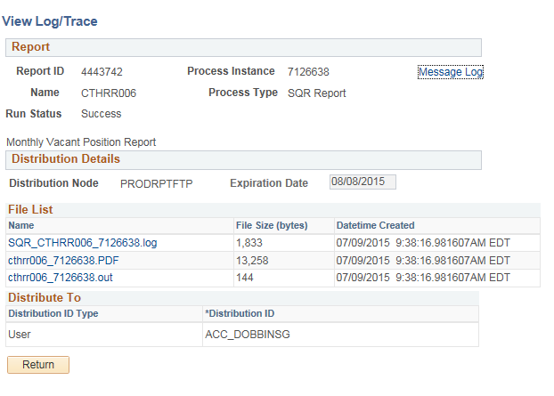

- Click on the cthrr006 xxxxx.PDF link to open the report

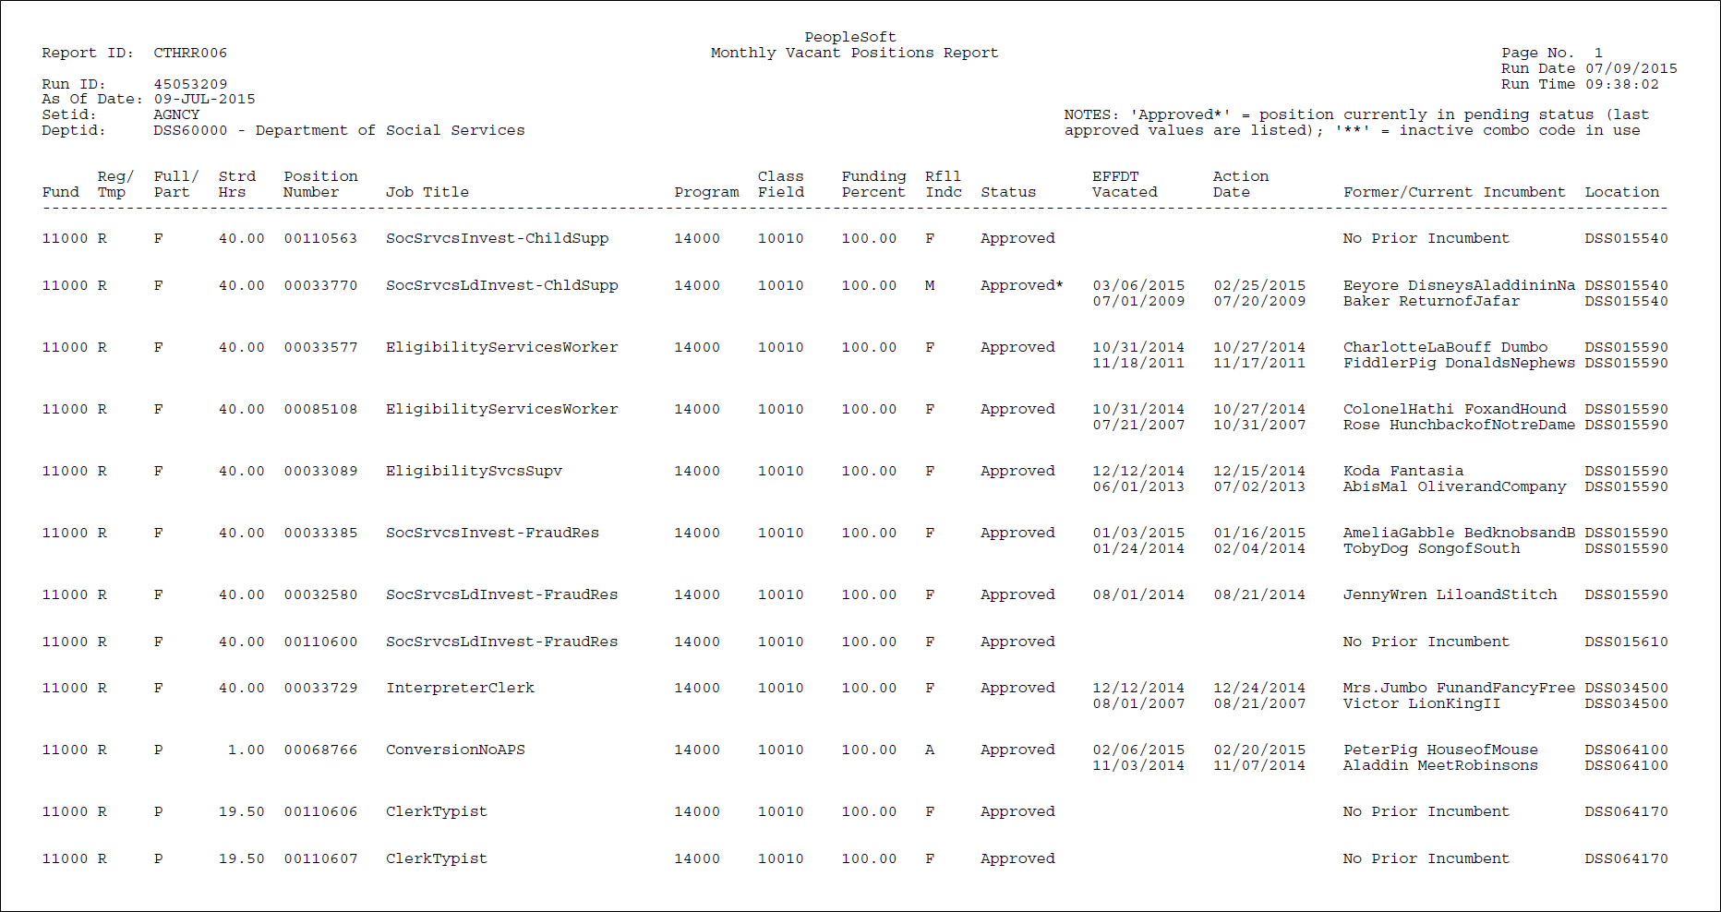

The PDF report display as above. All but two columns, position number and former/current incumbent have been displayed above.

Report Criteria and Features (Information in Former/Current Incumbent and Location field have been blocked for privacy reasons.)

- The Monthly Vacant Position Report should reflect all vacant positions which have an Effective Status of “Active” where the position has ever had a Position Status of “Approved”, including both appropriated and non-appropriated positions. (These fields are not located on the report, they are located in Position Data>Description tab.)
- Positions with a headcount of greater than one will only be listed if the Headcount Status is “Open”– meaning no incumbents. Positions with a Headcount Status of “Partially Filled” meaning at least one incumbent or ‘filled” meaning all available slots occupied will not be listed. (These fields are also not located on the report, they are located in Position Data>Specific Information tab.)
- New positions still in workflow (not yet with a Position Status of “Approved”) will not appear on the report.
- Vacant positions as specified above will continue to appear on the report until they have an Effective Status of “Inactive”.
- Positions undergoing some sort of change will appear as they did prior to the proposed action in process. This includes “Recycled” and “Rejected” positions which have not yet been returned to position status of “Approved”. On the Vacant Report, in the Status column these positions will be marked with an asterisk next to the status of “Approved”. In the report header (top right hand corner) is explained: NOTE: “Approved*”denotes position currently in pending status; last approved values are listed.
- Positions are arranged in order of Fund code, Location code, and Position Number.
- Positions which are split funded will appear twice to allow all funding values to display. In these cases the row of data will carry a Funding Percent column of less than “100.00”.
- The display columns are arranged from right to left:
  - Fund – Fund Code chartfield value of the position combination code.
  - Reg/Tmp – Regular/Temporary value on position data.
  - Full/Part – Full Time/Part Time value on position data.
  - Strd Hrs – Standard hours value on position data.
  - Position Number – Position number value.
  - Job Title – Title Field value from position data.
  - Program – Program Code chartfield value of the position combination code.
  - Class Field – SID chartfield value of the position combination code.
  - Funding Percent – Percent of Distribution value of the position combination code.
  - Rfll Indc – Refill Indicator value from position data.
  - Status – Position Status from position data, except where asterisk indicates that position is being changed in some way.
  - Effdt Vacated – The effective date of the job data row which vacated the position. Because this can be retroactive or in the future this may vary widely from the next field.
  - Action Date – The Date Created value from job data showing the date the entry was made which vacated the position.
  - Former/Current Incumbent – Most recent incumbents of the position. If never filled ‘No Prior Incumbent’.
  - Location – The position Location code value.

Other Position Resource Information:

The Monthly Position Status Report - CTHRR005 (Main Menu> Core-CT HRMS>Organizational Development > Position Management > Position Report) also contains vacant position information.

The online inquiry - Vacant Budgeted Position (Main Menu> Core-CT HRMS> Organizational Development> Position Management> Review Position/Budget Info> Vacant Budgeted Positions) also displays these same vacant positions. However the sort order is by position number and no funding information is included so there are not multiple lines for a single position number. This inquiry will give a quick count of vacant positions which are active.

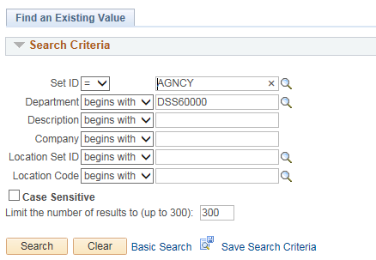

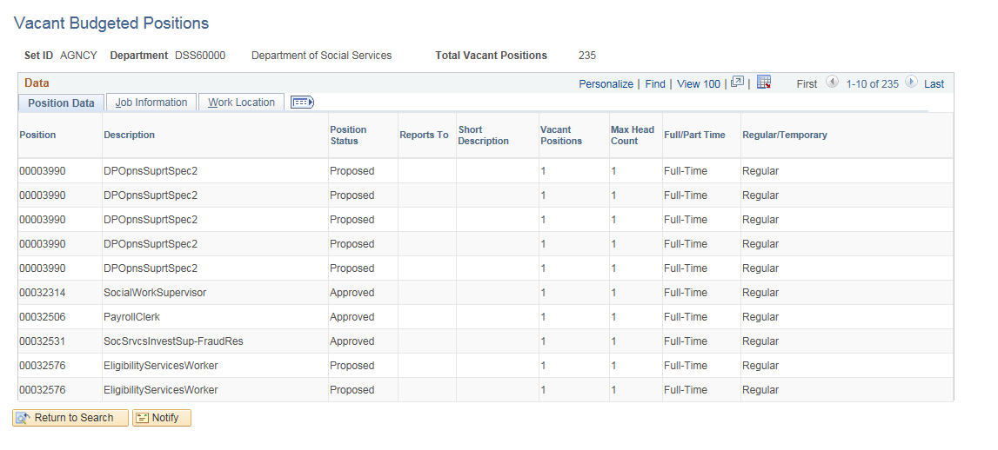

The inquiry displays the total number of vacant positions (as of today’s date) and displays them in position number order. Three tabs of position information are included.

The online inquiry screen Position History (Main Menu> Core-CT HRMS> Organizational Development> Position Management > Review Position/Budget Info) can display current and prior incumbent information in positions.
- Enter any position number you wish to check in the search page
- Click

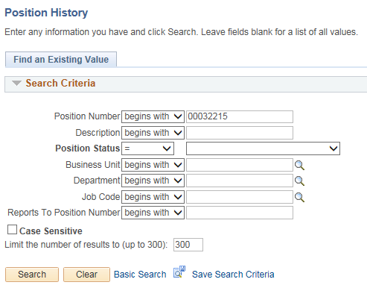

The Position History page displays.



