Establishing a New Position

Position processing in Core-CT is a fairly quick procedure if certain basic documentation required by the approvers is developed and on hand when the data is entered. The procedures to generate various position actions are detailed below. Although not every position action is detailed, the basic steps are the same and can be completed using a similar approach with modification to one or two fields as necessary. The first and most detailed procedure is to create a new position. Changes to already approved positions are much simpler because only the fields which are being adjusted will require update rather than each field having to be completed.

Agency Position Specialist should compile documentation relating to the position request such as:
- Internal position approval forms (if applicable)
- Table of Organization (if applicable)
- Department
- Location
- Job code
- Full or Part time
- Standard hours
- Salary Plan
- FTE value
- Adds to FTE Value
- Combination code
Also, prepare the text for the Detailed Position Description in a separate word or text document. The justification format and content is driven by the requirements of agency, DAS and/or OPM approvers and the type of action being requested.

- Navigate to: Main Menu> Core-CT HRMS> Organizational Development> Position Management> Maintain Positions/Budgets> Add/Update Position Info

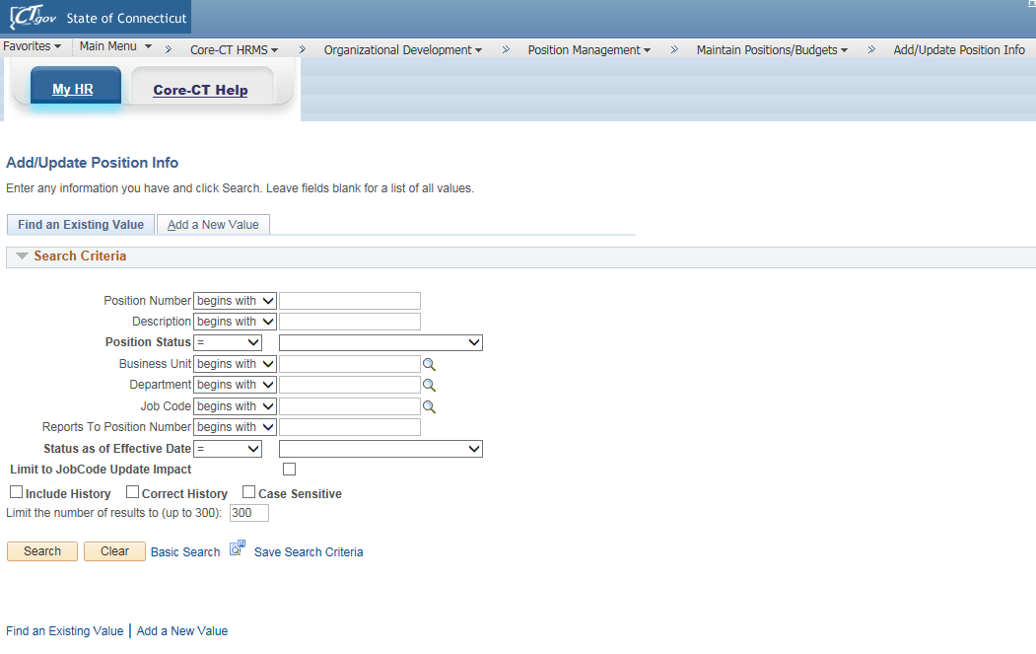
- The Add/Update Position Info search page displays.
- Click the Add a New Value tab or link. This will bring you to the Position Data pages.

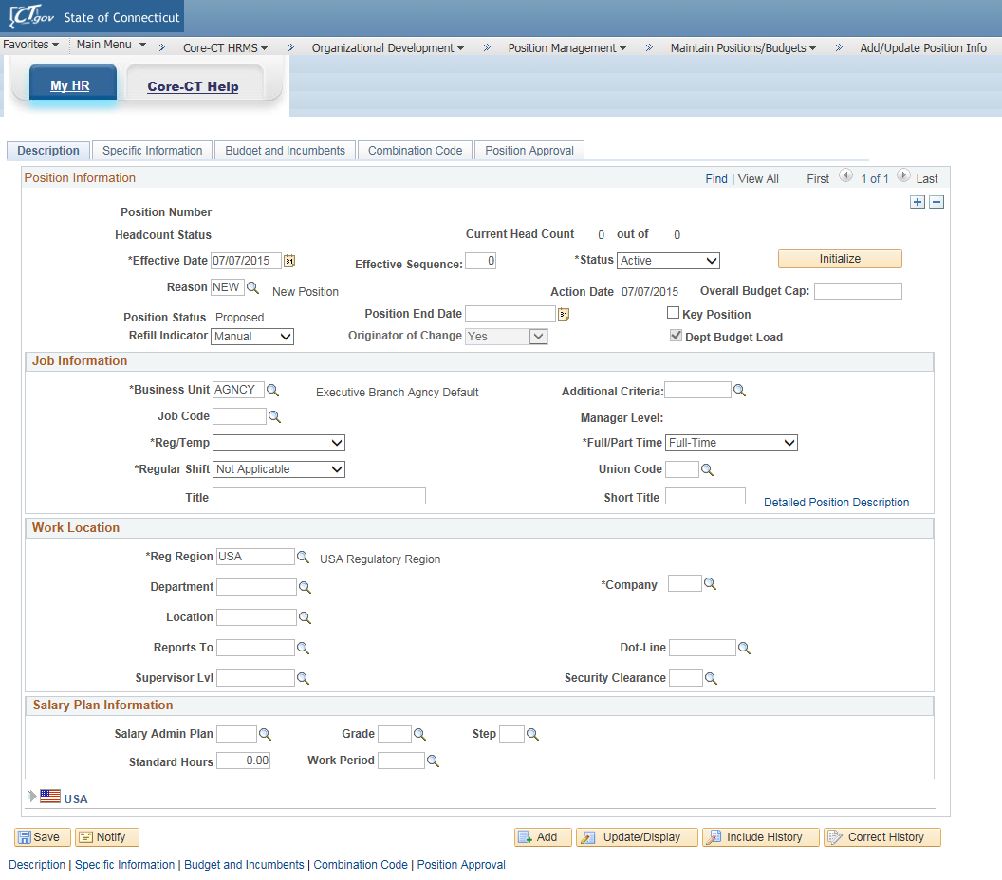
Note: Fields not identified in the following instructions are not used by Core-CT.

- (Mandatory) Today’s date will default in as the Effective Date. Enter the appropriate Effective Date for the position.
- (Mandatory) Effective Sequence – Will be ‘0’. This number is used to track multiple actions that occur on the same date. If there are additional actions on the same effective date the sequence would need to be manually change to ‘1’ and so on.
- (Mandatory) Status – defaults in as ‘Active’. A status of ‘Inactive’ means the position is no longer in use.
- System assumes all Action codes in “Position Data” is ‘Position Change’ and is not visible on the page.
- (Mandatory) The Reason code should default in as ‘NEW’. Do not change.
- Action Date defaults in as today’s date.
- Position Status defaults in as ‘Proposed’.
- (Optional) Position End Date – used to indicate if the position has an end date.
  - If the position is not a permanent position the expected last work day should be entered in the Position End Date field.
- (Mandatory) The Refill Indicator - defaults in as ‘Manual’ meaning refill is not authorized.
  - Update this field to ‘Auto’ if your agency does not require OPM budget approval for refills and ‘Six Months’ if refill approval is required. Keeping the status as ‘Manual’ will not allow the position to be filled.
- Originator of Change – defaults in as ‘Yes’ to indicate your user role is the originator of this transaction for workflow purposes. Do not change.
- (Mandatory) Business Unit – defaults in as ‘AGNCY’.
  - Options are: UNIVS – for UOC, UHC, CCC and CSU.
  - JUDCL – for Judicial
  - LEGMN – for Legislative Management
  - AGNCY – for all other agencies
- (Mandatory) Job Code - job classification number. If you are not aware of the job code number you can click on the search magnifying glass to bring you to the search page. If you are unsure of the job code description or the job code number you can go to the DAS website link at: http://das.ct.gov/HR/JobspecNew/JobSearch.asp to do a more detailed search. This listing does not include the salary plan.

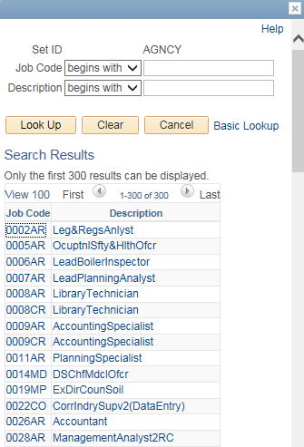

- Manager Level – defaults in according to the job code selected.
- (Mandatory) Reg/Temp – select ‘Regular’ – if position does not have a Position End Date or ‘Temporary’ – if position does have a Position End Date.
  - If the position is temporary (or durational in nature) please enter a Position End Date specifying the last day the incumbent will work.
- (Mandatory) Full/Part Time – indicate appropriate selection. (If position is less then the full time value, indicate Part Time.)
- (Mandatory) Union Code – defaults in from job code. Do not change.
- (Mandatory) Title - defaults in from job code. Do not change.
- (Mandatory) Short Title - defaults in from job code. Do not change.
- (Mandatory) Reg Region - defaults in as ‘USA’. Do not change.
- (Mandatory) Department - enter the three digit acronym for your agency used in Core-CT (e.g. DOC) in the Department field and click the search magnifying glass. Select the full department code from the resulting list or single value.

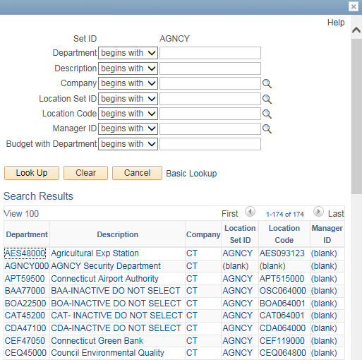

- Once you make a selection the system will return you to the “Description” tab.
- (Mandatory) Location code - defaults in from the Department code selected, correct as necessary. (To view the entire Location Code table, enter your three digit agency acronym in the Location field and click the search magnifying glass. To narrow the search, add more criteria such as the town location to the acronym (064 for Hartford) and then search. Once you have clicked on the selection, the system will return you to this page.)
- (Optional) Reports To – indicates which position this position will report to.
- (Mandatory) Salary Admin Plan – defaults in from selected job code. Do not change.
- (Mandatory) Grade – defaults in from selected job code. Do not change.
- (Mandatory) Step – defaults in from selected job code. (If salary plan of selected job code is a range plan, the Step field will be blank.)
  - The step value should always be the minimum or starting step for the class, unless a different step hiring rate is being requested. In these cases only it is permissible to adjust the step to request the rate. The next requested action in position data should adjust the rate back to step 1 or the minimum starting step for the class.
- (Mandatory) Standard Hours – defaults in from the job code selected. If the Full/Part Time indicator is set to ‘Part-Time’, reduce the Standard Hours to the appropriate amount.
- (Mandatory) Work Period – remains as default ‘WCT’. Do not change.
- Schedule – defaults in as Monday through Friday. (These fields not used by Core.)
- Click on USA Flag (bottom of page) – FLSA Status defaults in from job code selected.
- (Mandatory) Detailed Position Description –click on the link to open the text box for the position justification. Copy and paste the justification discussed on page 1 or type it in.

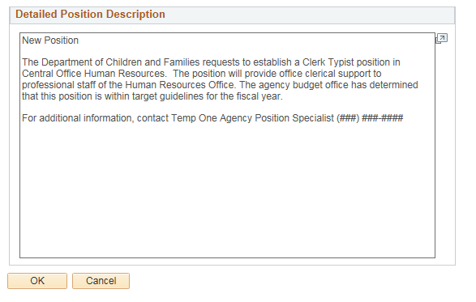

- Click “OK” to return to the “Description” page.
- NOTE: If you alter defaults derived by the Job code table, the altered fields will high light in yellow.
- Click on the “Specific Information” tab.
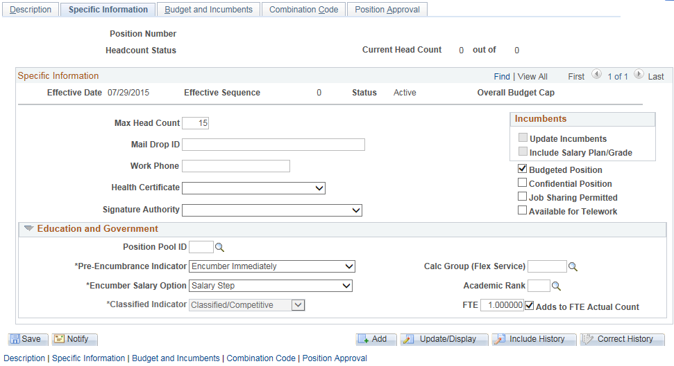

- (Mandatory) Max Head Count – defaults in as ‘1’. (Certain agencies have permission to increase the Max Head Count to other then ‘1’.)
- (Mandatory) Budgeted Position – defaults in as checked. This check is necessary to complete the Department Budget Build process for payroll processing. Do not change.
- (Mandatory) Pre-Encumbrance Indicator – defaults in as ‘Immediate’. Do not change.
- (Mandatory) Encumber Salary Option - defaults in as ‘Salary Step’. Do not change.
  - (Mandatory) FTE - enter the Full Time Equivalent value (1.00 = full time) or the appropriate decimal percentage if less than full time (standard hours divided by salary plan hours - 20 divided by 40 = .50).
  - (Mandatory) Adds to FTE Actual Count – check the box if the position is even partially funded through State appropriations and is Full time and permanent. Leave it blank if it is completely funded through other funds such as federal grants or agency revenues or if it is temporary or permanent part-time. This field is intended to track the permanent positions included in your agency’s budget.
  - Budget and Incumbents tab is an informational only page. This page will show incumbents once an employee has been hired into the position.
  - Click on the “Combination Code Information” tab.

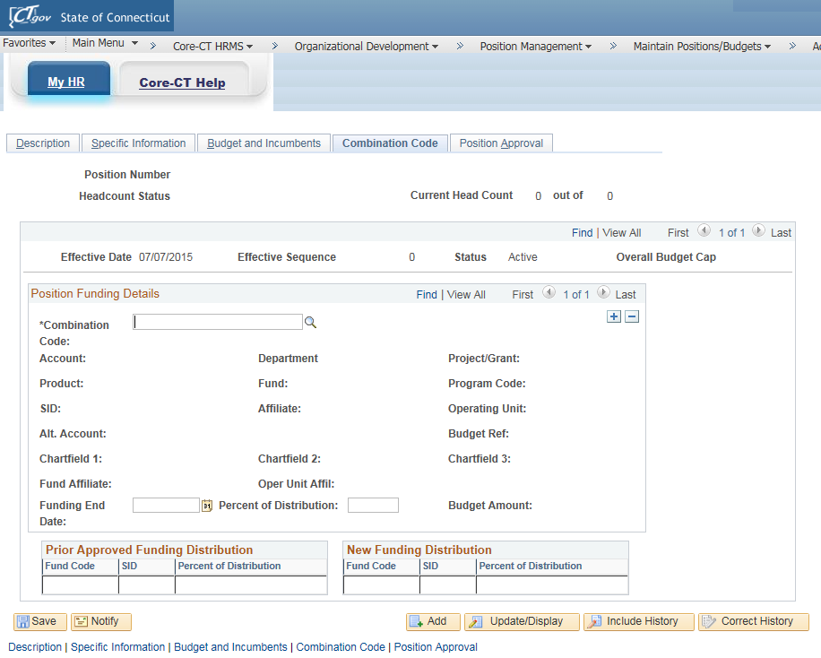

  - (Mandatory) Combination – this field specifies the agency funding source which should be utilized. If the HRMS combination code has been identified in the research done on page 1, this can be copied and pasted into the field. If not, click the search magnifying glass.

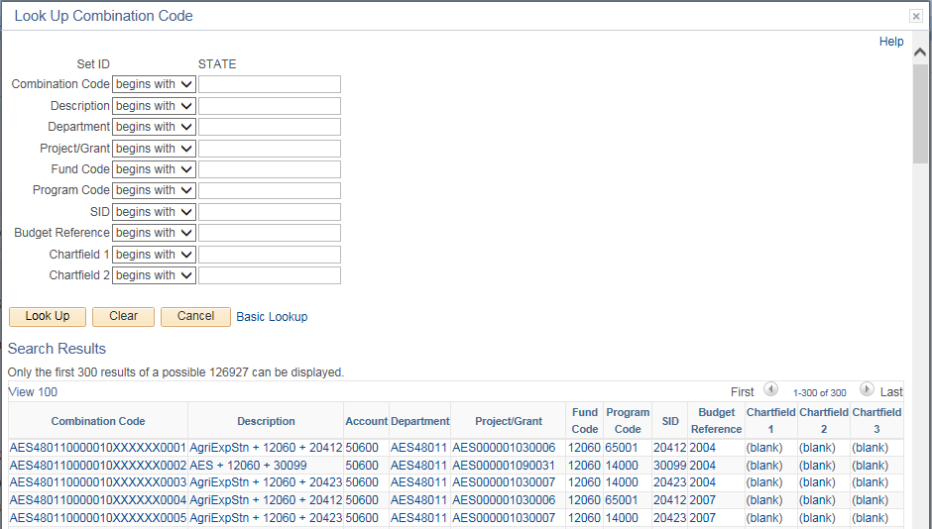

  - The “Look Up Combination Code” search page will appear.
  - If you only enter in your agencies three digit acronym in the Combination Code field all combination codes meeting the specified criteria will be found.
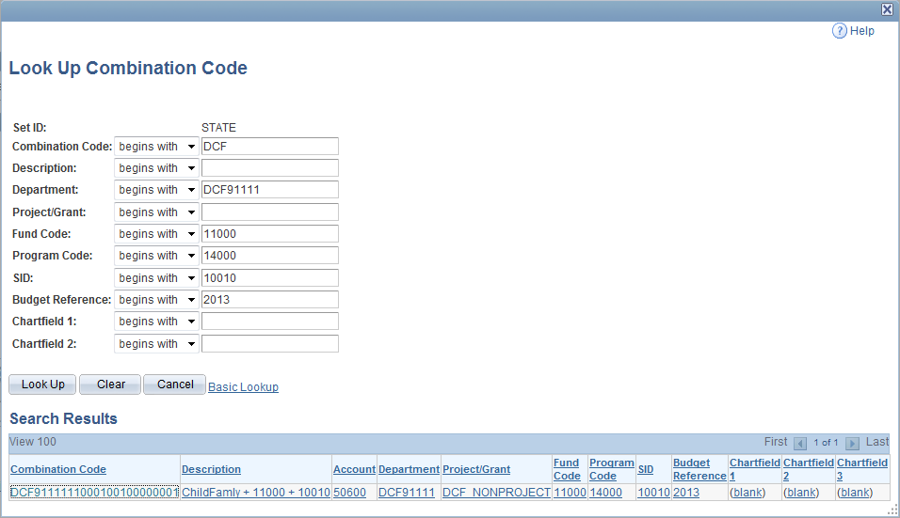
  - Enter the values from as many of the individual financial chartfields as are known, such as: Department, Project/Grant, Program, Fund, SID, Budget Reference, Chartfield 1 or Chartfield 2. Adding more criteria will narrow the results to fewer combination codes. When the correct combination code is found in the resulting search, click on the blue hyperlinked text to select that combination code onto the position record and the system will return you to the “Combination Code Information” tab.
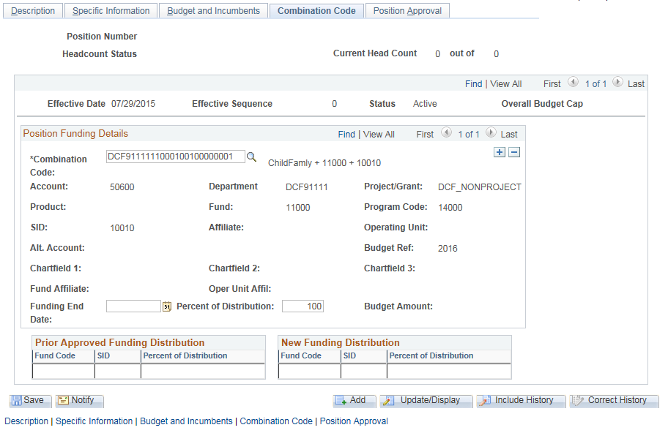

  - Notice that all of the financial chartfield values are displayed on the page.
  - (Mandatory) Percent of Distribution - enter a percentage. If this is to be the only funding source enter ‘100.00’. If the funding is to be split among two or more sources, enter the portion of 100% that the selected Combination code represents (for example ‘50.00’). Then, click the button in the “Position Funding Details” box so that another combination code can be added using the same procedure. To view both rows more easily, click on the View All link. Repeat until all funding sources and their percentages are properly recorded. Important: All percentages when added together must equal 100%.

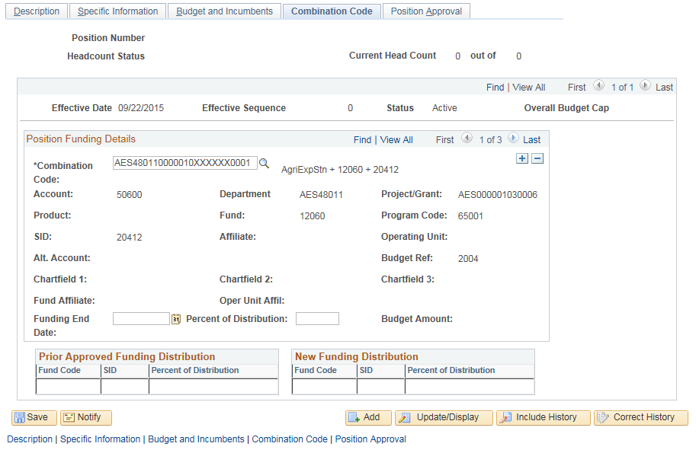

- Click “View All” to view all rows. Example of how multiple funding rows will appear prior to completion.
  - Example of how multiple funding rows will appear when completed.
  - Funding End Date - only if the funding specifically ends on a particular fiscal year date other than 06/30 (State Budget End Date) should a funding end date be entered. If a grant fund can be used until expended and doesn’t have a specific end date to be used, it can remain blank. For more information, check with your agency or OPM budget analyst regarding this field.
  - The Prior Approved Funding Distribution and New Funding Distribution boxes will be completed once this transaction is saved.
  - Click the tab or link for “Position Approval”.

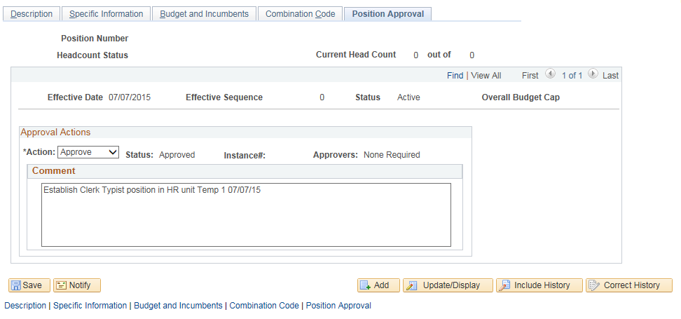

  - (Mandatory) Action – defaults in as ‘Approved’. Do not change.
  - (Mandatory) Comment - enter brief comments to describe the request and include your name and the date entered. As each succeeding approver enters a row and enters comments a complete record of approval comments is obtained. The system will copy the comments from page to page so approvers will only need to add their comments to those already entered on the previous rows.
- Click the “Save” pushbutton to save the transaction.

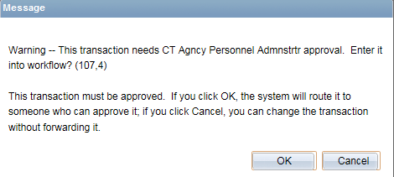

- A message will appear if position approval workflow is required. Click the “OK” pushbutton. In addition, the message will identify the level of approver who will receive the requested action in their worklist. The message will not appear if no workflow is required; the system will set the position status and approval status to ‘Approved’.

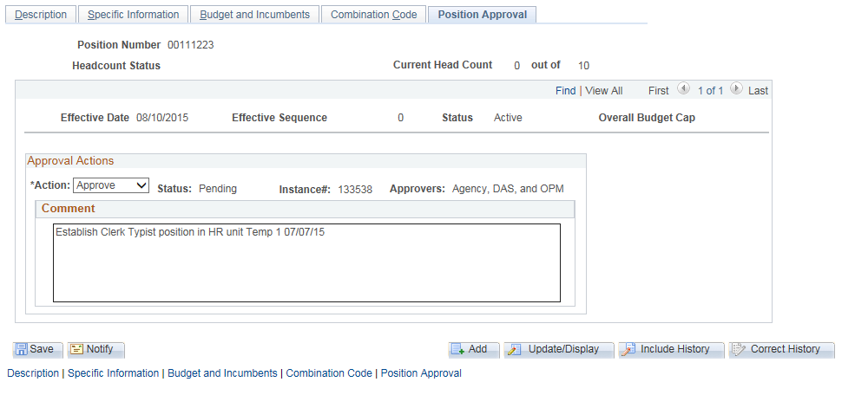

- Note that the position number is assigned and the approval status is set to ‘Pending’ and the Approvers are indicated as: Agency, DAS and OPM. Since some actions may not require approval by all three agencies it is a good practice to take note of the approval path the position will be taking.
- Once the position has entered workflow, the position is set to read only for all position users EXCEPT the approver(s) where the position has been routed for approval. See Position Worklist Approval Process job aid to review rules for approving actions within the worklist and to determine which actions will require approval and from whom approval will be required. Also included are instructions for processing retroactive effective dated position actions. These are often required to process reclassifications of position incumbents following grievances or labor agreements.
The next section gives an example of workflow processing from the first worklist approver for the above position.

Position Worklist

The Approver logs into Core-CT and enters the worklist by navigating to: Core-CT HRMS > Worklist > Worklist on the menu.

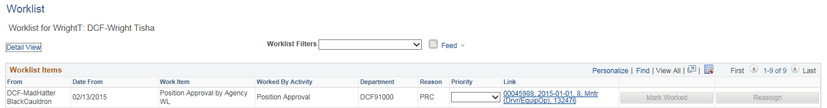

- The worklist for the approver should appear.
- The worklist can be filtered if different categories of actions are routed to the approver.
  - Usually originators find this feature most helpful because actions which are approved, recycled and denied can be focused on as a group by using the filter.
- The worklist can also be sorted by clicking on the underlined column headings.
  - Approvers often find this helpful in navigating through a large number of actions. They may want to sort by “Department” or by “Reason” code to group and find actions from certain originators. They are also able to set their own priorities in their worklist by clicking the dropdown arrow and selecting one of the values 1-High, 2-medium, 3-low.

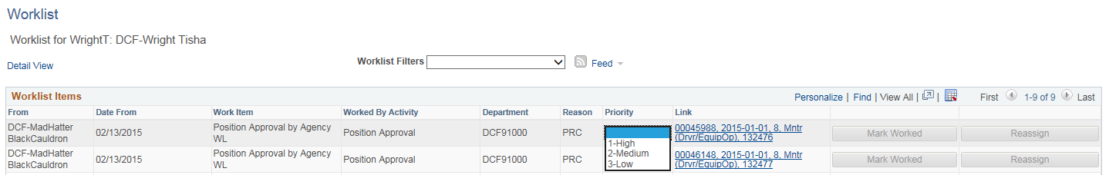

- To select a position for approval processing click on the blue hyperlink (this begins with the position number under the “Link” column heading). The position as saved by the previous user will appear.

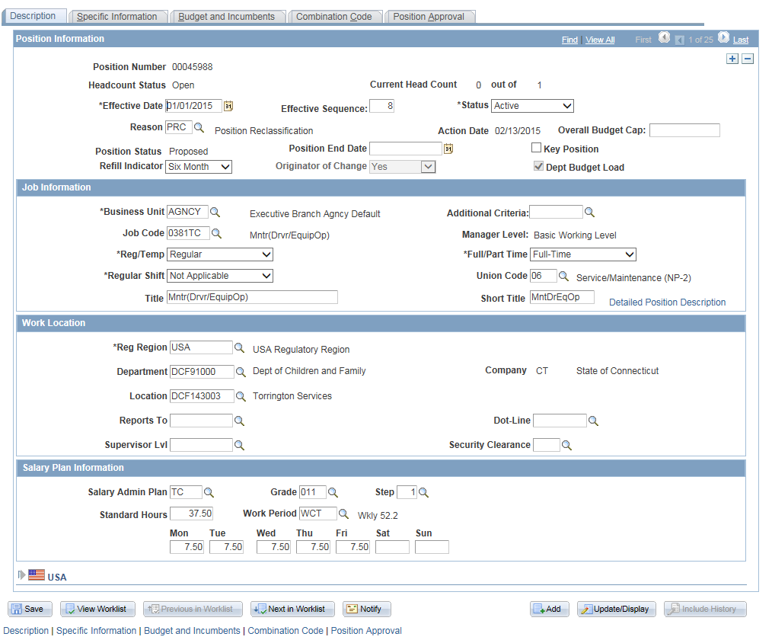

To process an action submitted to you by the originator or a previous approver:
- Add a new position row by clicking on the button.
- Determine if the Effective Date will remain the same. If it will remain the same as the previous row, the system updates the Effective Sequence to the next number.
- If this is a new position, the Reason code MUST be changed from ‘NEW’ to ‘EST’.
- The Refill Indicator should have been updated to ‘Six Months’ on any new position going through workflow.
  - If this is an existing position, the Refill Indicator should not be updated unless permission to fill is being requested. Do NOT routinely update.
  - Agencies who do not need to request refill approval, the position value should always be set to ‘Auto’.
  - For agencies where approval is required, the position refill indicator is reset by the system to manual at the end of the month which is six months after the date the refill request was originally approved by OPM. The system looks at the Action Date not the Effective Date. (This is how refill authorization is removed.)
- If the Full/Part time field is set to ‘Part Time’, this means the position does not have the full time standard hours normally assigned to the job code in that salary plan.
  - If part time, you would check the Standard Hours which have been indicated to make sure this is the correct amount of hours to be approved.
  - Also if the position is part time review the FTE (Full Time Equivalent) value on the next tab to be sure it is consistent with the standard hours indicated. (If full time equivalent = 40 hours and the position will work 20 hours the FTE = .500000.)
- Verify Salary Plan values are correct for the job code.
- Click on the hyperlink Detailed Position Description to review the position justification.
- Click on the “Specific Information” tab.

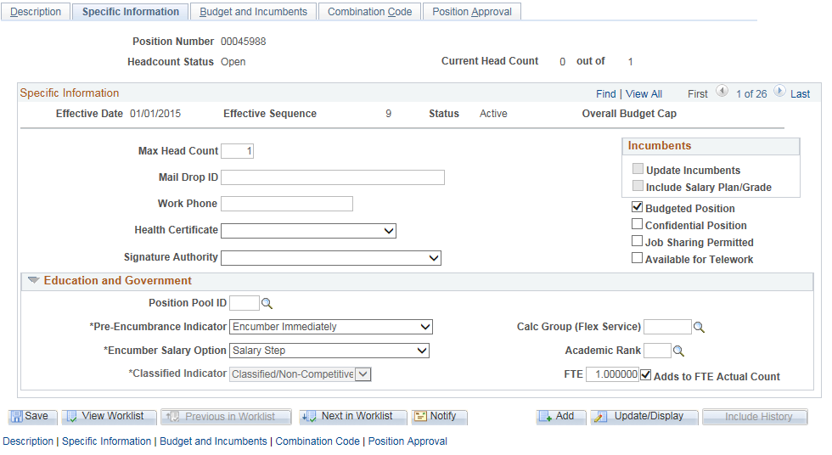

- Review the FTE field.
  - The FTE value should reflect the proportion of a full time position (see bullet above).
- Review the Adds To FTE Actual Count field.
  - The Adds To FTE Actual Count should be checked when any portion of the position is funded from state appropriations. (If it is completely funded from agency revenues or grant funds it should not be checked.)
- Click on the “Combination Code Information” tab.

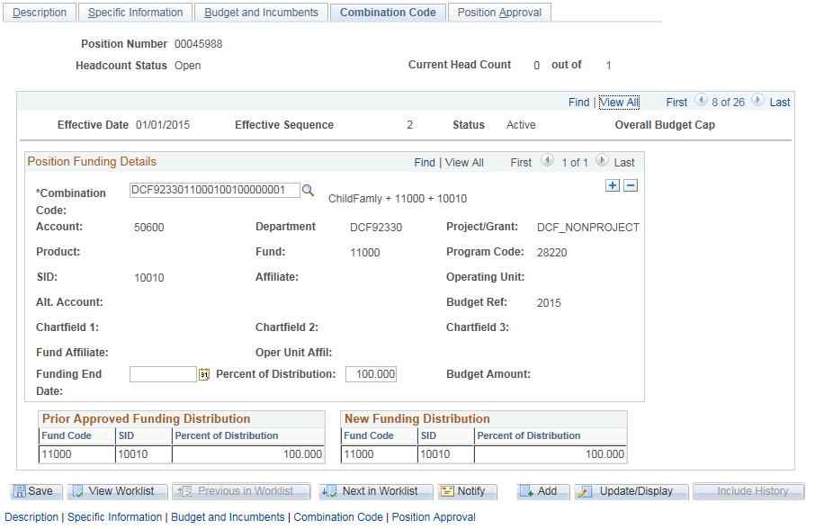

- Review the Combination code and the related financial chartfields associated with the combination code.
  - If the Percent of Distribution is less than ‘100.00’ view all pages in “Position Funding Details” by clicking on the View All hyperlink. If the funding is correct go on to next step.
- Click on the “Position Approval” tab.

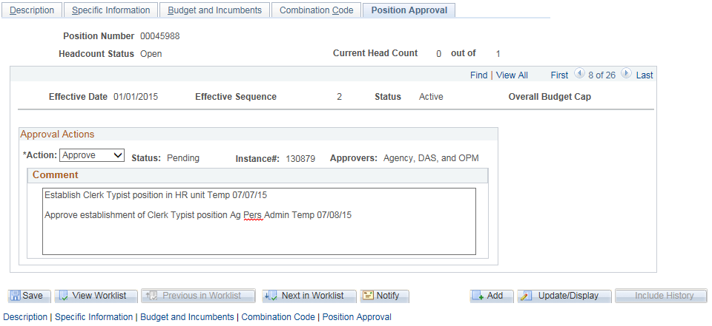
- Review the Action field status.
  - If the action is to be approved the default value of ‘Approve’ is already set in the Action field.
  - If the position needs correction before approval, set the Action field to ‘Recycle’.
  - If the position is to be denied set the Action field to ‘Deny’.
  - Review comments by originator and any previous approvers. Enter brief approval comments and your name and the date to document the action.
  - If you are returning the position to the originator by recycling or denying, be sure to document the changes needing to be made or the reason for denying.
    - The comments and instructions are important because recycling and denying keeps the action in a ‘Proposed’ position status on the “Description” tab. The originator will need to address the problems and either resubmit with needed changes or revert the position to prior status by adding in a new row.
- Click the Save button.

- A message should appear if the position requires additional workflow and the level of the next approver will be identified. Click OK.
- The position row added by the approver should save and the position will route to the identified next approver.
- See the previously mentioned job aid Position Worklist Approval Process for more information about steps originators should take to address recycled/denied positions.

For the identified position above the approval path is indicated in the Approvers field as Agency, DAS and OPM. Therefore, the following list of approvers will need to review this position:

- Agency Personnel Administrator
- Agency Budget Specialist
- DAS Analyst
- OPM Analyst
- OPM Senior Analyst
- OPM Section Director
- OPM Budget Director

This action will require final approval by the OPM Budget Director before returning approved to the originator. Approved, Recycled and Denied position actions are routed to the originator worklist both as a notification (approvals require no action) and as a worklist action.
- Recycled and denied requests require the originator to correct the action by adding a new effective dated row and resubmit.
- Approved actions appear with the Mark Worked pushbutton lit up on the worklist. This means it is a notification only and can be removed easily from the worklist by simply clicking the button without review.
- All other actions require the originator to open and update the position as appropriate.

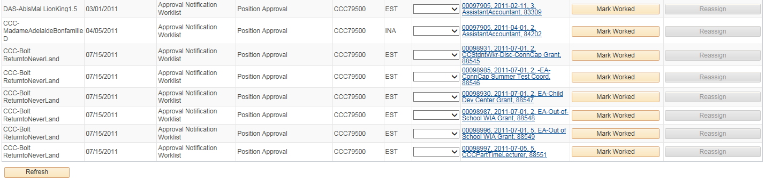

- Example of Positions returned to the originators worklist that have been ‘Approved’ and need no other processing. Click on the Mark Worked pushbutton to clear from list.

POSITION MODIFICATIONS

When positions are already in ‘Active/Approved’ status (fields located on the “Description” tab) and require a change, the changes are fairly easy to complete. Listed below are the most common types of actions:
- ‘PGC-Position General Change’ is often used to correct funding or to combine several actions that have no one description.
- ‘PRC-Position Reclassification’ is used to change the job code to another job code value.
- ‘PRF-Individual Position Refill’ is used to request authorization to refill a position after the refill authority has expired for the position.
  - If requesting a position to be reclassified and asking for permission to fill the position at the same time, use this reason code.
- ‘TRS-Transfer Within Same Agency/Department’ is used to transfer a position to another department code but in the SAME agency (example: DOC88350 to DOC89200). This reason code does not trigger workflow.
- ‘TRN-Transfer to a New Agency/Department’ is used to transfer the position to another state agency (example: DAS23000 to ITD25000). This reason code will trigger workflow.

In the following example we will combine several of these actions within one transaction to demonstrate how a more complex action than usual is performed.

In this scenario the following elements will be updated:
1) Reclassification will be requested.
2) Refill authority will be requested.
3) Funding change will be requested.

To modify positions follow these steps:

Agency Position Specialist should compile documentation relating to the position request such as:
- Internal position approval forms (if applicable)
- Table of Organization (if applicable)
- Department
- Location
- Job code
- Full or Part time
- Standard hours
- Salary Plan
- FTE value
- Adds to FTE Value
- Combination code
Also prepare the text for the Detailed Position Description in a separate word or text document. The justification format and content is driven by the requirements of agency, DAS and/or OPM approvers and the type of action being requested.

The Agency Position Specialist navigates to
Core-CT HRMS>Organizational Development>Position Management>Maintain Positions/Budgets>Add/Update Position Info

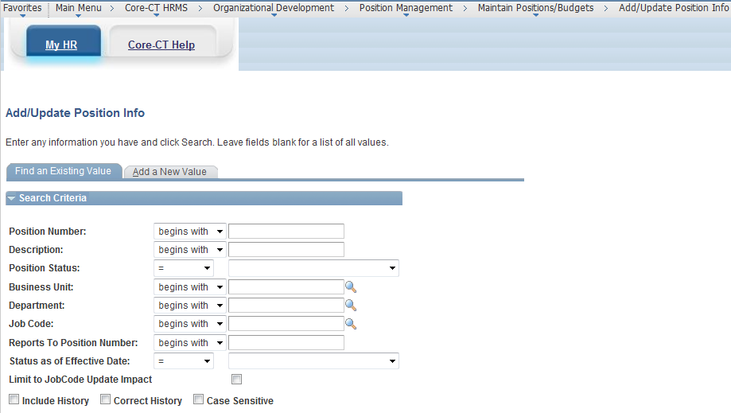

- Enter criteria to search for the position needing to be modified.
  - If the Position Number is known enter either all digits or you may ignore the leading zeros (enter either 00082534 or 82534).
  - If the position number is not known or more than one position needs to be updated, use other criteria to find these.
    - Enter the description in the Description field. (Partial descriptions can be entered by using part of the words or using wild cards which is the % sign. Example: if looking for all Clerk Typist you can enter just Clerk or %typist.)
    - To find only approved positions use the Position Status field and select ‘Approved’.
    - Enter in Department if you have security access to multiple departments.
    - To select only positions in a particular job code, enter the job code number in the Job Code field. (If you do not know the job code you can try the search using the Description field above or go to the DAS website for a complete listing. (See link at end of document.)
    - To find only ‘Active’ positions select this status from the Status as of Effective Date field.
- Once the search criteria are entered, click the Search pushbutton.

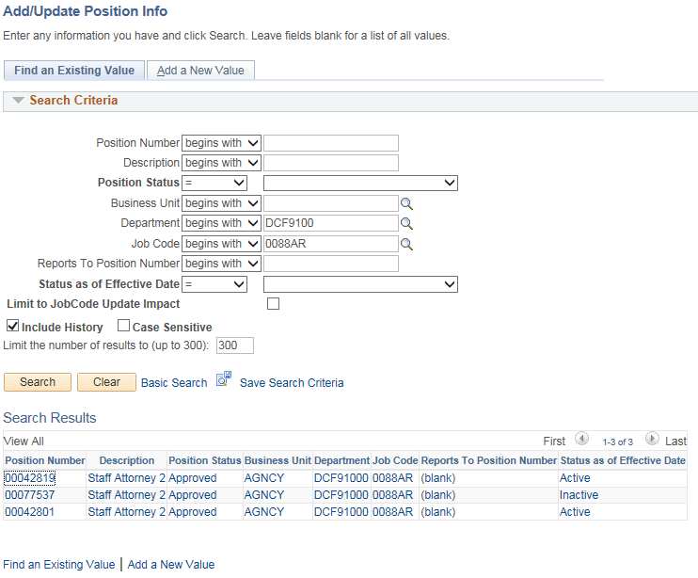

- Click the Include History checkbox to see all historical rows related to this position.
- When the search results return, select a position by clicking on any part of the blue hyperlink text. The current effective dated row of the position appears.

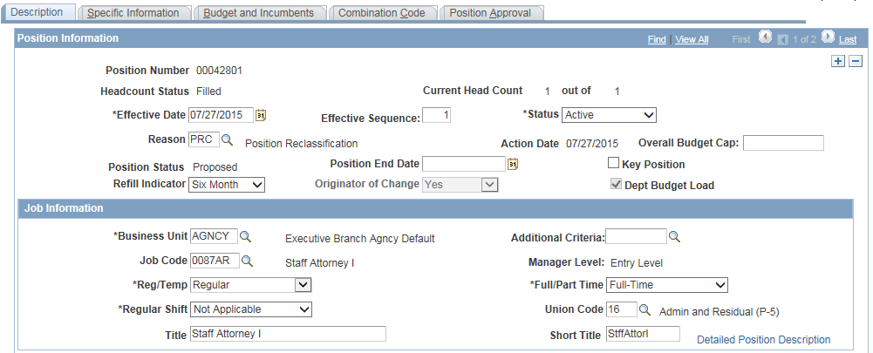

- Click the button to add a new row to for the updates. (System will not allow you to update the existing row.)
    - (Mandatory) Effective Date - enter the date. (Note: a retroactive date can also be entered except when the date entered is BEFORE the date of the current row in position data. WHEN THE DATE IS EARLIER, a correct history action is required.
  - The Position Worklist Approval Process job aid contains specific instructions for requesting this correct history action. The agency must submit the action with a current date to allow workflow to complete correctly, and then request Core-CT to correct the effective date.
  - When the date is the same or later, enter the date and update the Effective Sequence number if required. (When the same date is entered a sequence number which is one number higher is required.)
- (Mandatory) Reason code – select ‘PRC-Position Reclassification’ for this action since this action will combine reclassification, refill, and funding change. (Whenever multiple activities are taking place in one transaction, select the most significant reason code.) The Reason code does not trigger workflow. Workflow is triggered by the fields that are changing.
- (Mandatory) Refill Indicator – select ‘Six Months’. In this example we are requesting the position be filled so the Refill Indicator should be changed.
  - The refill value ‘Manual’ means not authorized to fill position.
  - The refill value ‘Auto’ means that authorization is not required or has been given in advance and the position may be filled.
  - If position is currently set to ‘Six Months’ but you are aware that the six month time limit is about to run out, contact Core-CT to reset the previous row to ‘Manual’ to trigger workflow.
- (Mandatory) Job code – select ‘0087AR’. In this example we are reclassifying the position from 0088AR to 0087AR.
  - When a new job code is entered the default values from the job code table will be populated into the position except for certain override values which have been intentionally entered on prior rows. For example: the Standard hours and Full/Part Time indicator may have been changed to set the position to a part time value in the past. If so, the new row will remain part time, but other values will change such as the job code and job code description, Manager Level, Title, Short Title, and Salary Plan, Grade and Step information.
- (Mandatory) Detailed Position Description – enter new justification. If the text field is populated, highlight the text and delete the old information. Then copy and paste the text prepared earlier into this area or type the necessary justification required by the approvers.
- Click OK when complete to return you to the “Description” tab.

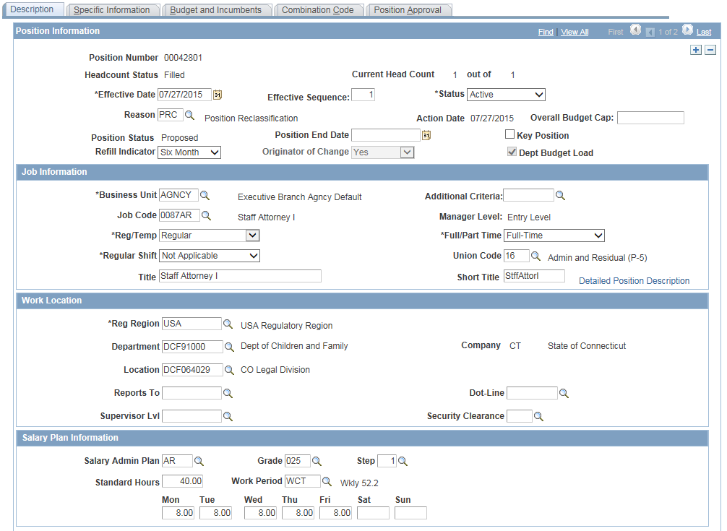
- The “Specific Information” tab should not be needed unless the position will be changing the hours. If so, click on the “Specific Information” tab and update the FTE value to correspond to the percentage of a full time schedule the position is on.

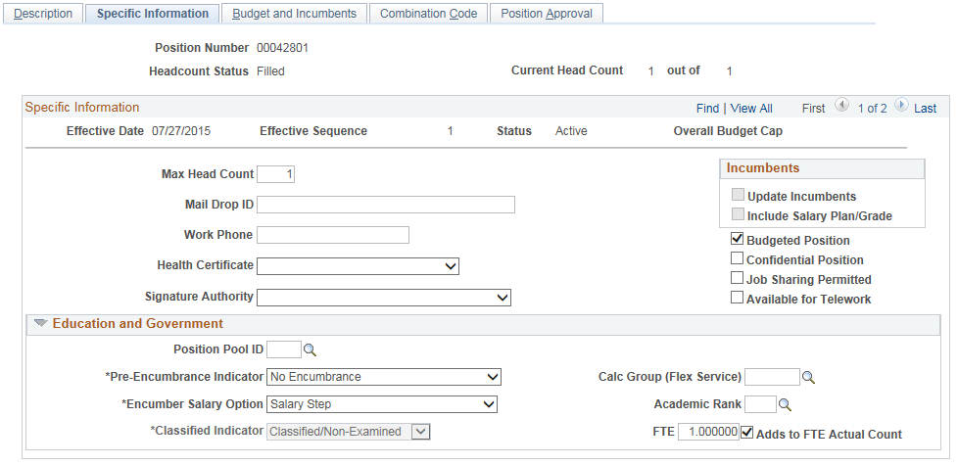

- Click on the “Combination Code Information” tab.

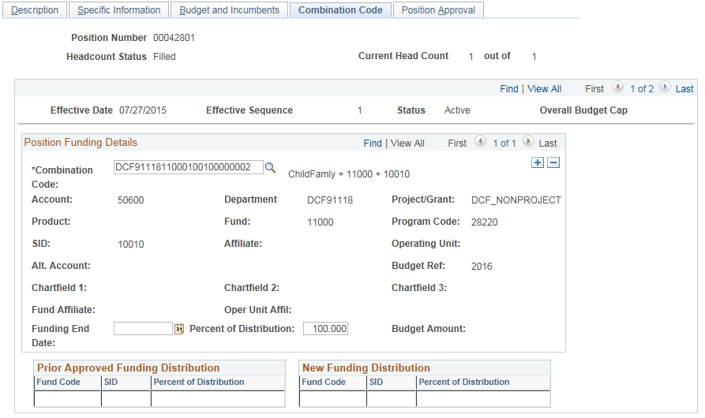
- (Mandatory) Combination code – enter the new combination code or click the magnifying glass to use the search page to look up the correct values. (In this example we are requesting the position’s combination code be changed.)
- (Mandatory) Percent of Distribution - if the same, go on the next step. If the funding is to be split into more than one combination code use the procedure described above to select the appropriate codes and assign the appropriate percentage.

- Click on the “Position Approval” tab.

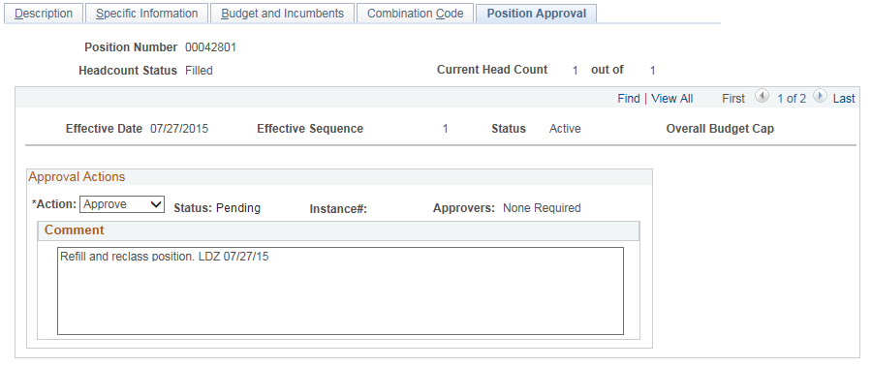
- On the “Position Approval” tab the Action should default to ‘Approve’. Enter brief comments to identify the action being requested such as “Refill, reclass and change funding for position. NJV 1/30/07”. Be sure to include your name or initials and the date so approvers can tell who has entered each row. When each approver adds a new row all comments on the previous row will be copied to the new comments page.
- Click Save pushbutton. If workflow is required, a message will indicate the level the position should be routed to and ask whether you wish to enter workflow.

- Click OK. The position saves and enters the worklist of the next approver.
- The Approvers field indicates the workflow path. In this case the workflow path is: ‘Agency, DAS and OPM’ to be approved. See worklist procedures above for worklist processing.

- The position needs to complete workflow and have a position status of ‘Approved’ to hire an employee into it.

Relevant Job Aids to Assist in Position Actions

Position Worklist Approval Process
http://www.core-ct.state.ct.us/hr/human_resources/doc/position_worklist_approval_process.doc

Position Approval History Report
http://www.core-ct.state.ct.us/hr/human_resources/doc/pstn_aprvl_hstry_rpt.doc

Positions Actions Processing
http://www.core-ct.state.ct.us/hr/human_resources/doc/position_actions_processing.doc

Positions Denied or Recycled
http://www.core-ct.state.ct.us/hr/human_resources/doc/pstns_denid_or_rcycld.doc

Action Reason Codes
http://www.core-ct.state.ct.us/hr/human_resources/doc/action_reason_codes.doc

Human Resources Date Definitions
http://www.core-ct.state.ct.us/hr/human_resources/doc/date_def_for_hr.doc

Additional Websites

DAS –Search for Job Descriptions
http://das.ct.gov/HR/JobspecNew/JobSearch.asp

