This flow illustrates how employees are enrolled in Dynamic (Time and Labor) Groups

Contains the criteria used to identify employees in which to enroll (i.e., Location Code)
Employee is not enrolled

NO
Dynamic Group Refresh process continues until all groups have been refreshed

Dynamic Group
Dynamic Group Refresh

Enroll employee
Process runs nightly to update enrollment
Process looks at each Dynamic Group to determine which employees’ data matches the criteria

YES
Employees whose data matches the criteria of the Dynamic Group are enrolled in the group.
Employee matches criteria?

Load Time and Labor Data
Load Time and Labor Data

Sample Dynamic Group Criteria
Location code
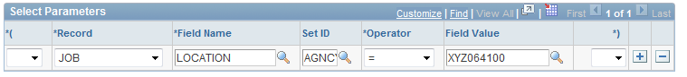
Multiple Location codes
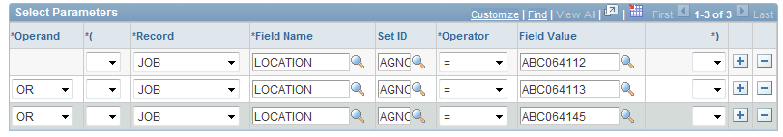
Multiple Location codes with Union code
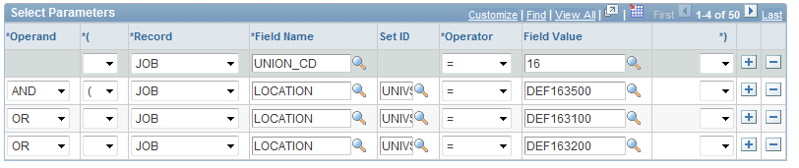
Location code with Shift
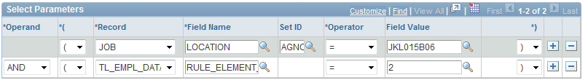
Department ID Reporting Group
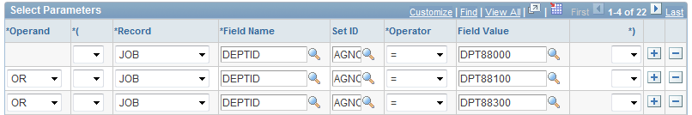
Department ID and Workgroup (union) Reporting Group


