This job aid describes the fields on the Time Reporter Data page.

Access Time Reporter Data:

For new hires: Main Menu > Core-CT HRMS > Time and Labor > Enroll Time Reporters > Create Time Reporter Data

OR

For existing employees: Main Menu > Core-CT HRMS > Time and Labor > Enroll Time Reporters > Maintain Time Reporter Data

OR

From Job Data (new hires or existing employees): Main Menu > Core-CT HRMS > Workforce Administration > Job Information > Job Data
- Click on the Employment Data link
- Click on the Time Reporter Data link

Example of Create Time Reporter Data page
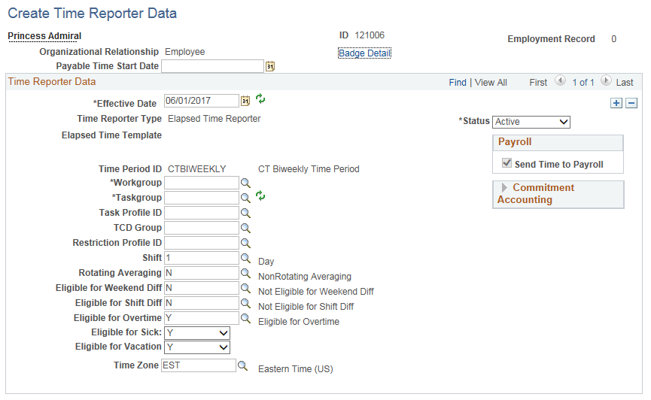

Example of Maintain Time Reporter Data page accessed from Time and Labor
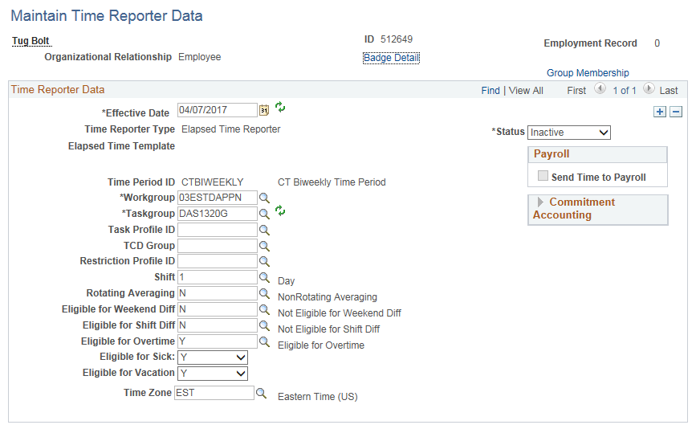

Example of Maintain Time Reporter Data page accessed from Job Data
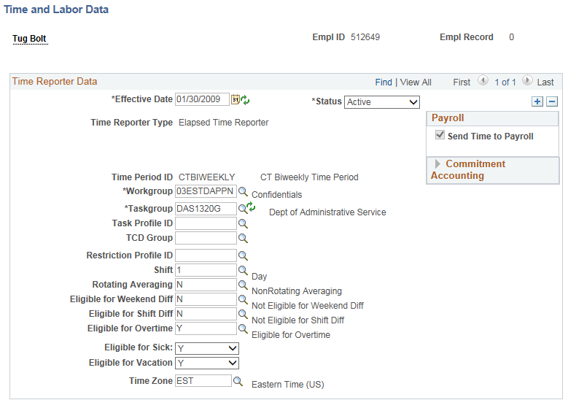
The following fields could be on the Create Time Reporter Data page, Maintain Time Reporter Data page, Job Data page or all three.

Badge Detail

This link is not used by Core-CT.

Payable Time Start Date:

This field is only available for a new hire on Create Time Reporter Data or Job Data. Once the page is saved for the first time, the field is no longer displayed. Enter the hire date or, if the hire is done retroactively, enter the first day of an unconfirmed pay period. The date indicates the pay period in which the employee will first be paid. The Payable Time Start Date does not need to match the Effective Date.

Effective Date:

Enter the hire date or the date of the change. Note that the hire row on Job Data must be saved in order to use a hire date prior to the current pay period. For changes, agency users can only use a Friday date and cannot select a date before the current pay period. For changes on a date that is not a Friday or that is contained in a prior period, log a Help Desk ticket with the Time and Labor Team. The Effective Date does not need to match the Payable Time Start Date.

Status:

The default value is ‘Active’ which opens the Timesheet for entry. Select ‘Inactive’ if you are terminating or placing the employee on a leave of absence.

For employees that are employed by an agency that uses Time and Labor, but will not be using the Timesheet for attendance, the Workgroup 100TLEXMPT must be selected with a status of ‘Inactive’.

Time Reporter Type:

This field cannot be changed. Core-CT only uses Elapsed Time Reporting.

Send Time to Payroll

This field cannot be changed. The box is checked when the employee is active and all time entered on the Timesheet is sent to Payroll. If the employee is inactive, the box will become unchecked.

Commitment Accounting

The fields in this box cannot be changed and they are always checked.
Time Period ID:

This value determines the period of time that can be viewed on the timesheet. Biweekly is used for all time reporters. It cannot be changed.

Workgroup:

Enter the employee’s Workgroup or select it from the list using the lookup button. The Workgroup indicates the employee’s bargaining unit and contains rules regarding attendance and pay, holiday schedules, default work schedules and the Time Reporting Codes the employee has access to. Refer to the Workgroups job aid for more information.

The following describes the naming convention for Workgroups. Refer to the Naming Standards for Time and Labor job aid for more information.

1-2 = the first two characters are used for the numeric code of the bargaining unit or labor unit.

3 = the next character is either a ‘P’ for Positive time reporters or an ‘E’ for Exception time reporters. Employees can either be Exception or Positive Time Reporters. Exception Time Reporters are assigned a work schedule and the scheduled hours are defaulted on the Timesheet with a Time Reporting Code of REG. Positive Time Reporters are assigned a zero-hour schedule and the Timesheet is blank.

4-6 = the next three characters are used to identify the holiday schedule for the group. The three character combination can be STD for standard holiday schedules or CON for continuous operations.

7-10 = the final four characters are reserved to distinguish between general workgroups and workgroups that are for specific agency use. If a workgroup ends with GEN it means that this workgroup is applicable to multiple agencies. If the workgroup ends with APPN, AP or A it means that employees in this workgroup enter their own time and must have their time approved before it will be paid. Otherwise the last four characters represent the agency’s acronym.

Naming Standards for 1199:
1-4 = the first four characters are 1199.

5 = the fifth character is either a ‘P’ for Positive time reporters or an ‘E’ for Exception time reporters.

6-10 = these characters indicate whether the Workgroup has a standard holiday schedule (S, ST, STD) or a continuous operations holiday schedule (C, CN, CO). Some workgroups names indicate what the standard hours are 7.5, 7.75 or 8 per day or 75 hours per week. Those that do not specify hours have a 7 hour standard day or 35 hours per week. The workgroups with 40 in the name are based on a 7 hour standard day and 35 hours per week. The last one or two characters are A, AN or AP to indicate that time needs to be approved (self-service).

Taskgroup:

The Taskgroup is used in Time and Labor for agency/department identification. Taskgroup changes will not take effect if there is time posted on the timesheet. The new Taskgroup will appear on attendance posted in a new pay period after the effective date.

The following describes the naming convention for Taskgroups. Refer to the Naming Standards for Time and Labor job aid for more information.

1-3 = the first three characters represent the agency acronym.

4 -7(8) = the next four (converted) or five (created after 2003) characters represent the agency number.

8(9) = the last character identifies if the Taskgroup is for general agency use (G), for agencies using Time Collection Devices (S) or for agencies using Projects Costing (P).

TaskProfile ID:

This field is not used by Core-CT and should be left blank.

TCD Group:

This field is not used by Core-CT and should be left blank.

Restriction Profile TCD:

This field is not used by Core-CT and should be left blank.

Shift:

This is the employee’s default shift assignment. Values can be ‘1’, ‘2’, ‘3’ or ‘4’. The default is ‘1’. This value can be overridden by entering a Shift on the Timesheet. During attendance processing, if no shift is found on the Timesheet the value in this field is used for rules processing.

Rotating Averaging:

The default value is ‘N’. This field is used by rules processing for employees who work a rotating schedule that is averaged over a period of time. If the value is ‘Y’, the employee must also be enrolled in a Workgroup that contains Rotating Averaging rules.

Refer to the Workgroups job aid to determine which Workgroups contain Rotating Averaging rules.

Eligible for Weekend Diff:

The default value is ‘N’. This field is used by rules processing for employees who work a shift that is eligible for weekend differential payments. If the value is ‘Y’, the employee must also be enrolled in a Workgroup that contains Weekend Diff rules and must report time on a weekend to an eligible shift. If the value is ‘N’, the employee is prevented from entering weekend differential Time Reporting Codes on the Timesheet. The only exception is for bargaining units 06 and 09 where the value can be ‘N’ and weekend differential codes can still be entered on the Timesheet.

Exceptions: Bargaining Units 06 and 09 can have the eligibility flag set to ‘N’ and still be able to enter Weekend Diff on the timesheet.

Refer to the Workgroups job aid to determine which Workgroups contain Weekend Diff rules.

Eligible for Shift Diff:

The default value is ‘N’. This field is used by rules processing for employees who work a shift that is eligible for shift differential payments. If the value is ‘Y’, the employee must also be enrolled in a Workgroup that contains Shift Diff rules and must report time to an eligible shift. If the value is ‘N’, the employee is prevented from entering shift differential Time Reporting Codes on the Timesheet. The only exception is for bargaining units 06 and 09 where the value can be ‘N’ and shift differential codes can still be entered on the Timesheet.

Exceptions: Bargaining Units 06, 09 and 15 can have the eligibility flag set to ‘N’ and still be able to enter Shift Diff on the timesheet.

Refer to the Workgroups job aid to determine which Workgroups contain Shift Diff rules.

Eligible for Overtime:

The default value is ‘Y’. This field is used by rules processing for employees who are eligible to earn overtime. If the value is ‘Y’, the employee must also be enrolled in a Workgroup that contains overtime rules and must report time using overtime Time Reporting Codes. If the value is ‘N’, the employee is prevented from entering overtime codes on the Timesheet.

Refer to the Workgroups job aid to determine which Workgroups contain Overtime rules.

Eligible for Sick:

The default value is ‘Y’. This field is used for Timesheet validation. If the employee is accruing sick time but is not eligible to use it, select ‘N’. If the value is ‘N’, the employee is prevented from entering sick Time Reporting Codes on the Timesheet.

This field can be used for employees who are eligible to earn sick time under PA 11-52 Connecticut Paid Sick Leave Law but who have not met the requirements to be entitled to use sick time. When the requirements have been met, add a new effective dated row and select ‘Y’.

Eligible for Vacation:

The default value is ‘Y’. This field is used for Timesheet validation. If the employee is accruing vacation time but is not eligible to use it, select ‘N’. If the value is ‘N’, the employee is prevented from entering vacation Time Reporting Codes on the Timesheet.

This field can be used for new hires who, during the first six months of employment are eligible to accrue vacation, but who cannot use it until the completion of six months of continuous state service. Upon completing the eligibility requirement, add a new effective dated row and select ‘Y’.

Time Zone:

The default is ‘EST’. This should not be changed.

Group Membership:

When the Time Reporter Data page is accessed through Time and Labor (not Job Data) for an existing employee, a Group Membership link is displayed on the page.

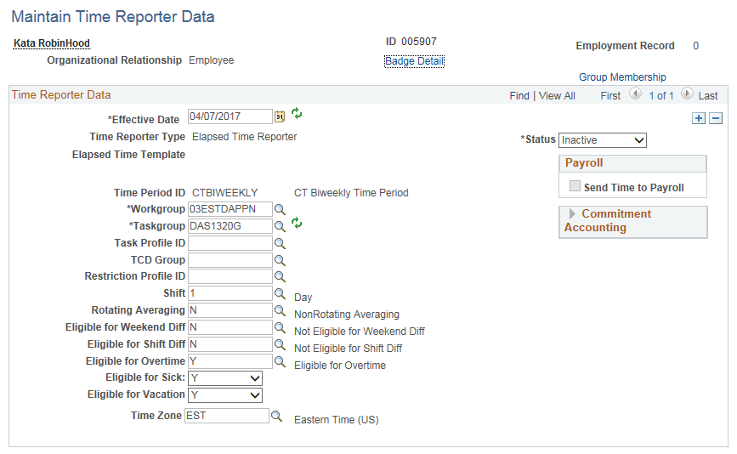

This link provides information on the Time and Labor Groups the employee is enrolled in. This can be helpful to Self-Service agencies for approvals or to all agencies for reporting.

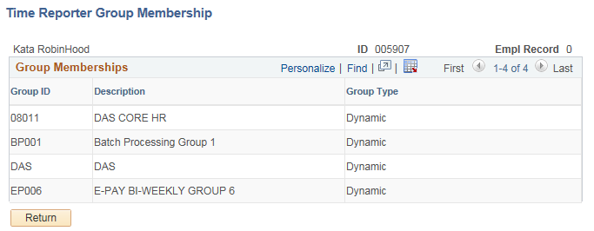

Group ID:

The ‘08’ group in this example is the agency specific Time and Labor Group to which the employee is enrolled. Each agency is assigned a range of Group numbers using the first two digits. The remaining digits in the Group ID are agency defined. These Group IDs are used for security access.

Refer to the Time and Labor Groups job aid to determine your agency’s Group numbers.

Group IDs that begin with ‘BP’ reflect the Time Administration (Time Admin) batch processing group that the employee’s time is processed with. Core-CT has defined groups BP001-BP010 based on workgroups. Refer to the Core-CT web page HRMS link for information about the nightly batch processing status. Issues with the batch processing will be posted there including any BP group that may not have completed. Employees will not have payable time created if a BP group did not complete successfully.

Refer to the Batch Processing Groups job aid to determine how employees are grouped for batch processing.

There are also agency specific Group IDs that are named using the agency’s three character acronym. This Group ID has been created for those users that need security access to timesheets for the entire agency, such as HR or Payroll.

Group IDs that begin with ‘EP’ are used for security purposes to allow users to view their paycheck/advise online in Core-CT (e-Pay). Core-CT has defined groups EP001-EP011 based on paygroups.

