This job aid describes how to run the Payable Status Report. However, the steps listed below apply to all reports. For a complete list of Time and Labor report names and navigation paths, please reference the Time and Labor Reports Job Aid.

IMPORTANT: It is not necessary to add a new Run Control ID each time a report is run. You may run reports under the same Run Control ID.
- Navigate to Main Menu > Core-CT HRMS > Time and Labor > Reports > Payable Status Report CTTLR252

- The Department Payable Status Rpt search page displays

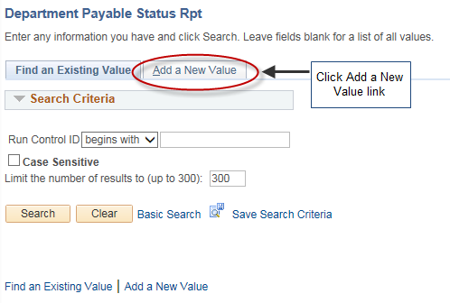

- Add a new value

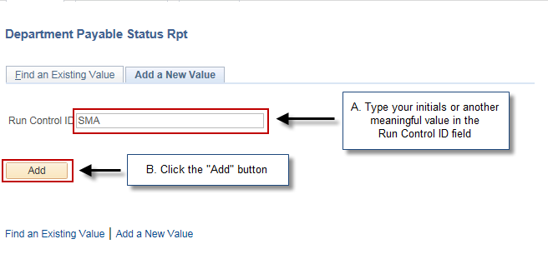

- The Payable Status Report page displays

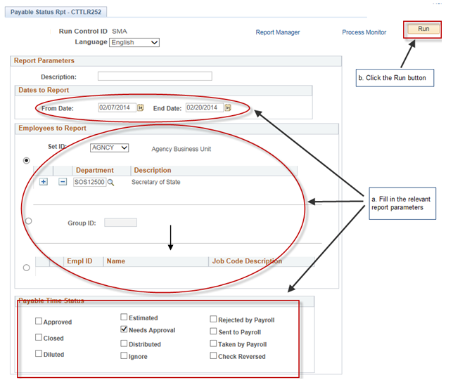

- The Process Scheduler Request page displays

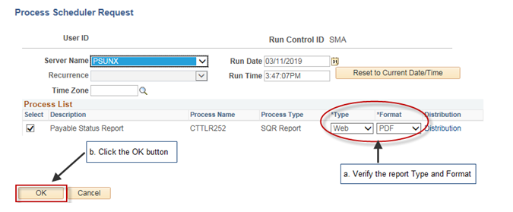

6. The Payable Status Report page displays

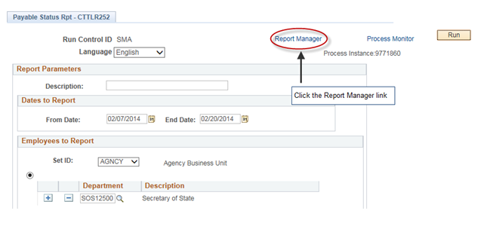

7. The Report List page displays

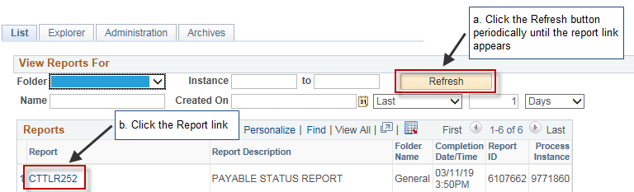

Special Note:
The Report List row will be blank until your report’s Status is Posted.

8. The Report/Log Viewer page displays

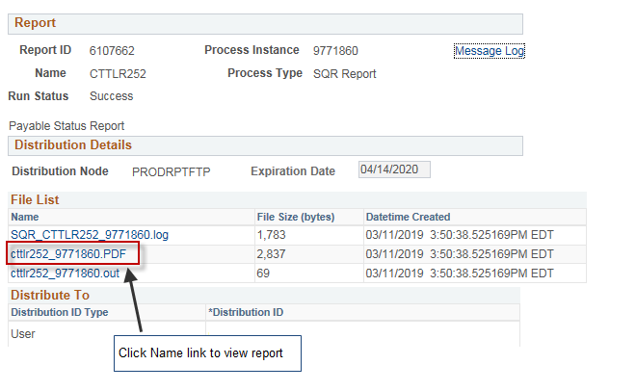

9. View your report.
Optional:
To print, click or select File > Print in your web browser.

Special Note:
You can view the Status (Queued, Generated, or Posted) on the Report List’s Administration Tab:


