Clearing Browser Cache
After major updates are made to the Core-CT application you should clear your browser’s cache files.
The process for clearing browser cache is different depending on the type of browser you are using. You can use Google to search for instructions for clearing cache for your specific browser or use the below guide.
Microsoft  Internet Explorer | On the right-hand side of the browser click the gear icon , followed by Safety, and finally Delete browing history…  The Ctrl-Shift-Del keyboard shortcut works too. Just hold down both the Ctrland Shift keys and then press the Del key.  Make sure the “Preserve Favorites website data” box is NOT checked.  Make sure “Temporary Internet files and website files”, “Cookies and website data” and “History” boxes are checked.  Click Delete.  Close all dialogue boxes and restart Internet Explorer. | 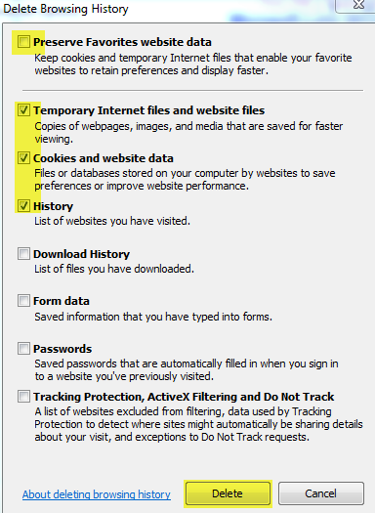
Mozilla  Firefox | Click the menu button and choose Options.  Select the “Privacy & Security” panel.  In the Cookies and Site Data Section, click Clear Data…  Confirm that all check boxes are selected.  Click Clear.  Click Clear Now to confirm.  Close and restart Firefox. | 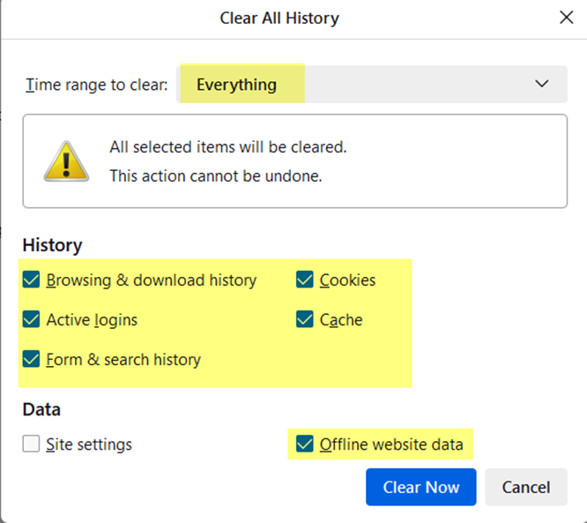
Google  Chrome | Click the More button and choose More toolsClear browsing data…  Confirm that all check boxes are selected.  Click Clear data.  Close and restart Chrome. | 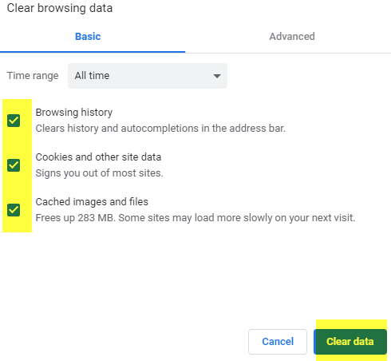
Microsoft  Edge | Open the Settings Menu. In the top right hand corner you'll see three dots in a horizontal line. ...  Locate Clearing Browsing Data. ...  Click Choosing What to Clear.  Make sure the first 3 boxes are checked.  Click Clear.  Close and Restart Edge | 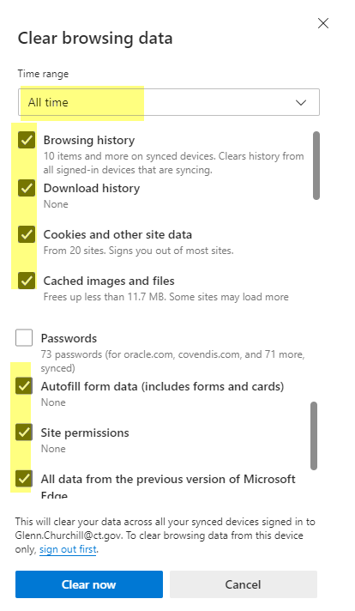
Safari /iPad, iPhone | To clear your history and cookies, go to Settings  Select Safari  Tap Clear History and Website Data. | 