Note: Any Financial Subject Area that has the Department Folder can use this variable. As an example we are demonstrating the Financials – Budgetary Control - Expense.
At the Criteria tab
Select the in Filters section

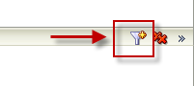
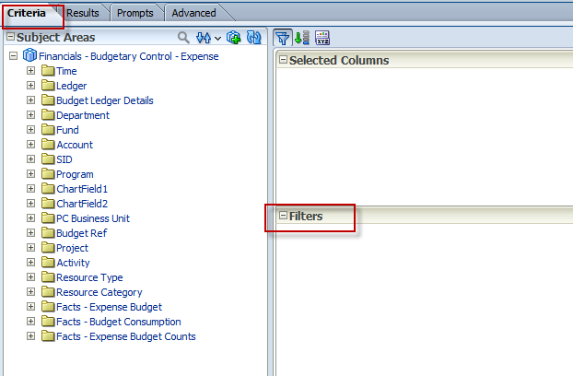

Expand the Department Tree folder:
Select the Filter Column Name : Dept Tree Eff Date++
Click OK

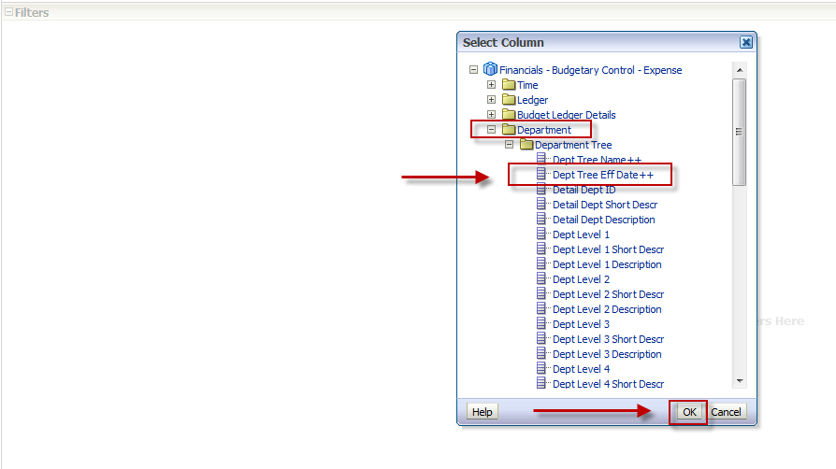
At the Add More Options dropdown – Select Session Variable
Click OK

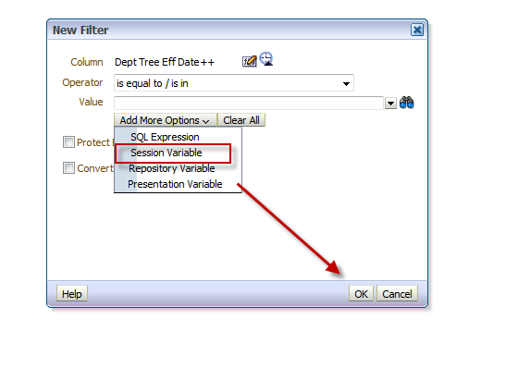
In the Session Variable Box:
Type in Session Variable Name: CURRENT_TREE_EFFDT
Click OK
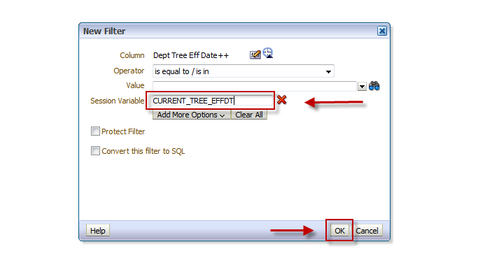
You have successfully added the Current Tree Effective Date

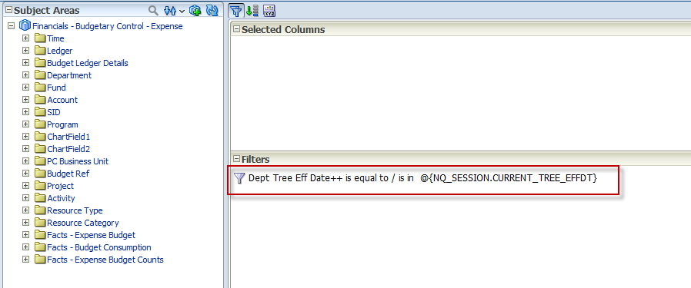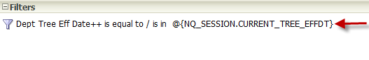
Here is the sample report without adding the filter.

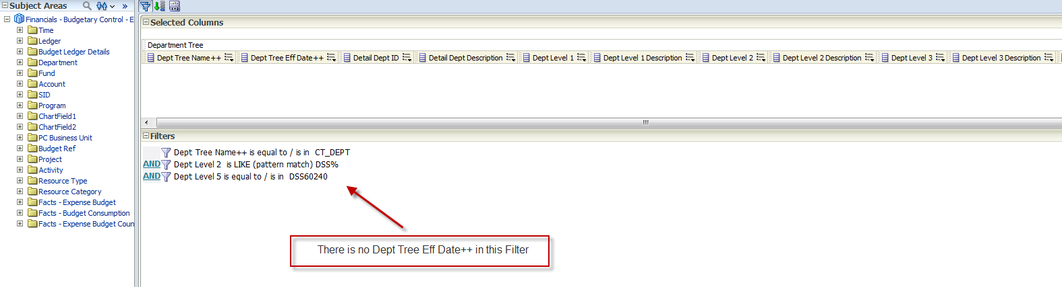
Results
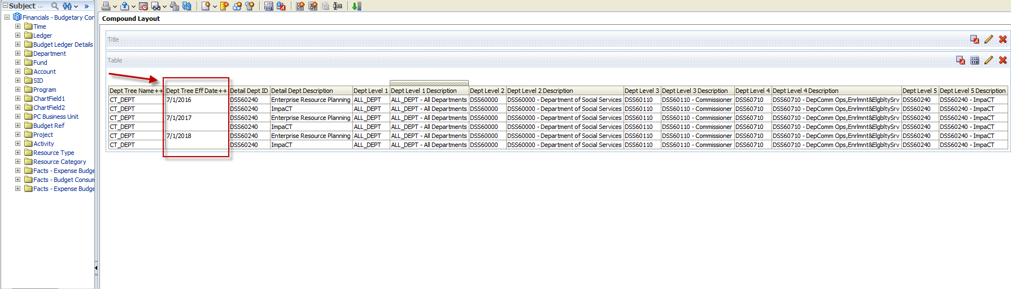

Sample Report with filter

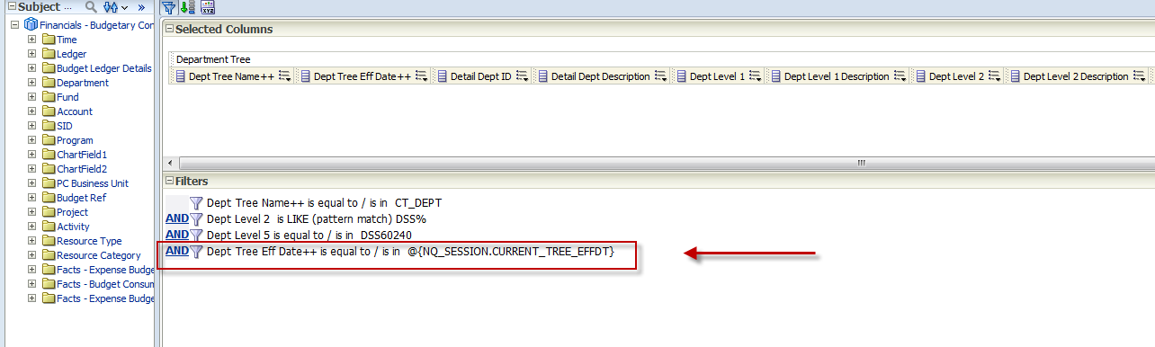
Results
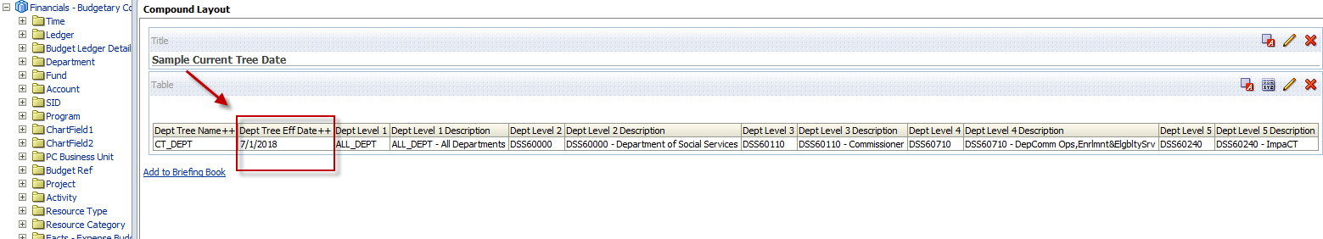

NOTE: If you are using the Department Tree columns in your report you will need this filter. If you are just using Department ID and Department columns this filter is not required.

